1.Create one IAM user and assign EC2 and S3 full access roles:-
Objective:
- Create an IAM user and grant full administrative permissions for Amazon EC2 and Amazon S3 services.

- Implementation:

- Created an IAM user named ec2-s3-user.
- Attached the AWS managed policy AmazonEC2FullAccess to provide complete access to EC2 resources.
- Attached the AWS managed policy AmazonS3FullAccess to provide complete access to S3 buckets and objects.
- Enabled AWS Management Console access by assigning a password.
- Generated Access Keys for AWS CLI access.

- Result: The IAM user can independently manage EC2 instances and S3 storage resources without using the root account.

``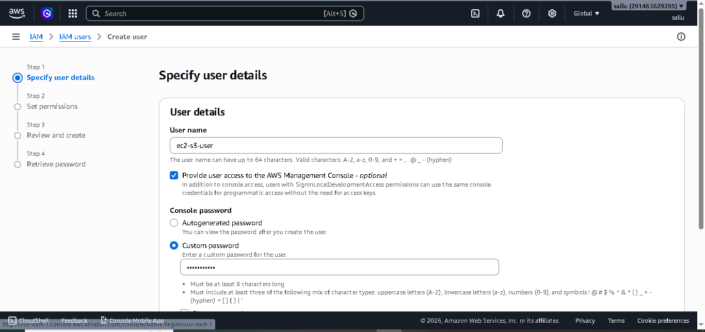

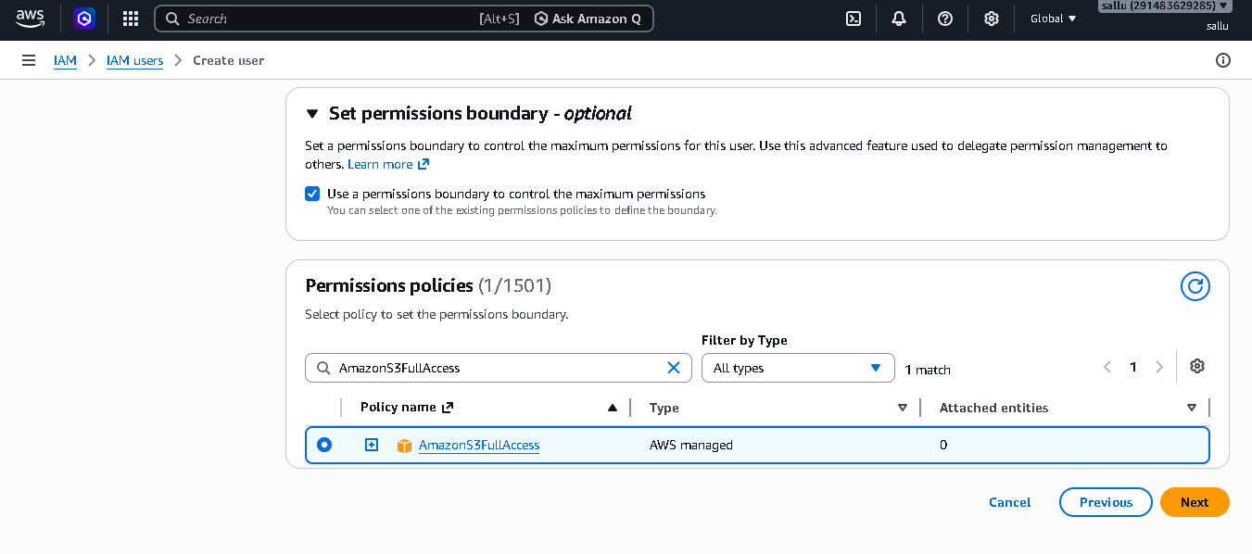
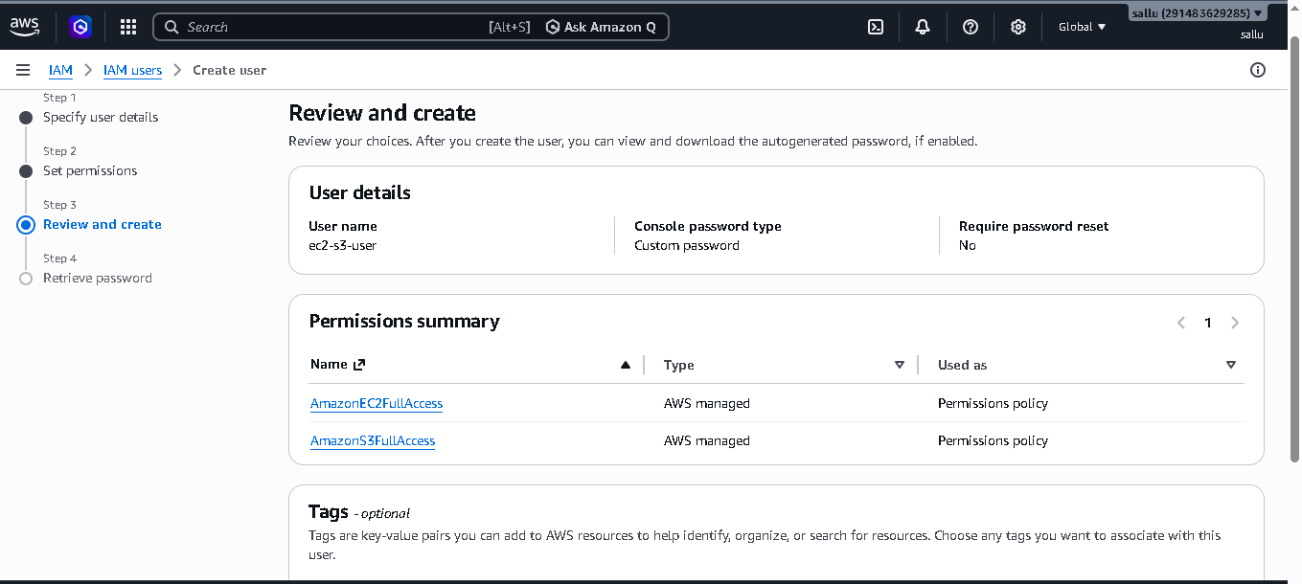
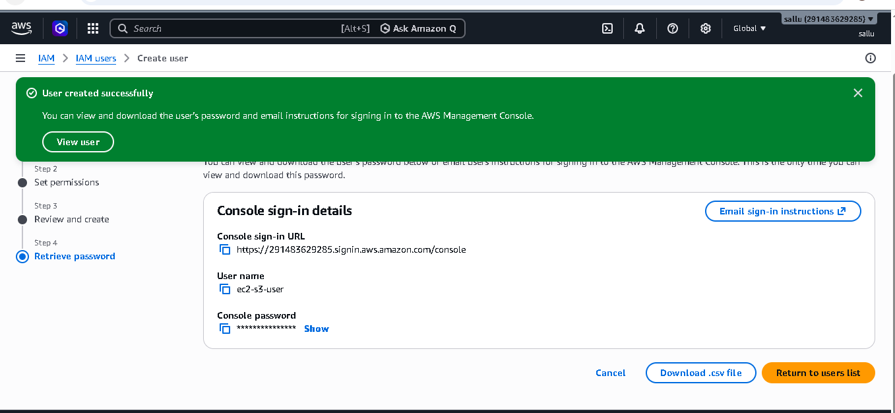
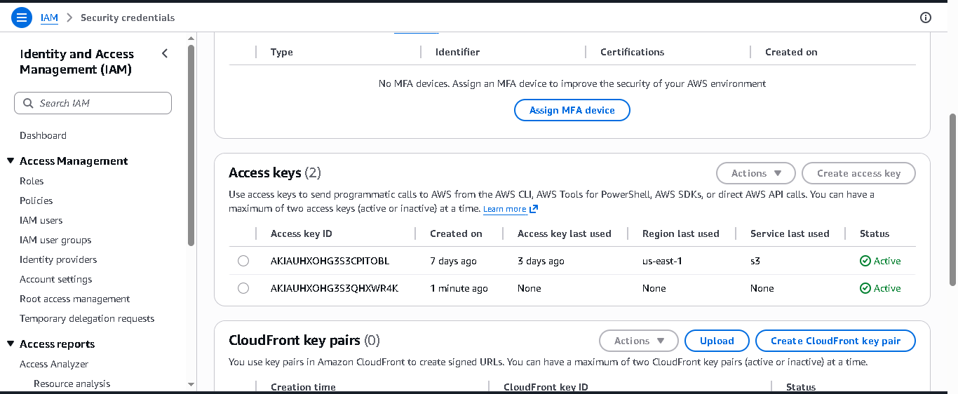
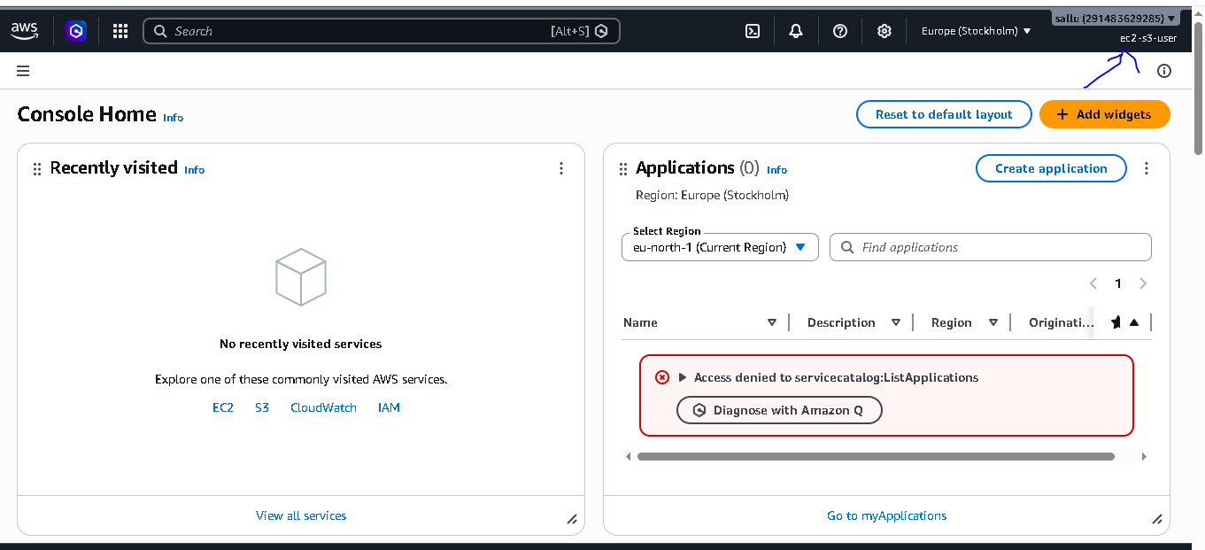
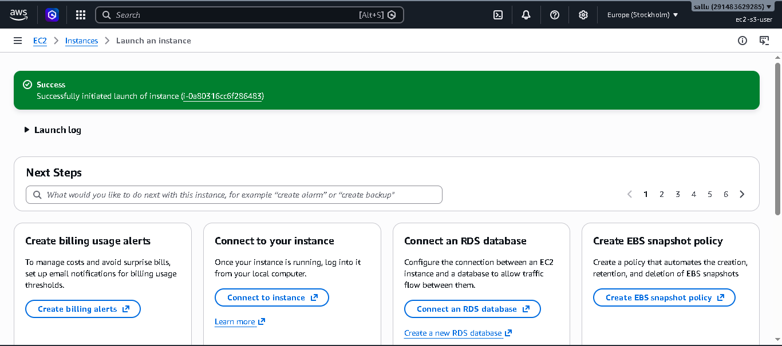
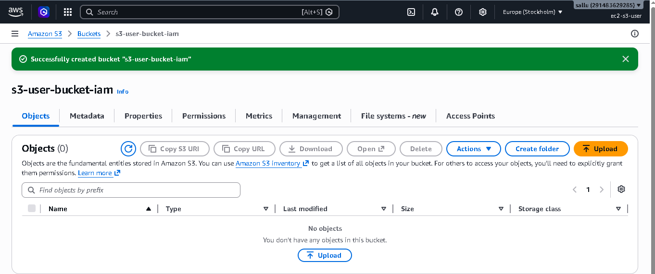

2. Create one group in IAM and assign read access for EC2:-
Architecture:

IAM
│
├── Group
│ │
│ └── EC2-ReadOnly-Group
│ │
│ └── AmazonEC2ReadOnlyAccess Policy
│
└── User
│
└── Added to EC2-ReadOnly-Group

# Creating an IAM Group and Assigning EC2 Read-Only Access

## Objective

The objective of this task is to create an IAM Group and assign EC2 read-only permissions so that users in the group can view EC2 resources without being able to make any changes.

## Description

AWS Identity and Access Management (IAM) allows administrators to manage access to AWS resources securely. Instead of assigning permissions directly to individual users, permissions can be attached to IAM Groups. Users added to the group automatically inherit the group's permissions.

In this task, an IAM Group named **EC2-ReadOnly-Group** was created. The AWS managed policy **AmazonEC2ReadOnlyAccess** was attached to the group. This policy grants permission to view EC2 resources such as instances, volumes, snapshots, security groups, and VPC information while preventing actions like launching, stopping, modifying, or terminating instances.

After creating the group, IAM users were added to it. Once added, the users inherited the read-only permissions associated with the group. When logged in, these users could access the EC2 Dashboard and view resource details but were restricted from performing administrative operations.

## Outcome

The IAM Group was successfully created and configured with EC2 read-only permissions. Users assigned to the group gained secure viewing access to EC2 resources while maintaining the principle of least privilege and enhancing overall AWS security management.

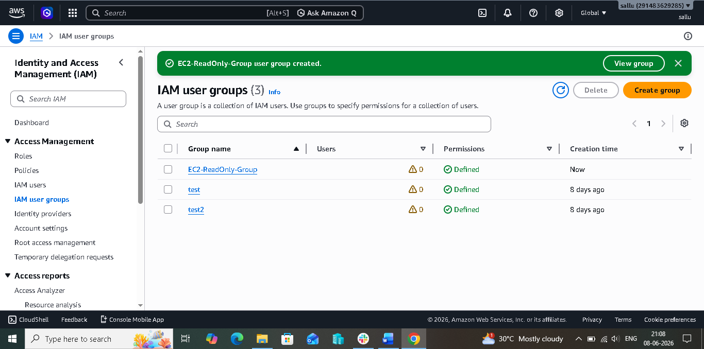

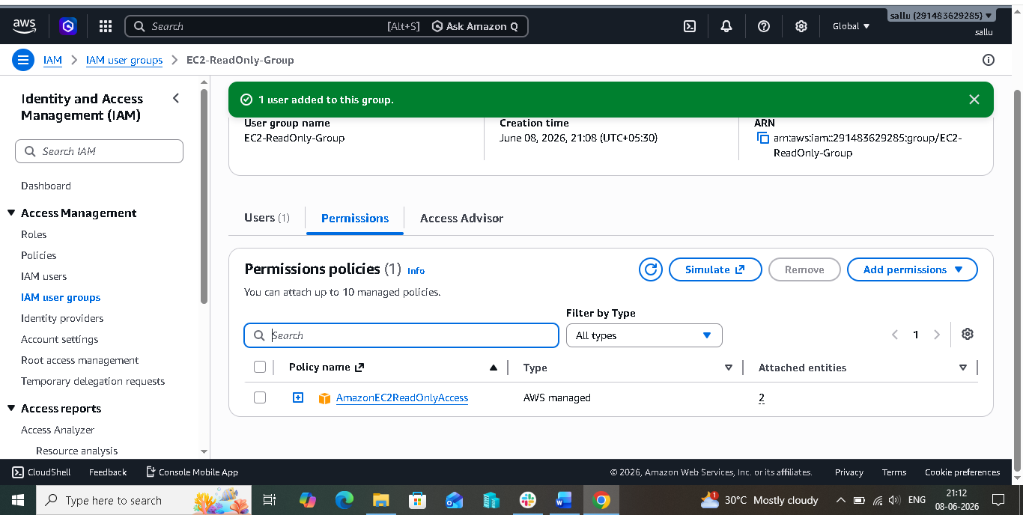

3.Create a new user named "Devops" and add to the group created in task 2:-

# Creating an IAM User and Adding the User to an Existing IAM Group

## Objective

The objective of this task is to create a new IAM user named **Devops** and add the user to the previously created IAM Group so that the user inherits the permissions assigned to the group.

## Description

AWS Identity and Access Management (IAM) provides the ability to create individual users and manage their access to AWS resources. Instead of assigning permissions directly to each user, AWS recommends using IAM Groups to simplify permission management.

In this task, a new IAM user named **Devops** was created through the IAM service. During the user creation process, appropriate access options were configured based on the requirement. After the user was successfully created, the user was added to the existing group **EC2-ReadOnly-Group** that was created in the previous task.

Since the group already had the **AmazonEC2ReadOnlyAccess** policy attached, the Devops user automatically inherited all permissions granted to the group. This eliminated the need to assign permissions directly to the user and ensured centralized access management.

Once the user was added to the group, the user could log in to the AWS Management Console and access EC2 resources in read-only mode. The user was able to view EC2 instances, volumes, security groups, and other related resources but was not authorized to create, modify, stop, start, or terminate EC2 instances.

## Outcome

The IAM user **Devops** was successfully created and added to the existing IAM Group. The user inherited the group's EC2 read-only permissions, enabling secure and controlled access to AWS resources while following IAM best practices and the principle of least privilege.

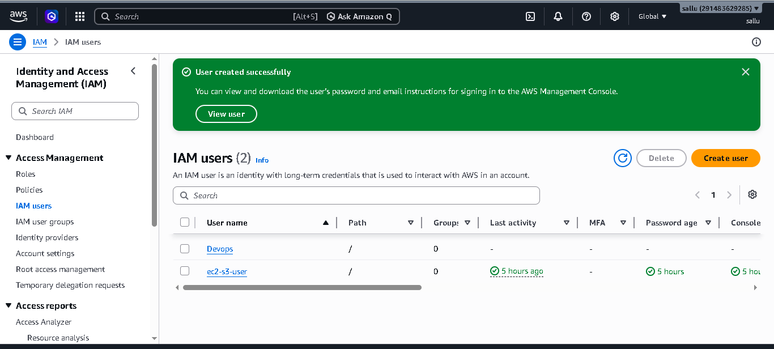

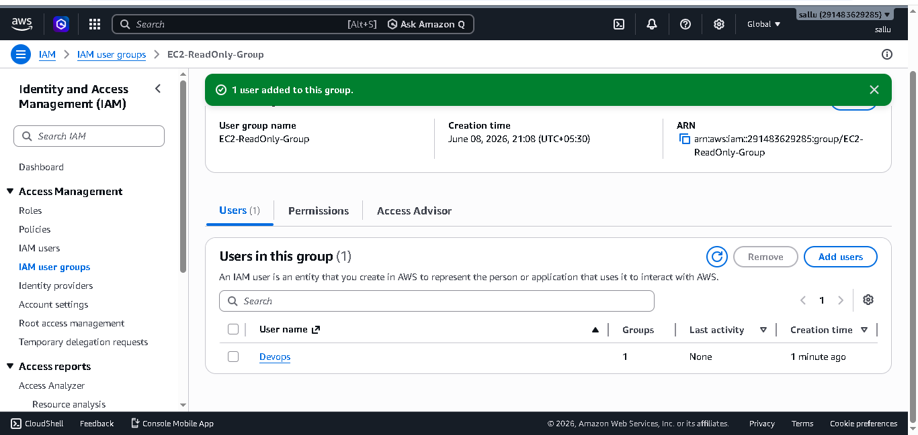

4. Write a bash script to create an IAM user with VPC full access:-

Objective:-

The objective of this task is to automate the creation of an IAM user and assign VPC Full Access permissions using a Bash script. Automation reduces manual effort, ensures consistency, and helps administrators efficiently manage AWS resources.

Description

AWS Identity and Access Management (IAM) is used to securely control access to AWS services and resources. Instead of manually creating users and assigning permissions through the AWS Management Console, AWS CLI commands can be executed through a Bash script to automate the process.

In this task, a Bash script was created to automate the creation of an IAM user named devops. The script used AWS CLI commands to create the IAM user and attach the AWS managed policy AmazonVPCFullAccess. This policy provides full administrative access to Amazon VPC resources, allowing the user to create, modify, and manage networking components within AWS.

The script also created a login profile for the user, enabling AWS Management Console access with an initial password. Upon first login, the user was required to reset the password for security purposes.

After the script execution was completed successfully, the IAM user inherited all permissions defined in the AmazonVPCFullAccess policy. The user was able to perform VPC-related operations such as creating VPCs, subnets, route tables, internet gateways, NAT gateways, security groups, and VPC endpoints.

Outcome

The Bash script successfully automated the creation of the IAM user devops and assigned the AmazonVPCFullAccess policy. As a result, the user gained full access to VPC resources and could manage AWS networking infrastructure without requiring manual user creation and permission assignment through the AWS Management Console.

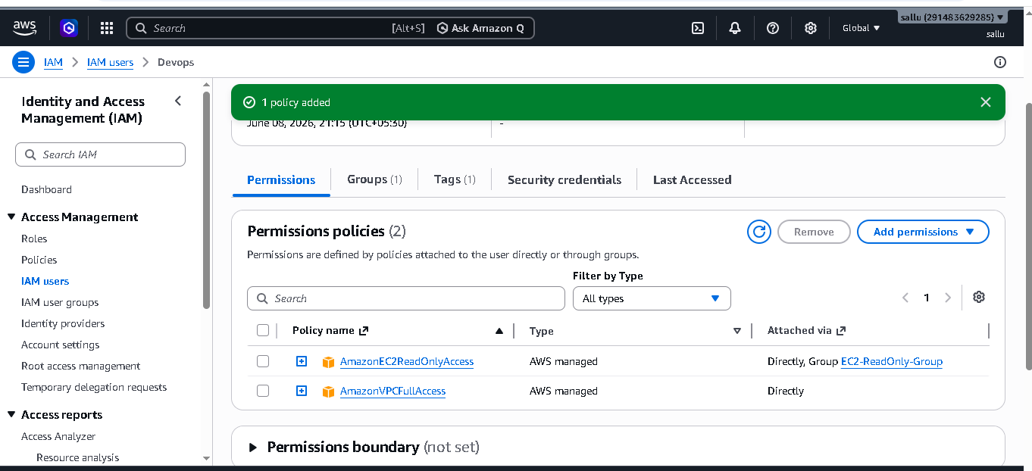

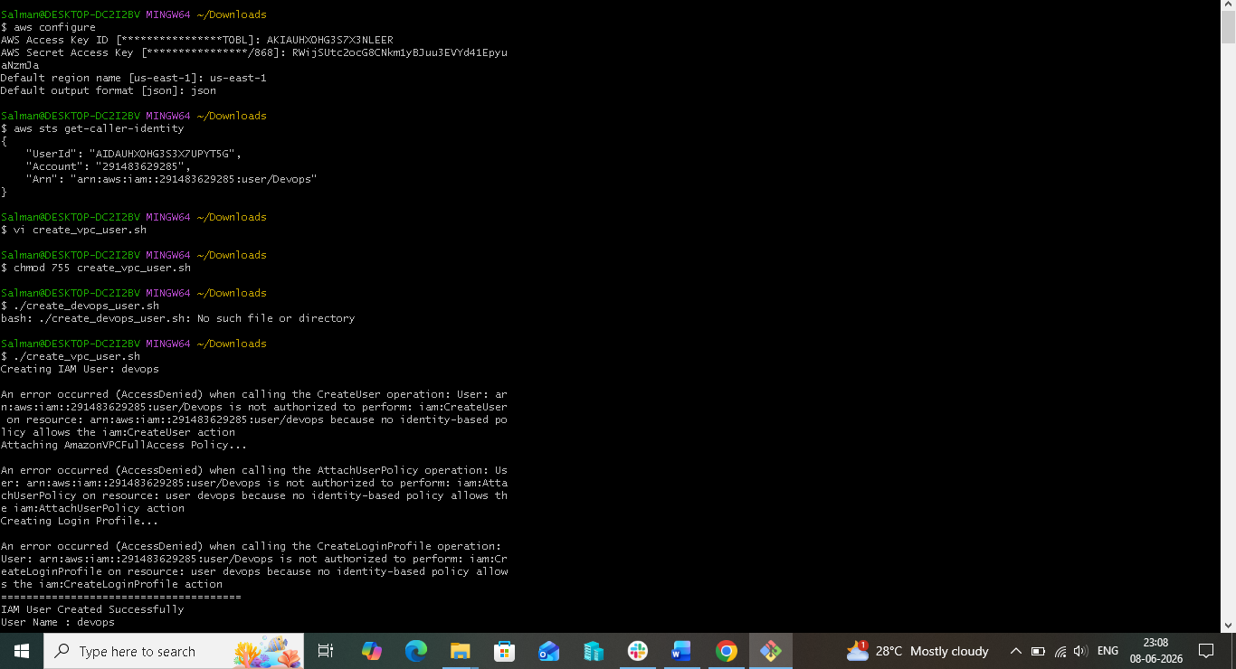

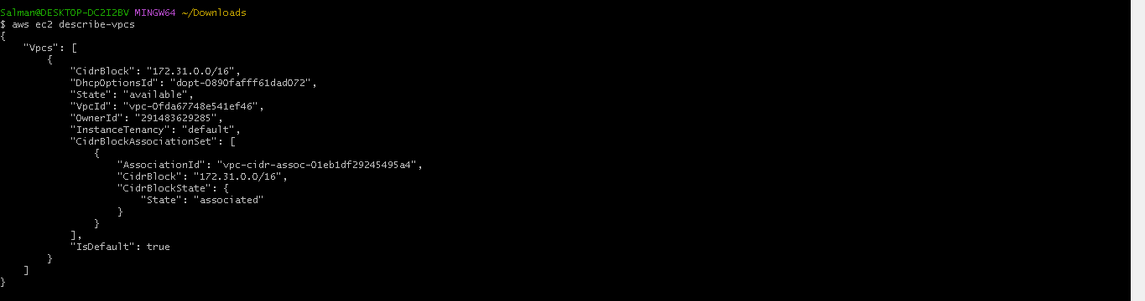

5. Create an IAM policy to allow EC2 access for a specific user in specific regions only:-

# 5. Creating an IAM Policy to Allow EC2 Access for a Specific User in a Specific Region

## Objective:-

- The objective of this task is to create a custom IAM policy that allows a user to access and manage Amazon EC2 resources only within a specific AWS region. This helps organizations enforce regional restrictions, improve security, and ensure compliance with business requirements.

- ## Description

- AWS Identity and Access Management (IAM) provides the capability to control user permissions through policies. In this task, a custom IAM policy was created to restrict EC2 access to a single AWS region, **US East (N. Virginia) - us-east-1**.

- The policy was configured using the IAM JSON policy editor. EC2 permissions were granted by allowing EC2 actions while applying a condition based on the AWS global condition key **aws:RequestedRegion**. This condition ensured that the user could perform EC2-related operations only when requests were made to the **us-east-1** region.

- After creating the policy, it was attached to a specific IAM user. Once assigned, the user was able to access and manage EC2 resources such as instances, security groups, volumes, and snapshots within the permitted region. When the same user attempted to access EC2 resources in any other AWS region, the requests were denied due to the region-based restriction defined in the IAM policy.

- This approach provides granular access control and prevents users from creating or managing resources outside approved AWS regions.

- ## Outcome

- The custom IAM policy was successfully created and attached to the designated IAM user. The user was granted EC2 access exclusively in the **us-east-1** region while access to EC2 resources in all other AWS regions was restricted. This implementation enhanced security and ensured that AWS resources were managed only within the approved region.

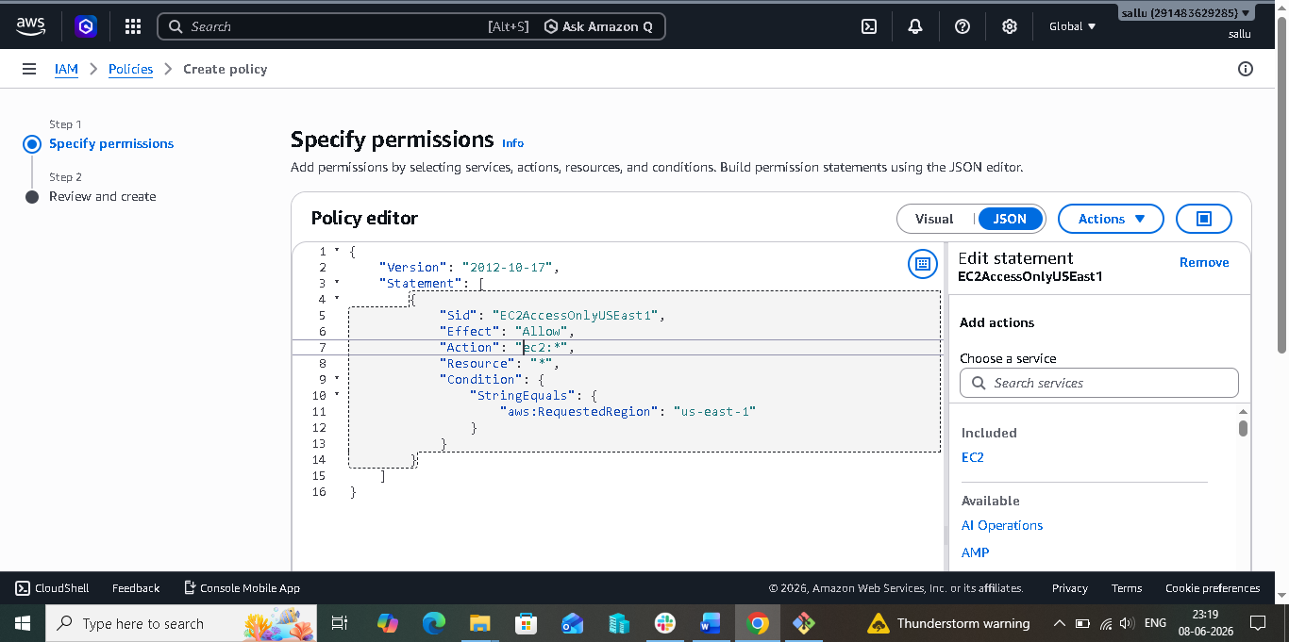

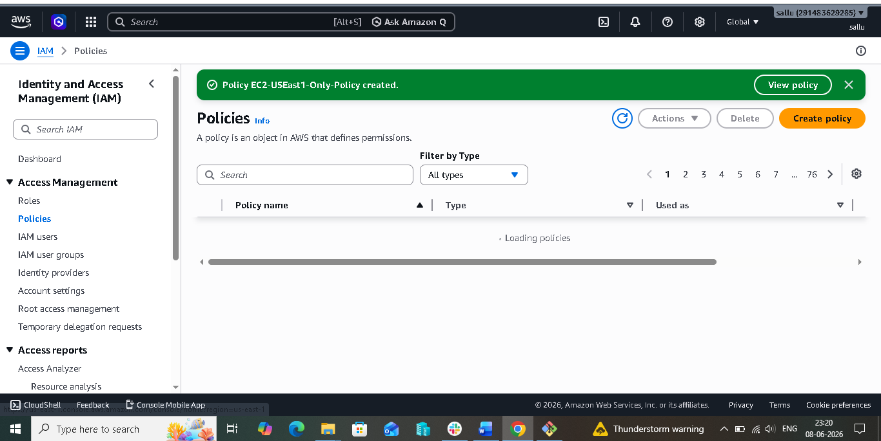

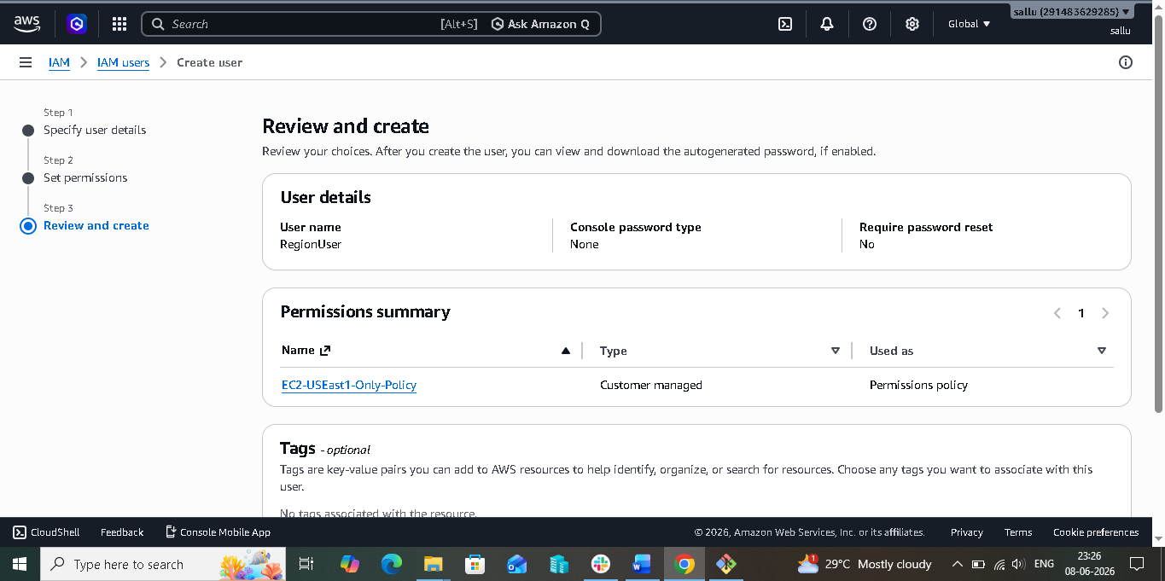

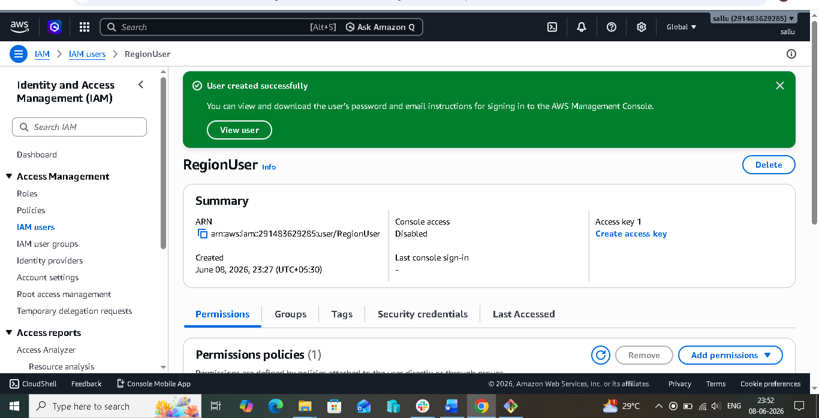

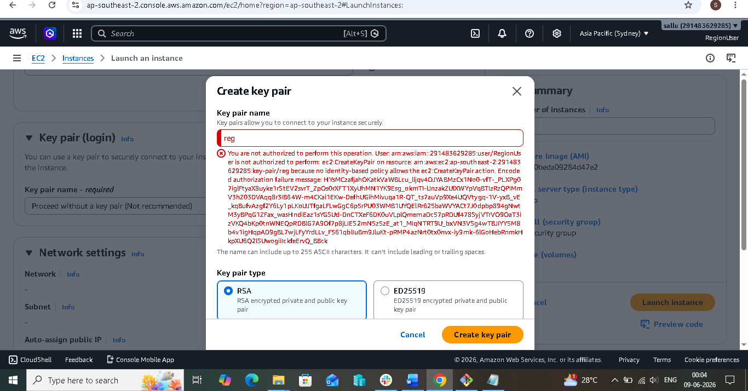

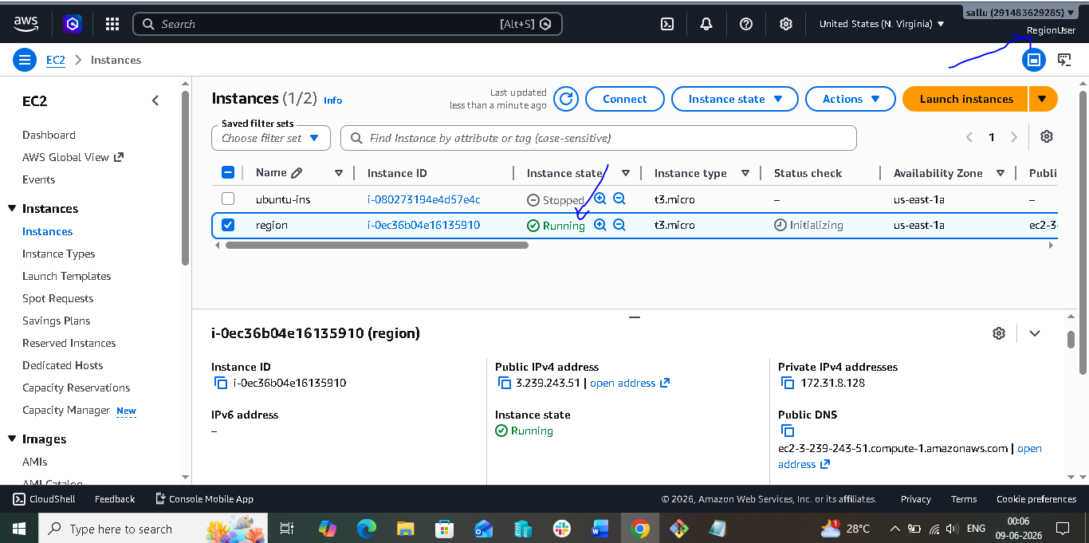

6. We have two accounts: Account A and Account B. Account A user should access an S3 bucket in Account B.
(Collaborate with a team member and execute this. This is mostly asked in every interview.) :-

- ## Objective

- The objective of this task is to allow an IAM user from Account A to access an S3 bucket located in Account B. This is a common enterprise requirement where resources are shared securely between different AWS accounts without creating duplicate users.

- ## Scenario

- An organization has two AWS accounts:

- Account A contains IAM users.
- Account B contains an S3 bucket that stores files.

- The requirement is to allow a user from Account A to access and download objects from the S3 bucket in Account B.

- AWS provides this functionality through Cross-Account Access using IAM Policies and S3 Bucket Policies.

- ---

- ## Step 1: Create an IAM User in Account A

- First, an IAM user was created in Account A. This user represents the person or application that requires access to resources located in another AWS account.

- The IAM user was provided with programmatic access so that AWS CLI commands could be used for testing and validation purposes.

- At this stage, the user belongs only to Account A and has no permissions to access resources in Account B.

- ---

- ## Step 2: Obtain the IAM User ARN

- After creating the user, the Amazon Resource Name (ARN) of the IAM user was copied.

- The ARN uniquely identifies the IAM user within AWS and is later used in the bucket policy of Account B to specify exactly who is allowed to access the bucket.

- Without the ARN, AWS would not know which external user is requesting access.

- ---

- ## Step 3: Create an S3 Bucket in Account B

- An S3 bucket was created in Account B.

- This bucket acts as the target resource that will be shared with the user from Account A.

- A sample file was uploaded to the bucket so that access could be verified after configuration.

- At this stage, only users within Account B can access the bucket.

- ---

- ## Step 4: Configure Bucket Policy in Account B

- A bucket policy was added to the S3 bucket.

- The purpose of this policy is to grant permission to the IAM user from Account A.

- The bucket policy explicitly allows:

- s3:ListBucket
- s3:GetObject

- The Principal section of the policy contains the IAM User ARN from Account A.

- This step is important because the bucket owner must explicitly trust external accounts before access can be granted.

- ---

- ## Step 5: Create IAM Policy in Account A

- Next, an IAM policy was created and attached to the IAM user in Account A.

- This policy grants permission to perform actions on the bucket located in Account B.

- The policy allows:

- Listing objects inside the bucket.
- Reading and downloading objects from the bucket.

- This step informs AWS that the user is allowed to make requests against the target bucket.

- ---

- ## Step 6: Understand AWS Permission Evaluation

- AWS evaluates permissions from both sides before granting access.

- The IAM policy attached to the user must allow the requested action.
- The S3 bucket policy must also allow the requested action.

- If either side denies access, the request fails.

- Therefore, cross-account access requires permissions from both the source account and the target account.

- ---

- ## Step 7: Configure AWS CLI

- AWS CLI was configured using the access key and secret key of the IAM user from Account A.

- This allows testing of cross-account access from the command line.

- The AWS CLI acts on behalf of the IAM user and sends requests to AWS services.

- ---

- ## Step 8: Verify Access

- The AWS CLI command was executed to list the contents of the bucket.

- aws s3 ls s3://s3b-bucket-05868

- A successful response confirmed that the IAM user from Account A could access the bucket located in Account B.

- Additional testing was performed by downloading an object from the bucket.

- Successful download verified that cross-account access was functioning correctly.

- ---

- ## Result

- Cross-account S3 access was successfully implemented between Account A and Account B.

- The IAM user from Account A was able to securely access and download files from the S3 bucket located in Account B without creating additional users in the target account.

- This implementation follows AWS security best practices by granting only the required permissions and maintaining account separation.

