SIMATS ENGINEERING
Assessment Tool 2 — Concept Mapping
Course: CSA07 — Computer Networks
CO1: Apply the functions of OSI layers in enabling reliable data transmission across networks

Q1. Missing Layers in the OSI Concept Map
Concept map: Application → Presentation → Session → Transport → Network → Data Link → Physical
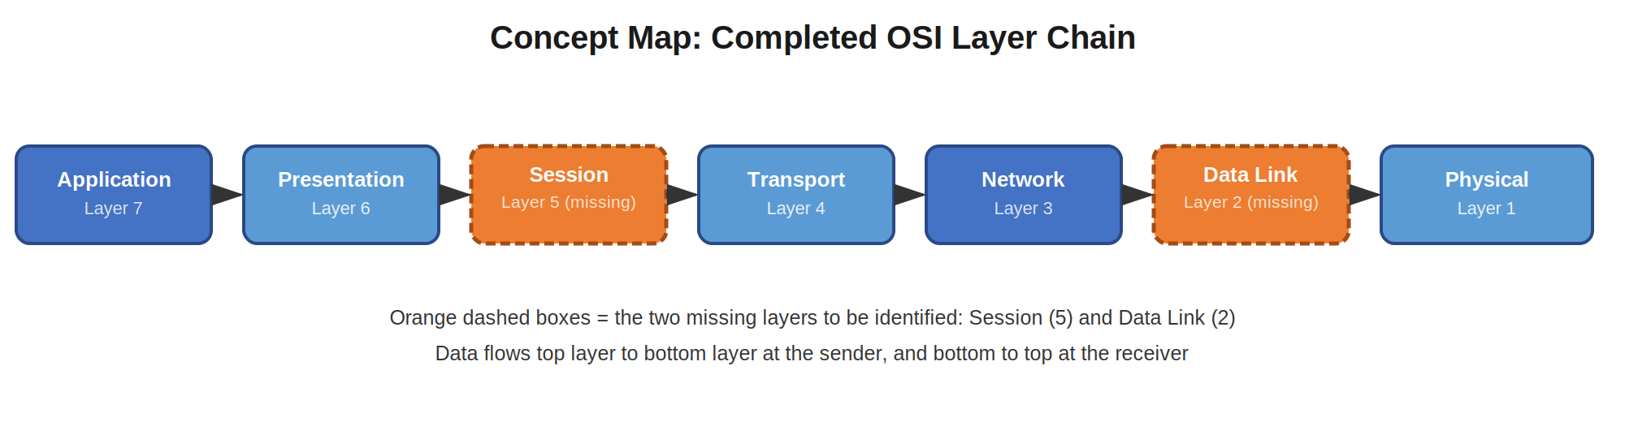
Figure 1: Completed seven-layer OSI concept map with the missing layers filled in
Analysis:
- Session Layer (missing, between Presentation and Transport): establishes, manages, and terminates the dialogue (session) between two communicating applications. It provides synchronization points, allowing communication to resume without restarting entirely if it is interrupted — essential for reliable, uninterrupted data exchange.
- Data Link Layer (missing, between Network and Physical): organizes bits from the Physical layer into frames, adds MAC addressing, and performs error detection (via CRC) for each hop across the local network. This ensures data is delivered correctly between directly connected devices.
Together, these two layers close the gap between application-level dialogue control and physical transmission. Without the Session layer, applications would have no way to manage ongoing conversations; without the Data Link layer, raw bits could not be organized or checked for errors before reaching the Physical medium. Their presence is what allows the encapsulation chain to support truly reliable, end-to-end communication.

Q2. Data Units Linked to OSI Layers
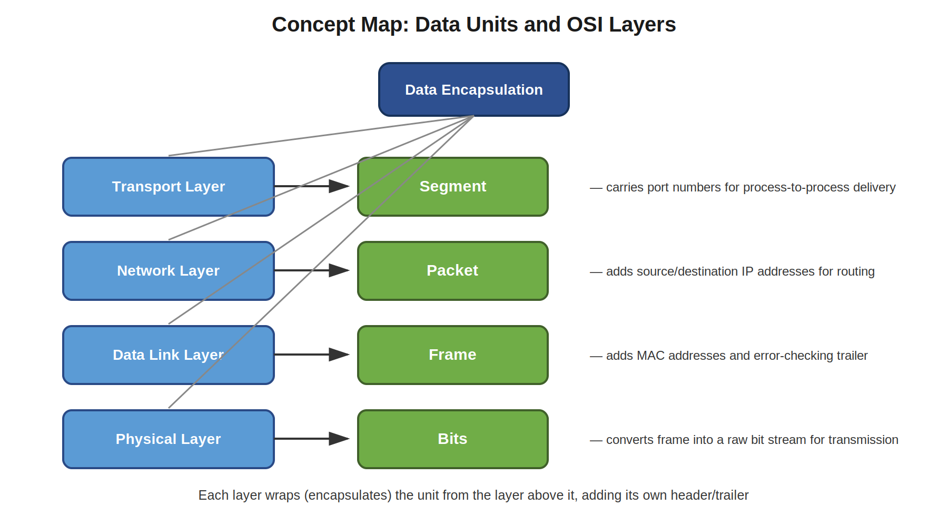
Figure 2: Concept map linking Segment, Packet, Frame, and Bits to their respective layers
Analysis:
- Transport Layer → Segment: application data is divided into segments, with port numbers added so the right process on the destination host receives it.
- Network Layer → Packet: each segment is encapsulated into a packet with source and destination IP addresses added, enabling routing across networks.
- Data Link Layer → Frame: each packet becomes a frame with MAC addresses and an error-checking trailer added, enabling delivery across a single physical link.
- Physical Layer → Bits: the frame is converted into a raw stream of bits (electrical, optical, or radio signals) for actual transmission over the medium.
This step-by-step transformation, known as encapsulation, is what makes reliable transmission possible: each layer adds exactly the control information it needs, without the layer above needing to know how the layer below achieves delivery. At the receiving end, the reverse process (de-encapsulation) strips each header/trailer in order, reconstructing the original data for the receiving application.

Q3. MAC and IP Addressing for Local and Global Delivery
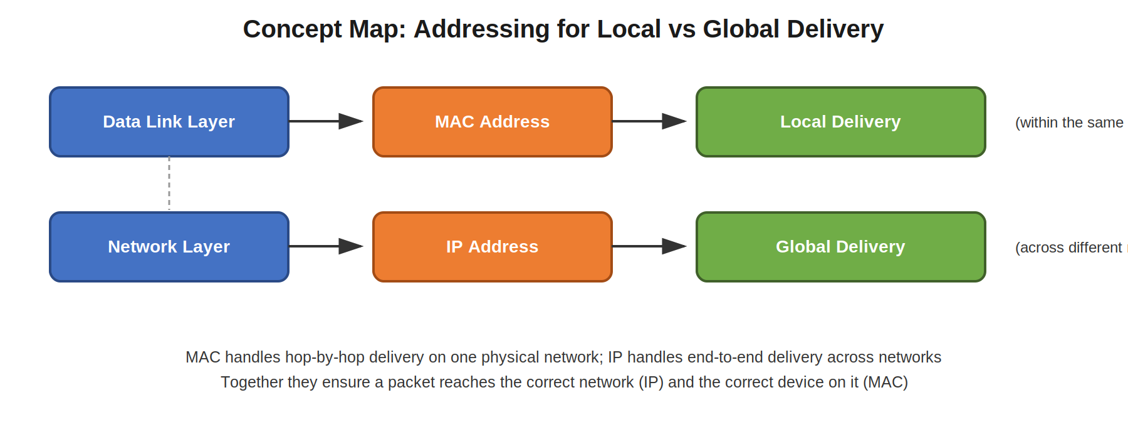
Figure 3: Concept map showing how MAC and IP addresses map to local and global delivery
Analysis:
- Data Link → MAC Address → Local Delivery: the MAC address is a physical, hardware-level address unique to a network interface. It is used only within a single local network (LAN) segment to deliver frames from one device directly to another on the same physical medium.
- Network → IP Address → Global Delivery: the IP address is a logical address that identifies both the network and the host. It allows packets to be routed across multiple interconnected networks, all the way to a destination anywhere on the internet.
These two addressing schemes work together in a hierarchy: IP addressing gets a packet to the correct network anywhere in the world (global delivery), while MAC addressing takes over for the final hop, delivering it to the exact device on that local network (local delivery). This division of responsibility — one address for the journey across networks and another for the last step within a network — is what allows data to travel reliably from source to destination even when many networks lie in between.

Q4. Error Control Across the Data Link and Transport Layers
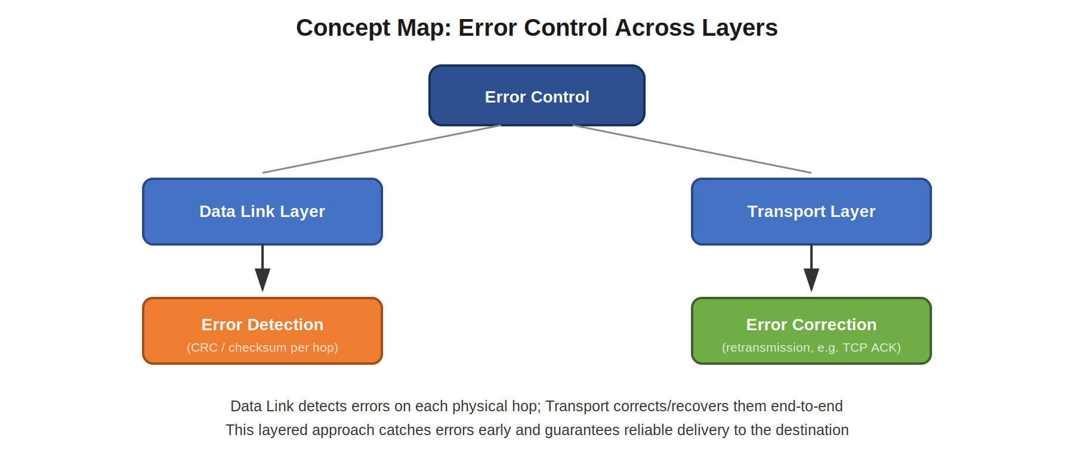
Figure 4: Concept map of complementary error-control responsibilities across layers
Analysis:
- Data Link Layer → Error Detection: uses techniques such as CRC (Cyclic Redundancy Check) or checksums to detect if bits were corrupted during transmission over a single physical link. It flags errors early, hop by hop.
- Transport Layer → Error Correction: uses acknowledgements, sequence numbers, and retransmission (e.g., in TCP) to recover from lost or corrupted segments, guaranteeing correct delivery end-to-end.
The interaction between these two layers creates a layered defense against errors: the Data Link layer catches problems close to where they occur, preventing obviously corrupted frames from propagating further, while the Transport layer provides an end-to-end guarantee that any data that still goes missing or arrives damaged is detected and retransmitted. This combination greatly improves overall reliability, since no single layer has to carry the entire burden of ensuring error-free communication.

Q5. Web Browsing Modeled Through the OSI Layers
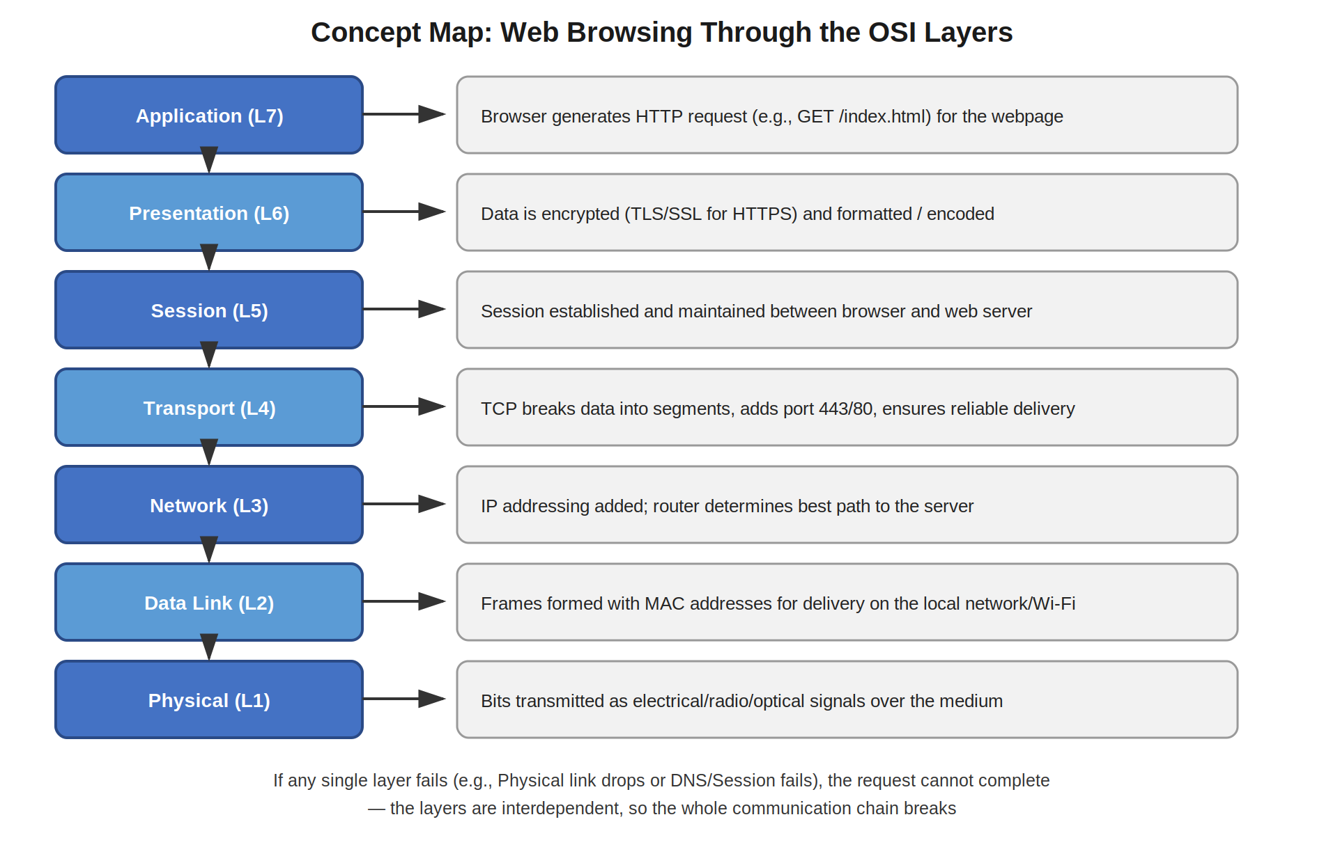
Figure 5: Concept map tracing a web browsing request through all seven OSI layers
Analysis:
When a user opens a webpage, each OSI layer contributes a specific function: the Application layer generates the HTTP(S) request; the Presentation layer encrypts and formats the data (TLS); the Session layer maintains the dialogue with the web server; the Transport layer (TCP) breaks data into segments and ensures reliable delivery; the Network layer (IP) determines the routing path; the Data Link layer frames the data with MAC addressing for the local network; and the Physical layer transmits the actual bits over the medium (Wi-Fi, cable, fiber, etc.).
Because each layer depends on the one below it, a failure at any single layer breaks the entire chain. For example, if the Physical layer loses signal (cable unplugged or Wi-Fi out of range), no frames can be sent, so the Network layer cannot route packets, the Transport layer cannot confirm delivery, and the Application layer never receives the webpage — the browser simply times out. This illustrates why OSI layers are interdependent: reliable web browsing requires every layer to perform its function correctly, in sequence.

Q6. Troubleshooting a Network Issue Using the Concept Map
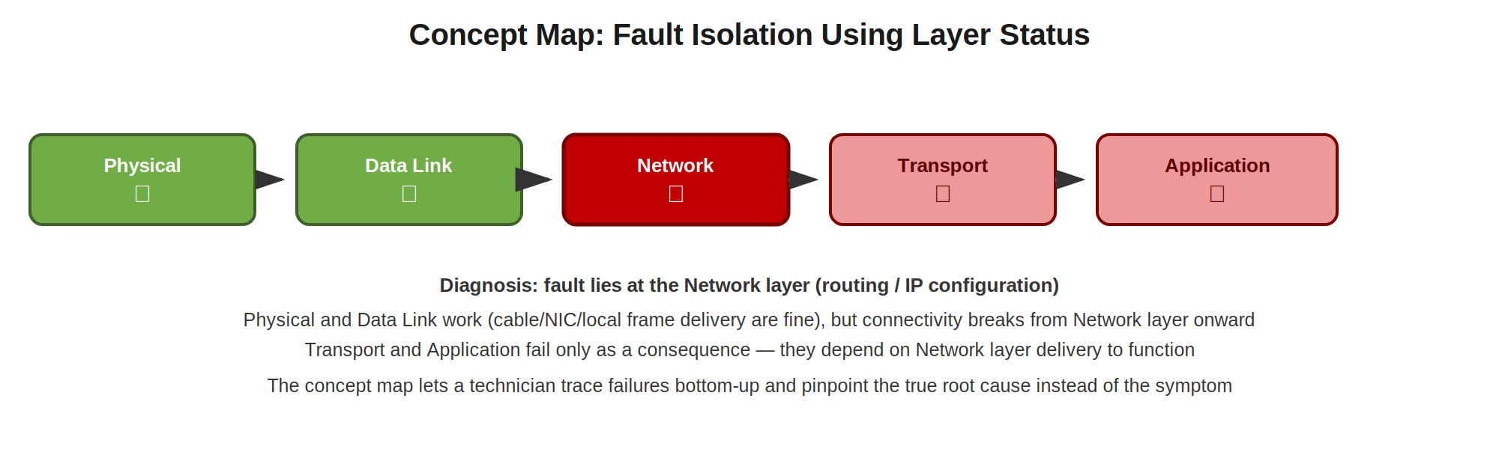
Figure 6: Layer-by-layer status used to isolate the point of failure
Analysis:
The concept map shows Physical and Data Link layers functioning correctly (✔), while Network, Transport, and Application layers are failing (✘). Since Transport and Application both depend on the Network layer to deliver packets, and both layers below Network are healthy, the fault can be isolated to the Network layer itself — most likely an IP addressing, subnet, gateway, or routing misconfiguration.
How the concept map helps in troubleshooting:
- It visually separates working layers from failing ones, so a technician doesn't need to guess where to start looking.
- Because OSI layers are dependent on the ones below them, the map lets the technician quickly recognize that Transport and Application failures here are consequences, not causes.
- It directs troubleshooting effort straight to the Network layer (checking IP configuration, routing tables, or gateway reachability) instead of wasting time on the physical cabling or application software, which are already confirmed to be working.
This bottom-up, layer-by-layer approach is exactly why the OSI model is valued in real-world network diagnostics: it turns a vague symptom ("the internet isn't working") into a precise, testable hypothesis about which layer has failed.

— End of Submission —

