<https://flatuicolors.com/>

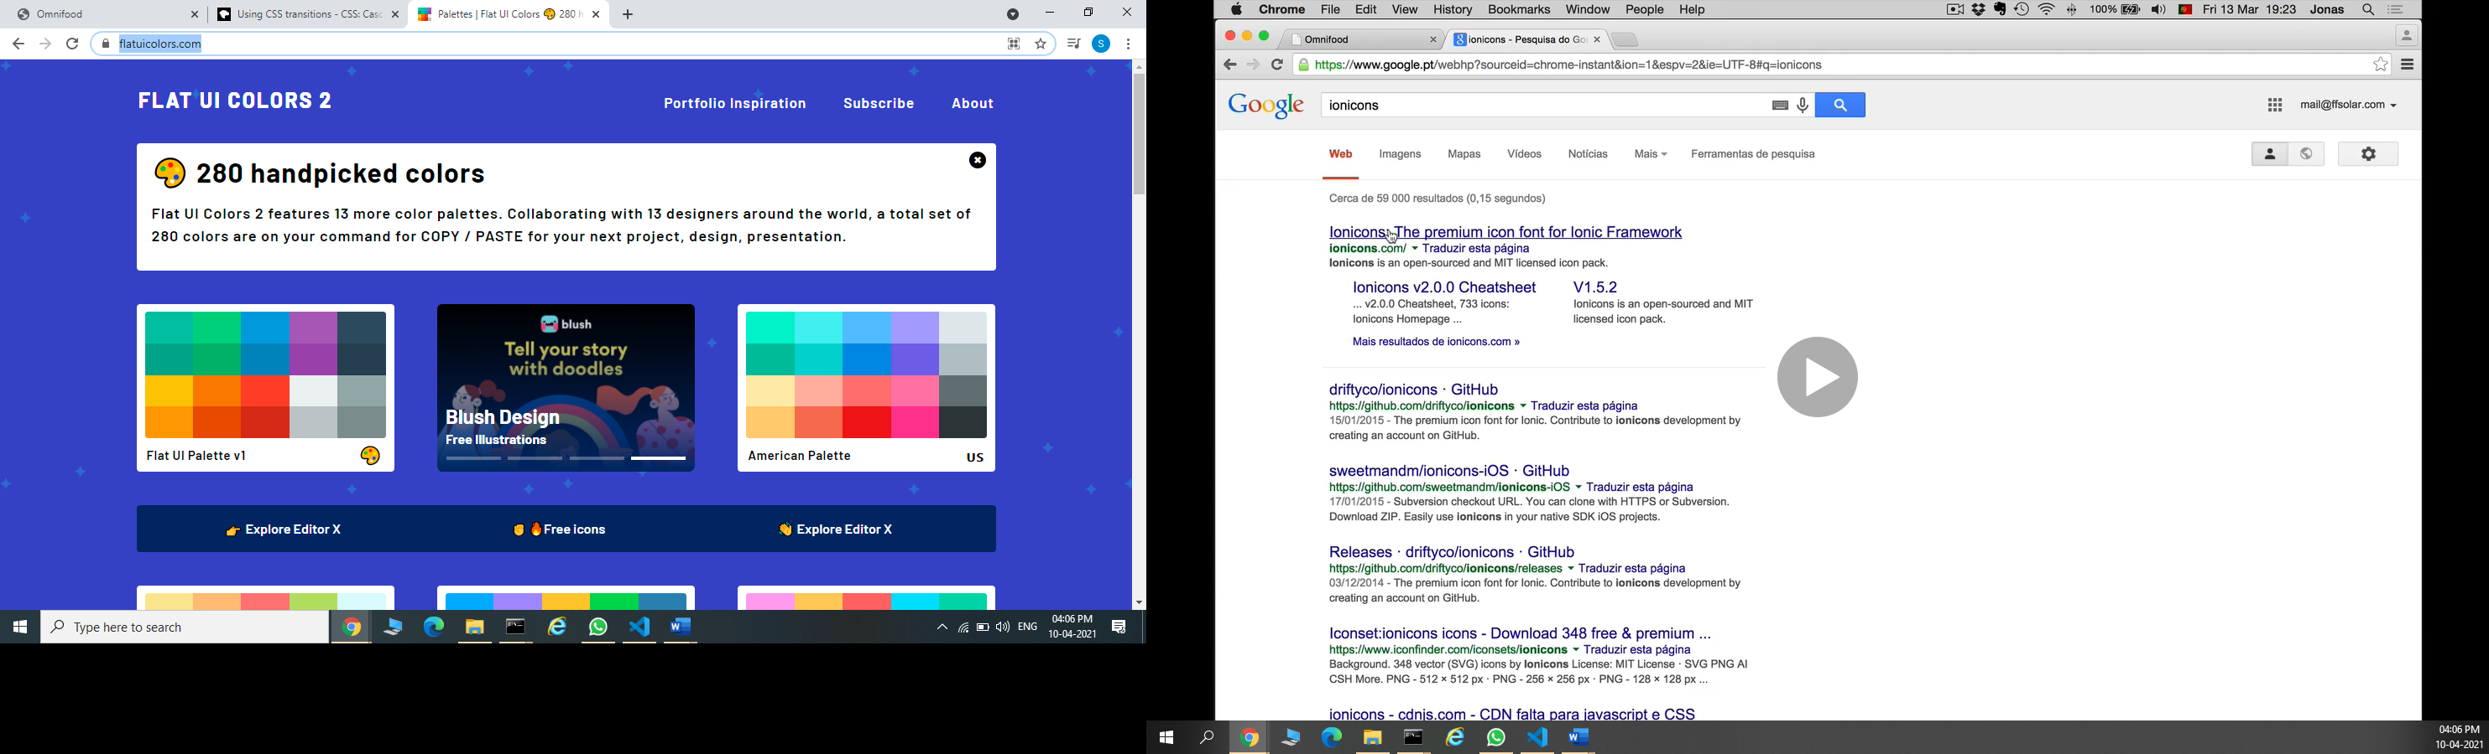

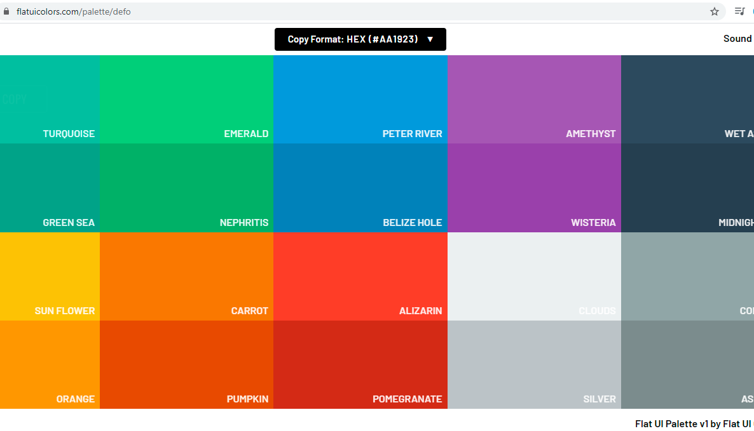

<https://www.0to255.com/>

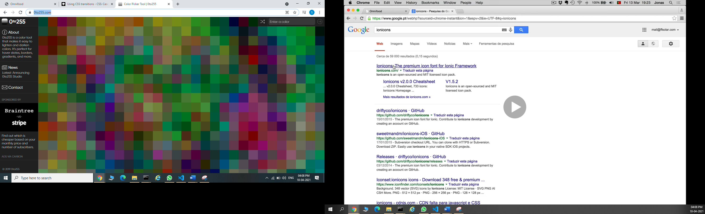

<https://ionicons.com/v2/>

