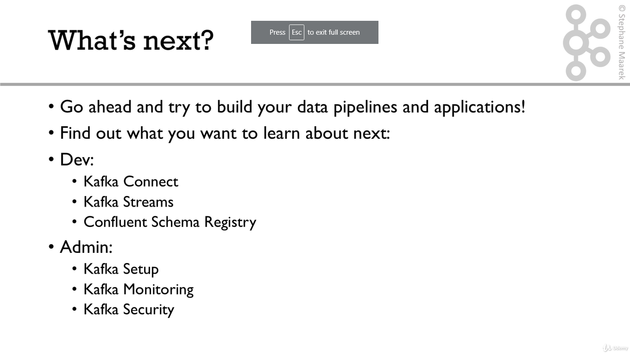

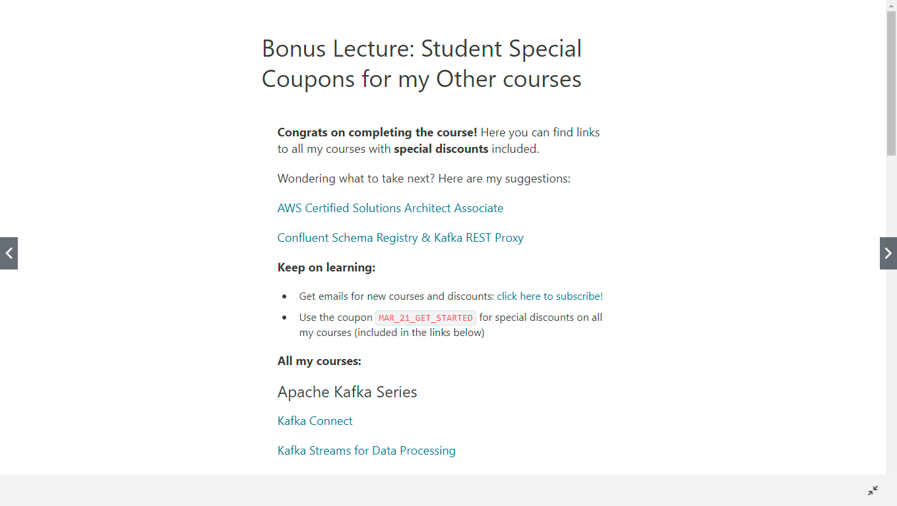

Bonus Lecture: Student Special Coupons for my Other courses

**Congrats on completing the course!** Here you can find links to all my courses with **special discounts** included.

Wondering what to take next? Here are my suggestions:

[AWS Certified Solutions Architect Associate](https://links.datacumulus.com/aws-certified-sa-associate-coupon)

[Confluent Schema Registry & Kafka REST Proxy](https://links.datacumulus.com/confluent-schema-registry-coupon)

**Keep on learning:**

* Get emails for new courses and discounts: [click here to subscribe!](https://courses.datacumulus.com/mailing-list)
* Use the coupon MAR_21_GET_STARTED for special discounts on all my courses (included in the links below)

**All my courses:**

Apache Kafka Series

[Kafka Connect](https://links.datacumulus.com/kafka-connect-coupon)

[Kafka Streams for Data Processing](https://links.datacumulus.com/kafka-streams-coupon)

[KSQL Hands On!](https://links.datacumulus.com/kafka-ksql-coupon)

[Kafka Setup and Administration](https://links.datacumulus.com/kafka-cluster-setup-coupon)

[Confluent Schema Registry & Kafka REST Proxy](https://links.datacumulus.com/confluent-schema-registry-coupon)

[Kafka Security](https://links.datacumulus.com/kafka-security-coupon)

[Kafka Monitoring and Operations](https://links.datacumulus.com/kafka-monitoring-operations-coupon)

[Confluent Certified Developer for Apache Kafka (CCDAK) - Practice Tests](https://links.datacumulus.com/confluent-certified-ccdak-coupon)

AWS Certifications

[AWS Certified Cloud Practitioner](https://links.datacumulus.com/aws-certified-practitioner-coupon)

[AWS Certified Cloud Practitioner [Practice Exams]](https://links.datacumulus.com/aws-cert-cloud-practitioner-pt-coupon)

[AWS Certified Solutions Architect Associate](https://links.datacumulus.com/aws-certified-sa-associate-coupon)

[AWS Certified Solutions Architect Associate [Practice Exams]](https://links.datacumulus.com/aws-cert-solution-architect-pt-coupon)

[Ultimate AWS Certified Developer Associate](https://links.datacumulus.com/aws-certified-dev-coupon)

[AWS Certified Developer Associate [Practice Exams]](https://links.datacumulus.com/aws-certified-dev-pt-coupon)

[AWS Certified SysOps Administrator Associate](https://links.datacumulus.com/aws-certified-sysops-coupon)

[AWS Certified SysOps Administrator Associate [Practice Exam]](https://links.datacumulus.com/aws-certified-sysops-pt-coupon)

[AWS Certified Solutions Architect Professional](https://links.datacumulus.com/aws-certified-sa-pro-coupon)

[AWS Certified Solutions Architect Professional [Practice Exam]](https://links.datacumulus.com/aws-certified-sa-pro-pt-coupon)

[AWS Certified DevOps Engineer Professional - Hands On!](https://links.datacumulus.com/aws-certified-devops-pro-coupon)

[AWS Certified DevOps Engineer Professional [Practice Exam]](https://links.datacumulus.com/aws-certified-devops-pro-pt-coupon)

[AWS Certified Data Analytics Specialty](https://links.datacumulus.com/aws-certified-data-analytics-coupon)

[AWS Certified Machine Learning Specialty - Hands On!](https://links.datacumulus.com/aws-certified-machine-learning-coupon)

[AWS Certified Database Specialty](https://links.datacumulus.com/aws-certified-database-coupon)

[AWS Certified Database Specialty [Practice Exam]](https://links.datacumulus.com/aws-certified-database-pt-coupon)

AWS Master Classes

[AWS CloudFormation MasterClass](https://links.datacumulus.com/aws-cloudformation-coupon)

[AWS Lambda and the Serverless Framework](https://links.datacumulus.com/aws-lambda-coupon)

[AWS EC2 Master Class (with Auto Scaling and Load Balancer)](https://links.datacumulus.com/aws-ec2-coupon)

[Amazon EKS Starter: Kubernetes on AWS](https://links.datacumulus.com/aws-eks-coupon)

[AWS AppSync & Amplify with React & GraphQL - Complete Guide](https://links.datacumulus.com/aws-appsync-amplify-coupon)

[Amazon ECS & Fargate Master Class](https://links.datacumulus.com/aws-ecs-coupon)

Data Engineering & API

[Complete Guide to Protocol Buffers 3](https://links.datacumulus.com/protocol-buffers-coupon)

[gRPC Java Master Class: Build Modern API & Microservices](https://links.datacumulus.com/grpc-java-coupon)

[gRPC Golang Master Class: Build Modern API & Microservices](https://links.datacumulus.com/grpc-golang-coupon)

[gRPC [C#] Master Class: Build Modern API & Microservices](https://links.datacumulus.com/grpc-csharp-coupon)

[gRPC Node.js Master Class: Build Modern API & Microservices](https://links.datacumulus.com/grpc-nodejs-coupon)

[Introduction to Apache NiFi](https://links.datacumulus.com/apache-nifi-coupon)

Fullscreen

Go to Previous lecture

122. THANK YOU!

Finish course