LSM (Log-Structured Merge) Tree indexing is a data structure and indexing technique designed to optimize write-heavy workloads while maintaining reasonable read performance. It’s widely used in modern NoSQL databases like Cassandra, RocksDB, LevelDB, and Bigtable. Unlike traditional indexing methods like B-trees, which focus on in-place updates and read efficiency, LSM trees prioritize fast writes by using a sequential, append-only approach. Let’s break it down step-by-step:

Core Concept
An LSM tree organizes data into multiple levels, starting with an in-memory structure and progressing to larger, immutable on-disk structures. Instead of updating data in place (like a B-tree), it appends new data sequentially and periodically merges it into sorted, persistent storage. This design leverages the high speed of sequential disk writes over random I/O.

Components of an LSM Tree
- Memtable:
  - An in-memory data structure (e.g., a skip list or balanced tree) where new writes (inserts, updates, deletes) are first recorded.
  - It’s small, fast, and volatile (lost on crash unless backed by a write-ahead log).
  - Once the memtable reaches a size threshold, it’s flushed to disk.
- Write-Ahead Log (WAL):
  - A durable, append-only log on disk that records every write before it hits the memtable.
  - Ensures data isn’t lost if the system crashes; the memtable can be rebuilt from the WAL.
- SSTables (Sorted String Tables):
  - Immutable, on-disk files created when the memtable is flushed.
  - Each SSTable contains a sorted list of key-value pairs, often with an index and a bloom filter for efficient lookups.
  - Organized into levels (e.g., L0, L1, L2, etc.), with each level exponentially larger than the previous one.
- Levels:
  - L0: The youngest level, directly flushed from the memtable. Files here may overlap (same keys can appear in multiple SSTables).
  - L1 and beyond: Older levels where SSTables are merged and compacted to eliminate overlaps and ensure keys are unique within each file. Higher levels are larger and more stable.

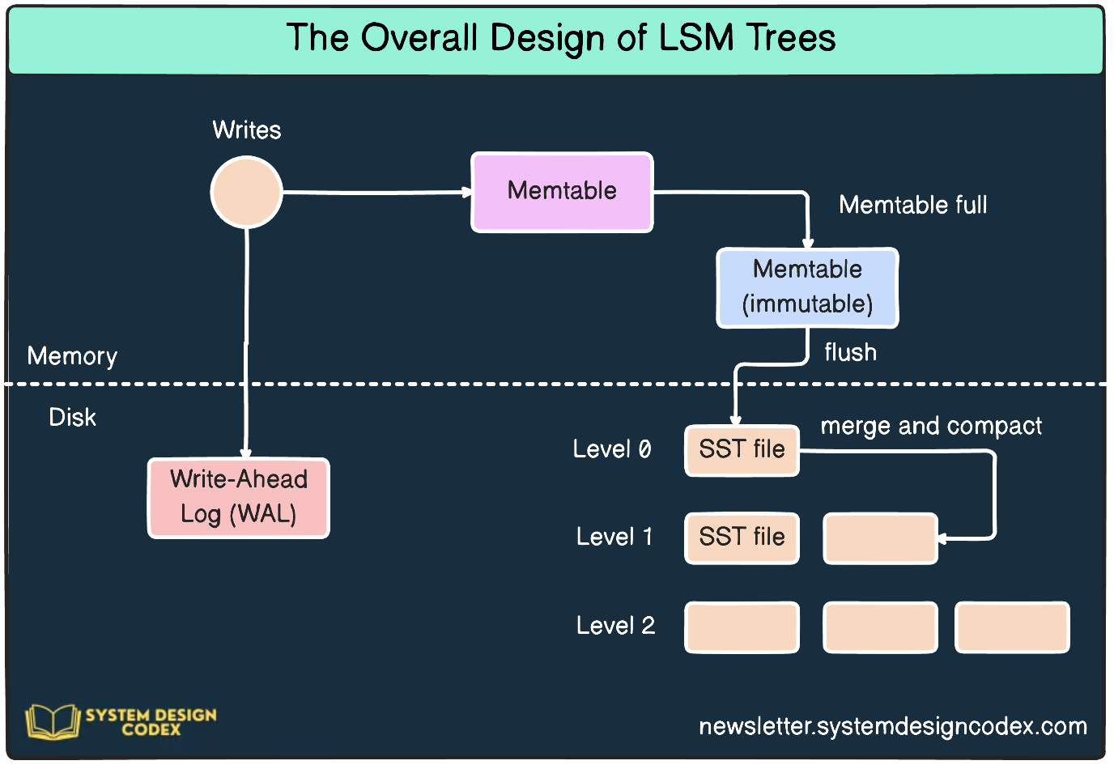

How LSM Tree Indexing Works
Write Path
- Insert/Update:
  - A new key-value pair is appended to the WAL for durability.
  - It’s then added to the memtable in memory, sorted by key. (Updates overwrite existing keys in the memtable.)
- Flush:
  - When the memtable fills up, it’s flushed to disk as an immutable SSTable at L0.
  - The memtable is cleared, and a new one starts accepting writes.
- Compaction:
  - Periodically, overlapping SSTables (e.g., in L0) are merged into a single SSTable at the next level (e.g., L1).
  - This process continues across levels, with higher levels containing older, larger, and more consolidated data.
  - Deletes are handled by adding "tombstone" markers, which are cleaned up during compaction.
Read Path
- Lookup:
  - Start with the memtable to find the latest value for a key.
  - If not found, search the SSTables, starting from L0 and moving to higher levels (newer data overrides older data).
  - Bloom filters (optional) help skip SSTables that don’t contain the key, reducing disk I/O.
- Result:
  - Return the most recent value found (or a tombstone if deleted).

Compaction Process
Compaction is the backbone of LSM trees, ensuring efficiency over time:
- Why: Overlapping SSTables in L0 (from frequent memtable flushes) slow down reads because multiple files must be checked.
- How:
  - Merge overlapping SSTables within a level or across levels (e.g., L0 → L1).
  - Remove duplicates, tombstones, and outdated entries.
  - Common strategies include:
    - Leveled Compaction: Limits the number of SSTables per level, merging them into the next level when full (used in LevelDB).
    - Size-Tiered Compaction: Groups SSTables of similar size and merges them into a larger SSTable (used in Cassandra).
- Trade-off: Compaction is I/O-intensive but keeps read performance manageable.

Key Characteristics
- Write-Optimized: Sequential writes to the WAL and SSTables avoid random disk I/O, making inserts/updates very fast.
- Read Trade-off: Reads may require checking multiple SSTables, but bloom filters, caching, and indexing within SSTables mitigate this.
- Space Amplification: Temporary duplication of data (before compaction) can increase storage use.
- Write Amplification: Compaction rewrites data multiple times, which can wear out SSDs faster.

Example Workflow
Imagine a key-value store using an LSM tree:
- You insert key1: value1:
  - Written to WAL, added to memtable.
- You update key1: value2:
  - WAL appends the update; memtable updates key1 to value2.
- Memtable fills and flushes to an L0 SSTable:
  - SSTable contains key1: value2.
- You insert key1: value3 later:
  - New SSTable in L0 has key1: value3.
- Compaction merges L0 SSTables:
  - Resulting L1 SSTable has only key1: value3.
- Read key1:
  - Check memtable (empty), then L0 (if any), then L1 → returns value3.

Advantages
- High Write Throughput: Ideal for logging, time-series data, or streaming workloads.
- Scalability: Handles large datasets by spreading data across levels.
- Crash Recovery: WAL ensures durability.
Disadvantages
- Slower Reads: Multiple levels and SSTables can increase lookup time.
- Compaction Overhead: Resource-intensive, especially with heavy writes.
- Space Usage: Temporary redundancy before compaction.

Use Cases
- Cassandra: Uses LSM trees for distributed, write-heavy key-value storage.
- RocksDB: Optimized for SSDs with LSM-based indexing.
- HBase: Combines LSM trees with a distributed architecture for big data.
In essence, LSM tree indexing sacrifices some read performance for blazing-fast writes, making it a go-to choice for systems where data ingestion speed is king. If you’d like a deeper dive into compaction strategies or a comparison with another technique, just ask!
LSM trees with pictorial representation flow sequence
Image

overall design of LSM trees
The overall design of an LSM (Log-Structured Merge) Tree is a write-optimized data structure that efficiently handles high-throughput write operations while maintaining reasonable read performance. It’s widely used in modern NoSQL databases like Cassandra, RocksDB, LevelDB, and Bigtable. The design revolves around breaking data storage into multiple components—some in memory, others on disk—organized into levels, with a focus on sequential writes and periodic merging (compaction) to manage data. Below, I’ll explain the overall design, its components, and how they interact, followed by a reference to the flow sequence in the images you provided.

Overall Design of LSM Trees
1. Core Philosophy
- Write Optimization: LSM trees are designed to handle high write throughput by avoiding random disk I/O. Instead of updating data in place (like B-trees), they append all writes sequentially, which is much faster on modern hardware (especially SSDs and HDDs).
- Multi-Level Structure: Data is organized into a hierarchy of levels, starting with an in-memory component and progressing to larger, immutable on-disk structures.
- Deferred Sorting and Merging: Writes are initially unsorted in memory, then sorted when flushed to disk, and periodically merged across levels to maintain efficiency.
2. Key Components
- Write-Ahead Log (WAL):
  - A durable, append-only log on disk that records every write operation (insert, update, delete) before it’s applied to the in-memory structure.
  - Ensures durability: if the system crashes, the WAL can be used to rebuild the in-memory state.
- Memtable:
  - An in-memory data structure (e.g., a skip list, red-black tree, or AVL tree) that holds the most recent writes.
  - Sorted by key for fast lookups and writes.
  - When the memtable reaches a size threshold, it’s flushed to disk as an immutable structure.
- Immutable Memtable (Optional):
  - A temporary in-memory structure that holds data while the memtable is being flushed to disk, allowing writes to continue without blocking.
- SSTables (Sorted String Tables):
  - Immutable, on-disk files that store sorted key-value pairs.
  - Each SSTable contains:
    - A data section with sorted key-value pairs.
    - An index for quick lookups within the SSTable.
    - A bloom filter (optional) to reduce unnecessary disk reads by quickly checking if a key might exist in the SSTable.
  - SSTables are organized into levels (L0, L1, L2, etc.), with each level exponentially larger than the previous one.
- Levels:
  - L0: The youngest level, directly flushed from the memtable. SSTables in L0 may overlap (i.e., the same key can appear in multiple SSTables).
  - L1 and Higher: Older levels where SSTables are merged to eliminate overlaps, ensuring keys are unique within each SSTable. Higher levels are larger and more stable.
- Bloom Filters:
  - Probabilistic data structures attached to each SSTable to quickly determine if a key might exist in that SSTable, reducing unnecessary disk I/O during reads.
- Compaction:
  - A background process that merges SSTables within or across levels to:
    - Remove duplicates and tombstones (markers for deleted keys).
    - Consolidate data into fewer, larger SSTables.
    - Ensure read efficiency by reducing the number of SSTables to search.
3. Data Flow and Operations
- Write Path:
  - A write (insert/update/delete) is appended to the WAL for durability.
  - The write is then added to the memtable in memory, sorted by key.
  - When the memtable fills up, it’s flushed to disk as an immutable SSTable at L0.
  - Over time, L0 SSTables are compacted and merged into L1, L1 into L2, and so on, with each level growing exponentially in size.
- Read Path:
  - Start with the memtable to find the latest value for a key.
  - If not found, check any immutable memtables.
  - Then search the SSTables, starting from L0 and moving to higher levels (newer data overrides older data).
  - Bloom filters help skip SSTables that don’t contain the key.
- Compaction:
  - Periodically, overlapping SSTables are merged to reduce redundancy and improve read performance.
  - Common strategies:
    - Leveled Compaction: Limits the number of SSTables per level, merging them into the next level when full (used in LevelDB).
    - Size-Tiered Compaction: Groups SSTables of similar size and merges them into a larger SSTable (used in Cassandra).
4. Design Trade-offs
- Write Amplification: Compaction rewrites data multiple times, which can increase I/O and wear out SSDs.
- Space Amplification: Temporary duplication of data (before compaction) can increase storage use.
- Read Amplification: Reads may need to check multiple SSTables across levels, though bloom filters and caching help mitigate this.
- Crash Recovery: The WAL ensures durability, and the memtable can be rebuilt from the WAL after a crash.

Pictorial Representation Flow Sequence (Referencing the Images)
The images you provided illustrate the LSM tree design using a tree metaphor, with labels and arrows showing the flow of data. Let’s break down the flow sequence based on the second image, which provides a clearer depiction of the write and read paths:
Image Analysis (Second Image):
- Tree Structure: The tree represents the LSM tree, with the trunk and branches symbolizing the flow of data between components.
- Memtable: Labeled at the top right, representing the in-memory structure where writes are first recorded.
- Write Path:
  - "Write Carteleubls" (likely a typo for "Write Operations") on the left side shows writes entering the system.
  - An arrow points to the Memtable, indicating that writes are first added to the in-memory memtable.
  - When the memtable fills, it’s flushed to disk as an SSTable Level 0 (labeled on the left side of the tree).
  - The arrow continues to SSTable Level 1 and SSTable Level 2, showing the progression of data through levels during compaction.
- Compaction:
  - The term "Mcltinotad" (likely a typo for "Compaction") on the right side indicates the merging process.
  - Arrows show SSTables being merged from one level to the next (e.g., Level 0 to Level 1, Level 1 to Level 2).
- Read Path:
  - The read path isn’t explicitly labeled, but it would follow the reverse direction: starting from the memtable, then checking SSTables from L0 to higher levels.
Flow Sequence:
- Write Operation:
  - A write operation enters the system and is appended to the WAL (not shown in the image but part of the design).
  - The write is added to the Memtable (top right).
- Flush to L0:
  - When the memtable fills, it’s flushed to disk as an SSTable at Level 0 (left side).
- Compaction Across Levels:
  - SSTables in L0 are merged into SSTable Level 1, then into SSTable Level 2 (shown by arrows moving downward through the tree).
  - This process continues, with each level growing larger and more consolidated.
- Read Operation (Implied):
  - A read would start at the memtable, then check SSTables from L0 to higher levels (reverse of the write path).
First Image:
- The first image is more abstract, with terms like "LSM," "Memtable," "SSTables," "Compaction Process," "Read," and "Write" scattered around the tree.
- It emphasizes the components and processes but doesn’t show a clear flow sequence like the second image.

Summary of LSM Tree Design
- Structure: A multi-level system with an in-memory memtable, a WAL for durability, and on-disk SSTables organized into levels (L0, L1, etc.).
- Write Path: Sequential appends to the WAL and memtable, followed by flushes to L0 SSTables and compaction to higher levels.
- Read Path: Check the memtable, then SSTables from L0 to higher levels, using bloom filters to optimize.
- Compaction: Merges SSTables to reduce redundancy and improve read performance.
- Use Case: Write-heavy workloads like time-series data, logging, or NoSQL databases.
The second image effectively captures the flow of data through the LSM tree, showing how writes move from the memtable to SSTables across levels, with compaction ensuring efficiency. If you’d like a more detailed diagram or a specific aspect of the design explored further, let me know!
compaction strategies comparison
B-tree indexing

