5 Class Design Principles [S.O.L.I.D.] in Java

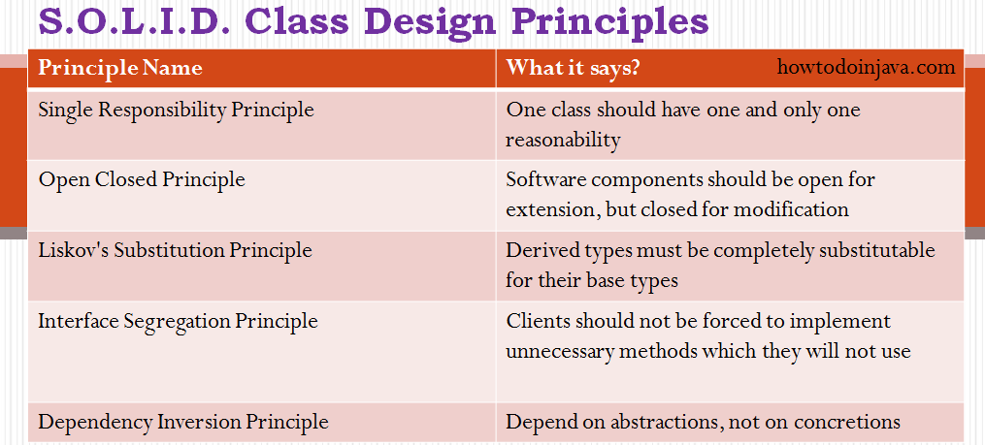
First Five principles named by Robert C. Martin (“Uncle Bob”)
The first five principles are principles of class design. They are:
SRP | The Single Responsibility Principle | A class should have one, and only one, reason to change.
OCP | The Open Closed Principle | You should be able to extend a classes behavior, without modifying it.
LSP | The Liskov Substitution Principle | Derived classes must be substitutable for their base classes.  (use design by contract)  Example :  User, Based, Derived, example.  void User(Base& b);  Derived d;  User(d);
ISP | The Interface Segregation Principle | Make fine grained interfaces that are client specific.
DIP | The Dependency Inversion Principle | Depend on abstractions, not on concretions.
The next six principles are about packages. In this context a package is a binary deliverable like a .jar file, or a dll as opposed to a namespace like a java package or a C++ namespace.
The first three package principles are about package cohesion, they tell us what to put inside packages:
REP | The Release Reuse Equivalency Principle | The granule of reuse is the granule of release.
CCP | The Common Closure Principle | Classes that change together are packaged together.
CRP | The Common Reuse Principle | Classes that are used together are packaged together.
The last three principles are about the couplings between packages, and talk about metrics that evaluate the package structure of a system.
ADP | The Acyclic Dependencies Principle | The dependency graph of packages must have no cycles.
SDP | The Stable Dependencies Principle | Depend in the direction of stability.
SAP | The Stable Abstractions Principle | Abstractness increases with stability.

