https://flatuicolors.com/
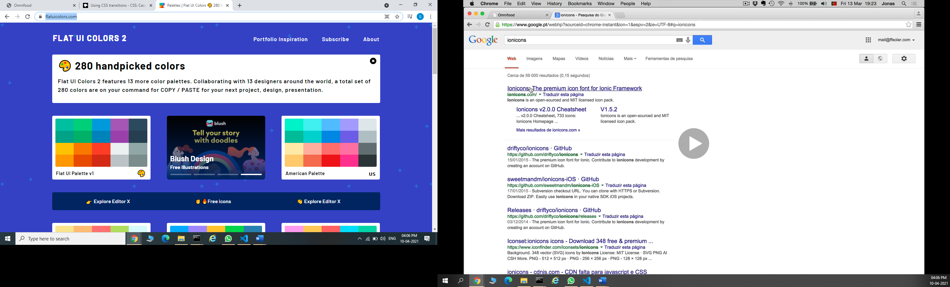
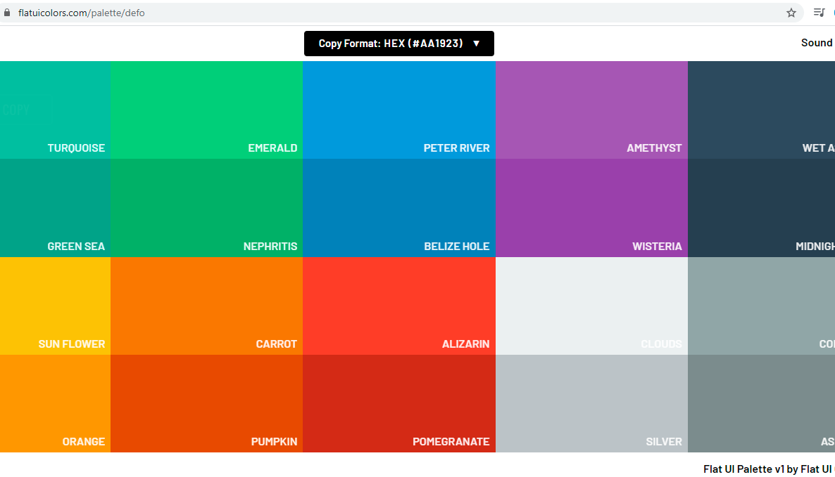

https://www.0to255.com/
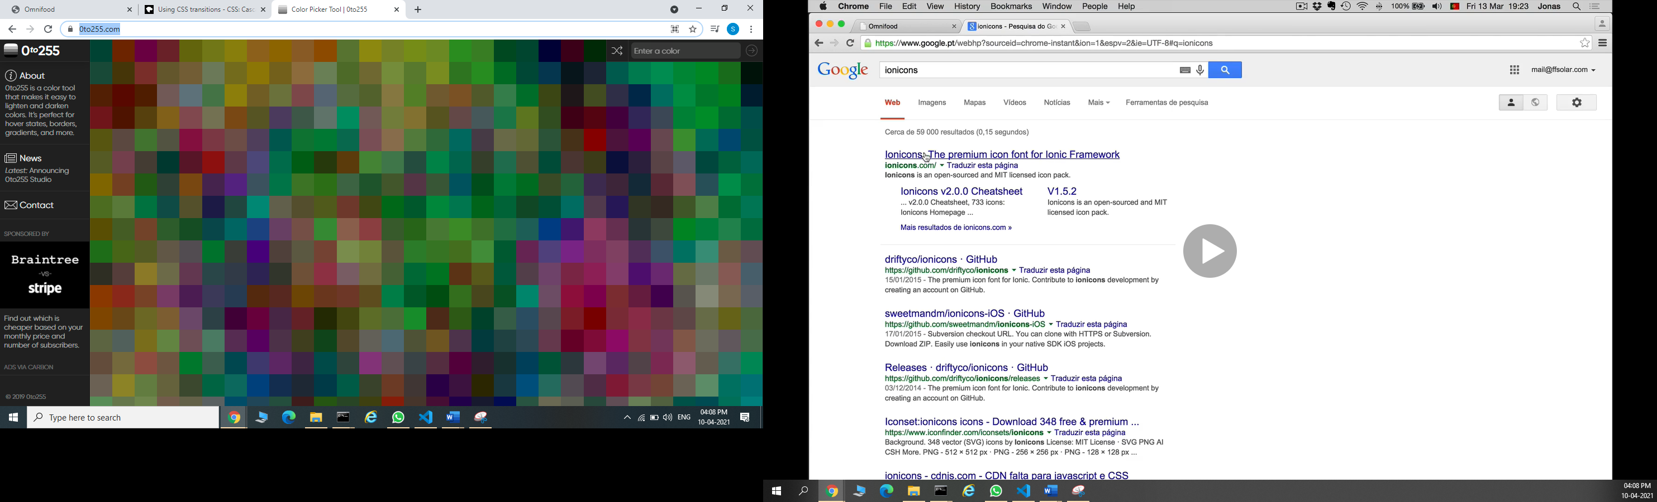

https://ionicons.com/v2/

