Spring security :

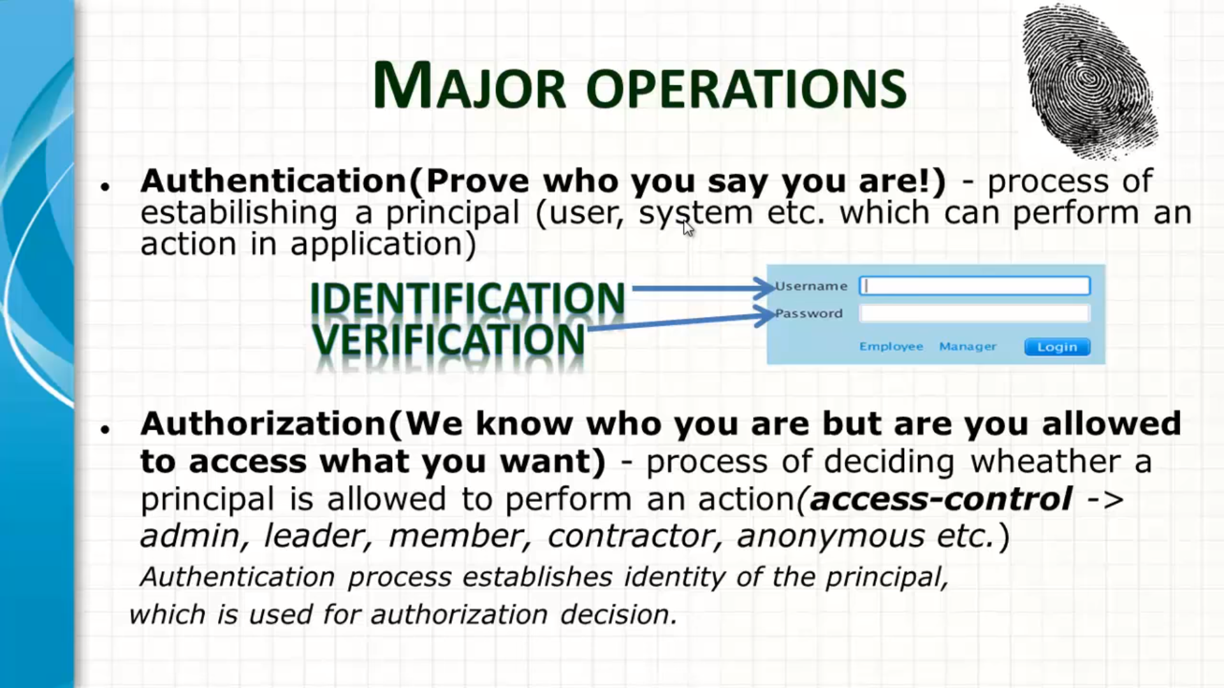

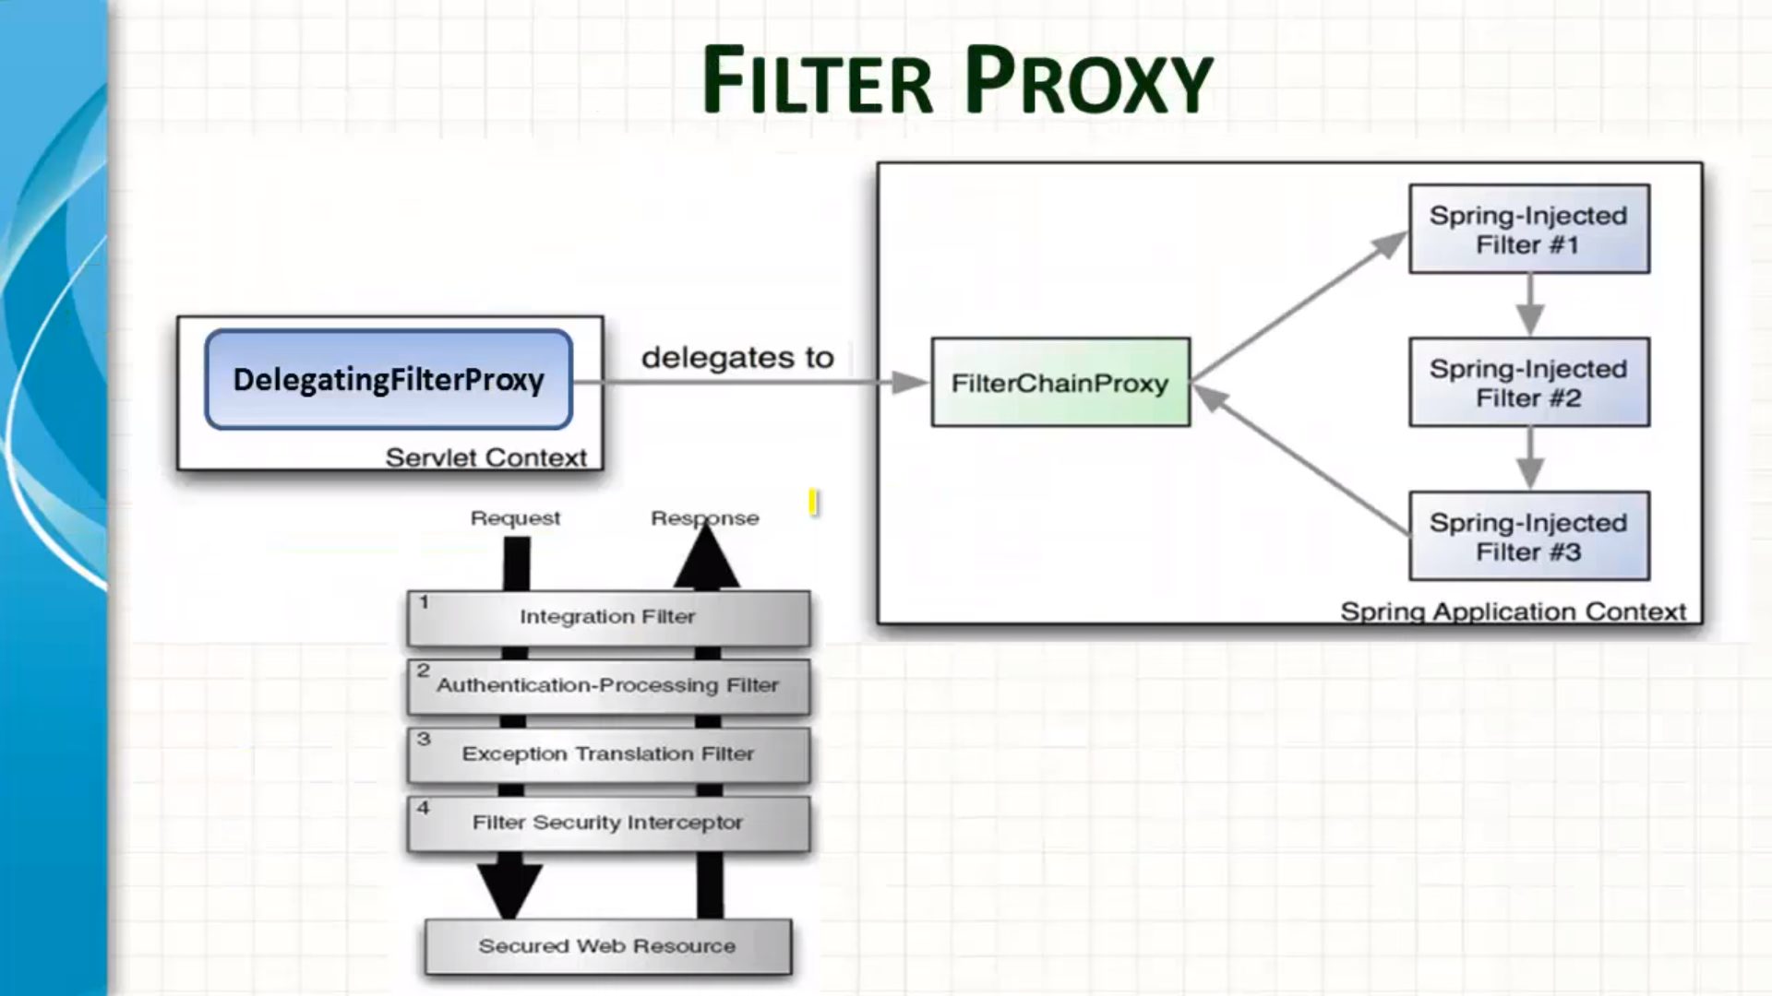

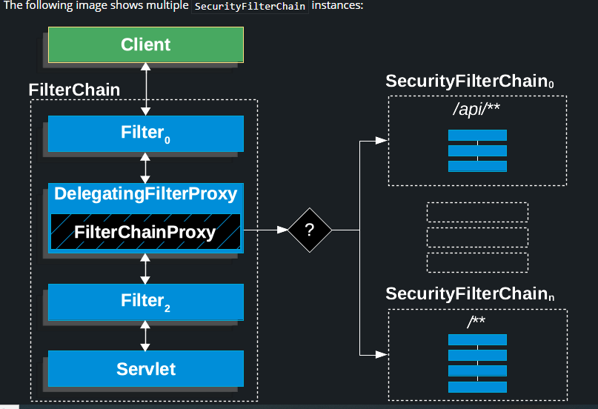
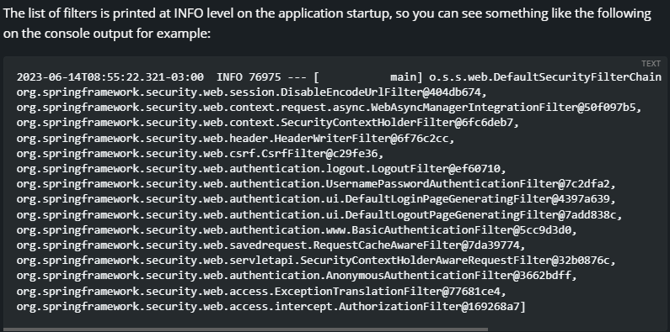

How to register custom filter
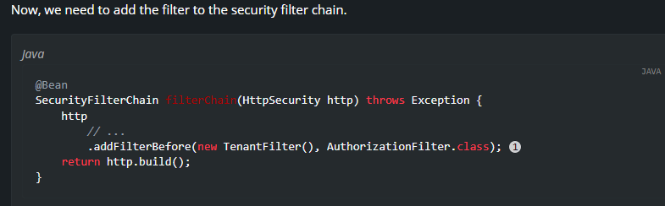
Be careful when you declare your filter as a Spring bean, either by annotating it with @Component or by declaring it as a bean in your configuration, because Spring Boot will automatically register it with the embedded container. That may cause the filter to be invoked twice, once by the container and once by Spring Security and in a different order.
@Bean
public FilterRegistrationBean<TenantFilter> tenantFilterRegistration(TenantFilter filter) {
FilterRegistrationBean<TenantFilter> registration = new FilterRegistrationBean<>(filter);
registration.setEnabled(false);
return registration;
}
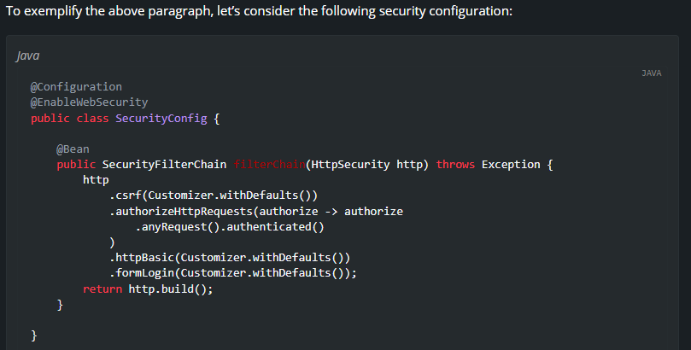

AbstractAuthenticationProcessingFilter
AbstractAuthenticationProcessingFilter is used as a base Filter for authenticating a user’s credentials. Before the credentials can be authenticated, Spring Security typically requests the credentials by using AuthenticationEntryPoint.
Next, the AbstractAuthenticationProcessingFilter can authenticate any authentication requests that are submitted to it.
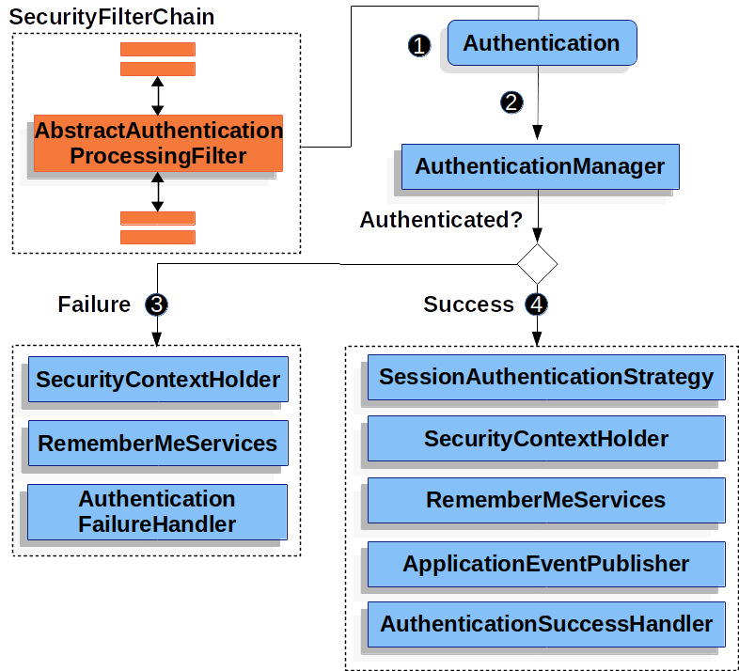
When the user submits their credentials, the AbstractAuthenticationProcessingFilter creates an Authentication from the HttpServletRequest to be authenticated. The type of Authentication created depends on the subclass of AbstractAuthenticationProcessingFilter. For example, UsernamePasswordAuthenticationFilter creates a UsernamePasswordAuthenticationToken from a username and password that are submitted in the HttpServletRequest.
Next, the Authentication is passed into the AuthenticationManager to be authenticated.
If authentication fails, then Failure.
- The SecurityContextHolder is cleared out.
- RememberMeServices.loginFail is invoked. If remember me is not configured, this is a no-op. See the rememberme package.
- AuthenticationFailureHandler is invoked. See the AuthenticationFailureHandler interface.
If authentication is successful, then Success.
- SessionAuthenticationStrategy is notified of a new login. See the SessionAuthenticationStrategy interface.
- The Authentication is set on the SecurityContextHolder. Later, if you need to save the SecurityContext so that it can be automatically set on future requests, SecurityContextRepository#saveContext must be explicitly invoked. See the SecurityContextHolderFilter class.
- RememberMeServices.loginSuccess is invoked. If remember me is not configured, this is a no-op. See the rememberme package.
- ApplicationEventPublisher publishes an InteractiveAuthenticationSuccessEvent.
- AuthenticationSuccessHandler is invoked. See the AuthenticationSuccessHandler interface.

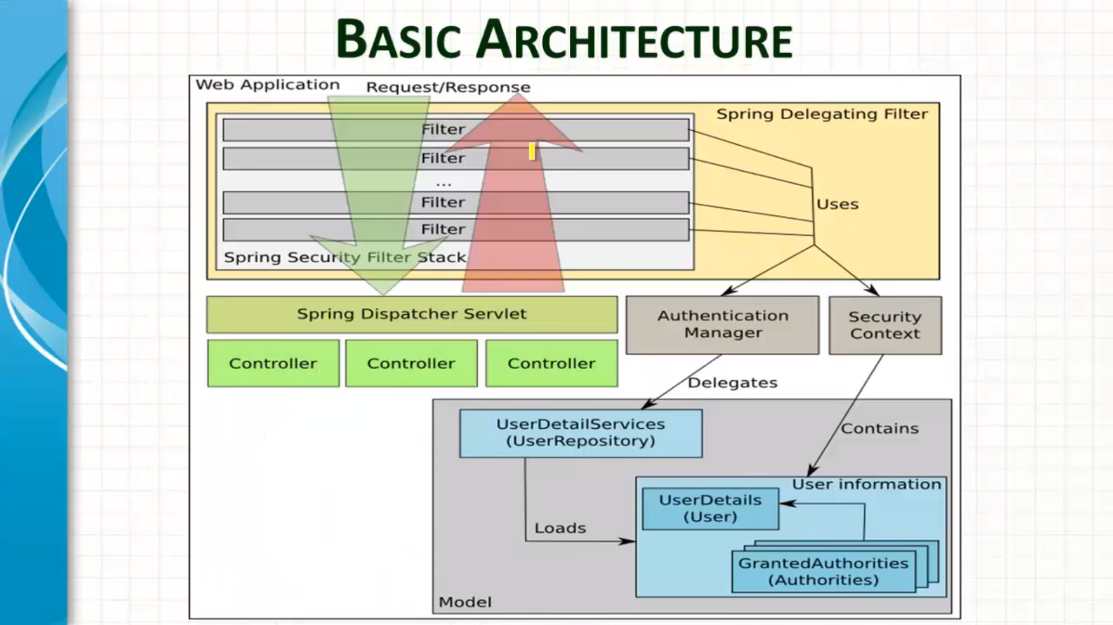
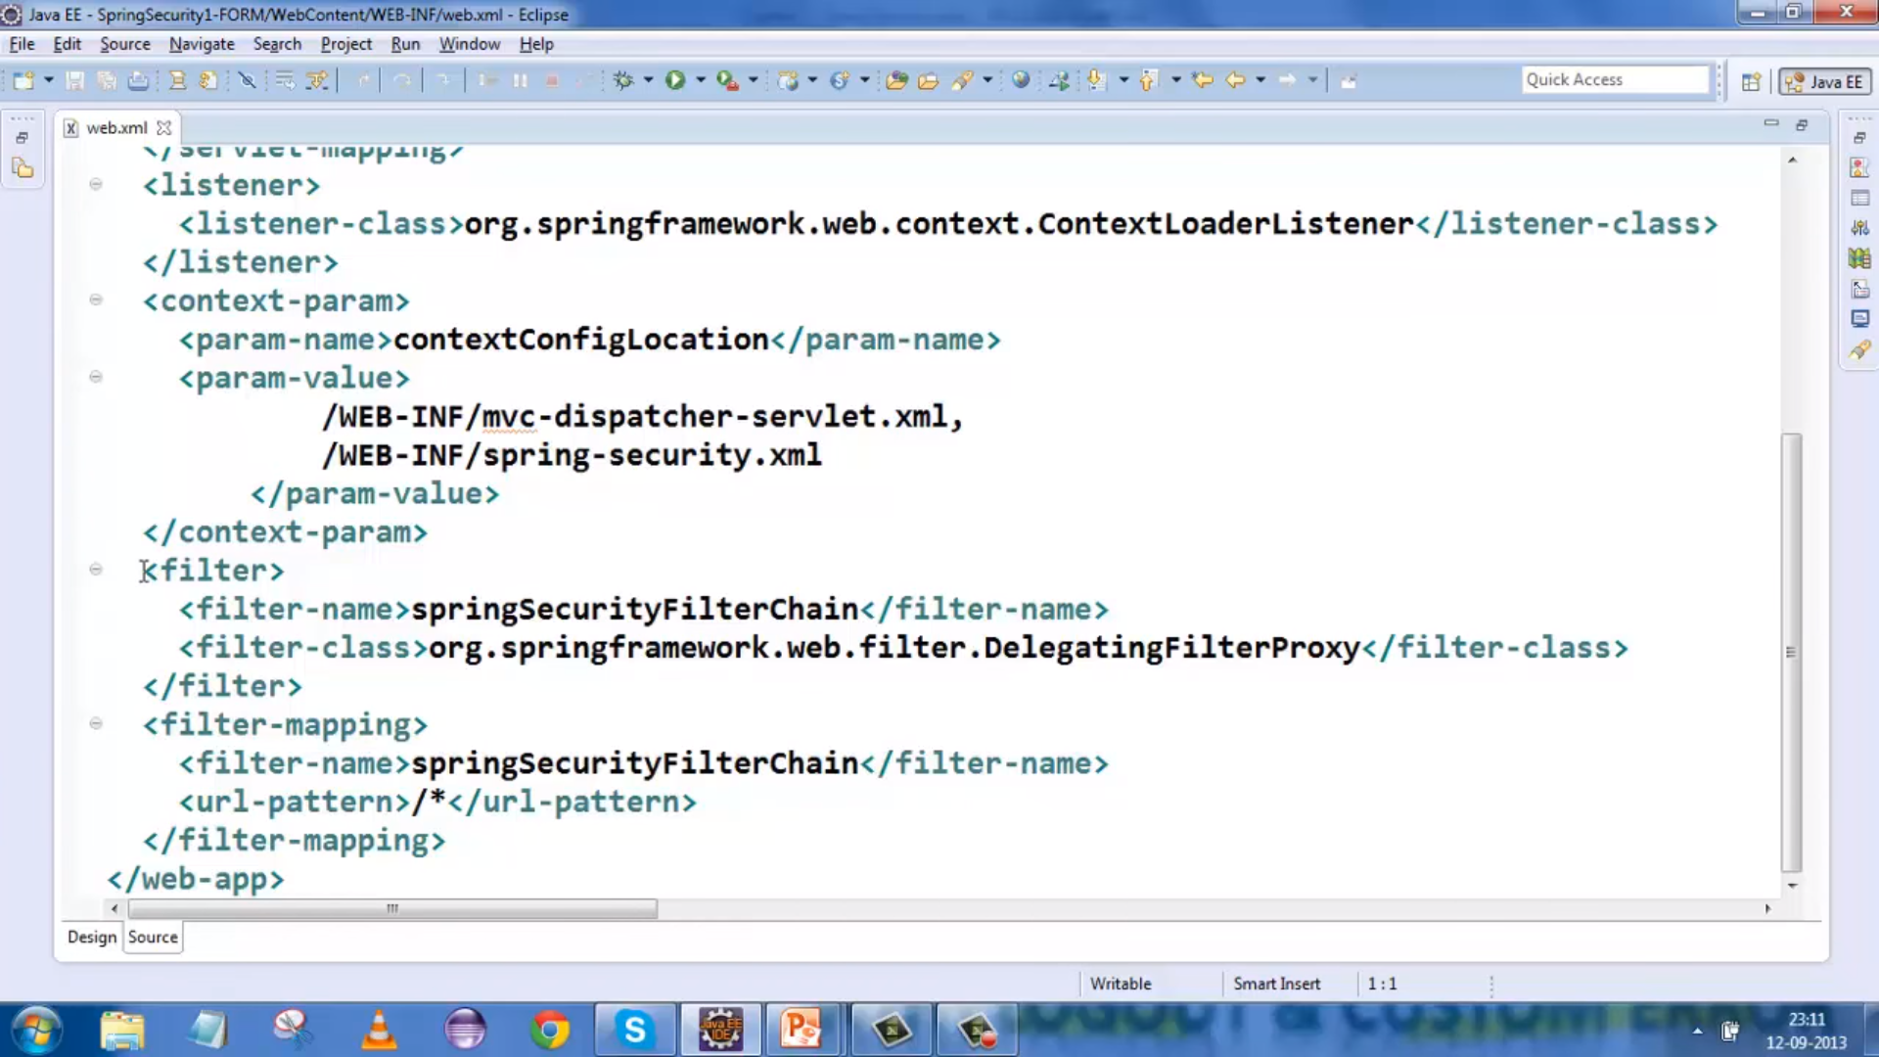

Basic & Form Security :

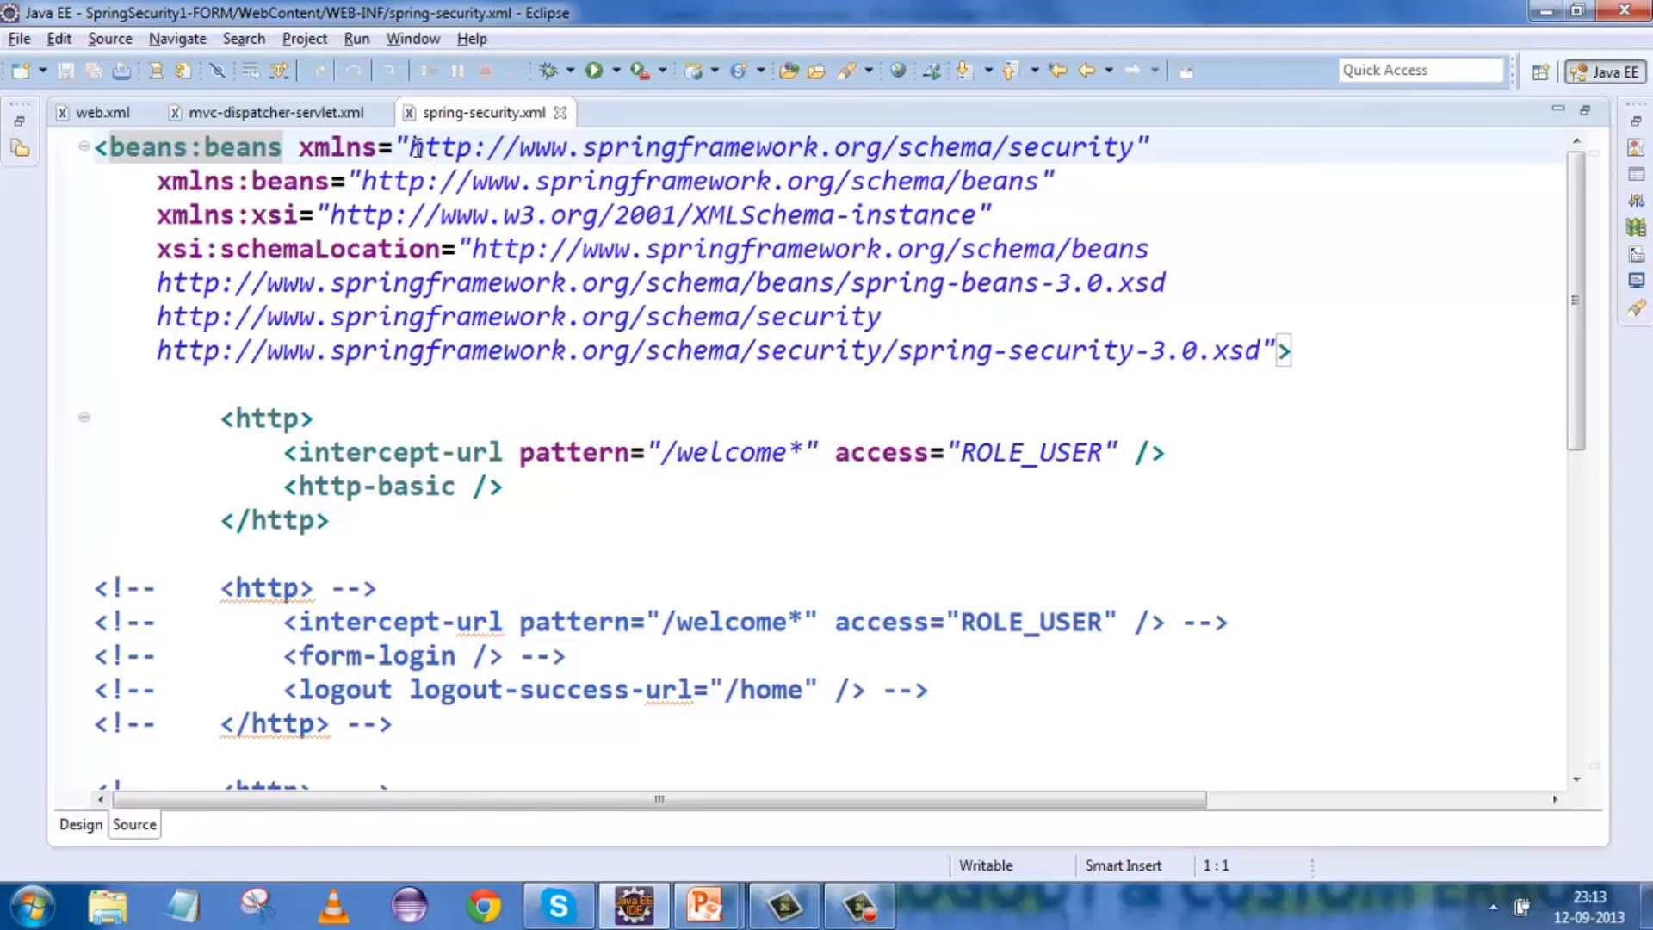

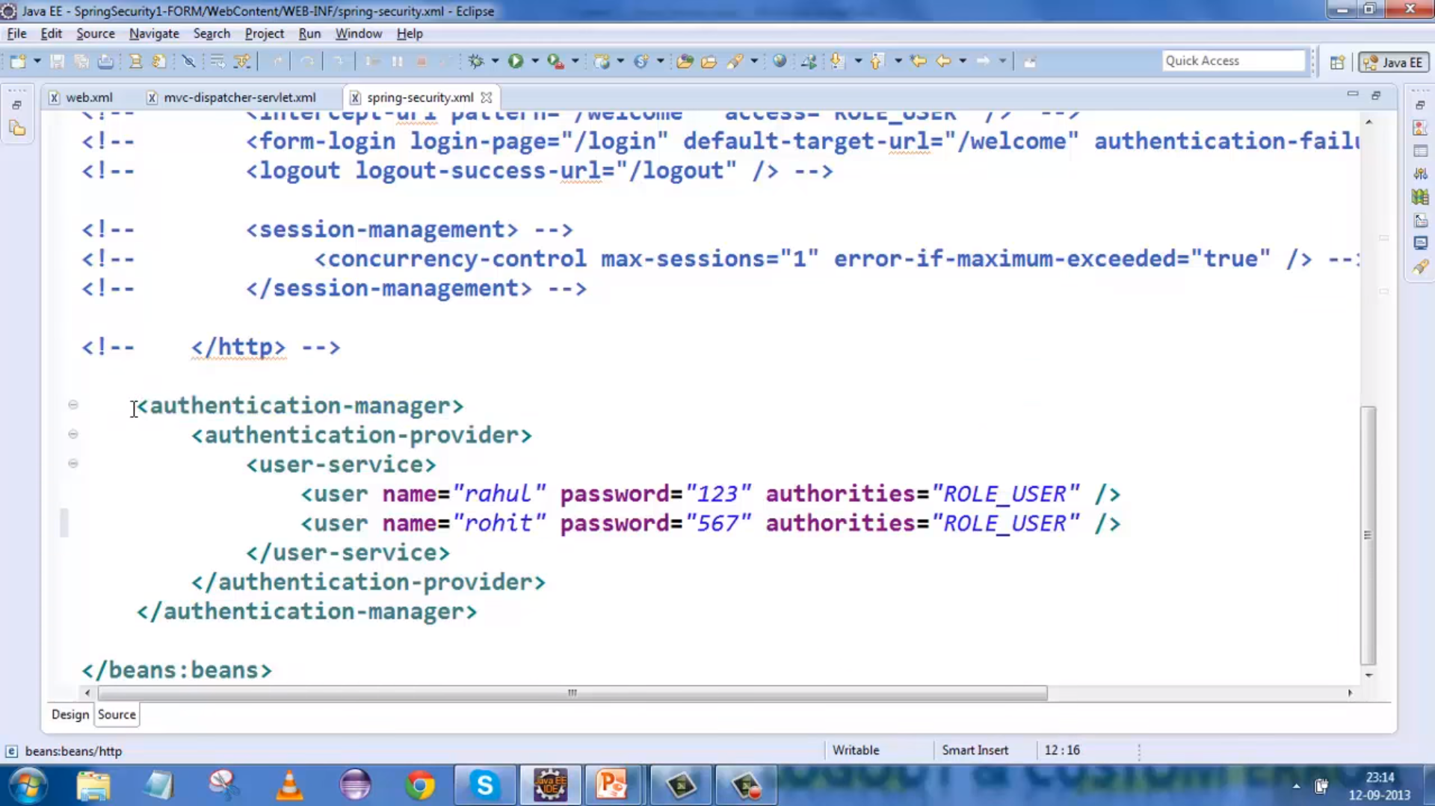
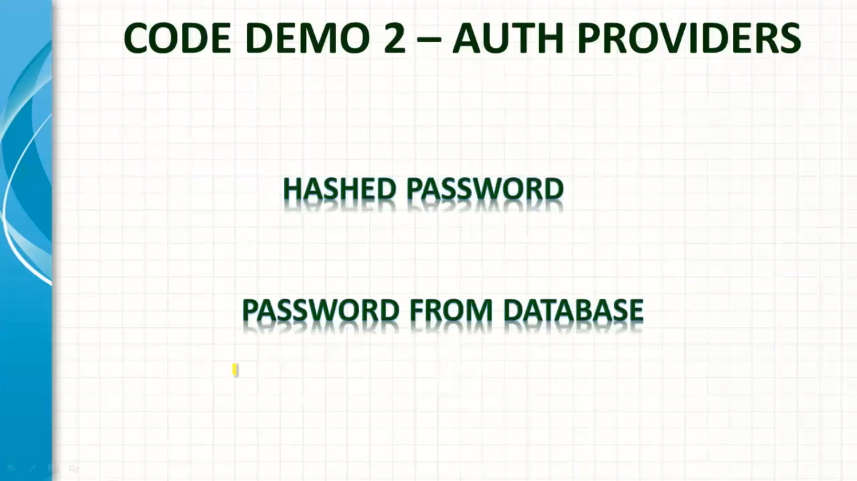
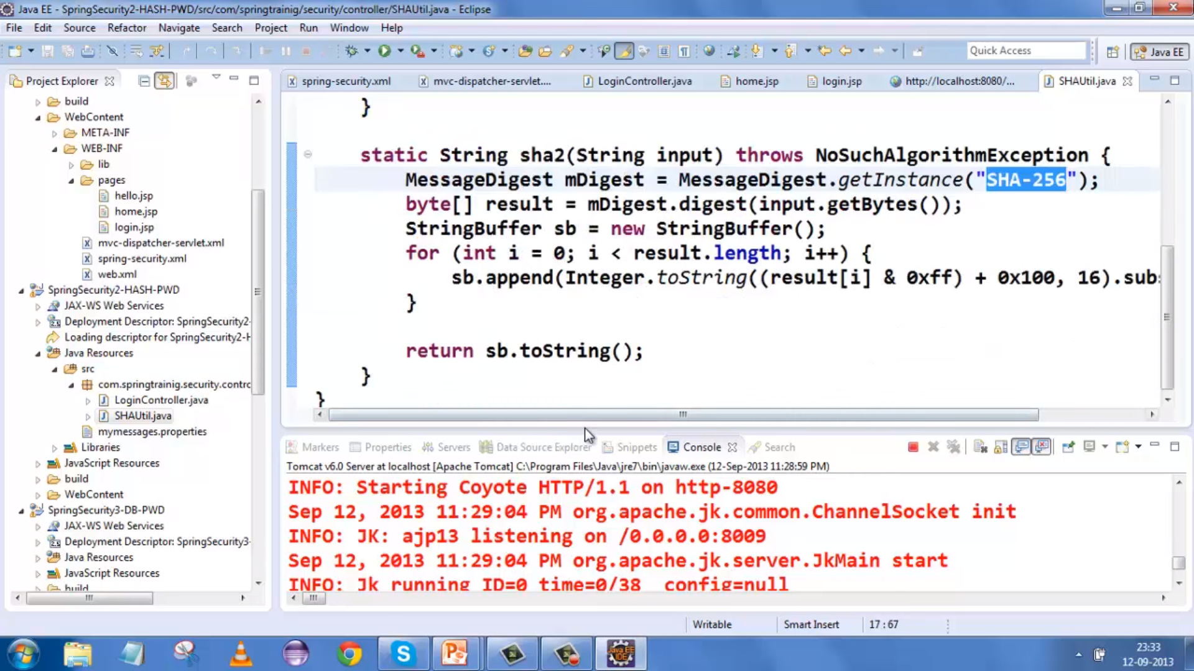

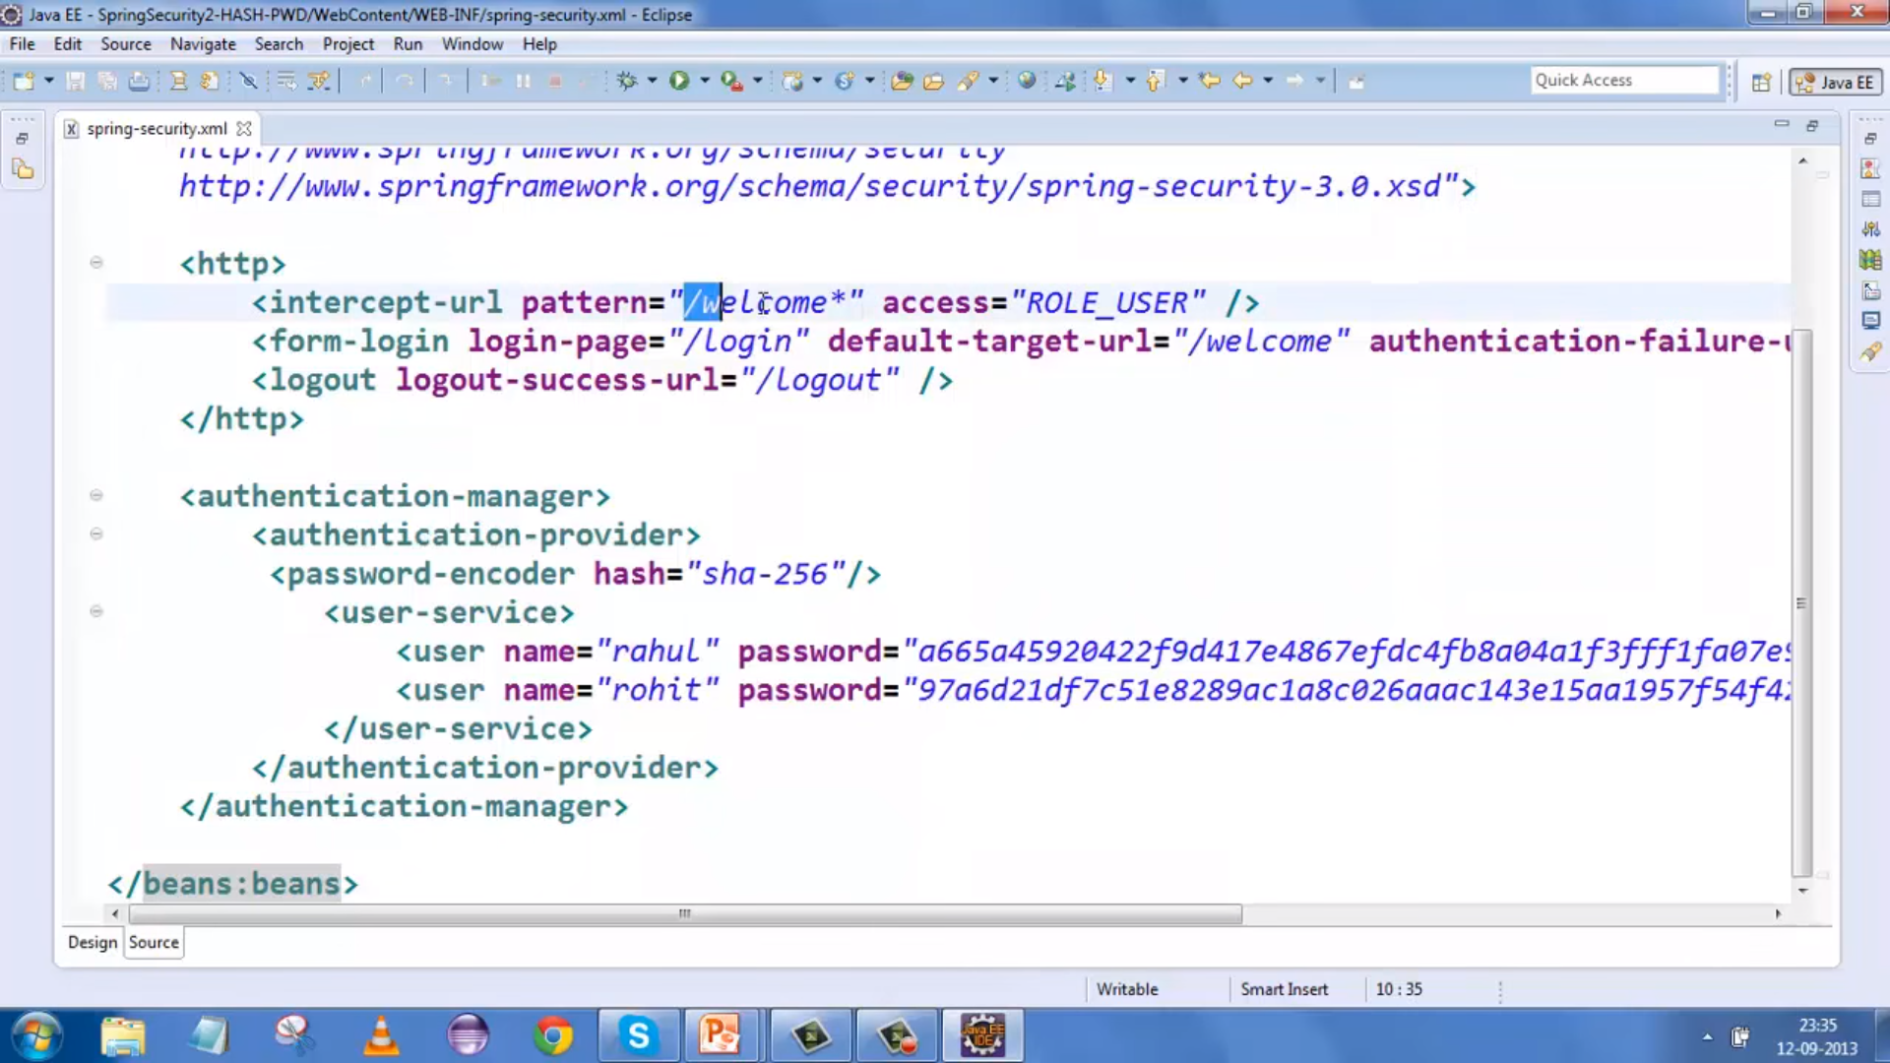

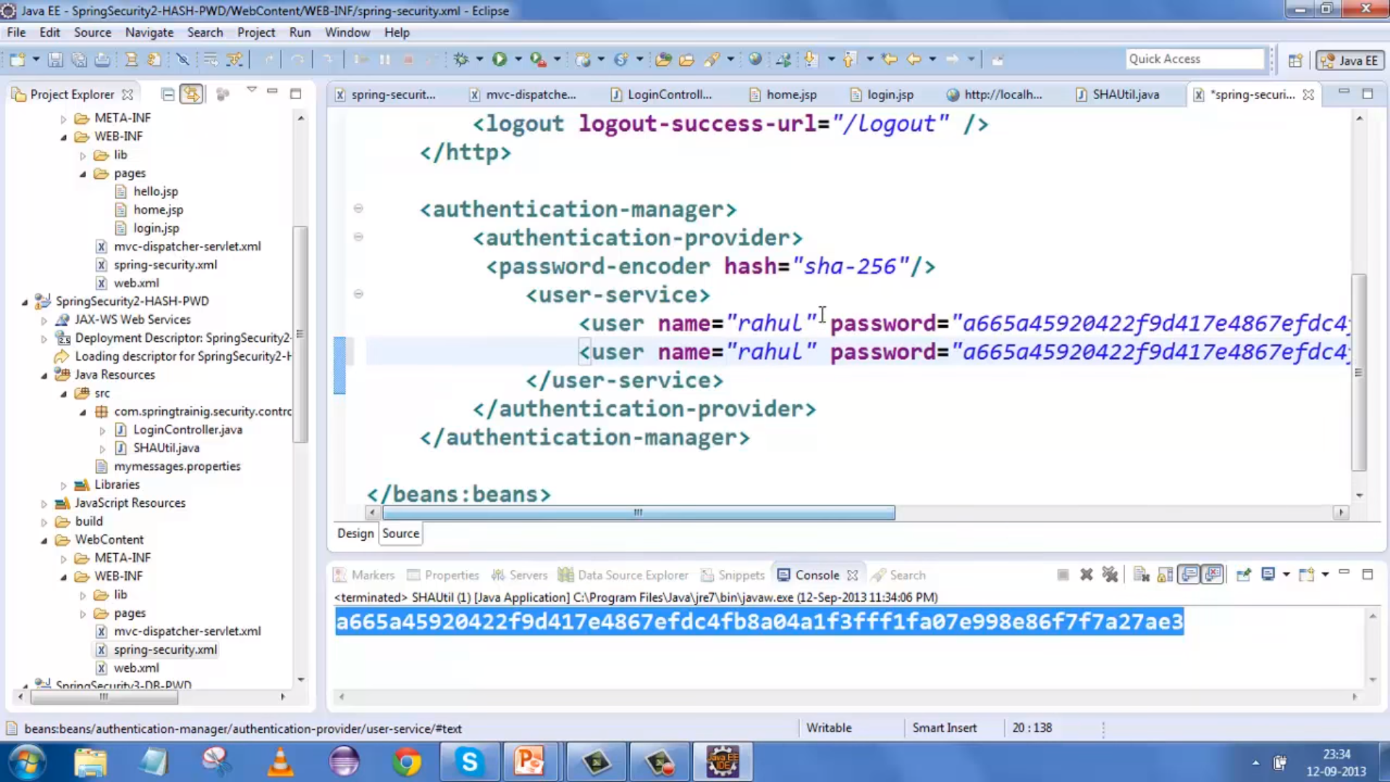
User Name & PWD from DB :

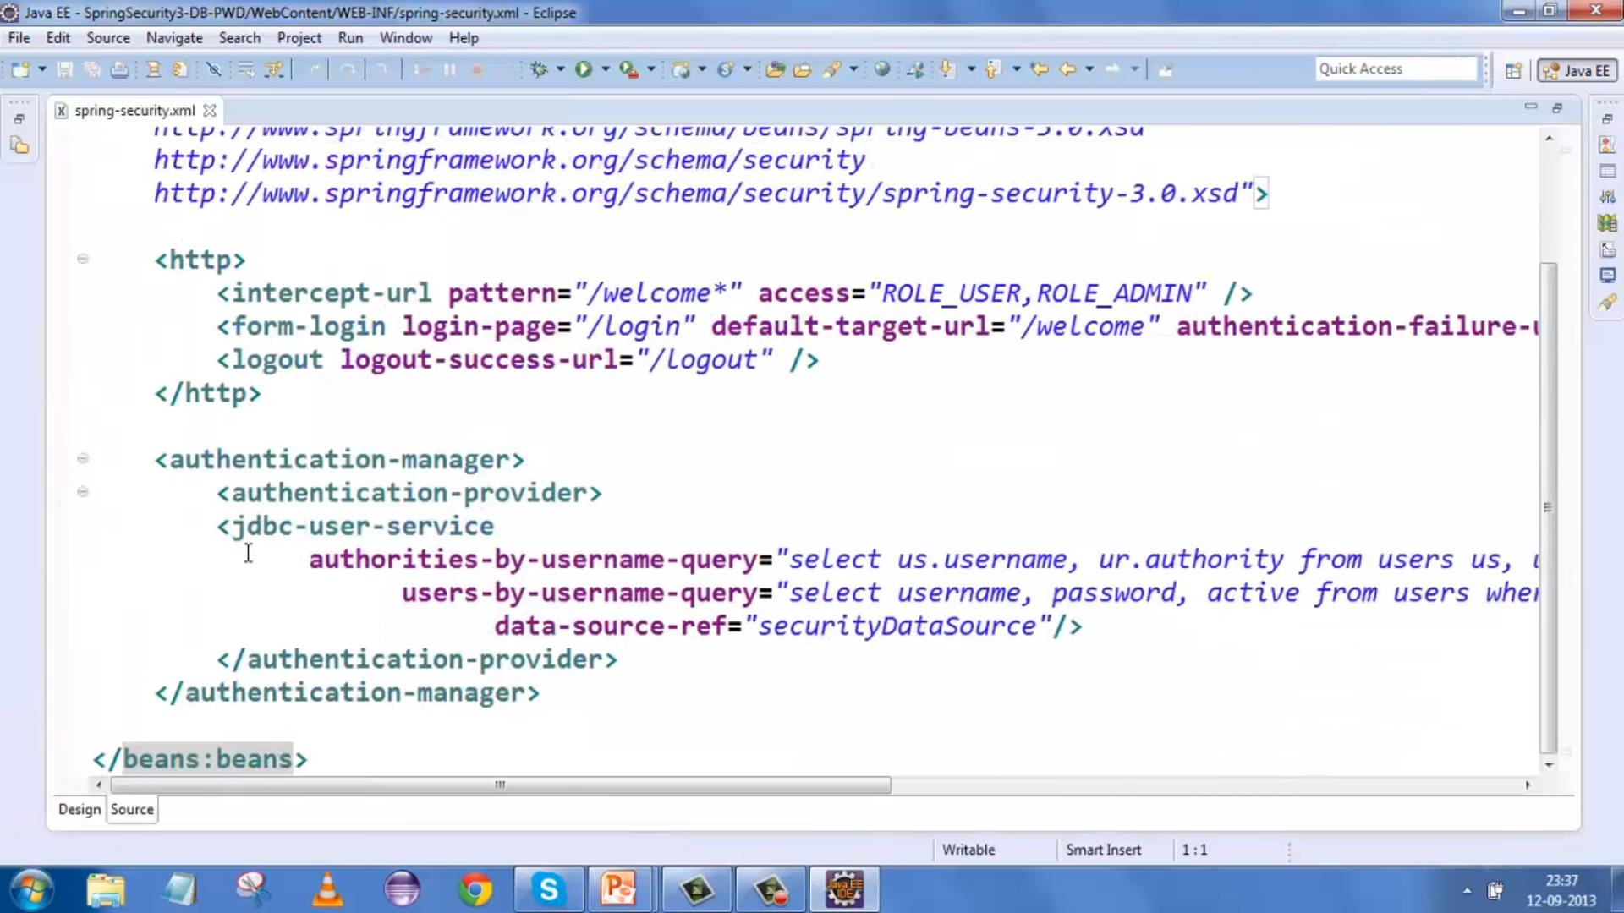

Authorization :

