Cli
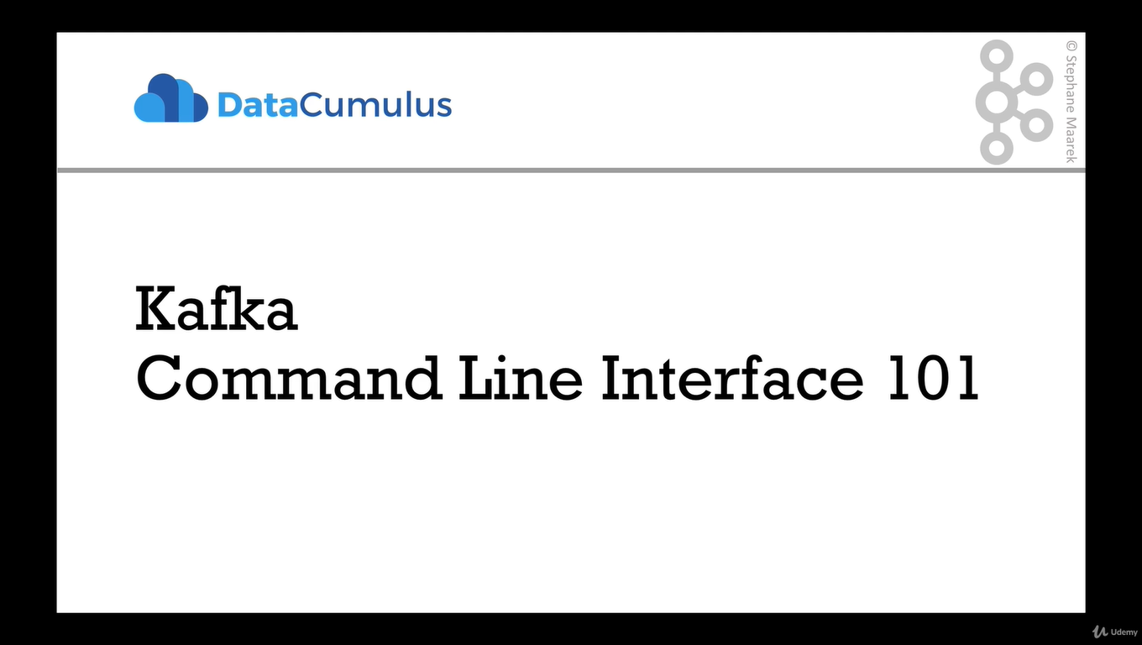
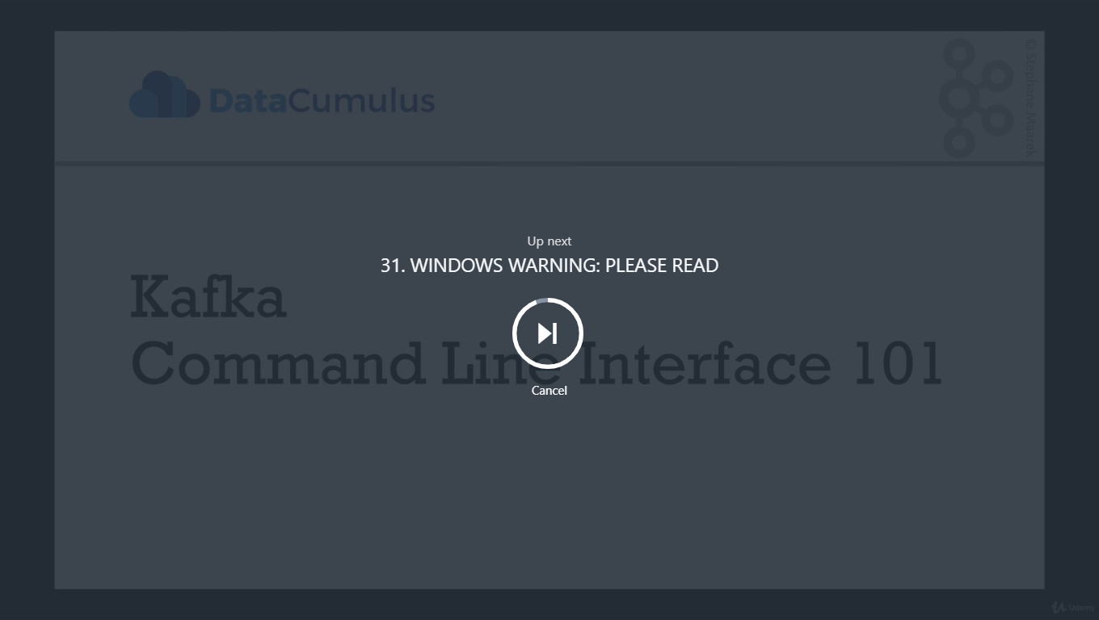
WINDOWS WARNING: PLEASE READ

WINDOWS USERS PLEASE READ
In the next lecture, do not run the command to DELETE topics
Because of a bug here: https://issues.apache.org/jira/browse/KAFKA-1194, it doesn't work. I'm actively working with the Kafka Dev team to see if I can get this fixed.
In the meantime, please do not delete topics. Otherwise your Kafka will crash and you won't be able to do the tutorial.
A workaround is to launch Kafka inside of a Linux VM and do the tutorial from there.
Thanks
Fullscreen
Go to Previous lecture
30. CLI Introduction
Go to Next lecture
32. Kafka Topics CLI

Makesure Zookeeper and kafka is started

We’ll start with kafka-topic command , the extension can be .sh,.bat or nothing (brew)

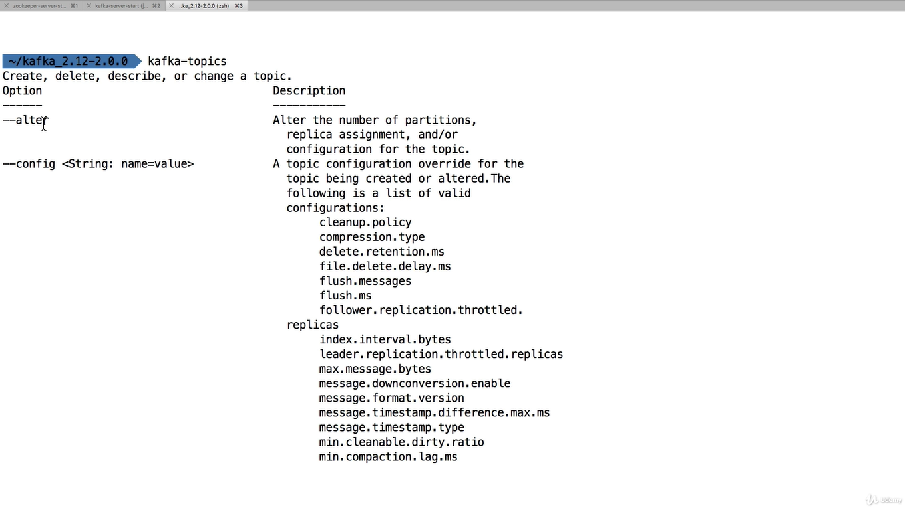
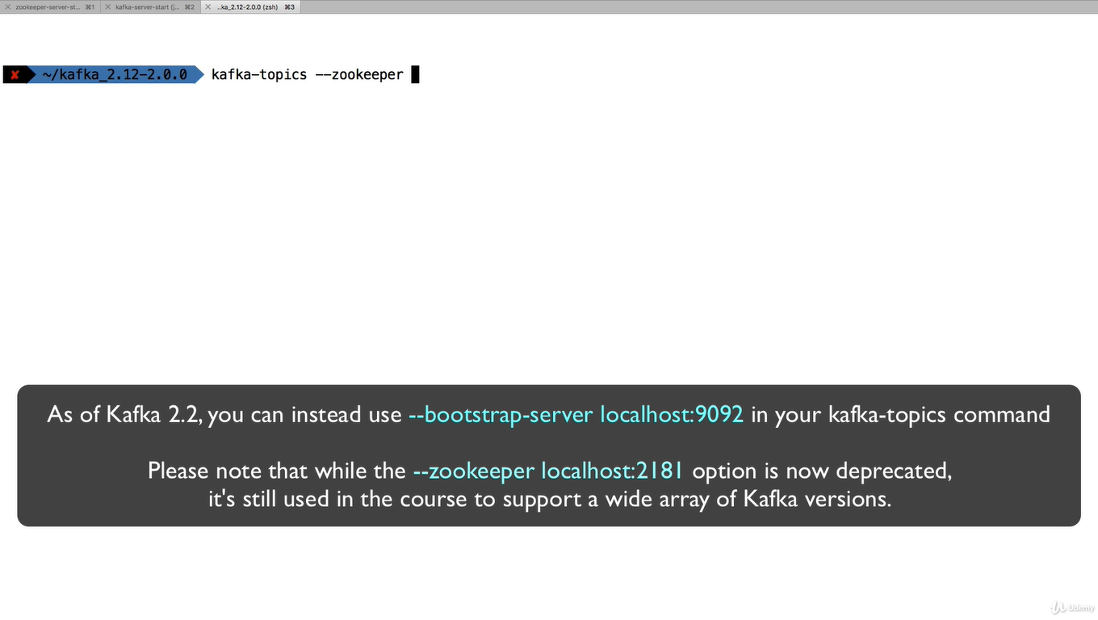

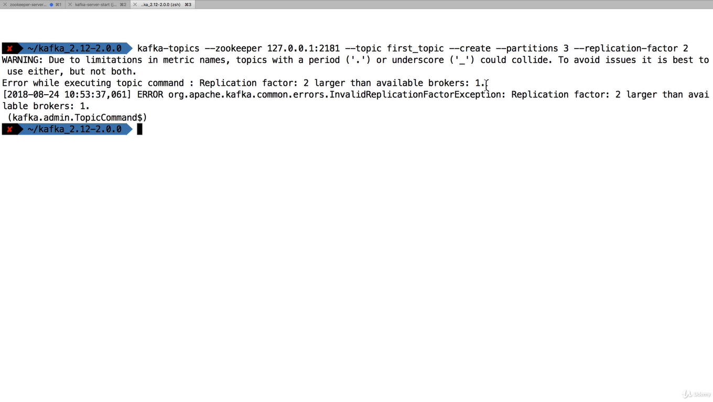

There is error because you can not start replication more than the broker count in this course we have just started one zooker and one kafka

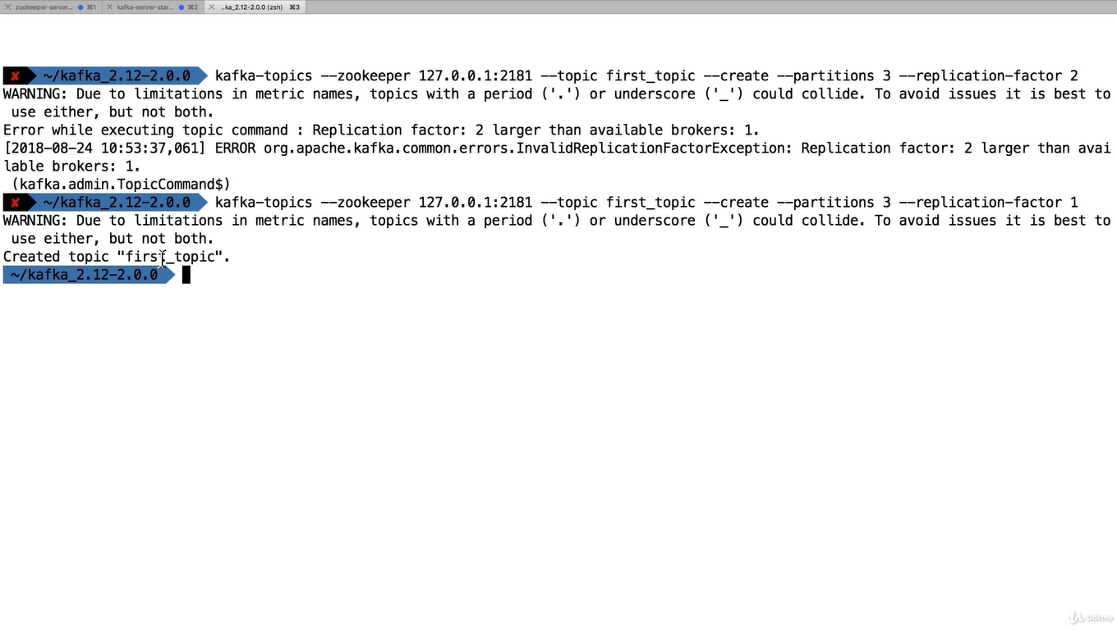
To list the topics
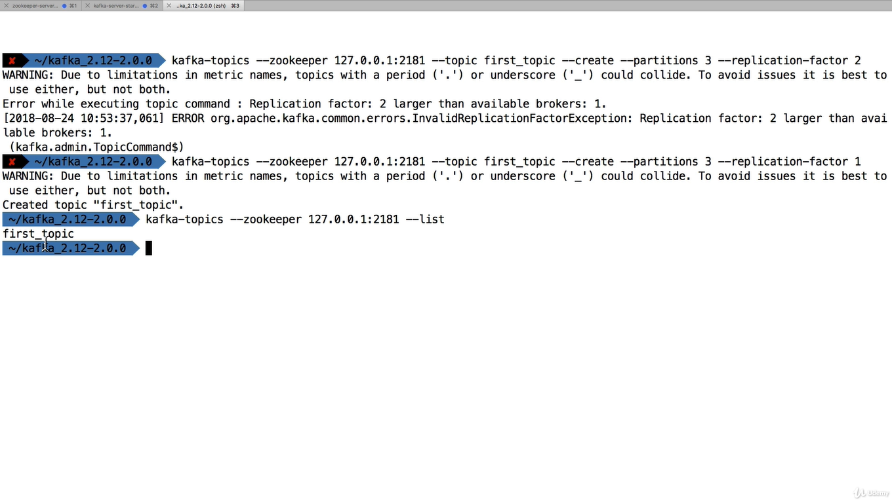

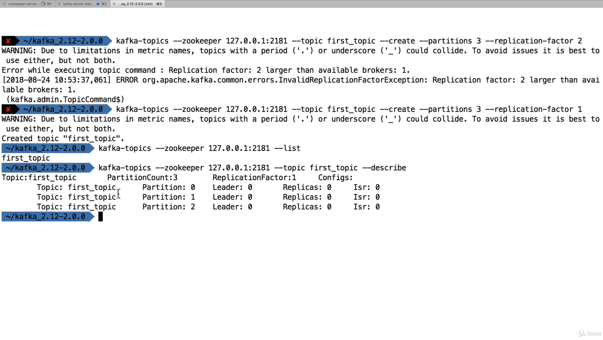
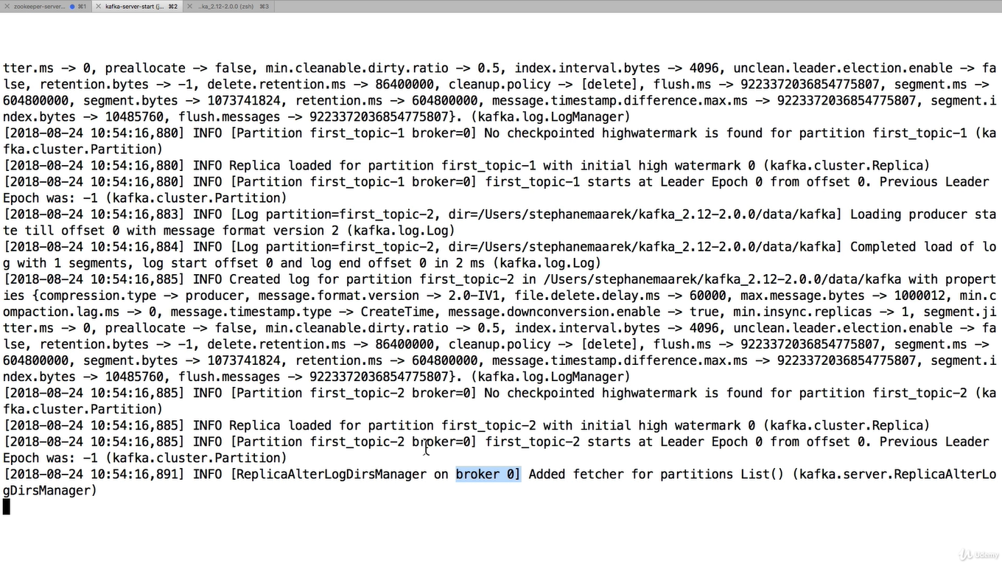
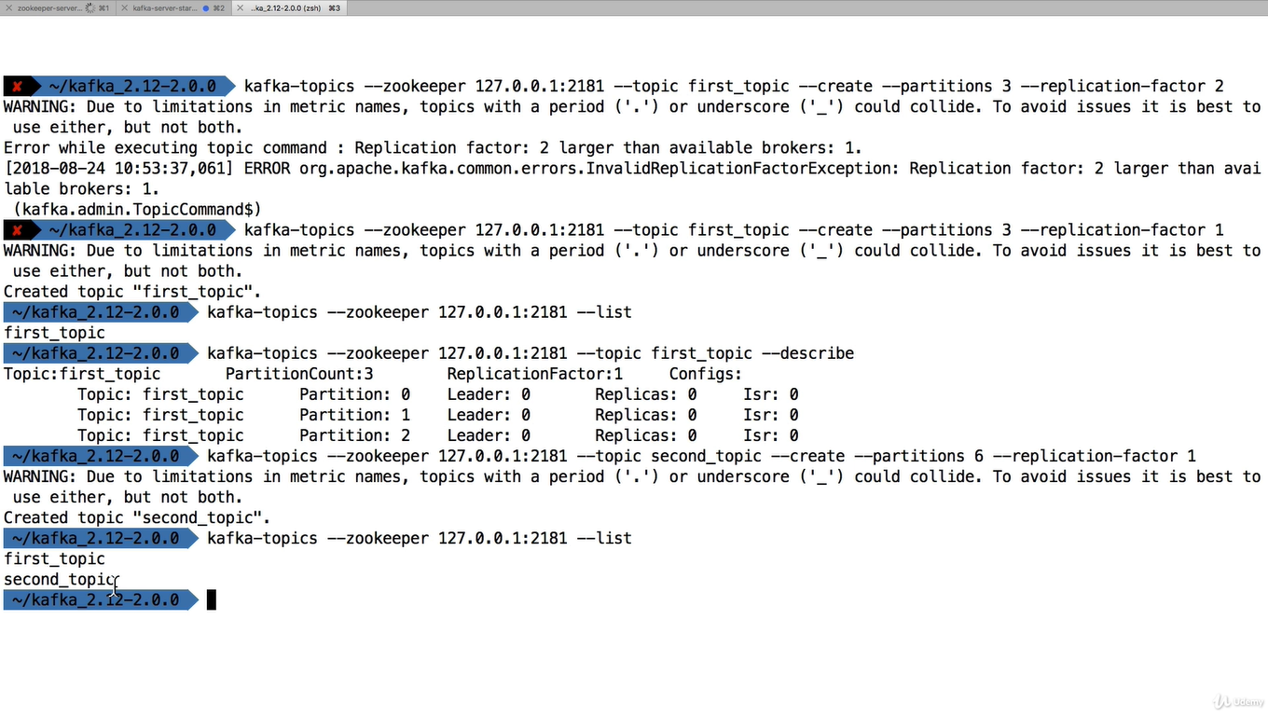

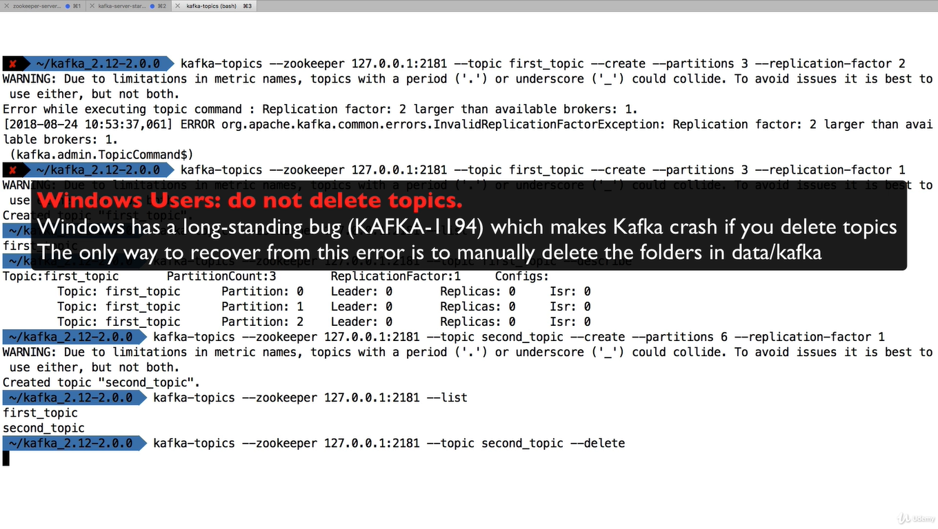
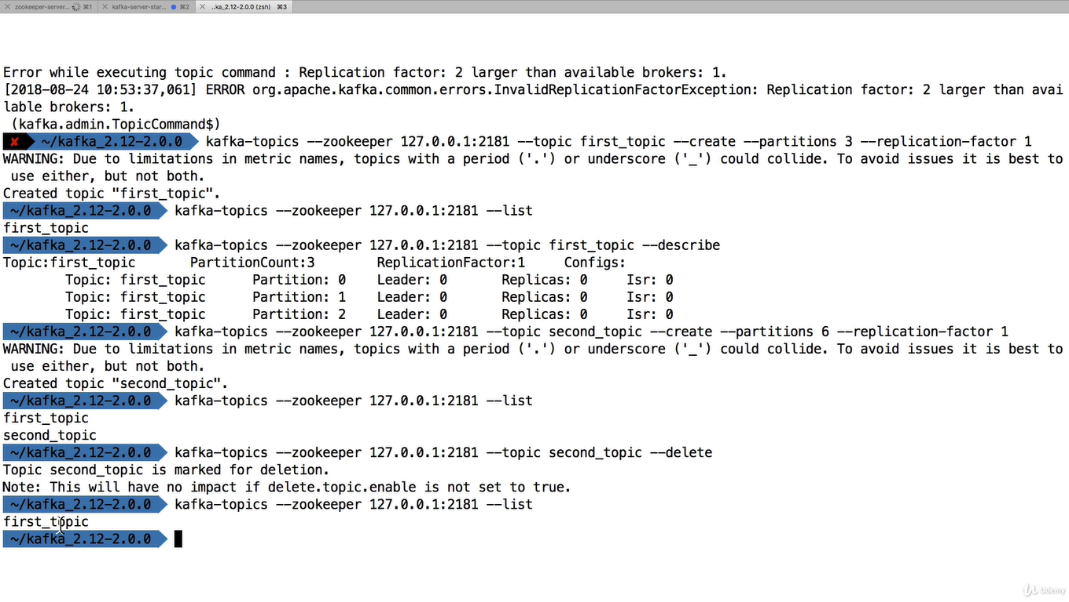
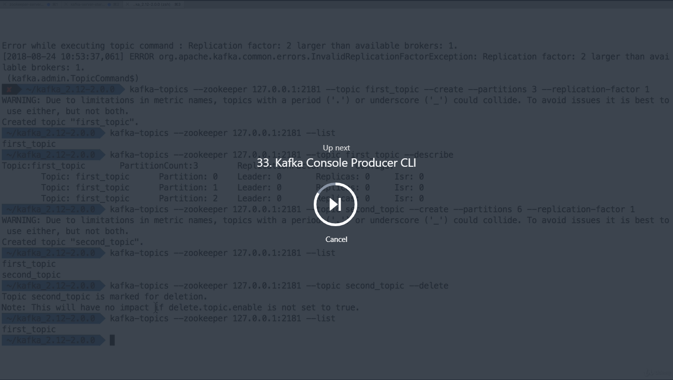
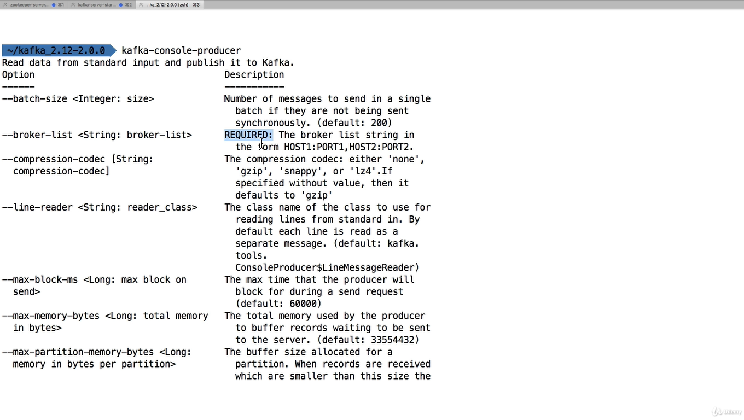

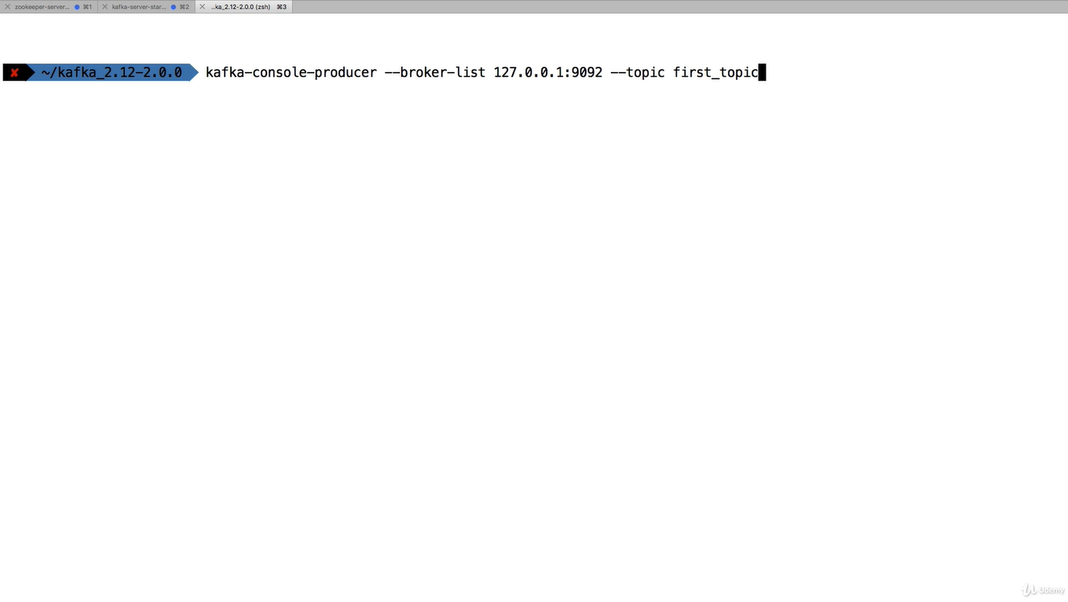

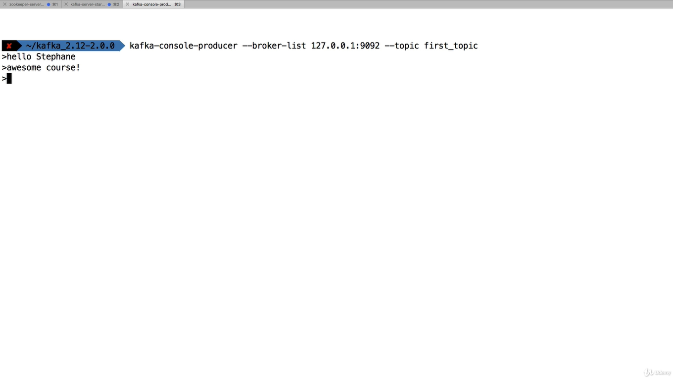
Stopped the producer

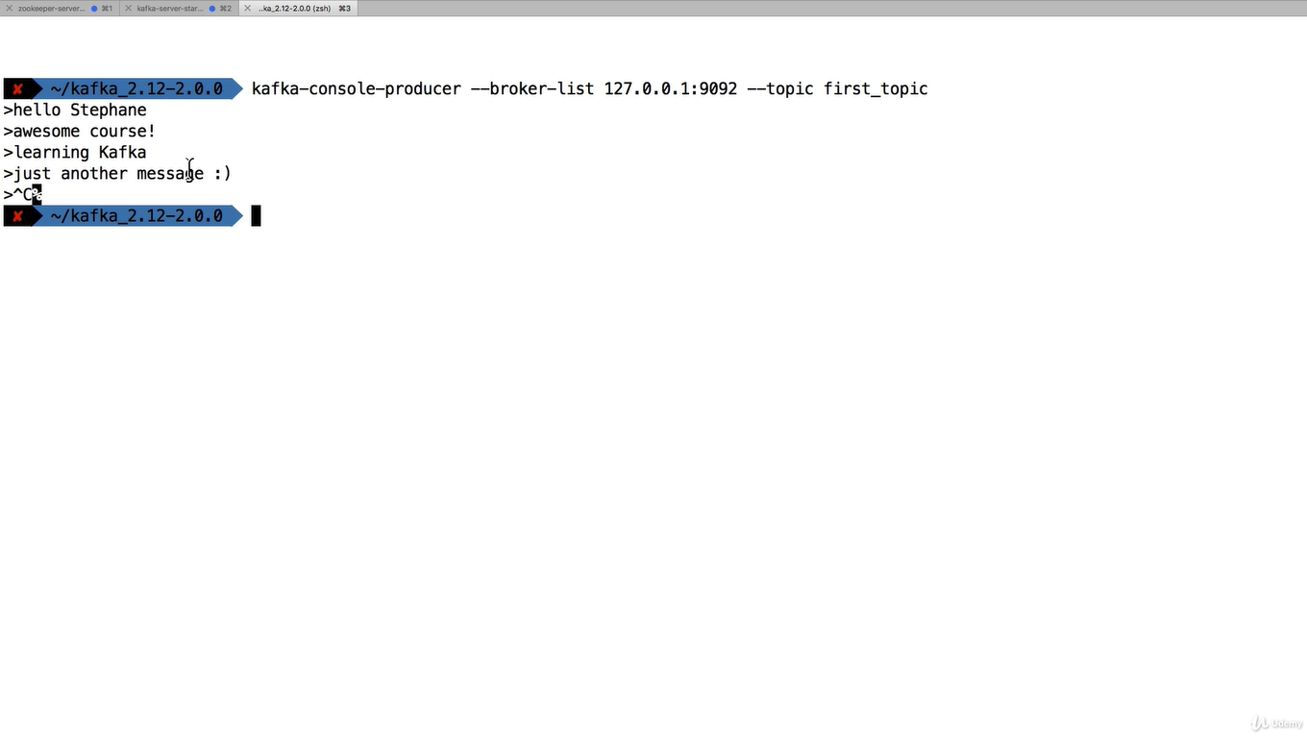
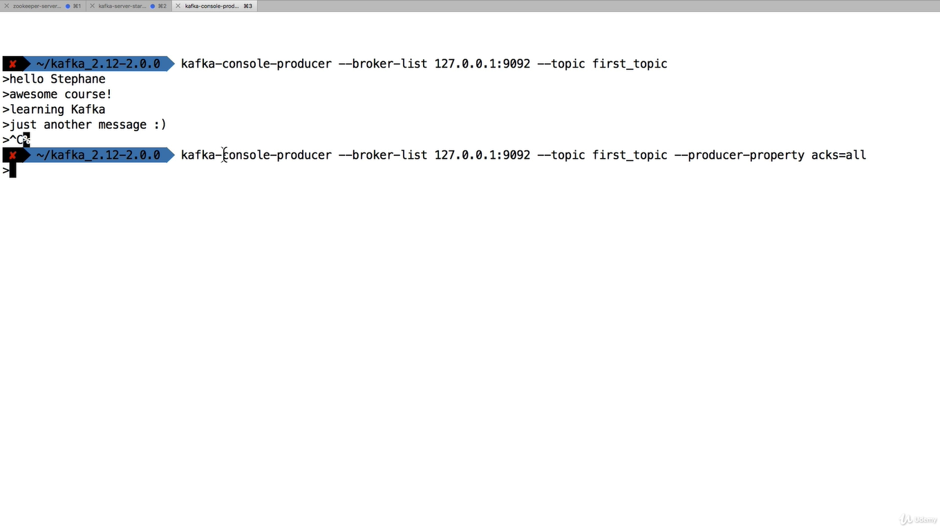
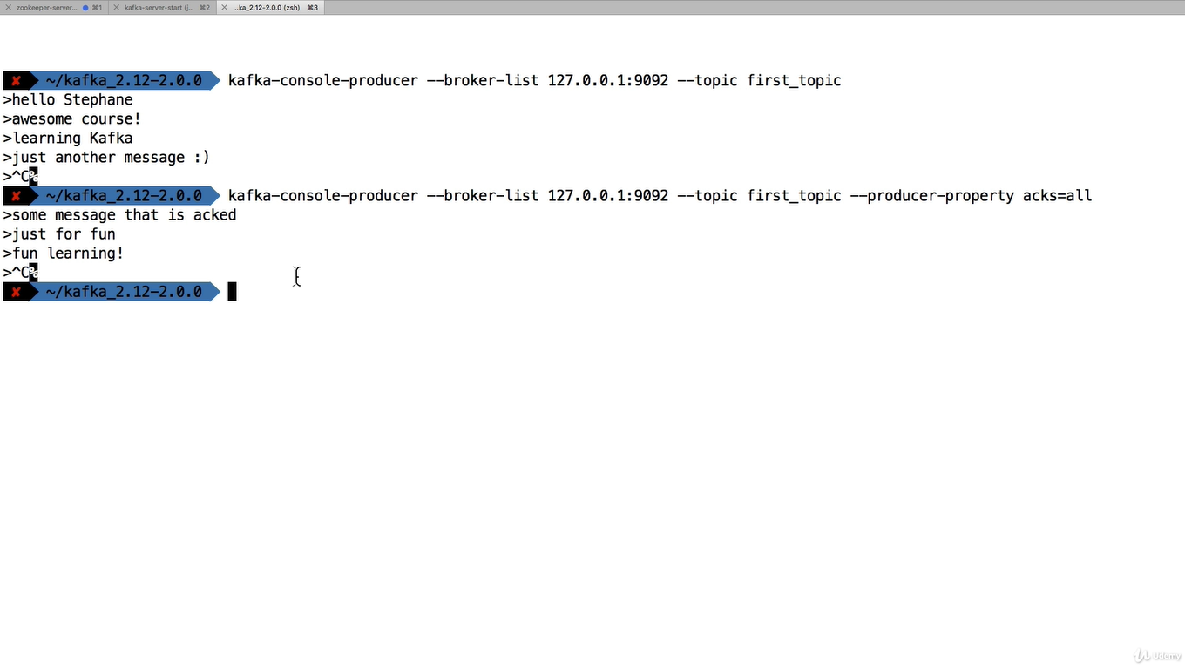
When we write something if topic does not exist then
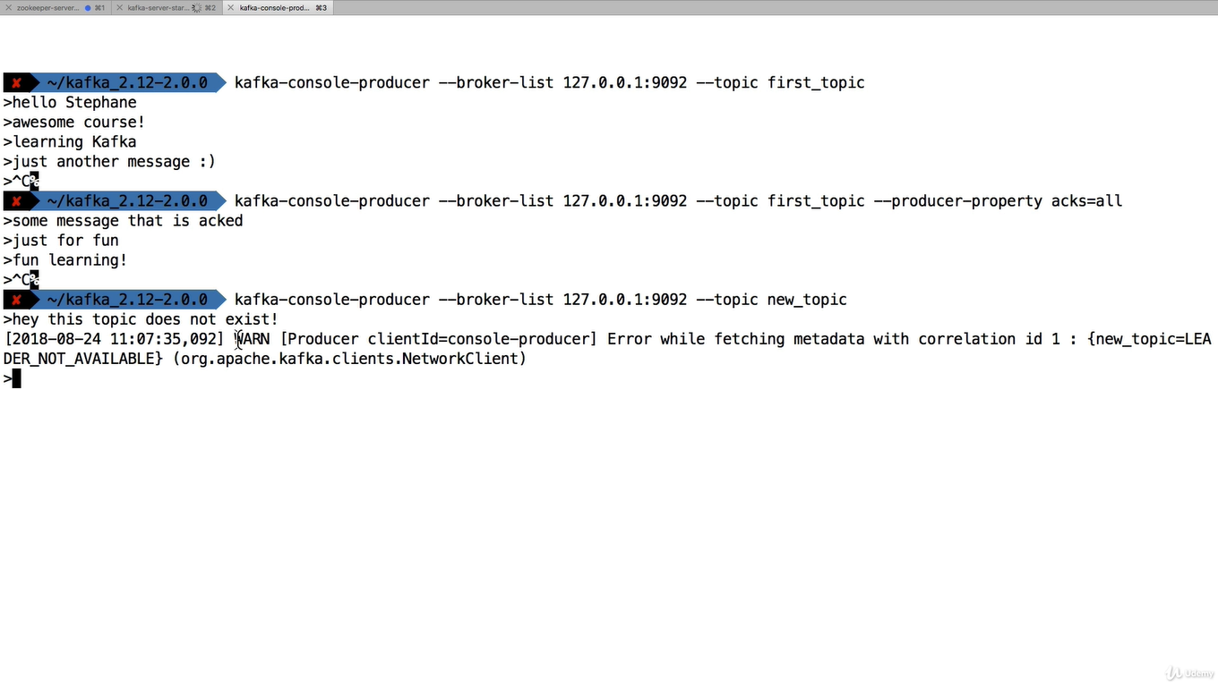
Here it’s created new topic
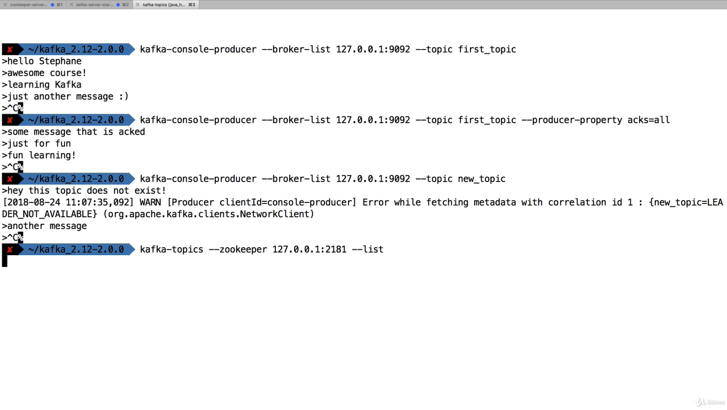

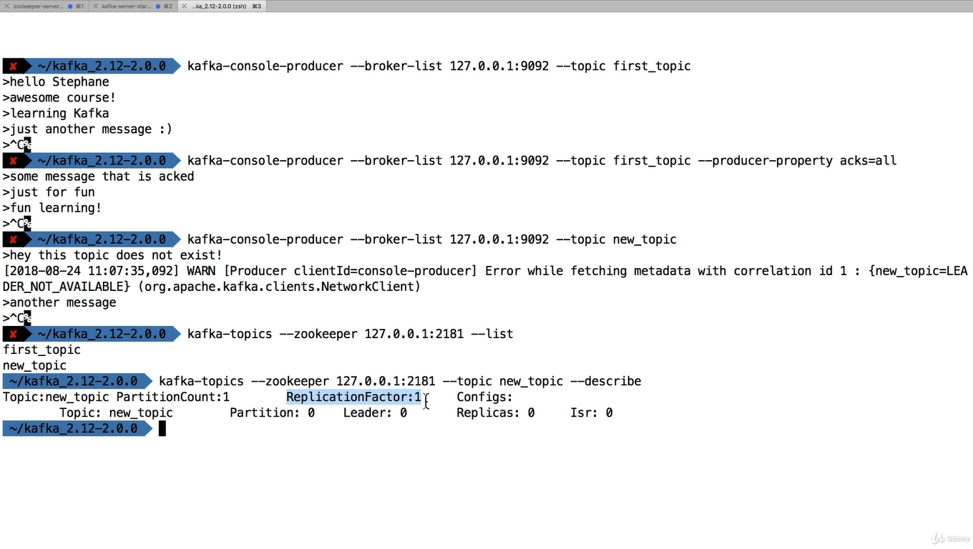
If the topic does not exist it create new topic with default setting.we can change by going to server.properties

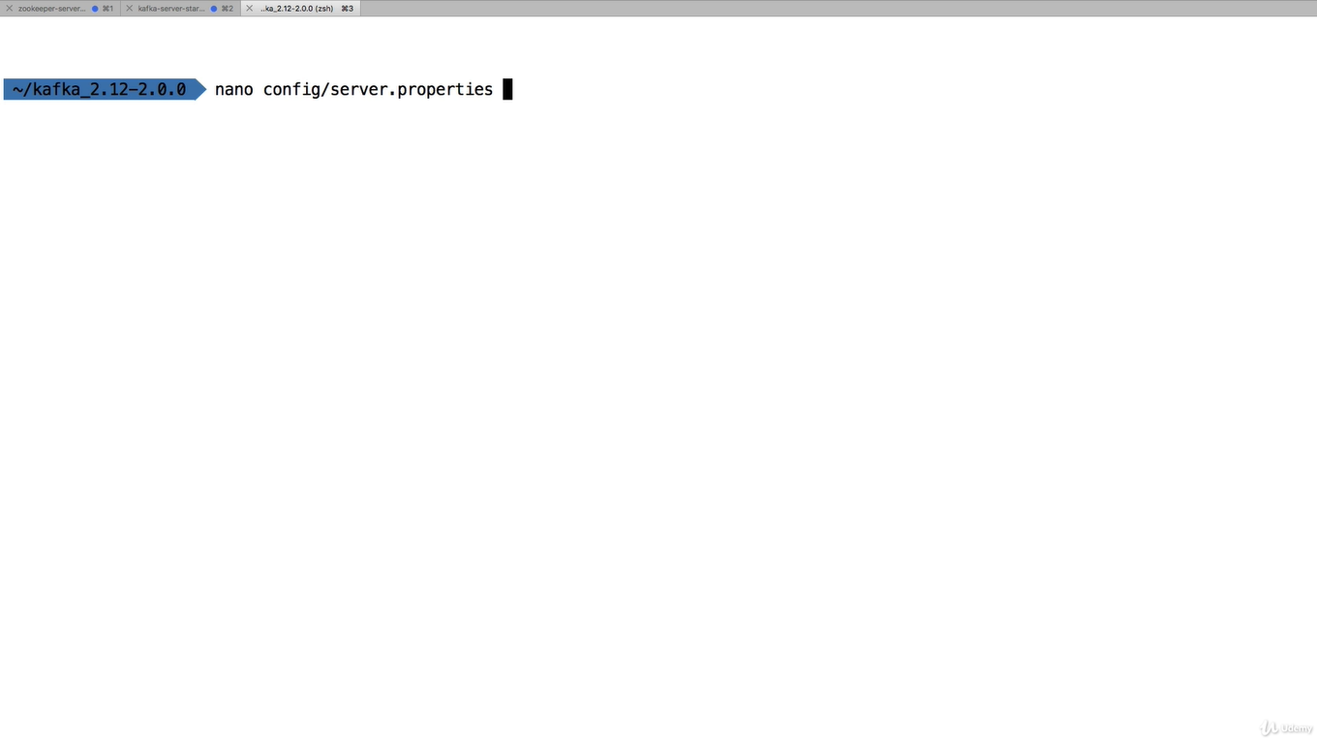

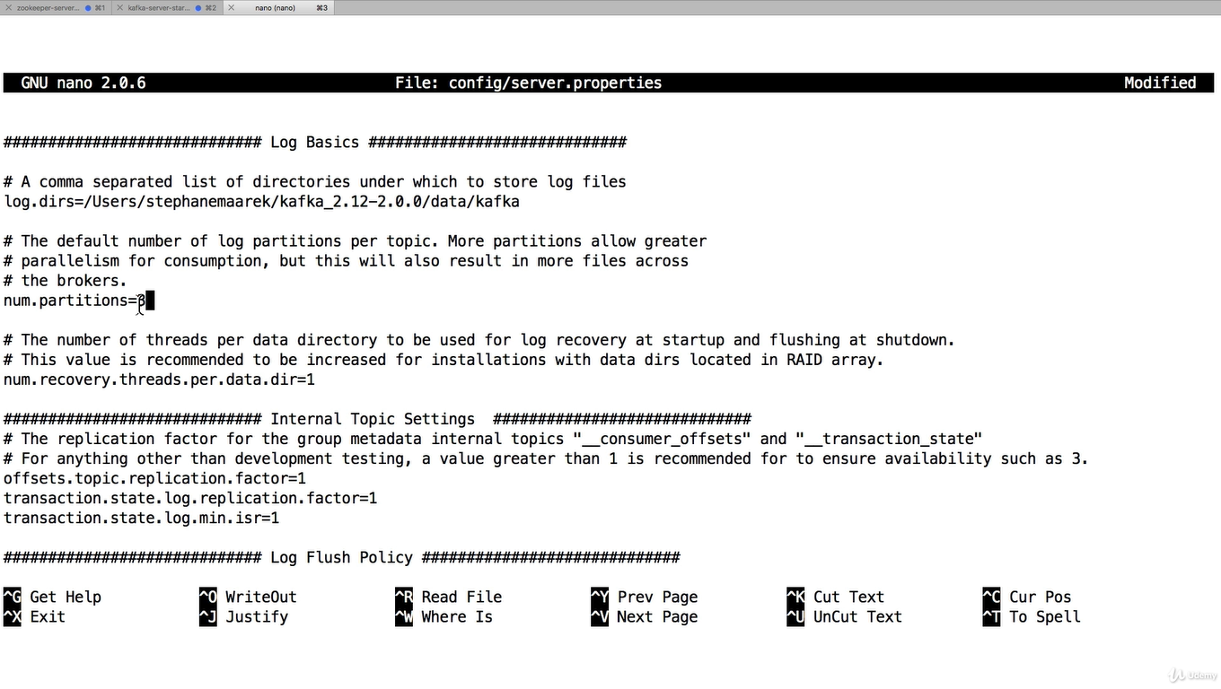

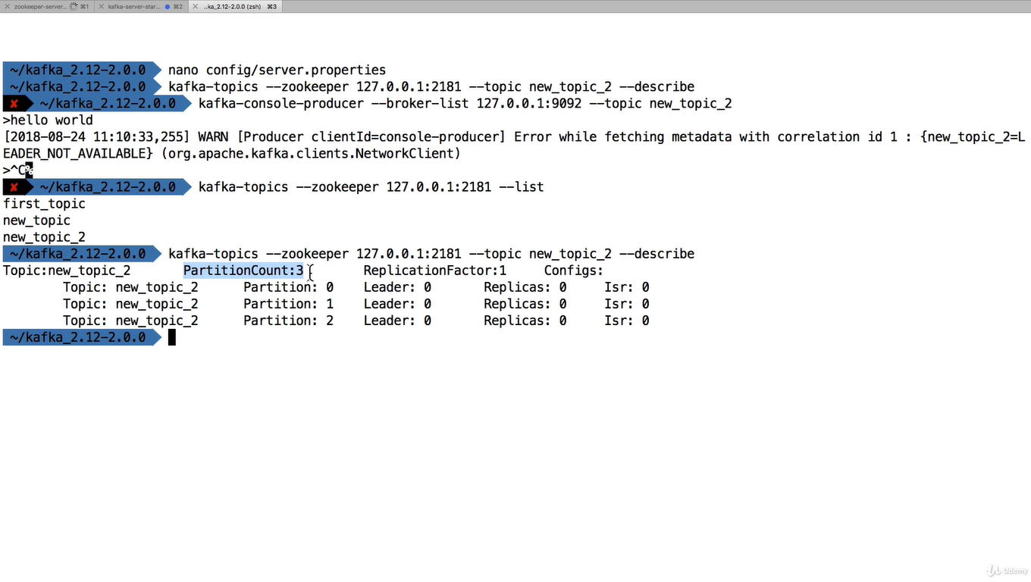

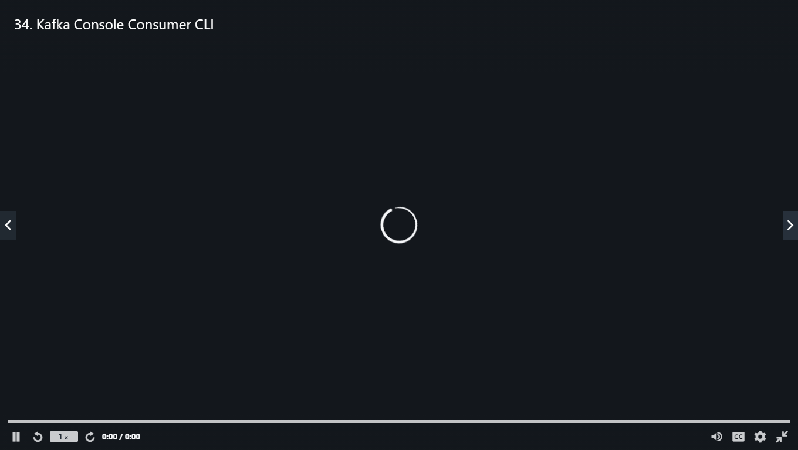

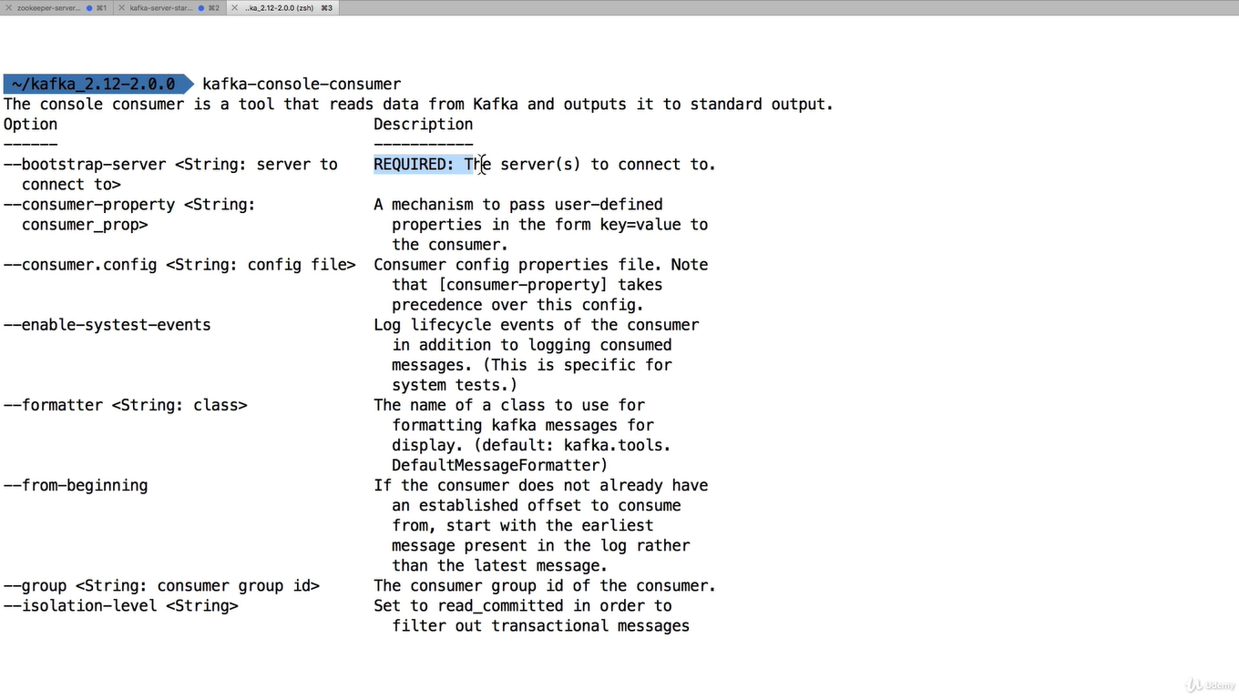
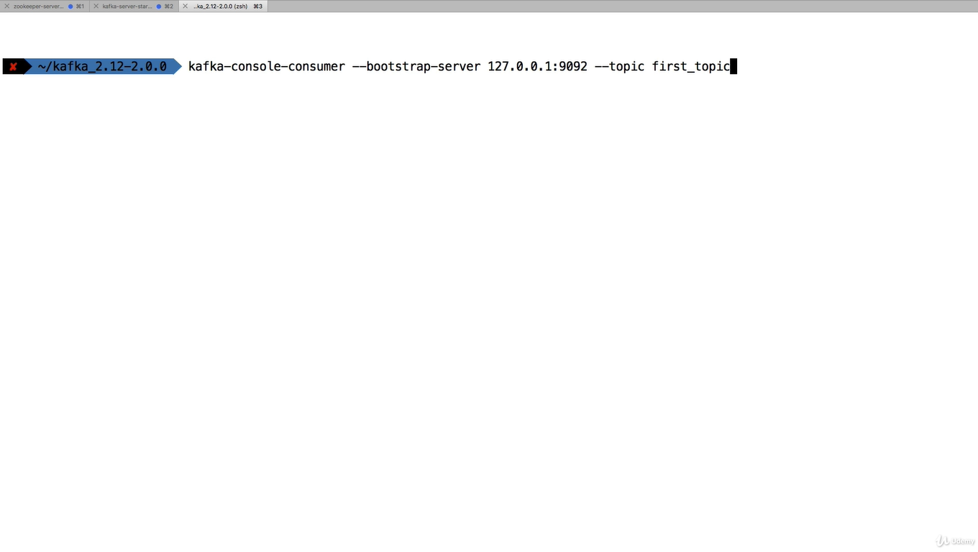
Nothing happens after this

Because kafka listener does not read messages created before we launch the consumer

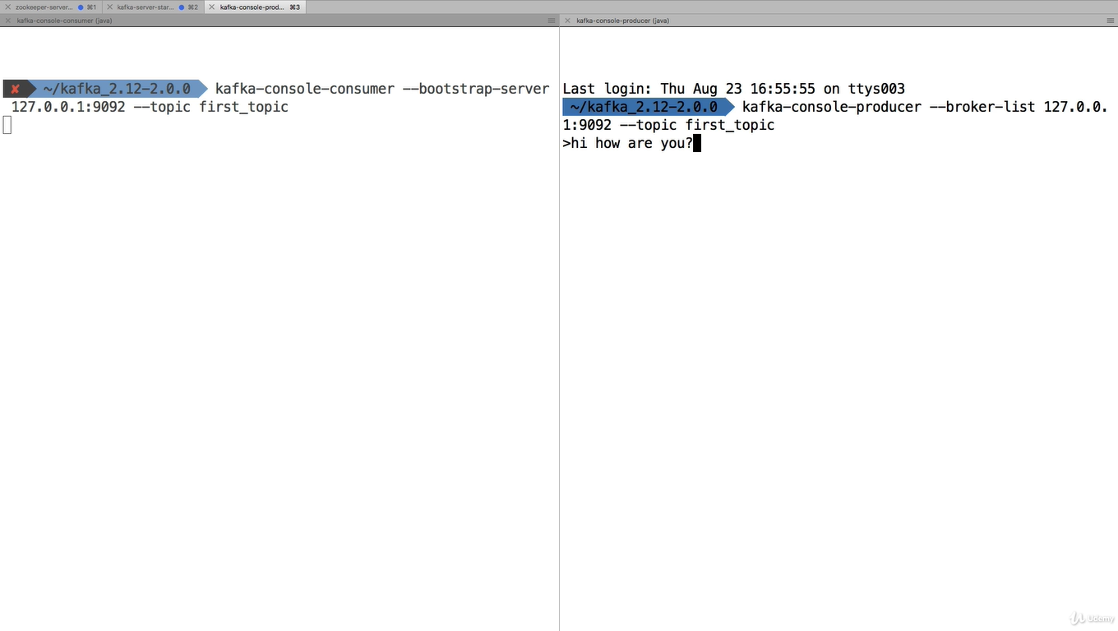
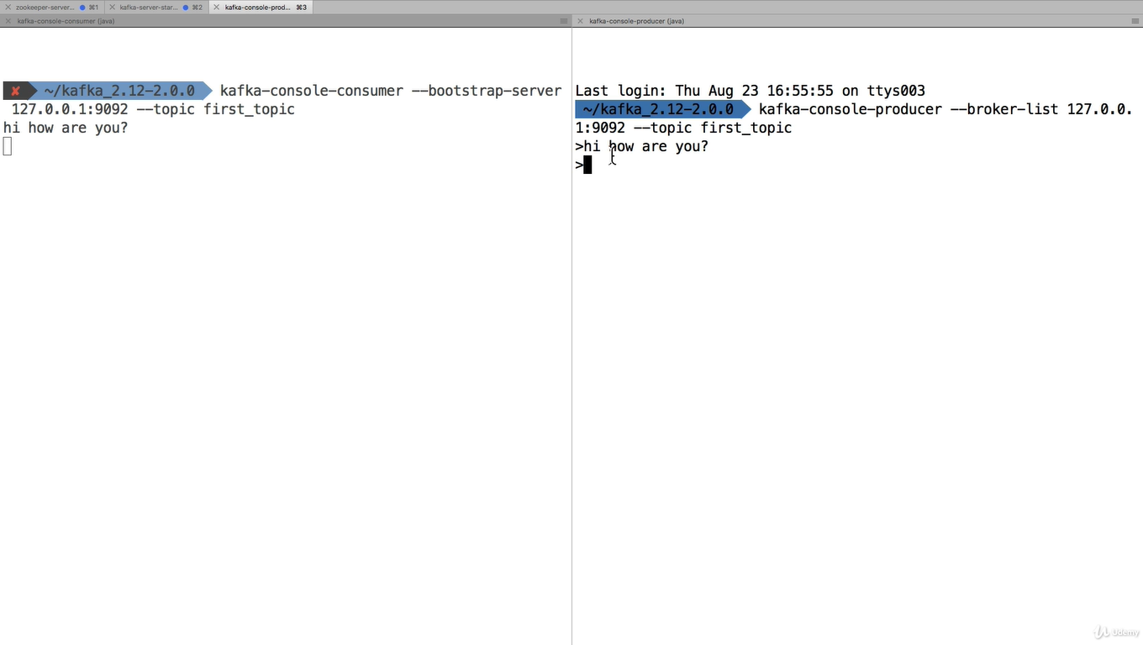
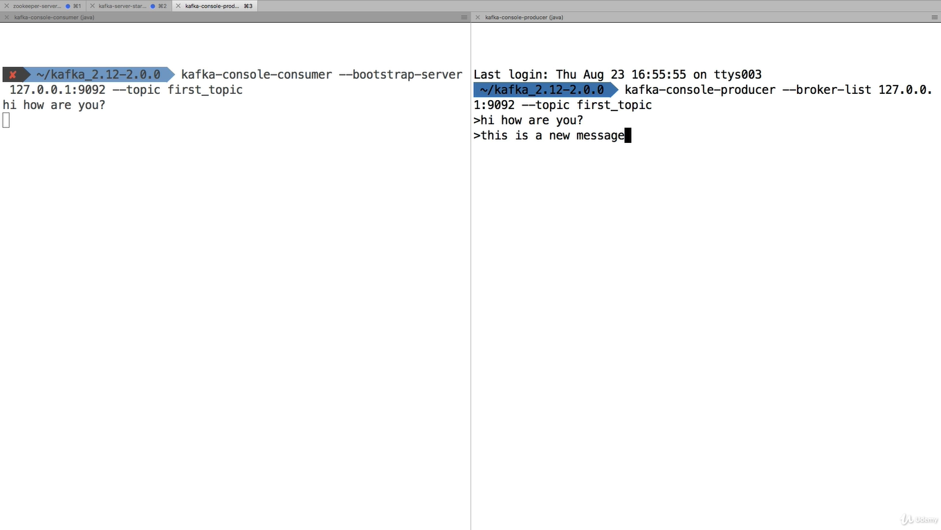
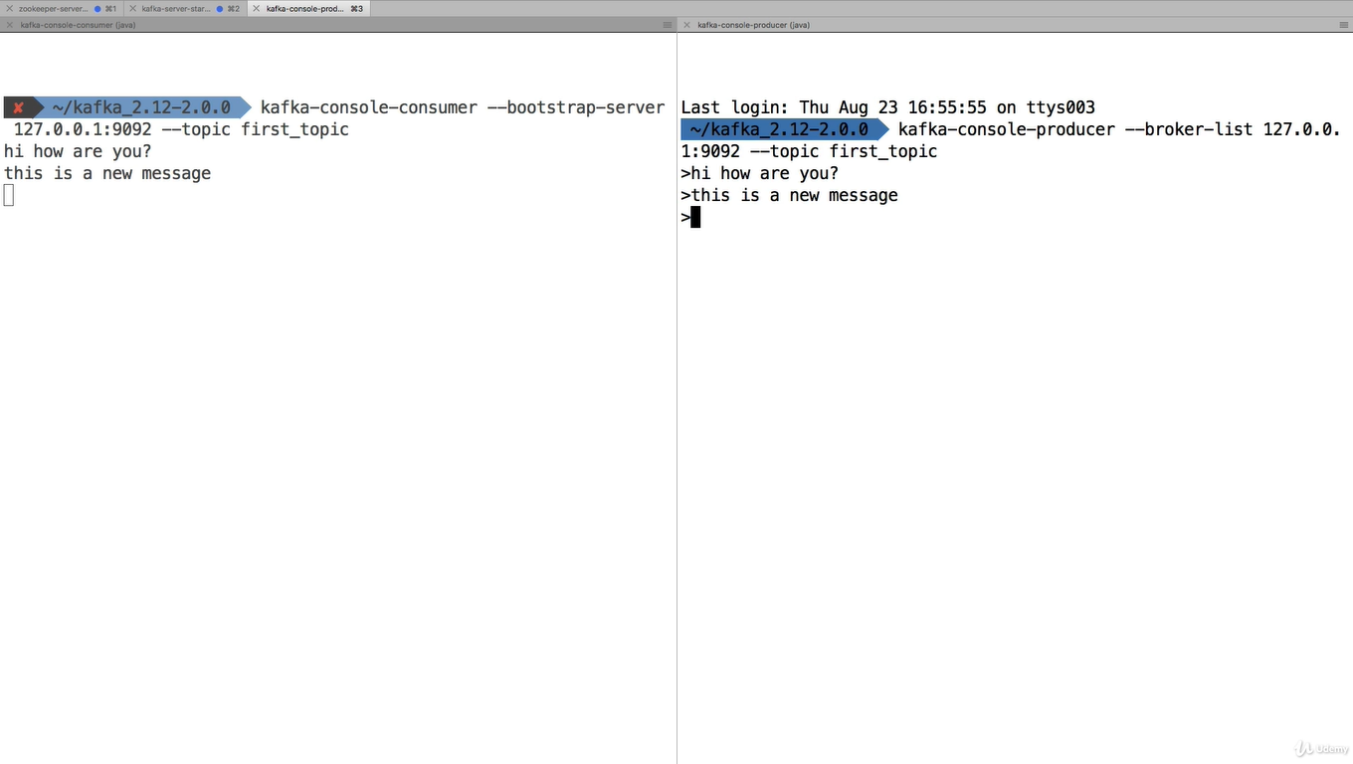
If you want read all the messages starts from beginning. Then follow below command
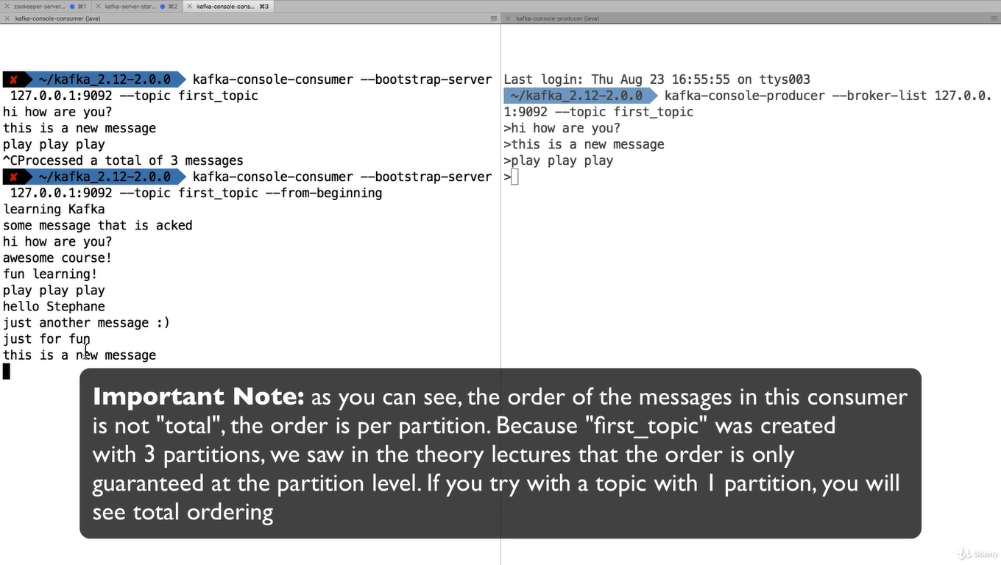

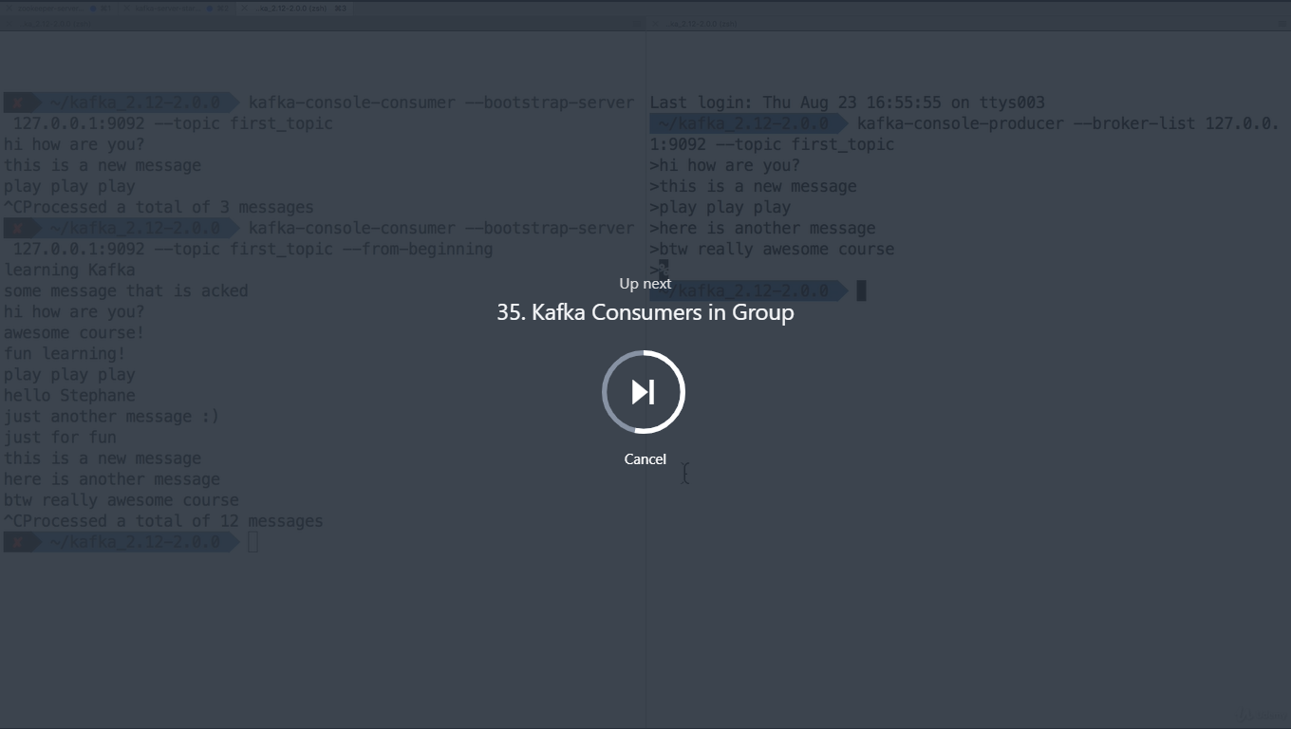

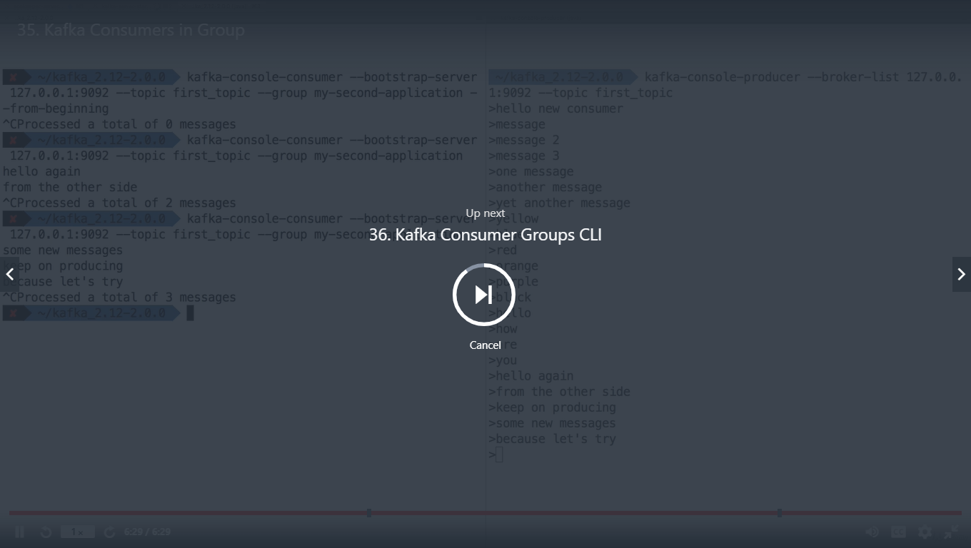
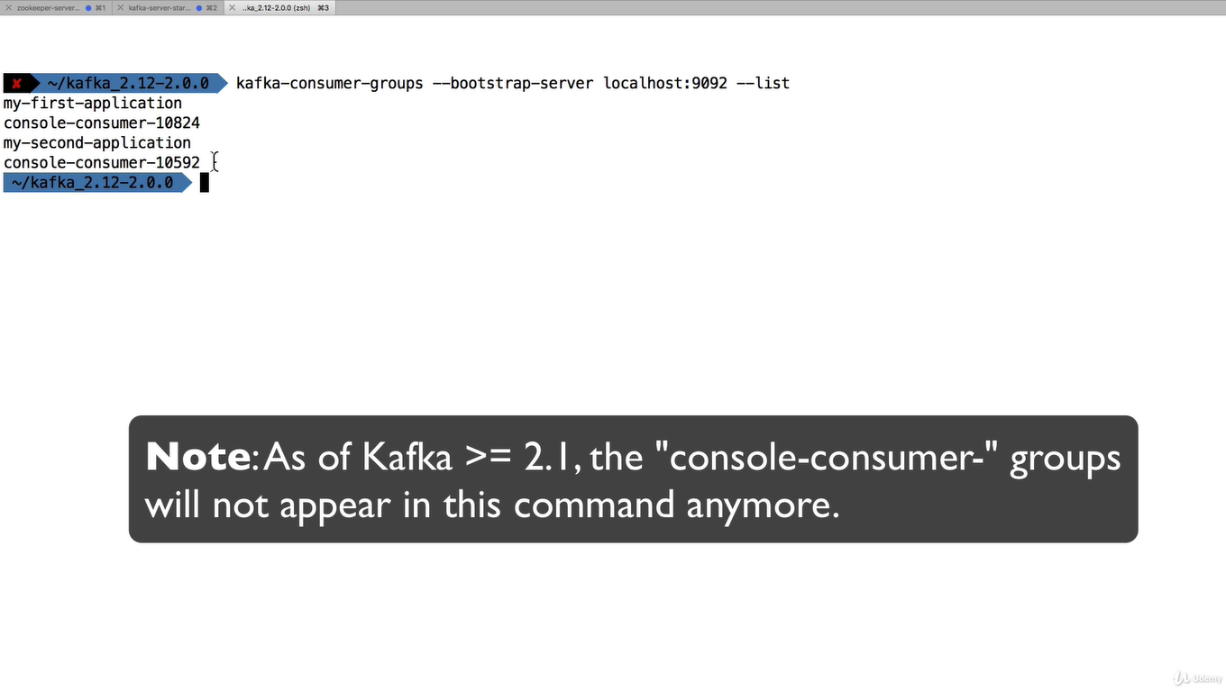
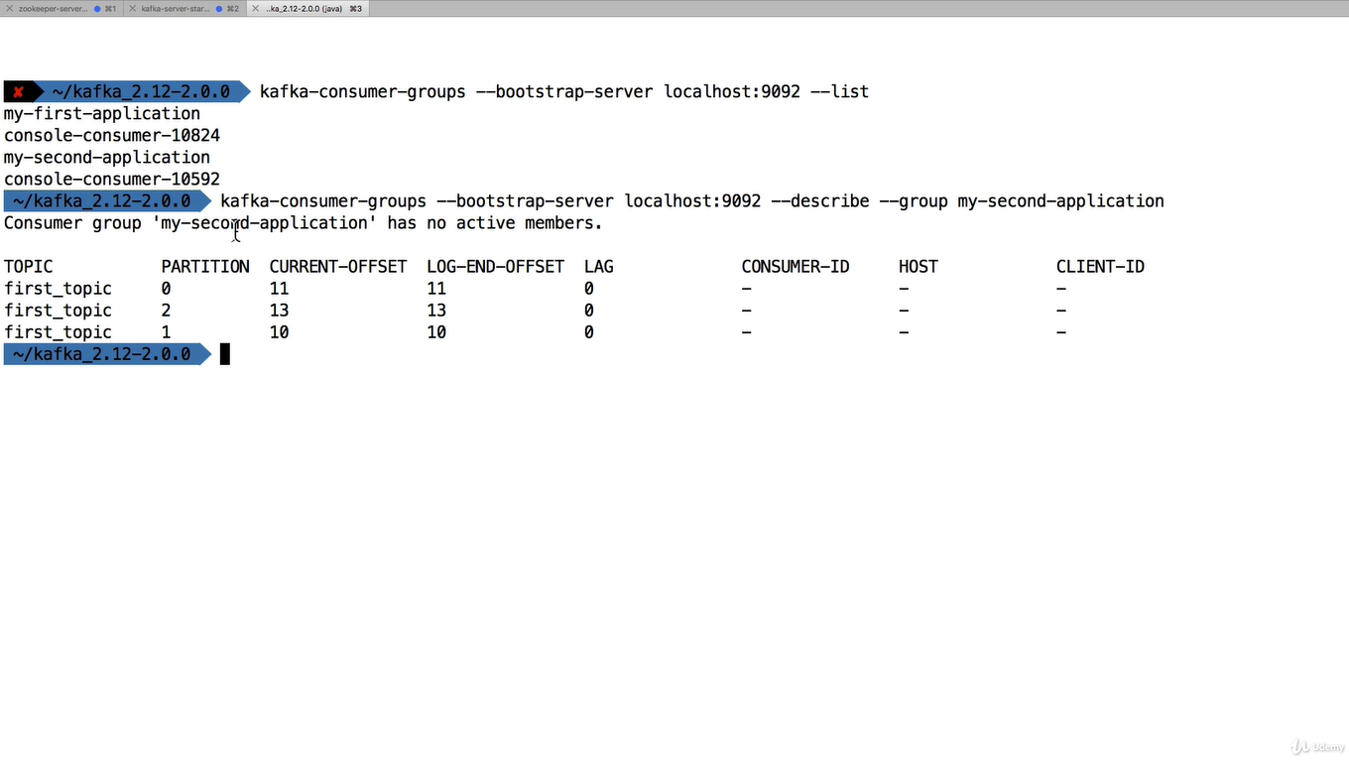

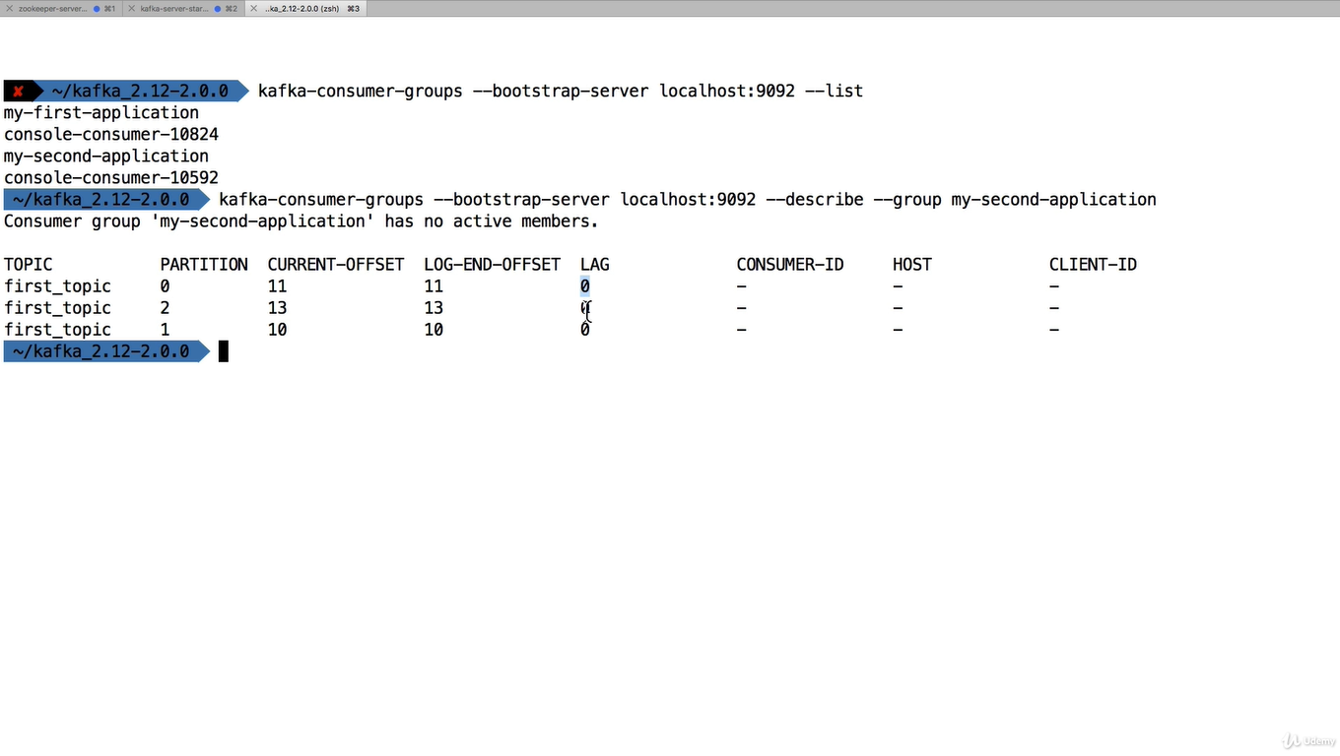
LAG =0 meanin nothing is pending to read

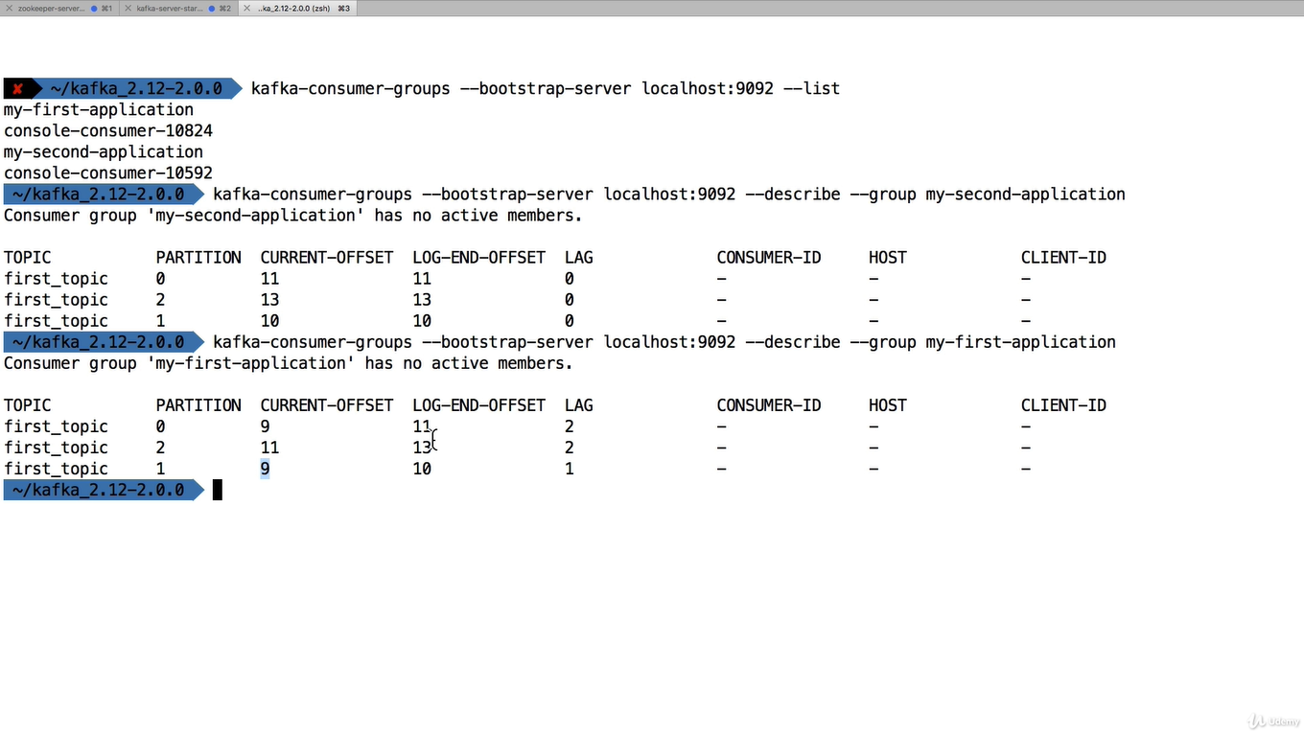
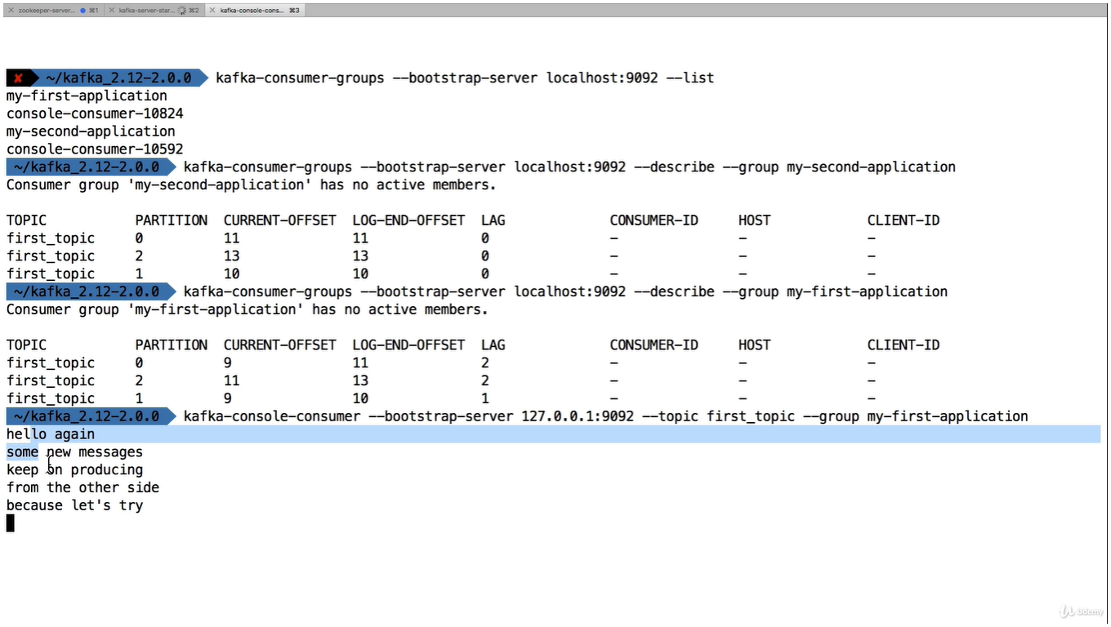
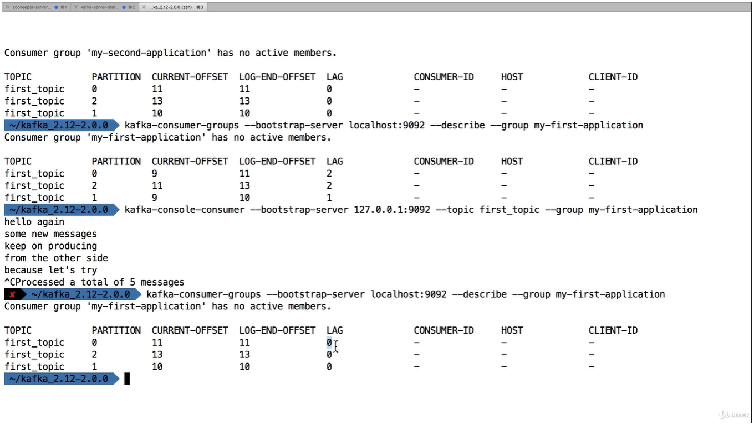
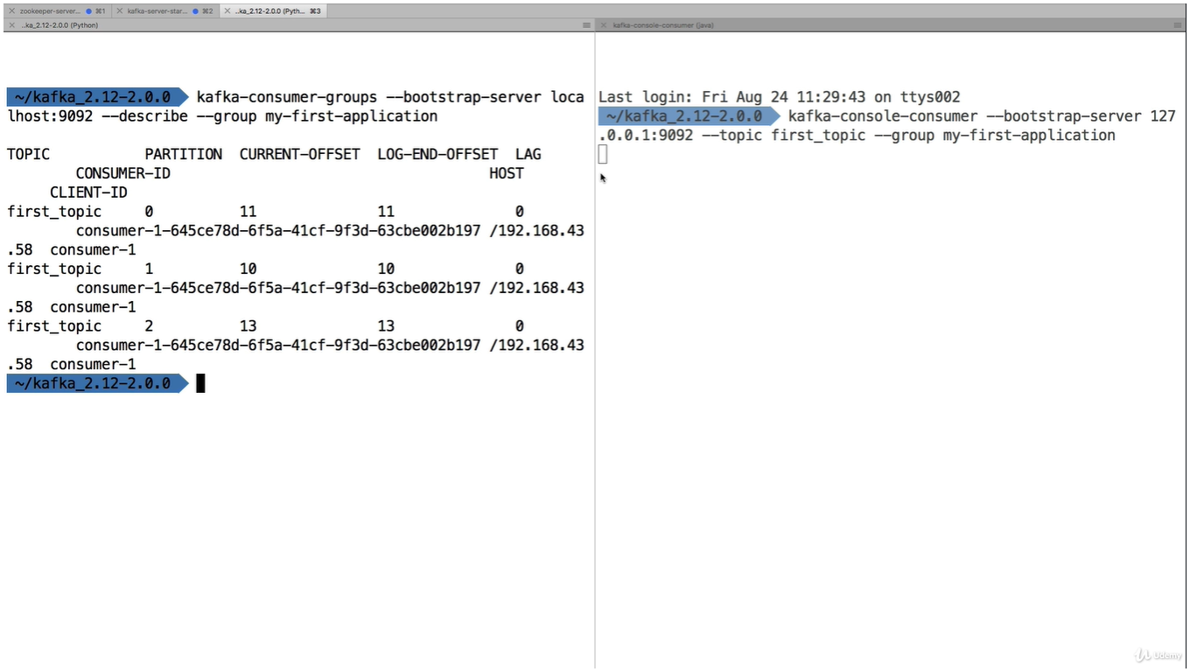
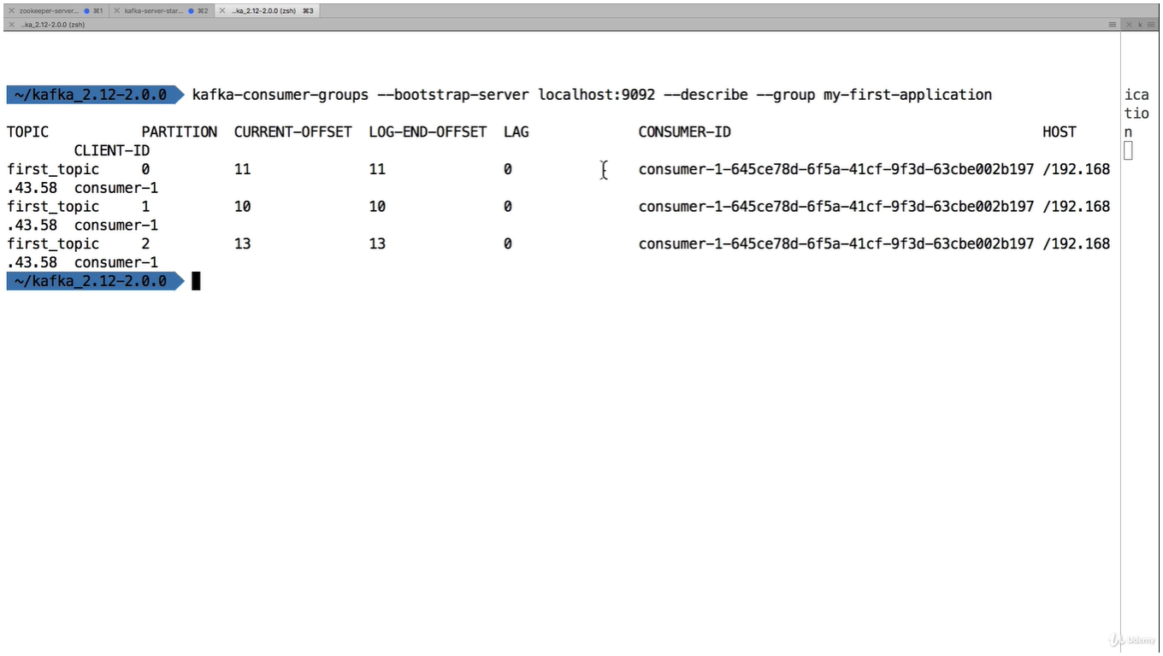

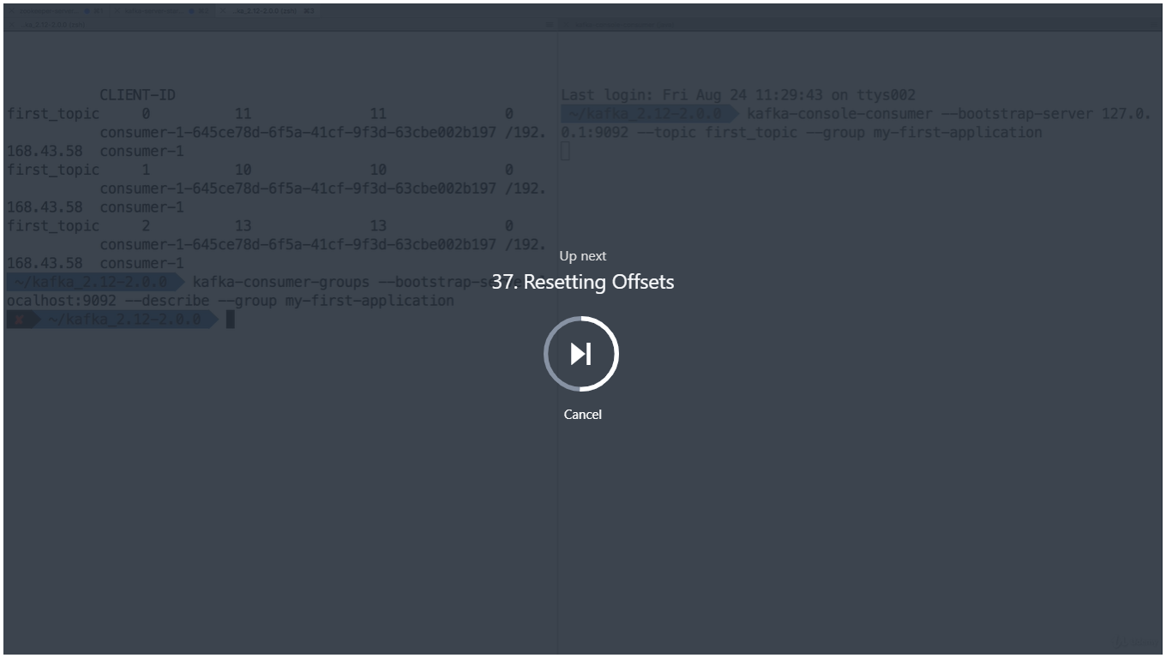
This is replay the data

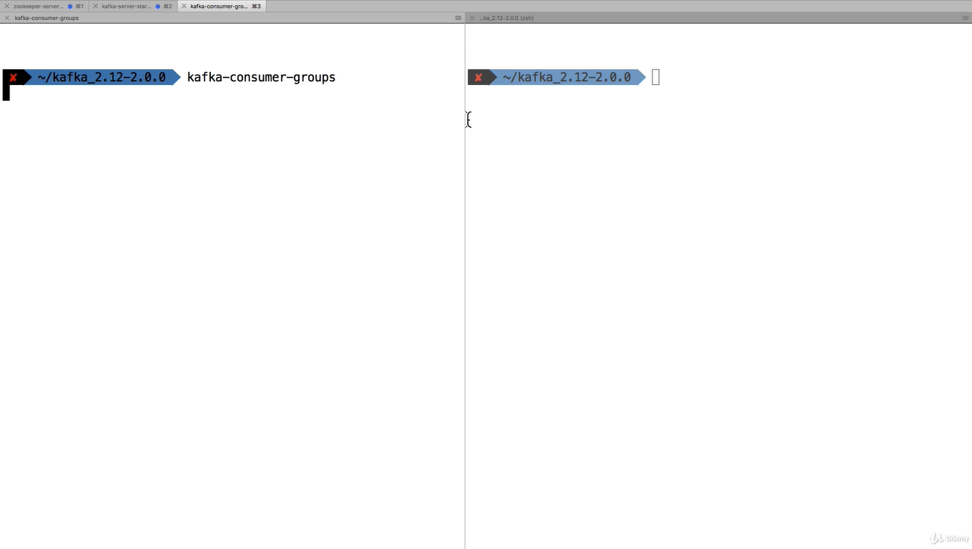

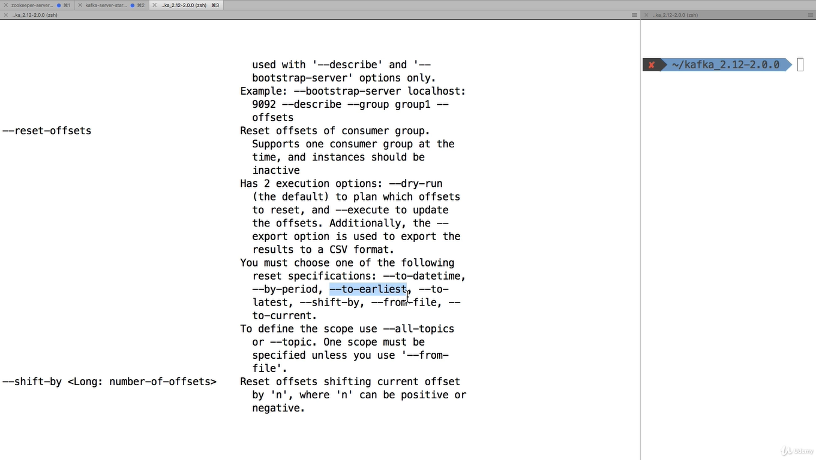
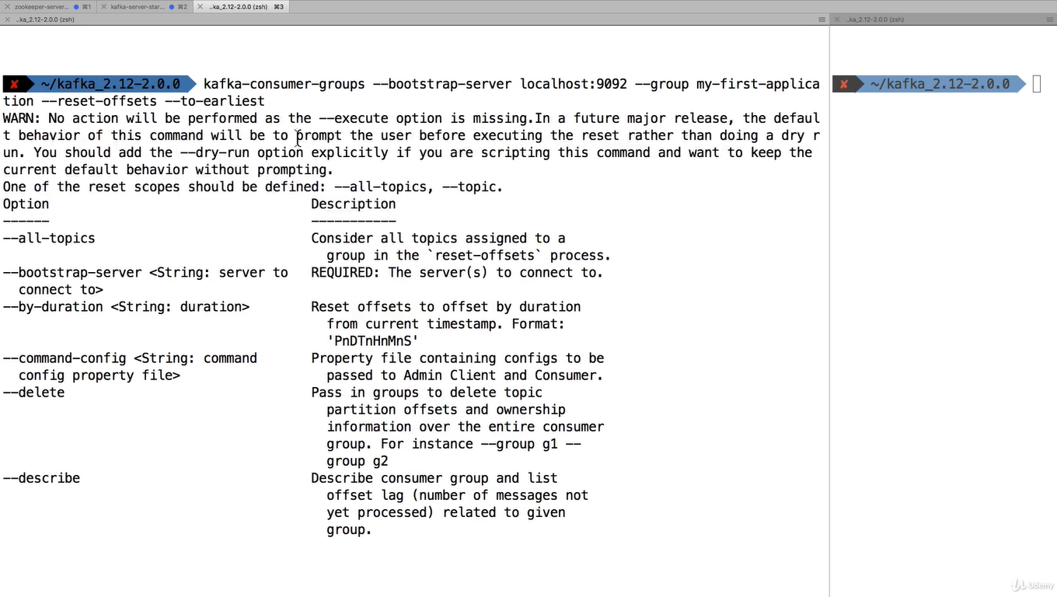
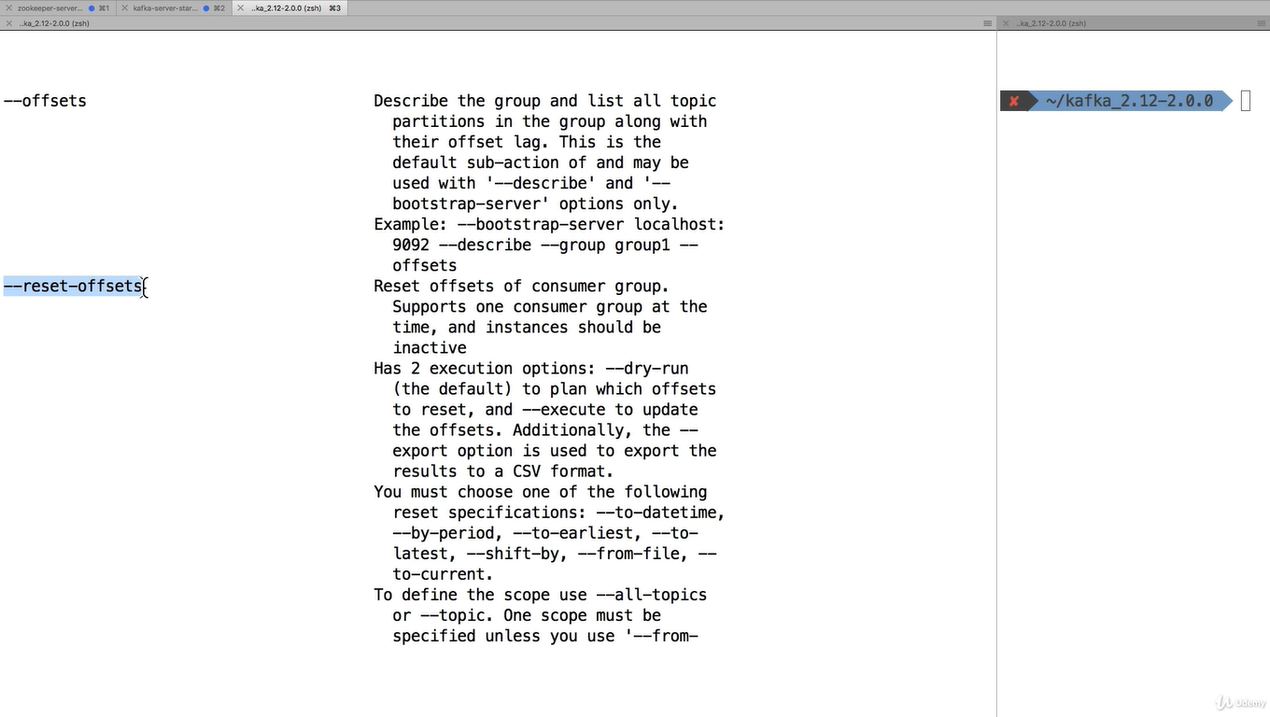
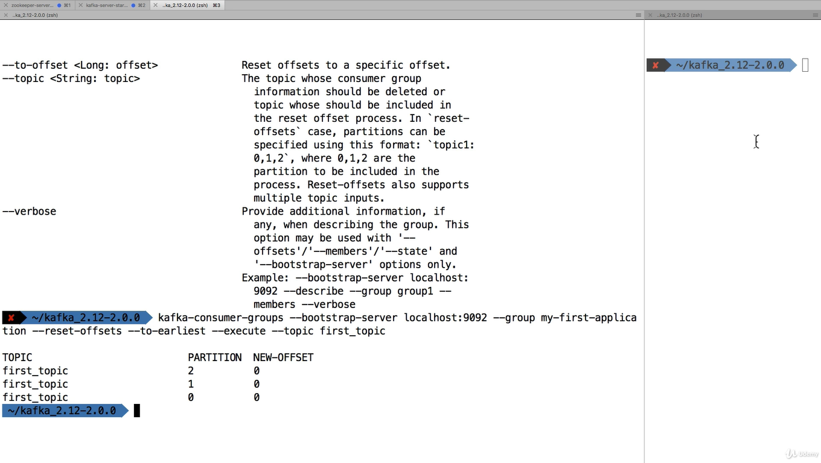
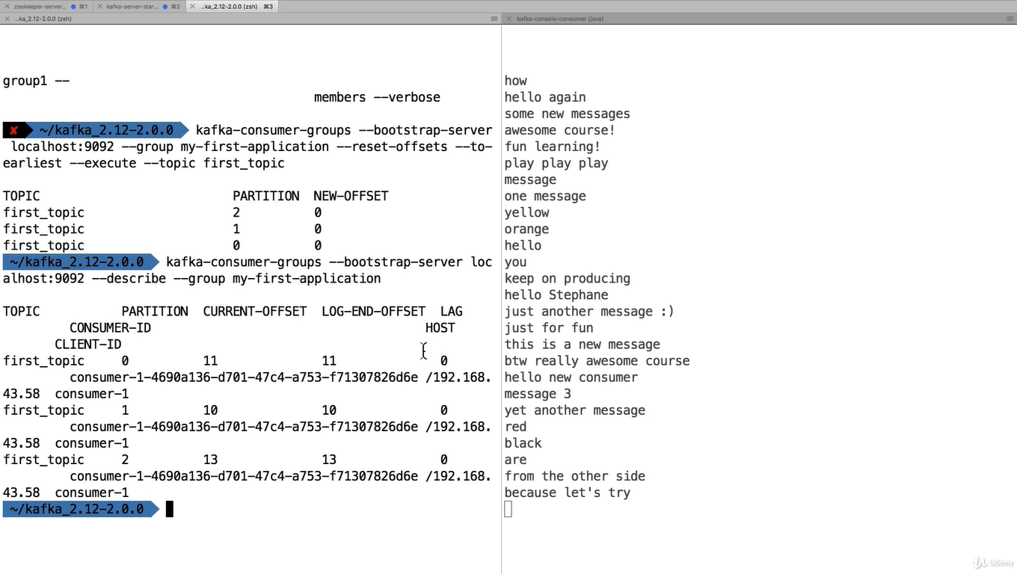

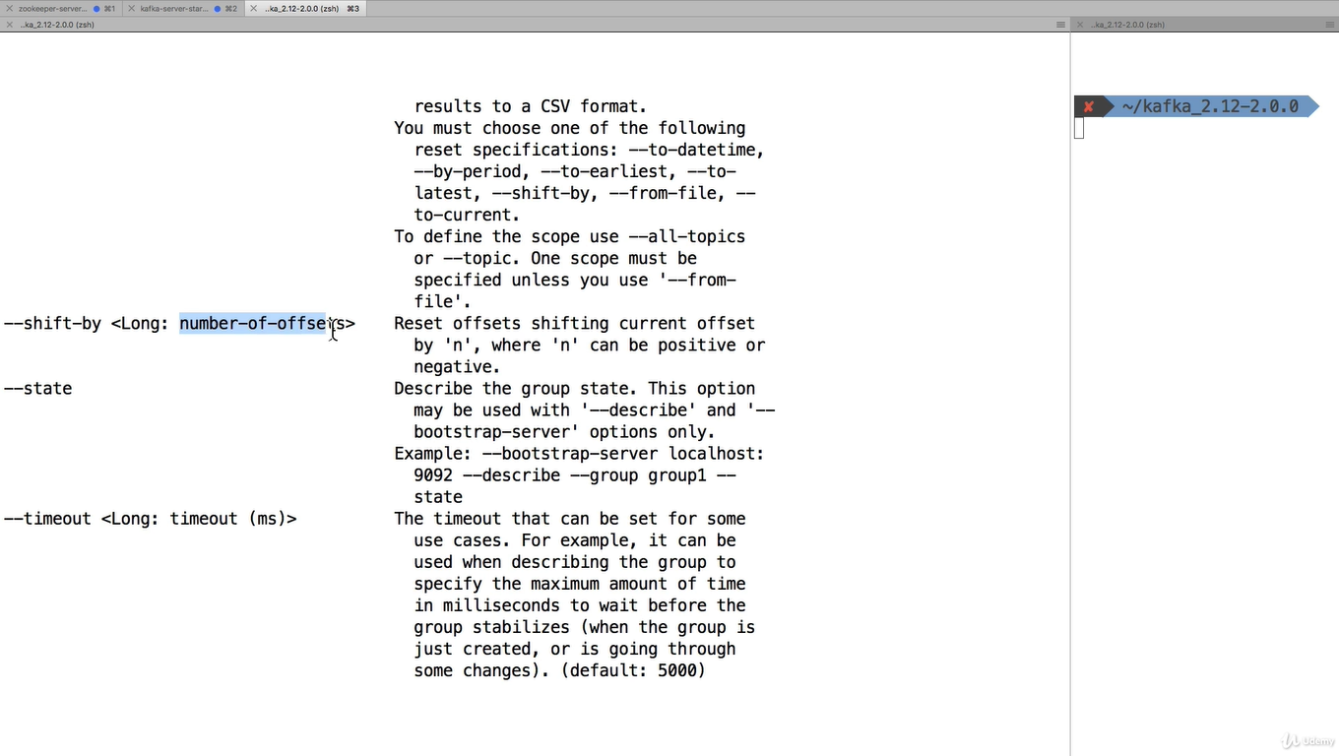

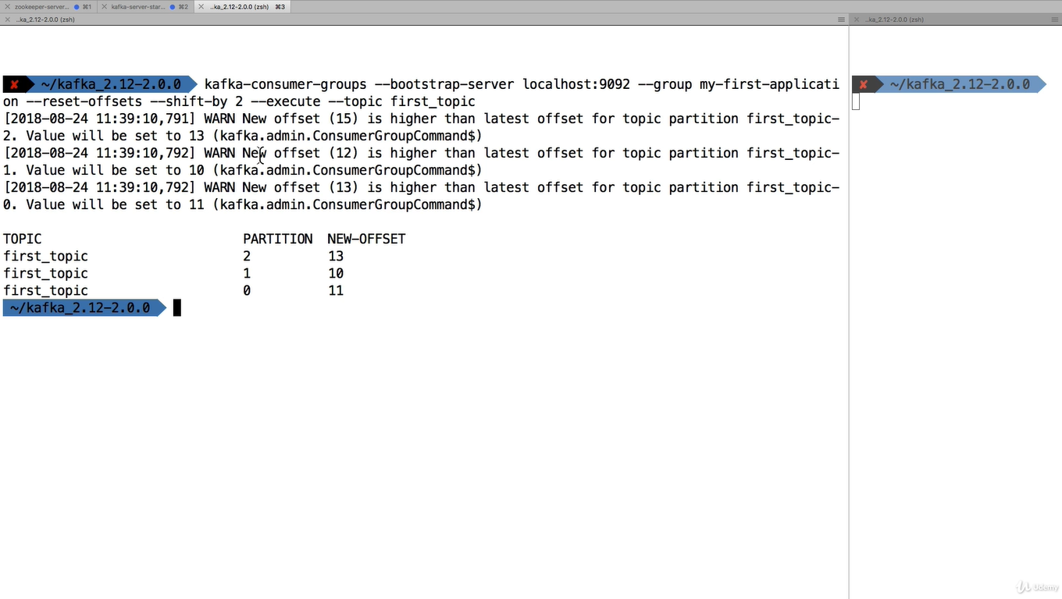
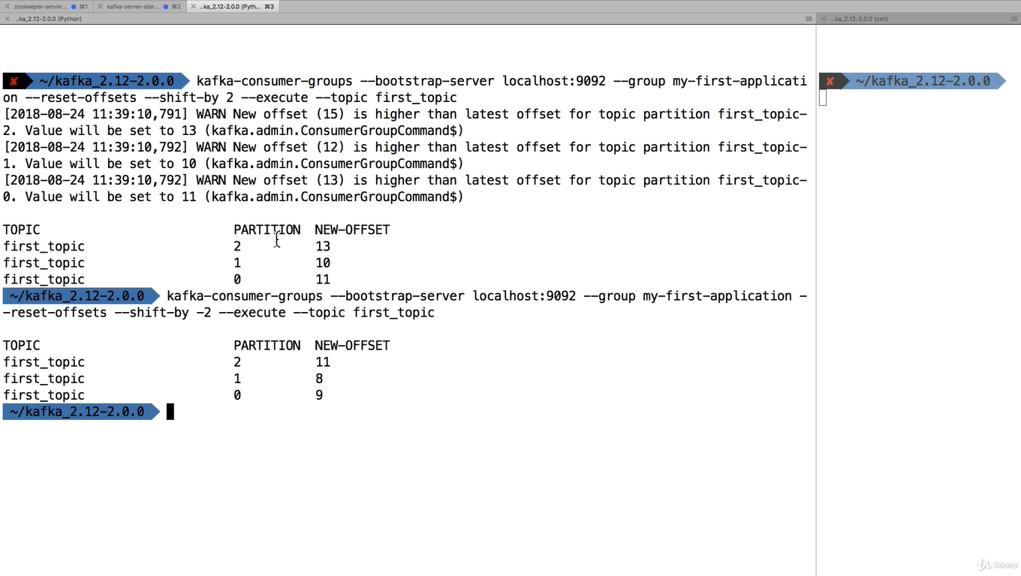
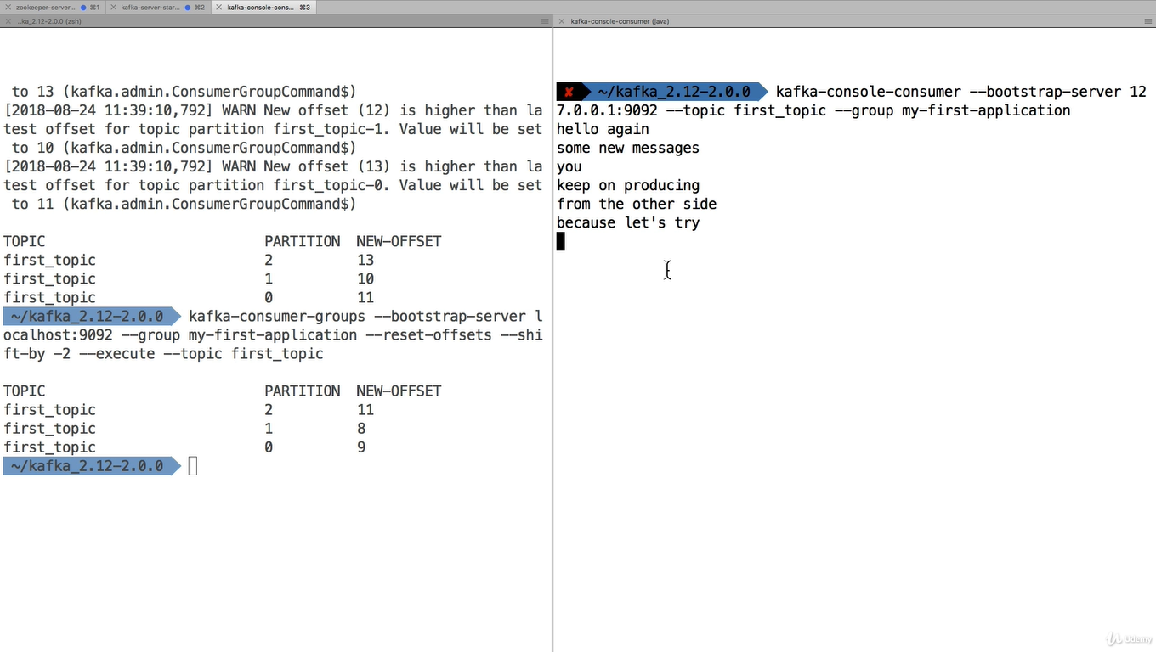
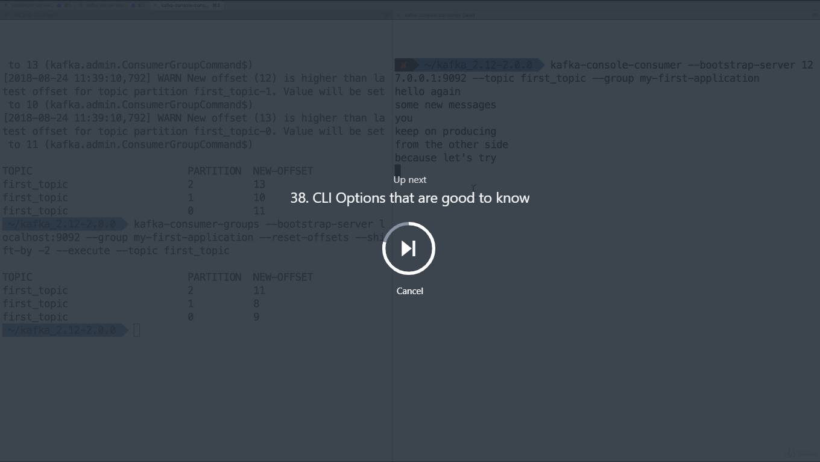

The CLI has many options, but here are the other that are most commonly used:
Producer with keys
- kafka-console-producer --broker-list 127.0.0.1:9092 --topic first_topic --property parse.key=true --property key.separator=,
- > key,value
- > another key,another value
Consumer with keys
- kafka-console-consumer --bootstrap-server 127.0.0.1:9092 --topic first_topic --from-beginning --property print.key=true --property key.separator=,

Conduktor - Kafka GUI
Kafka does not come bundled with a UI, but I have created a software name Conduktor to help you use Kafka visually.
You can download Conduktor here: https://www.conduktor.io/
Conduktor allows you to perform all the administrative tasks on Kafka (such as creating topics, partitions, etc), as well as produce and consume, all from within a desktop application that should work on Windows, Mac, and Linux.
Please look these two pages in cases you're having issues:
- Documentation: https://www.conduktor.io/docs
- The FAQ for installation issues (at the bottom of the page): https://www.conduktor.io/download
Finally, follow @GetConduktor on Twitter to get the latest updates!
Here are some screenshots from the software:
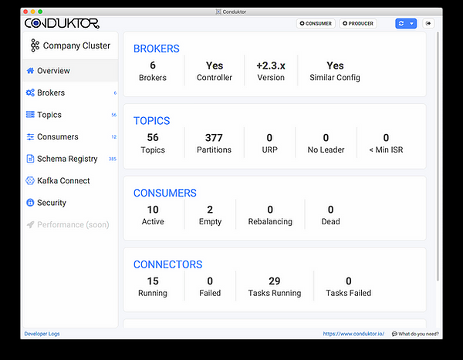

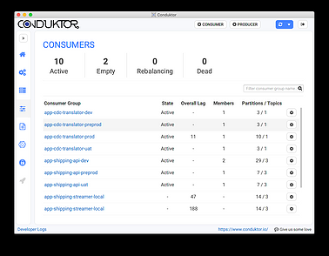

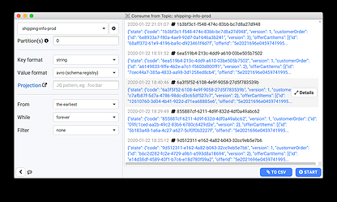

Overall in this course, we perform all the actions without any UI, which is good for learning how to properly use the CLI
Fullscreen
Go to Previous lecture
38. CLI Options that are good to
KafkaCat as a replacement for Kafka CLI
KafkaCat (https://github.com/edenhill/kafkacat) is an open-source alternative to using the Kafka CLI, created by Magnus Edenhill.
While KafkaCat is not used in this course, if you have any interest in trying it out, I recommend reading: https://medium.com/@coderunner/debugging-with-kafkacat-df7851d21968
Happy learning!

