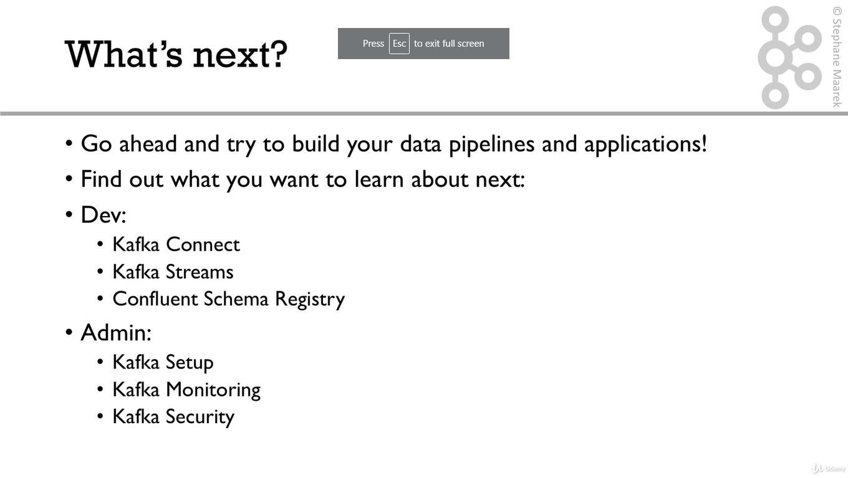

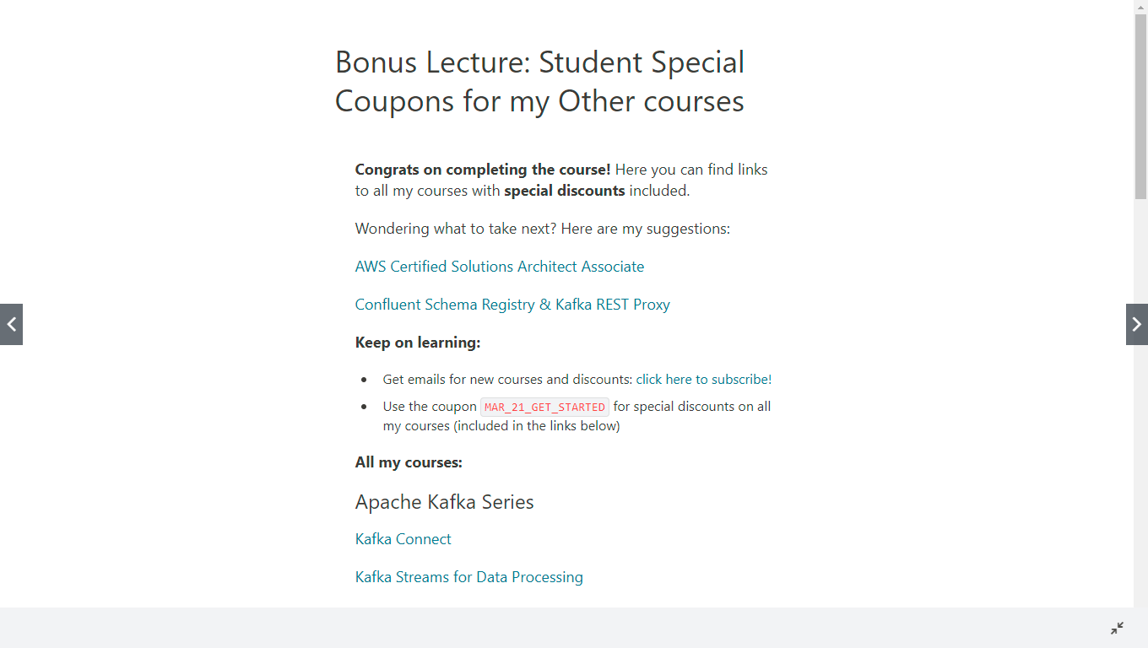

Bonus Lecture: Student Special Coupons for my Other courses
Congrats on completing the course! Here you can find links to all my courses with special discounts included.
Wondering what to take next? Here are my suggestions:
AWS Certified Solutions Architect Associate
Confluent Schema Registry & Kafka REST Proxy
Keep on learning:
- Get emails for new courses and discounts: click here to subscribe!
- Use the coupon MAR_21_GET_STARTED for special discounts on all my courses (included in the links below)
All my courses:

Apache Kafka Series
Kafka Connect
Kafka Streams for Data Processing
KSQL Hands On!
Kafka Setup and Administration
Confluent Schema Registry & Kafka REST Proxy
Kafka Security
Kafka Monitoring and Operations
Confluent Certified Developer for Apache Kafka (CCDAK) - Practice Tests

AWS Certifications
AWS Certified Cloud Practitioner
AWS Certified Cloud Practitioner [Practice Exams]
AWS Certified Solutions Architect Associate
AWS Certified Solutions Architect Associate [Practice Exams]
Ultimate AWS Certified Developer Associate
AWS Certified Developer Associate [Practice Exams]
AWS Certified SysOps Administrator Associate
AWS Certified SysOps Administrator Associate [Practice Exam]
AWS Certified Solutions Architect Professional
AWS Certified Solutions Architect Professional [Practice Exam]
AWS Certified DevOps Engineer Professional - Hands On!
AWS Certified DevOps Engineer Professional [Practice Exam]
AWS Certified Data Analytics Specialty
AWS Certified Machine Learning Specialty - Hands On!
AWS Certified Database Specialty
AWS Certified Database Specialty [Practice Exam]

AWS Master Classes
AWS CloudFormation MasterClass
AWS Lambda and the Serverless Framework
AWS EC2 Master Class (with Auto Scaling and Load Balancer)
Amazon EKS Starter: Kubernetes on AWS
AWS AppSync & Amplify with React & GraphQL - Complete Guide
Amazon ECS & Fargate Master Class

Data Engineering & API
Complete Guide to Protocol Buffers 3
gRPC Java Master Class: Build Modern API & Microservices
gRPC Golang Master Class: Build Modern API & Microservices
gRPC [C#] Master Class: Build Modern API & Microservices
gRPC Node.js Master Class: Build Modern API & Microservices
Introduction to Apache NiFi
Fullscreen
Go to Previous lecture
122. THANK YOU!
Finish course

