Password
1.problem:
Evalute password strings against minimum length , character category , repetition , prohibited-substring rules ;explain each failed condition.
2.Objectives:
Check length>=8, upper, digit, special by using @,#,$,%,! , no “123” or “password”.
3.Assumptions:
Special characters are allowed.
4.Algorithm.
start
Input password
Check each rule
Add error
If errors empty
Print(valid)
Else print(errors)
End
5.Pseudo code:
Read password
If len <8 error
Check upper lower digit special characters
If contains 123 error.
6.Test cases:
abc-invalid
Abc@5678-valid
Abc@1234-valid
7.Flow chart:
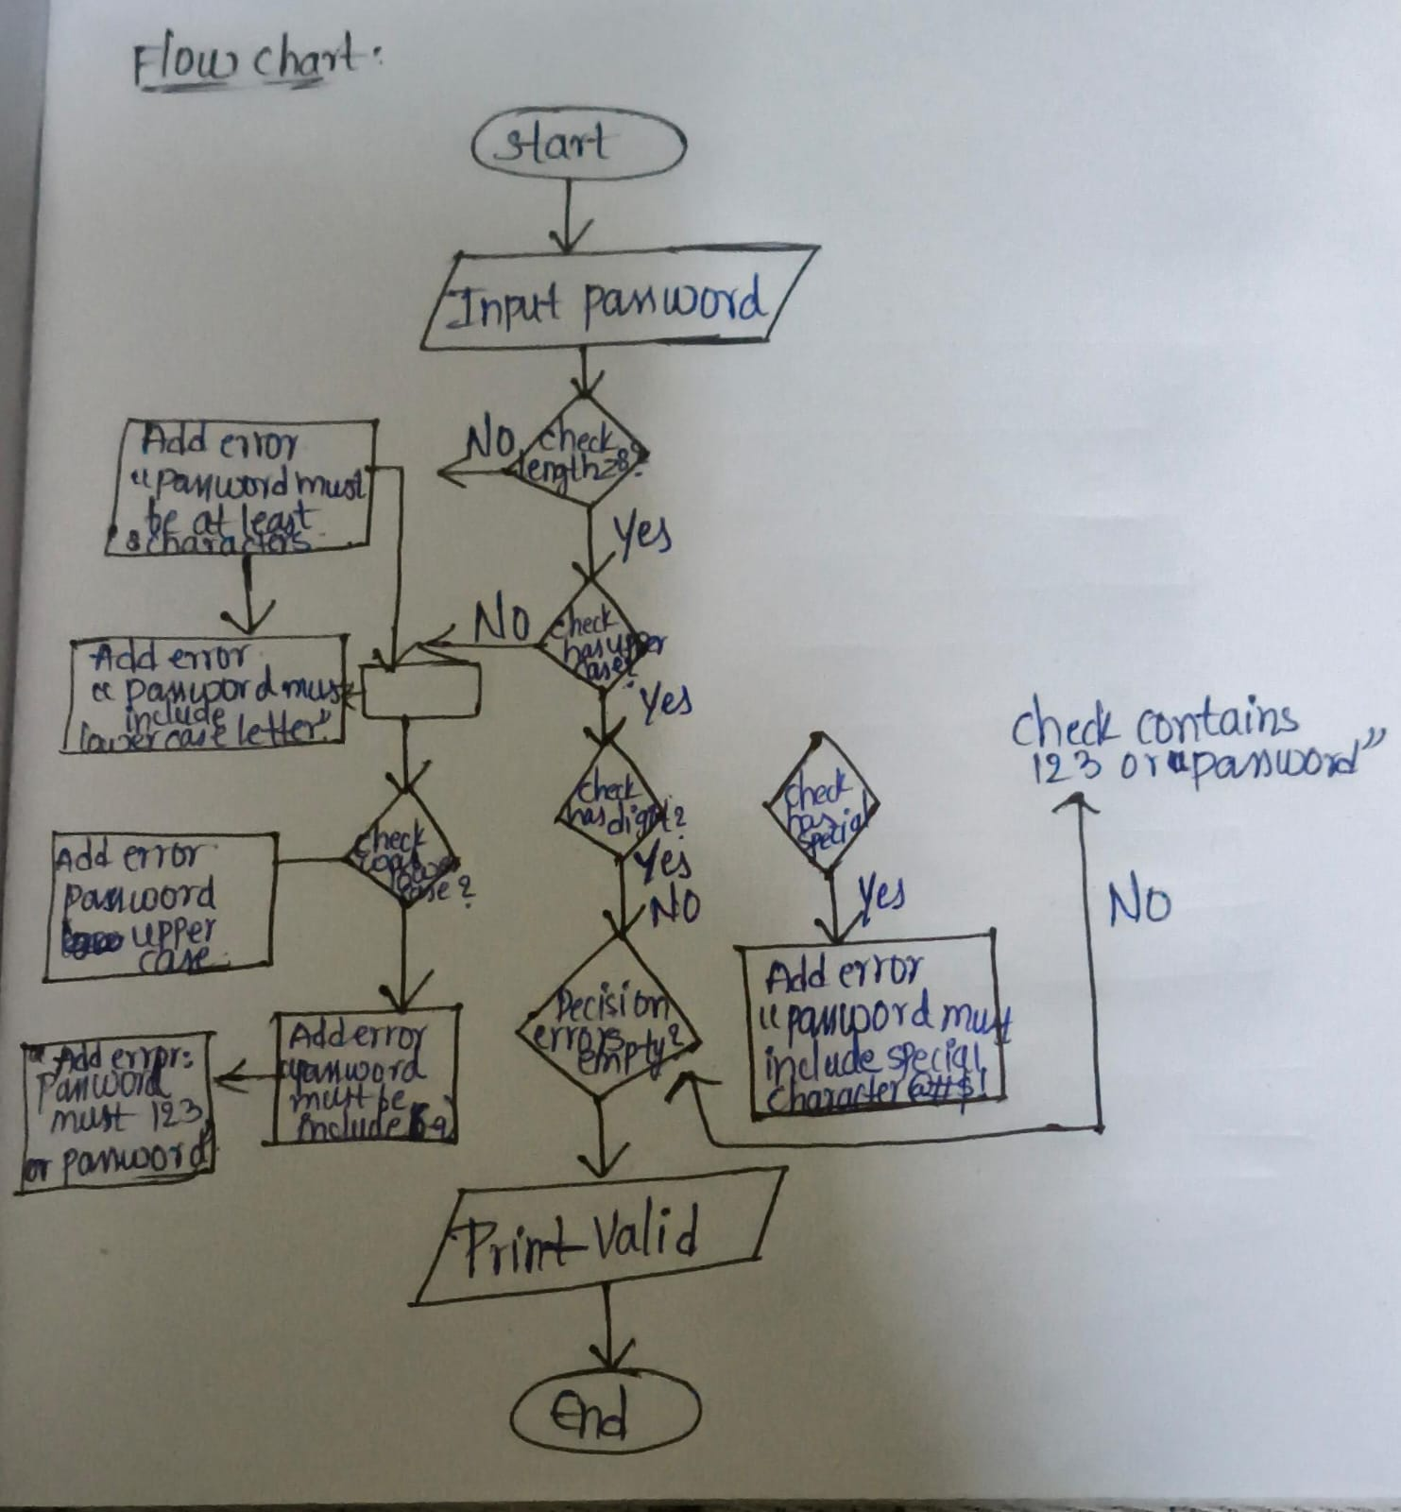

8.code:

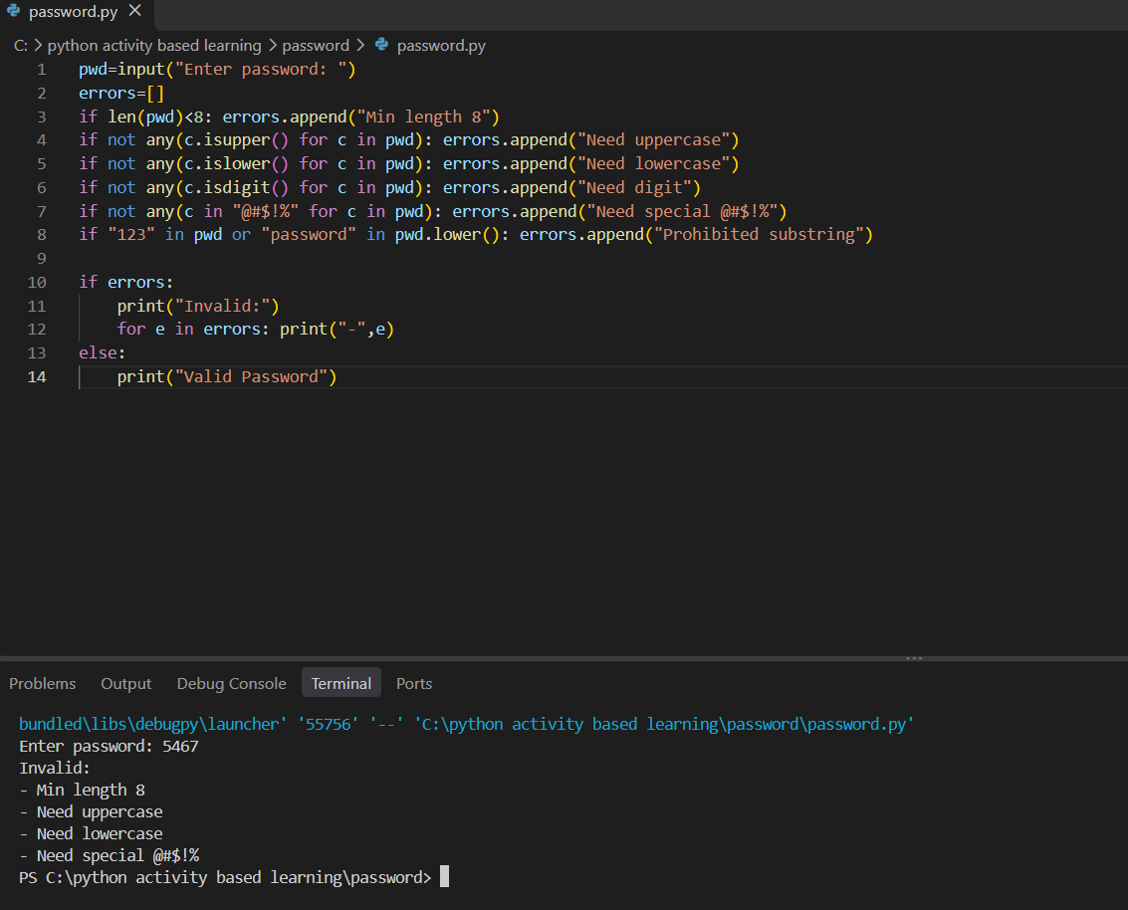
9.Conclusion:
All test cases are passed by using the rules of valid or invalid.

