Shopping
1.Problem:
Evalute a shopping basket containing multiple products and quantities , applying conditions, and determine which purchases must be reduced to remain with in a fixed budget.
2.Objectives:
To calculate total cost of all products . To check if with in budget . To apply discount 10% if total>1000
3.Assumptions:
Budget=Rs.2000
Discount 10% if total>Rs.1000
Each product has quantity and price
4.Algorithm:
Read Input budget
Input n=no of products
Set total =0
Loop i from 1 to n
Input quatity , price
Total = total+quantity*price
If total >1000
Total=total *0.9
If total <=budget
Print(“within budget”)
Else print(“Over budget by total”)
End
5.Pseudo code:
Read budget
Total=0
For i=1 to n
Read quantity,price
Total = quantity*price
If total>1000
Total =total *0.9
If total <=budget
Print(“within”)
Elses
Print(“Over”)
6.Test cases:
1.t1 | Budget:2000 | Products:1400 | After discount:1260 | within
2.t2 | Budget:1000 | Products:1200 | After discount:1080 | over
 |  |  | s
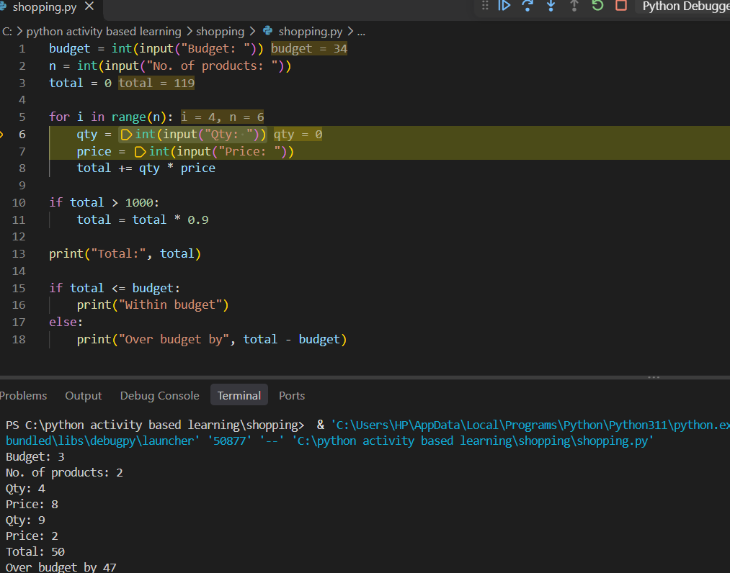
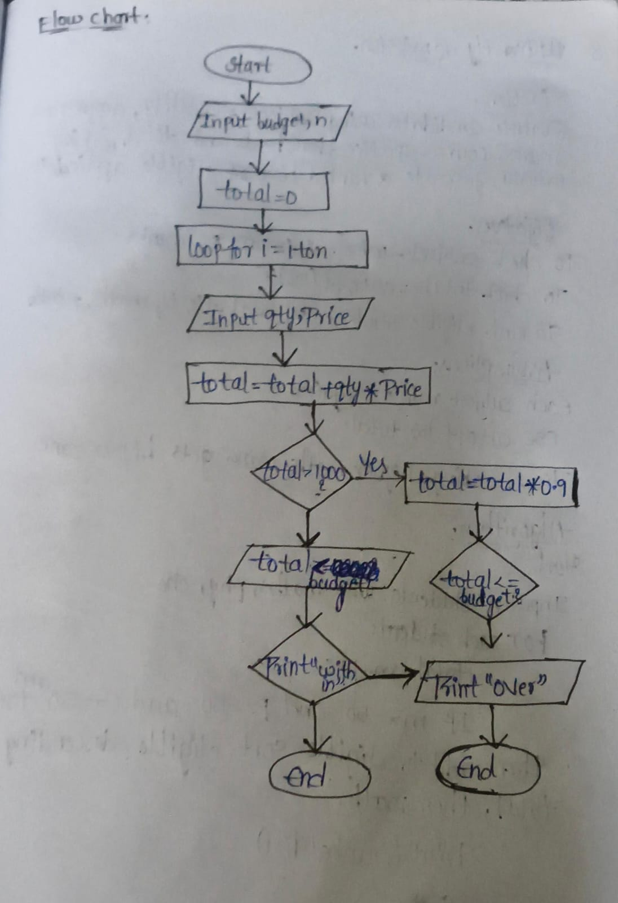
Conclusion:
Shopping budget logic implemented using loops and conditions. All test cases are passed.

