ATM
1.Problem:
Process sequence of deposits and with drawals, maintain simulated balance enforce with drawal limits.
2.Objectives:
To maintain balance , to reject invalid with drawals.
3.Assumptions:
Initial balance 10000,max withdrawal 5000 per transaction, no negative balance.
4.Algorithm:
Start balance=10000
Loop 3 transactions
Balance += amt if with draw check amt <=5000 and amt <=balance then balance=amt else reject.
Print balance
End
5.Pseudo code:
Balance=10000 for each transaction
Read, amt if choice ==deposit balance +=amt
Else if amt<=5000 and amt<=balance=amt
Else
Print(rejected)
Print(balance)
6.Test cases:
1. t1 | Deposit 2000 | Balance 12000
2. t2 | Withdraw 6000 | Rejected limit
3. t3 | Withdraw 15000 | Rejected insufficient
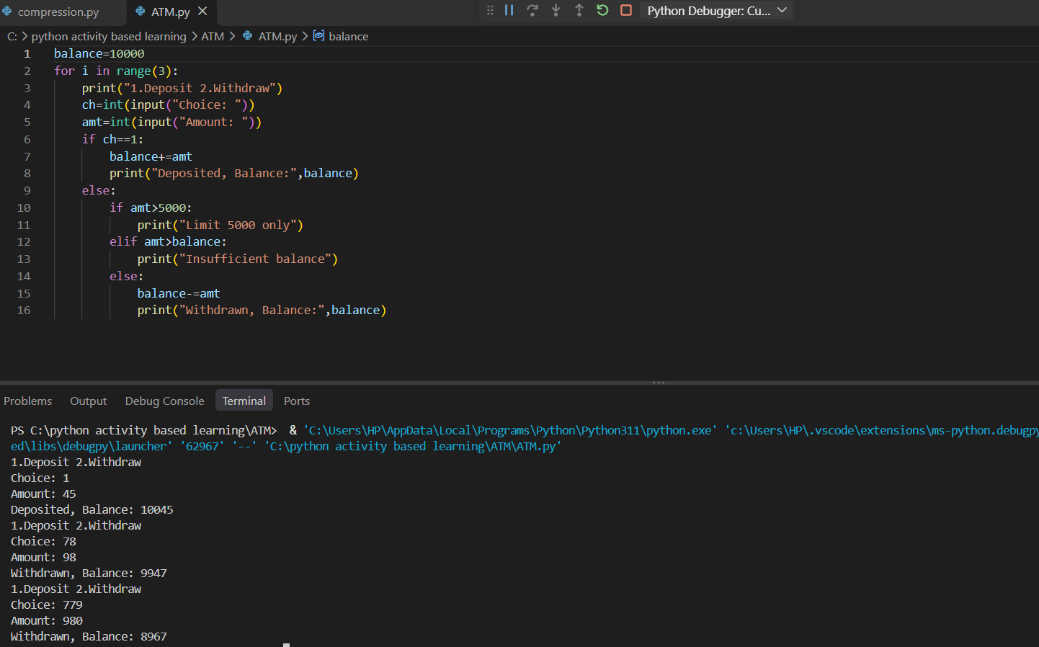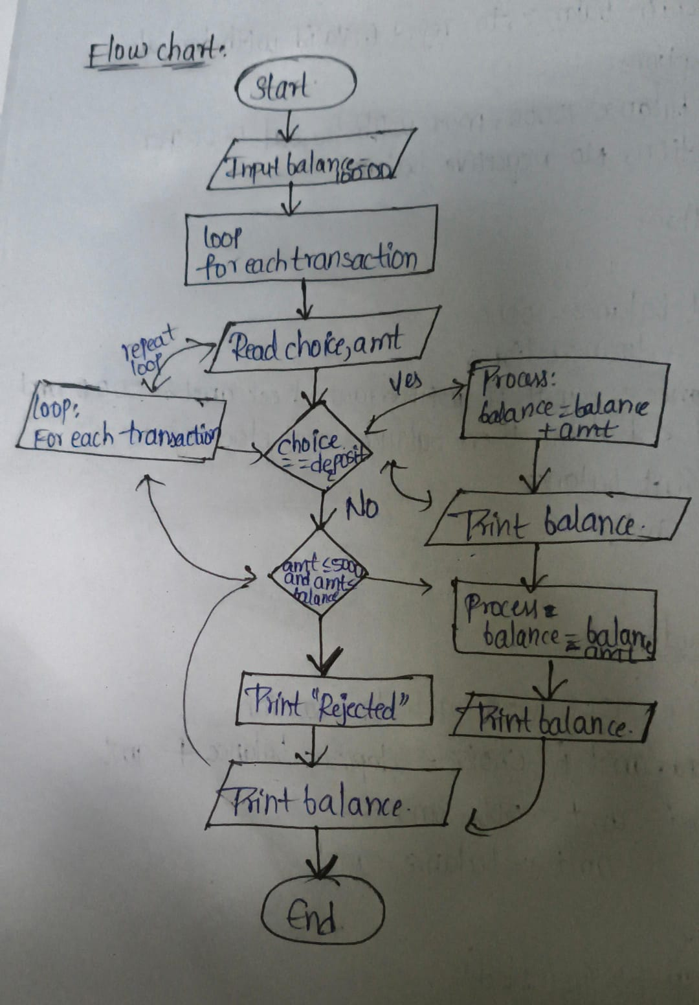
Conclusion:
ATM simulation works with loops.

