Transaction
1.Problem:
Process transaction identifiers and amounts, detect duplicate transactions identity threshold violations, generate list of suspicious entires.
2.Objectives:
Find duplicate ids find amount>500000 , create the suspicious list
3.Assumption:
Threshold 500000, duplicate id means suspicious
4.Algorithm:
Start
Input n ids amounts
Seen=[], suspicious=[]
Loop check duplicate and threshold
Print suspicious
End
5.Pseudo code:
Read n
For i check
If id in seen print duplicate
If amt >50000
Print(violation)
6.Test cases:
T1-1000
T2-60000
T1-1000
T1-duplicate
T2-violation
Pass
7.Flow chart: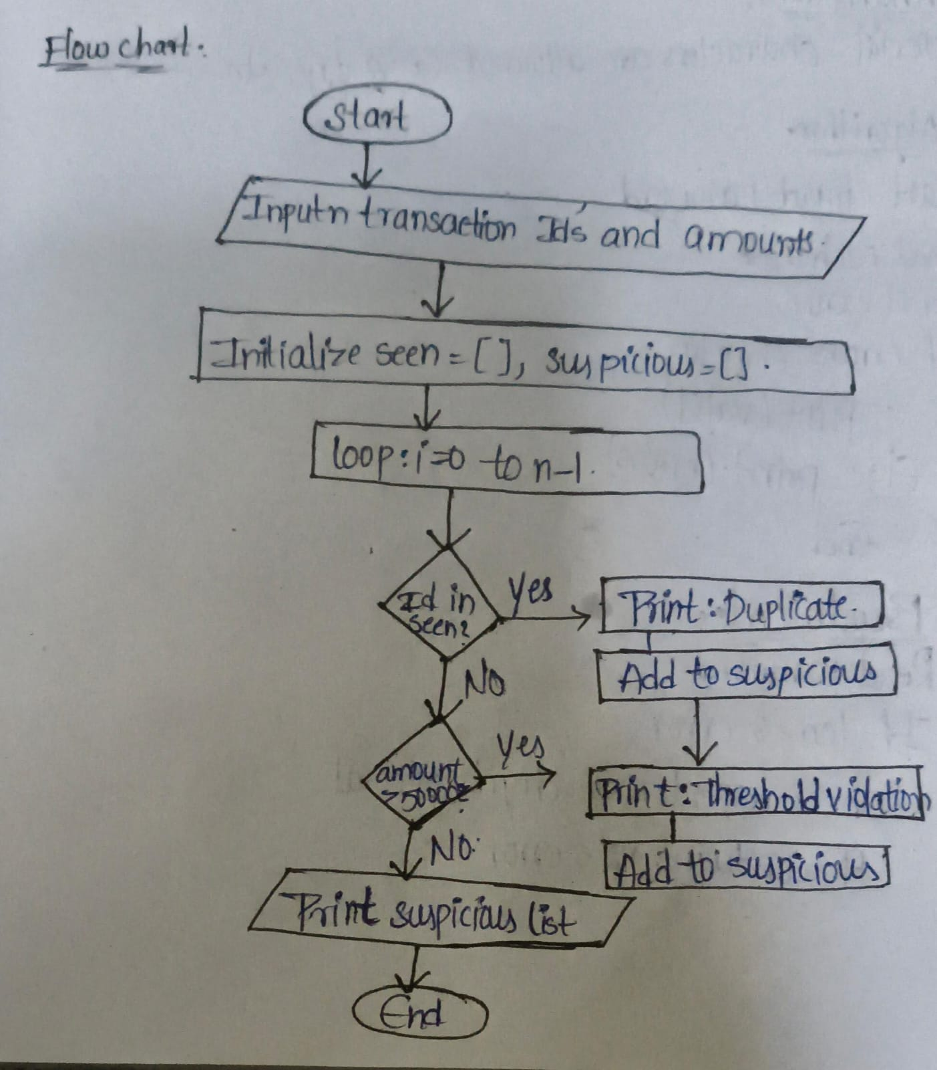8.code: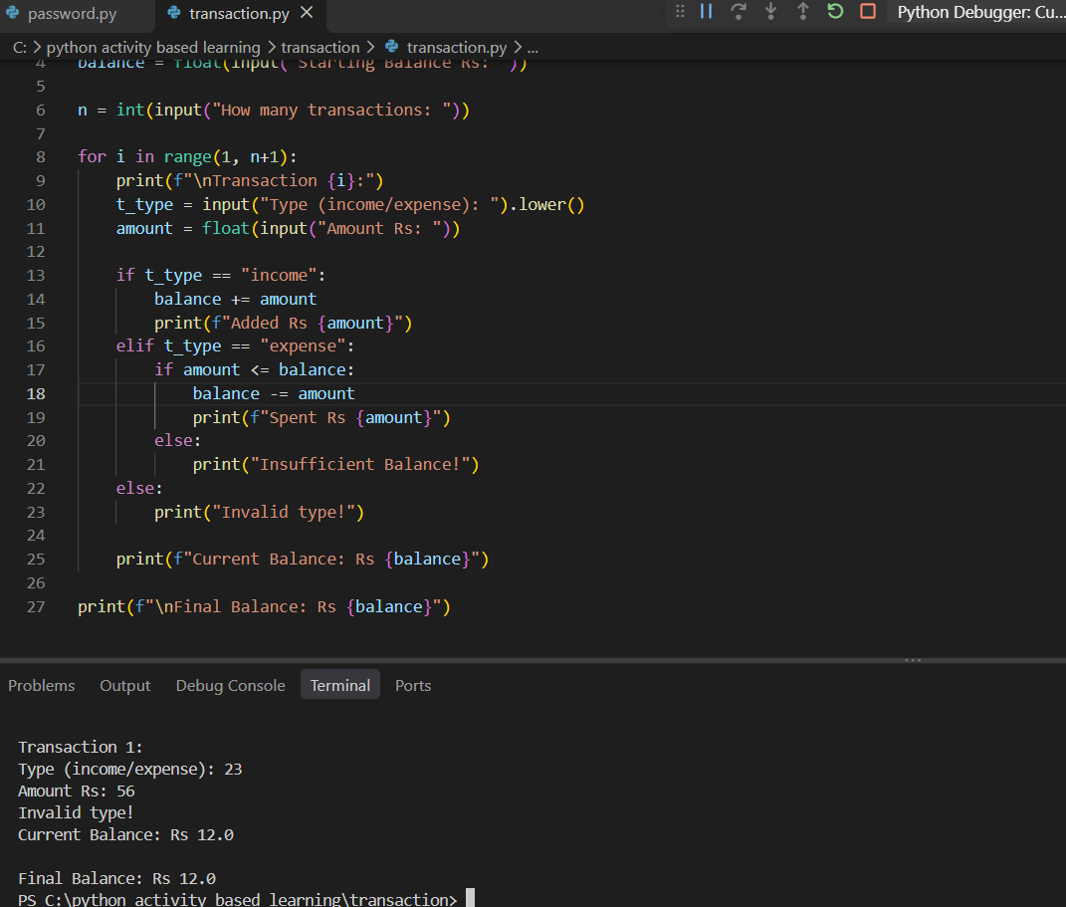
9.Conclusion:
All test cases are passed and by using the lists.

