Department of Computer Science and Engineering
SentinelOps SOC Alert-Triage Module
Debugging and Optimisation Report
Item | Details
Course Code & Name | CSA06 – Design and Analysis of Algorithms
Assessment | CO2 – Debugging and Optimisation Task
Course Outcome Assessed | Apply Brute Force technique to solve sorting, searching, Closest-Pair and Convex-Hull problems.
Maximum Marks | 50
Mode | Individual
Student Reg. No. | 192424311
Student Name | Shaik Shahid
GitHub repository | https://github.com/shaikshahid07/CO2_Debugging_Optimisation

1. Summary of the work
SentinelOps’ SOC alert-triage module has four functions: sort_alerts, is_blocked, find_signature and closest_logins. It failed in production: alerts vanished or were duplicated, blocked IP addresses got through, signatures at the end of a log were missed while false signatures were reported, and the “closest logins” report flagged the farthest pair. This report reproduces every failure, finds the nine defects behind them, fixes them one at a time without rewriting the code, and then optimises the corrected module for the production load of about 50,000 alerts and batches of 8,000 login events per day.
Table 1 - The four functions at a glance
Function | Defects | What went wrong | Optimisation
sort_alerts | D1, D2 | Index 0 never compared; key written to the wrong slot → alerts lost and duplicated | Insertion sort → sorted() (Timsort), stable, O(n log n)
is_blocked | D3, D4 | Match returned False; loop exited after the first entry | Hash-set index built once, O(1) lookups
find_signature | D5, D6 | Last alignment skipped; false hit after a mismatch at the last character | No redundant tests; Horspool and str.find compared
closest_logins | D7, D8, D9 | Searched the farthest pair; started at 0; paired points with themselves | i < j, squared distances, axis pruning, divide and conquer

How the report is organised. Parts (a) to (e) of the question paper are answered in Sections 2 to 6. Every number in the report was produced by running the code in the GitHub repository; the logs are in Supporting_Files/execution_logs and the screenshots are those logs rendered as terminal images. The pseudocode of the four functions is in Appendix B and as separate files in the Pseudocode folder.
Table 2 - Where each marking criterion is addressed
Criterion | Weight | Where in this report
Problem Identification | 20% | Section 2 (defect register, expected vs actual) and Section 3 (root cause of every defect)
Debugging | 25% | Section 3 (traces, one-fix-at-a-time re-testing, boundary tests, test harness)
Optimization | 20% | Section 4 and Appendix B (pseudocode), Appendix C (optimised code)
Analysis | 20% | Section 5 (operation counts, complexity, experiments, graphs, agreement with theory)
Code Quality | 15% | Section 6, Appendices C and D (docstrings, comments, test harness, repository layout)

2. Part (a): Reproduce and identify the defects

2.1 Test data and the original code
The module was run exactly as given (file original_module.py) on the test data of the question paper:
alerts = [("A1", 3), ("A2", 9), ("A3", 5), ("A4", 9), ("A5", 1)]
blocklist = ["10.0.0.5", "10.0.0.9", "172.16.4.2"]
queries = ["10.0.0.9", "10.0.0.5", "8.8.8.8"]
log, pattern = "FAILFAIXFAIL", "FAIL"
events = [(2, 3), (12, 30), (40, 50), (5, 1), (12, 10), (3, 4)] # (x, y) in km

Original code (unchanged; the file also contains a small demo that prints the results below):
import math

def sort_alerts(alerts): # insertion sort by severity, highest first
for i in range(1, len(alerts)):
key = alerts[i]
j = i - 1
while j > 0 and alerts[j][1] < key[1]:
alerts[j + 1] = alerts[j]
j -= 1
alerts[j] = key
return alerts

def is_blocked(blocklist, ip): # sequential search
for i in range(len(blocklist)):
if blocklist[i] == ip:
return False
else:
return False

def find_signature(log, pattern): # brute-force string matching, all occurrences
n, m = len(log), len(pattern)
hits = []
for i in range(n - m):
for j in range(m):
if log[i + j] != pattern[j]:
break
if j == m - 1:
hits.append(i)
return hits

def closest_logins(events): # brute-force closest pair of login locations
min_dist = 0
pair = None
for i in range(len(events)):
for j in range(len(events)):
d = math.sqrt((events[i][0] - events[j][0]) ** 2 +
(events[i][1] - events[j][1]) ** 2)
if d > min_dist:
min_dist = d
pair = (i, j)
return pair, min_dist

2.2 Expected output and actual output
The expected values were worked out by hand from the specification: highest severity first with equal severities in arrival order (A2 before A4); 10.0.0.9 and 10.0.0.5 are on the blocklist, 8.8.8.8 is not; “FAIL” occurs at positions 0 and 8 of the log line; and the closest pair of events is (2, 3) and (3, 4), i.e. indices 0 and 5, at √2 ≈ 1.4142 km.
Table 3 - Expected vs actual output of the original module
Function | Expected output | Actual output | Verdict
sort_alerts | [('A2', 9), ('A4', 9), ('A3', 5), ('A1', 3), ('A5', 1)] | [('A4', 9), ('A3', 5), ('A3', 5), ('A5', 1), ('A5', 1)] | WRONG: A1 and A2 lost, A3 and A5 duplicated
is_blocked (3 queries) | True, True, False | False, False, False | WRONG: blocked IPs reported as not blocked
find_signature | [0, 8] | [0, 4] | WRONG: false hit at 4, real hit at 8 missed
closest_logins | ((0, 5), 1.4142135623730951) | ((0, 2), 60.440052945046304) | WRONG: this is the FARTHEST pair

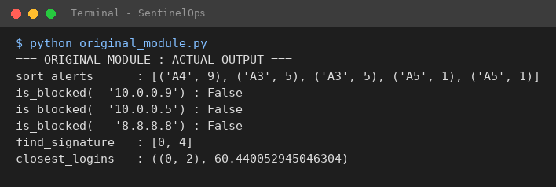
Figure 1 - Execution output of the original module (python original_module.py)

2.3 Defect register
The module contains nine defects. None is marked in the code; each was found by comparing the actual output with the expected output, tracing the loop by hand (Section 3) and re-running the code after every single change. The defect numbers D1 to D9 are used throughout the report and as # FIX Dn comments in corrected_module.py.
Table 4 - Defect register
ID | Function | Faulty line | Nature of the error | Symptom it causes
D1 | sort_alerts | while j > 0 and alerts[j][1] < key[1]: | Wrong loop bound (off by one): index 0 is never compared | Highest alert cannot move to the front; with D2 an alert is overwritten
D2 | sort_alerts | alerts[j] = key | Wrong insertion slot: must be j + 1 | An alert is overwritten and another is duplicated
D3 | is_blocked | return False (inside if blocklist[i] == ip) | Inverted result: a match returns False | Blocked addresses reported as not blocked
D4 | is_blocked | else: return False (and no return after the loop) | Premature exit and missing final return | Only the first entry is ever examined; an empty blocklist returns None
D5 | find_signature | for i in range(n - m): | Off-by-one: last alignment (i = n - m) never tried | Signature at the very end missed; a pattern as long as the log is never found
D6 | find_signature | if j == m - 1: (after the inner loop) | Wrong success test: also true after a break at the last character | False signatures reported; a 1-character pattern matches everywhere; an empty pattern crashes
D7 | closest_logins | min_dist = 0 | Wrong initial value: should be +infinity | No distance can ever be smaller than 0
D8 | closest_logins | if d > min_dist: | Wrong comparison direction | Finds the farthest pair instead of the closest
D9 | closest_logins | for j in range(len(events)): | Wrong inner range: j should start at i + 1 | Compares a point with itself (d = 0) and every pair twice

3. Part (b): Root causes and systematic debugging

3.1 Method
The code was debugged by reasoning and testing, not rewritten. For each function the same cycle was used:
- Observe the wrong output and form a hypothesis about where it comes from.
- Trace the loop by hand (and with debug_steps.py) to see exactly which line produces the wrong value.
- Change one line only, using exact text replacement on the original source so nothing is rewritten.
- Re-test after every single change, on the question’s data and on boundary cases, and compare with the expected value.
- Lock it in with the test harness (test_harness.py), which fails on the original code and passes on the corrected code.

3.2 sort_alerts (defects D1 and D2)
Intended behaviour. Insertion sort: take the next alert (the key), shift every alert with a lower severity one place to the right, and drop the key into the hole that is left. The comparison is strict (<), so alerts of equal severity are never swapped and keep their arrival order.
D2 – wrong insertion slot (alerts[j] = key). When the while loop ends, j points at the element that is not smaller than the key (or at −1 if there is none). The hole left by the shifting is at j + 1, not at j. Writing the key to j overwrites a perfectly good alert, and because the shifting loop has already made a copy of that alert one place to the right, the list ends up with one alert lost and one duplicated. In the trace below, pass i = 1 shifts nothing, so the key A2 is written on top of A1: A1 is lost and A2 appears twice.
D1 – wrong loop bound (while j > 0). The key must be compared with every earlier element, down to index 0. With j > 0 the loop stops as soon as j reaches 0, so the element at index 0 is never compared and never shifted. A key that belongs at the very front (here the severity-9 alerts) can therefore never get in front of it. The two defects hide each other: fixing only D1 makes j reach −1, and then alerts[j] = key writes to alerts[-1], which in Python is the last element. That is why the intermediate output after fixing D1 alone is [A1, A1, A1, A1, A4] (Table 5).
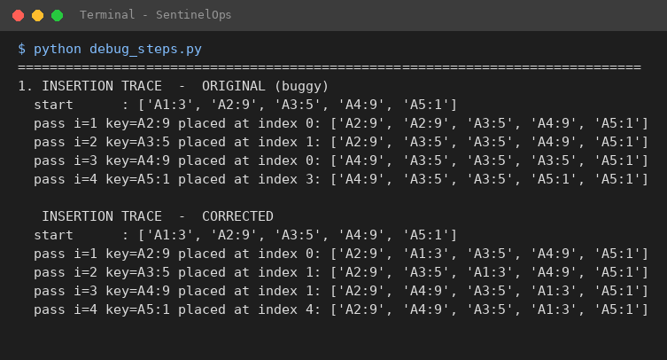
Figure 2 - Insertion trace of the alerts list: original (top) and corrected (bottom)
Reading the trace. In the original trace, after pass 1 the list is [A2, A2, A3, A4, A5]: A1 has been overwritten. After pass 3 the list is [A4, A3, A3, A3, A5], so A2 is gone too, and the final list [A4, A3, A3, A5, A5] contains duplicates exactly as seen in the actual output. In the corrected trace, pass 3 places A4 at index 1, directly behind A2, because 9 < 9 is false: equal severities are not passed, so the order A2, A4 is kept.
Fix.
while j >= 0 and alerts[j][1] < key[1]: # FIX D1: was j > 0
...
alerts[j + 1] = key # FIX D2: was alerts[j] = key

3.3 is_blocked (defects D3 and D4)
Intended behaviour. Sequential search: return True as soon as the address is found; return False only after every entry has been checked.
D3 – inverted result (return False on a match). The function found the address and then reported the opposite. This is exactly the production symptom “blocked IP addresses got through”. In fact no line of the original function can ever return True.
D4 – premature exit and missing final return. The else: return False branch runs for the first entry that does not match, so the loop ends after one iteration whatever the blocklist contains. Only index 0 is ever examined. Also, if the blocklist is empty the loop body never runs and the function falls off the end and returns None instead of False. Fixing D3 alone shows the effect clearly: the first entry 10.0.0.5 is now found, but the second entry 10.0.0.9 is still reported as not blocked (output [False, True, False] in Table 5).
Fix. The else branch is deleted and the return False is moved after the loop:
for i in range(len(blocklist)):
if blocklist[i] == ip:
return True # FIX D3: was return False
# FIX D4: the "else: return False" branch was removed
return False # FIX D4: verdict only after all entries were checked

3.4 find_signature (defects D5 and D6)
Intended behaviour. Slide the pattern along the log. At each start position i compare the characters one by one; if all m characters match, i is a hit. There are n − m + 1 start positions: 0, 1, …, n − m.
D5 – off-by-one in the outer loop (range(n - m)). range(n - m) produces 0 … n − m − 1, so the last start position i = n − m is never tried. In the test, n = 12 and m = 4, so i = 8 is skipped and the real signature at the end of the log is missed (row i = 8 of the alignment table). If the pattern is as long as the log (n = m), the range is empty and nothing is ever found.
D6 – wrong success test (if j == m - 1). The test was meant to say “all m characters matched”, but it is evaluated after the inner loop and cannot tell how the loop ended. If the loop was left by break at the very last character (the first m − 1 characters matched and the last one did not), j is also m − 1, so a false hit is recorded. In the log, the window at i = 4 is FAIX: F, A and I match, X ≠ L at j = 3, the loop breaks with j = 3 = m − 1, and position 4 is wrongly reported. The same flaw makes a 1-character pattern match at every position (a mismatch at j = 0 leaves j = 0 = m − 1), and for an empty pattern j is never assigned, so the function crashes with UnboundLocalError (this is what happens when the test harness is run on the original code).
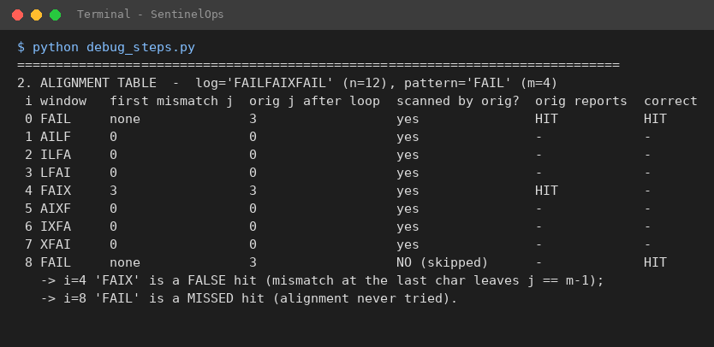
Figure 3 - Alignment table for log = FAILFAIXFAIL and pattern = FAIL
Fix. Python’s for … else runs the else part only when the loop finished without a break, which is exactly “all characters matched”:
for i in range(n - m + 1): # FIX D5: was range(n - m)
for j in range(m):
if log[i + j] != pattern[j]:
break
else: # FIX D6: was if j == m - 1
hits.append(i)

3.5 closest_logins (defects D7, D8 and D9)
Intended behaviour. Brute force: compute the distance of every pair of events once and keep the pair with the smallest distance.
D8 – wrong comparison direction (d > min_dist). The code keeps a new pair when its distance is larger than the best so far, so it searches for the farthest pair. For the test data it returns events 0 and 2, i.e. (2, 3) and (40, 50), 60.44 km apart, instead of events 0 and 5, 1.41 km apart. In production this is the “flagged logins hundreds of kilometres apart”.
D7 – wrong initial value (min_dist = 0). A running minimum must start at +∞ so that the first distance replaces it. With 0, no distance is ever smaller. Because D8 turned the search into a running maximum, the value 0 happened to work for it, which is why D7 stayed hidden.
D9 – wrong inner range (range(len(events))). The inner loop starts at 0 instead of i + 1, so the function also compares every event with itself (distance 0) and examines every pair twice, (i, j) and (j, i): n² distance computations instead of n(n − 1)/2. With the original > the zero distances were harmless, but after D7 and D8 are fixed the self-pair (0, 0) with d = 0 would always win; see the staged results below.
Fix.
min_dist = math.inf # FIX D7: was 0
...
for j in range(i + 1, len(events)): # FIX D9: was range(len(events))
...
if d < min_dist: # FIX D8: was d > min_dist
The three fixes depend on each other, so they were applied in the order D8, D7, D9 and the function was re-run after each one (Table 5).

3.6 Re-testing after every correction
The fixes were applied one at a time to the original source text by exact string replacement (debug_steps.py), and the function was run again on the test data after each fix. Each row of Table 5 is the original code plus only the fixes listed.
Table 5 - Output after each individual fix
Function | Fixes applied | Output | Meaning
sort_alerts | none (original) | [('A4', 9), ('A3', 5), ('A3', 5), ('A5', 1), ('A5', 1)] | alerts lost / duplicated
 | D1 | [('A1', 3), ('A1', 3), ('A1', 3), ('A1', 3), ('A4', 9)] | writes to alerts[-1]: still wrong
 | D1 + D2 | [('A2', 9), ('A4', 9), ('A3', 5), ('A1', 3), ('A5', 1)] | CORRECT
is_blocked | none (original) | False, False, False; empty blocklist → None | everything False
 | D3 | False, True, False; empty blocklist → None | only the first entry works
 | D3 + D4 | True, True, False; empty blocklist → False | CORRECT
find_signature | none (original) | [0, 4] | false hit, real hit missed
 | D5 | [0, 4, 8] | real hit found, false hit remains
 | D5 + D6 | [0, 8] | CORRECT
closest_logins | none (original) | ((0, 2), 60.440052945046304) | farthest pair
 | D8 | (None, 0) | nothing is < 0
 | D8 + D7 | ((0, 0), 0.0) | a point paired with itself
 | D8 + D7 + D9 | ((0, 5), 1.4142135623730951) | CORRECT

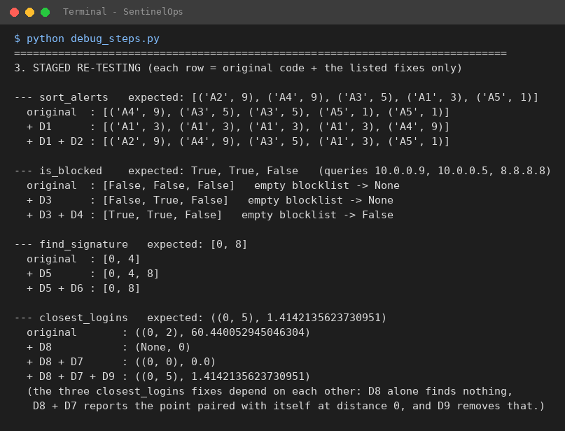
Figure 4 - Execution output of the staged re-tests (python debug_steps.py, section 3)

3.7 Boundary tests
The boundary cases required by the question, and a few more, are checked by the test harness. Every case passes for the corrected module, the optimised module and, for the functions that have several optimised variants, for each variant (130 checks in total; see Section 6).
Table 6 - Boundary tests (all PASS on the corrected and the optimised code)
Function | Case | Expected | Result
sort_alerts | empty list | [] | PASS
sort_alerts | single alert [("X", 4)] | [("X", 4)] | PASS
sort_alerts | equal severities [("B",5),("A",5),("C",5)] | order unchanged (stable) | PASS
sort_alerts | highest alert at index 0 after sorting [("L",1),("H",9)] | [("H",9),("L",1)] | PASS
sort_alerts | already sorted / reverse sorted | best and worst case: same correct result | PASS
is_blocked | empty blocklist | False (not None) | PASS
is_blocked | first, last and absent address; empty address string | True, True, False, False | PASS
is_blocked | one-entry list (match / no match); duplicate entries | True / False; True | PASS
find_signature | pattern at the very end ("xxxxFAIL") | [4] | PASS
find_signature | pattern at the very start; pattern equal to the whole log | [0]; [0] | PASS
find_signature | pattern longer than the log ("FAI" vs "FAIL") | [] | PASS
find_signature | near miss "FAIX"; no occurrence; empty log | [] | PASS
find_signature | overlapping occurrences ("AAAA", "AA") | [0, 1, 2] | PASS
find_signature | single-character pattern ("abcab", "a"); empty pattern | [0, 3]; [] | PASS
closest_logins | empty list; one event (fewer than two events) | (None, None) | PASS
closest_logins | exactly two events (0,0) and (3,4) | ((0, 1), 5.0) | PASS
closest_logins | duplicate location; all points identical | distance 0.0, first pair | PASS
closest_logins | all points on one vertical line | ((2, 3), 1.0) | PASS
closest_logins | tie: two pairs at the same distance | pair with the smallest indices | PASS

3.8 The corrected module
The corrected module keeps the structure and the algorithms of the original (insertion sort, sequential search, brute-force matching and brute-force closest pair). Only the nine faulty lines were changed, and each change is marked # FIX Dn. Two small boundary rules were added so that the function behaves sensibly on degenerate input: an empty signature matches nothing, and fewer than two events give (None, None).
"""
SentinelOps SOC Alert-Triage Module -- CORRECTED VERSION (debugged, not rewritten)
CSA06 Design and Analysis of Algorithms | CO2 Debugging and Optimisation Task

The structure of the original code is kept exactly as it was (same function
names, same algorithms: insertion sort, sequential search, brute-force string
matching and brute-force closest pair). Only the faulty lines were changed.
Every change is marked with a comment of the form # FIX Dn where Dn is the
defect number used in the report:

D1, D2 sort_alerts D3, D4 is_blocked
D5, D6 find_signature D7, D8, D9 closest_logins
"""
import math

def sort_alerts(alerts):
"""Insertion sort by severity, highest first; equal severities keep arrival order."""
for i in range(1, len(alerts)):
key = alerts[i]
j = i - 1
while j >= 0 and alerts[j][1] < key[1]: # FIX D1: was j > 0 (index 0 never compared)
alerts[j + 1] = alerts[j]
j -= 1
alerts[j + 1] = key # FIX D2: was alerts[j] = key (wrong slot)
return alerts

def is_blocked(blocklist, ip):
"""Sequential search: True if ip is on the blocklist, otherwise False."""
for i in range(len(blocklist)):
if blocklist[i] == ip:
return True # FIX D3: was return False (match reported as not-blocked)
# FIX D4: the else: return False branch was removed - it ended the search
# after the very first element. "Not found" is decided only after the loop.
return False # FIX D4: verdict after all elements were checked
# (also makes an empty blocklist return False, not None)

def find_signature(log, pattern):
"""Brute-force string matching: every start position of pattern in log (overlaps included)."""
n, m = len(log), len(pattern)
hits = []
if m == 0: # boundary rule: an empty signature matches nothing
return hits
for i in range(n - m + 1): # FIX D5: was range(n - m) (last alignment skipped)
for j in range(m):
if log[i + j] != pattern[j]:
break
else: # FIX D6: was if j == m - 1 (also true after a break
hits.append(i) # at the last character -> false hit)
return hits

def closest_logins(events):
"""Brute-force closest pair of login locations. Returns ((i, j), distance) with i < j."""
if len(events) < 2: # boundary rule: no pair exists
return None, None
min_dist = math.inf # FIX D7: was 0 (nothing can be smaller than 0)
pair = None
for i in range(len(events)):
for j in range(i + 1, len(events)): # FIX D9: was range(len(events)) (self-pairs and repeats)
d = math.sqrt((events[i][0] - events[j][0]) ** 2 +
(events[i][1] - events[j][1]) ** 2)
if d < min_dist: # FIX D8: was d > min_dist (searched the FARTHEST pair)
min_dist = d
pair = (i, j)
return pair, min_dist

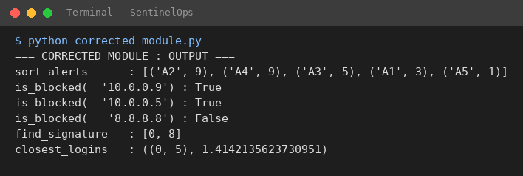
Figure 5 - Execution output of the corrected module (python corrected_module.py)

4. Part (c): Optimise the corrected module
The corrected module gives the right answers but would be too slow for the production load. The optimisations below change how the answer is computed and never what is returned; this is checked by the test harness, which runs the same unit tests on the corrected and the optimised code and also compares them on 920 random inputs (many with ties and equal severities).
Table 7 - Optimisation plan
Function | Cost of the corrected version | Technique | Cost after optimisation
sort_alerts | about 0.225 n² comparisons on random alerts (n = 50,000: about 562 million) | Python’s stable sorted(key, reverse=True) (Timsort) | O(n log n); about n on ordered data
is_blocked | O(n) per query, so O(q n) for q queries | Hash-set index built once | O(n) once, then O(1) per query
find_signature | about 1.04 n comparisons on random text, m (n − m + 1) in the worst case | No redundant tests; Horspool skip table; str.find loop | about 1.1–1.4 n/m on random text (Horspool)
closest_logins | n (n − 1)/2 distance computations, each with a square root | i < j, squared distances, sort and prune; divide and conquer | about 1.3 n (pruned, random data); O(n log n) guaranteed (divide and conquer)

4.1 sort_alerts: is insertion sort still suitable?
The number of comparisons of insertion sort is n − 1 + I (minus the few keys that travel all the way to the front), where I is the number of inversions, i.e. pairs of alerts that are in the wrong order. If the alerts are already nearly sorted, I is small and insertion sort is very fast, close to n comparisons. If they arrive in arbitrary order, I is about n²/4 for distinct severities and the cost is quadratic.
Answer. Insertion sort is a good algorithm for nearly sorted data: in the experiment with 50,000 alerts of which 1% were out of place, it needed only 51,156 comparisons (1,157 shifts + n − 1). But SentinelOps cannot promise that its 50,000 daily alerts arrive nearly in order: they come from many sensors. For random order the same sort would need about 562,538,750 comparisons, whereas the built-in sort needed 355,909, which is about 1,581 times fewer.
Decision. The module uses sorted(alerts, key=..., reverse=True). Timsort first looks for runs that are already in order, so on nearly sorted data it also needs only about n comparisons (52,167 at n = 50,000, within 2% of insertion sort), but on random data it never exceeds O(n log n). It is stable, and reverse=True keeps equal elements in their original order, so alerts of equal severity stay in arrival order exactly as required. For small or nearly sorted inputs insertion sort can be slightly cheaper in comparisons (at n = 1,000 it needs 1,060 against 1,989), which is a fair price for the protection against the quadratic worst case. The corrected insertion sort is kept in the module (insertion_sort_alerts) as the reference for the experiments.

4.2 is_blocked: repeated lookups
A sequential search costs up to n comparisons per query. The SOC checks every incoming source address, so the blocklist is searched again and again while it hardly changes. The better approach is to pay once to build an index and then answer each query in constant time: build_blocklist() puts the addresses in a hash set (O(n), done once) and is_blocked() is then a single membership test, ip in index (O(1) on average). If the blocklist changes rarely, the index is simply rebuilt or updated with add and remove. The answers are identical to the sequential search; even a plain list can still be passed to is_blocked().

4.3 find_signature: no redundant comparisons
What was redundant in the original. The inner loop already stops at the first mismatching character, so it does not compare more characters than necessary. The redundant work was (1) the extra test if j == m - 1 executed after every one of the n − m windows (and, as D6 showed, it was also wrong), and (2) the loop bound, which had to be corrected to n − m + 1 windows. The optimised brute-force function uses for … else, so there is no extra test, tries exactly the n − m + 1 alignments that fit, and returns immediately for an empty pattern or a pattern longer than the log.
Going further. Brute force still compares about one character per log position. Two alternatives that return the same list of hits were added for comparison: Horspool’s algorithm, which compares each window from right to left and uses a table of shifts to skip several positions at once when the last character of the window cannot occur in the pattern, and a loop around the C-implemented str.find (searching again from i + 1, so overlapping hits are not missed).

4.4 closest_logins: remove waste, then prune
- Eliminate self and repeated pairs. Only pairs with i < j are examined (this is also fix D9). It halves the work: n(n − 1)/2 instead of n² pair evaluations.
- Remove unnecessary square roots. The pair with the smallest distance is also the pair with the smallest squared distance, because the square root is increasing. The optimised function compares dx² + dy² and takes one square root at the very end.
- Prune pairs that cannot be closest. The points are sorted along the axis with the larger spread. For each point the scan to the right stops as soon as the gap along that axis alone, squared, is already larger than the best squared distance found so far, because every later point is even farther along the axis. Pairs with equal squared distance are still examined, so ties are resolved exactly as in the brute force (smallest indices win).
- Guarantee the worst case (divide and conquer). The pruned scan is fast for spread-out points but can degrade to O(n²) (Section 5.5). closest_logins_dc splits the points by x, solves both halves recursively and then checks only the strip around the dividing line, where each point has to be compared with only a few neighbours in y order. The recurrence T(n) = 2T(n/2) + O(n) gives O(n log n) for every input.
Optimised code and pseudocode. The complete optimised module is listed in Appendix C and the pseudocode of all four functions (corrected and optimised) is in Appendix B and in the Pseudocode folder of the repository.
Design decisions that keep the outputs identical. sort_alerts now returns a new sorted list and leaves the input list untouched (the returned value is the same); closest_logins returns (None, None) for fewer than two events; an empty signature gives [].

5. Part (d): Analyse before and after
Method. Every function was instrumented with a counter for its basic operation (severity comparisons, equality tests, character comparisons, distance computations). Counts do not depend on the machine, so they are the main evidence; run times are given as a secondary indication because they include Python’s own overhead. All experiments use the random seed 2026 and are reproduced by experiments.py and the notebook CO2_Experiments.ipynb. In every experiment all versions were also checked to return the same answer.

5.1 sort_alerts
Operations before (corrected insertion sort). Pass i compares the key with the elements before it until one is not smaller. The total is C(n) = I + (n − 1) − F, where I is the number of shifts (inversions) and F the number of keys that reach the front (then no final failing comparison is needed). Best case: already ordered, I = 0, C = n − 1, O(n). Worst case: reverse order, I = n(n − 1)/2, C = n(n − 1)/2, O(n²). Average: each pair of alerts is inverted with probability P(sᵢ < sⱼ). For k equally likely severity levels this is (k − 1)/(2k), i.e. 0.45 for the ten levels used here (0.5 for all-different severities), so I ≈ 0.45 · n(n − 1)/2 ≈ 0.225 n² and the time is O(n²). Space O(1).
Operations after (Timsort). Best case n − 1 comparisons (one run); worst and average case O(n log n), at most about n log₂ n comparisons; extra space O(n) for merging.
Table 8 - sort_alerts on random alerts (severity 1–10): prediction vs measurement
n | Predicted shifts 0.45·n(n−1)/2 | Measured shifts | Difference | Insertion comparisons | sorted() comparisons | n log₂ n
1,000 | 224,775 | 216,551 | -3.7% | 217,547 | 6,756 | 9,966
2,000 | 899,550 | 900,632 | +0.1% | 902,630 | 13,815 | 21,932
5,000 | 5,623,875 | 5,633,481 | +0.2% | 5,638,478 | 35,391 | 61,439
10,000 | 22,497,750 | 22,287,543 | -0.9% | 22,297,542 | 70,911 | 132,877

Table 9 - sort_alerts on nearly sorted alerts (1% of the alerts displaced by up to 10 places)
n | Shifts (inversions) | Insertion comparisons | Shifts + n − 1 (prediction) | sorted() comparisons
1,000 | 61 | 1,060 | 1,060 | 1,989
5,000 | 228 | 5,227 | 5,227 | 6,279
10,000 | 409 | 10,408 | 10,408 | 11,446
50,000 | 1,157 | 51,156 | 51,156 | 52,167

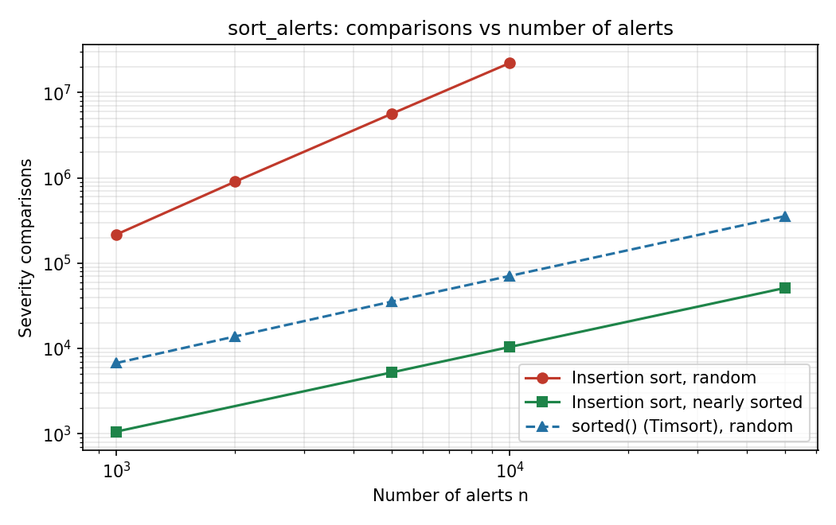
Figure 6 - sort_alerts: severity comparisons against the number of alerts (log-log scale)
Do the measurements agree with the analysis? Yes. On random data the number of shifts is within 3.7% of the predicted 0.45 · n(n − 1)/2 (the small differences come from how many equal severities the random sample happens to contain), and doubling n multiplies the comparisons by about 4 (217,547 comparisons at n = 1,000, 902,630 at n = 2,000, 5,638,478 at n = 5,000), the signature of O(n²). On nearly sorted data the comparisons equal shifts + n − 1 exactly in all four rows, so insertion sort is linear there. The built-in sort stays below n log₂ n everywhere and is about n to 2n on nearly sorted data. In wall-clock time sorted() is faster in every row (for example 2.2848 s against 0.00125 s for 10,000 random alerts), because it is also implemented in C.

5.2 is_blocked
Before (sequential search). A present address at a random position needs (n + 1)/2 comparisons on average, an absent one needs n; best case 1, worst case n. For q queries of which half are present: q · (3n/4) comparisons, O(q n). Space O(1). After (hash set). Build the index once in O(n) time and O(n) space; each lookup takes O(1) on average (O(n) only if every address collided, which is practically impossible), so q queries cost O(n + q).
Table 10 - is_blocked: 1,000 queries (500 present, 500 absent)
Blocklist size n | Predicted comparisons 500·(n+1)/2 + 500·n | Measured sequential comparisons | Difference | Hash lookups | Time seq. / hash (s)
1,000 | 750,250 | 748,022 | -0.3% | 1,000 | 0.0175 / 7.3e-05
10,000 | 7,500,250 | 7,544,311 | +0.6% | 1,000 | 0.1951 / 0.000104
100,000 | 75,000,250 | 75,396,223 | +0.5% | 1,000 | 2.7973 / 0.000139
Agreement. The measured counts are within 0.6% of the prediction and grow ten times when n grows ten times, which is linear behaviour. The hash lookups stay at one per query and all 1,000 queries together take less than 0.2 milliseconds with the hash set, while the sequential search takes several seconds for 100,000 addresses.

5.3 find_signature
Before (brute force). There are n − m + 1 windows. Each window costs at least 1 and at most m character comparisons. Best case: the first character differs in every window: n − m + 1 comparisons. Worst case: e.g. log = AAA…A and pattern = AA…AB: m (n − m + 1) comparisons, O(n m). Average case on random text over σ symbols: the k-th character of a window is compared with probability σ⁻⁽ᵏ⁻¹⁾, so a window costs 1 + 1/σ + 1/σ² + … ≈ σ/(σ − 1) comparisons; for σ = 27 that is 1.038, so about 1.04 n in total, O(n). Space O(1). After (Horspool). Preprocessing O(m + σ) time and space; on random text the average number of comparisons is roughly proportional to n/m (the window moves about m positions per step); the worst case is still O(n m). After (str.find loop). The same search is done by an optimised C routine, so the number of Python-level steps is only the number of hits.
Table 11 - find_signature: character comparisons and run time (random logs of 200,000 characters over 27 symbols, 40 planted signatures)
Pattern length m | Predicted brute force (n−m+1)·27/26 | Measured brute force | Measured Horspool | Horspool · m / n | Brute (s) | Horspool / find (s)
4 | 207,689 | 207,835 | 55,287 | 1.11 | 0.0267 | 0.0092 / 0.000144
8 | 207,685 | 208,130 | 30,129 | 1.21 | 0.0274 | 0.0056 / 0.000148
16 | 207,677 | 208,195 | 17,130 | 1.37 | 0.029 | 0.0045 / 9.9e-05

Worst case check. For a log of 10,000 letters A and the pattern AAAAAAAB (m = 8) the formula m (n − m + 1) = 79,944 was measured exactly: brute force made 79,944 comparisons, Horspool 9,993 (it compares the last character first, finds B ≠ A at once and shifts by 1).
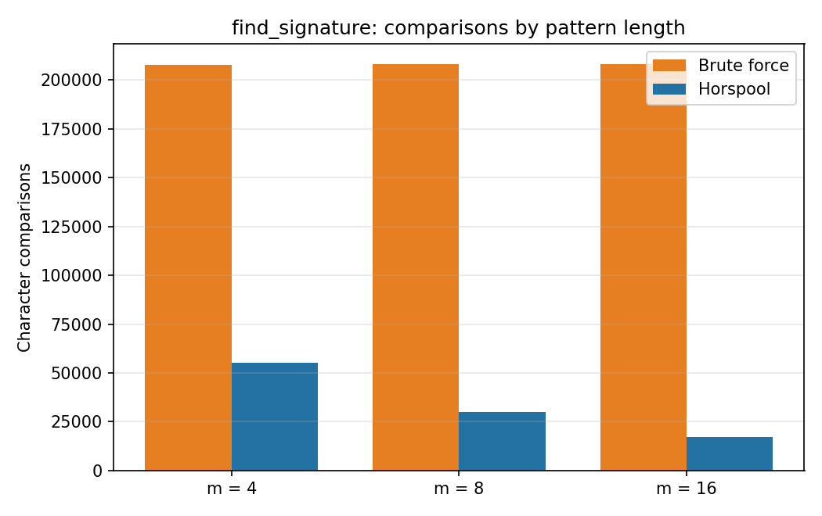
Figure 7 - find_signature: character comparisons by pattern length (random log of 200,000 characters)
Agreement. Brute force made 1.039 n comparisons on the random logs, matching the predicted 27/26 = 1.038 n to within 0.1%, and the worst case matched the formula exactly. Horspool’s comparisons shrink as the pattern gets longer (55,287 → 30,129 → 17,130), about 1.1 to 1.4 n/m, as expected for a skip-based algorithm. The str.find loop is fastest in time because it runs in C. All three returned identical hit lists in every experiment.

5.4 closest_logins
Before. The original loops over all n² ordered pairs, including n self-pairs, and takes a square root each time: n² distance computations. The corrected brute force examines n(n − 1)/2 pairs: Θ(n²) in the best, average and worst case, space O(1). At n = 8,000 this is 31,996,000 distance computations (64,000,000 for the original). After (pruned scan). Sorting costs O(n log n). For points spread over a square of side L, the closest distance is about L/n, so only a constant number of points lie in the gap window of a point: about c · n distance computations in total, i.e. O(n log n) overall on random data. Worst case: if many points share almost the same coordinate on the sorted axis, the gap never reaches the best distance and the scan degrades to O(n²). After (divide and conquer). T(n) = 2T(n/2) + O(n) = O(n log n) for every input; space O(n).
Table 12 - closest_logins: distance computations (random points in a 1000 × 1000 km square)
n | Original n² | Corrected n(n−1)/2 | Optimised (pruned) | Divide and conquer | Pruned, mean of 5 batches | Divide and conquer, mean of 5
1,000 | 1,000,000 | 499,500 | 1,982 | 1,118 | 1,647 | 1,123
2,000 | 4,000,000 | 1,999,000 | 2,503 | 2,300 | 2,826 | 2,290
4,000 | 16,000,000 | 7,998,000 | 5,794 | 4,575 | 5,272 | 4,649
8,000 | 64,000,000 | 31,996,000 | 13,478 | 9,391 | 10,692 | 9,346

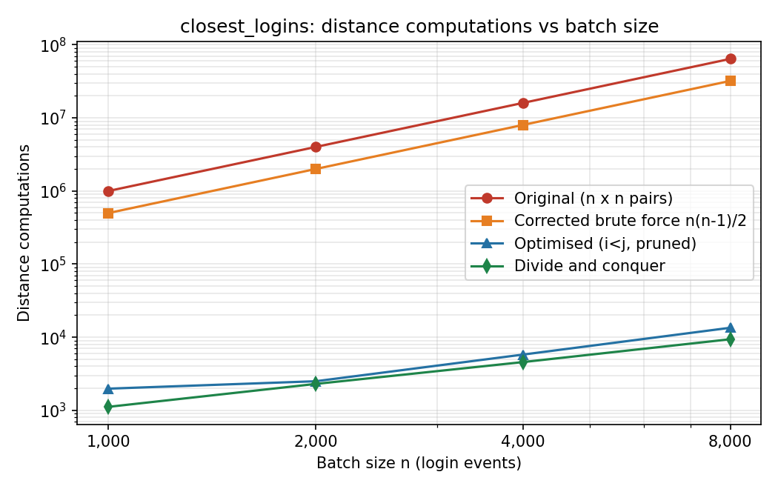
Figure 8 - closest_logins: distance computations against batch size (log-log scale)
Reading the table. At n = 8,000 the original makes 64,000,000 distance computations and the corrected brute force 31,996,000; the pruned version needs 13,478 (mean over five batches: 10,692) and divide and conquer 9,391. That is 5,986 times fewer than the original and 2,993 times fewer than the corrected brute force. The pruned count of a single batch depends on how early a close pair is met, so it is not perfectly smooth (it is therefore also given as a mean of five batches); the mean stays between 1.3 n and 1.7 n for all four batch sizes, i.e. it grows linearly.
Table 13 - closest_logins: run time in seconds
n | Original loop structure | Corrected brute force | Optimised (pruned) | Divide and conquer | Closest distance (km)
1,000 | 0.204 | 0.14 | 0.0013 | 0.0069 | 1.3476
2,000 | 0.976 | 0.438 | 0.0016 | 0.0095 | 0.4406
4,000 | 3.277 | 1.582 | 0.0032 | 0.0182 | 0.1534
8,000 | 13.122 | 6.885 | 0.0079 | 0.0452 | 0.1022

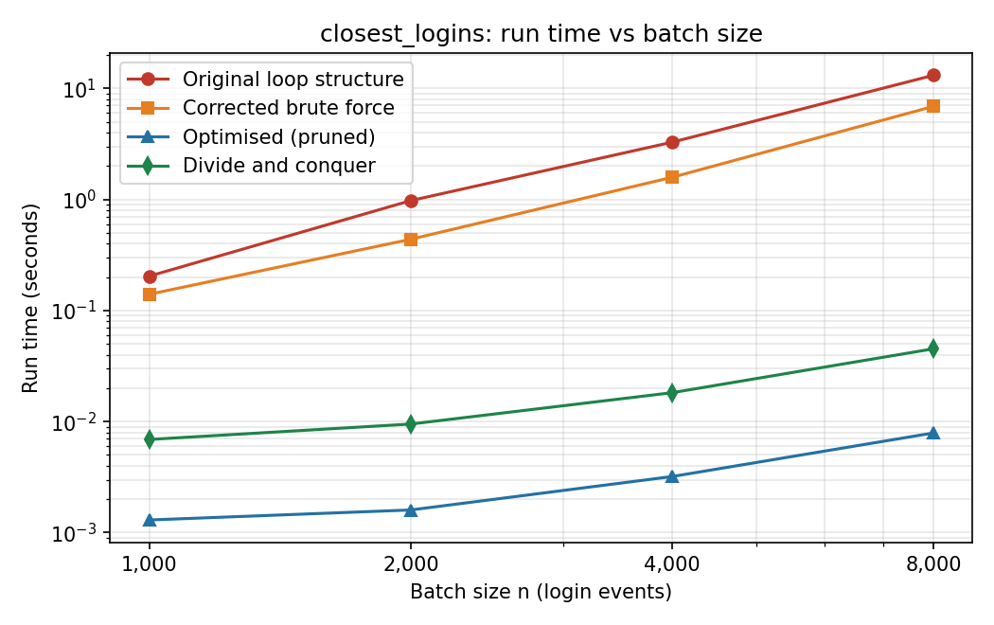
Figure 9 - closest_logins: run time against batch size (log-log scale)

5.5 Worst case for the simple pruning
To show why divide and conquer was added, points were placed on two vertical lines (x = 0 and x = 1000, half of the events on each). Along x the gap inside a line is always 0, so the pruned scan can never stop early.
Table 14 - closest_logins: distance computations when the points lie on two vertical lines
n | Corrected brute force | Optimised (pruned) | n²/4 − n/2 | Divide and conquer
1,000 | 499,500 | 249,500 | 249,500 | 1,080
2,000 | 1,999,000 | 999,000 | 999,000 | 2,136
4,000 | 7,998,000 | 3,998,000 | 3,998,000 | 4,280
Agreement. The pruned scan made exactly n²/4 − n/2 computations (2 · C(n/2, 2)), i.e. it degrades to O(n²) as predicted, while divide and conquer needed only about 1.07 n. This is the reason the module offers both: the pruned scan is the quickest on the usual spread-out login locations, and closest_logins_dc gives a guarantee for any layout.

5.6 Complexity summary
Table 15 - Time and space complexity before and after optimisation (n = size of the input, q = number of queries)
Function | Version | Best | Average | Worst | Space
sort_alerts | Corrected (insertion sort) | n − 1  O(n) | ≈ 0.225 n²  O(n²) | n(n − 1)/2  O(n²) | O(1)
 | Optimised (Timsort) | n − 1  O(n) | O(n log n) | O(n log n) | O(n)
is_blocked | Corrected (sequential) | 1 | ≈ n/2 found,  n not found | n  O(n) per query | O(1)
 | Optimised (hash set) | O(1) | O(1) per query,  O(n) to build | O(n) per query (collisions) | O(n)
find_signature | Corrected (brute force) | n − m + 1 | ≈ 1.04 n  O(n) | m (n − m + 1)  O(n m) | O(1)
 | Optimised (Horspool) | ≈ n/m | ≈ 1.1–1.4 n/m | O(n m) | O(m + σ)
closest_logins | Original (n² pairs) | n² | n² | n² | O(1)
 | Corrected brute force | n(n − 1)/2 | n(n − 1)/2 | n(n − 1)/2  Θ(n²) | O(1)
 | Optimised (pruned) | O(n log n) | ≈ 1.3 n computations  + O(n log n) sort | O(n²) | O(n)
 | Optimised (divide and conquer) | O(n log n) | O(n log n) | O(n log n) | O(n)

5.7 Do the measurements agree with the analysis?
- Yes, in every experiment. The measured counts matched the derived formulas: the nearly-sorted insertion sort count equals shifts + n − 1 exactly; the sequential blocklist search was within 1% of 3n/4 per query; brute-force matching was within 0.1% of n · 27/26 on random text and exactly m (n − m + 1) in the worst case; the pruned closest-pair scan was exactly n²/4 − n/2 on the adversarial layout.
- Where the data matters. The average-case figures (insertion sort on random alerts, pruned closest pair) depend on the data, so they agree with the prediction only approximately (within 4% for sorting) and the pruned closest-pair count is shown as a mean over five batches as well as for one batch.
- Operation counts versus time. Run times follow the same order as the counts but are not proportional, because sorted, str.find and the hash set run in C, while the other loops run in the Python interpreter. For the brute-force closest pair at n = 8,000, 31,996,000 computations took about 7 s; the pruned scan needed under 0.01 s.
- Production impact. For 50,000 alerts the sort drops from about 562 million comparisons to about 356 thousand; for a batch of 8,000 login events the closest-pair search drops from 64 million distance computations to about ten thousand, with identical output.

6. Part (e): Production-quality code

6.1 Code quality
- Docstrings. Every function and module of optimised_module.py has a docstring that states the purpose, the arguments, the return value and the complexity.
- Meaningful comments. Comments explain why (for example why the scan stops when gap² > best, or why i + 1 is used in the str.find loop), not what each line does. Every changed line of the corrected module carries a # FIX Dn comment.
- Clear structure. Three modules with identical function names (original_module, corrected_module, optimised_module), one test harness, one experiments script, one notebook. Boundary rules (empty pattern, fewer than two events) are stated in the docstrings.
- Measurement without pollution. The optional stats argument counts basic operations for the experiments and costs nothing when it is left out.
- Reproducibility. Fixed random seed (2026); every log, CSV, graph and screenshot in the repository is produced by a script.

6.2 Test harness
test_harness.py checks every function, including all boundary cases of Section 3.7. It runs each unit test on both the corrected module and every variant of the optimised module (sorted, insertion_sort_alerts, hash set, sequential search, brute-force / Horspool / str.find matching, pruned and divide-and-conquer closest pair), then compares the optimised functions with the corrected ones on 920 random inputs. The random inputs deliberately contain many ties and equal severities (small coordinate grids, only six severity levels) because ties are where optimisations most often change a result.
Table 16 - Test harness result
Run | Checks | Result
Corrected module + optimised module (python test_harness.py) | 130 | PASS: 130 passed, 0 failed (exit code 0)
Same harness aimed at the ORIGINAL module (control) | 60 reached | 44 passed, 16 FAILED, then the run crashes with UnboundLocalError on the empty-pattern test
The control run shows that the harness really detects the defects: it is not a test that every program would pass. The screenshots of the passing run are in Appendix A.

6.3 GitHub repository
The complete solution is organised as required in the repository https://github.com/shaikshahid07/CO2_Debugging_Optimisation:
CO2_Debugging_Optimisation/
|-- Pseudocode/
| 01_sort_alerts.md 02_is_blocked.md 03_find_signature.md 04_closest_logins.md
|-- Source_Code/
| original_module.py the buggy code exactly as given
| corrected_module.py debugged, every change marked # FIX Dn
| optimised_module.py production version
| test_harness.py 130 checks
| debug_steps.py traces and one-fix-at-a-time re-tests
| experiments.py operation counts and run times
| CO2_Experiments.ipynb notebook that runs all experiments
| make_screenshots.py renders the logs as screenshots
|-- Report/
| CO2_SentinelOps_Report.docx
|-- Supporting_Files/
| datasets/ execution_logs/ results/ graphs/ screenshots/ notebook_run/
`-- README.md

6.4 Assumptions and limitations
- Rules chosen for degenerate input (the question does not specify them): an empty signature matches nothing; fewer than two login events return (None, None); ties in the closest pair are resolved in favour of the smallest indices (i, j).
- sort_alerts no longer modifies its argument. The original sorted the caller’s list in place and also returned it; the optimised function returns a new list. The returned value is the same.
- Floating-point distances. The pruned and divide-and-conquer versions compare squared distances, the brute force compares square roots. For real-valued coordinates two different squared distances could in theory give the same square root; this never happened in any experiment or random test, and for integer coordinates the tie handling is exact.
- Run times are indicative. They depend on the machine and on the Python version; the operation counts do not. The experiments were run on Python 3.12.
- Horspool’s worst case is still O(n m), and the pruned closest-pair scan has an O(n²) worst case (Section 5.5). Divide and conquer is the safe choice when nothing is known about the data.
- Screenshots. The execution screenshots are terminal-style images rendered from the saved execution logs by make_screenshots.py, so the text in them is exactly what the programs printed. Running the commands in VS Code gives the same text.

7. Code of Conduct
I Shaik Shahid / 192424311 (Name / Reg. No.) certify that this submission is my original work and that I have adhered to the guidelines specified for this assessment. I understand that any violation of academic integrity rules will result in disciplinary action.
Signature of the Student: ______________________________ Date: ____________________

Appendix A: Execution output screenshots
Output of the optimised module on the test data (all versions agree with the corrected module):
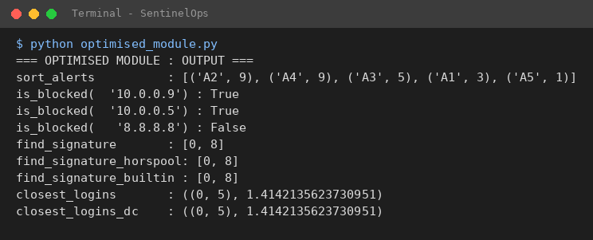
Figure 10 - Execution output of the optimised module (python optimised_module.py)
Output of the test harness (130 checks, shown in four parts):
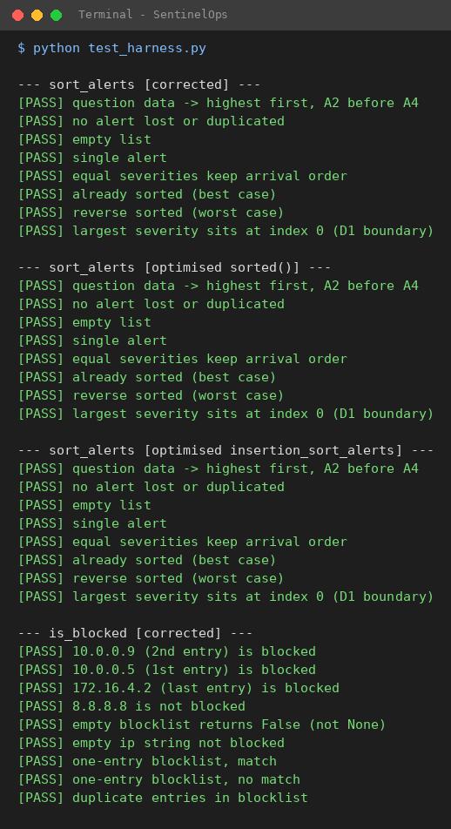
Figure 11 - Test harness output, part 1 of 4 (sort_alerts)
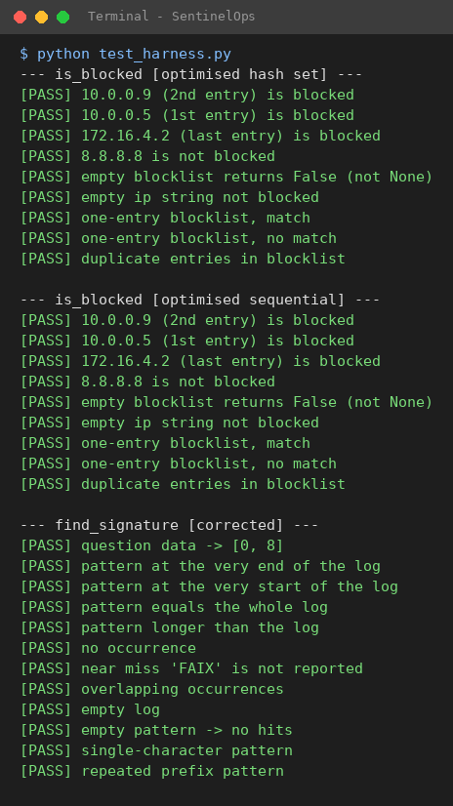
Figure 12 - Test harness output, part 2 of 4 (is_blocked, start of find_signature)
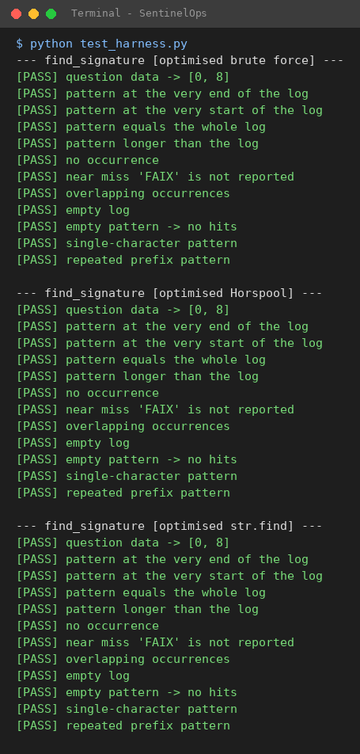
Figure 13 - Test harness output, part 3 of 4 (find_signature, start of closest_logins)
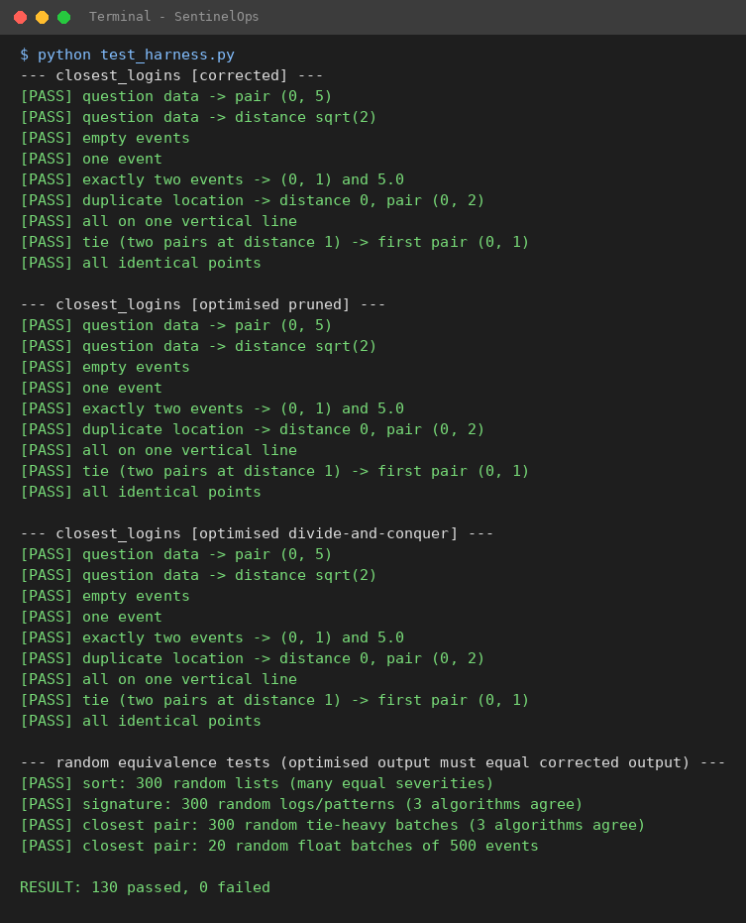
Figure 14 - Test harness output, part 4 of 4 (closest_logins and the random equivalence tests)
Output of the experiments script (also stored in Supporting_Files/execution_logs/06_experiments_run.txt):
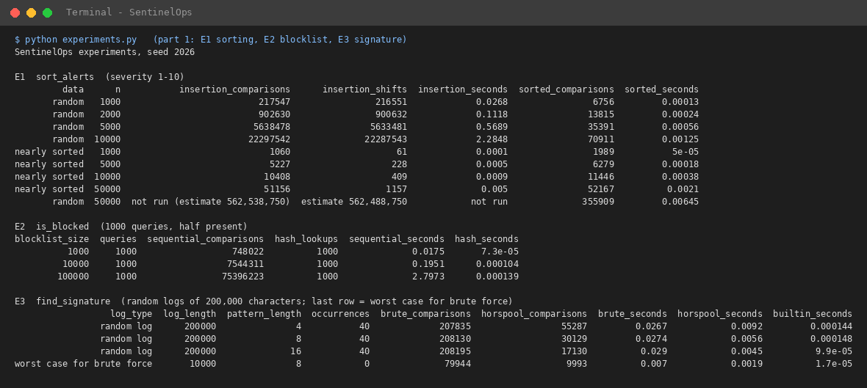
Figure 15 - Experiments E1 to E3 (sorting, blocklist, signature search)
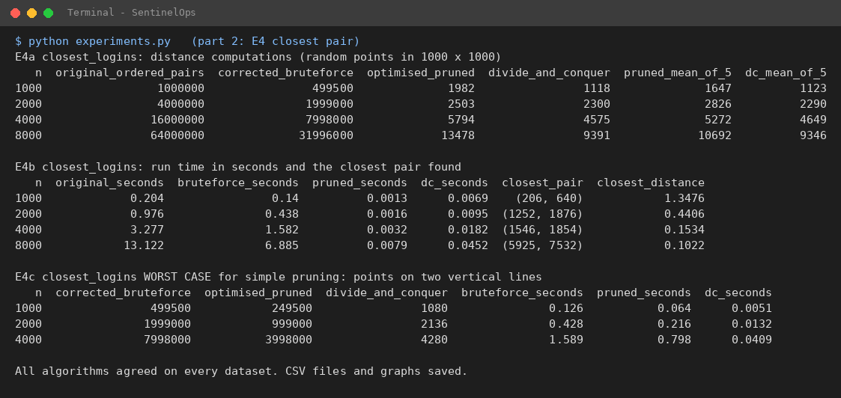
Figure 16 - Experiments E4a to E4c (closest pair)

Appendix B: Pseudocode of the four functions
Corrected and optimised pseudocode for each function. The same text, together with the best/average/worst-case tables, is in the Pseudocode folder.

B.1 Pseudocode 1 - sort_alerts (sort alerts by severity, highest first)

A. Corrected algorithm (insertion sort - original idea, defects D1 and D2 fixed)
ALGORITHM SortAlerts_Corrected(alerts)
n <- length(alerts)
FOR i <- 1 TO n - 1 DO
key <- alerts[i] // alert to be inserted
j <- i - 1
WHILE j >= 0 AND severity(alerts[j]) < severity(key) DO // FIX D1: j >= 0 (was j > 0)
alerts[j + 1] <- alerts[j] // shift the lower-severity alert one place right
j <- j - 1
END WHILE
alerts[j + 1] <- key // FIX D2: slot j + 1 (was slot j)
END FOR
RETURN alerts
END ALGORITHM

B. Optimised algorithm (hybrid merge/insertion sort = Timsort, via sorted)
ALGORITHM SortAlerts_Optimised(alerts)
RETURN SORTED(alerts, KEY = severity, ORDER = descending, STABLE)
END ALGORITHM

B. Optimised algorithm (hybrid merge/insertion sort = Timsort, via sorted)
split the list into natural runs (already ordered stretches; descending runs are reversed)
extend short runs to a minimum length using binary insertion sort
merge neighbouring runs, always keeping the merge stable

B.2 Pseudocode 2 - is_blocked (is an IP address on the blocklist?)

A. Corrected algorithm (sequential search - defects D3 and D4 fixed)
ALGORITHM IsBlocked_Corrected(blocklist, ip)
n <- length(blocklist)
FOR i <- 0 TO n - 1 DO
IF blocklist[i] = ip THEN
RETURN TRUE // FIX D3: a match means BLOCKED (was FALSE)
END IF
// FIX D4: no "else RETURN FALSE" here - one non-matching entry proves nothing
END FOR
RETURN FALSE // FIX D4: decided only after EVERY entry was checked
END ALGORITHM // (also correct for an empty blocklist)

B. Optimised algorithm (hash-set index built once)
ALGORITHM BuildBlocklist(blocklist) // run ONCE, e.g. when the blocklist is loaded
index <- empty hash set
FOR EACH address IN blocklist DO
INSERT address INTO index
END FOR
RETURN index
END ALGORITHM

ALGORITHM IsBlocked_Optimised(index, ip) // run for EVERY query
RETURN (ip IS A MEMBER OF index) // hash ip, look in one bucket
END ALGORITHM

B.3 Pseudocode 3 - find_signature (all start positions of a signature in a log line)

A. Corrected algorithm (brute force - defects D5 and D6 fixed)
ALGORITHM FindSignature_Corrected(log, pattern)
n <- length(log); m <- length(pattern)
hits <- empty list
IF m = 0 THEN RETURN hits // empty signature matches nothing
FOR i <- 0 TO n - m DO // FIX D5: n - m INCLUSIVE, i.e. n - m + 1 alignments (was n - m - 1)
j <- 0
WHILE j < m AND log[i + j] = pattern[j] DO
j <- j + 1
END WHILE
IF j = m THEN // FIX D6: all m characters matched (was "j = m - 1" after a break)
APPEND i TO hits
END IF
END FOR
RETURN hits
END ALGORITHM

B2. Horspool (skip table)
ALGORITHM FindSignature_Horspool(log, pattern)
n <- length(log); m <- length(pattern)
hits <- empty list
IF m = 0 OR m > n THEN RETURN hits
// shift table: distance from the LAST occurrence of each character (excluding the final one) to the pattern end
FOR EACH character c DO shift[c] <- m // default: skip the whole pattern
FOR k <- 0 TO m - 2 DO shift[pattern[k]] <- m - 1 - k
i <- 0
WHILE i <= n - m DO
k <- m - 1
WHILE k >= 0 AND log[i + k] = pattern[k] DO // compare right to left
k <- k - 1
END WHILE
IF k < 0 THEN APPEND i TO hits
i <- i + shift[ log[i + m - 1] ] // skip using the window's LAST character
END WHILE
RETURN hits
END ALGORITHM

B3. Built-in search in a loop (C implementation)
ALGORITHM FindSignature_Builtin(log, pattern)
hits <- empty list
IF pattern is empty OR m > n THEN RETURN hits
i <- FIND(log, pattern, from 0) // library routine, returns -1 if none
WHILE i <> -1 DO
APPEND i TO hits
i <- FIND(log, pattern, from i + 1) // i + 1 so overlapping matches are not skipped
END WHILE
RETURN hits
END ALGORITHM

B.4 Pseudocode 4 - closest_logins (closest pair of login locations)

A. Corrected algorithm (brute force - defects D7, D8 and D9 fixed)
ALGORITHM ClosestLogins_Corrected(events)
n <- length(events)
IF n < 2 THEN RETURN (NONE, NONE)
minDist <- INFINITY // FIX D7: was 0
pair <- NONE
FOR i <- 0 TO n - 1 DO
FOR j <- i + 1 TO n - 1 DO // FIX D9: only pairs with i < j (was j from 0)
d <- SQRT( (x[i] - x[j])^2 + (y[i] - y[j])^2 )
IF d < minDist THEN // FIX D8: smaller is better (was d > minDist)
minDist <- d; pair <- (i, j)
END IF
END FOR
END FOR
RETURN (pair, minDist)
END ALGORITHM

B. Optimised algorithm 1 - pruned brute force
ALGORITHM ClosestLogins_Optimised(events)
n <- length(events)
IF n < 2 THEN RETURN (NONE, NONE)
axis <- the coordinate (x or y) with the LARGER spread (max - min)
order <- indices 0..n-1 sorted by coordinate axis // O(n log n)
best <- INFINITY // best SQUARED distance
bestPair <- NONE
FOR a <- 0 TO n - 1 DO
FOR b <- a + 1 TO n - 1 DO
gap <- axis-coordinate(order[b]) - axis-coordinate(order[a])
IF gap^2 > best THEN BREAK // every later point is even farther along the axis
d2 <- (x[order[a]] - x[order[b]])^2 + (y[order[a]] - y[order[b]])^2 // no square root
cand <- (MIN(order[a], order[b]), MAX(order[a], order[b]))
IF d2 < best OR (d2 = best AND cand < bestPair) THEN
best <- d2; bestPair <- cand
END IF
END FOR
END FOR
RETURN (bestPair, SQRT(best)) // ONE square root in total
END ALGORITHM

C. Optimised algorithm 2 - divide and conquer (for comparison)
ALGORITHM ClosestLogins_DC(events)
px <- points sorted by x; py <- the same points sorted by y // done ONCE
RETURN Solve(px, py)

FUNCTION Solve(px, py)
IF |px| <= 3 THEN RETURN brute force on px
mid <- |px| DIV 2; midX <- x of px[mid]
(pxL, pyL) <- left half (points px[0..mid-1], kept in y order)
(pxR, pyR) <- right half (points px[mid..], kept in y order)
best <- BETTER( Solve(pxL, pyL), Solve(pxR, pyR) ) // smaller distance, ties -> smaller pair
strip <- points of py whose (x - midX)^2 <= best // in y order
FOR EACH point p IN strip DO
FOR EACH later point q IN strip DO
IF (y[q] - y[p])^2 > best THEN BREAK // at most a few q per p
best <- BETTER(best, distance(p, q))
END FOR
END FOR
RETURN best
END FUNCTION

Appendix C: Optimised module (optimised_module.py)
"""
SentinelOps SOC Alert-Triage Module -- OPTIMISED PRODUCTION VERSION
CSA06 Design and Analysis of Algorithms | CO2 Debugging and Optimisation Task

Workload this module is tuned for: about 50,000 alerts and batches of 8,000
login events per day. Every optimisation keeps the output identical to
corrected_module.py (this is checked by test_harness.py).

Summary of the optimisations
----------------------------
sort_alerts insertion sort O(n^2) -> Timsort via sorted() O(n log n), O(n) if nearly sorted
is_blocked sequential search O(n) -> hash set lookup O(1) average per query
find_signature brute force, redundant -> brute force with no waste, plus Horspool and
checks removed str.find() for comparison
closest_logins O(n^2) with sqrt, i != j -> i < j, squared distances, sorted-axis pruning,
plus a divide-and-conquer version O(n log n)

Optional argument stats (a dict) is used by the experiments to count basic
operations; it is ignored when it is None, so normal use is not slowed down.
"""
import math

# --------------------------------------------------------------------------
# 1. Sorting alerts
# --------------------------------------------------------------------------
def sort_alerts(alerts):
"""Return the alerts sorted by severity, highest first.

Alerts with equal severity keep their arrival order, because Python's sort
is stable and reverse=True preserves the original order of equal elements.

Args:
alerts: list of (alert_id, severity) tuples.
Returns:
A new sorted list (the input list is not modified).
Complexity: O(n log n) worst case, O(n) when the data is already
(nearly) in order, because Timsort detects existing runs.
"""
return sorted(alerts, key=lambda alert: alert[1], reverse=True)

def insertion_sort_alerts(alerts, stats=None):
"""Corrected insertion sort, kept as a reference and for the comparison experiments.

Sorts IN PLACE by severity (highest first, stable) and returns the list.
If stats is a dict, stats['comparisons'] receives the number of severity
comparisons made and stats['shifts'] the number of element moves.
"""
comparisons = shifts = 0
for i in range(1, len(alerts)):
key = alerts[i]
j = i - 1
while j >= 0:
comparisons += 1 # one severity comparison
if alerts[j][1] < key[1]:
alerts[j + 1] = alerts[j] # shift the smaller severity one place right
shifts += 1
j -= 1
else:
break
alerts[j + 1] = key
if stats is not None:
stats["comparisons"], stats["shifts"] = comparisons, shifts
return alerts

class _CountingKey:
"""Wrapper that counts how many times Python's sort compares two severities."""
count = 0
__slots__ = ("v",)

def __init__(self, v):
self.v = v

def __lt__(self, other):
_CountingKey.count += 1
return self.v < other.v

def sort_alerts_counted(alerts, stats):
"""Same result as sort_alerts(), but records stats['comparisons'] (used in experiments)."""
_CountingKey.count = 0
result = sorted(alerts, key=lambda a: _CountingKey(a[1]), reverse=True)
stats["comparisons"] = _CountingKey.count
return result

# --------------------------------------------------------------------------
# 2. Blocklist lookups
# --------------------------------------------------------------------------
def build_blocklist(blocklist):
"""Build the lookup index ONCE (O(n)); reuse it for every query."""
return frozenset(blocklist)

def is_blocked(blocklist_index, ip):
"""True if ip is on the blocklist.

blocklist_index should come from build_blocklist(); a plain list also works
(same answer) but then each lookup is a slow O(n) sequential search.
Complexity: O(1) average per lookup with the hash-set index.
"""
return ip in blocklist_index

def is_blocked_sequential(blocklist, ip, stats=None):
"""Corrected sequential search, kept for the comparison experiment.

If stats is a dict, stats['comparisons'] receives the number of equality tests.
"""
comparisons = 0
found = False
for item in blocklist:
comparisons += 1
if item == ip:
found = True
break
if stats is not None:
stats["comparisons"] = comparisons
return found

# --------------------------------------------------------------------------
# 3. Signature search (all occurrences, overlaps included)
# --------------------------------------------------------------------------
def find_signature(log, pattern, stats=None):
"""Brute-force string matching with no redundant work.

Redundancy removed compared with the original:
* only the n - m + 1 alignments that can actually fit are tried;
* a window is rejected at its FIRST mismatching character (early exit);
* there is no extra test after the inner loop (for/else instead).
If stats is a dict, stats['comparisons'] receives the character comparisons.
Returns the list of start positions ([] for an empty pattern or one longer than the log).
"""
n, m = len(log), len(pattern)
hits = []
comparisons = 0
if m == 0 or m > n:
if stats is not None:
stats["comparisons"] = 0
return hits
for i in range(n - m + 1):
for j in range(m):
comparisons += 1
if log[i + j] != pattern[j]:
break
else:
hits.append(i)
if stats is not None:
stats["comparisons"] = comparisons
return hits

def find_signature_horspool(log, pattern, stats=None):
"""Horspool's algorithm: compares the window right-to-left and skips ahead using a shift table.

Same output as find_signature(); on average far fewer comparisons for longer patterns.
"""
n, m = len(log), len(pattern)
hits = []
comparisons = 0
if m == 0 or m > n:
if stats is not None:
stats["comparisons"] = 0
return hits
shift = {} # distance from the last occurrence to the pattern end
for k in range(m - 1):
shift[pattern[k]] = m - 1 - k
i = 0
while i <= n - m:
k = m - 1
while k >= 0:
comparisons += 1
if log[i + k] != pattern[k]:
break
k -= 1
if k < 0:
hits.append(i)
i += shift.get(log[i + m - 1], m) # skip based on the window's LAST character
if stats is not None:
stats["comparisons"] = comparisons
return hits

def find_signature_builtin(log, pattern):
"""Same output using the C-implemented str.find() in a loop (fastest in practice)."""
hits = []
if not pattern or len(pattern) > len(log):
return hits
i = log.find(pattern)
while i != -1:
hits.append(i)
i = log.find(pattern, i + 1) # i + 1 so overlapping matches are found too
return hits

# --------------------------------------------------------------------------
# 4. Closest pair of login locations
# --------------------------------------------------------------------------
def closest_logins_bruteforce(events, stats=None):
"""Corrected brute force (every pair i < j, with square roots) - the 'before' baseline."""
count = 0
if len(events) < 2:
if stats is not None:
stats["distance_computations"] = 0
return None, None
min_dist = math.inf
pair = None
for i in range(len(events)):
for j in range(i + 1, len(events)):
count += 1
d = math.sqrt((events[i][0] - events[j][0]) ** 2 +
(events[i][1] - events[j][1]) ** 2)
if d < min_dist:
min_dist = d
pair = (i, j)
if stats is not None:
stats["distance_computations"] = count
return pair, min_dist

def closest_logins(events, stats=None):
"""Optimised brute force. Returns ((i, j), distance) with i < j, or (None, None) if < 2 events.

Optimisations (output identical to the corrected brute force):
1. only pairs with i < j are examined: no self-pairs, no repeated pairs;
2. squared distances are compared, so math.sqrt is called only ONCE at the end;
3. pruning: points are sorted along the axis with the larger spread; for each
point the scan to the right stops as soon as the gap along that axis alone
already exceeds the best distance found (no later point can be closer);
4. ties are broken exactly like the plain brute force (smallest (i, j) wins).
"""
n = len(events)
if n < 2:
if stats is not None:
stats["distance_computations"] = 0
return None, None
xs = [e[0] for e in events]
ys = [e[1] for e in events]
axis = 0 if (max(xs) - min(xs)) >= (max(ys) - min(ys)) else 1
order = sorted(range(n), key=lambda k: events[k][axis])
best = math.inf # best SQUARED distance so far
best_pair = None
count = 0
for a in range(n):
ia = order[a]
xa, ya = events[ia][0], events[ia][1]
va = events[ia][axis]
for b in range(a + 1, n):
ib = order[b]
gap = events[ib][axis] - va
if gap * gap > best: # prune: the rest are even farther along the axis
break
dx = xa - events[ib][0]
dy = ya - events[ib][1]
d2 = dx * dx + dy * dy
count += 1
cand = (ia, ib) if ia < ib else (ib, ia)
if d2 < best or (d2 == best and cand < best_pair):
best, best_pair = d2, cand
if stats is not None:
stats["distance_computations"] = count
return best_pair, math.sqrt(best)

def closest_logins_dc(events, stats=None):
"""Divide-and-conquer closest pair, O(n log n). Same output as closest_logins().

Split by x, solve both halves, then check only the narrow vertical strip around
the dividing line: each strip point needs to be compared with at most a few
neighbours in y-order.
"""
n = len(events)
counter = [0]
if n < 2:
if stats is not None:
stats["distance_computations"] = 0
return None, None
pts = [(events[k][0], events[k][1], k) for k in range(n)]
px = sorted(pts) # sorted by x (then y, index)
py = sorted(pts, key=lambda p: (p[1], p[0], p[2]))

def d2_of(p, q):
counter[0] += 1
return (p[0] - q[0]) ** 2 + (p[1] - q[1]) ** 2

def cand_of(p, q):
return (p[2], q[2]) if p[2] < q[2] else (q[2], p[2])

def better(a, b): # (d2, pair) tuples: smaller wins, ties -> smaller pair
return a if a <= b else b

def solve(px, py):
size = len(px)
if size <= 3: # base case: brute force
best = (math.inf, None)
for i in range(size):
for j in range(i + 1, size):
best = better(best, (d2_of(px[i], px[j]), cand_of(px[i], px[j])))
return best
mid = size // 2
mid_x = px[mid][0]
left_ids = {p[2] for p in px[:mid]}
pyl = [p for p in py if p[2] in left_ids]
pyr = [p for p in py if p[2] not in left_ids]
best = better(solve(px[:mid], pyl), solve(px[mid:], pyr))
strip = [p for p in py if (p[0] - mid_x) ** 2 <= best[0]]
for i in range(len(strip)):
for j in range(i + 1, len(strip)):
if (strip[j][1] - strip[i][1]) ** 2 > best[0]:
break # farther apart in y than the best distance
best = better(best, (d2_of(strip[i], strip[j]), cand_of(strip[i], strip[j])))
return best

best_d2, best_pair = solve(px, py)
if stats is not None:
stats["distance_computations"] = counter[0]
return best_pair, math.sqrt(best_d2)

if __name__ == "__main__":
alerts = [("A1", 3), ("A2", 9), ("A3", 5), ("A4", 9), ("A5", 1)]
blocklist = ["10.0.0.5", "10.0.0.9", "172.16.4.2"]
queries = ["10.0.0.9", "10.0.0.5", "8.8.8.8"]
log, pattern = "FAILFAIXFAIL", "FAIL"
events = [(2, 3), (12, 30), (40, 50), (5, 1), (12, 10), (3, 4)]

print("=== OPTIMISED MODULE : OUTPUT ===")
print("sort_alerts :", sort_alerts(alerts))
index = build_blocklist(blocklist)
for q in queries:
print(f"is_blocked({q!r:>12}) :", is_blocked(index, q))
print("find_signature :", find_signature(log, pattern))
print("find_signature_horspool:", find_signature_horspool(log, pattern))
print("find_signature_builtin :", find_signature_builtin(log, pattern))
print("closest_logins :", closest_logins(events))
print("closest_logins_dc :", closest_logins_dc(events))

Appendix D: Test harness (test_harness.py)
"""
Test harness for the SentinelOps SOC Alert-Triage Module.

Runs every test against BOTH the corrected module (debugged original) and the
optimised module, so that the optimisations are proven not to change any output.
Run with: python test_harness.py
Exit code 0 = all tests passed.
"""
import math
import random
import sys

import corrected_module as cor
import optimised_module as opt

passed = failed = 0

def check(name, actual, expected):
"""Print PASS/FAIL for one test case and keep the totals."""
global passed, failed
ok = actual == expected
passed += ok
failed += (not ok)
print(f"[{'PASS' if ok else 'FAIL'}] {name}")
if not ok:
print(f" expected: {expected!r}\n actual : {actual!r}")

# ---------------------------------------------------------------- test data from the question paper
ALERTS = [("A1", 3), ("A2", 9), ("A3", 5), ("A4", 9), ("A5", 1)]
BLOCKLIST = ["10.0.0.5", "10.0.0.9", "172.16.4.2"]
LOG, PATTERN = "FAILFAIXFAIL", "FAIL"
EVENTS = [(2, 3), (12, 30), (40, 50), (5, 1), (12, 10), (3, 4)]

SORTED_ALERTS = [("A2", 9), ("A4", 9), ("A3", 5), ("A1", 3), ("A5", 1)]

def run_sort_tests(name, sort_fn):
print(f"\n--- sort_alerts [{name}] ---")
check("question data -> highest first, A2 before A4", sort_fn(list(ALERTS)), SORTED_ALERTS)
check("no alert lost or duplicated", sorted(sort_fn(list(ALERTS))), sorted(ALERTS))
check("empty list", sort_fn([]), [])
check("single alert", sort_fn([("X", 4)]), [("X", 4)])
check("equal severities keep arrival order",
sort_fn([("B", 5), ("A", 5), ("C", 5)]), [("B", 5), ("A", 5), ("C", 5)])
check("already sorted (best case)", sort_fn(list(SORTED_ALERTS)), SORTED_ALERTS)
check("reverse sorted (worst case)", sort_fn(list(reversed(SORTED_ALERTS))),
[("A4", 9), ("A2", 9), ("A3", 5), ("A1", 3), ("A5", 1)])
check("largest severity sits at index 0 (D1 boundary)",
sort_fn([("L", 1), ("H", 9)]), [("H", 9), ("L", 1)])

def run_blocked_tests(name, make_index, blocked_fn):
print(f"\n--- is_blocked [{name}] ---")
idx = make_index(BLOCKLIST)
check("10.0.0.9 (2nd entry) is blocked", blocked_fn(idx, "10.0.0.9"), True)
check("10.0.0.5 (1st entry) is blocked", blocked_fn(idx, "10.0.0.5"), True)
check("172.16.4.2 (last entry) is blocked", blocked_fn(idx, "172.16.4.2"), True)
check("8.8.8.8 is not blocked", blocked_fn(idx, "8.8.8.8"), False)
check("empty blocklist returns False (not None)", blocked_fn(make_index([]), "10.0.0.5"), False)
check("empty ip string not blocked", blocked_fn(idx, ""), False)
check("one-entry blocklist, match", blocked_fn(make_index(["1.1.1.1"]), "1.1.1.1"), True)
check("one-entry blocklist, no match", blocked_fn(make_index(["1.1.1.1"]), "2.2.2.2"), False)
check("duplicate entries in blocklist", blocked_fn(make_index(["a", "a", "b"]), "b"), True)

def run_signature_tests(name, find_fn):
print(f"\n--- find_signature [{name}] ---")
check("question data -> [0, 8]", find_fn(LOG, PATTERN), [0, 8])
check("pattern at the very end of the log", find_fn("xxxxFAIL", "FAIL"), [4])
check("pattern at the very start of the log", find_fn("FAILxxxx", "FAIL"), [0])
check("pattern equals the whole log", find_fn("FAIL", "FAIL"), [0])
check("pattern longer than the log", find_fn("FAI", "FAIL"), [])
check("no occurrence", find_fn("abcdef", "xyz"), [])
check("near miss 'FAIX' is not reported", find_fn("FAIX", "FAIL"), [])
check("overlapping occurrences", find_fn("AAAA", "AA"), [0, 1, 2])
check("empty log", find_fn("", "FAIL"), [])
check("empty pattern -> no hits", find_fn("FAIL", ""), [])
check("single-character pattern", find_fn("abcab", "a"), [0, 3])
check("repeated prefix pattern", find_fn("AAAB", "AAB"), [1])

def run_closest_tests(name, closest_fn):
print(f"\n--- closest_logins [{name}] ---")
pair, dist = closest_fn(EVENTS)
check("question data -> pair (0, 5)", pair, (0, 5))
check("question data -> distance sqrt(2)", math.isclose(dist, math.sqrt(2)), True)
check("empty events", closest_fn([]), (None, None))
check("one event", closest_fn([(1, 1)]), (None, None))
pair, dist = closest_fn([(0, 0), (3, 4)])
check("exactly two events -> (0, 1) and 5.0", (pair, dist), ((0, 1), 5.0))
pair, dist = closest_fn([(1, 1), (9, 9), (1, 1)])
check("duplicate location -> distance 0, pair (0, 2)", (pair, dist), ((0, 2), 0.0))
pair, dist = closest_fn([(0, 0), (0, 5), (0, 9), (0, 10)])
check("all on one vertical line", (pair, dist), ((2, 3), 1.0))
pair, dist = closest_fn([(0, 0), (1, 0), (5, 5), (6, 5)])
check("tie (two pairs at distance 1) -> first pair (0, 1)", (pair, dist), ((0, 1), 1.0))
pair, dist = closest_fn([(5, 5), (5, 5), (5, 5)])
check("all identical points", (pair, dist), ((0, 1), 0.0))

# ---------------------------------------------------------------- run the unit tests on both modules
run_sort_tests("corrected", cor.sort_alerts)
run_sort_tests("optimised sorted()", opt.sort_alerts)
run_sort_tests("optimised insertion_sort_alerts", lambda a: opt.insertion_sort_alerts(a))
run_blocked_tests("corrected", lambda b: b, cor.is_blocked)
run_blocked_tests("optimised hash set", opt.build_blocklist, opt.is_blocked)
run_blocked_tests("optimised sequential", lambda b: b, opt.is_blocked_sequential)
run_signature_tests("corrected", cor.find_signature)
run_signature_tests("optimised brute force", opt.find_signature)
run_signature_tests("optimised Horspool", opt.find_signature_horspool)
run_signature_tests("optimised str.find", opt.find_signature_builtin)
run_closest_tests("corrected", cor.closest_logins)
run_closest_tests("optimised pruned", opt.closest_logins)
run_closest_tests("optimised divide-and-conquer", opt.closest_logins_dc)

# ---------------------------------------------------------------- equivalence on random data
print("\n--- random equivalence tests (optimised output must equal corrected output) ---")
rng = random.Random(2026)

ok = True
for _ in range(300):
data = [(f"A{k}", rng.randint(1, 6)) for k in range(rng.randint(0, 40))]
ok &= opt.sort_alerts(data) == cor.sort_alerts(list(data)) == opt.insertion_sort_alerts(list(data))
check("sort: 300 random lists (many equal severities)", ok, True)

ok = True
for _ in range(300):
log = "".join(rng.choice("AB") for _ in range(rng.randint(0, 30)))
pat = "".join(rng.choice("AB") for _ in range(rng.randint(0, 5)))
ref = cor.find_signature(log, pat)
ok &= (opt.find_signature(log, pat) == ref == opt.find_signature_horspool(log, pat)
== opt.find_signature_builtin(log, pat))
check("signature: 300 random logs/patterns (3 algorithms agree)", ok, True)

ok = True
for _ in range(300):
ev = [(rng.randint(0, 6), rng.randint(0, 6)) for _ in range(rng.randint(0, 40))] # small grid -> many ties
ref = cor.closest_logins(ev)
ok &= opt.closest_logins(ev) == ref == opt.closest_logins_dc(ev)
check("closest pair: 300 random tie-heavy batches (3 algorithms agree)", ok, True)

ok = True
for _ in range(20):
ev = [(rng.uniform(0, 500), rng.uniform(0, 500)) for _ in range(500)]
ref = cor.closest_logins(ev)
ok &= opt.closest_logins(ev) == ref == opt.closest_logins_dc(ev)
check("closest pair: 20 random float batches of 500 events", ok, True)

print(f"\nRESULT: {passed} passed, {failed} failed")
sys.exit(1 if failed else 0)

