Department of Computer Science and Engineering
Final Design and Analysis
KartIQ: Divide-and-Conquer Engine | Parts (a) and (f)
Student Name | Shaik Shahid
Student Reg. No. | 192424311
Course Code & Name | CSA06 – Design and Analysis of Algorithms
Assessment | CO3 – Case Study – Divide-and-Conquer Engine of a Retail Data Analytics Platform (KartIQ)

1. Case Understanding Summary (Part a)
Module | Computational requirement | Key issues | Consequence of a poor algorithm
Module 1 – Nightly Order Consolidation | Sort about 10,000,000 orders per night by timestamp for the audit report, before the reporting deadline. | (i) Stability: orders of the same second from different gateways must keep arrival order.  (ii) Guaranteed running time: the report must finish every night, so the worst case matters.  (iii) Memory: out-of-place merging needs an extra buffer of the same size as the data.  (iv) The data may be larger than RAM. | An unstable sort (e.g. plain Quick Sort or Heap Sort) breaks gateway-by-gateway reconciliation and fails the audit; an O(n²) sort needs about 5×10¹³ comparisons and misses the deadline.
Module 2 – Live Seller Leaderboard | Re-sort the scores of 100,000 sellers every few seconds; data is almost always nearly sorted. | (i) Worst-case behaviour: first-element pivot on sorted / nearly sorted data gives splits of 0 and n−1.  (ii) Recursion depth up to n (stack overflow risk).  (iii) Stability is not required, memory should stay small (in-place).  (iv) Nearly sorted input is the normal case, not a rare one. | T(n) = Θ(n²): about 5×10⁹ comparisons per refresh instead of about 1.7×10⁶; the leaderboard freezes during sales.
Module 3 – Order Lookup | Find an order by timestamp in the consolidated list of 10,000,000 orders; return the first of several equal timestamps. | (i) Sorted-data precondition: binary search is valid only on the sorted output of Module 1.  (ii) Duplicates: the standard search returns any match, not the first.  (iii) Static array, no extra memory needed; mid computation must not overflow. | A linear scan costs up to 10,000,000 comparisons per lookup (seconds under load); searching unsorted data with binary search returns wrong answers.
Module 4 – Recommendation Scores | Compute C = A × B for n × n matrices with n = 1,024 so that scores can be refreshed more than once a day. | (i) Matrix size: n³ = 1,073,741,824 scalar multiplications for the conventional method.  (ii) Memory: 8 MiB per float64 matrix; Strassen needs about 3n² extra elements.  (iii) Strassen reduces multiplications but increases additions, overhead and rounding error.  (iv) n must be a power of two (pad otherwise). | The conventional method keeps recommendations at one refresh a day; naive full-depth Strassen may be slower in practice because of overhead.

Common thread: all four modules are divide-and-conquer problems, but they differ in what matters most – stability and a guaranteed bound (Module 1), robustness on nearly sorted data (Module 2), a sorted precondition (Module 3) and matrix size (Module 4).

2. Final Algorithmic Design (Part f)
Module | Chosen algorithm | Time complexity | Extra memory | Reason for the choice
1. Order consolidation | Merge Sort (stable, top-down; external k-way merge if data > RAM) | Θ(n log n) in all cases; ≈ 2.2×10⁸ comparisons for 10⁷ orders | O(n): ≈ 160 MB buffer (16 B records); external: O(RAM) + heap of k | Stable (equal timestamps keep gateway arrival order), guaranteed worst case, merges naturally from disk.
2. Seller leaderboard | Quick Sort with median-of-three pivot, smaller-side recursion, insertion sort for ≤ 16 elements, heap-sort fallback (introsort) | Θ(n log n) expected and guaranteed with fallback; ≈ 1.7×10⁶ comparisons for 10⁵ sellers | O(log n) stack, in place | Removes the n² behaviour (5×10⁹ comparisons) on nearly sorted data; no stability needed; fast, cache-friendly.
3. Order lookup | Binary Search, first-occurrence variant on the Module 1 output | O(log n); at most 24 iterations for 10⁷ orders (best case O(1) for the standard version) | O(1) iterative | Needs only the sorted array; returns the first (earliest) order of equal timestamps; 416,667× fewer comparisons than a scan.
4. Recommendation scores | Hybrid Strassen (top 3 levels, cutoff 128) with an optimised conventional kernel at the leaves | Θ(n^2.81) above the cutoff; 7³×128³ = 719,323,136 multiplications for n = 1,024 (vs 1,073,741,824) | ≈ 3n² elements = 24 MiB temporaries plus A, B, C = 24 MiB | Saves 33 % of the multiplications while avoiding the overhead of deep recursion.

3. Main Trade-off and Condition to Change
Module | Main trade-off | One condition under which I would change the decision
1 | Guaranteed O(n log n) and stability are paid for with O(n) extra memory and more data movement. | Data larger than RAM, or input already arrives as sorted gateway streams → external / k-way (natural) merge, O(n log k).
2 | Speed and O(log n) space are bought with instability and a pivot heuristic that adversarial inputs can still defeat. | Only a few scores change per refresh (few inversions) → insertion sort / Timsort in O(n + inversions); or equal scores need a stable order → Merge Sort.
3 | O(log n) lookup with O(1) memory requires a sorted, static array; inserts cost O(n). | Continuous inserts or lookups by order ID → hash index or B-tree.
4 | Fewer multiplications are paid for with more additions, extra memory and weaker numerical stability. | Benchmark shows the BLAS kernel is faster (as measured here at n = 1,024), n is small or the matrices are sparse → plain blocked / sparse multiplication.

4. Workload Summary and Comparison
Module | Workload | Poor choice | Chosen design | Improvement
1 | 10,000,000 orders | O(n²) sort: ≈ 5×10¹³ comparisons (or unstable sort: audit fails) | Merge Sort: ≈ 2.2×10⁸ | ≈ 220,000× fewer comparisons
2 | 100,000 sellers | First pivot: 4,999,950,000 | Median-of-three: ≈ 1,660,964 | ≈ 3,010× fewer
3 | 10,000,000 orders | Linear scan: 10,000,000 | Binary search: 24 | ≈ 416,667× fewer
4 | n = 1,024 | Conventional: 1,073,741,824 mults | Hybrid (cutoff 128): 719,323,136 | 33 % fewer mults (73.7 % with full recursion)

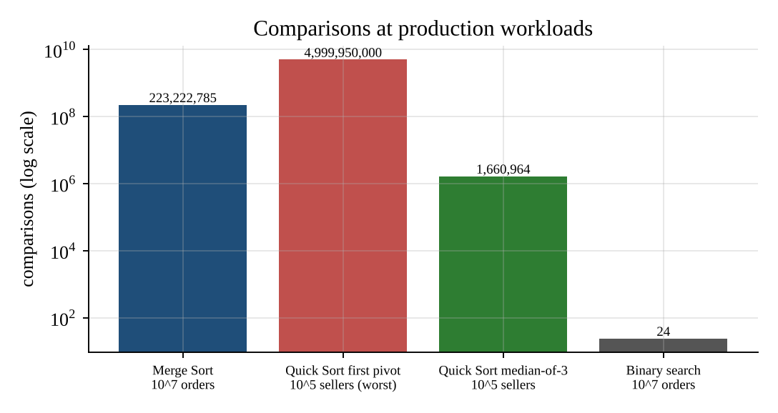
Figure 1. Comparisons at the production workloads (log scale).

5. End-to-End Pipeline
Nightly: Module 1 sorts the day’s orders (stable) → the sorted list is the index for Module 3 lookups the next day. Every few seconds: Module 2 re-sorts the seller scores in place. Periodically (more often than daily): Module 4 recomputes C = A × B with the hybrid kernel. Each module’s report in this repository contains pseudocode, runnable code, traces, recurrences, graphs and screenshots.

6. Recommendations
- Deploy Merge Sort with a single reusable buffer; add external k-way merge for peak days; sort compact key arrays rather than objects.
- Replace the first-element pivot by median-of-three (with insertion-sort cutoff and heap-sort fallback); monitor the recursion depth.
- Keep a small sorted “intraday” buffer for orders that arrive after consolidation, so binary search stays valid.
- Benchmark the Strassen hybrid on the production hardware before enabling it; keep BLAS as the default.

Declaration (Code of Conduct)
I Shaik Shahid (Reg. No. 192424311) certify that this submission is my original work and that I have adhered to the guidelines specified for this assessment. I understand that any violation of academic integrity rules will result in disciplinary action.
Signature of the Student: ____________________ Date: ______________

