Department of Computer Science and Engineering
Module 1 – Merge Sort for Nightly Order Consolidation
KartIQ Retail Data Analytics Platform | Parts (a) and (b)
Student Name | Shaik Shahid
Student Reg. No. | 192424311
Course Code & Name | CSA06 – Design and Analysis of Algorithms
Assessment | CO3 – Case Study – Divide-and-Conquer Engine of a Retail Data Analytics Platform (KartIQ)

1. Case Understanding (Part a)
Module | Computational requirement | Key issues | Consequence of a poor algorithm
Module 1 – Nightly Order Consolidation | Sort about 10,000,000 orders per night by timestamp for the audit report, before the reporting deadline. | (i) Stability: orders of the same second from different gateways must keep arrival order.  (ii) Guaranteed running time: the report must finish every night, so the worst case matters.  (iii) Memory: out-of-place merging needs an extra buffer of the same size as the data.  (iv) The data may be larger than RAM. | An unstable sort (e.g. plain Quick Sort or Heap Sort) breaks gateway-by-gateway reconciliation and fails the audit; an O(n²) sort needs about 5×10¹³ comparisons and misses the deadline.

Decision: use Merge Sort. It is the standard stable O(n log n) comparison sort with a guaranteed worst case, and it extends naturally to external (disk-based) sorting.

2. Divide, Conquer and Combine (Part b)
- Divide: split A[lo..hi] at mid = ⌊(lo+hi)/2⌋ into two halves of almost equal size (no comparisons).
- Conquer: sort both halves recursively; a sub-array of size 0 or 1 is already sorted (base case).
- Combine: merge the two sorted halves with two pointers. When the timestamps are equal the element of the LEFT half is taken first (“<=”), which preserves arrival order.
Pseudocode (file Pseudocode/merge_sort_pseudocode.txt):
MODULE 1 - MERGE SORT (stable) FOR NIGHTLY ORDER CONSOLIDATION
Input : array A[0..n-1] of orders (timestamp, orderID) in gateway arrival order
Output: A sorted by timestamp; equal timestamps keep arrival order

ALGORITHM MergeSort(A, lo, hi)
if lo >= hi then return // base case: 0 or 1 element
mid <- floor((lo + hi) / 2) // DIVIDE
MergeSort(A, lo, mid) // CONQUER left half
MergeSort(A, mid + 1, hi) // CONQUER right half
Merge(A, lo, mid, hi) // COMBINE

ALGORITHM Merge(A, lo, mid, hi)
L <- copy of A[lo..mid]
R <- copy of A[mid+1..hi]
i <- 0 ; j <- 0 ; k <- lo
while i < |L| and j < |R| do
if L[i].timestamp <= R[j].timestamp then // '<=' : left wins ties (STABLE)
A[k] <- L[i] ; i <- i + 1
else
A[k] <- R[j] ; j <- j + 1
k <- k + 1
while i < |L| do A[k] <- L[i] ; i <- i + 1 ; k <- k + 1
while j < |R| do A[k] <- R[j] ; j <- j + 1 ; k <- k + 1

3. Execution Trace on the Sample Orders
Input (arrival order): (105,O1), (102,O2), (105,O3), (101,O4), (102,O5), (103,O6).
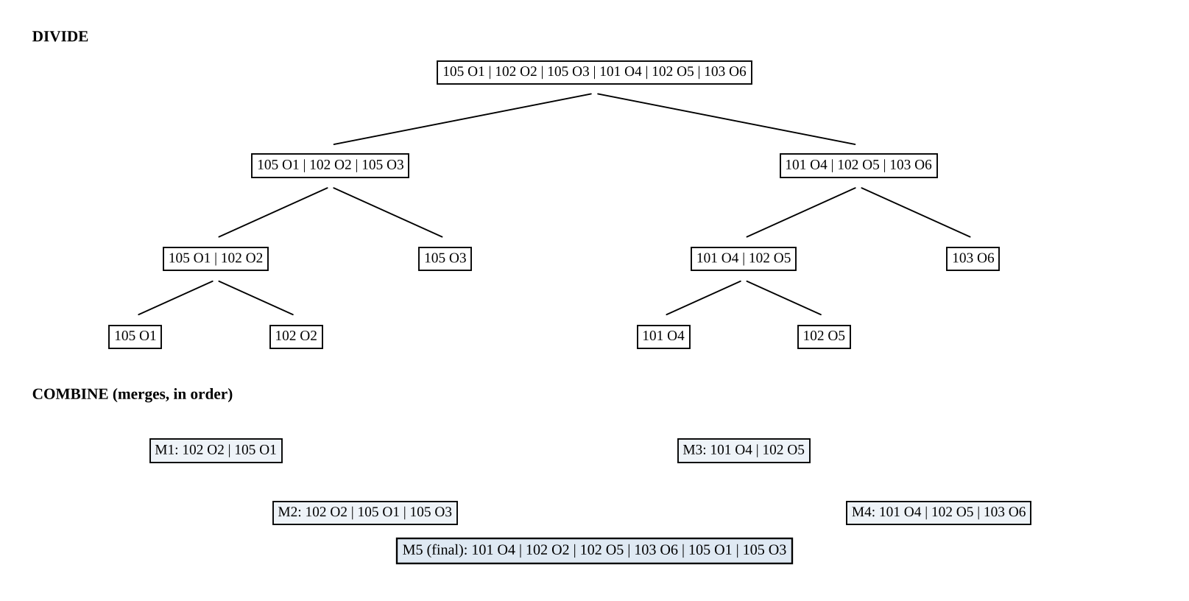
Figure 1. Divide tree and the five merges for the sample orders.
Merge | Left run | Right run | Result | Comparisons
M1 | (105,O1) | (102,O2) | (102,O2), (105,O1) | 1
M2 | (102,O2), (105,O1) | (105,O3) | (102,O2), (105,O1), (105,O3) | 2
M3 | (101,O4) | (102,O5) | (101,O4), (102,O5) | 1
M4 | (101,O4), (102,O5) | (103,O6) | (101,O4), (102,O5), (103,O6) | 2
M5 | (102,O2), (105,O1), (105,O3) | (101,O4), (102,O5), (103,O6) | (101,O4), (102,O2), (102,O5), (103,O6), (105,O1), (105,O3) | 4
 |  |  | Total comparisons | 10

Stability proof on the sample.
- Timestamp 105: O1 arrived before O3. In M2 the comparison is 105 (left, O1) <= 105 (right, O3), so O1 is copied first. In M5 the two 105-orders are the last elements of the left run and are copied in the same order: O1, O3.
- Timestamp 102: O2 (left run) and O5 (right run) are compared in M5 as 102 <= 102, so O2 goes first: O2, O5.
- Hence every group of equal timestamps appears in arrival order (the program checks this automatically, see Figure 3).

4. Recurrence and Complexity
Dividing costs O(1), merging n elements costs at most n − 1 comparisons, so
T(n) = 2 T(n/2) + (n − 1), T(1) = 0
Expansion for n = 2ᵏ: T(n) = 2T(n/2) + n − 1 = 4T(n/4) + (n − 2) + (n − 1) = … = 2ᵏT(1) + k·n − (2ᵏ − 1). Therefore
T(n) = n lg n − n + 1 = Θ(n log n)
Master Theorem check: a = 2, b = 2, f(n) = Θ(n) = Θ(n^(log₂ 2)), case 2, so T(n) = Θ(n log n). Merge Sort has the same bound in the best, average and worst case; only the constant changes (best case about (n/2) lg n comparisons when the input is already sorted).
n (measured, random data) | Measured comparisons | n lg n − n + 1 (upper bound)
8 | 15 | 17
32 | 122 | 129
128 | 739 | 769
512 | 3,970 | 4,097
2,048 | 19,967 | 20,481
8,192 | 96,113 | 98,305

5. Estimate for 10,000,000 Orders
Quantity | Calculation | Value
log₂ n | log₂(10⁷) = 7 × 3.3219 | 23.2535 (⌈lg n⌉ = 24)
Comparisons ≈ n lg n | 10⁷ × 23.2535 | 232,534,967 ≈ 2.33 × 10⁸
Worst case n⌈lg n⌉ − 2^⌈lg n⌉ + 1 | 10⁷×24 − 16,777,216 + 1 | 223,222,785
Best case ≈ (n/2) lg n | sorted input | 116,267,483
Quadratic sort for comparison | n(n−1)/2 | ≈ 5 × 10¹³
Memory (16 B/record) | data 160 MB + auxiliary buffer 160 MB | ≈ 320 MB

Assumption: a record is a timestamp (8 bytes) plus an order ID (8 bytes) = 16 bytes; real objects with strings are larger, which is another reason to sort compact keys or indexes. At an illustrative 10⁸ comparisons per second the 2.2×10⁸ comparisons need roughly 2–3 seconds of comparison work, against about 6 days for 5×10¹³ comparisons.

6. Memory and Data That Does Not Fit in RAM
- Memory: Merge Sort is not in place; the merge needs an auxiliary array of n records, so space is O(n) (allocate it once and reuse it at every level, not a new array per merge).
- External merge sort: (1) read chunks that fit in RAM (e.g. 1,000,000 orders), sort each with Merge Sort and write it to disk as a sorted run → 10 runs; (2) k-way merge the 10 runs with a min-heap keyed by (timestamp, run index). The run index is the tie-breaker, so stability is preserved across runs.
- Cost: two sequential passes over 160 MB (read + write each), and n lg k = 10⁷ × lg 10 ≈ 33,219,281 comparisons in the merge pass.
- Other options: the gateways already deliver time-ordered streams, so a k-way merge of the gateway streams (or Timsort-style natural runs) avoids most of the sorting work.

7. Implementation Screenshots
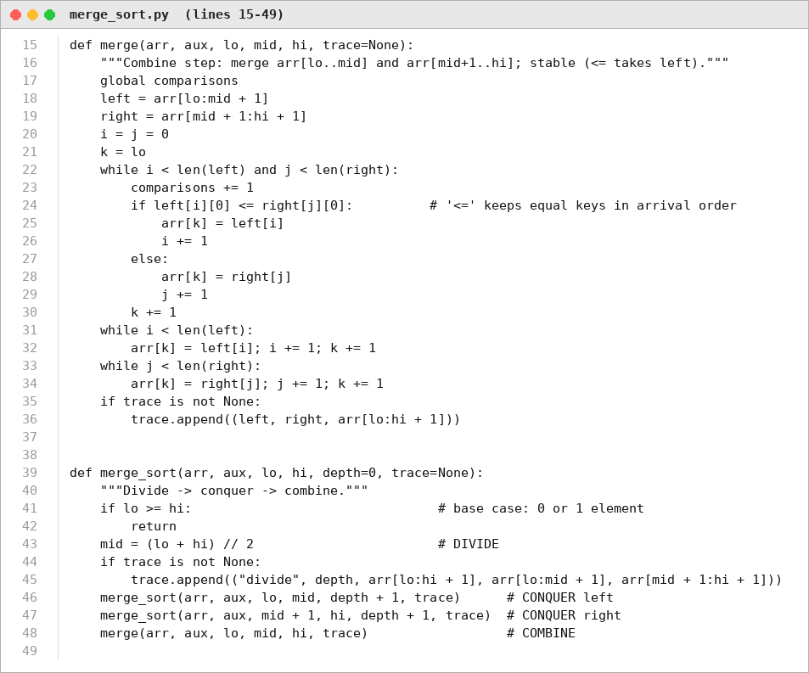
Figure 2. Source code: merge() and merge_sort() (Source_Code/merge_sort.py).
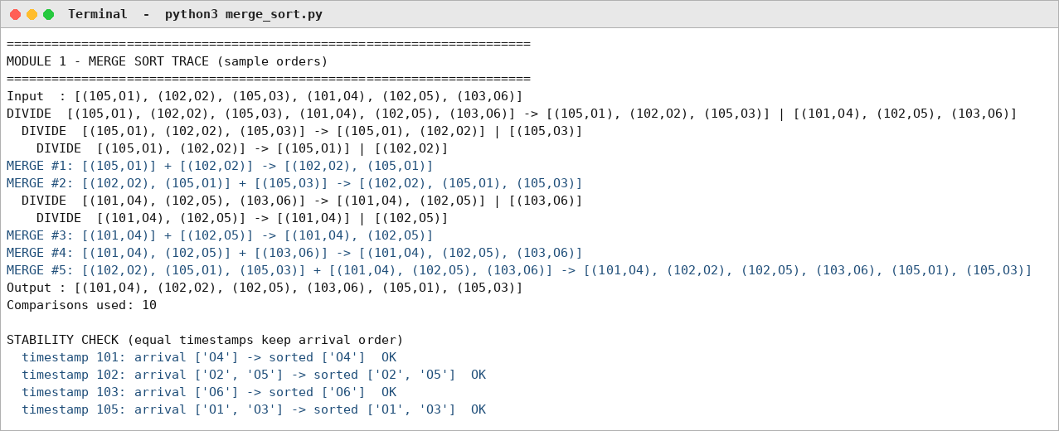
Figure 3. Program output: divide/merge trace and stability check.
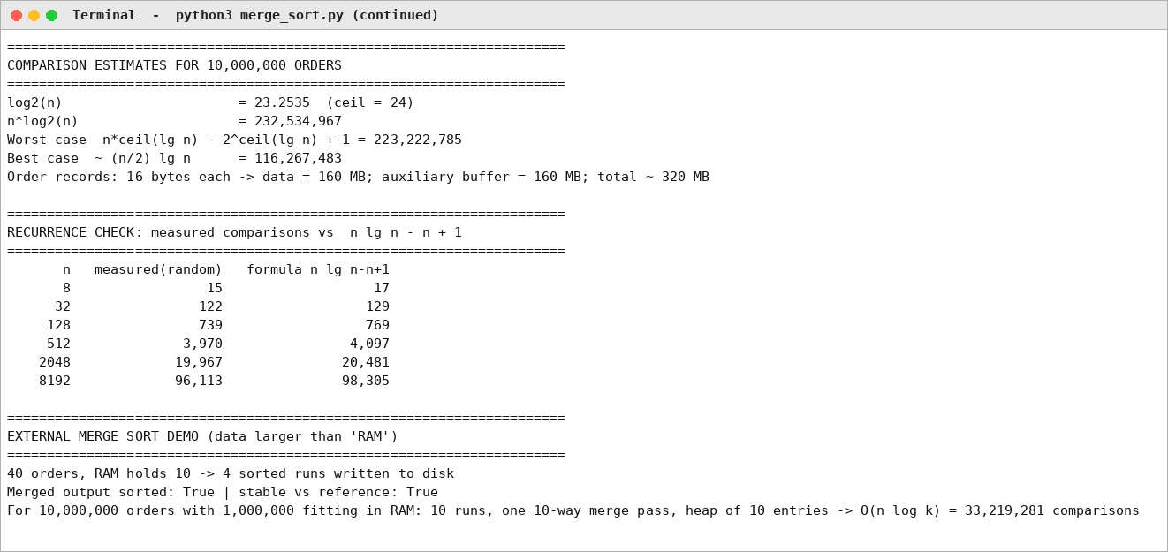
Figure 4. Program output: estimates, recurrence check and external merge demonstration.

8. Experimental Results
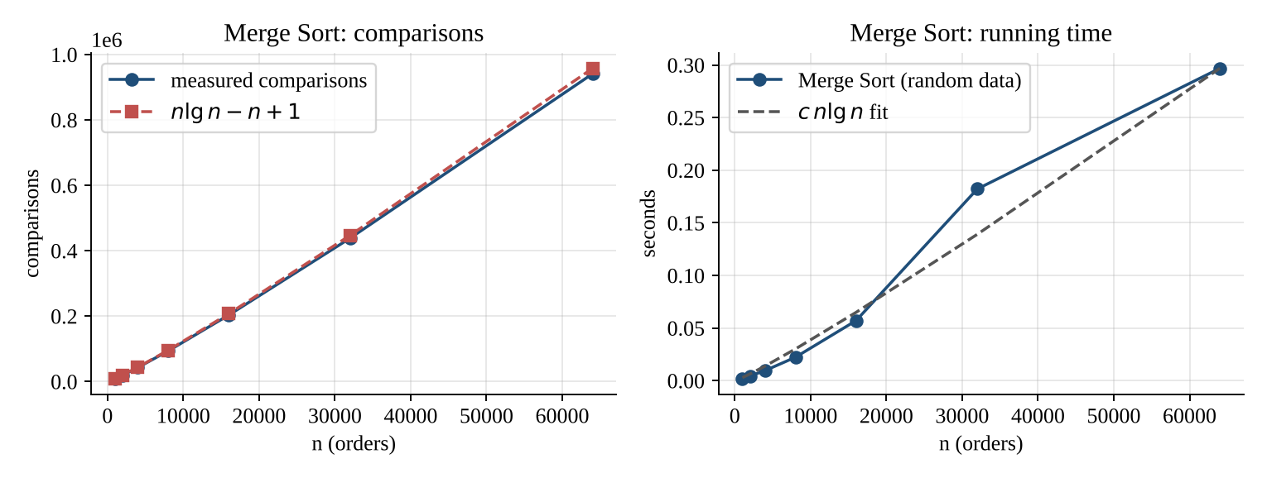
Figure 5. Measured comparisons and running time of Merge Sort versus n.
The measured comparisons stay just below n lg n − n + 1 and the running time follows c·n lg n, confirming the recurrence. (Timings are from pure Python on the submission machine; only the growth rate matters.)

9. Limitations, Trade-offs and Recommendation
- Trade-off: guaranteed O(n log n) and stability are paid for with O(n) extra memory and more data movement than Quick Sort.
- Limitation: sorting 10⁷ Python objects needs far more than 320 MB; use compact arrays, or sort a key/index array.
- Improvement: external merge sort for data larger than RAM; k-way merge of already sorted gateway streams; insertion sort for runs shorter than about 16 elements.
- Condition to change: if the input arrives as long pre-sorted runs, switch to a natural / k-way merge, which is also stable and close to O(n log k).

