Department of Computer Science and Engineering
Module 2 – Quick Sort for the Live Seller Leaderboard
KartIQ Retail Data Analytics Platform | Parts (a) and (c)
Student Name | Shaik Shahid
Student Reg. No. | 192424311
Course Code & Name | CSA06 – Design and Analysis of Algorithms
Assessment | CO3 – Case Study – Divide-and-Conquer Engine of a Retail Data Analytics Platform (KartIQ)

1. Case Understanding (Part a)
Module | Computational requirement | Key issues | Consequence of a poor algorithm
Module 2 – Live Seller Leaderboard | Re-sort the scores of 100,000 sellers every few seconds; data is almost always nearly sorted. | (i) Worst-case behaviour: first-element pivot on sorted / nearly sorted data gives splits of 0 and n−1.  (ii) Recursion depth up to n (stack overflow risk).  (iii) Stability is not required, memory should stay small (in-place).  (iv) Nearly sorted input is the normal case, not a rare one. | T(n) = Θ(n²): about 5×10⁹ comparisons per refresh instead of about 1.7×10⁶; the leaderboard freezes during sales.

2. Divide, Conquer and Combine
- Divide: partition A[lo..hi] around a pivot so that smaller scores are on its left and the others on its right; the pivot is then in its final position.
- Conquer: sort the left and right parts recursively.
- Combine: nothing to do, because the parts are already in place; all the work is in Partition (n − 1 comparisons).
Pseudocode (file Pseudocode/quick_sort_pseudocode.txt):
ALGORITHM QuickSort(A, lo, hi) // CURRENT design: first-element pivot
if lo < hi then
p <- Partition(A, lo, hi) // DIVIDE (all the work happens here)
QuickSort(A, lo, p - 1) // CONQUER left
QuickSort(A, p + 1, hi) // CONQUER right ; COMBINE = nothing

ALGORITHM Partition(A, lo, hi)
pivot <- A[lo] ; i <- lo
for j <- lo + 1 to hi do
if A[j] < pivot then
i <- i + 1 ; swap A[i], A[j]
swap A[lo], A[i]
return i // n - 1 comparisons

3. One Partition Step on the Sample Scores
Scores: 42, 17, 63, 8, 55, 29. Pivot = first element = 42, i = 0 (i marks the last score known to be smaller than the pivot).
j | A[j] | A[j] < 42 ? | Action | Array after the step | i
start | – | – | pivot = 42 | 42, 17, 63, 8, 55, 29 | 0
1 | 17 | yes | i=1, swap A[1],A[1] | 42, 17, 63, 8, 55, 29 | 1
2 | 63 | no | none | 42, 17, 63, 8, 55, 29 | 1
3 | 8 | yes | i=2, swap A[2],A[3] | 42, 17, 8, 63, 55, 29 | 2
4 | 55 | no | none | 42, 17, 8, 63, 55, 29 | 2
5 | 29 | yes | i=3, swap A[3],A[5] | 42, 17, 8, 29, 55, 63 | 3
end | – | – | swap A[0],A[3] | 29, 17, 8, 42, 55, 63 | 3

Result: pivot 42 is at index 3 (final position); left part {29, 17, 8} (all < 42), right part {55, 63}. The partition used 5 = n − 1 comparisons. Sorting the whole sample needs 9 comparisons and recursion depth 3.

4. Why the First-Element Pivot Makes the Leaderboard Slow
The leaderboard data is already (almost) sorted. In sorted data the first element is the smallest of its sub-array, so Partition produces an empty left part and a right part of n − 1 elements, again with its smallest element in front, and so on. The “divide” step is completely unbalanced: the recursion depth becomes n and each level still pays a full scan. Quick Sort only works well when the pivot splits the data roughly in half; with this pivot rule the common case (nearly sorted) is exactly the worst case.

5. Recurrences and Solutions
Case | Recurrence | Solution
Best (balanced split) | T(n) = 2T(n/2) + (n − 1), T(1) = 0 | T(n) = n lg n − n + 1 = Θ(n log n)
Worst (sorted / nearly sorted, first pivot) | T(n) = T(n − 1) + (n − 1), T(1) = 0 | T(n) = (n−1) + (n−2) + … + 1 = n(n − 1)/2 = Θ(n²)
Average (random order / random pivot) | T(n) = (n − 1) + (2/n) Σ T(i) | ≈ 2n ln n = 1.39 n lg n = Θ(n log n)

Worst-case solution by expansion: T(n) = T(n−1) + (n−1) = T(n−2) + (n−2) + (n−1) = … = Σ k (k = 1..n−1) = n(n−1)/2. Best case by the Master Theorem: a = 2, b = 2, f(n) = Θ(n), case 2, Θ(n log n).

6. Estimate for 100,000 Sellers (Nearly Sorted)
Case | Calculation | Comparisons
First-element pivot, nearly sorted (worst) | n(n − 1)/2 = 10⁵ × 99,999 / 2 | 4,999,950,000 (≈ 5.0 × 10⁹)
Balanced pivot (median-of-three, best case) | n lg n = 10⁵ × 16.61 | 1,660,964 (≈ 1.7 × 10⁶)
Random pivot, average | 2n ln n | 2,302,585
Ratio worst / best | 4,999,950,000 / 1,660,964 | ≈ 3,010 ×
Recursion depth | worst n vs. best ≈ lg n | 100,000 frames vs. about 17

At an illustrative 10⁹ comparisons per second the worst case needs about 5 seconds per refresh (the freeze), while the balanced case needs about 2 milliseconds. The deep recursion (100,000 frames) can also overflow the call stack.

7. Proposed Improved Pivot Strategy
- Median-of-three: use the median of A[lo], A[mid], A[hi] as pivot. On sorted and nearly sorted data it picks the middle element, so splits are balanced and the best-case recurrence applies.
- Smaller side first: recurse into the smaller part and loop on the larger one; stack depth ≤ lg n ≈ 17.
- Insertion sort for tiny parts (≤ 16): fewer calls and very fast on nearly sorted small ranges.
- Safety net (introsort): if the depth exceeds 2 lg n, switch to Heap Sort, so even adversarial inputs stay O(n log n).
- Alternative: a random pivot gives expected O(n log n) for every input; if only very few scores move between refreshes, an adaptive sort (insertion sort / Timsort, O(n + inversions)) is even cheaper.
n (nearly sorted) | First pivot | n(n−1)/2 | Median-of-three | Random pivot | n lg n
250 | 30,827 | 31,125 | 1,505 | 2,001 | 1,991
500 | 123,810 | 124,750 | 3,500 | 4,684 | 4,483
1,000 | 496,201 | 499,500 | 7,993 | 10,561 | 9,966
2,000 | 1,980,537 | 1,999,000 | 17,976 | 24,009 | 21,932
4,000 | 7,930,344 | 7,998,000 | 39,936 | 52,344 | 47,863

Measured comparisons (program output): the first-element pivot follows n(n−1)/2 almost exactly; median-of-three stays at or below n lg n.

8. Implementation Screenshots
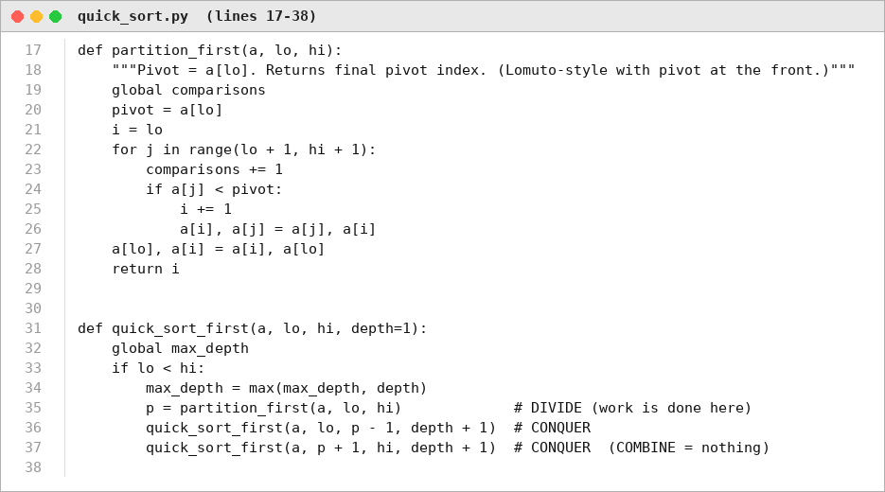
Figure 1. Source code: first-element pivot Partition and Quick Sort (Source_Code/quick_sort.py).
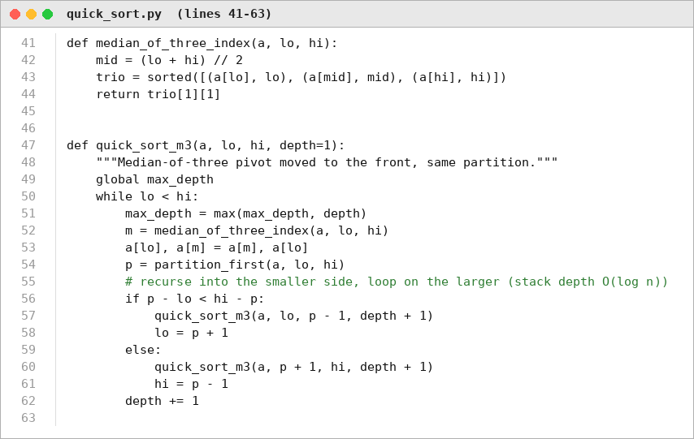
Figure 2. Source code: median-of-three pivot, smaller-side recursion.
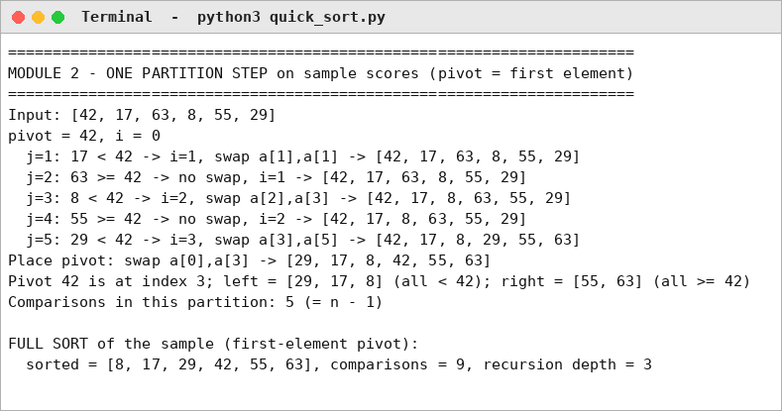
Figure 3. Program output: partition trace on the sample scores.
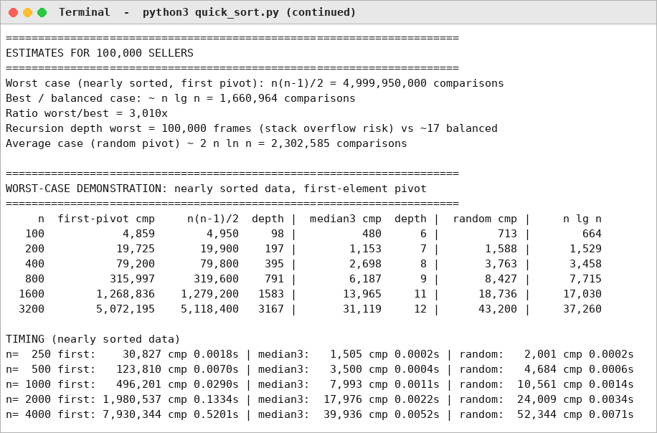
Figure 4. Program output: estimates for 100,000 sellers and measured comparisons.
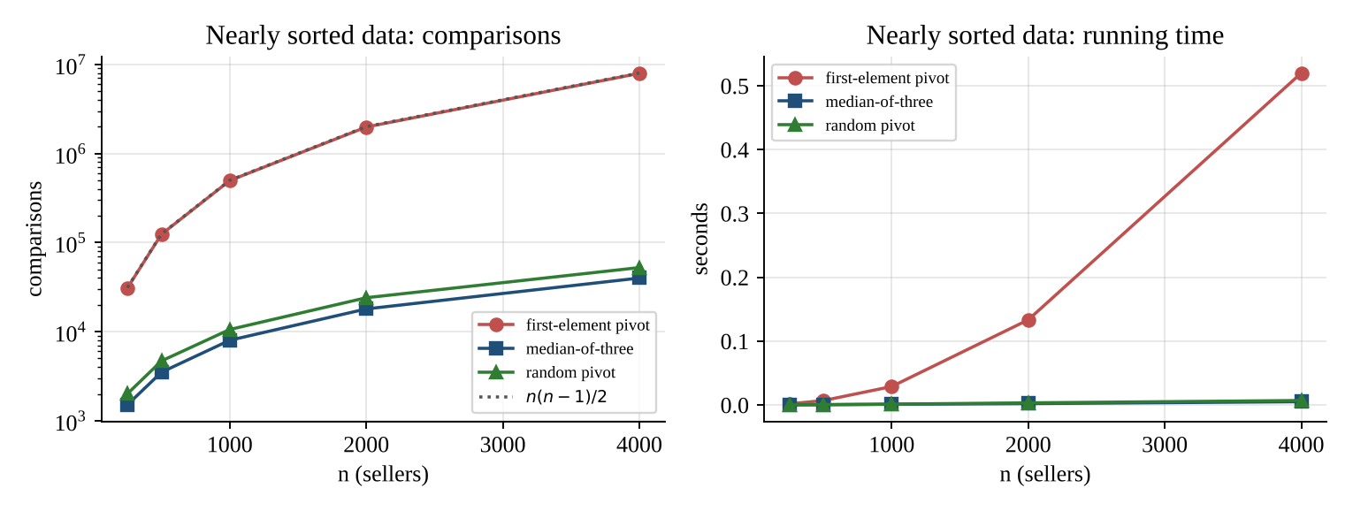
Figure 5. Nearly sorted data: first-element pivot is quadratic, median-of-three and random pivot are n log n.

9. Limitations, Trade-offs and Recommendation
- Trade-off: Quick Sort is in place (O(log n) stack) and fast in practice, but it is not stable and its worst case depends on the pivot rule.
- Median-of-three removes the sorted-input worst case but not every adversarial input; the introsort fallback guarantees O(n log n).
- Condition to change: if only a handful of scores change between refreshes (inversions k ≪ n lg n), use insertion sort / Timsort with O(n + k); if equal scores must keep a fixed order, use a stable sort.

