Department of Computer Science and Engineering
Module 3 – Binary Search for Order Lookup
KartIQ Retail Data Analytics Platform | Parts (a) and (d)
Student Name | Shaik Shahid
Student Reg. No. | 192424311
Course Code & Name | CSA06 – Design and Analysis of Algorithms
Assessment | CO3 – Case Study – Divide-and-Conquer Engine of a Retail Data Analytics Platform (KartIQ)

1. Case Understanding (Part a)
Module | Computational requirement | Key issues | Consequence of a poor algorithm
Module 3 – Order Lookup | Find an order by timestamp in the consolidated list of 10,000,000 orders; return the first of several equal timestamps. | (i) Sorted-data precondition: binary search is valid only on the sorted output of Module 1.  (ii) Duplicates: the standard search returns any match, not the first.  (iii) Static array, no extra memory needed; mid computation must not overflow. | A linear scan costs up to 10,000,000 comparisons per lookup (seconds under load); searching unsorted data with binary search returns wrong answers.

2. Why Sorted Order Is Essential
Binary search compares the key with the middle element and then discards one whole half. This is correct only if all elements on one side of the middle are ≤ it and all on the other side are ≥ it, i.e. the list is sorted by timestamp. On unsorted data the discarded half may contain the key. Example (program output, Figure 3): in the unsorted sample list the timestamp 101 exists at index 3, but binary search returns −1 (not found). The sorted list of Module 1 is therefore a precondition, and because Module 1 uses a stable sort, the first element of a group of equal timestamps is also the earliest arrival.

3. Divide, Conquer and Combine
- Divide: compute mid = lo + (hi − lo)/2 (overflow-safe) and compare A[mid] with the key.
- Conquer: continue in only ONE half (left if key < A[mid], right if key > A[mid]).
- Combine: nothing; the answer of the half is the answer of the whole.
Pseudocode (file Pseudocode/binary_search_pseudocode.txt):
ALGORITHM BinarySearch(A, lo, hi, key) // returns ANY match
if lo > hi then return -1 // empty range
mid <- floor((lo + hi) / 2) // DIVIDE
if A[mid].timestamp = key then return mid
if A[mid].timestamp < key then return BinarySearch(A, mid + 1, hi, key) // CONQUER
else return BinarySearch(A, lo, mid - 1, key) // (no combine)

ALGORITHM FirstOccurrence(A, n, key) // MODIFIED: FIRST match
lo <- 0 ; hi <- n - 1 ; first <- -1
while lo <= hi do
mid <- lo + floor((hi - lo) / 2)
if A[mid].timestamp = key then
first <- mid // remember the hit ...
hi <- mid - 1 // ... but keep searching to the LEFT
else if A[mid].timestamp < key then lo <- mid + 1
else hi <- mid - 1
return first // -1 if the key is absent

4. Recurrence and Maximum Comparisons
T(n) = T(n/2) + 1, T(1) = 1
Expansion: T(n) = T(n/2) + 1 = T(n/4) + 2 = … = T(n/2ᵏ) + k. The range reaches size 1 when k = lg n, so T(n) = lg n + 1 for n = 2ᵏ and, for any n, T(n) = ⌊lg n⌋ + 1 = Θ(log n). Master Theorem: a = 1, b = 2, f(n) = Θ(1) = Θ(n^0), case 2, T(n) = Θ(log n).
Quantity | Calculation | Value
Maximum comparisons for n = 10,000,000 | ⌊log₂(10⁷)⌋ + 1 = ⌊23.2535⌋ + 1 | 24
Linear search worst case | n | 10,000,000
Speed-up in comparisons | 10,000,000 / 24 | ≈ 416,667 ×
Check: 2²³ = 8,388,608 < 10⁷ < 2²⁴ = 16,777,216 | range halves at most 24 times | 24 iterations

Verified by the program: simulated worst case on 10,000,000 sorted timestamps = 24 iterations. Space: O(1) for the iterative version, O(log n) stack for the recursive version.

5. Modified Search: First Order with a Given Timestamp
The standard search stops at the first hit, which may be any of several equal timestamps (for key 102 it returned index 2, order O5, while the first one is O2 at index 1). The modification: when A[mid] equals the key, record mid as a candidate but continue the search in the LEFT half (hi = mid − 1). The last recorded candidate is the leftmost match. The recurrence is unchanged (still one comparison per halving); the only difference is that the search always runs until the range is empty, so the worst case ⌊lg n⌋ + 1 = 24 is also reached for successful searches.
Key | Iterations (lo, hi, mid → decision) | Result
102 | (0,5,2) hit, record, go left → (0,1,0) 101<102, go right → (1,1,1) hit, record, go left | index 1 → (102, O2)
105 | (0,5,2) 102<105, right → (3,5,4) hit, record, left → (3,3,3) 103<105, right | index 4 → (105, O1)
101 | (0,5,2) 102>101, left → (0,1,0) hit, record, left | index 0 → (101, O4)
104 (absent) | (0,5,2) right → (3,5,4) 105>104, left → (3,3,3) 103<104, right | not found (−1)

6. Implementation Screenshots
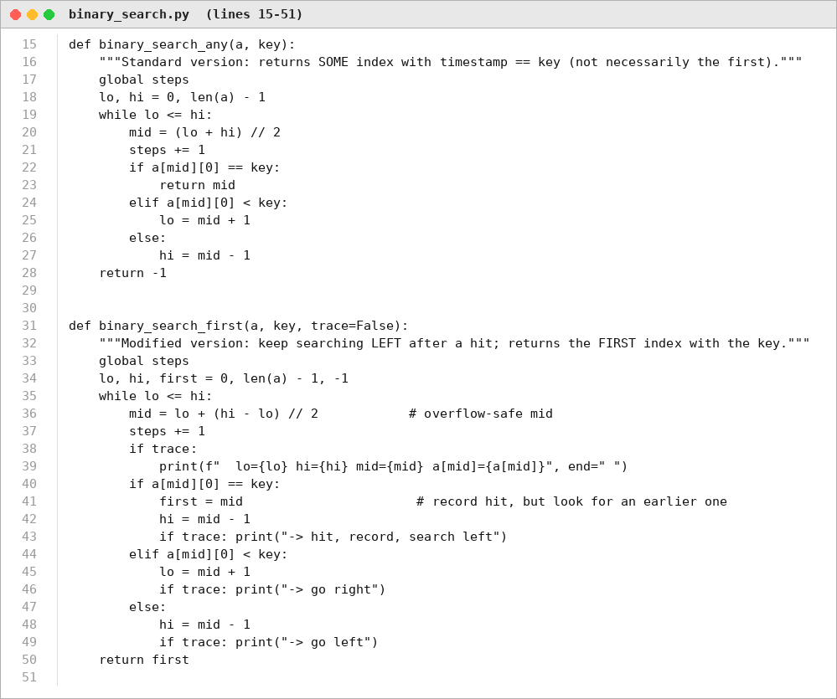
Figure 1. Source code: standard and first-occurrence binary search (Source_Code/binary_search.py).
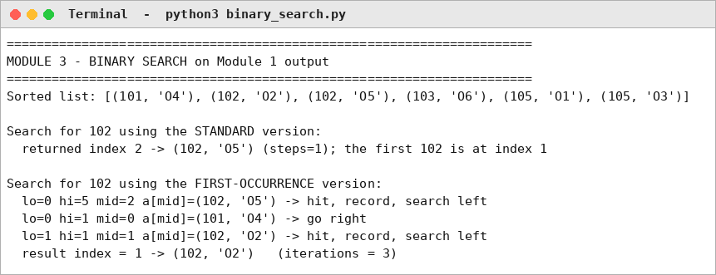
Figure 2. Program output: trace on the sample list (standard vs first-occurrence).
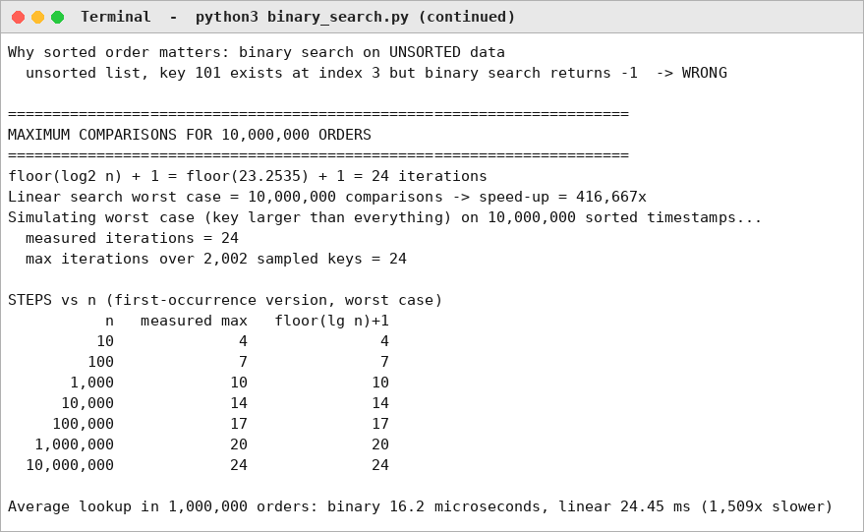
Figure 3. Program output: unsorted-data failure, 24 iterations for 10,000,000 orders, steps versus n.

7. Experimental Results
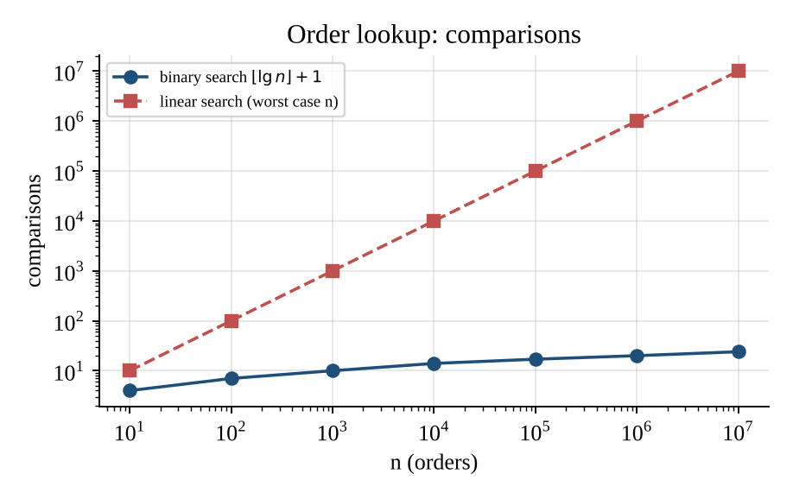
Figure 4. Comparisons versus n: ⌊lg n⌋+1 for binary search against n for linear search.
Measured average lookup in a list of 1,000,000 orders (pure Python, duplicates present): binary search 16.2 microseconds, linear scan 24.45 milliseconds (about 1,509 times slower).

8. Limitations, Trade-offs and Recommendation
- Trade-off: O(log n) lookup and O(1) memory need a sorted static array; inserting a new order costs O(n) (or a re-merge).
- Orders that arrive after the nightly consolidation should be kept in a small separate sorted buffer and searched first, then merged at night.
- Condition to change: if lookups are by order ID with continuous inserts, use a hash index or a B-tree instead of a sorted array.

