Department of Computer Science and Engineering
Module 4 – Strassen’s Method for Recommendation Scores
KartIQ Retail Data Analytics Platform | Parts (a) and (e)
Student Name | Shaik Shahid
Student Reg. No. | 192424311
Course Code & Name | CSA06 – Design and Analysis of Algorithms
Assessment | CO3 – Case Study – Divide-and-Conquer Engine of a Retail Data Analytics Platform (KartIQ)

1. Case Understanding (Part a)
Module | Computational requirement | Key issues | Consequence of a poor algorithm
Module 4 – Recommendation Scores | Compute C = A × B for n × n matrices with n = 1,024 so that scores can be refreshed more than once a day. | (i) Matrix size: n³ = 1,073,741,824 scalar multiplications for the conventional method.  (ii) Memory: 8 MiB per float64 matrix; Strassen needs about 3n² extra elements.  (iii) Strassen reduces multiplications but increases additions, overhead and rounding error.  (iv) n must be a power of two (pad otherwise). | The conventional method keeps recommendations at one refresh a day; naive full-depth Strassen may be slower in practice because of overhead.

2. Divide, Conquer and Combine
- Divide: split A, B (n × n) into four n/2 × n/2 blocks each.
- Conquer: compute only SEVEN block products M1…M7 recursively (the conventional method needs eight).
- Combine: build the four blocks of C with additions and subtractions (8 block additions) – 18 block additions in total per level.

3. Strassen Products and Reconstruction
Product | Formula
M1 | (A11 + A22)(B11 + B22)
M2 | (A21 + A22) B11
M3 | A11 (B12 − B22)
M4 | A22 (B21 − B11)
M5 | (A11 + A12) B22
M6 | (A21 − A11)(B11 + B12)
M7 | (A12 − A22)(B21 + B22)

C11 = M1 + M4 − M5 + M7, C12 = M3 + M5, C21 = M2 + M4, C22 = M1 − M2 + M3 + M6
Pseudocode (file Pseudocode/strassen_pseudocode.txt):
ALGORITHM Strassen(A, B, n)
if n <= CUTOFF then return ConventionalMultiply(A, B) // hybrid leaf
split A and B into four n/2 x n/2 blocks each // DIVIDE
M1 <- Strassen(A11 + A22, B11 + B22, n/2) // CONQUER: seven products
M2 <- Strassen(A21 + A22, B11, n/2)
M3 <- Strassen(A11, B12 - B22, n/2)
M4 <- Strassen(A22, B21 - B11, n/2)
M5 <- Strassen(A11 + A12, B22, n/2)
M6 <- Strassen(A21 - A11, B11 + B12, n/2)
M7 <- Strassen(A12 - A22, B21 + B22, n/2)
C11 <- M1 + M4 - M5 + M7 // COMBINE
C12 <- M3 + M5
C21 <- M2 + M4
C22 <- M1 - M2 + M3 + M6
return [C11 C12 ; C21 C22]

4. Verification on the 2 × 2 Sample
A = [[1, 7], [3, 5]], B = [[1, 3], [7, 5]] (a11=1, a12=7, a21=3, a22=5; b11=1, b12=3, b21=7, b22=5).
Product | Calculation | Value
M1 | (1 + 5)(1 + 5) | 36
M2 | (3 + 5)(1) | 8
M3 | 1 (3 − 5) | −2
M4 | 5 (7 − 1) | 30
M5 | (1 + 7)(5) | 40
M6 | (3 − 1)(1 + 3) | 8
M7 | (7 − 5)(7 + 5) | 24

Entry | Strassen | Conventional | Match
C11 | M1 + M4 − M5 + M7 = 36 + 30 − 40 + 24 = 50 | 1·1 + 7·7 = 50 | yes
C12 | M3 + M5 = −2 + 40 = 38 | 1·3 + 7·5 = 38 | yes
C21 | M2 + M4 = 8 + 30 = 38 | 3·1 + 5·7 = 38 | yes
C22 | M1 − M2 + M3 + M6 = 36 − 8 − 2 + 8 = 34 | 3·3 + 5·5 = 34 | yes

C = [[50, 38], [38, 34]]. Strassen used 7 multiplications and 18 additions/subtractions; the conventional method uses 8 multiplications and 4 additions.

5. Recurrence and Solution
T(n) = 7 T(n/2) + Θ(n²), M(n) = 7 M(n/2), M(1) = 1
Expanding for n = 2ᵏ: M(n) = 7ᵏ = 7^(lg n) = n^(lg 7) ≈ n^2.807. Master Theorem: a = 7, b = 2, f(n) = Θ(n²); since n^(log₂ 7) = n^2.807 grows faster than n² (case 1), T(n) = Θ(n^(log₂ 7)) = Θ(n^2.81). Additions: A(n) = 7A(n/2) + 18(n/2)² with A(1) = 0 gives A(2ᵏ) = 6(7ᵏ − 4ᵏ).

6. Operation Counts for n = 1,024 (k = 10)
Method | Scalar multiplications | Scalar additions | Total
Conventional | n³ = 1,073,741,824 | n²(n−1) = 1,072,693,248 | 2,146,435,072
Strassen (to 1×1) | 7¹⁰ = 282,475,249 | 6(7¹⁰ − 4¹⁰) = 1,688,560,038 | 1,971,035,287
Hybrid, cutoff 128 (3 levels) | 7³ × 128³ = 719,323,136 | 741,130,240 | 1,460,453,376
Hybrid, cutoff 64 (4 levels) | 7⁴ × 64³ = 629,407,744 | 672,288,768 | 1,301,696,512
Hybrid, cutoff 8 (op-count optimum) | 7⁷ × 8³ = 421,654,016 | 678,896,320 | 1,100,550,336

- Multiplications: 282,475,249 / 1,073,741,824 = 0.263, i.e. Strassen needs 26.3 % of the multiplications (73.7 % fewer, 3.8 times less).
- Total operations: only 0.918 times the conventional total (8.2 % fewer) because the 18 block additions per level add 1.69 × 10⁹ additions.
- Memory: one 1,024 × 1,024 float64 matrix = 8 MiB; A, B, C = 24 MiB; Strassen temporaries about 3n² elements = 24 MiB more.

7. Why Strassen May Still Not Be Faster in Practice
- Extra additions and memory traffic: 18 matrix additions per level plus temporaries; real speed is limited by memory bandwidth and cache misses, not only by multiplications.
- Recursion overhead: at a 1 × 1 leaf the work per call is tiny; the measured numpy-based recursion down to 1 × 1 blocks at n = 256 took 25.1 s against 0.11 s for the conventional row-by-column loops.
- Optimised libraries: BLAS kernels use SIMD, blocking and multiple cores and run at near hardware peak; for n = 1,024 numpy BLAS took 0.0445 s, our hybrid with cutoff 128 took 0.1208 s.
- Numerical stability: the weaker error bounds of Strassen matter for floating-point scores.
- Size: the break-even point of real implementations is typically a few hundred to a few thousand; padding to a power of two is also needed for other n.

8. Practical Hybrid
Use Strassen only for the top two or three levels of recursion and switch to an optimised conventional (blocked / BLAS) kernel once the blocks are at most 64–128. For n = 1,024 and cutoff 128 this performs 7³ = 343 block products of size 128 × 128 (719,323,136 multiplications, 33 % fewer than conventional) and keeps the recursion shallow. Further refinements: reuse preallocated buffers for M1…M7, use the Winograd variant (15 instead of 18 additions), pad odd sizes with zeros, and verify with a randomised check (C x = A (B x)) in production.
Cutoff | Multiplications | Total ops (mult + add) | Ratio to conventional
1 | 282,475,249 | 1,971,035,287 | 0.918
8 | 421,654,016 | 1,100,550,336 | 0.513
16 | 481,890,304 | 1,108,079,872 | 0.516
32 | 550,731,776 | 1,181,223,936 | 0.550
64 | 629,407,744 | 1,301,696,512 | 0.606
128 | 719,323,136 | 1,460,453,376 | 0.680
256 | 822,083,584 | 1,653,932,032 | 0.771
1024 | 1,073,741,824 | 2,146,435,072 | 1.000

Measured wall-clock result (numpy, n = 512, best of 3): cutoff 64: 0.0177 s, cutoff 128: 0.0117 s, cutoff 256: 0.0080 s, cutoff 512: 0.0051 s. On this machine the pure library multiplication (cutoff 512) is fastest, so the recommendation is: benchmark on the production hardware, and keep the hybrid only where it wins.

9. Implementation Screenshots
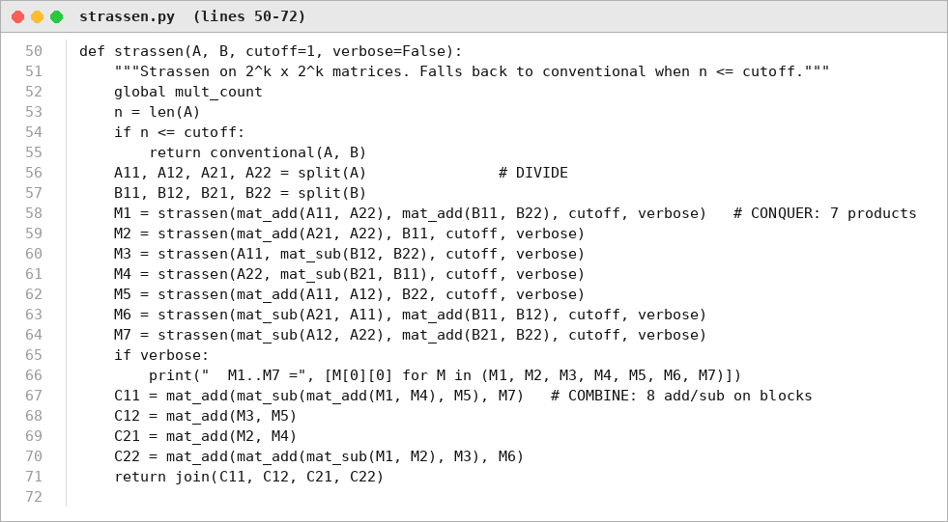
Figure 1. Source code: Strassen recursion with cutoff (Source_Code/strassen.py).
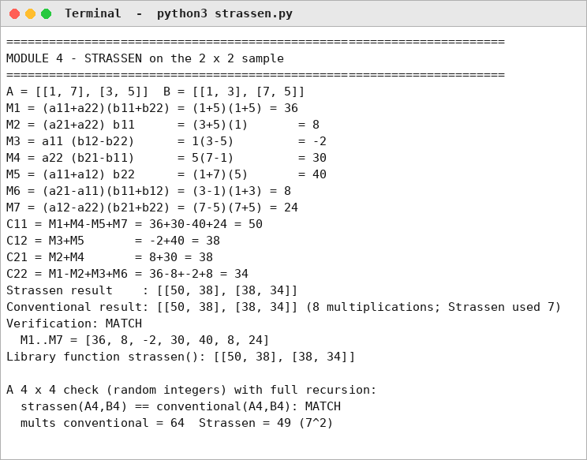
Figure 2. Program output: products, reconstruction and verification on the 2 × 2 sample.
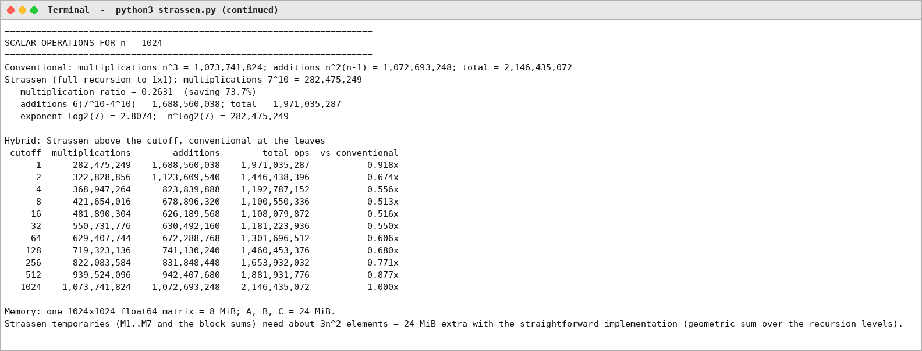
Figure 3. Program output: operation counts and cutoff table for n = 1,024.
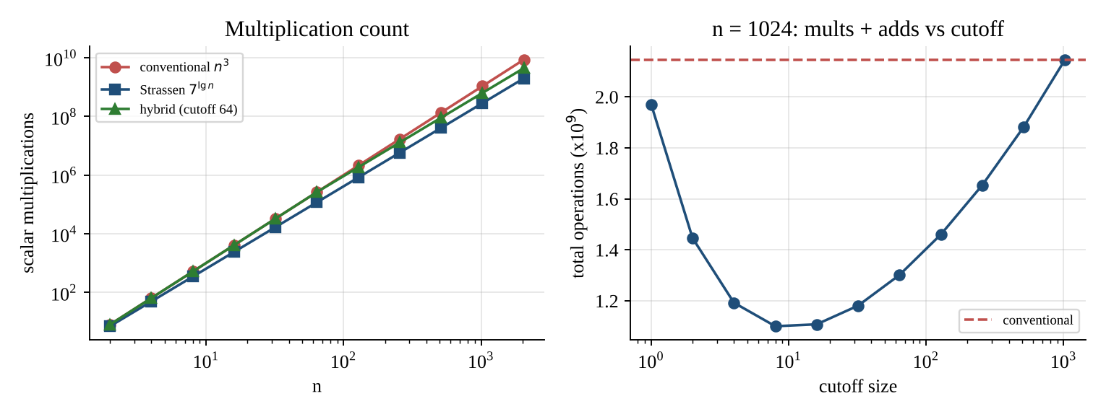
Figure 4. Multiplication counts versus n, and total operations versus cutoff for n = 1,024.
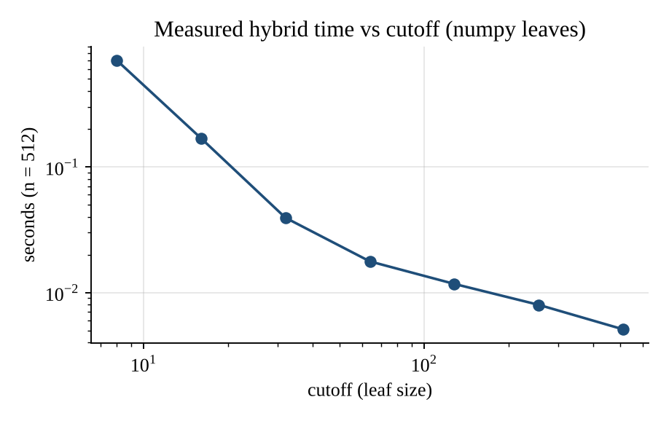
Figure 5. Measured time versus cutoff (n = 512, numpy leaves).

10. Limitations, Trade-offs and Recommendation
- Trade-off: about 26 % of the multiplications (full recursion) in exchange for more additions, 3n² extra memory, more complex code and weaker numerical stability.
- Recommendation: hybrid Strassen with a leaf size of 64–128 using an optimised kernel, enabled only if a benchmark on the real hardware shows a gain.
- Condition to change: if the matrices are sparse, or n is below roughly 1,000–2,000, or the library kernel is faster in the benchmark, use the plain blocked / BLAS multiplication.

