Department of Computer Science and Engineering

Final Design and Analysis
KartIQ: Divide-and-Conquer Engine | Parts (a) and (f)

Student Name | Shaik Shahid
Student Reg. No. | 192424311
Course Code & Name | CSA0607 - Design and Analysis of Algorithms
Assessment | CO3 - Case Study - Divide-and-Conquer Engine of KartIQ

1. Case Overview (Part a - all modules)
Module | Requirement | Key issues | Consequence of a poor choice
1 Order consolidation | Sort 10^7 orders by timestamp nightly | Stability by gateway, worst-case guarantee, O(n) memory, may exceed RAM | O(n^2) sorts need about 5 x 10^13 comparisons; unstable sort breaks auditing
2 Seller leaderboard | Re-sort 10^5 nearly sorted scores every few seconds | Worst case on sorted data, recursion depth, in-place memory | About 5 x 10^9 comparisons per refresh; freeze and stack overflow
3 Order lookup | Find first order with a timestamp in 10^7 sorted orders | Sorted precondition, duplicates, boundaries | 10^7 comparisons per linear lookup; wrong results if unsorted or if the first duplicate is not returned
4 Recommendation scores | C = A x B, n = 1,024 | n^3 cost, memory, power-of-two size, extra additions, stability | 1.07 x 10^9 multiplications per refresh; pure Strassen has overhead that can cancel the saving

2. Final Algorithmic Design (Part f)
Module | Chosen algorithm | Time complexity | Extra memory | Reason for choice
1 | Stable Merge Sort (external k-way merge if data > RAM) | Theta(n log n) in all cases; about 2.2 x 10^8 comparisons for 10^7 | O(n): about 160 MB buffer for 16-byte records; k block buffers when external | Only choice that is both stable and has a guaranteed worst case
2 | Quick Sort with median-of-three pivot, recursion on the smaller side (insertion sort for tiny partitions) | Best/average Theta(n log n) (about 1.66 x 10^6 comparisons for 10^5); worst Theta(n^2) for adversarial input | O(log n) stack | In place, fast in practice, nearly sorted input is balanced by the pivot
3 | Binary Search, first-occurrence (lower-bound) version | Theta(log n); at most 24 comparisons for 10^7 | O(1) | Needs only the sorted list from Module 1 and returns the first duplicate
4 | Hybrid Strassen (cutoff 64, conventional/BLAS below) | Theta(n^2.81) above the cutoff; 629,407,744 multiplications for n = 1,024 | O(n^2): temporary matrices, about 24 MiB for A, B, C plus buffers | Fewer multiplications than conventional without the overhead of recursing to 1 x 1

3. Main Trade-off and Condition to Change Each Decision
Module | Main trade-off | One condition under which the choice changes
1 | Memory (O(n) buffer) and a slightly slower constant factor in exchange for stability and a worst-case guarantee | If the feed already arrives as long sorted runs, use natural merge sort (Timsort), which is close to O(n); if data exceed RAM, switch to the external version
2 | No worst-case guarantee and not stable, in exchange for in-place speed | If scores can be crafted by sellers (adversarial input) or hard real-time limits apply, use introsort / Heap Sort fallback; if only a few scores change, use insertion sort or update only the changed sellers
3 | Requires a sorted array that must be rebuilt/merged when new orders arrive | If lookups are by unique order ID or inserts are frequent, use a hash index or B-tree
4 | Fewer multiplications in exchange for more additions, O(n^2) temporary memory, and weaker numerical stability | If n is below about 256, hardware has tuned BLAS/GPU kernels, or matrices are sparse, use the vendor routine (as measured here, BLAS equals the best cutoff at n = 512)

4. Algorithm Comparison
Algorithm | Best | Average | Worst | Extra space | Stable | Key requirement
Merge Sort | n log n | n log n | n log n | O(n) | Yes | None
Quick Sort (first pivot) | n log n | n log n | n^2 | O(n) stack worst case | No | Avoid sorted input
Quick Sort (median-of-three) | n log n | n log n | n^2 (rare) | O(log n) | No | None
Binary Search | 1 | log n | log n | O(1) | - | Sorted array
Conventional multiplication | n^3 | n^3 | n^3 | O(1) beyond result | - | None
Strassen (hybrid) | n^2.81 | n^2.81 | n^2.81 | O(n^2) | - | Power-of-two size (or padding)

5. Operations per Run: Baseline versus Chosen Design
Module | Naive baseline | Chosen design | Improvement
1 (10^7 orders) | Insertion sort worst case 5.0 x 10^13 comparisons | Merge Sort 2.2 x 10^8 comparisons | about 225,000 x fewer
2 (10^5 scores) | First-pivot Quick Sort 5.0 x 10^9 comparisons | Median-of-three about 1.7 x 10^6 comparisons | about 3,000 x fewer
3 (10^7 orders) | Linear search 10^7 comparisons | Binary search 24 comparisons | about 416,000 x fewer
4 (n = 1,024) | Conventional 1.07 x 10^9 multiplications | Hybrid Strassen 6.29 x 10^8 multiplications | 41.4% fewer

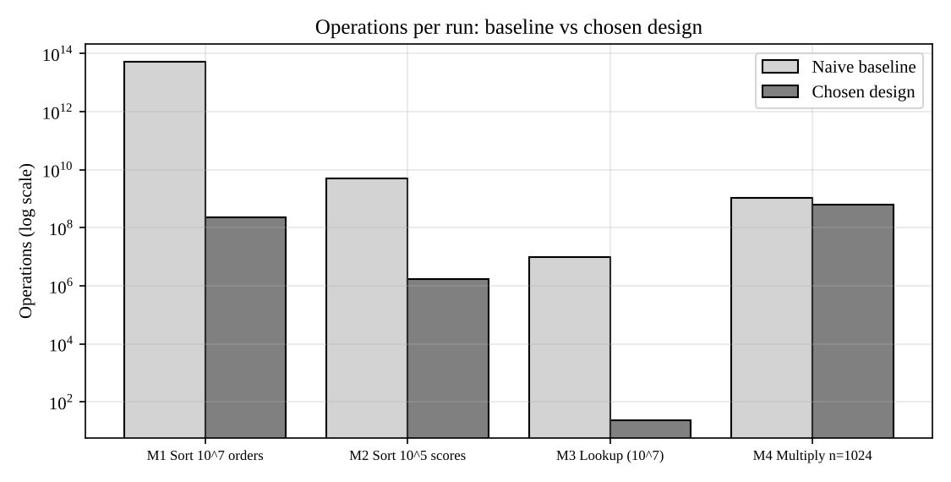
Figure: operations per run, baseline versus chosen design (log scale)

6. Memory Requirements (production workloads)
Module | Data | Extra memory of chosen design
1 | 10^7 x 16 B = 160 MB (assumed compact record) | 160 MB merge buffer; external version: k block buffers + disk for runs
2 | 10^5 scores x 8 B = 0.8 MB | O(log n), about 17 stack frames
3 | Sorted list of Module 1 (160 MB) | O(1): a few variables
4 | A, B, C: 3 x 8 MiB = 24 MiB | about 1-2 additional matrices with buffer reuse

7. Recommendations
- Deploy the four designs together: Module 1 produces the stable sorted order that Module 3 depends on; do not replace Module 1 with an unstable sort.
- Validate every release by comparing the output with a trusted library sort / bisect / numpy product (the supplied programs do this).
- Add the safeguards named above (introsort fallback for the leaderboard, external merge for large days, tuned BLAS cutoff for multiplication) and benchmark on production hardware before fixing the final parameters.
- Assumptions to confirm: 16-byte records, about 10^8 comparisons per second and the matrix cutoff are estimates; production values must be measured.

