Department of Computer Science and Engineering

Module 1 - Merge Sort for Nightly Order Consolidation
KartIQ: Retail Data Analytics Platform | Part (a) and Part (b)

Student Name | Shaik Shahid
Student Reg. No. | 192424311
Course Code & Name | CSA0607 - Design and Analysis of Algorithms
Assessment | CO3 - Case Study - Divide-and-Conquer Engine of KartIQ

1. Case Understanding (Part a)
Item | Analysis
Computational requirement | Sort about 10,000,000 orders per night by timestamp for the audit report, before the reporting deadline.
Key issues | (i) Stability: orders with the same second from different payment gateways must keep arrival order, because auditors reconcile gateway by gateway. (ii) Guaranteed running time: the report must finish every night, so the worst case matters, not only the average. (iii) Memory: out-of-place sorting needs an extra buffer. (iv) The data may be larger than RAM.
Consequence of a poor algorithm | Insertion/selection sort needs up to n(n-1)/2 = 5 x 10^13 comparisons for n = 10^7, so the report misses its deadline. An unstable sort (e.g. Quick Sort) can reorder equal-timestamp orders and break the auditors' gateway-by-gateway reconciliation; Quick Sort also has an O(n^2) worst case.

2. Divide, Conquer and Combine (Part b)
- Divide: split the array A[p..r] at the midpoint q = floor((p+r)/2) into two halves of size about n/2. This costs O(1).
- Conquer: sort each half recursively. A sub-array with 0 or 1 elements is the base case and is already sorted.
- Combine: merge the two sorted halves using a single left-to-right pass over both. The merge costs at most n - 1 comparisons for n elements.
- Why it is stable: in MERGE, when L[i].timestamp == R[j].timestamp the element of the LEFT half is copied first (test uses <=). The left half always holds the earlier arrivals, so equal timestamps keep their arrival order.

3. Pseudocode
MODULE 1 - STABLE MERGE SORT (orders sorted by timestamp)
Student: Shaik Shahid | Reg. No. 192424311 | CSA0607

MERGE-SORT(A, p, r)
1 if p < r // base case: 0 or 1 element is already sorted
2 q = floor((p + r) / 2) // DIVIDE : split A[p..r] into two halves
3 MERGE-SORT(A, p, q) // CONQUER : sort left half
4 MERGE-SORT(A, q + 1, r) // CONQUER : sort right half
5 MERGE(A, p, q, r) // COMBINE : merge two sorted halves

MERGE(A, p, q, r)
1 n1 = q - p + 1 ; n2 = r - q
2 let L[1..n1] and R[1..n2] be new arrays // auxiliary memory O(n)
3 for i = 1 to n1: L[i] = A[p + i - 1]
4 for j = 1 to n2: R[j] = A[q + j]
5 i = 1 ; j = 1 ; k = p
6 while i <= n1 and j <= n2
7 if L[i].timestamp <= R[j].timestamp // "<=" : on a tie take LEFT element (earlier arrival)
8 A[k] = L[i] ; i = i + 1 // -> this single operator makes the sort STABLE
9 else
10 A[k] = R[j] ; j = j + 1
11 k = k + 1
12 while i <= n1: A[k] = L[i] ; i = i + 1 ; k = k + 1
13 while j <= n2: A[k] = R[j] ; j = j + 1 ; k = k + 1

Recurrence : T(n) = 2 T(n/2) + (n - 1) , T(1) = 0 -> T(n) = n lg n - n + 1 = Theta(n log n)
Space : O(n) auxiliary (L and R) + O(log n) recursion stack

4. Execution Trace on the Sample Orders
Input (timestamp, order ID): (105,O1), (102,O2), (105,O3), (101,O4), (102,O5), (103,O6). Using indices 0-5:
Step | Operation | Result
1 | Divide [O1 O2 O3 O4 O5 O6] | [105-O1, 102-O2, 105-O3] | [101-O4, 102-O5, 103-O6]
2 | Divide left | [105-O1] | [102-O2, 105-O3]
3 | Divide [102-O2, 105-O3] | [102-O2] | [105-O3]
4 | MERGE 1: [102-O2] + [105-O3] | [102-O2, 105-O3] (1 comparison)
5 | MERGE 2: [105-O1] + [102-O2, 105-O3] | [102-O2, 105-O1, 105-O3] (2 comparisons; 105-O1 vs 105-O3 is a tie, left element O1 is taken first)
6 | Divide right: [101-O4] | [102-O5, 103-O6]; divide [102-O5, 103-O6] | [102-O5] | [103-O6]
7 | MERGE 3: [102-O5] + [103-O6] | [102-O5, 103-O6] (1 comparison)
8 | MERGE 4: [101-O4] + [102-O5, 103-O6] | [101-O4, 102-O5, 103-O6] (2 comparisons)
9 | MERGE 5 (final): left [102-O2, 105-O1, 105-O3] + right [101-O4, 102-O5, 103-O6] | [101-O4, 102-O2, 102-O5, 103-O6, 105-O1, 105-O3] (3 comparisons)

Total comparisons = 1 + 2 + 1 + 2 + 3 = 9 (program output confirms 9). In the final merge: 102-O2 vs 101-O4 takes 101-O4; 102-O2 vs 102-O5 is a tie, so the LEFT element O2 is taken first; then 105-O1 vs 102-O5 takes O5; 105-O1 vs 103-O6 takes O6; the right half is exhausted and O1, O3 are copied.

Stability demonstration
Timestamp | Arrival order | Order after sort | Stable?
102 | O2, O5 | O2, O5 | Yes
105 | O1, O3 | O1, O3 | Yes

If the tie test were '<' instead of '<=', the right element would be copied first on equal keys and O5 would precede O2 (and O3 would precede O1): this would break the auditors' reconciliation.

5. Recurrence and Solution
Each call does the divide in O(1), two recursive calls on n/2 elements, and a merge of at most n - 1 comparisons:
T(n) = 2 T(n/2) + (n - 1), T(1) = 0
Expansion for n = 2^k:
T(n) = 2T(n/2) + n - 1 = 4T(n/4) + 2n - 3 = 8T(n/8) + 3n - 7 = ... = 2^k T(1) + k n - (2^k - 1)
T(n) = n lg n - n + 1 = Theta(n log n)
Check with the Master Theorem: a = 2, b = 2, f(n) = Theta(n) = Theta(n^(log_b a)) = Theta(n), Case 2, so T(n) = Theta(n log n). Recursion tree: lg n + 1 levels; the merges at every level cost at most n comparisons in total. Merge Sort has the same Theta(n log n) in the best, average and worst case (the best case is about half as many comparisons, (n lg n)/2).

6. Estimate for n = 10,000,000 Orders
- lg(10^7) = 23.2535.
- Upper bound n lg n - n + 1 = 232,534,967 - 10,000,000 + 1 = 222,534,968, about 2.2 x 10^8 comparisons. The exact worst-case figure for n not a power of two is n*ceil(lg n) - 2^ceil(lg n) + 1 = 10^7 x 24 - 16,777,216 + 1 = 223,222,785, about 2.23 x 10^8.
- At an assumed 10^8 comparisons per second this is roughly 2-3 seconds of comparison work in compiled code; real time is dominated by memory and disk traffic.
- Insertion sort would need about 5 x 10^13 comparisons, which is more than 200,000 times as many.

7. Memory Requirement and Data That Does Not Fit in RAM
- In memory: assuming a compact 16-byte record (8-byte timestamp + 8-byte order ID), the data occupy 10^7 x 16 B = 160 MB and the merge buffer another 160 MB, so about 320 MB in total. Space complexity is O(n) auxiliary + O(log n) stack. Real order records are larger (for example 200 B gives about 2 GB data + 2 GB buffer), which motivates the external approach.
- External merge sort when data > RAM: (1) Run formation: read M records at a time (M fits in RAM), sort them with Merge Sort, write each sorted run to disk: n/M runs. (2) Multiway merge: merge k runs at once using a min-heap that holds one block from each run in memory; break ties on (timestamp, original arrival sequence/run number) so stability is kept. (3) Number of passes = 1 + ceil(log_k(n/M)). Example: n = 10^7, M = 10^6 gives 10 runs and a single 10-way merge, so the data are read and written only twice.
- Alternatives: sort only (timestamp, arrival-sequence, pointer) keys and fetch records afterwards; partition the day's orders by hour, sort each hour independently and concatenate (hours are already ordered by timestamp).

8. Experimental Results
n | Measured comparisons (random data) | n lg n - n + 1
1,000 | 8,693 | 8,967
10,000 | 120,511 | 122,878
100,000 | 1,536,330 | 1,560,965
500,000 | 8,837,162 | 8,965,785

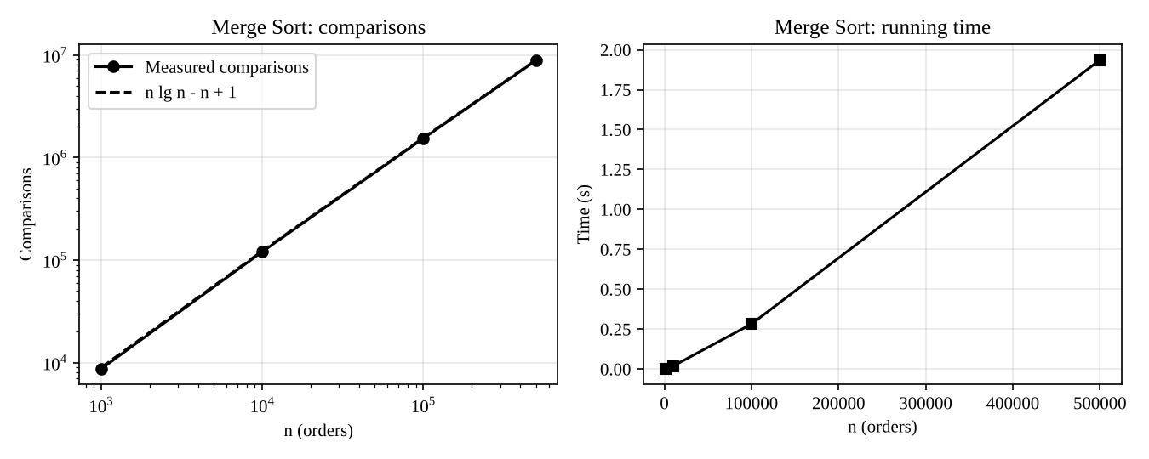
Figure: measured comparisons match n lg n - n + 1; running time grows as n log n

9. Limitations and Improvements
- Extra O(n) memory: use external merge sort, or an in-place stable merge (slower constant).
- Does not exploit existing order: use natural merge sort / Timsort when the feed arrives in sorted runs (about O(n) for presorted data).
- Use insertion sort for sub-arrays of size <= 16 and avoid copying by alternating source and destination arrays; the 10 gateways could sort in parallel and be merged with a 10-way merge.

10. Source Code Screenshots
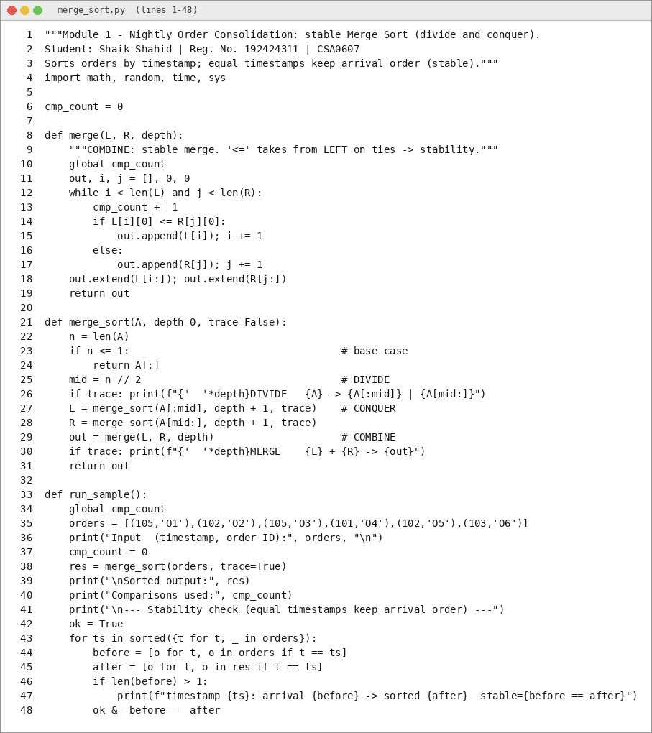
Figure: merge_sort.py (1 of 2)
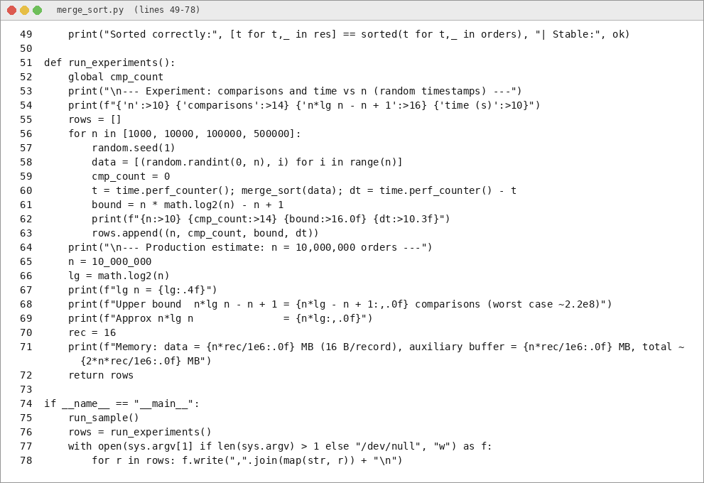
Figure: merge_sort.py (2 of 2)

11. Output Screenshots
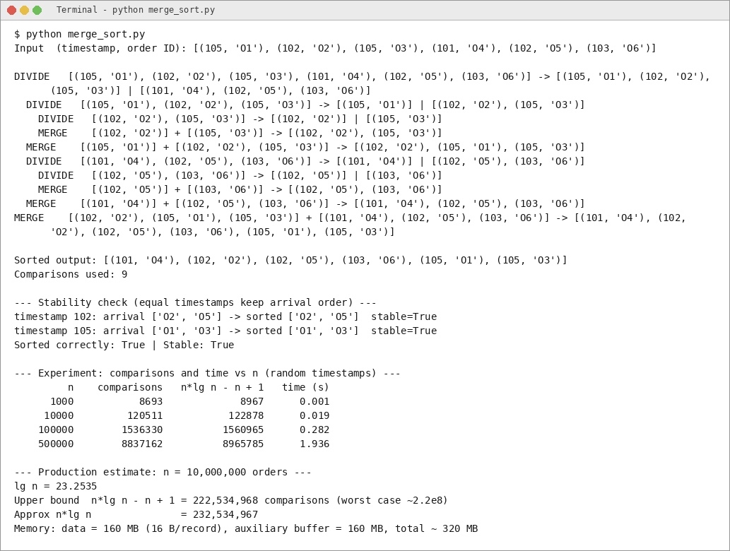
Figure: program output (1 of 1)

