Department of Computer Science and Engineering

Module 2 - Quick Sort for the Live Seller Leaderboard
KartIQ: Retail Data Analytics Platform | Part (a) and Part (c)

Student Name | Shaik Shahid
Student Reg. No. | 192424311
Course Code & Name | CSA0607 - Design and Analysis of Algorithms
Assessment | CO3 - Case Study - Divide-and-Conquer Engine of KartIQ

1. Case Understanding (Part a)
Item | Analysis
Computational requirement | Re-sort the scores of 100,000 sellers every few seconds, in place and quickly, on data that is almost always nearly sorted.
Key issues | (i) Worst-case behaviour: a first-element pivot on sorted or nearly sorted data gives very unbalanced partitions and O(n^2) work. (ii) Recursion depth up to n - 1 = 99,999 frames may overflow the stack. (iii) Memory: Quick Sort is in place, so no large buffer is needed. (iv) Stability is not needed (the scores are the keys).
Consequence of a poor algorithm | About n(n-1)/2 = 4,999,950,000 comparisons per refresh (about 3,000 times more than n lg n), so the leaderboard freezes in every sale event; deep recursion can even crash the service.

2. Divide, Conquer and Combine
- Divide: PARTITION chooses a pivot and rearranges the array so every score smaller than the pivot is to its left and the rest to its right; the pivot lands at its final position p.
- Conquer: sort the left part A[lo..p-1] and right part A[p+1..hi] recursively.
- Combine: nothing to do, because the sub-arrays are sorted in place and the pivot is already in its final position.

3. Pseudocode
MODULE 2 - QUICK SORT (live seller leaderboard)
Student: Shaik Shahid | Reg. No. 192424311 | CSA0607

--- A. Current implementation: first element as pivot ---
QUICKSORT(A, lo, hi)
1 if lo < hi
2 p = PARTITION(A, lo, hi) // DIVIDE : place pivot at its final index p
3 QUICKSORT(A, lo, p - 1) // CONQUER: sort scores smaller than pivot
4 QUICKSORT(A, p + 1, hi) // CONQUER: sort scores not smaller than pivot
// COMBINE: nothing to do (sorting is in place)

PARTITION(A, lo, hi) // pivot = A[lo]
1 pivot = A[lo] ; i = lo
2 for j = lo + 1 to hi
3 if A[j] < pivot
4 i = i + 1
5 swap A[i] with A[j]
6 swap A[lo] with A[i]
7 return i

--- B. Improved version: median-of-three pivot, recurse on smaller part ---
MEDIAN-OF-THREE(A, lo, hi)
1 mid = floor((lo + hi) / 2)
2 if A[mid] < A[lo] : swap A[mid], A[lo]
3 if A[hi] < A[lo] : swap A[hi], A[lo]
4 if A[hi] < A[mid]: swap A[hi], A[mid] // now A[lo] <= A[mid] <= A[hi]
5 swap A[lo] with A[mid] // median becomes the pivot at A[lo]

QUICKSORT-M3(A, lo, hi)
1 while lo < hi
2 if hi - lo >= 2 : MEDIAN-OF-THREE(A, lo, hi)
3 p = PARTITION(A, lo, hi)
4 if p - lo < hi - p // recurse on the SMALLER side only
5 QUICKSORT-M3(A, lo, p - 1) ; lo = p + 1
6 else
7 QUICKSORT-M3(A, p + 1, hi) ; hi = p - 1 // loop handles the larger side -> depth <= lg n

Best case : T(n) = 2T(n/2) + (n-1) = Theta(n log n)
Worst case : T(n) = T(n-1) + (n-1) = n(n-1)/2 = Theta(n^2) (sorted / nearly sorted data, first-element pivot)
Space : O(n) stack worst case (first-element pivot) ; O(log n) with smaller-side recursion

4. One Partition Step on the Sample Scores
Scores: 42, 17, 63, 8, 55, 29. Pivot = first element = 42, i = 0.
j | A[j] | Test A[j] < 42 | Action | Array after step
1 | 17 | Yes | i = 1, swap A[1] with A[1] | 42 17 63 8 55 29
2 | 63 | No | none | 42 17 63 8 55 29
3 | 8 | Yes | i = 2, swap A[2] with A[3] | 42 17 8 63 55 29
4 | 55 | No | none | 42 17 8 63 55 29
5 | 29 | Yes | i = 3, swap A[3] with A[5] | 42 17 8 29 55 63
end |  |  | swap pivot A[0] with A[3] | 29 17 8 42 55 63

The pivot 42 is now at index 3 with left part [29, 17, 8] and right part [55, 63]: 5 comparisons for 6 elements (n - 1). The sub-arrays are then sorted recursively; the whole sample needs 9 comparisons in total.

5. Why the First-Element Pivot Makes the Leaderboard Slow
Between two refreshes only a few scores change, so the array is already almost in order. The first element of a sorted array is its minimum: the partition then puts nothing on the left and n - 1 elements on the right. The next call has the same problem on n - 1 elements, and so on. The array is split into sizes 0 and n - 1 at every level instead of n/2 and n/2, so the recursion tree degenerates into a chain of depth about n. Each level still costs about n comparisons, giving n levels x n work = Theta(n^2). The depth is also n, so the stack grows to roughly 100,000 frames. Sorted-ness, which a human regards as 'easy', is the worst case for this pivot rule.

6. Recurrences and Solutions

Best case (balanced partitions)
T(n) = 2 T(n/2) + (n - 1), T(1) = 0 -> T(n) = n lg n - n + 1 = Theta(n log n)
Master Theorem: a = 2, b = 2, f(n) = Theta(n), Case 2.

Worst case (pivot is the minimum or maximum)
T(n) = T(n - 1) + (n - 1), T(1) = 0
T(n) = (n-1) + (n-2) + ... + 1 = n(n - 1)/2 = Theta(n^2)
Average case (random pivot) is about 2 n ln n = 1.39 n lg n comparisons, which is still Theta(n log n).

7. Estimate for 100,000 Nearly Sorted Sellers
Pivot rule | Comparisons for n = 100,000 | Notes
First element (worst case) | n(n-1)/2 = 4,999,950,000 | about 5 x 10^9; measured values reach 99.3% of this bound on nearly sorted data
Balanced partitions (best case) | n lg n = 100,000 x 16.61 = 1,660,964 | about 1.7 x 10^6
Median-of-three on nearly sorted data | about 1.66 x 10^6 plus 3 per partition | measured: 99,510 for n = 8,000 versus n lg n = 103,726
Ratio worst : best | about 3,010 : 1

8. Improved Pivot Strategy: Median-of-Three
Take the first, middle and last elements, order them, and use their median as the pivot (the pseudocode swaps it to A[lo]).
- Why it works: in a sorted or nearly sorted array the middle element is close to the true median, so the partition is nearly balanced and the recurrence becomes T(n) = 2T(n/2) + Theta(n). Measured on nearly sorted data, comparisons fall from 31.8 million to 99,510 for n = 8,000 (about 320 times fewer) and the time from 1.71 s to 0.009 s.
- Cost: three extra comparisons per partition, negligible.
- Memory: recursing on the smaller side and looping on the larger bounds the stack depth to lg n, so extra space is O(log n) (about 17 frames for 100,000 sellers).
- Remaining weakness: specially constructed 'median-of-three killer' inputs still give O(n^2). Safeguards: random pivot, or introsort (switch to Heap Sort when the depth exceeds 2 lg n), plus insertion sort for partitions of at most 16 elements.

9. Experimental Results (nearly sorted input, 50 adjacent swaps)
n | First pivot comparisons | n(n-1)/2 | Median-of-3 comparisons | n lg n | Time first (s) | Time median-of-3 (s)
500 | 112,079 | 124,750 | 4,210 | 4,483 | 0.0043 | 0.0003
1,000 | 472,923 | 499,500 | 9,427 | 9,966 | 0.0177 | 0.0006
2,000 | 1,940,868 | 1,999,000 | 20,872 | 21,932 | 0.0741 | 0.0015
4,000 | 7,885,062 | 7,998,000 | 45,751 | 47,863 | 0.3116 | 0.0037
8,000 | 31,766,596 | 31,996,000 | 99,510 | 103,726 | 1.6047 | 0.0122

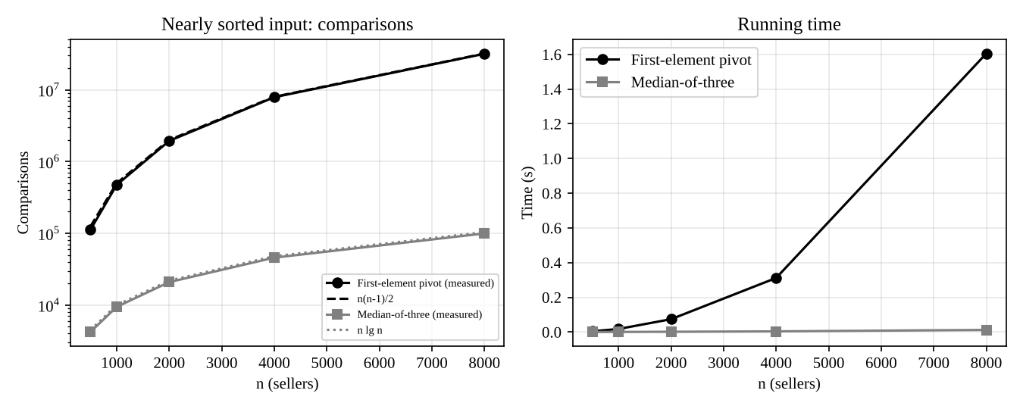
Figure: first-element pivot grows quadratically; median-of-three stays near n lg n

10. Limitations and Trade-offs
- Quick Sort is not stable and its worst case is not eliminated, only made unlikely.
- If only a handful of scores change, a full re-sort is wasteful: insertion sort costs O(n + inversions), or a balanced tree/heap can update only the changed sellers in O(log n) each.
- The leaderboard also only needs the top-K for display: a partial sort or Quick Select gives the top K in O(n).

11. Source Code Screenshots
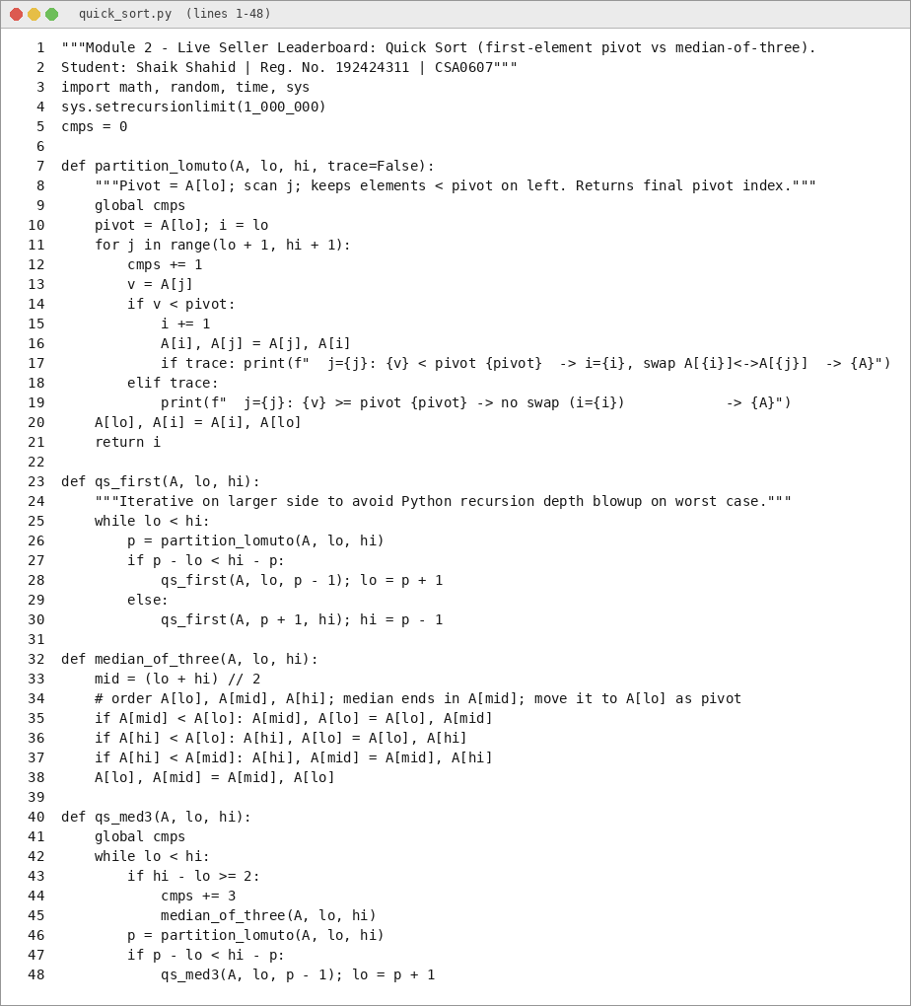
Figure: quick_sort.py (1 of 2)
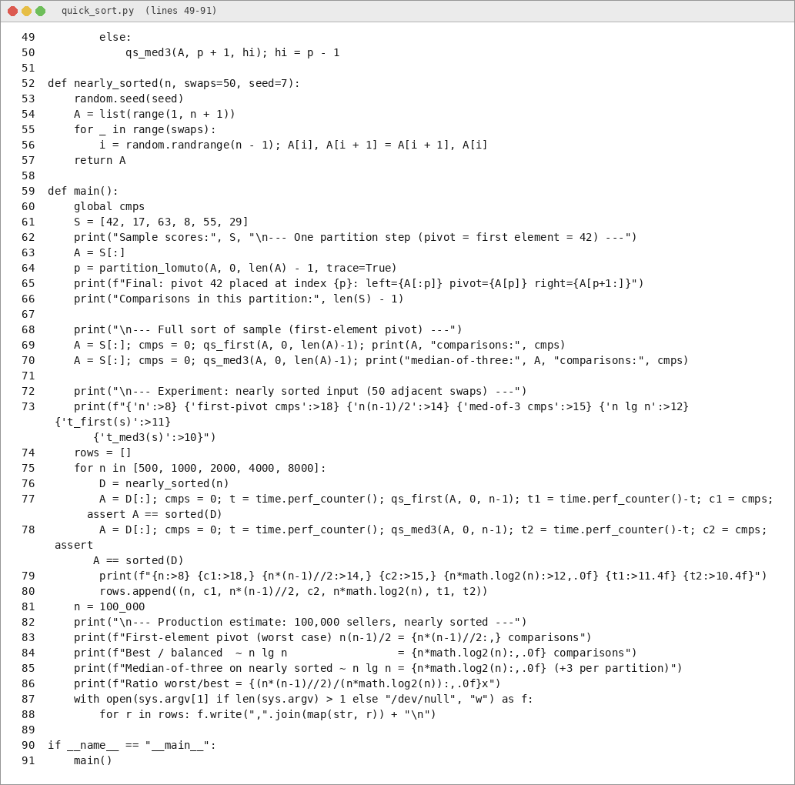
Figure: quick_sort.py (2 of 2)

12. Output Screenshots
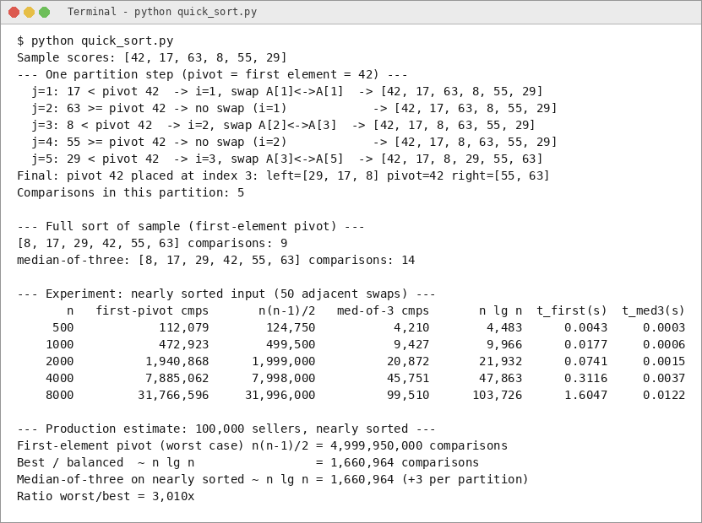
Figure: program output (1 of 1)

