Department of Computer Science and Engineering

Module 3 - Binary Search for Order Lookup
KartIQ: Retail Data Analytics Platform | Part (a) and Part (d)

Student Name | Shaik Shahid
Student Reg. No. | 192424311
Course Code & Name | CSA0607 - Design and Analysis of Algorithms
Assessment | CO3 - Case Study - Divide-and-Conquer Engine of KartIQ

1. Case Understanding (Part a)
Item | Analysis
Computational requirement | Find an order by timestamp in the consolidated list of about 10,000,000 orders in a fraction of a second; when several orders share the timestamp, return the first of them.
Key issues | (i) Sorted-data precondition: the list must be the sorted output of Module 1. (ii) Duplicates: standard binary search may return any matching order, not the first. (iii) Memory: the search needs only O(1) extra space. (iv) Boundary conditions and missing timestamps.
Consequence of a poor algorithm | Linear search needs up to 10,000,000 comparisons per lookup (against 24), so support staff wait seconds under load. Binary search on unsorted data returns wrong answers; returning a non-first duplicate gives staff the wrong order.

2. Divide, Conquer and Combine
- Divide: compare the key with the middle element A[mid].
- Conquer: discard the half that cannot contain the key and search the remaining half only (one recursive subproblem of size n/2).
- Combine: nothing to combine; the answer of the single sub-problem is the answer.

3. Why the Sorted Order from Module 1 Is Essential
Binary search throws away half of the array after one comparison. This is valid only if A[mid] < key implies that every element to the left of mid is also < key, which is exactly the sorted-order property. On unsorted data the discarded half may contain the key. Demonstration from the program: on the unsorted list (105,O1), (102,O2), (105,O3), (101,O4), (102,O5), (103,O6) a search for 101 returns 'not found' although 101 is at index 3. The sort in Module 1 must also be stable, because the 'first' order of a timestamp must be the first to arrive.

4. Pseudocode
MODULE 3 - BINARY SEARCH (order lookup by timestamp)
Student: Shaik Shahid | Reg. No. 192424311 | CSA0607

PRECONDITION: A[0..n-1] is sorted by timestamp (output of Module 1).

--- A. Standard binary search (returns ANY matching index) ---
BINARY-SEARCH(A, n, key)
1 lo = 0 ; hi = n - 1
2 while lo <= hi
3 mid = floor((lo + hi) / 2) // DIVIDE : choose the middle element
4 if A[mid].timestamp == key return mid
5 else if A[mid].timestamp < key
6 lo = mid + 1 // CONQUER: search right half only
7 else
8 hi = mid - 1 // CONQUER: search left half only
9 return -1 // COMBINE: nothing to combine (answer comes from one half)

--- B. First-occurrence search (leftmost order with the timestamp) ---
FIRST-OCCURRENCE(A, n, key)
1 lo = 0 ; hi = n - 1 ; result = -1
2 while lo <= hi
3 mid = floor((lo + hi) / 2)
4 if A[mid].timestamp == key
5 result = mid // remember this hit ...
6 hi = mid - 1 // ... but keep looking LEFT for an earlier one
7 else if A[mid].timestamp < key
8 lo = mid + 1
9 else
10 hi = mid - 1
11 return result // -1 if the timestamp does not exist

Recurrence : T(n) = T(n/2) + 1 , T(1) = 1 -> T(n) = floor(lg n) + 1 = Theta(log n)
Space : O(1) (iterative)

5. Recurrence and Solution
T(n) = T(n/2) + 1, T(1) = 1
Expansion: T(n) = T(n/4) + 2 = T(n/8) + 3 = ... = T(1) + k = k + 1 for n = 2^k, so
T(n) = lg n + 1 (in general floor(lg n) + 1) = Theta(log n)
Master Theorem: a = 1, b = 2, f(n) = Theta(1) = Theta(n^(log_2 1)), Case 2, so T(n) = Theta(log n). The best case is 1 comparison (key in the middle).

6. Maximum Comparisons for 10,000,000 Orders
floor(lg 10,000,000) + 1 = floor(23.2535) + 1 = 24
Check: 2^23 = 8,388,608 < 10^7 < 2^24 = 16,777,216, so at most 24 halvings are needed. Linear search needs up to 10,000,000 comparisons, so binary search is about 416,000 times fewer in the worst case.
n | Maximum comparisons floor(lg n)+1
1,000 | 10
10,000 | 14
100,000 | 17
1,000,000 | 20
10,000,000 | 24

7. Modification: Return the First Order with a Given Timestamp
When A[mid] equals the key we must not stop. We record mid as the current answer and continue in the LEFT half (hi = mid - 1), because an earlier order with the same timestamp can only be to the left. When the search ends the last recorded answer is the leftmost match; if nothing was recorded the result is -1.
Correctness invariant: every index < lo holds a timestamp < key, every index > hi holds a timestamp > key or is a recorded match, and 'result' is the smallest matching index seen so far. When lo > hi the interval is empty, so result is the first occurrence.

Trace on the consolidated sample list
Sorted list: 0:(101,O4) 1:(102,O2) 2:(102,O5) 3:(103,O6) 4:(105,O1) 5:(105,O3). Key = 102.
Step | lo | hi | mid | A[mid] | Action | result
1 | 0 | 5 | 2 | 102 | match: result = 2, search left (hi = 1) | 2
2 | 0 | 1 | 0 | 101 | 101 < 102: lo = 1 | 2
3 | 1 | 1 | 1 | 102 | match: result = 1, hi = 0 | 1
end | 1 | 0 |  |  | lo > hi: stop | 1

The result is index 1, order O2, the first arrival for timestamp 102 (standard binary search returned index 2, O5, in one comparison). For key 105 the search returns index 4 (O1); for the missing key 104 it returns -1. A test against Python's bisect_left on 200,000 random timestamps with many duplicates (5,000 random keys) gave 0 mismatches and at most 18 comparisons = floor(lg n) + 1.

8. Limitations and Improvements
- Requires a sorted array: new orders arriving after the nightly sort must be merged in (merge a small sorted batch, O(n)) or kept in a small separate structure that is searched first.
- The first-occurrence version always runs the full lg n iterations (no early exit) but it is still at most 24 comparisons.
- For frequent exact lookups by unique order ID a hash index (O(1) average) is faster; for range queries or frequent inserts use a B-tree. Use interpolation search only if timestamps are close to uniform.
- Use mid = lo + (hi - lo) / 2 in fixed-width integer languages to avoid overflow.

9. Experimental Results
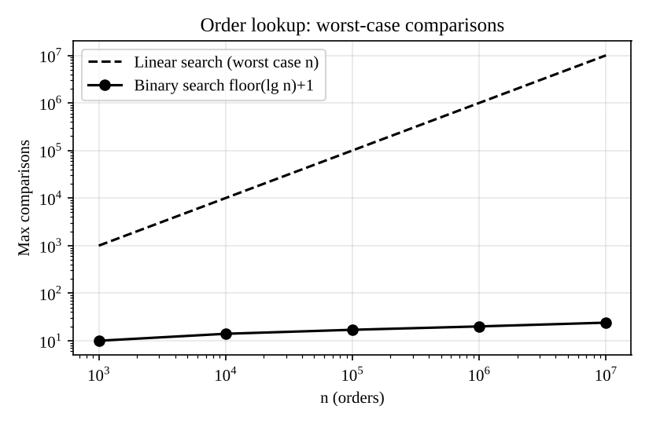
Figure: worst-case comparisons, binary versus linear search

10. Source Code Screenshots
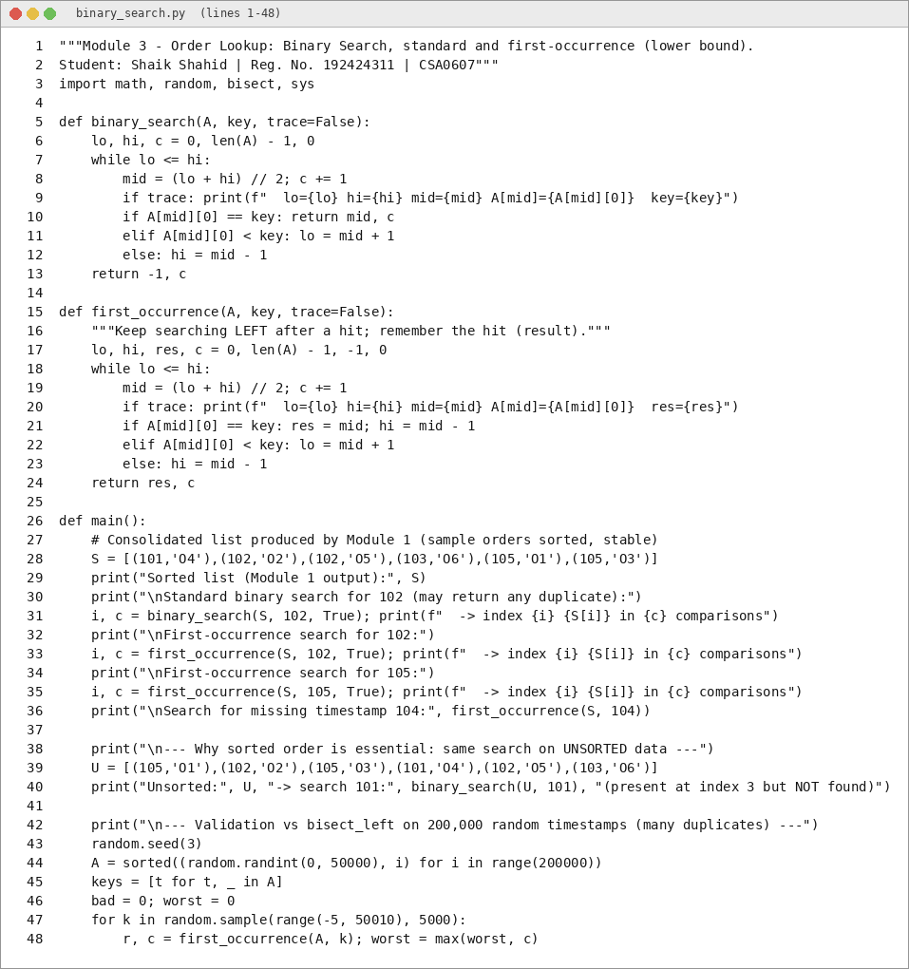
Figure: binary_search.py (1 of 2)
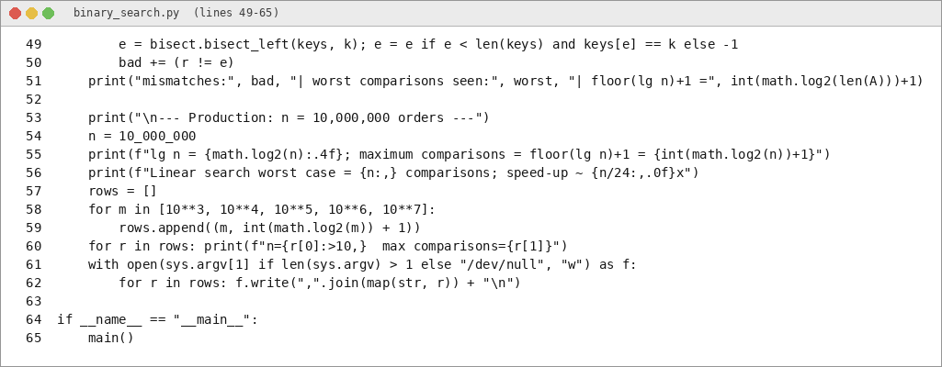
Figure: binary_search.py (2 of 2)

11. Output Screenshots
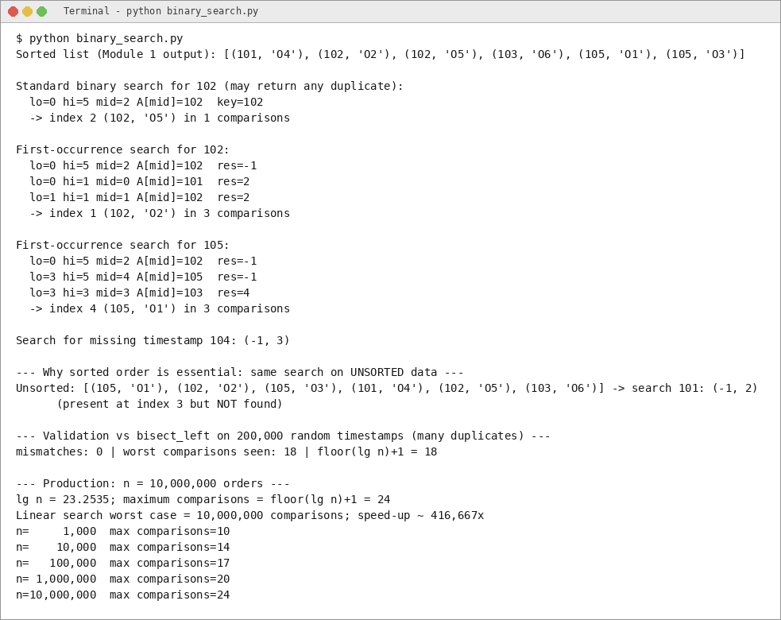
Figure: program output (1 of 1)

