Department of Computer Science and Engineering

Module 4 - Strassen's Method for Recommendation Scores
KartIQ: Retail Data Analytics Platform | Part (a) and Part (e)

Student Name | Shaik Shahid
Student Reg. No. | 192424311
Course Code & Name | CSA0607 - Design and Analysis of Algorithms
Assessment | CO3 - Case Study - Divide-and-Conquer Engine of KartIQ

1. Case Understanding (Part a)
Item | Analysis
Computational requirement | Compute C = A x B for n x n matrices with n = 1,024 (segments x features times features x products) so recommendations can be refreshed more often than once a day.
Key issues | (i) Matrix size: the conventional method needs n^3 = 1,073,741,824 multiplications. (ii) Memory: three 1,024 x 1,024 matrices of 8-byte values take 3 x 8 MiB = 24 MiB, and Strassen needs extra temporary matrices. (iii) Strassen needs n to be a power of two (1,024 = 2^10 qualifies; other sizes need padding). (iv) Extra additions and weaker numerical stability.
Consequence of a poor algorithm | The conventional triple loop wastes about 1.07 x 10^9 multiplications per refresh. A pure Strassen with recursion down to 1 x 1 saves multiplications but has heavy recursion, allocation and addition overhead and may be slower than an optimised conventional routine.

2. Divide, Conquer and Combine
- Divide: split A, B and C into four n/2 x n/2 blocks (index arithmetic only).
- Conquer: compute seven products M1..M7 recursively, instead of the eight needed by the conventional block method.
- Combine: build the four blocks of C from additions and subtractions of M1..M7 (O(n^2) work).

3. Seven Strassen Products and Reconstruction
M1 = (A11 + A22)(B11 + B22)
M2 = (A21 + A22) B11
M3 = A11 (B12 - B22)
M4 = A22 (B21 - B11)
M5 = (A11 + A12) B22
M6 = (A21 - A11)(B11 + B12)
M7 = (A12 - A22)(B21 + B22)

C11 = M1 + M4 - M5 + M7
C12 = M3 + M5
C21 = M2 + M4
C22 = M1 - M2 + M3 + M6

4. Verification on the 2 x 2 Sample
A = [[1, 7], [3, 5]], B = [[1, 3], [7, 5]], so A11 = 1, A12 = 7, A21 = 3, A22 = 5; B11 = 1, B12 = 3, B21 = 7, B22 = 5.
Product | Calculation | Value
M1 | (1 + 5)(1 + 5) | 36
M2 | (3 + 5)(1) | 8
M3 | 1 (3 - 5) | -2
M4 | 5 (7 - 1) | 30
M5 | (1 + 7)(5) | 40
M6 | (3 - 1)(1 + 3) | 8
M7 | (7 - 5)(7 + 5) | 24

Block | Formula | Value | Conventional check
C11 | M1 + M4 - M5 + M7 = 36 + 30 - 40 + 24 | 50 | 1x1 + 7x7 = 50
C12 | M3 + M5 = -2 + 40 | 38 | 1x3 + 7x5 = 38
C21 | M2 + M4 = 8 + 30 | 38 | 3x1 + 5x7 = 38
C22 | M1 - M2 + M3 + M6 = 36 - 8 - 2 + 8 | 34 | 3x3 + 5x5 = 34

C = [[50, 38], [38, 34]], identical to the conventional product, using 7 multiplications instead of 8. The program also verified the algorithm against the conventional product on a random 64 x 64 integer matrix pair (match = True).

5. Pseudocode
MODULE 4 - STRASSEN'S MATRIX MULTIPLICATION (C = A x B, n a power of 2)
Student: Shaik Shahid | Reg. No. 192424311 | CSA0607

STRASSEN(A, B, n, cutoff)
1 if n <= cutoff : return CONVENTIONAL(A, B) // hybrid base case (cutoff = 1 gives pure Strassen)
2 h = n / 2
3 split A into A11 A12 / A21 A22 and B into B11 B12 / B21 B22 // DIVIDE (index arithmetic only)
4 M1 = STRASSEN(A11 + A22, B11 + B22) // CONQUER: seven recursive products
5 M2 = STRASSEN(A21 + A22, B11)
6 M3 = STRASSEN(A11, B12 - B22)
7 M4 = STRASSEN(A22, B21 - B11)
8 M5 = STRASSEN(A11 + A12, B22)
9 M6 = STRASSEN(A21 - A11, B11 + B12)
10 M7 = STRASSEN(A12 - A22, B21 + B22)
11 C11 = M1 + M4 - M5 + M7 // COMBINE: 8 additions/subtractions of h x h blocks
12 C12 = M3 + M5
13 C21 = M2 + M4
14 C22 = M1 - M2 + M3 + M6
15 return [[C11, C12], [C21, C22]]

CONVENTIONAL(A, B)
1 for i = 1..n: for j = 1..n: C[i][j] = 0 ; for k = 1..n: C[i][j] += A[i][k] * B[k][j]
2 return C

Recurrence : M(n) = 7 M(n/2) , M(1) = 1 -> M(n) = 7^(lg n) = n^(lg 7) = n^2.807
Time : T(n) = 7 T(n/2) + 18 (n/2)^2 -> Theta(n^(lg 7))
Space : O(n^2) extra for the sums/differences and the seven products

6. Recurrences and Solutions
Multiplications: M(n) = 7 M(n/2), M(1) = 1 -> M(n) = 7^(lg n) = n^(lg 7) = n^2.807
Running time: T(n) = 7 T(n/2) + 18 (n/2)^2 = 7 T(n/2) + Theta(n^2)
Master Theorem: a = 7, b = 2, f(n) = Theta(n^2); n^(log_2 7) = n^2.807 grows faster than n^2 (Case 1), so T(n) = Theta(n^(lg 7)) = Theta(n^2.81). Conventional method: Theta(n^3). Additions: A(n) = 7A(n/2) + 4.5 n^2 gives A(n) = 6(n^(lg 7) - n^2).

7. Comparison for n = 1,024
Method | Scalar multiplications | Additions | Total arithmetic operations | Fraction of conventional
Conventional | 1,073,741,824 (n^3) | 1,072,693,248 | 2,146,435,072 | 1.000
Strassen to 1 x 1 | 282,475,249 (7^10) | 1,688,560,038 | 1,971,035,287 | 0.918
Hybrid, cutoff 64 | 629,407,744 (7^4 x 64^3) | 672,288,768 | 1,301,696,512 | 0.606

- Pure Strassen cuts multiplications by 1 - 282,475,249 / 1,073,741,824 = 73.7% (ratio 0.263).
- But the additions rise from about 1.07 x 10^9 to about 1.69 x 10^9, so the total saving in arithmetic is only 8.2%.
- The hybrid with cutoff 64 performs 4 levels of Strassen and conventional multiplication on 64 x 64 blocks: 41.4% fewer multiplications and 39.4% fewer total operations.

8. Why Strassen May Still Not Be Faster in Practice, and a Practical Hybrid
- 18 matrix additions per level add memory traffic that is slower than a multiply-add on modern CPUs with fused multiply-add and SIMD.
- Recursion and temporary-matrix allocation overhead; poor cache reuse compared with blocked, vendor-tuned BLAS.
- Numerical stability is weaker than for the conventional method (larger error bounds with floating-point scores).
- Requires padding to a power of two for other n; extra memory O(n^2).
- The asymptotic advantage appears only above a break-even size, typically a few hundred or more.
Measured on n = 512 (Python/numpy base case, see table): recursing down to small blocks is very slow (cutoff 8: 0.533 s), the time falls steadily as the cutoff rises, and with a cutoff of 256 it equals optimised BLAS (0.007 s). In this benchmark the base case is already a highly tuned library routine, so Strassen cannot beat it: this confirms that the cutoff must be tuned to the platform.
Cutoff | Time (s), n = 512 | Scalar multiplications
8 | 0.623 | 60,236,288
16 | 0.105 | 68,841,472
32 | 0.030 | 78,675,968
64 | 0.015 | 89,915,392
128 | 0.011 | 102,760,448
256 | 0.007 | 117,440,512
BLAS A@B | 0.0071 | 134,217,728

Proposed hybrid: use Strassen recursion only while n > cutoff (design value 64, tuned per machine between 64 and 256) and call the conventional / BLAS routine for blocks of size cutoff or smaller. Pad n to the next power of two (not needed for 1,024), reuse temporary buffers to bound extra memory, and parallelise the seven products. With cutoff 64 this performs 629,407,744 multiplications, 41.4% fewer than conventional.
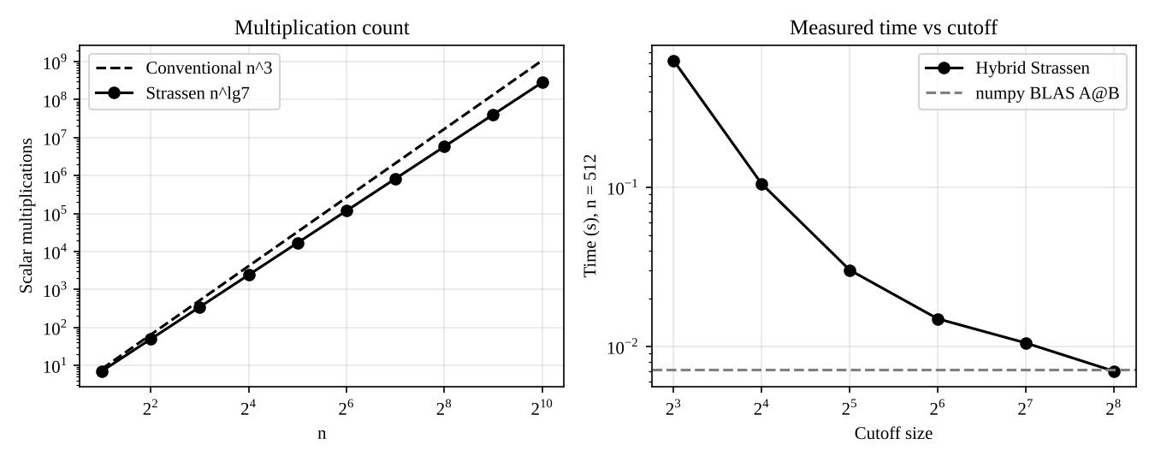
Figure: multiplication counts (left) and measured time versus cutoff (right)

9. Memory
- A, B and C at n = 1,024 with 8-byte values: 3 x 1,024^2 x 8 B = 24 MiB (12 MiB with float32).
- Strassen needs temporary matrices at each level: with buffer reuse the extra space is O(n^2), a constant multiple (about 1-2 times) of one matrix; a naive implementation that allocates new sums at every level uses more and costs allocation time.

10. Source Code Screenshots
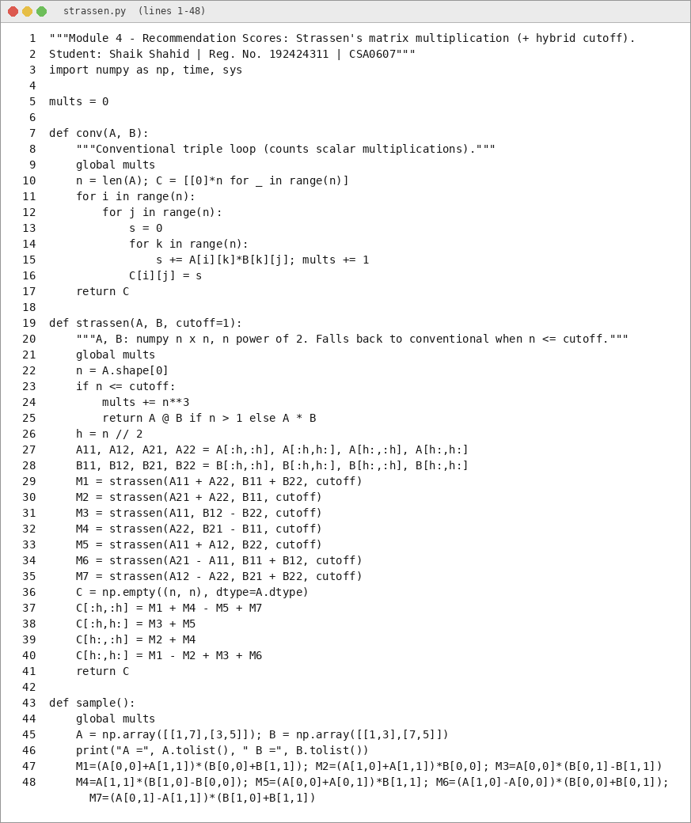
Figure: strassen.py (1 of 3)
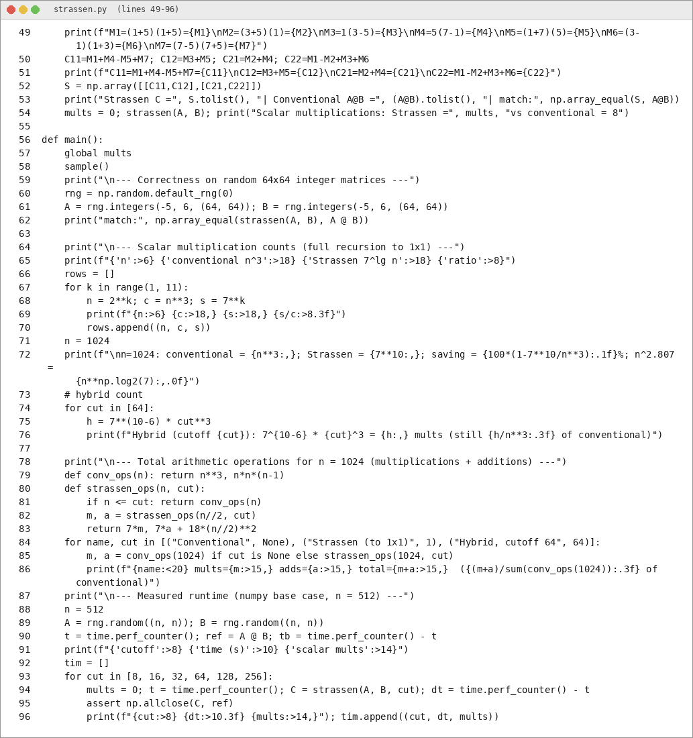
Figure: strassen.py (2 of 3)
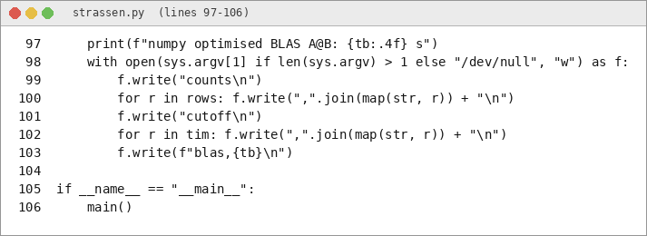
Figure: strassen.py (3 of 3)

11. Output Screenshots
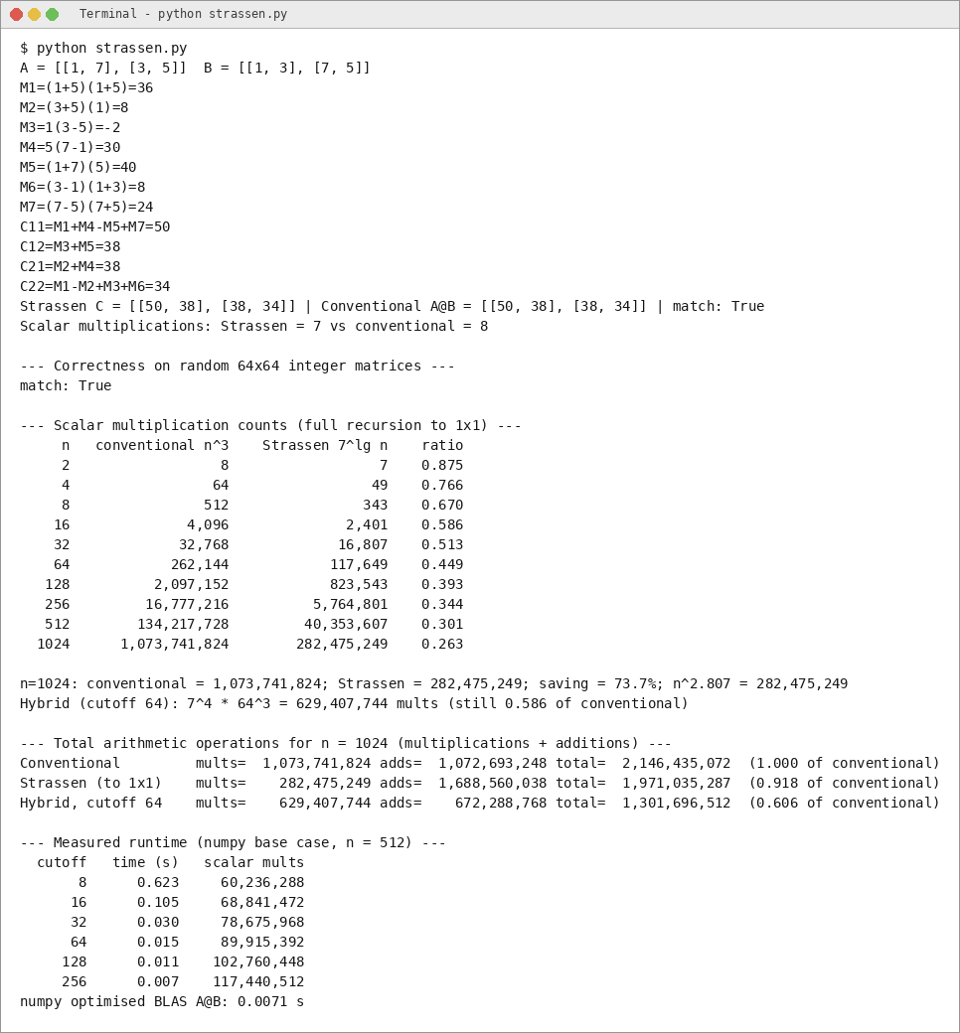
Figure: program output (1 of 1)

