**INTERSHIP REPORT**

**ON**

**PYTHON PROJECT ON COMPITATIVE CODING**

**A intership Report is submitted**

**In accordance with requirement of degree of**

**BACHELOR OF TECHNOLOGY**

**IN**

**ELECTRICAL AND ELECTRONICS ENGINEERING**

Submitted by

SK. SHAHID

21KQ1A0257

Under the Mentorship of

**M. SRAVAN MANTRI**

** Professor**

**DEPARTMENT OF ELECTRICAL AND EL ECTRONICS ENGINEERING**

PACE INSTITUTE OF TECNOLOGY AND SCIENCES (AUTONOMOUS)

(Affiliated to Jawaharlal Nehru Technological University Kakinada, Kakinada &

Accredited by NAAC ‘A’ GRADE,An ISO 9001-2015 Certified Institution)

NH-16, Valluru Post , Prakasam District, A.P-523272.

Project title

Shopper Trend Analysis

**Abstract:**

This document provides an overview of the processes involved in creating a supermarket shopping list and generating a corresponding bill. The supermarket shopping list is an essential tool for consumers to plan their purchases, manage their budget, and ensure they obtain all necessary items during their visit to the store. The generation of the bill is a crucial step that summarizes the purchased items, calculates the total cost

**Description:**

Our project is about the supermarket items list and their prices,mainly the items choosed by customers are added and generate the bill for those selected items. A supermarket shopping list is a detailed inventory of items a consumer plans to purchase during their visit to a supermarket. This list serves multiple purposes, including budget management, ensuring all necessary items are bought, and minimizing the time spent in the store. Here are the key components and steps involved in creating a supermarket shopping list

**Functional Requirements:**

• **User Interface**:

* Options to add, view, update items from the shopping list.
* Option to generate the final bill.

• **Shopping List Management**:

* Add items to the shopping list with details such as name,quantity,price.
* Edit existing items (change quantity, update name/category).
* Display the current shopping list.

• **Billing System**:

* Store prices for each item.
* Calculate the total cost of items in the shopping list.
* Generate a detailed bill showing itemized costs, total cost, and final amount payable.

**Technical Requirements**

1. **Python Standard Libraries**:
   * Use built-in libraries such as def for handling functions and OS for file operations.
2. **Data Storage**:
   * Use a simple data storage approach like lists or dictionaries to store items and their details.
3. **Modular Code**:
   * Functions to handle different tasks like adding items, calculating totals, and generating bills.
   * A main function to drive the program and handle user inputs.

**Non Requirements**

**1.Advanced Security Features**:

Advanced security measures such as encryption, user authentication, or access control are not required. The program will be a local, single-user application.

**2. Mobile App Development**:

Creating a mobile version of the application or integrating with mobile platforms is not required.

**3.Complex Error Handling**:

While basic error handling is necessary, implementing complex error recovery mechanisms is not required.

**4.Offline Access/Syncing**:

He program does not need to support offline access or data synchronization across multiple devices.

**Approach:**

**Define Objectives and Scope:**

1. **Objectives**:
   * Identify shopping patterns and trends.
   * Understand customer preferences.
   * Optimize inventory and marketing strategies.
2. **Scope**:
   * Determine the types of data to be collected (e.g., demographics, product details).

**Data Collection**

1. **Sources**:
   * Customer relationship management (CRM) systems for demographic data.
   * Online sources (e.g., e-commerce websites, social media).
2. **Data Points**:
   * Customer details: age, gender, location, membership status.
   * Product details: category, brand, price.

**Trend Analysis**

1. **Time Series Analysis**:
   * Decompose time series data into trend, seasonal, and residual components.
   * Apply smoothing techniques (e.g., moving average) to identify trends.
2. **Segmentation**:
   * Segment customers based on purchasing behavior using clustering algorithms (e.g., K-means, hierarchical clustering).
   * Identify key segments such as high-value customers, frequent shoppers, and seasonal buyers.

**Program:**

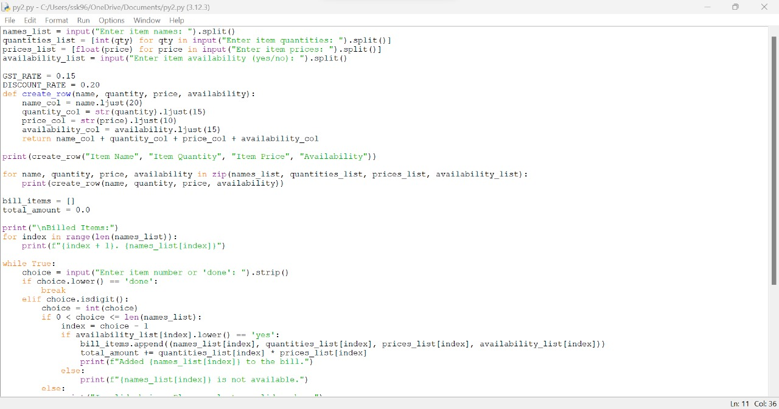

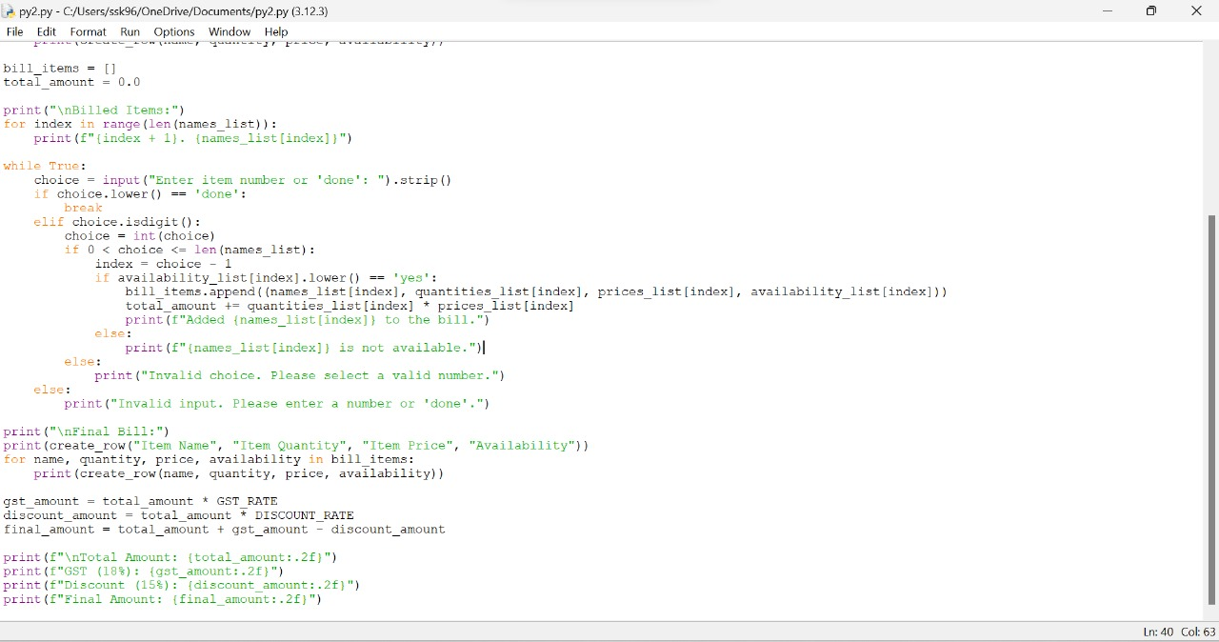

**Out Put:**

