Project Documentation
Automated Car Catalog System For Enhanced Showroom Management
(ServiceNow Administration)

Team Details
- Team ID: LTVIP2026TMIDS36395
- Team Size: 4
- Team Leader: Muppana John Joshua
- Team Member: Akula Ravi Chandra
- Team Member: Satti Bhargavi
- Team Member: Shaik Shajith

INTRODUCTION

Project Overview
The automobile showroom industry often faces challenges in managing requests for vehicle details and bookings. Manual systems can lead to errors, slow processing, and poor customer experience. This project aims to build a structured and automated car catalog system using ServiceNow to streamline vehicle listing, customer ordering, approval workflows, and notifications.

Purpose
The purpose is to replace inefficient manual car booking and catalog systems with a digital platform using ServiceNow's Service Catalog and Workflow capabilities. Customers can easily request cars like Polo, Thar, and XUV700, while the backend team can manage tasks, approvals, and communications more efficiently.

IDEATION PHASE

Problem Statement
Manual car booking methods in showrooms often lead to confusion, delayed approvals, and lack of centralized data. Customers face issues with unclear communication and tracking. Our project digitizes this process to bring clarity, automation, and efficiency.

Empathy Map Canvas
  - Who? Customers and showroom staff (sales team, managers)
  - Think/Feel? Customers feel unsure about request status; staff overwhelmed by manual tracking.
  - See? Delays, lack of transparency
  - Say/Do? Repeated follow-ups, paper-based requests
  - Hear? Complaints about service delays
  - Pain? No proper catalog, inefficient approval
  - Gain? Seamless request process, automated updates

Brainstorming
Considered:
  - Using paper/manual booking
  - Excel-based logs
  - ServiceNow Catalog System – chosen for scalability, automation, and integration potential.

REQUIREMENT ANALYSIS

Customer Journey Map
The customer journey begins when a user logs into the ServiceNow portal. They navigate to the Mahendra car catalog, browse through the available models under various categories, and select the desired car. Upon submitting the request, an automated workflow is triggered that handles approval and task assignment. Based on the outcome, a notification is sent, and the car is marked for delivery.

Flow:
Customer logs in → Browses car catalog → Selects model → Submits request → Workflow triggered → Task assigned and processed → Notification sent → Car delivered

Solution Requirements
To meet the needs of a streamlined and automated car request process, the following components were required:
- A custom catalog named "Mahendra"
- Categories: Sudden, XUV, Sports
- Items: Polo, Thar, XUV700
- Images, descriptions, and pricing for each item
- Approval workflow (2 levels)
- Task assignments and completion tracking
- Notification on approval or rejection

Data Flow Diagram

User→Service Portal→Catalog→Request Form→Workflow→Task Table
↓

Notification → Mail → User/Group

Technology Stack
- Platform: ServiceNow
- Languages/Scripting: JavaScript (using Glide APIs), HTML for email templates

Modules Used:
  - Service Catalog
  - Workflow Editor
  - Notification
  - Roles and Groups
  - Tables (Task Extension)
- Testing Method: Manual testing performed through the ServiceNow Service Portal to validate functionality, request processing, and email triggers

PROJECT DESIGN

Problem-Solution Fit

The traditional method of manually processing car requests in showrooms often results in delays, miscommunication, and inefficient tracking. The Mahendra Car Catalog System solves this by introducing a categorized, searchable online catalog with automated workflows. This ensures requests are handled quickly, approvals are structured, and customers receive timely updates. It enhances operational transparency, reduces manual errors, and significantly improves the overall request experience for both customers and staff.

Proposed Solution
To address the problem effectively, the following components were implemented:

Catalog Setup: A central catalog named “Mahendra” to manage all car-related items.
  - Categories: Three organized categories – Sudden, XUV, and Sports – to make browsing easier.
  - Catalog Items: Three car models – Polo, Thar, and XUV700 – with rich descriptions, images, and pricing details.
  - Roles: A custom role emp1 was created to define specific user access and permissions.
  - Groups: A showroom group was set up, managed by Abraham Lincoln, with relevant members added for task handling.
  - Custom Table: A dedicated table cars fulfillment was created by extending the Task table to track car-related requests.
  - Workflows: Implemented multi-level approval workflows (Salesperson → Supervisor), task generation for fulfillment and production, and email notifications for approvals or rejections.
Solution Architecture

Frontend:
The ServiceNow Service Portal acts as the user interface where users can browse the catalog, view car models, and submit requests seamlessly.

Logic Layer:
Contains Workflows, UI Policies, and Portal Settings that handle:
    - Multi-level approvals
    - Task assignments
    - Dynamic form behavior
    - Request submission logic

Backend (Data Layer):
Uses the custom cars fulfillment table to store and manage request data, along with task statuses like “Ready to Pickup” or “Deployment Failed.”

Notifications Layer:
Configured email notifications for both request approval and rejection, sent to individual users and groups with dynamic content.

Access Control:
Access to catalog items, workflow actions, and task handling is controlled via the emp1 role and showroom group membership. This ensures only authorized users can approve, reject, or fulfill requests.

PROJECT PLANNING & SCHEDULING
The project was executed through a structured and iterative development approach to ensure smooth implementation and testing of all components. The following key phases were followed:
  - Catalog Structure Setup - Created the primary catalog (Mahendra) along with relevant categories (Sudden, XUV, and Sports) to organize car models effectively.
  - Catalog Item Configuration - Added detailed catalog items such as Polo, Thar, and XUV700, including images, pricing, and comprehensive descriptions.
  - User and Role Management - Created necessary user profiles, assigned appropriate roles (e.g., emp1), and grouped users under a team (showroom) for efficient role-based access.
  - Table and Workflow Design - Developed a custom table (cars fulfillment) extended from the Task table, and configured multi-level approval workflows with task creation and status tracking.
  - Portal Configuration - Set portal settings for request submission and ensured visibility of catalog items through the Service Portal.
  - Notification Integration - Implemented email notifications for request approval and rejection scenarios, customized using HTML templates for professional communication.
  - Testing and Validation - Performed manual testing via the Service Portal to validate catalog behavior, workflows, approvals, task assignments, and notification delivery.

IMPLEMENTATION WORKFLOW

This section outlines the complete implementation steps followed in the
Mahendra Car Catalog System using ServiceNow:

Step 1: Create Catalog

- Open ServiceNow.
- In the left-hand navigation, click on All and search for Maintain Catalog.
- Click on Maintain Catalog under the Catalog Definition section.
- Click on the New button.
- Enter the following details:
  - Name: Mahendra
  - Application: Global
  - Description: A car showroom catalog
- Click Submit to save the catalog.
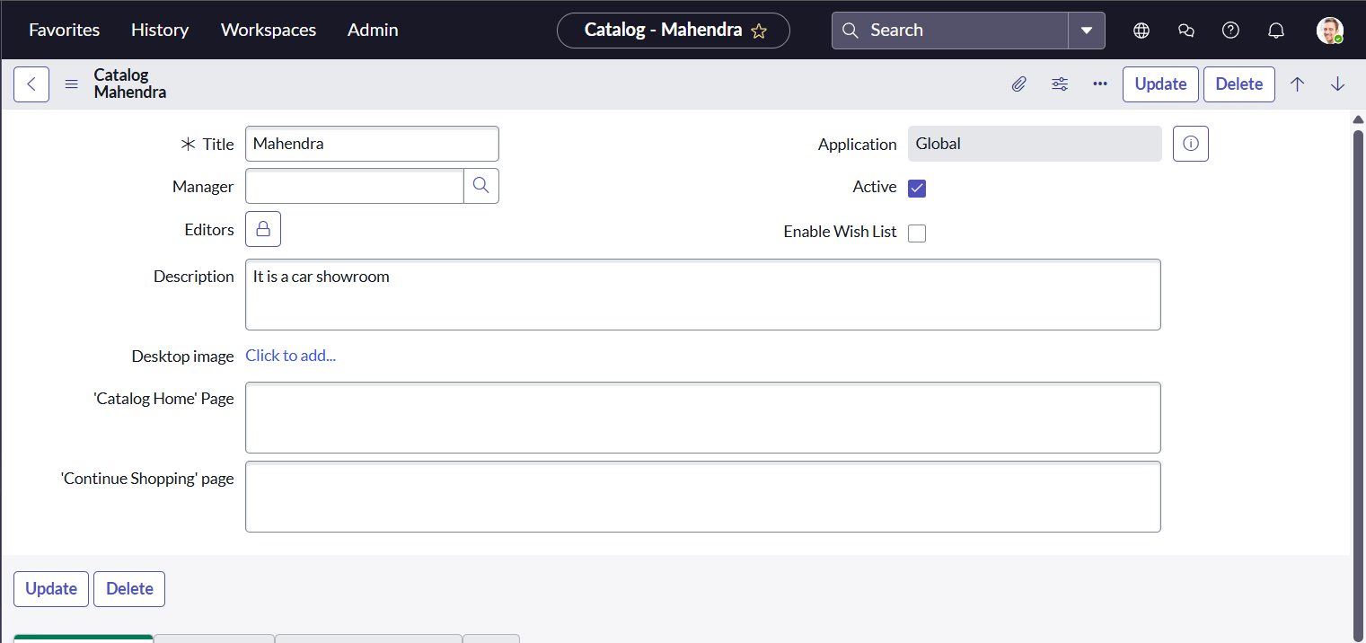

Step 2: Create Categories & Add Cars

- Create categories: Sudden, XUV, Sports under the Mahendra catalog.
- Add 3 catalog items:
  - Polo (Sudden) – Price: ₹70, Recurring: ₹90
  - Thar (XUV) – Price: ₹150, Recurring: ₹170
  - XUV700 (Sports) – Price: ₹200, Recurring: ₹211
- Add short/long descriptions, images, and set request method to Request for each.

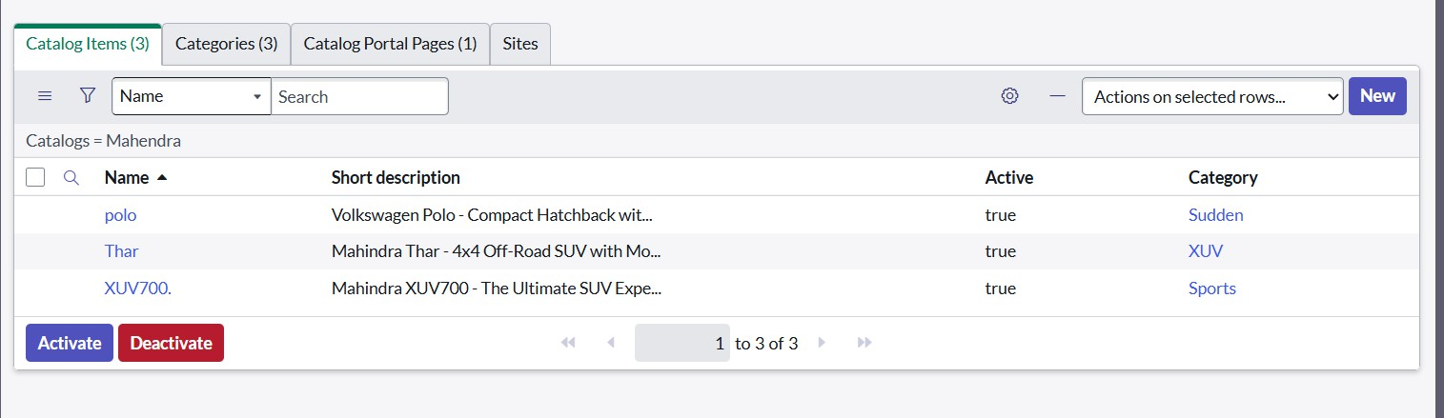

Step 3: Create a User

- Go to All → Users under System Security.
- Click New, enter:
  - User ID: 01
  - Name: Salesperson
  - Role: emp1
- Click Save and Submit.
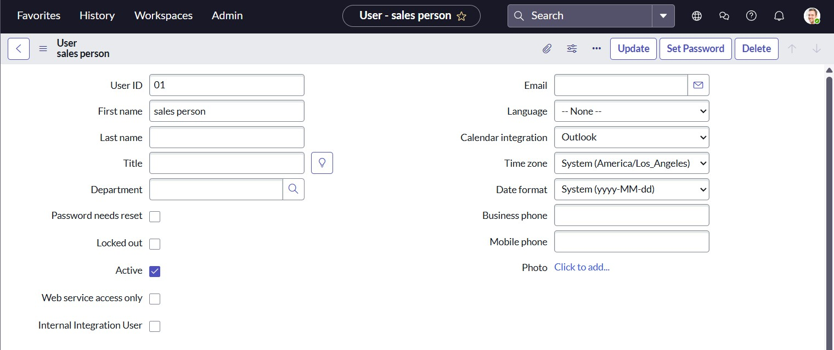

Step 4: Create Role

- Go to All → Roles under System Security.
- Click New, enter Role Name: emp1.
- Click Submit.

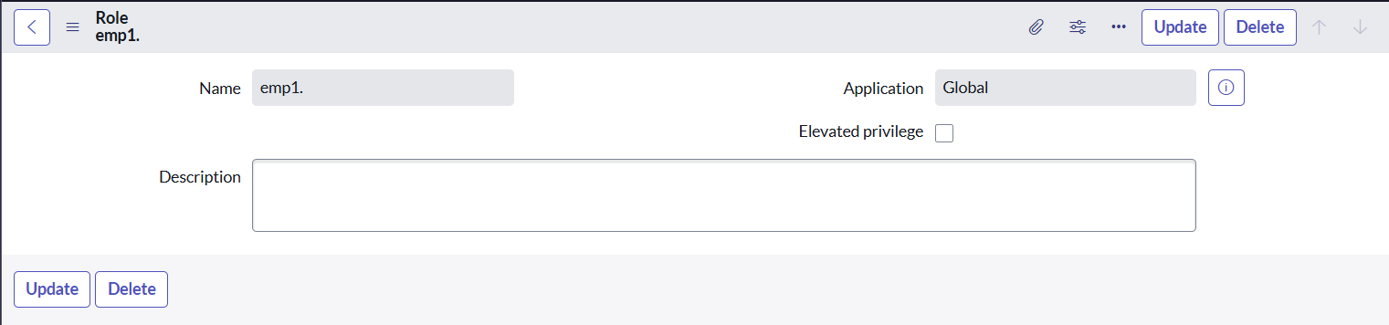

Step 5: Create Group

- Go to All → Groups under System Security.
- Click New, enter:
  - Group Name: showroom
  - Manager: Abraham Lincoln
- Click Submit, then add members: Salesperson, Salesperson2, Salesperson3 and click Update.
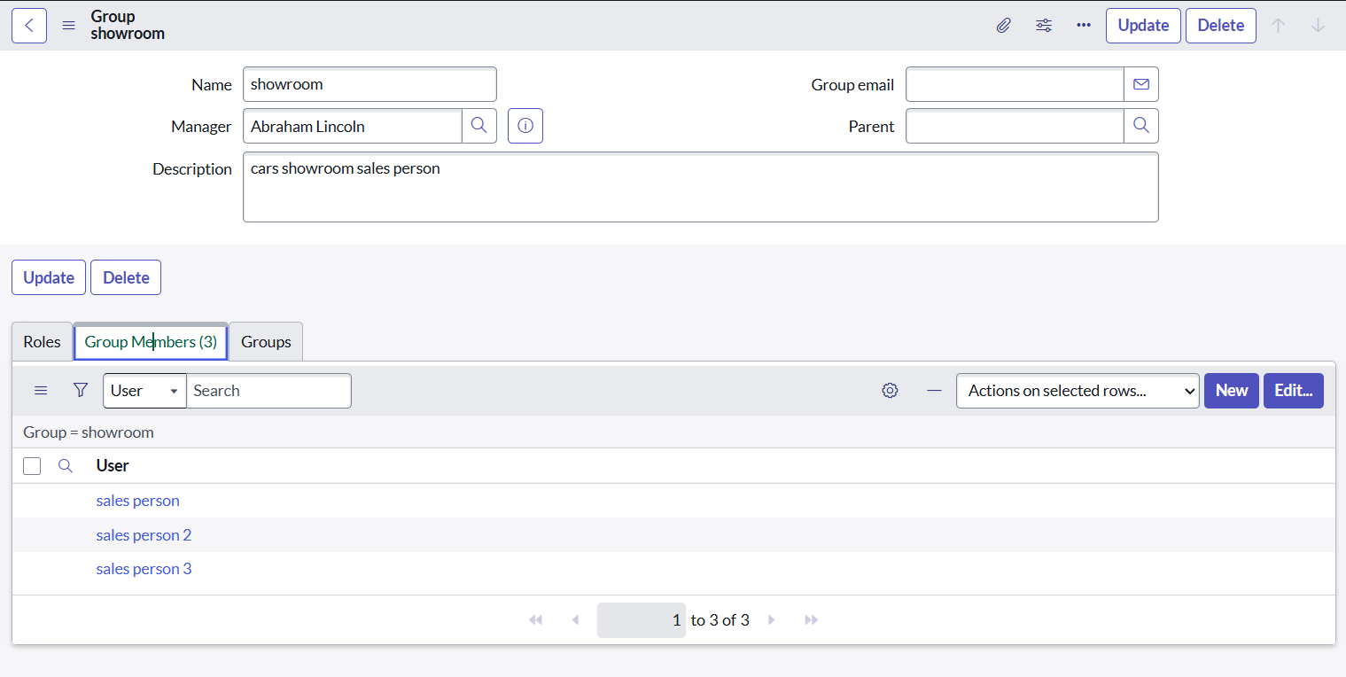

Step 6: Create Table

- Go to All → Tables under System Definition.
- Click New, enter:
  - Table Name: cars fulfillment
  - Extends Table: Task
- Click Save and Submit.

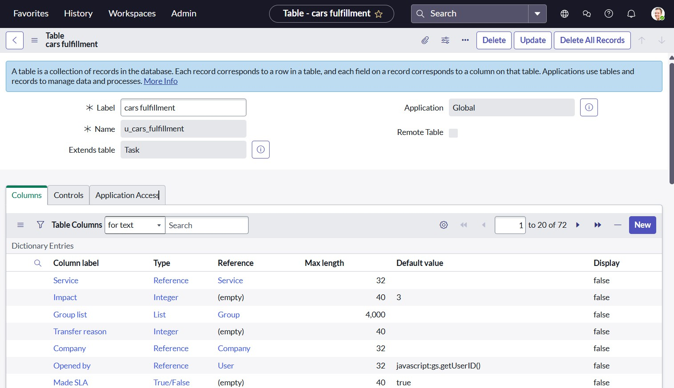

Step 7: Assign Workflow to Mahendra Catalog
- Go to Workflow Editor → Click New Workflow → Search and select

Test.
- Add steps:
- Approval (Sales) → User: Salesperson
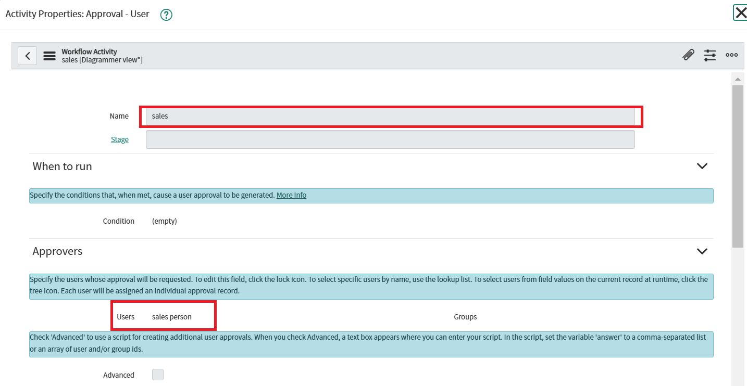

- Approval (2nd Level) → User: Supervisor

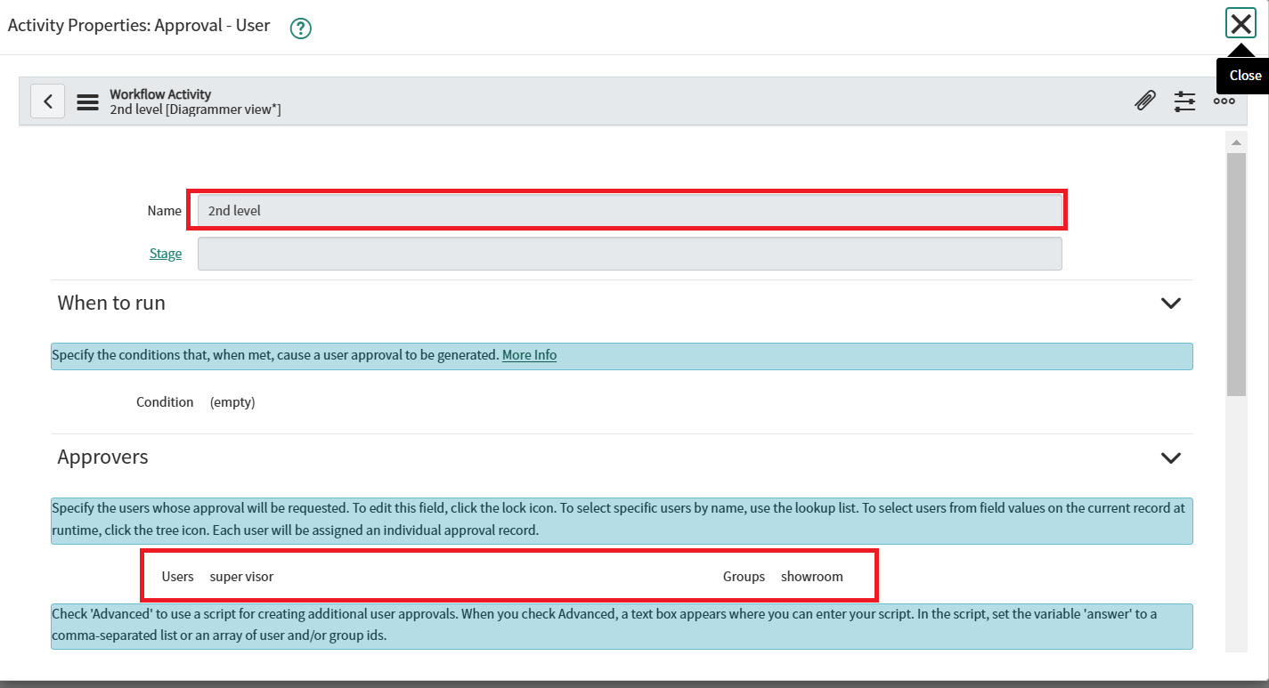

Task: Car Company

- Table: cars fulfillment, Priority: 1
- Set: Car Status = Ready to Pickup, State = Closed Complete
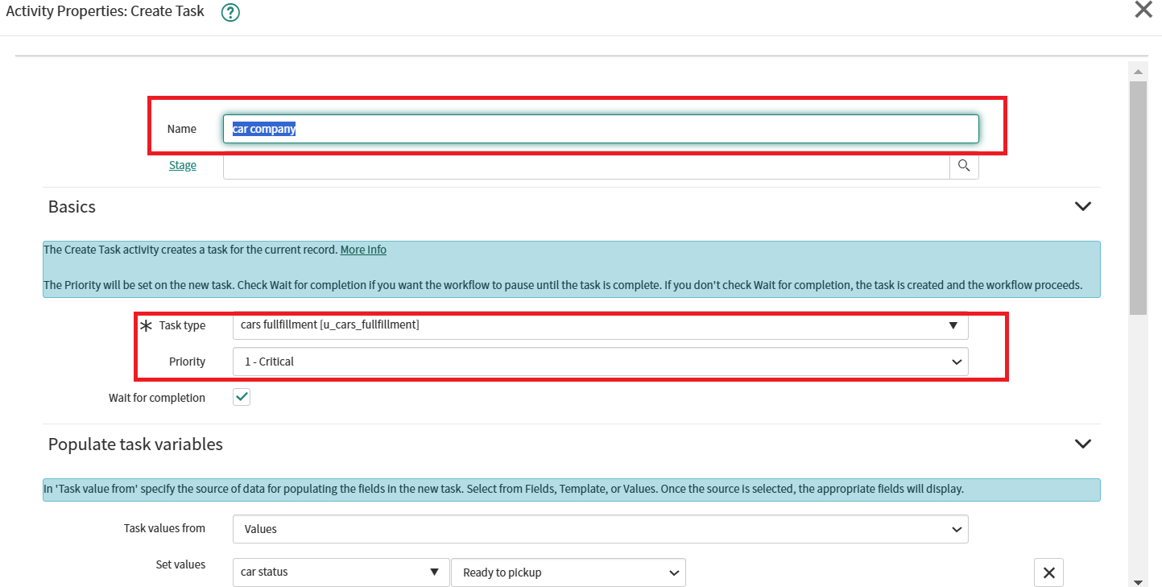

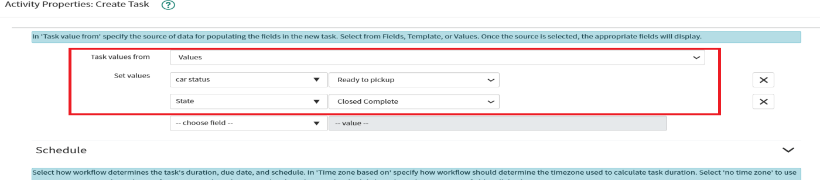

Task: Car Production
  - Table: cars fulfillment, Priority: 1
  - Set: Car Status = Deployment Failed, State = Closed Incomplete
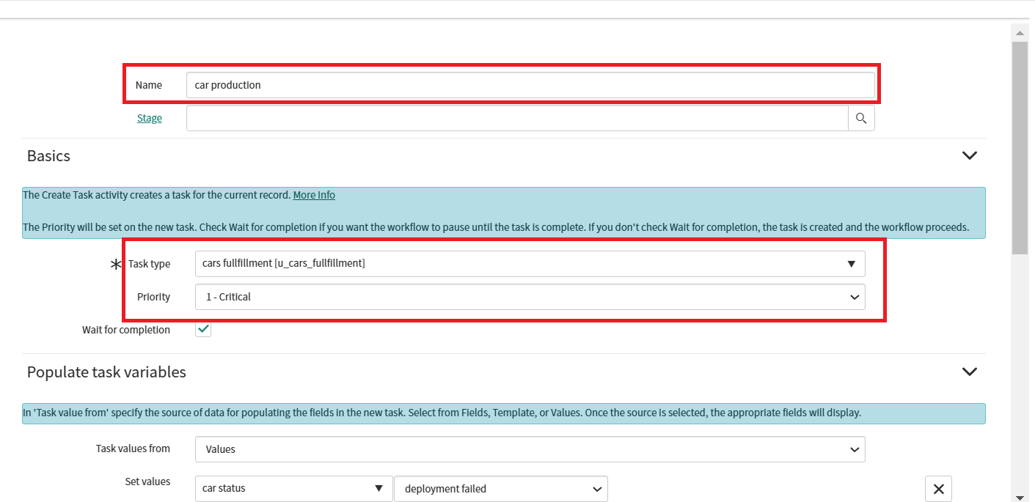
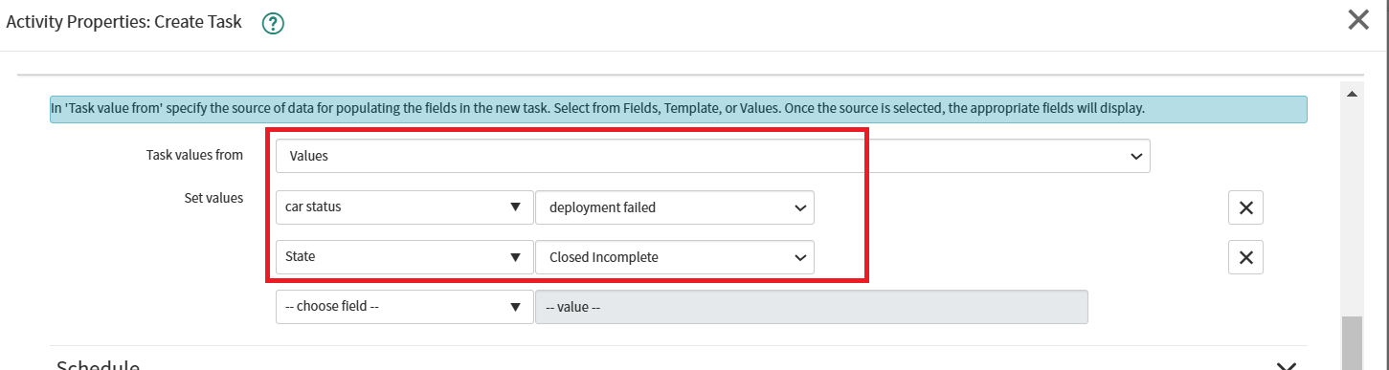

Notification: Booking Confirmation
  - To: Abraham Lincoln, Group: Showroom
  - Subject: Car Showroom, Message: Approval mail (HTML)

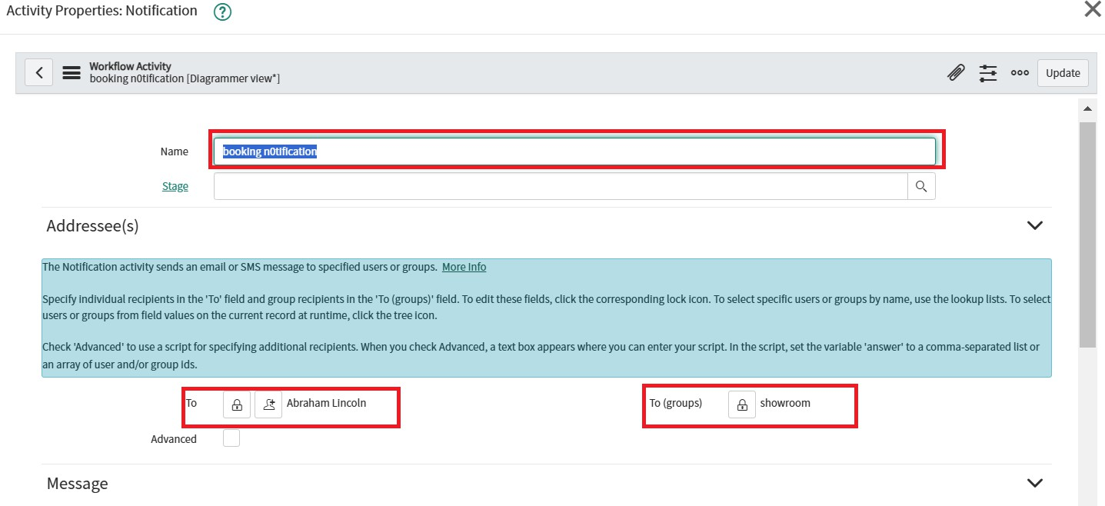

Notification: Car Rejection
  - To: Abraham Lincoln, Group: Showroom
  - Subject: Car Showroom, Message: Booking approval is rejected
  - Click Submit and End the workflow.
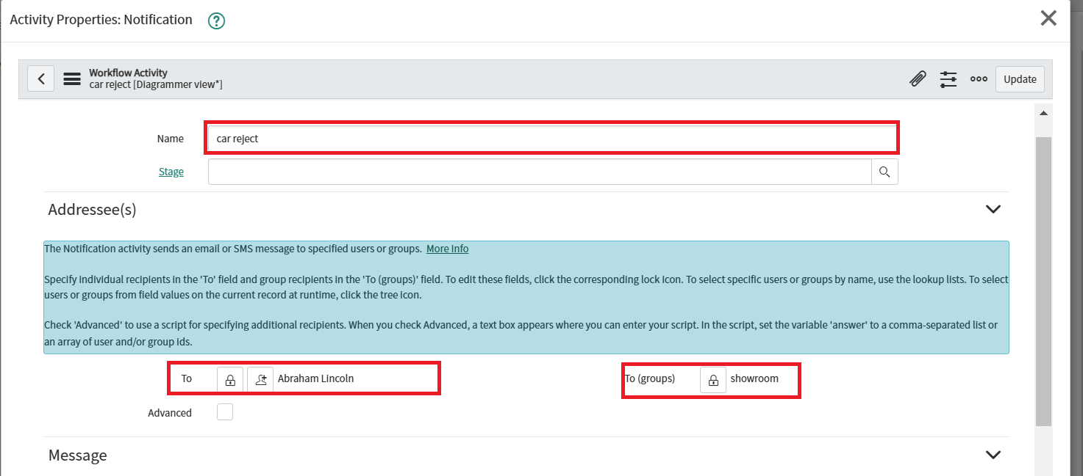
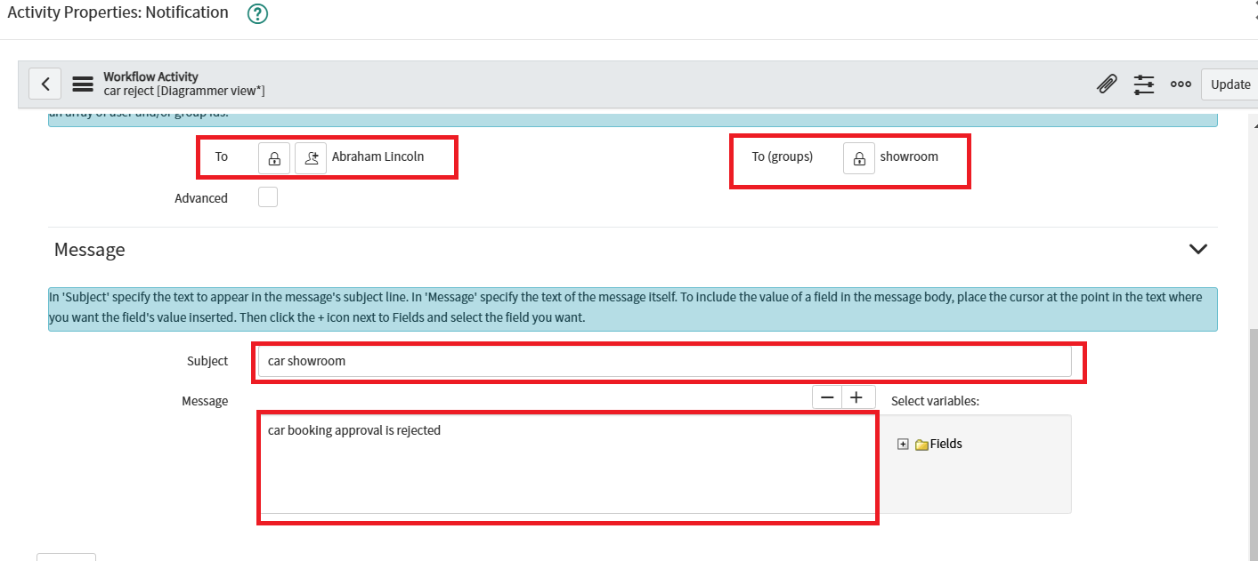

This is the final workflow
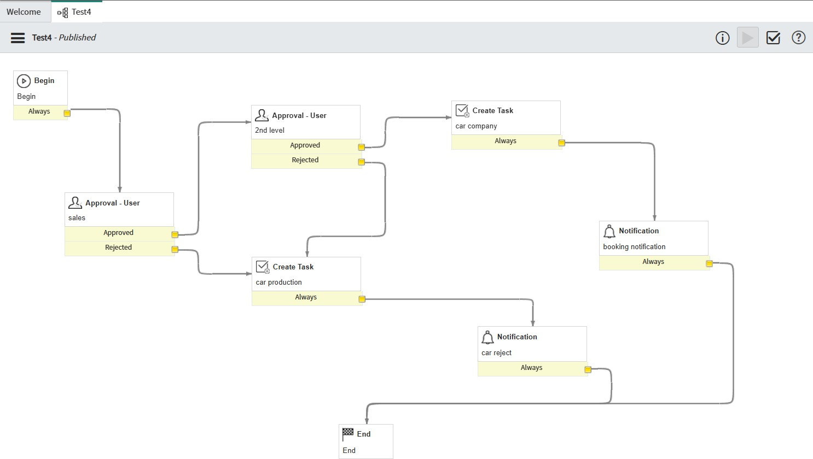

FUNCTIONAL AND PERFORMANCE TESTING

Performance Testing
  - Form loads correctly with appropriate cars
  - Price, descriptions, and images display as expected
  - Approvals processed as per workflow
  - Emails sent based on approval status
  - Requests appear in the task table
  - All fields validated for correctness
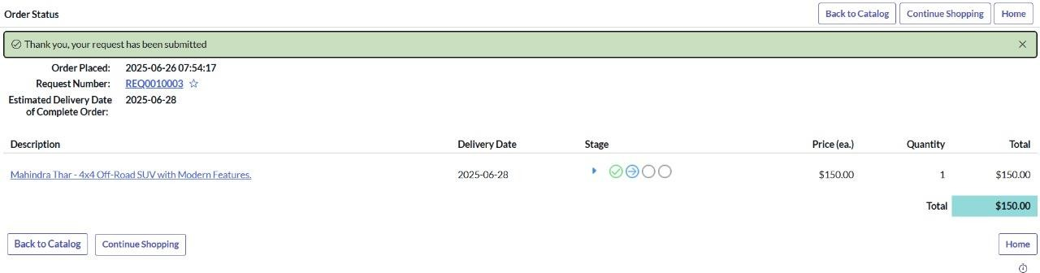

ADVANTAGEDISADVANTAGES

Advantages
  - Fully automated approval and booking system
  - Easy car selection via categories
  - Email-based communication improves transparency
  - Flexible design for future expansion

Disadvantages
  - Requires ServiceNow admin-level knowledge
  - Workflow logic setup can be complex initially

CONCLUSION
The Mahendra Car Catalog System provides a robust digital solution for managing car showroom requests. Through automated workflows, dynamic catalog items, and real-time tracking, it streamlines operations and enhances user satisfaction. The categorized structure allows users to easily browse and request vehicles, while the approval workflow ensures proper verification. Email notifications keep users updated at every stage, making the entire process transparent and efficient. Overall, the system improves service delivery and reduces manual workload for showroom staff.

FUTURE SCOPE
  - We can add a review or feedback option for each car so that users can share their experience, helping others make better choices and giving the showroom useful insights.
  - A dashboard based on user roles (like admin or salesperson) can be added to show useful analytics, such as the number of requests, popular cars, and request statuses.
  - Integrating WhatsApp or email notifications would keep users informed with real-time updates on their car booking status, making communication faster and more convenient.
  - We can allow users to book multiple cars in a single request, which would be useful for bulk bookings or for businesses that need more than one vehicle.

  - A payment gateway integration can also be added so users can directly pay booking fees online, making the process smoother and more complete.

APPENDIX
Notification HTML Template (Booking)
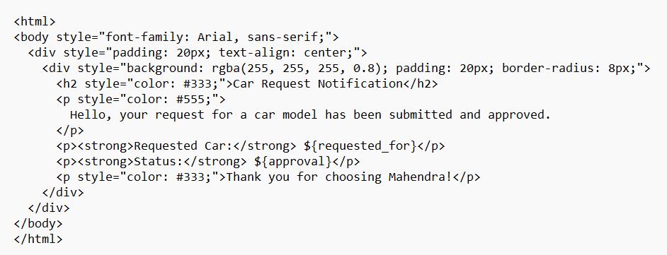

Notification Text (Rejection)
