**Scenario:**

State's Electricity Board needs to automate its billing process. As part of the extension implementation, calculating bill amount for each user is one of the requirement.

**Functionalities:**

1. Display a form to get the EB bill details.

2. Calculate the bill amount based on the details given by the user.

**Model,**

EBBill model class is already given for your reference.

**Controller,**

A controller named '**EBBillController**', is given for you.

**Implement the following 3 actions,**

**1) EBBill (no argument)**

This action will display a form as shown in the sample below using **EBBill.cshtml**.

The form in the view must be bound to  '**EBBill**' model. On submit, 'EBBill' action with argument must be invoked.

*Return type must be****ActionResult****.*

**2) EBBill (HttpPost)**

This action will accept '**EBBill**' Model as parameter.

a)Calculate the bill amount based on the values in the model.

b)Assign the bill amount to the property 'Bill_Amount' in the 'EBBill' object.

c)Display the same view with calculated bill amount as shown in the sample input/output.

*Note : On this action property POST must be given*

*Return type must be****ActionResult*.**

Calculate the bill amount based on the given rules:

a)Units upto 50 then,  cost =  50 *1

b)Units  > 50 and <=100 then,  cost =  50 *1 + 50*2

*Example: Units is 78 then, cost = 50 *1 + 28 *2*

c)Units  > 100 and <=200 then,  cost= 50 * 1 + 50 * 2 + 100 *3

*Example: Units is 135 then, cost = 50 *1 + 50 *2 + 35*3*

d)Units  >200 then,  cost= 50 * 1+ 50 * 2 + 100 *3 + remaining units*5

Example: Units is 450 then, cost = 50 *1 + 50 *2 + 100*3 + 250 * 5

**3) Print**

On clicking the 'href' print in the view, this action must be invoked.

This action must display the Bill details that is already available in 'EBBill' Model object.

*Return type must be****ActionResult.***

**Implement the following Views:**

**1. EBBill.cshtml**

a)Create a **form**mapped to **EBBill Model using HTML Helper.**

**NOTE : While creating the form, 'id' MUST be available ( hint : use HTMLHelper )**

id="Bill_No"  
id="Consumer_Name"  
id="Pre_Reading"  
id="Cur_Reading"  
id="Submit"

b) Implement a **Link**for**'Print' .**On clicking this link, the 'Print' action must be invoked and the bill details must be displayed.

**2) Print.cshtml**

This view must display the values in the EBBill object as shown below.

*Hint: You are free to choose ANY CSS look and feel.*

**Sample Input/Output**

**URI,**

**EBBill/EBBilll**

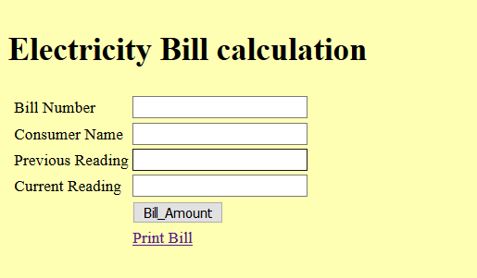

**On Submit,**

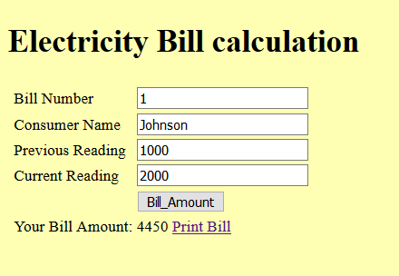

**On Clicking the link 'Print Bill'**

