UAE Lab Vision AI
TS A&I · Innovate · Test · Validate · Enable

Figure 1 — UAE Lab Vision AI overview
AI-Powered Lab Operations — Hands-free. Smarter. Faster.
Connecting our engineers, equipment and knowledge through AI glasses, a mobile app, and Mission Control.

Project links (click to open on GitHub)
Item | Link
Repository | github.com/shaiksultan/VisionClaw
Branch | uae-lab-vision-ai
README on GitHub | Open full README.md
Install guide | Open DEMO_INSTALL_AND_USE.md
APKs folder | Open apks/
Releases | v1.0.0-demo — download Vision AI APK
Main development | Sultan Sharief Shaik (@shaiksultan)
Organization | UAELAB

Download & install apps (APK)
App | Download | Size
UAE Lab Vision AI (glasses / phone) | UAE-Lab-Vision-AI.apk | ~156 MB
UAE Lab Expert (call receiver) | UAE-Lab-Expert.apk | ~26 MB

Install with ADB:
adb install -r UAE-Lab-Vision-AI.apk
adb install -r UAE-Lab-Expert.apk
Note: Vision AI APK is on GitHub Releases (over git’s 100 MB limit). Expert APK is in the repository apks/ folder. On Lab Expert, set Mission Control URL to http://YOUR_PC_IP:8090.

About this project
UAE Lab Vision AI turns Meta Ray-Ban glasses and Android phones into a voice-first lab assistant. Field and lab engineers speak naturally; agents call lab systems, create evidence, and can escalate to a live Expert Engineer with glasses video.

What it delivers
Capability | Description
Voice AI Assistant | Real-time multimodal conversation (speech + vision)
Live camera & video | Glasses / phone camera into Gemini Live and Expert sessions
Tool calling | Intent → inventory, knowledge, tests, tickets, lab APIs
Expert collaboration | Live WebRTC call from glasses to Mission Control / Lab Expert

Voice-activated agents (Mission Control)
Say the agent name to launch the corresponding lab service:
Agent | Example prompt | What it does
Expert Engineer | “Open Expert Engineer” | Remote expert via live video
Lab Inventory | “Open Lab Inventory” | Find/add equipment; stock & location
Lab Knowledge | “Open Lab Knowledge” | Approved procedures & runbooks
Evidence Tickets | “Open Evidence Tickets” | Photo/video evidence + tracked ticket
Digital Capture | “Open Digital Capture” | Lab environments & digital context
Mobile PS | “Start Mobile PS…” | Dual-UE packet-core validation
Visual Troubleshoot | Visual fault assist | Camera-assisted troubleshooting

Other voice-activated services
Additional agents demonstrate the flexibility of the UAE Lab Vision AI platform:
Service | Example | Purpose
Live Music | “Open Live Music” | Voice-driven music discovery and playback
BBC Radio | “Open BBC Radio” | Radio content via natural voice commands
Live Football | “Open Live Football” | Football updates / demo audio by voice

Technology overview
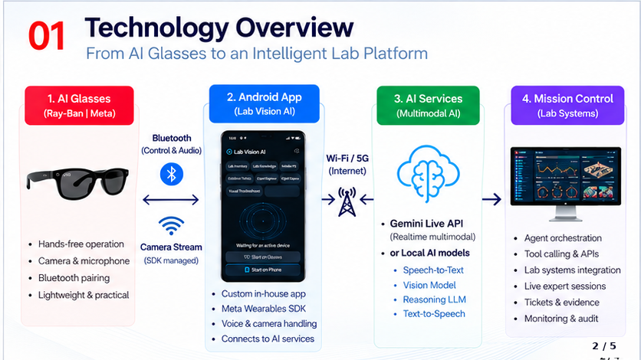
Figure 2 — From AI glasses to an intelligent lab platform

Technology stack & key components
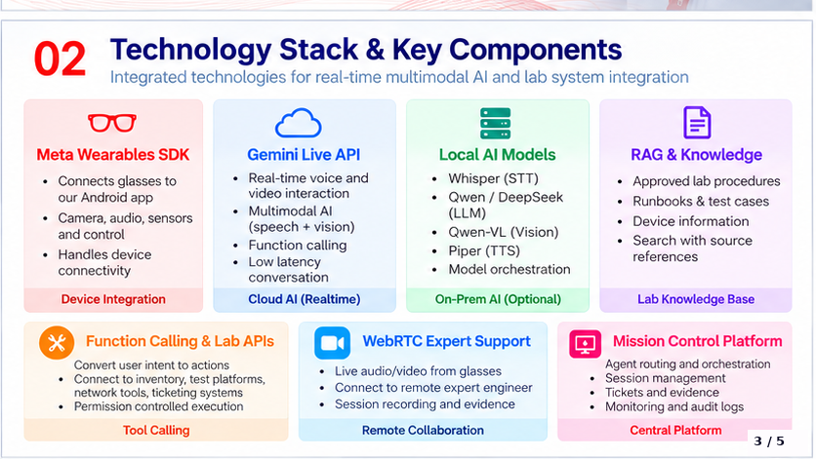
Figure 3 — Technology stack & key components
Layer | Role
Meta Wearables SDK | Glasses ↔ Android: camera, audio, sensors, control
Gemini Live API | Realtime voice + vision, function calling, low latency
Local AI (optional) | Whisper STT · Qwen/DeepSeek LLM · Qwen-VL · Piper TTS
RAG & Knowledge | Approved procedures, runbooks, device info, cited search
Function calling & lab APIs | Intent → inventory, tests, network tools, ticketing
WebRTC Expert Support | Live A/V from glasses → expert; session evidence
Mission Control | Agent routing, sessions, tickets, monitoring

Quick start
Full instructions: DEMO_INSTALL_AND_USE.md on GitHub

Clone
git clone -b uae-lab-vision-ai https://github.com/shaiksultan/VisionClaw.git
cd VisionClaw

Mission Control (PC)
cd people-directory
npm install
npm start
Open http://localhost:8090 (or http://YOUR_PC_IP:8090 from phones).

Demo flow (short)
- Start Mission Control on the PC.
- Open UAE Lab Vision AI → Start on Glasses or Phone → AI ON.
- Try: “Open Lab Inventory”, “Open Lab Knowledge”, “Open Evidence Tickets”, “Open Expert Engineer”.
- On a second phone, answer with UAE Lab Expert.
- End the call → review the open evidence ticket in Mission Control.

Credits & lineage

Design concept
Concept and design contributors:
Name | Role
Ayman Elnashar | Design concept
Mohamed S. AlZaabi | Design concept
Mohammad Sameer | Design concept
Yunus Shaikh | Design concept

Main development
Name | Role
Sultan Sharief Shaik (@shaiksultan) | Main development — UAE Lab Vision AI app, Mission Control, agents, Expert Engineer, and demo platform

UAE Lab Vision AI · TS A&I · Click any blue link above to open GitHub
https://github.com/shaiksultan/VisionClaw

