UAE Lab Vision AI
TS A&I · Innovate · Test · Validate · Enable
VP / Team Share Pack — How to access, install, and use

Figure 1 — UAE Lab Vision AI overview
AI-Powered Lab Operations — Hands-free. Smarter. Faster.
Connecting our engineers, equipment and knowledge through AI glasses, a mobile app, and Mission Control. This pack is for leadership and teams: share the GitHub links below, install the apps, and run the demo.

1. For the VP — what to share with teams
Please forward this document (or the GitHub links) to teams who will try the pilot. Everything needed to clone, install APKs, and run Mission Control is linked below. Blue text is clickable and opens GitHub in a browser.
Share this | Click to open
Source code & docs (branch) | uae-lab-vision-ai on GitHub
Project README | Open README.md
Install & use guide | Open DEMO_INSTALL_AND_USE.md
Download Vision AI APK | UAE-Lab-Vision-AI.apk (Releases)
Download Expert APK | UAE-Lab-Expert.apk
All releases | Releases page
Repository home | github.com/shaiksultan/VisionClaw

2. What UAE Lab Vision AI is
A voice-first lab operations platform for UAELAB. Engineers use Meta Ray-Ban glasses or a phone; AI agents talk to lab systems; experts can join a live video call from Mission Control or the Lab Expert app.
Capability | Description
Voice AI Assistant | Realtime multimodal conversation (speech + vision)
Live camera & video | Glasses / phone into Gemini Live and Expert sessions
Tool calling | Inventory, knowledge, tests, tickets, lab APIs
Expert collaboration | Live WebRTC from glasses → Mission Control / Lab Expert

Voice-activated agents
Say the agent name to launch the service:
Agent | Say this | Outcome
Expert Engineer | “Open Expert Engineer” | Live remote expert video
Lab Inventory | “Open Lab Inventory” | Find/add gear; stock & location
Lab Knowledge | “Open Lab Knowledge” | Procedures & runbooks
Evidence Tickets | “Open Evidence Tickets” | Photo/video + tracked ticket
Digital Capture | “Open Digital Capture” | Lab digital capture
Mobile PS | “Start Mobile PS…” | Dual-UE validation
Visual Troubleshoot | Visual assist | Camera-assisted troubleshooting

Other voice services (same platform)
Service | Say this | Purpose
Live Music | “Open Live Music” | Music playback by voice
BBC Radio | “Open BBC Radio” | Live radio by voice
Live Football | “Open Live Football” | Demo sports / audio by voice

3. Technology overview
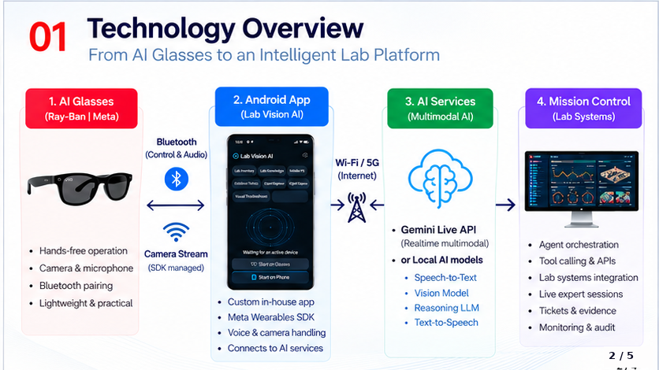
Figure 2 — AI glasses → Android app → AI services → Mission Control
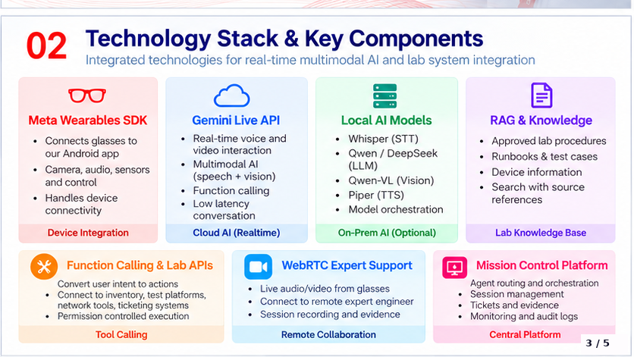
Figure 3 — Technology stack & key components

4. How teams use it (setup)

A) Fast path — install APKs only (recommended for demos)
Needs: two Android phones (or one phone + PC browser for Mission Control), same Wi‑Fi as the PC.
- 1. On a PC, start Mission Control (section B) so http://PC_IP:8090 is reachable.
- 2. Download UAE-Lab-Vision-AI.apk from Releases (link above).
- 3. Download UAE-Lab-Expert.apk from the APKs folder (link above).
- 4. Install both: adb install -r … or open the APK on the phone (allow unknown apps).
- 5. On Lab Expert, set Mission Control base URL to http://YOUR_PC_IP:8090.
- 6. Open UAE Lab Vision AI → Start on Phone or Glasses → AI ON → try agent prompts.
ADB install commands:
adb install -r UAE-Lab-Vision-AI.apk
adb install -r UAE-Lab-Expert.apk

B) Mission Control on the lab PC
Requires Node.js 22.5+ on the PC.
git clone -b uae-lab-vision-ai https://github.com/shaiksultan/VisionClaw.git
cd VisionClaw\people-directory
npm install
npm start
Open http://localhost:8090 on the PC, or http://YOUR_PC_IP:8090 from phones.
Full written guide: DEMO_INSTALL_AND_USE.md

C) Optional services
Service | Port | Purpose
Mission Control | 8090 | Dashboard, agents, Expert Engineer queue
Mobile PS API / UI | 8100 / 5173 | Dual-UE lab validation
OpenClaw gateway | 18789 | Extra tool routing (optional)

5. Suggested demo script (5–10 minutes)
- Show Mission Control in the browser (agent roster / dashboard).
- On glasses or phone: AI ON → “Open Lab Inventory” / “Open Lab Knowledge”.
- Create evidence: “Open Evidence Tickets” with a visible alarm or screen.
- Call support: “Open Expert Engineer” — Lab Expert phone rings → answer → live video.
- End call from Mission Control or Lab Expert — ticket remains for review.
- Optional: “Open Live Music” or “Open BBC Radio” to show extensible agents.

6. Who needs what
Role | Needs
Lab / field engineer | UAE Lab Vision AI APK + Wi‑Fi + Mission Control URL
Expert / support | UAE Lab Expert APK (or Mission Control Support page)
Lab ops / demo host | PC with Mission Control running; share PC IP
Developers | GitHub branch + Node/Android Studio (see install guide)

7. Credits

Design concept
Name | Role
Ayman Elnashar | Design concept
Mohamed S. AlZaabi | Design concept
Mohammad Sameer | Design concept
Yunus Shaikh | Design concept

Main development
Name | Role
Sultan Sharief Shaik (@shaiksultan) | Main development — app, Mission Control, agents, Expert Engineer, demo platform

8. Support & next steps
For access issues (Wi‑Fi IP, Gemini key, glasses pairing), contact the main developer or follow the troubleshooting section in the install guide on GitHub.
Primary links again: Repository · Branch · Releases / APKs

UAE Lab Vision AI · TS A&I · Confidential for internal team sharing
Attach this Word file in email — all blue links open GitHub

