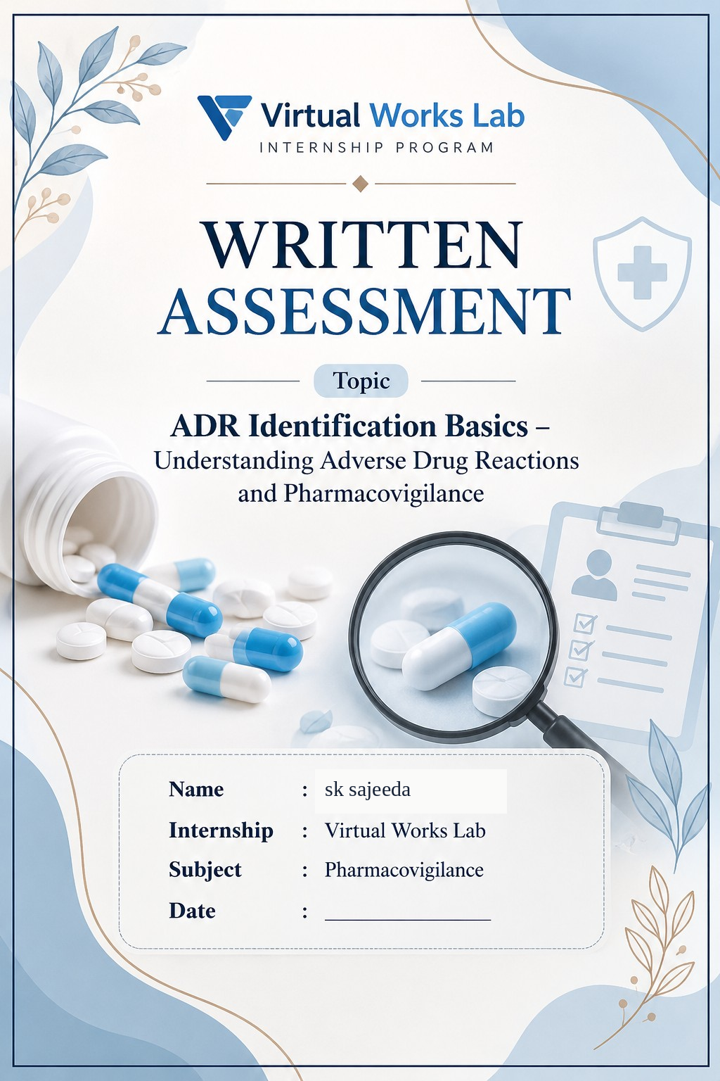
b

INTRODUCTION
Medicines play an important role in treating diseases and improving human health. However, sometimes medicines may cause unwanted or harmful effects known as Adverse Drug Reactions (ADRs).
Pharmacovigilance is the science of detecting, assessing, understanding and preventing adverse effects related to medicines. It helps healthcare professionals monitor medicine safety and protect patients from harmful reactions.
Identifying and reporting ADRs is essential for ensuring the safe and effective use of medicines.
The main aim of this assessment is to understand ADRs, their types, identification and the importance of pharmacovigilance.
ADVERSE DRUG REACTION
Adverse drug reaction (ADR) is any response to a drug which is noxious & unintended & which occurs at doses normally used in man for prophylaxis, diagnosis, or therapy of disease, or for the modification of physiological function.
EXAMPLE
A person takes an antibiotic (Amoxicillin) to treat an infection. After taking the medicine, the person develops a skin rash and itching.This unwanted effect is called an Adverse Drug Reaction (ADR)

THALIDOMIDE
Thalidomide is a medicine that was introduced in the late 1950s and was used to treat morning sickness (nausea and vomiting) in pregnant women. However, it caused severe birth defects in babies when taken during pregnancy.
ADVERSE DRUG REACTION OF THALIDOMIDE
- It caused severe birth defects.
- Babies were born with shortened or missing arms and legs.
- This condition is called Phocomelia.
- It became one of the most famous drug safety disasters in medical history.

EFFECT PRODUCED BY A DRUG
Effect produced by a drug means the changes or responses that occur in the body after taking a medicine. These effects may be beneficial or harmful.
Examples:
Therapeutic Effect: Desired effect of a drug (e.g., Paracetamol reduces fever).
Side Effect: Unwanted effect (e.g., Drowsiness).
Toxic Effect: Harmful effect due to excessive drug dosage.
Adverse Drug Reaction (ADR): Harmful or unintended reaction to a drug when used at normal doses.

TOXIC EFFECTS OF DRUGS
1. Pharmacological Effects
Harmful effects caused by the excessive or unwanted action of a drug on the body.
Example: Excessive bleeding due to anticoagulant drugs.
2. Pathological Effects
Damage or abnormal changes in body tissues and organs caused by drugs.
Example: Liver damage due to certain drugs.
3. Genotoxic Effects
Effects that damage DNA or genetic material and may cause mutations.
Example: Certain anticancer drugs can damage DNA.
4. Allergic Reactions
Unexpected immune system reactions to a drug.
Example: Skin rashes, itching and swelling due to penicillin.
Type 1– Immediate Hypersensitivity
- Also called Anaphylactic or IgE-mediated reaction.
- It occurs within minutes after exposure to an allergen.
- Mediated by IgE antibodies.
- Mast cells release histamine and other chemical mediators.
Examples:
- Allergic asthma
- Hay fever
- Food allergy
- Anaphylaxis (severe allergic reaction)

Type 2– Cytotoxic Hypersensitivity
- Also called Antibody-mediated reaction.
- It occurs when IgG or IgM antibodies attack antigens present on the surface of body cells.
- This causes destruction or damage of cells.
Examples:
- Mismatched blood transfusion reaction
- Hemolytic disease of the newborn
- Autoimmune hemolytic anemia

Type 3– Immune Complex Hypersensitivity
- It occurs due to the formation of antigen-antibody complexes.
- These complexes get deposited in tissues.
- This causes inflammation and tissue damage.
Examples:
- Serum sickness
- Systemic lupus erythematosus (SLE)
- Arthus reaction
- Some forms of glomerulonephritis

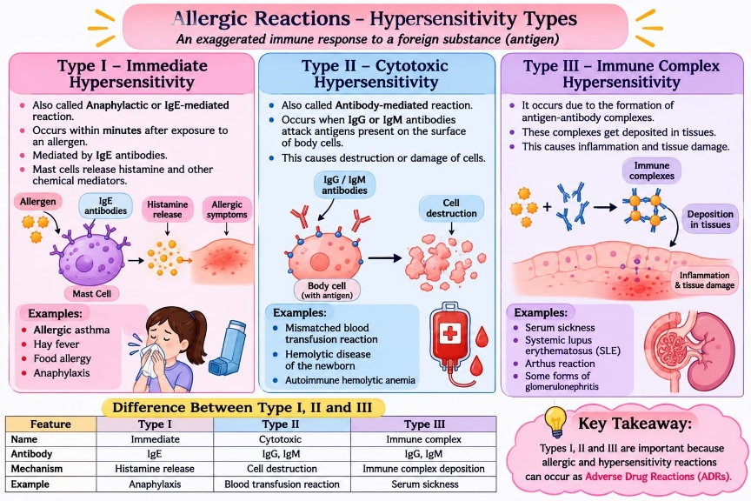

5. Idiosyncratic Reactions
Unusual and unpredictable reactions to a drug in certain individuals.
Example: Haemolysis caused by certain drugs in susceptible individuals with G6PD deficiency.
6. Pharmacogenetic Variations
Genetic differences between individuals that influence how they respond to drugs.
Example: Some people metabolize certain drugs slowly due to genetic differences.
7. Teratogenic Effects
Harmful effects of drugs on the developing foetus during pregnancy, causing birth defects.
Example: Thalidomide causes limb deformities in babies.
FDA PREGNANCY RISK CATEGORIES – A,B,C,D & X.
1. TYPE A
- Controlled studies in pregnant women show no risk to the fetus.
- Considered the lowest risk category.
Example: Folic acid (at recommended doses).

2. TYPE B
Animal studies show no fetal risk, but adequate human studies are unavailable, OR animal studies show risk that human studies have not confirmed.
Example: Amoxicillin.
3. TYPE C
- Animal studies have shown adverse effects on the fetus.
- Adequate human studies are unavailable.
- Benefits may justify use in certain situations.
Example: Fluconazole (especially at higher doses).
4. TYPE D
- There is evidence of fetal risk in humans.
- May be used in serious conditions when benefits outweigh risks.
Example: Phenytoin, Valproic acid.
5. TYPE X
- Studies show fetal abnormalities or clear fetal risk.
- Risks outweigh any possible benefits.
- Contraindicated during pregnancy.
Example: Thalidomide, Isotretinoin

OTHER CATEGORIZATION OF ADR
Acute: Occurs within minutes or hours.
Subacute: Develops over days or weeks.
Latent: Appears after months or years.

TYPES OF ADR BASED ON SEVERITY
- Minor: Mild reaction; does not require special treatment.
- Moderate: Requires medical treatment or change in medication.
- Severe: Serious reaction that may require hospitalization or cause disability.
- Lethal (Fatal): ADR that results in death.

PHARMACOVIGILANCE
Pharmacovigilance is the process of monitoring the safety of medicines and identifying harmful effects of drugs.
Main Objectives
- To improve patient safety.
- To detect adverse drug reactions (ADRs).
- To assess drug safety.
- To prevent harmful effects of medicines.
- To promote the safe use of medicines.

ADVERSE EVENT (AE)
An adverse event is any unwanted medical occurrence in a patient after using a medicine, which does not necessarily have a causal relationship with the drug.
Examples:
- Headache
- Fever
- Vomiting
- Dizziness
- Diarrhea

SERIOUS ADVERSE EVENT (SAE)
A serious adverse event is any unwanted medical occurrence that results in Death or Life-threatening condition or Hospitalization or prolongation of existing hospitalization. or Persistent or significant disability or Congenital anomaly or birth defect

Examples:
- Severe allergic reaction (anaphylaxis).
- Heart attack.
- Severe liver injury.
- Hospitalization due to a drug reaction.

CAUSALITY ASSESSMENT
Causality assessment is the process of determining the relationship between a drug and an adverse drug reaction (ADR).
1. WHO-UMC Scale
WHO-UMC is a method used to assess the relationship between a drug and an adverse drug reaction
2. Naranjo Algorithm
Naranjo Algorithm is a questionnaire-based method used to determine the probability that an adverse reaction is caused by a drug.

BRADFORD HILL CRITERIA
Bradford hill criteria are a set of guidelines used to determine whether there is a cause-and-effect relationship between exposure to a drug and an adverse effect.

PHARMACOVIGILANCE PROGRAMME OF INDIA (PVPI)
The Pharmacovigilance Programme of India (PvPI) was launched by the Government of India in July 2010 under the Central Drugs Standard Control Organization (CDSCO). It aims to monitor the safety of medicines and identify, assess, understand and prevent adverse drug reactions (ADRs).
PvPI collects and analyses ADR reports from healthcare professionals and patients through Adverse Drug Reaction Monitoring Centres (AMCs). It helps ensure the safe and rational use of medicines and protects patients from harmful drug effects.
Objectives
- To monitor the safety of medicines.
- To identify and detect adverse drug reactions (ADRs).
- To assess and prevent drug-related risks.
- To promote the safe and rational use of medicines.
- To collect and analyse ADR reports.
- To create awareness among healthcare professionals and the public.
- To protect patients from harmful effects of medicines.
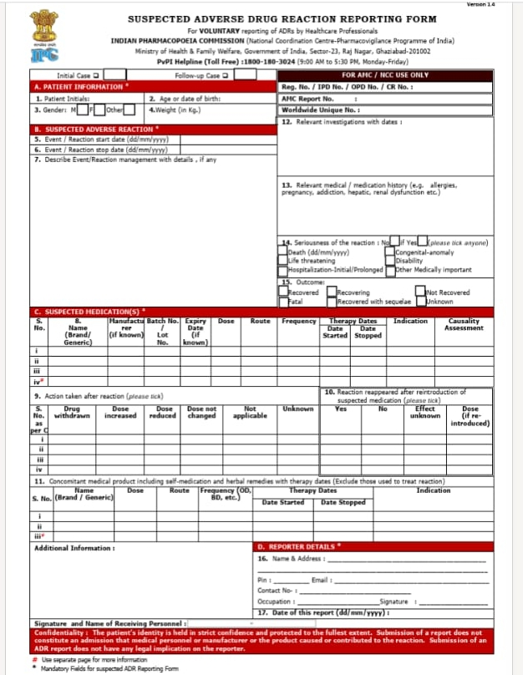

WHO CAN REPORT ADRS UNDER PVPI?
Anyone can report a suspected Adverse Drug Reaction (ADR), including:
- Doctors
- Pharmacists
- Nurses
- Other healthcare professionals
- Patients
- Consumers and their family members
HOW TO REPORT ADRS UNDER PVPI
- Identify the ADR: Observe any unwanted reaction after taking a medicine.
- Collect information: Note the patient's details, medicine name, dose and reaction.
- Fill the reporting form: Healthcare professionals use the Suspected ADR Reporting Form. Patients can use the Medicines Side-effect Reporting Form.
- Submit the form: Send it to the nearest ADR Monitoring Centre (AMC) or National Coordination Centre (NCC-PvPI).
- Report through other methods: Use the PvPI helpline or ADR PvPI mobile app.
Explanation of ADR Reporting Form (PvPI)
The Suspected Adverse Drug Reaction Reporting Form is used to report unwanted or harmful reactions experienced by patients after taking medicines. The form contains the following sections:

- Patient Information: Includes patient initials, age, sex and weight.
- Details of Suspected ADR: Records the reaction experienced by the patient, date of onset, severity and outcome.
- Suspected Medication: Includes the name of the suspected medicine, dose, route, frequency and duration of treatment.
- Concomitant Medications: Details of other medicines taken by the patient at the same time.
- Relevant Medical History: Includes previous illnesses, allergies and other relevant medical conditions.
- Reporter Details: Includes the name, profession, contact details and signature of the person reporting the ADR.
- Importance of ADR Reporting Form
- Helps identify new and unknown ADRs.
- Monitors the safety of medicines.
- Helps prevent harmful drug reactions.
- Improves patient safety.
- Supports safe use of medicines.

THINGS TO CONSIDER WHILE REPORTING ADR
- Suspected drug details: Mention the medicine name, dose, route and frequency.
- Reaction details: Clearly describe the adverse reaction.
- Date of onset: Mention when the reaction started.
- Medical history: Include relevant diseases, allergies and previous drug reactions.
- Concomitant medicines: Report other medicines taken by the patient.
- Seriousness: Mention whether the reaction was serious or non-serious.
- Treatment and outcome: Record the treatment given and the patient's condition.
- Reporter details: Provide the reporter's name and contact information.
- Timely reporting: Report suspected ADRs as early as possible.
WHERE TO SUBMIT THE COMPLETED ADR REPORTING FORM?
Under the Pharmacovigilance Programme of India (PvPI), the completed form can be submitted through the following methods:
Nearest ADR Monitoring Centre (AMC): Submit the form at a nearby hospital or medical college having an AMC.
National Coordination Centre (NCC): Send the completed form directly to NCC-PvPI.
Email: pvpi.ipc@gov.in
Toll-free helpline: 1800 180 3024
Mobile app: ADR PvPI.

THANK YOU
VIRTUAL WORKS LAB
Pharmacovigilance Internship

