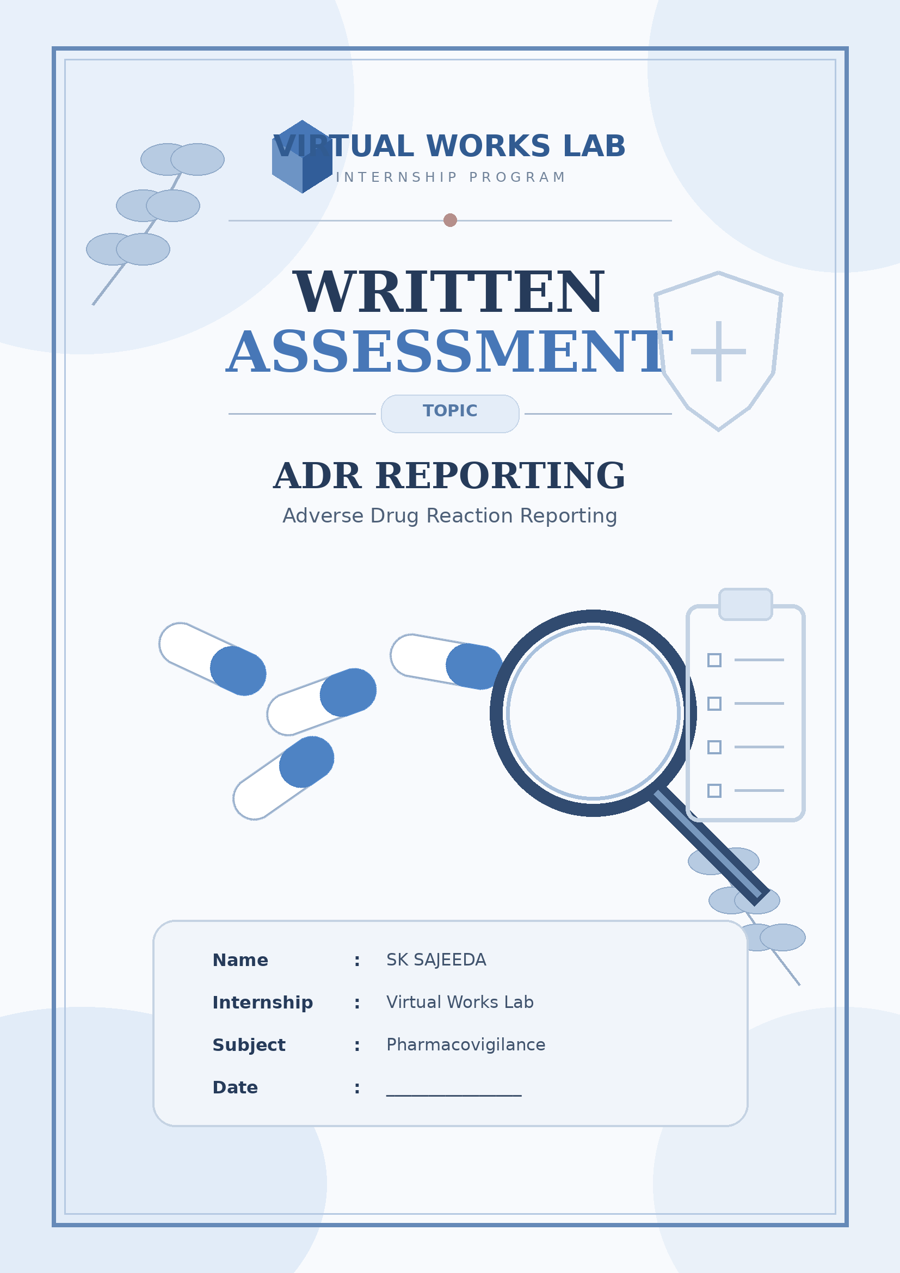
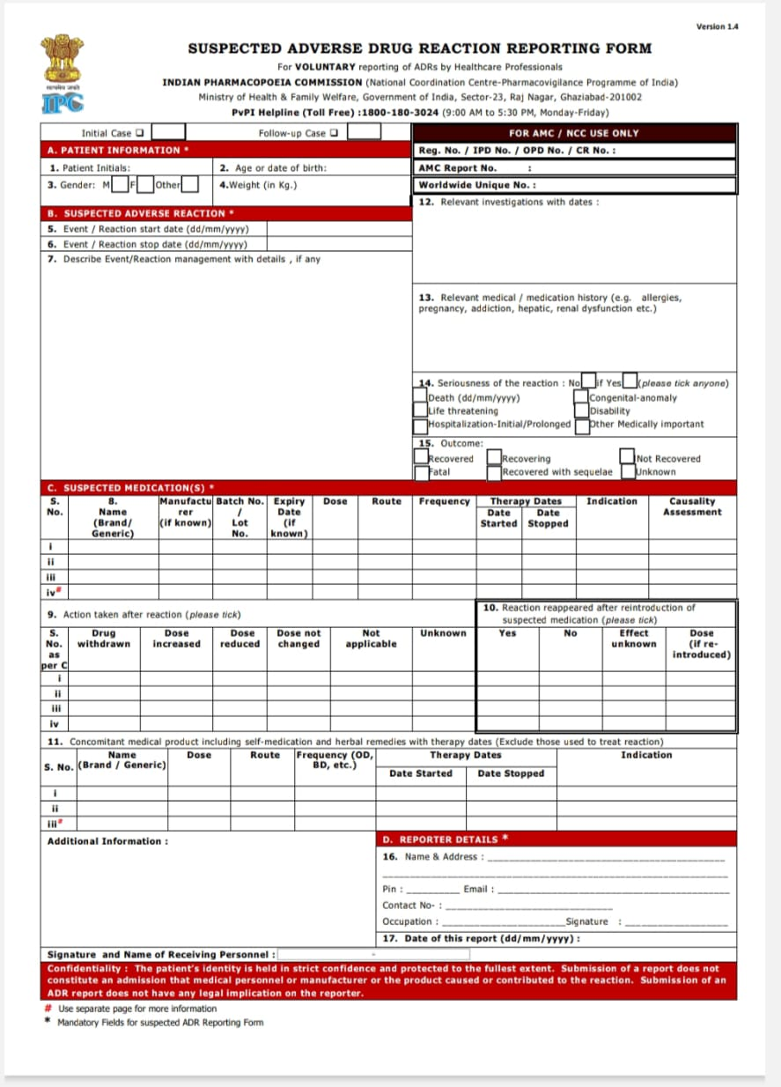
Case study: A patient takes Amoxicillin 500 mg and develops a skin rash and itching. The suspected reaction is an adverse drug reaction (ADR)
Step 1: Patient information (Section A)
- Use the following sample details: Form field Sample information
      - Patient initials: R.K.
        - Age: 25 years
        - Gender: Female
        - Weight: 55 kg
      - Case type : Initial case
Step 2: Suspected adverse reaction (Section B)

Form field Sample information
Reaction Skin rash and itching
Reaction start date 10/11/2026
Reaction stop date 12/11/2026 (sample)
Reaction management Patient evaluated
By doctor suspected
Reviewed and
Symptomatic treatment
Given.

Step 3: Suspected medication details (Section C)
Field Information
Drug name Amoxicillin
Generic name Amoxicillin
Manufacturer Not available
Batch number Not available
Expiry date Not available
Dose 500 mg
Route Oral
Frequency Three times daily
Start date 08/11/2026
Stop date 10/11/2026
Indication Bacterial throat infection
Causality assessment To be assessed

Step 4: Action taken after reaction
In the sample case:
- Drug withdrawn: Yes (if confirmed by treating doctor).
- Dose increased: No.
- Dose reduced: No.
- Dose unchanged: No.
- Not applicable: No.
Step 5: Reaction reappeared after reintroduction
- Yes: Not established.
- No: Not established.
- Effect unknown: Select if the information is unavailable.

Step 6: Relevant investigations
Write the available investigation details.
Example:
- Clinical examination: Skin rash present.
- Itching: Present.
- Other laboratory investigations: Not available.
Do not invent laboratory results.
Step 7: Medical and medication history
Sample entry:
- Known drug allergy: Not known.
- Previous history of skin allergy: Not known.
- Other medical conditions: Not available.
- Concomitant medication: Not available.

Step 8: Seriousness of reaction
For this hypothetical mild rash case, assuming no serious criteria:
Step 9: outcome
- Recovered: Yes (if confirmed).
- Recovering: No.
- Not recovered: No.
- Fatal: No.
Step 10: Reporter details (Section D)
Enter the actual details of the person reporting:
- Name
- Address
- PIN code
- Email
- Contact number
- Occupation: Pharmacist
- Signature
- Date of report

Step 11: Causality assessment

Causality assessment helps determine whether Amoxicillin may have caused the reaction.

Final ADR case summary

- Suspected ADR: Amoxicillin
- Drug: Amoxicillin 500 mg
- Reaction: Skin rash and itching
- Patient: 25-year-old female
- Indication: Bacterial throat infection
- Route: Oral
- Frequency: Three times daily
- Suspected ADR type: Skin-related reaction
- Seriousness: Non-serious in this example
- Causality: Pending assessment

