Thesis Title



Your Name
Your College

Centre for Sustainable Development
Department of Engineering
University of Cambridge

This dissertation is submitted for the degree of Doctor of Philosophy
February 2015

The template was produced by Malcolm Morgan and Kayla Friedman for the Centre for Sustainable Development, University of Cambridge, UK

Dedication goes here
optional

This page is for a personal statement of quote
optional

Declaration
This dissertation is the result of my own work and includes nothing, which is the outcome of work done in collaboration except where specifically indicated in the text. It has not been previously submitted, in part or whole, to any university of institution for any degree, diploma, or other qualification.
In accordance with the Department of Engineering guidelines, this thesis is does not exceed 65,000/80,000 (delete as appropriate) words, and it contains less than 150 figures.

Signed:______________________________________________________________

Date:_________________________________________________________________

Your Name and full qualifications
Cambridge

(This declaration should also make clear any parts of the work that have been submitted for any other qualification. See:
http://www.admin.cam.ac.uk/students/studentregistry/exams/submission/phd/submitting.html )

Summary / Abstract (Delete as Preferred)
The summary must be written in English and should consist of a piece of connected prose forming an abstract of the dissertation and be about 300 words in length. If at all possible, it should be accommodated on one side of A4 sized paper. It should bear the candidate's name and the exact title of the dissertation at the head of the page.
If candidates submit a soft-bound dissertation in the first instance, they will need when submitting the final hard-bound copy of the dissertation, to provide a further, loose-leaf, copy of this summary, identical to that bound into the final version, for the University Library file.
The summary will be considered by the examiners and, if the dissertation is approved, be deposited in the University Library for consultation and inter-library loan.

Acknowledgements

Thank you to Kayla Friedman and Malcolm Morgan of the Centre for Sustainable Development, University of Cambridge, UK for producing the Microsoft Word thesis template used to produce this document.

Contents
1 Introduction 1
1.1 Requirements 1
1.2 Paper and electronic copies of the dissertation 3
2 Using this Template 4
2.1 Getting Started 4
2.1.1 Using the DOCX file 4
2.1.2 Using the DOTX file to start a new document 5
2.1.3 Using the DOTX file to migrate and existing document 5
2.2 Improved Spelling and Grammar Checking 5
2.3 Understanding Styles 6
2.4 Themes 7
2.5 Margins 8
2.6 Headers and Footers 8
2.6.1 Editing Header and Footers 9
2.7 Working with Images 10
2.8 Captions 10
2.9 Cross References 10
2.10 Updating Automatically Generated Content 11
3 Style Examples 12
3.1 Heading 2 13
3.1.1 Heading 3 13
3.2 Heading 2 13
3.2.1 Heading 3 13
4 Information taken from Cambridge Student Registry 17
4.1 Style and Format 17
4.2 Binding 18
4.3 Including Other Written Material 19
4.4 Including a CD-ROM (or other item) 19
4.5 Word Limits and Stylistic Conventions: Requirements Of The Degree Committees 20
4.6 Engineering 20
4.7 Extending The Word Limit 20
5 Information from CUED 21
5.1 Appointment Of Examiners And Approval Of Title 21
5.2 Format of Your Dissertation 21
5.3 Submission of Your Dissertation 22
5.4 Examination Procedure 22
6 From ‘planning a PhD’ 23
6.1 Typing and Printing of Dissertations 23
6.2 Acknowledgements 23
7 References 24
8 Appendices 25

List of Tables
Table 3.1 This is the caption to a table, and the styles used in tables. 14

List of Figures
Figure 2.1: Grammar Options in Word 2010 6
Figure 2.2: The Home Tab in Word 2010 showing Style on the right hand side 6
Figure 2.3: Colour Themes in Word 2010 are on the Page Layout Tab 7
Figure 2.4: Margin Settings in Word 2010 8
Figure 2.5 Cross-reference options in Word 2010 10
Figure 3.1: This is a picture of a running kitten. In addition, this caption style is used to caption pictures and tables. Captions include the numbering system included the chapter number. Captions default to above content. 14

List of Abbreviations and Acronyms

List of Appendices
Appendix Heading 1 16
Appendix 1 Example Title 26
Appendix 2 27

Introduction
This document is intended to provide useful information about producing a thesis in terms of content, editing, and production of copies. This document was first written with Microsoft Word 2010 in 2013; it was last updated in February 2015. No further updates are planned, and the template is provided “as is” with no promise of ongoing support.
CSD Thesis Template by Kayla Friedman and Malcolm Morgan is licensed under a Creative Commons Attribution-Non Commercial-Share Alike 4.0 International License.
Further information from
https://neuraldischarge.wordpress.com/2013/11/05/the-only-phdmasters-thesis-template-for-word-you-will-ever-need/
This document contains content and advice taken from the University of Cambridge and the University of Cambridge, Department of Engineering. Which is the property of those respective organisations.
Requirements for a PhD / Masters Degree vary. The guidance and formatting in this document is for PhD in Engineering from the University of Cambridge. Please check with your own institution before submitting.

Requirements

Dissertation length
The dissertation should be about 65000 words

Structure
The structure of the dissertation should broadly follow this outline.
- Abstract. 2-300 words long and give a very brief overview of the whole dissertation, including your findings.
- Introduction
- Middle chapters
  - Aims, methods, data, description, analysis
- Conclusions. The conclusion section should be quite short, 5 pages at the most, and normally 1 or 2. It should:
  - sum up the findings made during your research,
  - have a short introductory section explaining the process of your dissertation,
  - often have recommendations for the future.
  - answer the research question that your dissertation addresses.
- References
- Appendices
IT IS VERY IMPORTANT to check that your chapters link together coherently; at the start of each chapter you might have an introductory paragraph setting the scene for the contents and at the end of each chapter it may help to have a few paragraphs summing up it's contents.
Spreadsheets should be inserted as tables.
Some students find Excel using in developing the structure with word counts, etc.
Finally, your title is expected to reflect the content!

Interaction with supervisor
It is useful to know when your tutor is generally unavailable, bearing in mind that you will be working on it during the summer holiday period. Make sure you give your text to the tutor so that they have enough time to look at it before any critical date or meeting, Check with your tutor whether they want a printed copy or whether a computer document will do.
Before giving document to tutor:
- If you have trouble with English, ask a friend to check it for you.
- Do Ctrl-A to select all text and F9 to recalculate. This updates automatic numbering, table of contents etc.
- Do a spell and grammar check.
- Tracking changes. If your tutor or someone else edits your document, it is useful for them to use Track Changes (Alt-TT).
- Read the Word for Thesis writing PowerPoint on the camtools site

Paper and electronic copies of the dissertation
We require a bound copy and an electronic copy of your dissertation. .

Bound copies
We require two canvas bound copies with hard or soft cover. On the spine the lettering should be in the format:

Electronic copies
These should be in Word or PDF format. It is useful to have it on a CD, but if the whole lot can be zipped to under 10MB then you can also email it to your tutor.

Using this Template
Instructions in this section were written for Word 2010, they are similar in Word 2007, and Word 2013, but may be different in Word 2003 and Word for Mac.

Getting Started
The most up to date version of the template is available at:
http://neuraldischarge.wordpress.com/2013/11/05/the-only-phdmasters-thesis-template-for-word-you-will-ever-need/

Two different versions are available. The DOCX version is just a normal Word Document, you can use and edit this versions as you would any other document. The DOTX version is a word template and therefore can be applied to an existing document or used as the template to a new document. The DOCX version includes this help text. The DOTX version only includes the standard front matter. The benefit of using the DOTX template is that there is separation of styling and content, which reduces the risk of breaking the template.

Using the DOCX file
You can use this document to write you thesis, simply delete the help text and start writing into the document.

Using the DOTX file to start a new document
Create a new document from the template:
File > New > New from existing
The select the DOTX template
A word document will open containing the basic structure of the PhD Template. Scroll down to page 11 and select the text that says “Select this text and the paste your existing document here.”
Delete this text and start writing your thesis.
Remember to use the special style for appendix headings

Using the DOTX file to migrate and existing document
Create a new document from the template:
File > New > New from existing
The select the DOTX template
A word document will open containing the basic structure of the PhD Template. Scroll down to page 11 and select the text that says “Select this text and the paste your existing document here.”
Now go to your existing document and copy all the text, if you have existing front matter such as cover pages, tables of contents etc do not copy those.
Go back to the PhD Template and past your text.
Select All (Ctrl + A) and then press F9 to update all the automatically generated content. If prompted select Update Whole Table.
You may need to make additional changes to your document such as formatting appendix titles to the appendix style, checking that styles have been correctly applied and repositioning images.
If you have numbered your headings incorrectly in your old document, you may find that the new document has double heading numbers.

Improved Spelling and Grammar Checking
As default Word does not enable all the spelling and grammar checking features. You can get extra spelling and grammar checks by going to:
File > Options > Proofing
The under “when correcting spelling and grammar in Word” click Settings.
Here you can use the drop down menu to make work check Grammar & Style, and use the tick boxes to choose which features to check for. Most academic writing includes passive sentences so you may wish to turn off this feature. You can also set style features such as comma positions, and number of spaces between sentences. I recommend you set these to “Always, inside, 2.”

Figure 2.1: Grammar Options in Word 2010
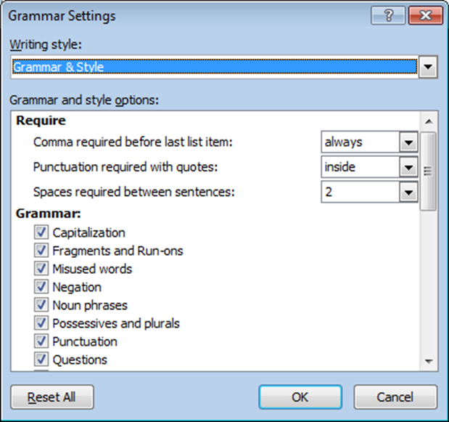

Understanding Styles
The template makes heavy usage of Word Styles. When used correctly styles save a lot of time and make formatting your document easier. Rather than formatting each piece of text individually, you create styles for different parts of the text e.g. headings, captions, references etc. You then just tell Word what style to use on what part of the text.

Figure 2.2: The Home Tab in Word 2010 showing Style on the right hand side
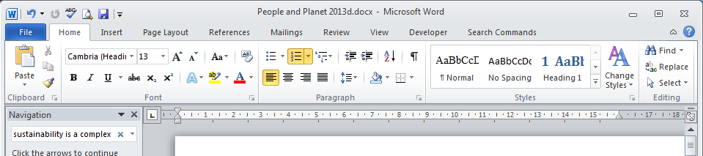

As part of the Template we have created styles which meet the needs of most academic texts. If you do not like the fonts we have chosen you can simple modify the styles and the whole document will change automatically. To modify a style right click on it an select Modify.
Styles are also used to automatically create things like tables of contents.
Styles can be found in the Home Tab in Word 2010 and a list of different styles used and how they appear is on page 12.

Themes
Themes dictate how your document looks and set colours, fonts etc. They work in partnership with styles. The Theme for the Template is called CSD Template V2 and uses the aspect colour scheme.
Figure 2.3: Colour Themes in Word 2010 are on the Page Layout Tab
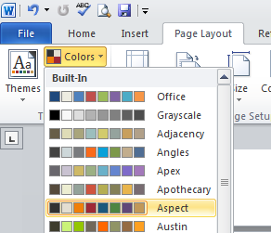
Changing the theme will also affect things like excel graphs pasted into your documents. You can also load the theme into Power Point and Excel to create other content will a consistent appearance.

Margins
The Template includes margins that comply to the University of Cambridge Standard and are a good starting point. If you have to comply with other rules on Margins, you can change them by going to Page Layout > Margins > Custom Margins.
Remember to apply margins to the whole document, and that you need mirror margins on a thesis with wider margins by the spine. Otherwise, the document will be unreadable when bound.
Figure 2.4: Margin Settings in Word 2010
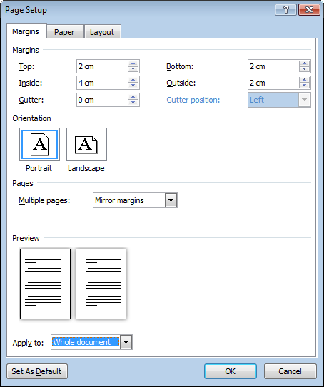

Headers and Footers
The template is automatically set up with Headers and Footers.
As default
- Cover pages have no headers or footers
- Front matter have no headers, and footers contain only page numbers in Roman numerals
- Main pages have headers with your thesis title, name, and date. Footers contain the chapter title and the page number in Arabic numerals.
The title of the thesis and your name are set on the cover page. The date updates automatically.
The template supports different headers and footer for odd and even pages. This allows the page numbers to switch sides as they do in a book.

Editing Header and Footers
Other places have full guides to working with headers and footers, so this is just a few notes on headers and footers in the template.
The template breaks the links between headers and footer on pervious pages at:
- The cover page
- The front matter
- The main section of the document
- Between odd and even pages
If you tamper with headers and footers, you may find odd things happen in other parts of the document. Nevertheless, if you do want to make a change this checklist should help.
- Do you want you change to happen on both odd and even pages? If so, you will need to make all the changes twice.
- Do you want the change to cross the boundaries between sections? If so you will have to make the changes on both sides. I recommend not relinking sections unless your are a Word Expert.
- Will any of the changes you make remove or alter sections, chapter headings, and the cover page? If so, you may have to redo the headings and footers manually.

The automatically generated text in the headers and footers is produced using.
Quick Parts > Fields > StyleRef and then the appropriate part of the document.
Or
Quick Parts > Document Property > Author for the authors name. This also appears on the cover page as an editable field.

Working with Images
Word is not good for handling images. More coming Soon

Captions
Captions can be added to Figures, Tables, etc by going to References > Insert Caption. As default the caption include the chapter number. This can be edited using the Numbering Options.

Cross References
If you want to refer to another part of the document, you don’t want to have to keep changing that reference as the figure number or page number changes. You can get Word to update these automatically by using the Cross Reference feature. Got to References > Cross-reference.
Figure 2.5 Cross-reference options in Word 2010
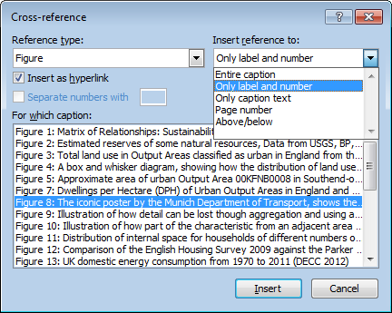

Updating Automatically Generated Content
Automatically generated content such as cross references, tables of contents, list of figures may need periodic updating. You can either right click on the object and select Update field to update a single area, or to update everything Select All (Ctrl + A) and the press F9. This may take a while on a whole thesis so always save before updating.

Style Examples
This section includes examples of all the styles used in the template. This text is in the Normal Style and should be used for body text. The Title above is in Heading 1 should be used for chapter titles. It will automatically start a new page and includes some spacing before and after.
Below is a list of heading styles, the template supports up to 6 levels of headings. Only the top three levels appear in the table of contents. Headings appear in the table of contents up to Level 3 and are automatically converted to small caps.

Heading 2

Heading 3

Heading 4

Heading 5

Heading 6

Heading 6

Heading 2

Heading 3

Heading 4

Heading 5

Heading 6

Heading 6

Heading 1 – No Number
Heading 1 – No number is used for headings that you don’t want to have heading numbers. For example in the front matter. They do not appear in the table of contents.

Heading 2 – No Number
Heading 2 – No number is used for headings that you don’t want to have heading numbers. For example in the front matter. They do not appear in the table of contents.

- Bullet Style for bullet points
  - Bullet Level 2

Figure 3.1: This is a picture of a running kitten. In addition, this caption style is used to caption pictures and tables. Captions include the numbering system included the chapter number. Captions default to above content.
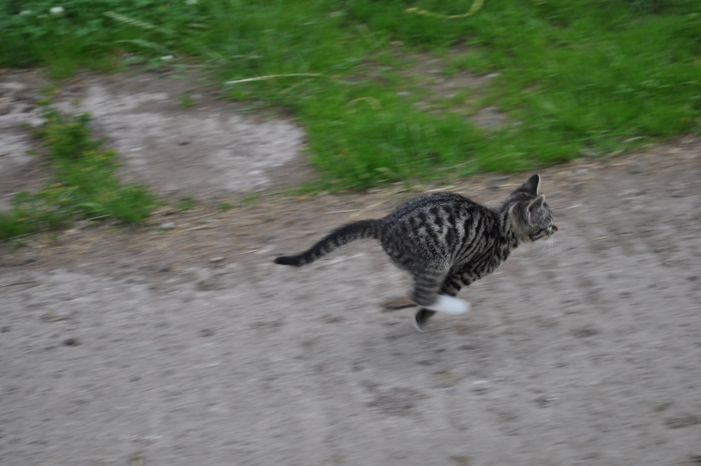

Table 3.1 This is the caption to a table, and the styles used in tables.
Table Head Text | Table Head Text | Table Head Text
Table Text | Table Text | Table Text
- Table Text Numbered | - Table Text Numbered | - Table Text Numbered
Table Text Tab | Table Text Tab | Table Text Tab

This is what it looks like to add a footnote, and this is how endnote looks.

This is a quote

This is a dedication; use it for the dedication and quotes in the front matter.

This is a list
List 2
List 3
List 4
List 5

- Numbered List Part 1
- Number List Part 2
- Numbered List Part 3

Table of Figures
This is the text used in tables of figures, tables, appendices etc

Appendix Heading 1
This heading called Appendix Heading should only be used for heading appendices, and it will automatically appear in the list of appendices. It will automatically start a new page.

Information taken from Cambridge Student Registry
The information can be found here:
http://www.admin.cam.ac.uk/students/studentregistry/exams/submission/phd/format.html

Style and Format
- the dissertation, apart from quotations and recognised technical formulae, must be written in English
- typescript on A4 paper
- portrait format is expected, but landscape format may exceptionally be allowed by some degree committees
- double-sided printing is permissible for both soft and hard-bound dissertations
- one-and-a-half spaced type
- minimum font size for text is 11pt (12pt is preferred) and 10pt for footnotes. Easily readable fonts are preferred for example, Arial, Times New Roman
- the dissertation must include a title page giving the candidate's full name, their college, the full title of the dissertation, and the degree for which it is submitted. It should also include a summary, a declaration of originality and a statement of length if a word limit has been set by the degree committee.
Care should be taken to ensure that the text is legible. The quality of printing should allow for copying; manuscript or similar entries should be of an ineradicable nature.
Photographs and other illustrations should be scanned or printed into the text. Where this is not the case, they must be originals, not photocopies, and securely fixed. Sticky tape is not acceptable as an adhesive.
The form in which the dissertation is presented, and the care with which it has been prepared and illustrated, are in themselves evidence of the candidate's capabilities and will receive consideration as such. Candidates are strongly advised to check carefully for typing errors, spelling mistakes and poor English. The correction of such errors may be a condition of approval for the degree. Care must be taken to ensure that the correct version of text appears in the copies of the dissertation submitted for examination.
Submitting a soft-bound dissertation in the first instance must not be viewed as a means of submitting a provisional, unpolished version.
Examiners are not expected to copy edit work, although, of course, they will deal with errors of fact and typographical errors that affect the meaning, as well as larger issues. The extent to which the text has or has not been properly prepared may influence their recommendation concerning the award of the degree.

Binding
Two bound copies of the dissertation are to be submitted for examination; these copies may be hard or soft-bound.
Hard-bound means permanently stitched and bound in stiff covers with the title of the dissertation and the candidate's name clearly inscribed on the spine.
Soft-bound must be bound in such a way for the contents to be securely fixed within the covers, which must bear the title and candidate's name.
It is a condition for proceeding to the degree that candidates submit a hard-bound copy to the Board of Graduate Studies for deposit in the University Library.
If candidates submit a soft-bound copy in the first instance, they should produce the final hard-bound copy only after receiving a letter of approval for their degree from the Secretary of the Board of Graduate Studies. This will almost certainly delay the date by which the candidates can graduate. Board meetings take place a week or so before graduation days and this time interval is generally too short for the production of a hard-bound dissertation in time for approval being given for admission to the degree.
If a soft-bound copy is submitted, it will certainly be necessary to provide a new copy for hard binding as most methods of soft binding (e.g. comb/wire binding) create holes that would weaken conventional binding and will lead to an unacceptable loss of the margin. Also, it makes it impossible to trim the book, head and tail, as the holes will appear.
Thesis binding expenses up to £30 are available for students registered for an PhD, MSc, MLitt. Forms are available from your graduate tutor; please note that students must be able to demonstrate financial hardship.
For advice on binding contact the Graduate Union.

Including Other Written Material
Candidates may submit with their dissertation other unconnected or unrelated work which they have published; such work may, at the discretion of the examiners, be taken into consideration.

Including a CD-ROM (or other item)
If candidates wish to include an audio or videotape, a film, computer programmes or a CD-Rom in an Appendix she/he will need to make an application to the Board of Graduate Studies before submitting the thesis. The Board of Graduate Studies may, on the recommendation of the degree committee, allow candidates to do this provided the material is presented either in slip envelopes within the binding of the dissertation or, for more bulky items, gathered into a supplementary volume of similar format to the bound dissertation. Nothing should be attached to the outside of the cover of the dissertation.
Please note that the inclusion of a CD does not provide a means of escaping the constraints of word limits.
Application forms are available from the candidate's Self-Service pages.

Word Limits and Stylistic Conventions: Requirements Of The Degree Committees
Candidates should write as concisely as is consistent with clear and adequate exposition. The following degree committees have prescribed the limits of length or stylistic requirements given below. If candidates have been working under any one of these degree committees, they must submit a certificate stating their dissertation does not exceed the prescribed limit when the dissertation is submitted.
These limits and requirements are strictly observed by the Board and the degree committees and, unless approval to exceed the prescribed limit has been obtained beforehand (see: 'Extending the Word Limit' below), a dissertation that exceeds the limit may not be examined until its length complies with the prescribed limit.

Engineering
PhD dissertations not to exceed, without prior permission of the degree committee, 65,000 words, including appendices, bibliography, footnotes, tables and equations not to contain more than 150 figures. A candidate must submit with their dissertation a statement signed by the candidate themself giving the length of the dissertation and the number of figures. Any dissertation which, without the prior permission of the degree committee, exceeds the permitted limits, will be referred back to the candidate before being forwarded to the examiners.

Extending The Word Limit
Dissertation word limits are set by degree committees. If candidates need to increase their word limits they will need to apply for permission.
Application forms are available from candidates' Self-Service pages.

Information from CUED
The CUED website has a page on dissertation information including a useful pdf entitled “Planning a PhD”. The information below and additional links can be found here:
http://www.eng.cam.ac.uk/postgraduate/current-students/dissertation-submission

Appointment Of Examiners And Approval Of Title
At least four weeks before you intend to submit your dissertation please email the Graduate Studies Office with the title of your dissertation and your proposed submission date. After consulting with your supervisor the GSO will arrange for your examiners to be appointed and your title approved.

Format of Your Dissertation
PhD dissertations must not exceed, without prior permission of the Degree Committee, 65,000 words, including appendices, bibliography, footnotes, tables and equations, and not to contain more than 150 figures. You must submit with your dissertation a statement signed by yourself giving the length of the dissertation and the number of figures. Any application to exceed the prescribed length must be accompanied by a statement from the supervisor explaining why the extended length is required. Any dissertation which, without the prior permission of the Degree Committee, exceeds the permitted limits, will be referred back to the candidate before being forwarded to the Examiners.

Submission of Your Dissertation
PhD dissertations are submitted at the Board of Graduate Studies office in Mill Lane where they are checked, logged and then forwarded to the Graduate Studies Office. Providing examiners have been appointed your dissertations will be forwarded to the examiners within 2 days of receipt.

Examination Procedure
Your dissertation will be forwarded to your examiners as soon as possible. We will write to you informing you that this has been done. An oral examination will be arranged by your examiners and you will be informed of the time and date. We ask the examiners to arrange this examination within 2 months of receiving the dissertation but this is not always possible. At the oral examination or just after it you will be given a list of any corrections required by the examiners. One or both of the examiners will check your corrections, usually the internal examiner. The corrections can be completed on an electronic copy of the dissertation and forwarded to the examiner, some examiners will prefer to have a printed copy. When the corrections are completed you can go ahead and get the hardbound copies made. The Graduate Union can arrange this for you. http://www.gradunion.cam.ac.uk/
The Engineering Degree Committee will not consider your examiners reports until any corrections have been made and have been approved by the examiners.

From ‘planning a PhD’

Typing and Printing of Dissertations
Candidates should select a type font that produces clear script of adequate size. The text must be clear and of a size (12-pt is standard) that is easy to read. As a guide, about 12 words per line and 45 lines per page would be suitable. It is permissible for dissertations to be printed on both sides of the page using one and a half spaced typing. The Board of Graduate Studies will accept dissertations in either A4 or A5 format. Candidates may wish to discuss the choice of format with their Supervisor beforehand.

Acknowledgements
Regulation 8 of the regulations for the Doctor of Philosophy states that 'a student, in submitting a dissertation, shall state, generally in a preface and specifically in notes or in a bibliography, the sources from which his or her information is derived, the extent to which he or she has availed himself or herself of the work of others, and the portions of his or her dissertation which he or she claims as his or her own original work.' Examiners pay particular attention to this regulation. A candidate should discuss the matter fully with his or her supervisor during the writing of the dissertation, and should consult the Secretary of the Degree Committee if difficulties arise.

References
Bournemouth University, 2005, Citing References, www.bournemouth.ac.uk/academic_services/documents/Library/Citing_References.pdf. [Accessed August 2006].

Appendices
Appendix Heading 1 16
Appendix 1 Example Title 26
Appendix 2 27

Appendix 1 Example Title
As a default, appendixes do not appear in the table of contents but instead have their own table of appendices.
To achieve this appendices have their own heading style, which is visually similar to the main headings but are functionally different.
The Appendices do require the chapter heading page so that the beginning of appendices is listed in the table of contents and so that the footers say Appendices rather than saying References.
Appendix Headings automatically start on a new page.

Appendix 2

This is a foot note
This is an endnote they will automatically be places at the end of the document section. As default this is at the end of the references.

