SCHOOL OF COMPUTER SCIENCE AND ARTIFICIAL INTELLIGENCE |  |  |  |  | DEPARTMENTOF COMPUTER SCIENCE ENGINEERING
ProgramName:M. Tech/MCA/MSC |  |  |  | AssignmentType: Lab |  |  | AcademicYear:2025-2026
CourseCoordinatorName |  |  |  | Venkataramana Veeramsetty
CourseCode |  |  |  | CourseTitle |  | AI Assisted Problem Solving Using Python
Year/Sem |  |  | II/I | Regulation |  | R24
DateandDay  of Assignment |  |  | Week5- Monday | Time(s)
Duration |  |  | 2 Hours | Applicableto  Batches
AssignmentNumber:11.3(Presentassignmentnumber)/24(Totalnumberofassignments)
 | Q.No. | Question |  |  |  |  |  | ExpectedTime  to complete
 | 1 | Lab 11 – Data Structures with AI: Implementing Fundamental Structures  Lab Objectives  - To implement fundamental data structures with the assistance of AI tools.  - To understand how AI suggests different implementations and optimizations.  - To analyze the readability, correctness, and performance of AI-generated code.  - To reinforce problem-solving skills using AI-powered coding assistance.  Learning Outcomes  After completing this lab, students will be able to:  - Implement stack, queue, and linked list using Python with AI support.  - Use AI tools to optimize and refactor basic data structure operations.  - Compare multiple AI-suggested implementations for the same structure.  - Apply AI assistance to generate test cases for verifying data structure behavior.  - Demonstrate understanding of trade-offs in AI-generated solutions.  Task Description #1 – Stack class implementation  Task: Ask AI to implement a stack class with push(), pop(), peek() and is_empty() methods  Task Description #2 – Queue Implementation  Task: Use AI to generate a Queue class with enqueue(), dequeue(), and is_empty().  Task Description #3 – Linked List Implementation  Task: Ask AI to create a singly linked list with insert_at_end(), insert_at_beginning(), and display().  Task Description #4 – Binary Search Tree (BST)  Task: Ask AI to generate a simple BST with insert() and inorder_traversal(). |  |  |  |  |  | Week5 - Monday

- Task Description #1 – Stack class implementation
Task: Ask AI to implement a stack class with push(), pop(), peek() and is_empty() methods
Ans:
PROMPT: #Task Description #1 – Stack class implementation
#Task: Ask AI to implement a stack class with push(), pop(), peek() andis_empty() methods

CODE:
#Task Description #1 – Stack class implementation
#Task: Ask AI to implement a stack class with push(), pop(), peek() andis_empty() methods

class Stack:
def __init__(self):
self.items = []
def push(self, item):
"""Add an item to the top of the stack."""
self.items.append(item)
def pop(self):
"""Remove and return the item from the top of the stack.
Raises IndexError if the stack is empty."""
if self.is_empty():
raise IndexError("pop from empty stack")
return self.items.pop()
def peek(self):
"""Return the item at the top of the stack without removing it.
Raises IndexError if the stack is empty."""
if self.is_empty():
raise IndexError("peek from empty stack")
return self.items[-1]
def is_empty(self):
"""Return True if the stack is empty, False otherwise."""
return len(self.items) == 0
# Example usage:
if __name__ == "__main__":
stack = Stack()
stack.push(1)
stack.push(2)
stack.push(3)
print(stack.peek()) # Output: 3
print(stack.pop()) # Output: 3
print(stack.is_empty()) # Output: False
print(stack.pop()) # Output: 2
print(stack.pop()) # Output: 1
print(stack.is_empty()) # Output: True

OUTPUT:
3
3
False
2
1
True

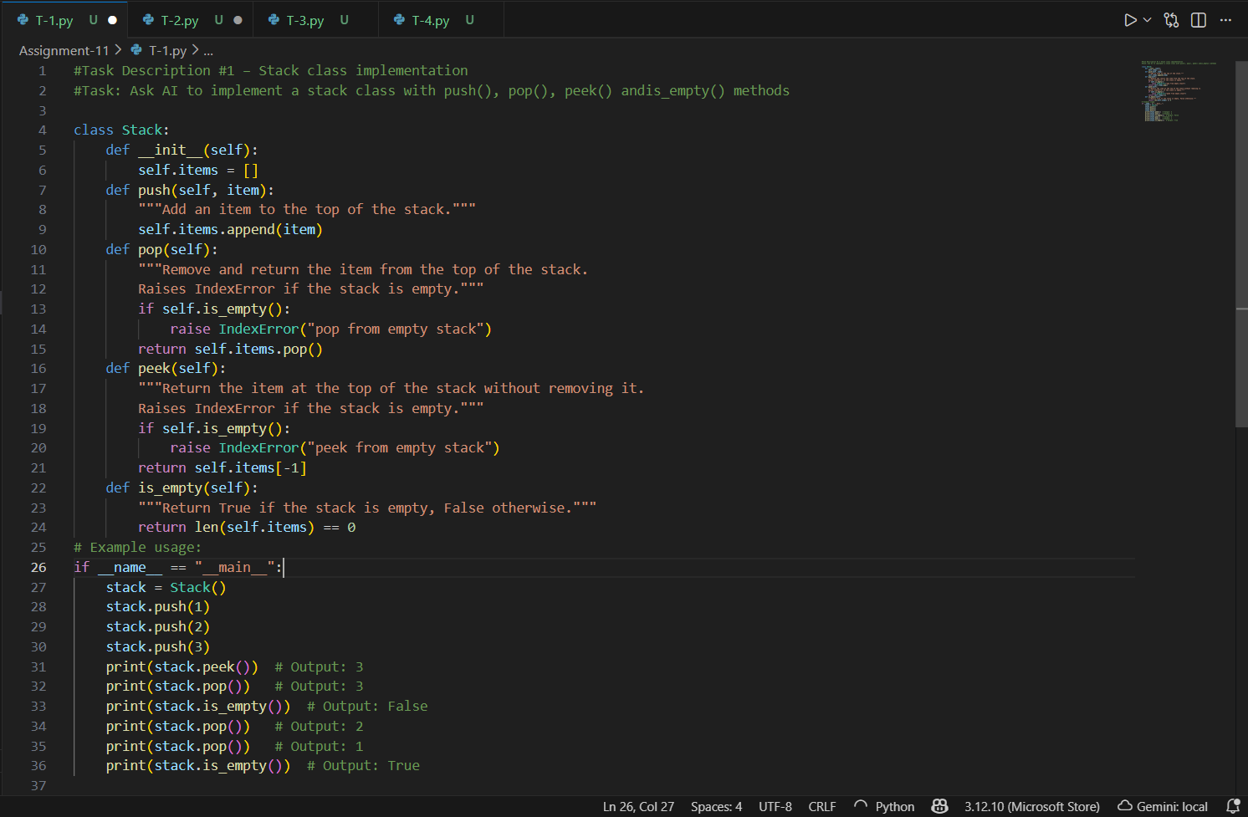
Figure 1: T-1 code
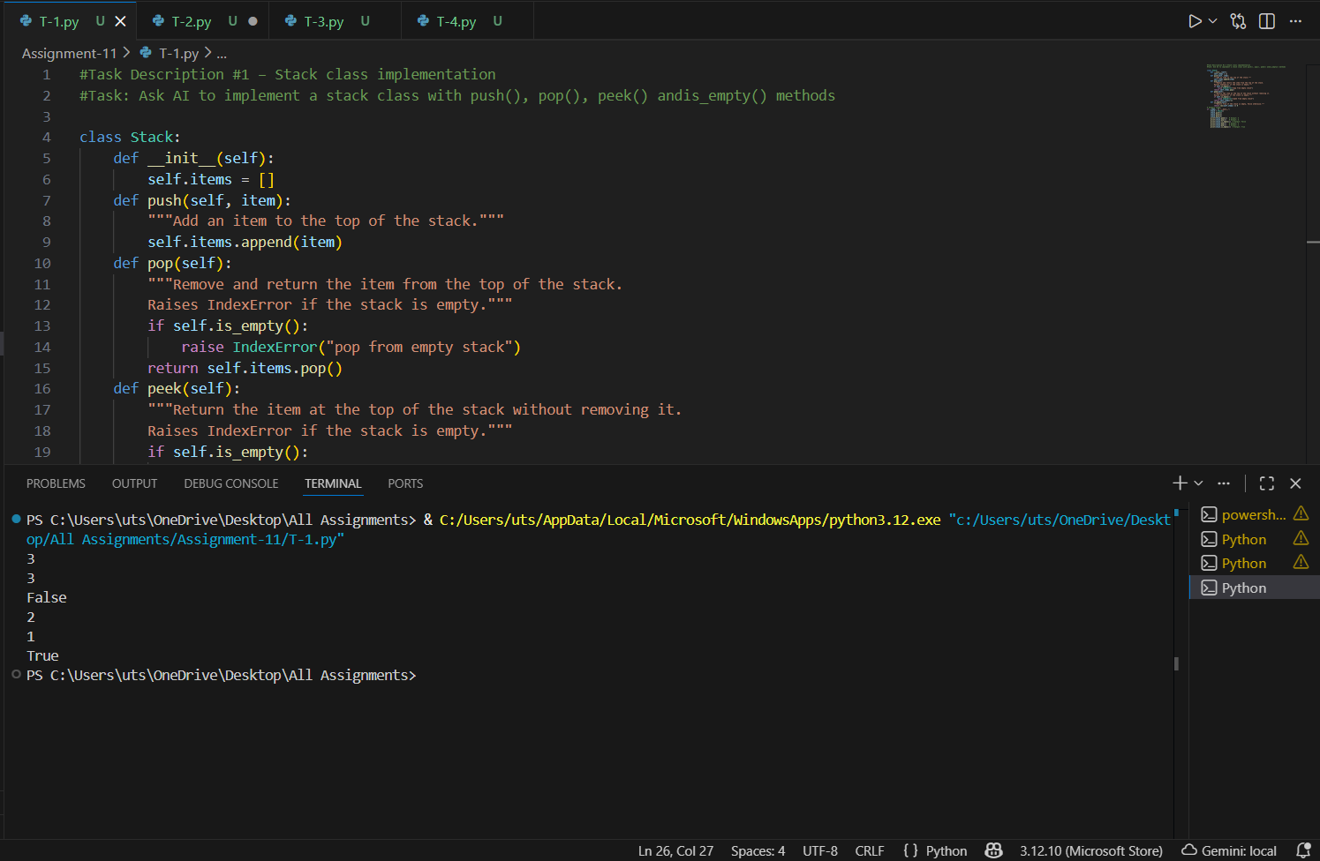
Figure 2: T-1 output

- Task Description #2 – Queue Implementation
Task: Use AI to generate a Queue class with enqueue(), dequeue(), and is_empty().
Ans:
PROMPT: Task Description #2 – Queue Implementation
Task: Use AI to generate a Queue class with enqueue(), dequeue(), and is_empty().
CODE:
#Task Description #2 – Queue Implementation
#Task: Use AI to generate a Queue class with enqueue(), dequeue(), and is_empty() GIVE WITH COMMENTS
class Queue:
def __init__(self):
self.items = []

def enqueue(self, item):
"""Add an item to the end of the queue."""
self.items.append(item)

def dequeue(self):
"""Remove and return the item from the front of the queue.
Raises IndexError if the queue is empty."""
if self.is_empty():
raise IndexError("dequeue from empty queue")
return self.items.pop(0)
def is_empty(self):
"""Return True if the queue is empty, False otherwise."""
return len(self.items) == 0

# Example usage:
if __name__ == "__main__":
queue = Queue()
queue.enqueue(1)
queue.enqueue(2)
queue.enqueue(3)
print(queue.dequeue()) # Output: 1
print(queue.is_empty()) # Output: False
print(queue.dequeue()) # Output: 2
print(queue.dequeue()) # Output: 3
print(queue.is_empty()) # Output: True
try:
queue.dequeue() # This will raise an IndexError
except IndexError as e:
print(e) # Output: dequeue from empty queue

OUTPUT:
1
False
2
3
True
dequeue from empty queue

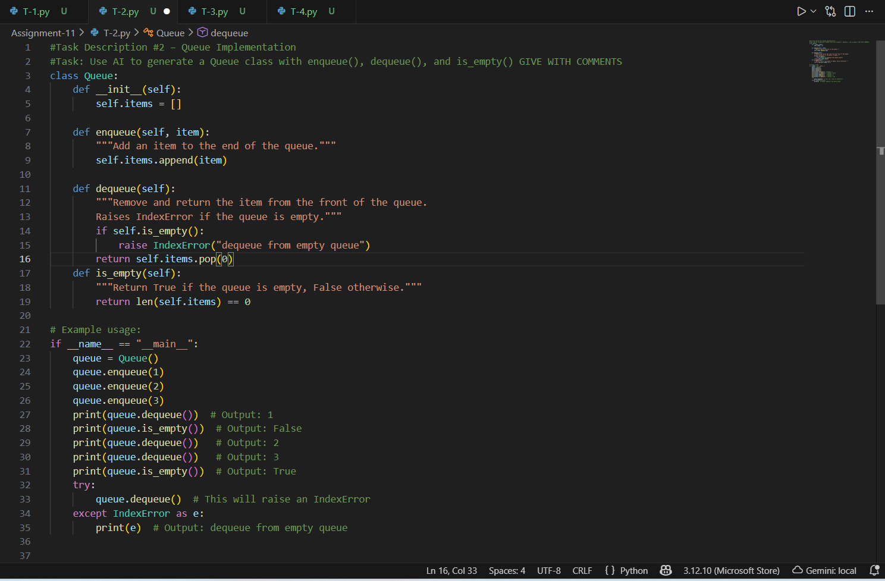
Figure 3: T-2 Code

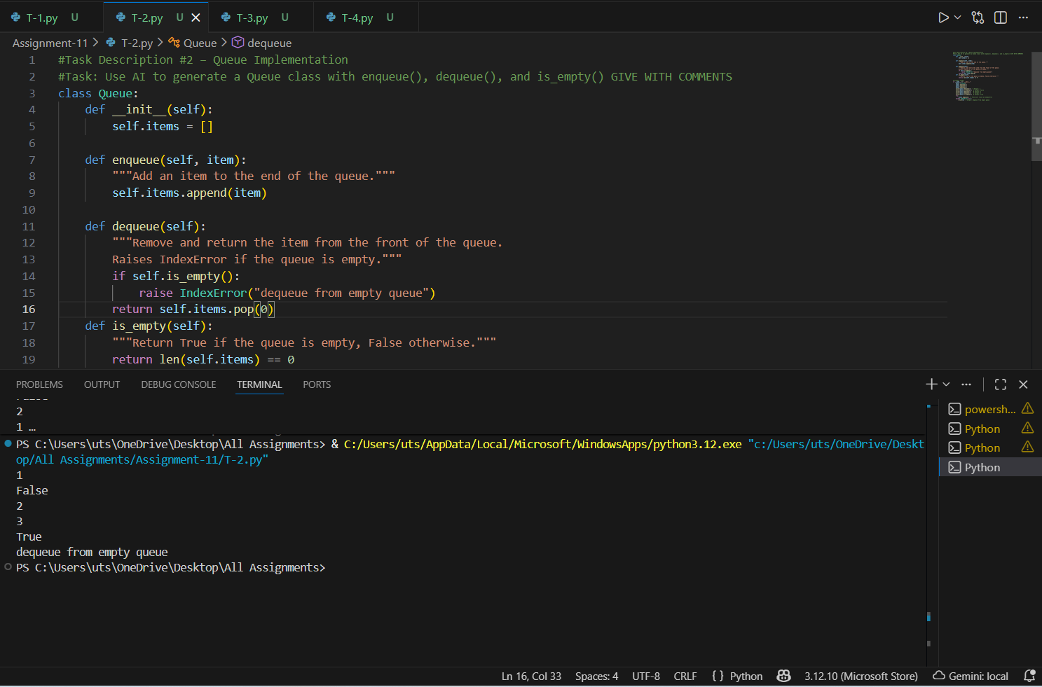
Figure 4:T-2 output

- Task Description #3 – Linked List Implementation
Task: Ask AI to create a singly linked list with insert_at_end(), insert_at_beginning(), and display().
Ans:
PROMPT: Task: Ask AI to create a singly linked list with insert_at_end(), insert_at_beginning(), and display().

CODE:
#Task Description #3 – Linked List Implementation
#Task: Ask AI to create a singly linked list with insert_at_end(),insert_at_beginning(), and display()

class Node:
def __init__(self, data):
self.data = data
self.next = None
class SinglyLinkedList:
def __init__(self):
self.head = None
def insert_at_end(self, data):
"""Insert a new node with the given data at the end of the list."""
new_node = Node(data)
if not self.head:
self.head = new_node
return
last = self.head
while last.next:
last = last.next
last.next = new_node
def insert_at_beginning(self, data):
"""Insert a new node with the given data at the beginning of the list."""
new_node = Node(data)
new_node.next = self.head
self.head = new_node
def display(self):
"""Display the linked list."""
current = self.head
elements = []
while current:
elements.append(current.data)
current = current.next
print("Linked List:", " -> ".join(map(str, elements)))
# Example usage:
if __name__ == "__main__":
linked_list = SinglyLinkedList()
linked_list.insert_at_end(1)
linked_list.insert_at_end(2)
linked_list.insert_at_beginning(0)
linked_list.display() # Output: Linked List: 0 -> 1 -> 2
linked_list.insert_at_end(3)
linked_list.display() # Output: Linked List: 0 -> 1 -> 2 -> 3
linked_list.insert_at_beginning(-1)
linked_list.display() # Output: Linked List: -1 -> 0 -> 1 -> 2 -> 3

OUTPUT:
Linked List: 0 -> 1 -> 2
Linked List: 0 -> 1 -> 2 -> 3
Linked List: -1 -> 0 -> 1 -> 2 -> 3
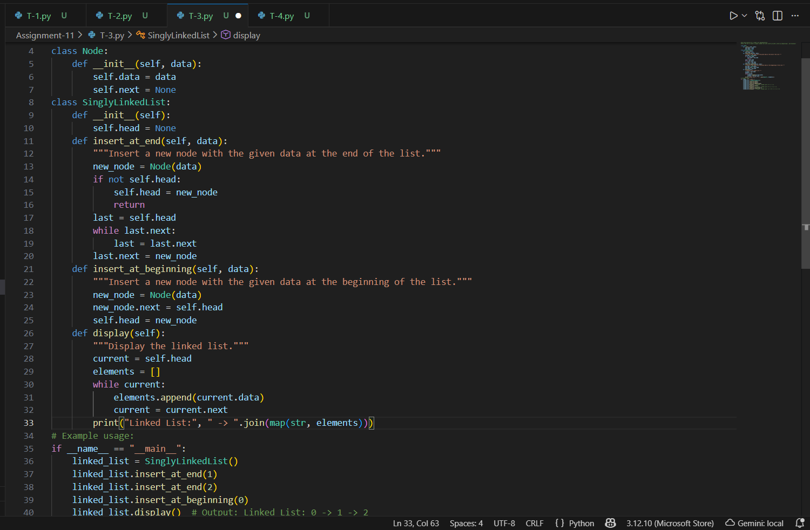
Figure 5: T-3 code
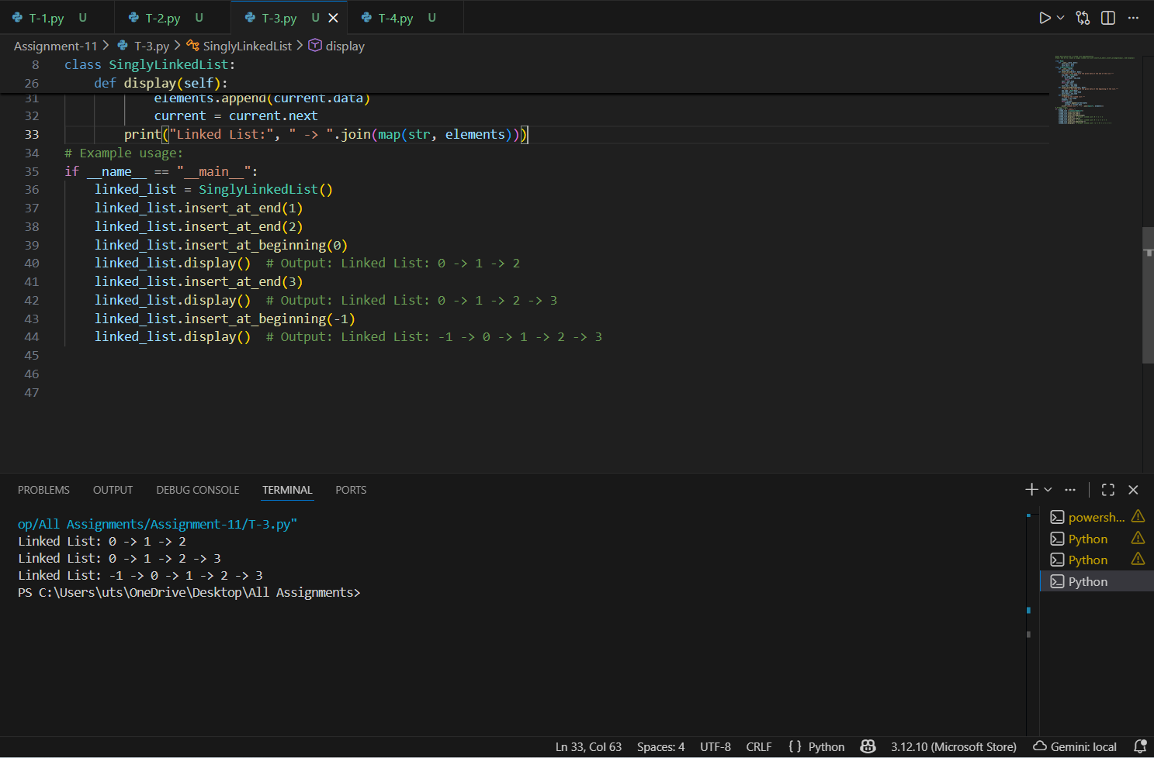
Figure 6: T-3 output
- Task Description #4 – Binary Search Tree (BST)
Task: Ask AI to generate a simple BST with insert() and inorder_traversal().

Ans:
PROMPT:
Task: Ask AI to generate a simple BST with insert() and inorder_traversal().
CODE:
#Task Description #4 – Binary Search Tree (BST)
#Task: Ask AI to generate a simple BST with insert() and inorder_traversal().

class TreeNode:
def __init__(self, key):
self.left = None
self.right = None
self.val = key
class BST:
def __init__(self):
self.root = None

def insert(self, key):
if self.root is None:
self.root = TreeNode(key)
else:
self._insert_rec(self.root, key)

def _insert_rec(self, node, key):
if key < node.val:
if node.left is None:
node.left = TreeNode(key)
else:
self._insert_rec(node.left, key)
else:
if node.right is None:
node.right = TreeNode(key)
else:
self._insert_rec(node.right, key)

def inorder_traversal(self):
return self._inorder_rec(self.root)

def _inorder_rec(self, node):
res = []
if node:
res = self._inorder_rec(node.left)
res.append(node.val)
res = res + self._inorder_rec(node.right)
return res

# Example usage:
if __name__ == "__main__":
bst = BST()
bst.insert(50)
bst.insert(30)
bst.insert(20)
bst.insert(40)
bst.insert(70)
bst.insert(60)
bst.insert(80)

print("Inorder traversal of the BST:", bst.inorder_traversal())

OUTPUT:
Inorder traversal of the BST: [20, 30, 40, 50, 60, 70, 80]

