ASSIGNMENT-1
2505B04203, Shaik. Yasmin(ES)

Lab 1: Environment Setup – GitHub Copilot and VS Code Integration
Lab Objectives:
● To install and configure GitHub Copilot in Visual Studio Code.
● To explore AI-assisted code generation using GitHub Copilot.
● To analyze the accuracy and effectiveness of Copilot's code suggestions.
● To understand prompt-based programming using comments and code context
Lab Outcomes (LOs):
After completing this lab, students will be able to:
● Set up GitHub Copilot in VS Code successfully.
● Use inline comments and context to generate code with Copilot.
● Evaluate AI-generated code for correctness and readability.
● Compare code suggestions based on different prompts and programming styles

- Task Description#1
● Install and configure GitHub Copilot in VS Code. Take screenshots of each step.
Week1 -
Wednesday
Expected Output#1
● Install and configure GitHub Copilot in VS Code. Take screenshots of each steP
Ans:

Figure 1: Authorisation page of GitHub Copilot
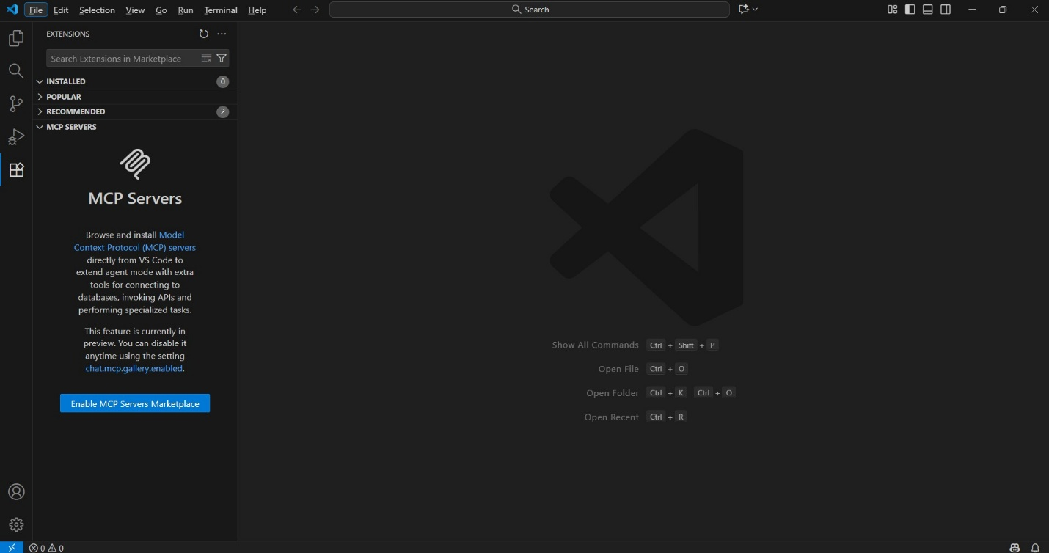
Figure 2: Extension Market place open in VS code

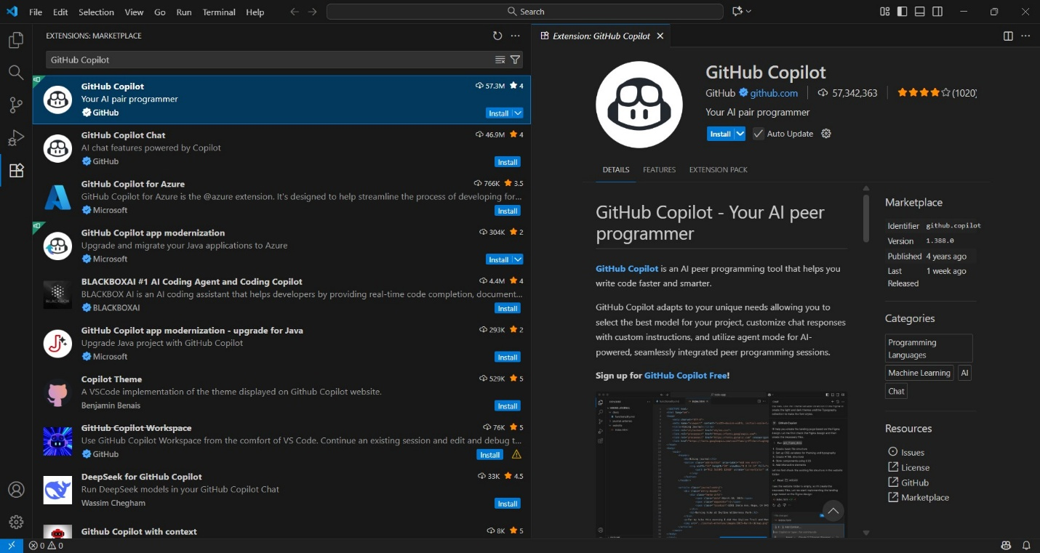
Figure 3: Github Copilot in search bar of Extension Marketplace

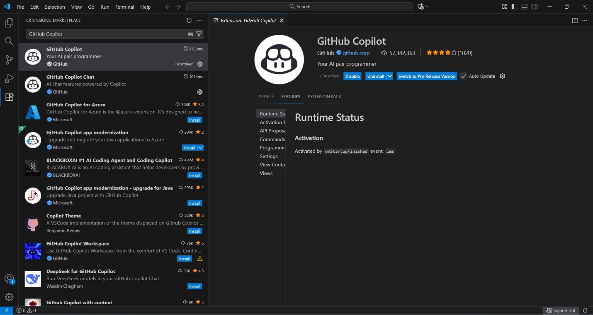
Figure 4: GitHub copilot Installation

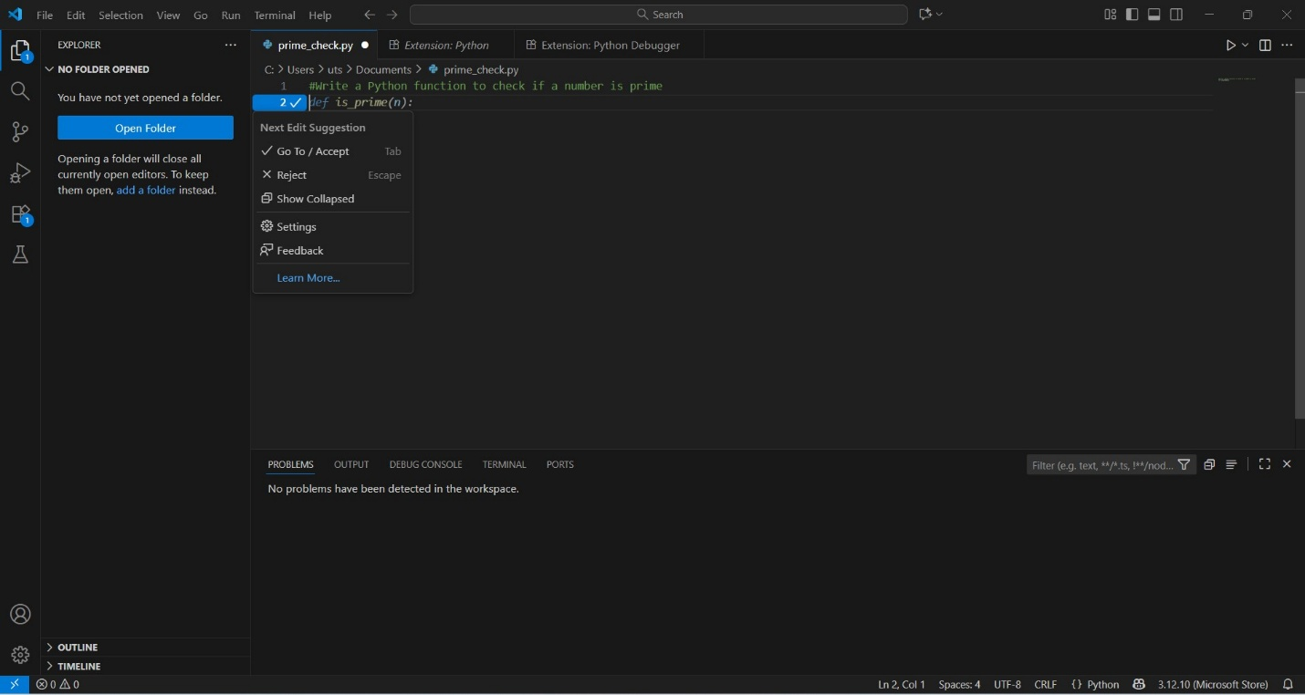
Figure 5: Installation is done and it can understand the comments

- Task Description#2
● Use Copilot to generate a is_prime() Python function.
Expected Output#2
● Function to check primality with correct logic.
Ans:
#Write a Python function to check if a number is prime
def is_prime(n): # Function to check if a number is prime
if n <= 1: # Step 1: Numbers less than or equal to 1 are NOT prime
return False
# Step 2: Loop from 2 to the square root of n (efficient checking)
# If any number divides n evenly, then n is NOT prime
for i in range(2, int(n**0.5) + 1):
if n % i == 0:
print(f"{n} is not a prime number.")
return False # Exit function since it's not prime
# Step 3: If loop finishes with no divisors, it's prime
print(f"{n} is a prime number.")
return True

print(is_prime(2))
print(is_prime(11))
print(is_prime(4))
print(is_prime(15))

OUTPUT:
2 is a prime number.
True
11 is a prime number.
True
4 is not a prime number.
False
15 is not a prime number.
False

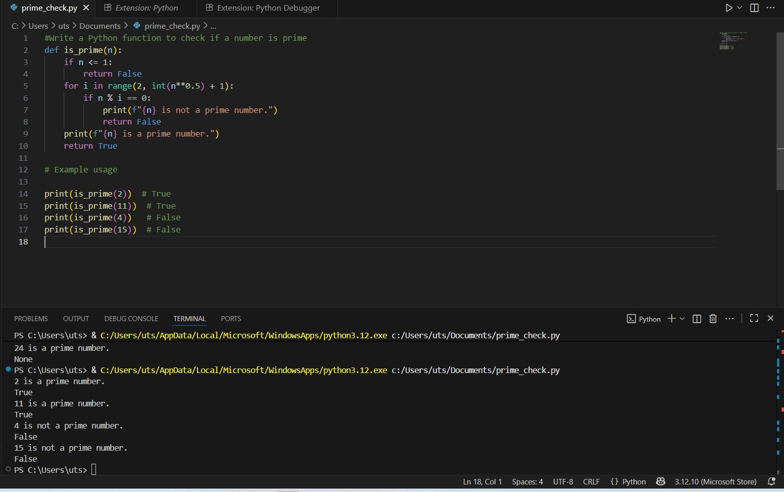
Figure 6: To check a no. is prime or not code and along with Output

- Task Description#3
● Write a comment like # Function to reverse a string and use Copilot to generate the
function.
Expected Output#3
● Auto-completed reverse function
Ans:
# Function to reverse a string
def reverse_string(s: str) -> str:
# The [::-1] slice notation reverses the string.
# It starts from the end of the string and moves backward by 1 step.
return s[::-1]
print(reverse_string("hello"))
print(reverse_string("world"))
print(reverse_string("Python"))
OUTPUT:
olleh
dlrow
nohtyP
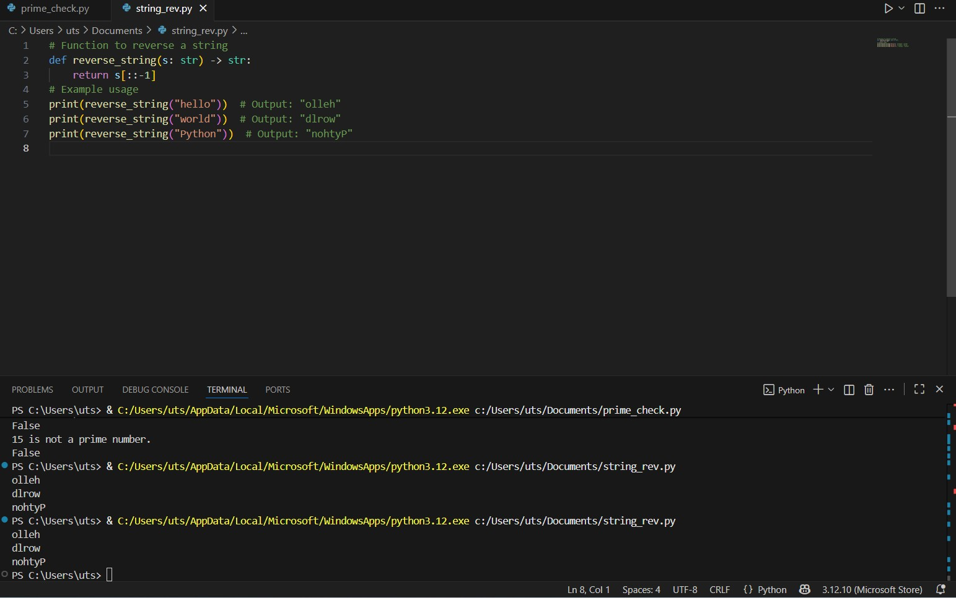
Figure 7: String reverse code and Output
- Task Description#4
● Generate both recursive and iterative versions of a factorial function using comments..
Expected Output#4
● Two working factorial implementation
Ans: # Function to calculate factorial using recursion
def factorial(n: int) -> int:
if n < 0:
raise ValueError("Factorial is not defined for negative numbers.")
# Base case: factorial of 0 or 1 is 1
elif n == 0 or n == 1:
return 1
# Recursive case: n! = n * (n-1)!
else:
return n * factorial(n - 1)
# Function to calculate factorial using iteration
def factorial_iterative(n: int) -> int:
if n < 0:
raise ValueError("Factorial is not defined for negative numbers.")
result = 1
# Multiply numbers from 2 up to n
for i in range(2, n + 1):
result *= i
return result
# Printing the Factorial of Numbers
print(factorial(5))
print(factorial_iterative(5))
print(factorial(2))
print(factorial_iterative(2))

OUTPUT:
120
120
2
2
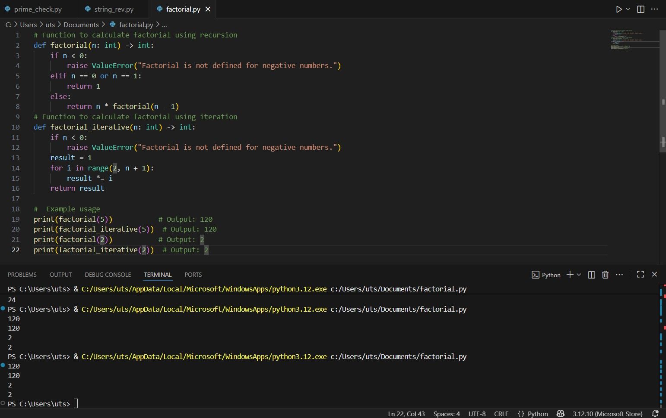
Figure 8: Factorial of a number with recursion and iteration code and output

- Task Description#5
● Use Copilot to find the largest number in a list. Assess code quality and efficiency.
Expected Output#5
● A valid function with your review
Ans:
# Defining a Function to find the largest number in a list
def largest_number(numbers: list) -> int:
# Step 1: Checking if the list is empty
if not numbers:
raise ValueError("The list is empty.")
# Step 2: Assume the first element is the largest initially
max_num = numbers[0]
# Step 3: Loop through the list to compare each element
for num in numbers:
# If num is greater than max_num, then it enters into the if statement and continues through the loop and returns the largest number
if num > max_num:
max_num = num
return max_num
print(largest_number([3, 5, 2, 8, 1]))
print(largest_number([-10, -5, -2, -8, -1]))
print(largest_number([0, 0, 0, 0]))
print(largest_number([100, 200, 50, 300, 150]))
OUTPUT:
8
-1
0
300
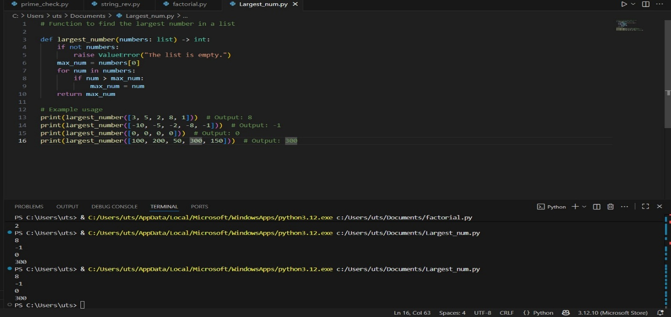
Figure 9: Largest number in a list code and output

