ASSIGNMENT-3
Shaik. Yasmin, (ES).
- Application for TGNPDCL
Objective: Build an application using Python program for TGNPDCL, to generate the
bill based on energy consumption and type of customer with the help of AI tools.
Build a python application as per below instructions
• Read all the required data like PU,CU and Type of customer
• Calculate bill amount based on number of units consumed, type of customer
and other charges
• Finally print the values of EC(Energy Charges),FC(Fixed
Charges),CC(Customer Char-ges),ED(Electricity Duty Charges),bill as per
expected output
Requirements:
• VS Code with Github Copilot and/or Google Colab with Gemini
• Students should bring power bill from their home
Deliverables:
• Print energy bill for given inputs and verify with bill taken by students
Week2 -
Wednesday
Ans:
#Defines a function named calculate_electricity_bill.It takes 3- parameters:
- previous_reading,
- current_reading,
- customer_type
def calculate_electricity_bill(previous_reading, current_reading, customer_type):
# Calculating the units consumed
units_consumed = current_reading - previous_reading
# Define rates based on customer type per one unit
if customer_type == 'residential':
rate_per_unit = 2.46 # rate per unit for residential
fixed_charge = 20.00
customer_charge = 70.00
# calculating the Energy Charge
energy_charge = units_consumed * rate_per_unit
electricity_charge = energy_charge
ed = electricity_charge * 0.0243 # ED calculation
# Define rates based on customer type per one unit
elif customer_type == 'commercial':
rate_per_unit = 1.5 # rate per unit for commercial
fixed_charge = 50.00
customer_charge = 100.00
energy_charge = units_consumed * rate_per_unit
electricity_charge = energy_charge
ed = electricity_charge * 0.05 # ED calculation
else:
raise ValueError("Invalid customer type. Choose 'residential' or 'commercial'.")
# Calculating total bill
total_bill = electricity_charge + fixed_charge + customer_charge + ed
# Print the bill components
print(f"EC={electricity_charge:.2f}, FC={fixed_charge:.2f}, CC={customer_charge:.2f}, ED={ed:.2f}, Total Bill={total_bill:.2f}")
calculate_electricity_bill(2309, 2400, 'residential')
calculate_electricity_bill(2309, 2400, 'commercial')

OUTPUT:
EC=223.86, FC=20.00, CC=70.00, ED=5.44, Total Bill=319.30
EC=136.50, FC=50.00, CC=100.00, ED=6.83, Total Bill=293.32
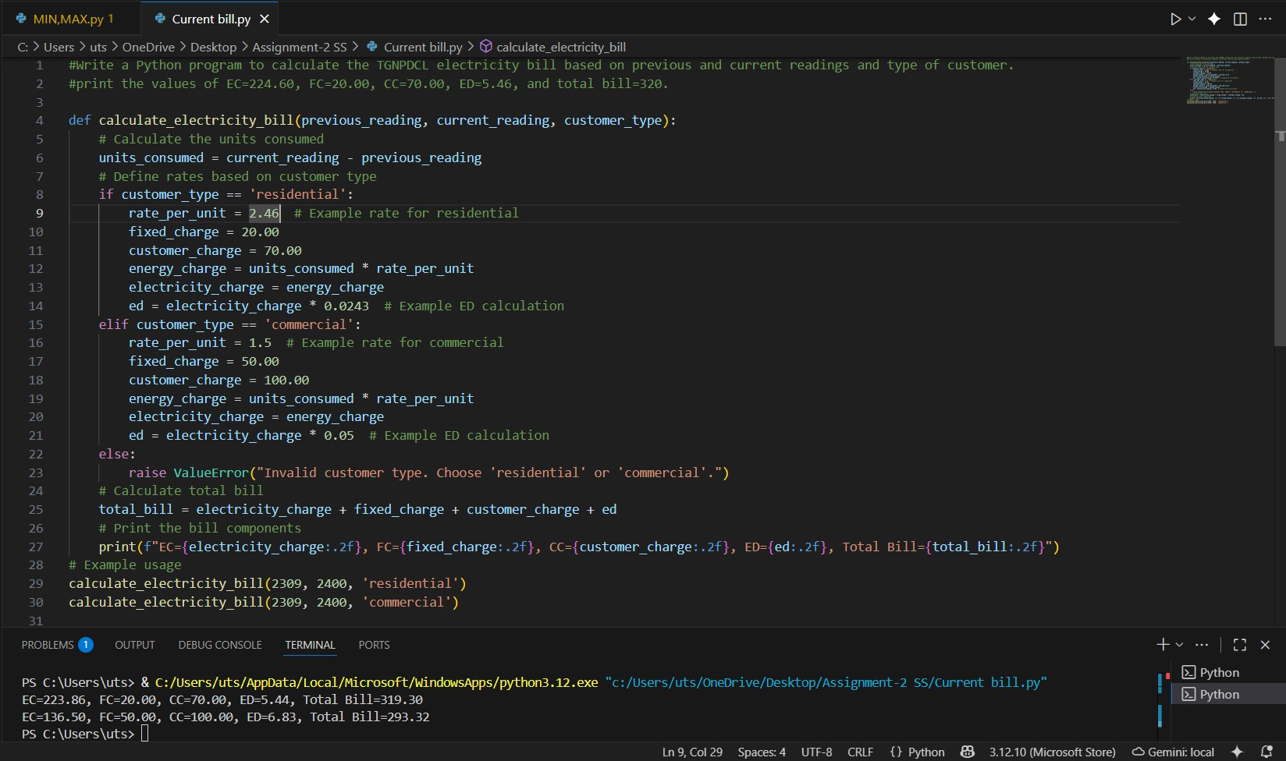
Figure 1: Code for TGNPDCL Bill to calculate EC, FC, ED, CC and Total Bill

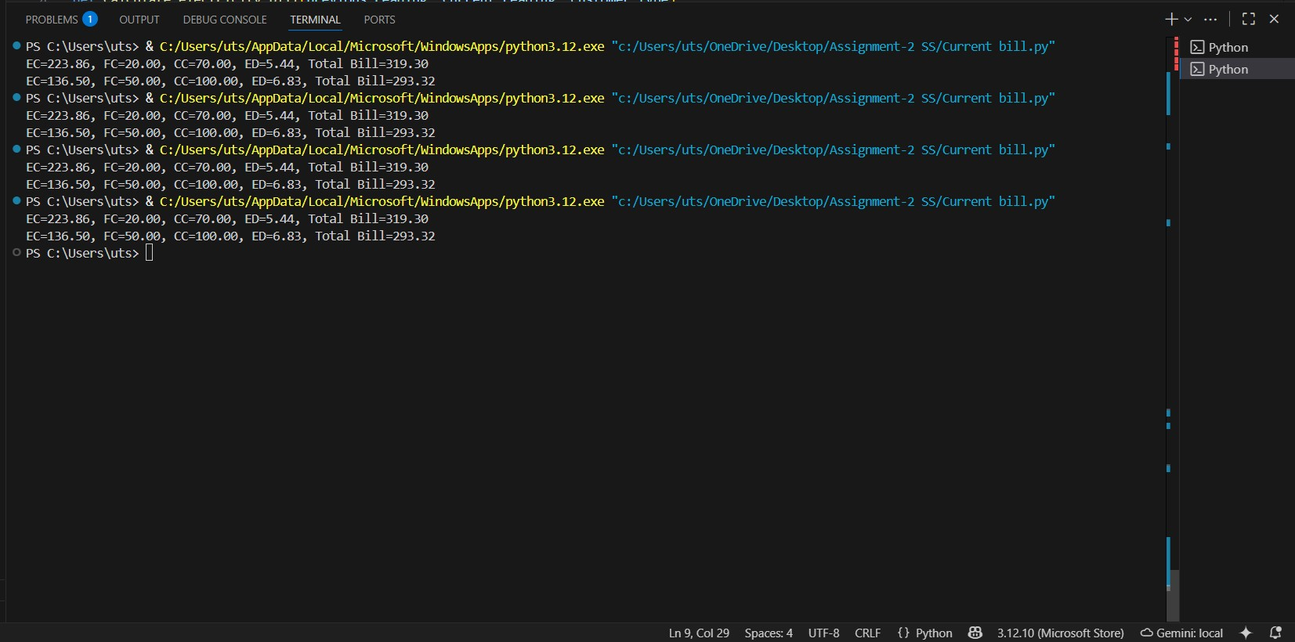
Figure 2: Output of the Residential and Commercial type bill

