ASSIGNMENT-4
2505B04203, Shaik. Yasmin (ES)
- Task Description#1
● Zero-shot: Prompt AI to write a function that checks whether a given year is a leap
year.
Expected Output#1
● AI-generated function with no examples provided
Ans:
#ZERO-SHOT Prompt to Copilot:
def is_leap_year(year):
# Function to check if a given year is a leap year.
if (year % 4 == 0 and year % 100 != 0) or (year % 400 == 0):
return True
else:
return False
year = 2020
print(f"{year} is a leap year: {is_leap_year(year)}")
year = 1900
print(f"{year} is a leap year: {is_leap_year(year)}")
OUTPUT:
2020 is a leap year: True
1900 is a leap year: False

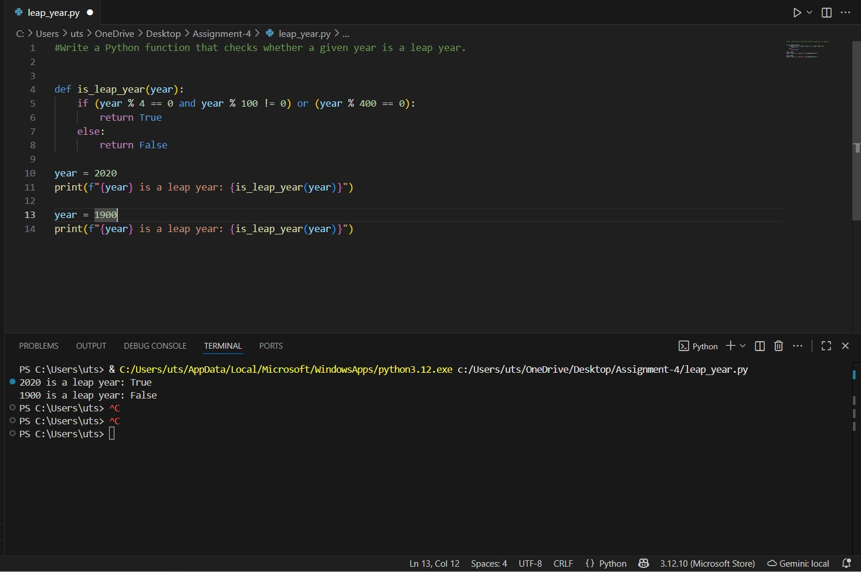
Figure 1: Leap Year zero-shot prompt in copilot code and output

- Task Description#2
● One-shot: Give one input-output example to guide AI in writing a function that
converts centimeters to inches.
Expected Output#2
● Function with correct conversion logic
Ans:
#ONE-SHOT PROMPT WITH COPILOT:
def cm_to_inches(cm):
#Function that converts cm into inches
inches = cm / 2.54
return inches
print(cm_to_inches(10))
print(cm_to_inches(25.4))
OUTPUT:
3.937007874015748
10.0
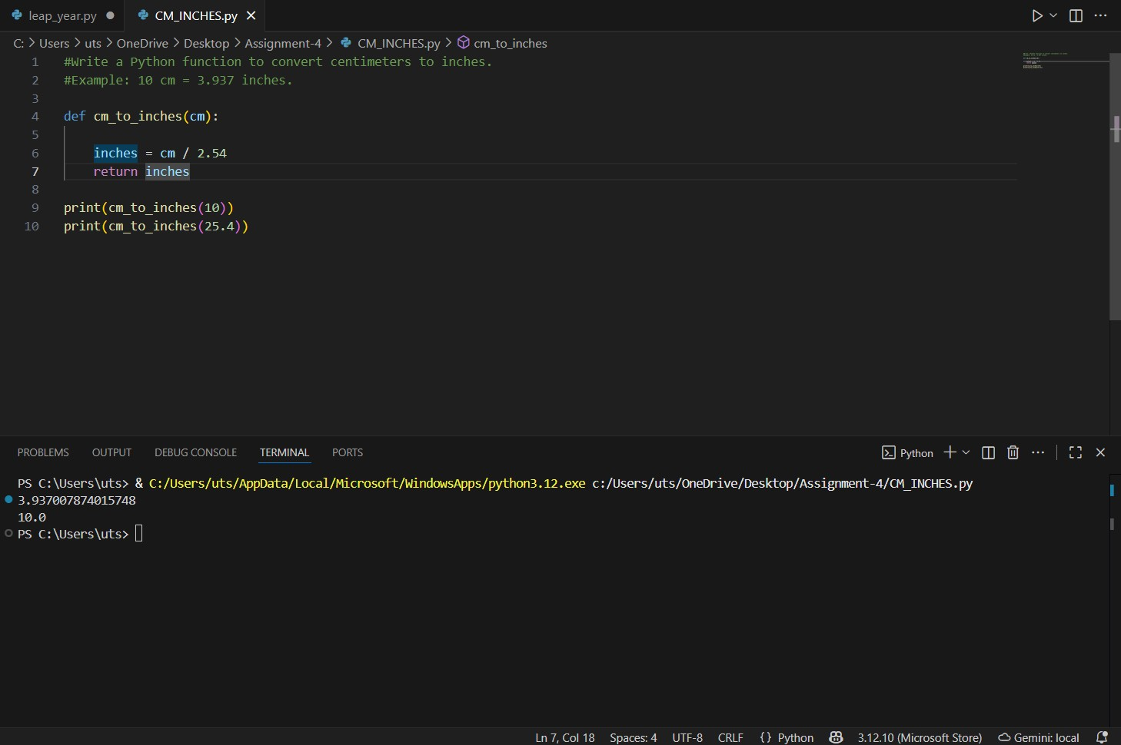
Figure 2: One-Shot Prompt Example using copilot to convert cm to inches code and output

- Task Description#3
● Few-shot: Provide 2–3 examples to generate a function that formats full names as
“Last, First”.
Expected Output#3
● Well-structured function respecting the examples
Ans:
#Few-shot Prompt using copilot
def format_name(full_name): # Defines a Function
name_parts = full_name.split() #splitting the string into a list of words
first_names = " ".join(name_parts[:-1])
last_name = name_parts[-1]
formatted_name = f"{last_name}, {first_names}" # formatted as per output
return formatted_name
print(format_name("Shaik Yasmin"))
print(format_name("Potti Baby"))
print(format_name("Shaik Yakub"))
print(format_name("Shaik Shabana"))

OUTPUT:
Yasmin, Shaik
Baby, Potti
Yakub, Shaik
Shabana, Shaik
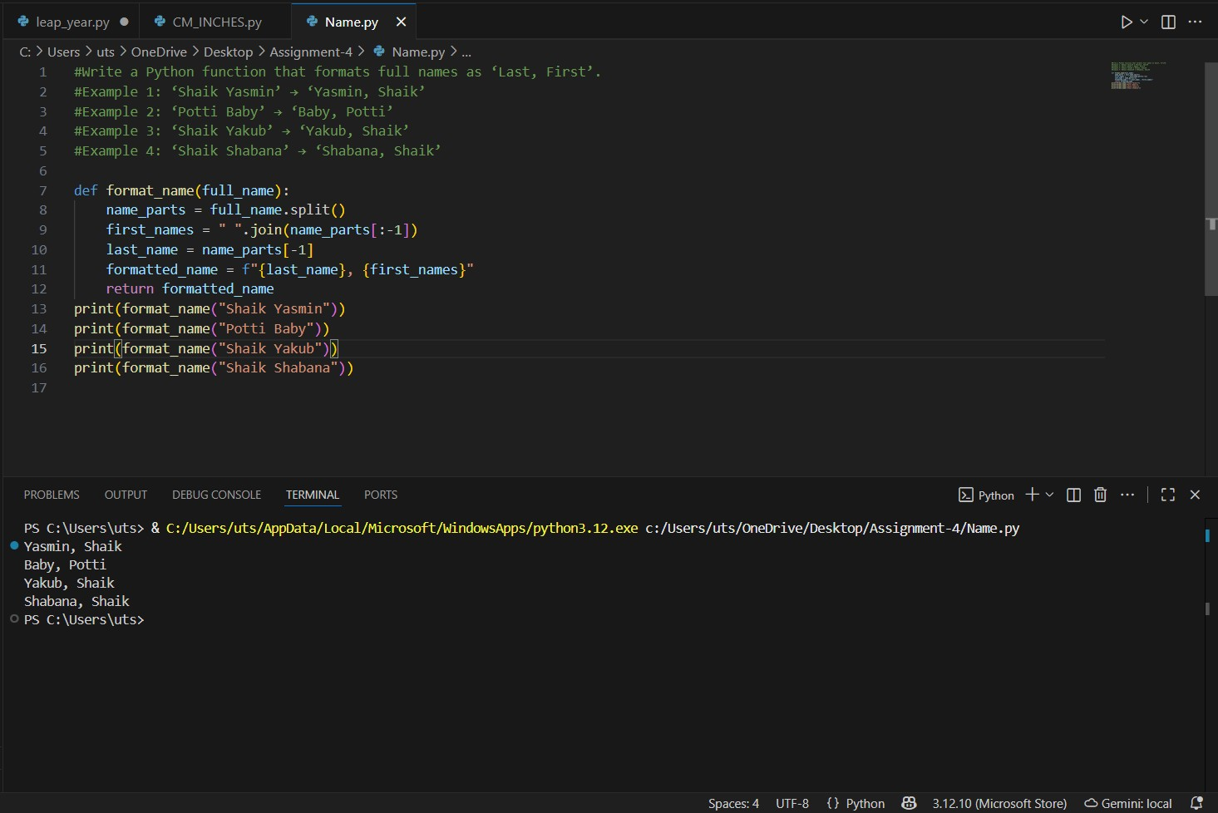
Figure 3: Few-shot prompt code and output using copilot

- Task Description#4
● Compare zero-shot and few-shot prompts for writing a function that counts the
number of vowels in a string.
Expected Output#4
● Functional output and comparative reflection
Ans:
- #Zero-shot Prompt to AI
# Write a Python function to count the number of vowels in a string.
#Code using Zero-shot Prompt
#Function to count vowels in a String
def count_vowels(input_string):
vowels = "aeiouAEIOU"
count = 0
for char in input_string:
if char in vowels:
count += 1
return count
print(count_vowels("Hello World"))
print(count_vowels("Python Programming"))

OUTPUT:
Number of vowels in 'Hello World': 3
Number of vowels in 'Python Programming': 4
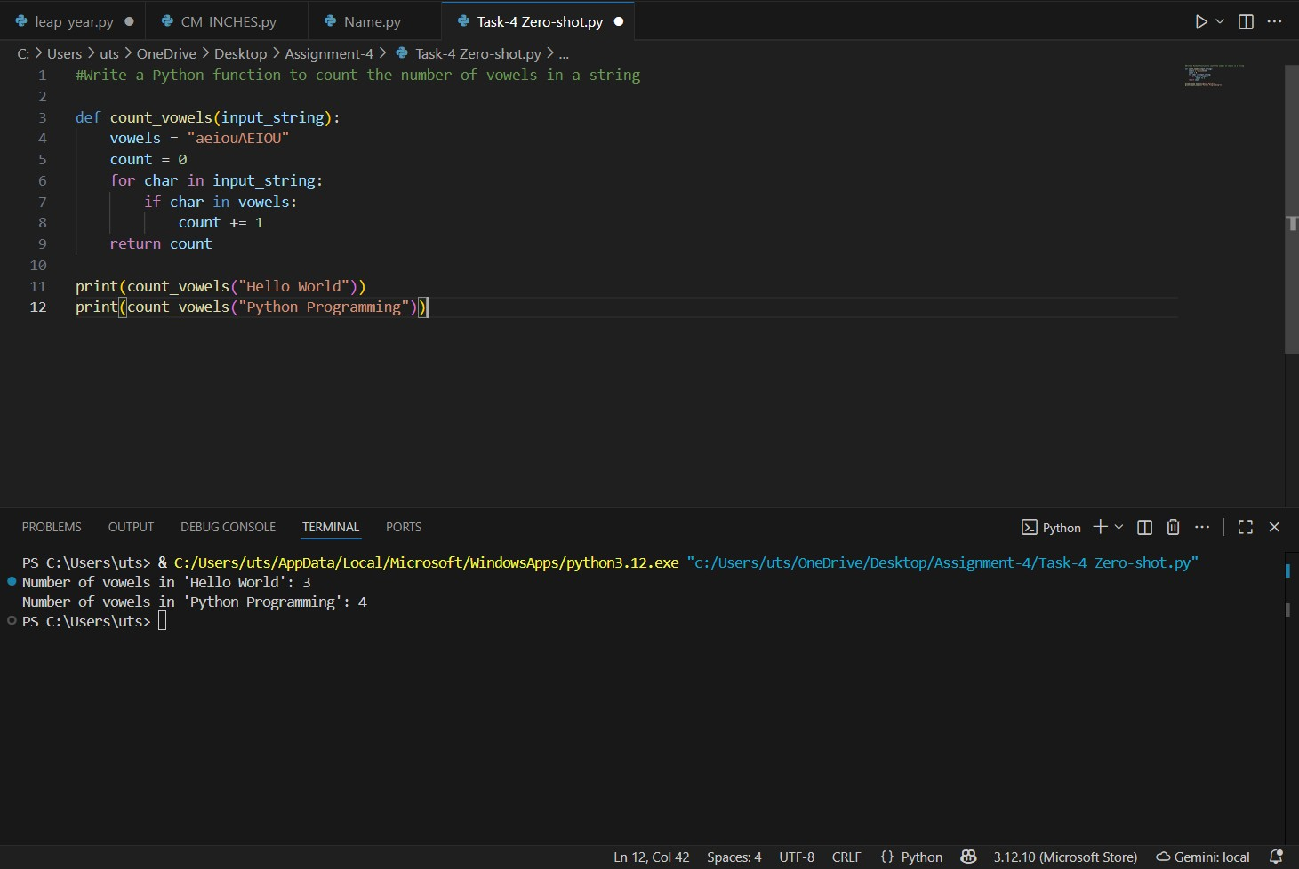
Figure 4: Count of Vowels code and output with Zero-shot prompt using copilot
- #Few-shot prompt to AI
“Write a Python function that counts the number of vowels in a string.
Example 1: ‘hello’ → 2
Example 2: ‘PYTHON’ → 1
Example 3: ‘Education’ → 5”
# Function to count vowels in a string (Few-shot)
def count_vowels(s):
vowels = "aeiouAEIOU"
count = 0
for char in s:
if char in vowels:
count += 1
return count

print(count_vowels("hello"))
print(count_vowels("PYTHON"))
print(count_vowels("Education"))

OUTPUT:
2
1
5

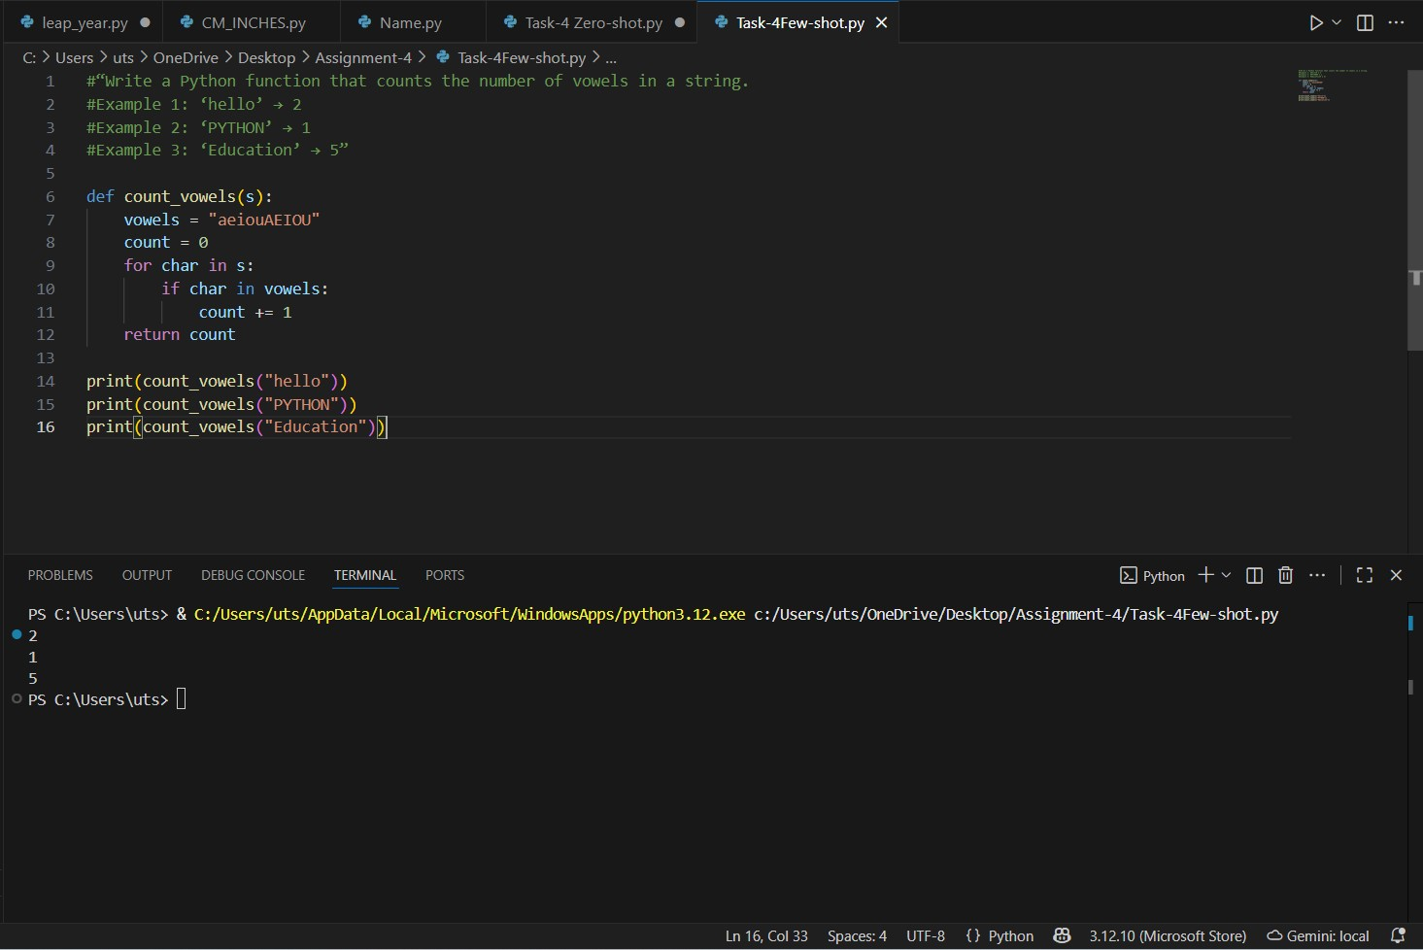
Figure 5: Vowels count code and output using Few-shot prompt in copilot

Zero-Shot Output | Few-Shot Output
No examples given | 2–3 examples provided
Basic function — works correctly | More optimized and Pythonic
Simple but slightly longer | Cleaner and more compact
Minimal | AI inferred better logic from examples
Works fine but basic | Better structured and efficient

- Task Description#5
● Use few-shot prompting to generate a function that reads a .txt file and returns the
number of lines.
Expected Output#5
● Working file-processing function with AI-guided logic
Ans:
Few-shot AI prompt:
#“Write a Python function that reads a text file and returns the number of lines.
#Example 1: For a file with 3 lines → Output: 3
#Example 2: For a file with 0 lines → Output: 0
#Example 3: For a file with 5 lines → Output: 5”
def count_lines_in_file(file_path):
# Open the file in read mode
with open(file_path, 'r') as file:
lines = file.readlines()
return len(lines)
#Creating a file and writing 3 lines in it
with open('example.txt', 'w') as f:
f.write("Hello World\n")
f.write("Welcome to AI Lab\n")
f.write("My name is Yas\n")
print(count_lines_in_file('example.txt'))
OUTPUT:
3
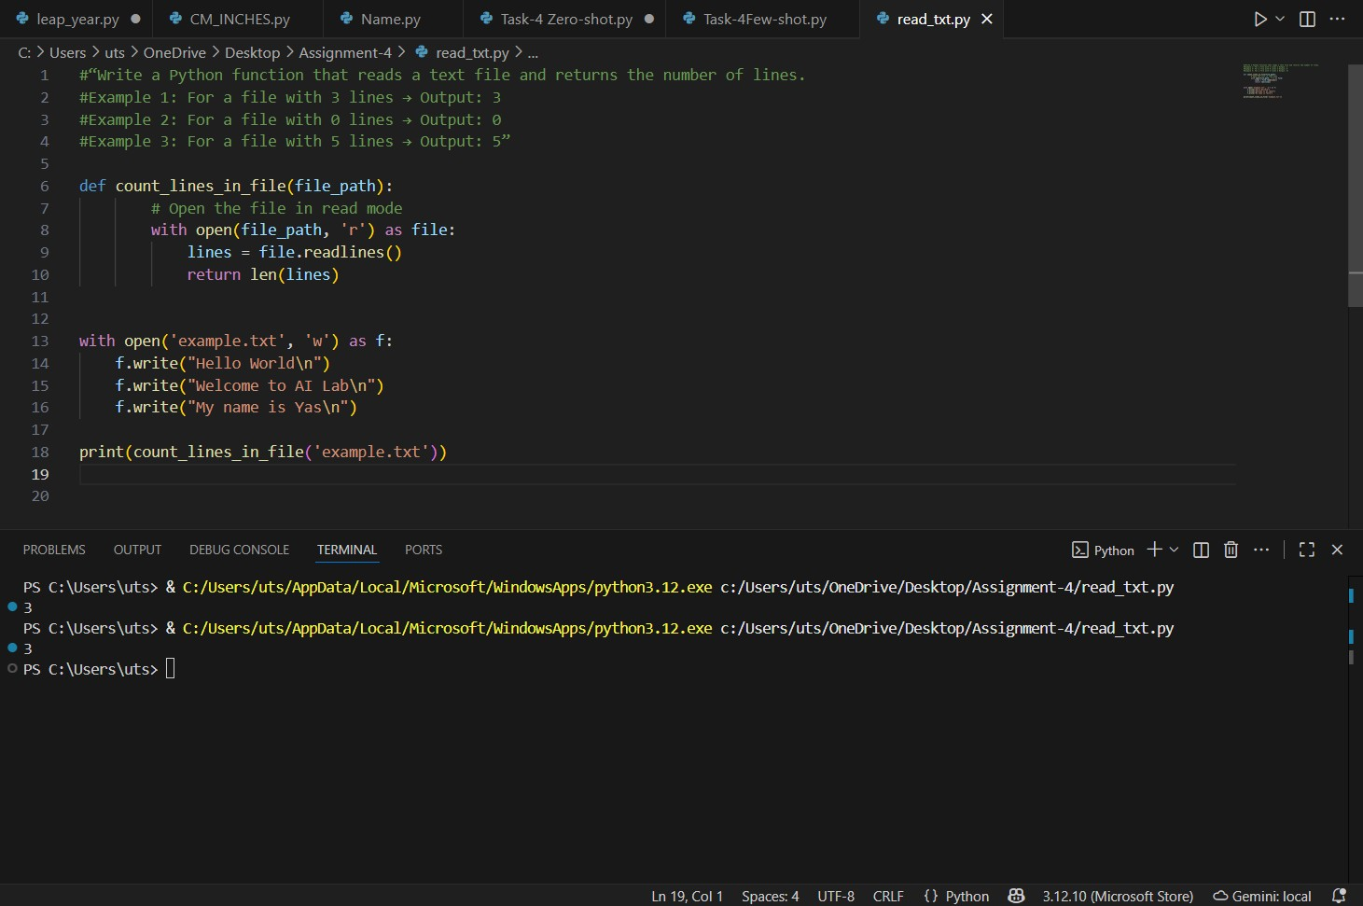
Figure 6: Few-shot AI prompt to read no. of lines from .txt file

