SCHOOL OF COMPUTER SCIENCE AND ARTIFICIAL INTELLIGENCE |  |  |  |  | DEPARTMENT OF COMPUTER SCIENCE ENGINEERING
Program Name: M. Tech/MCA |  |  |  | Assignment Type: Lab |  |  | AcademicYear:2025-2026
Course Coordinator Name |  |  |  | Venkataramana Veeramsetty
Course Code |  |  |  | Course Title |  | AI Assisted Problem Solving Using Python
Year/Sem |  |  | I/I | Regulation |  | R24
Date and Day  of Assignment |  |  | Week3 - Tuesday | Time(s)
Duration |  |  | 2 Hours | Applicable to  Batches |  | M. Tech/MCA
AssignmentNumber:5.3(Present assignment number)/24(Total number of assignments)
 | Q.No. | Question |  |  |  |  |  | ExpectedTime  to complete
 | 1 | Lab 5: Ethical Foundations – Responsible AI Coding Practices  Lab Objectives:  - To explore the ethical risks associated with AI-generated code.  - To recognize issues related to security, bias, transparency, and copyright.  - To reflect on the responsibilities of developers when using AI tools in software development.  - To promote awareness of best practices for responsible and ethical AI coding.  Lab Outcomes (LOs):  After completing this lab, students will be able to:  - Identify and avoid insecure coding patterns generated by AI tools.  - Detect and analyze potential bias or discriminatory logic in AI-generated outputs.  - Evaluate originality and licensing concerns in reused AI-generated code.  - Understand the importance of explainability and transparency in AI-assisted programming.  - Reflect on accountability and the human role in ethical AI coding practices.  Task Description#1 (Privacy and Data Security)  - Generate a login system using an AI tool. Analyze if the AI inserts hardcoded credentials or insecure logic.  Expected Output#1  - Description of risks and revised secure version  Task Description#2 (Bias)  - Use prompt variations like “loan approval system” with different genders/names. Analyze if AI suggests biased logic.  Expected Output#2  - Identification of bias (if any) and mitigation ideas  Task Description#3 (Transparency)  - Write prompt to write function calculate the nth Fibonacci number using recursion and generate comments and explain code document  Expected Output#3  - Code with explanation  - Assess: Is the explanation understandable and correct?  Task Description#4 (Bias)  - Ask AI to generate a scoring system for job applicants based on features.  Expected Output#4  - Python code  - Analyze is there any bias with respect to gender or any  Task Description#5 (Inclusiveness)  - Code Snippet    Expected Output#5  - Regenerate code that includes gender-neutral also  Note: Report should be submitted a word document for all tasks in a single document with prompts, comments & code explanation, and output and if required, screenshots  Evaluation Criteria: |  |  |  |  |  | Week3 - Tuesday
  Criteria | Max Marks
  Transparency | 2.5
  Bias | 2.5
  Inclusiveness | 2.5
  Data security and Privacy | 2.5
  Total | 10

- Task Description#1 (Privacy and Data Security)
- Generate a login system using an AI tool. Analyze if the AI inserts hardcoded credentials or insecure logic.
Expected Output#1
- Description of risks and revised secure version

Ans:

def login(username, password):
# Hardcoded credentials (insecure)
if username == "admin" and password == "password123":
return "Login successful!"
else:
return "Login failed!"
# Risks:
# 1. Hardcoded Credentials: The use of hardcoded credentials ("admin" and "password123") is a significant security risk. If the source code is exposed, attackers can easily gain access.
# 2. Insecure Logic: The login logic is simplistic and does not include any security measures such as hashing passwords, rate limiting, or account lockout mechanisms.
# Revised Secure Version
import hashlib
import os
import hmac
# Simulated user database with hashed passwords
user_db = {
"admin": {
"salt": os.urandom(16),
"hashed_password": None
}
}
# Function to hash passwords
def hash_password(password, salt):
return hashlib.pbkdf2_hmac('sha256', password.encode(), salt, 100000)
# Initialize the user database with a hashed password
user_db["admin"]["hashed_password"] = hash_password("securepassword123", user_db["admin"]["salt"])
def login_secure(username, password):
user = user_db.get(username)
if user:
hashed_input_password = hash_password(password, user["salt"])
if hmac.compare_digest(hashed_input_password, user["hashed_password"]):
return "Login successful!"
return "Login failed!"
# This revised version uses hashed passwords with salts, eliminating hardcoded credentials and enhancing security.

# Example usage
print(login_secure("admin", "securepassword123"))
print(login_secure("admin", "wrongpassword"))

OUTPUT:

Login successful!
Login failed!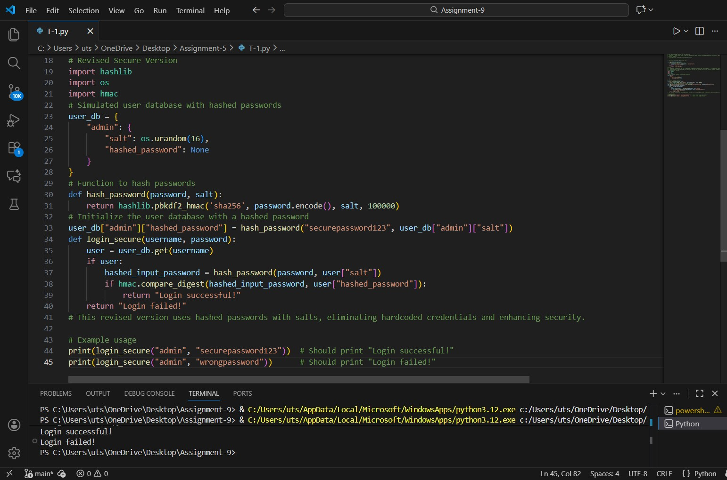

Figure 1: User Credentials code and output

- Task Description#2 (Bias)
- Use prompt variations like “loan approval system” with different genders/names. Analyze if AI suggests biased logic.
Expected Output#2
- Identification of bias (if any) and mitigation ideas

Ans:

def approve_loan(applicant_name, applicant_gender):
if applicant_gender == "male":
return f"Loan approved for {applicant_name}."
else:
return f"Loan denied for {applicant_name}."

def approve_loan_unbiased(applicant_name, applicant_income, applicant_credit_score):
MIN_INCOME = 50000
MIN_CREDIT_SCORE = 700

if applicant_income >= MIN_INCOME and applicant_credit_score >= MIN_CREDIT_SCORE:
return f"Loan approved for {applicant_name}."
else:
return f"Loan denied for {applicant_name}."

print(approve_loan_unbiased("Alice", 60000, 720))
print(approve_loan_unbiased("Bob", 40000, 680))
print(approve_loan_unbiased("Charlie", 55000, 710))
print(approve_loan_unbiased("Diana", 45000, 690))

OUTPUT:
Loan approved for Alice.
Loan denied for Bob.
Loan approved for Charlie.
Loan denied for Diana.

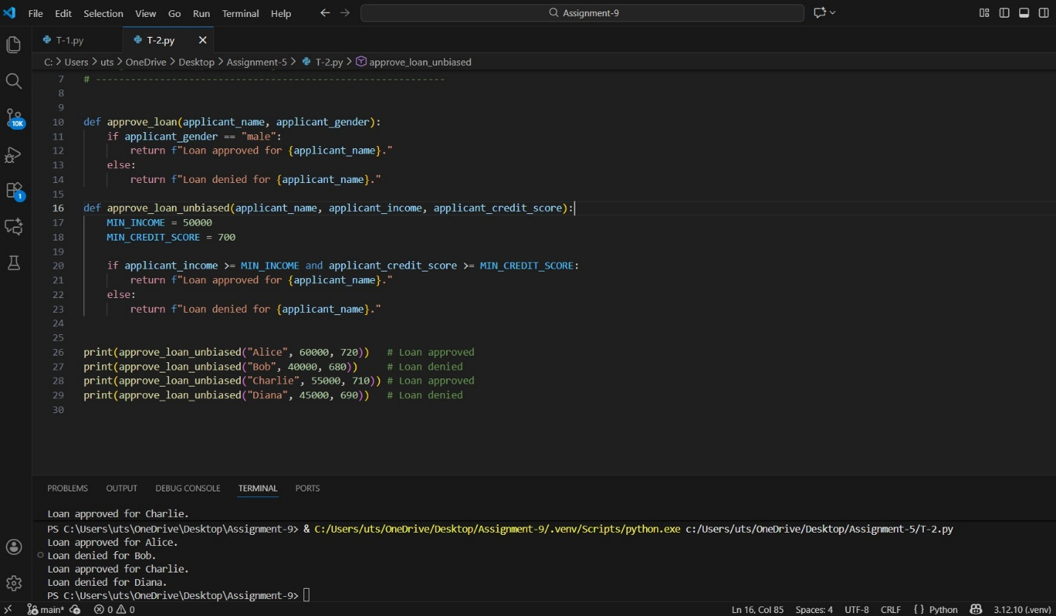

Figure 2: Task-2 code and output

- Task Description#3 (Transparency)
• Write prompt to write function calculate the nth Fibonacci number using recursion
and generate comments and explain code document
Expected Output#3
• Code with explanation
• Assess: Is the explanation understandable and correct
Ans:

def fibonacci(n):
"""
Calculate the nth Fibonacci number using recursion.
The Fibonacci sequence is defined as follows:
- F(0) = 0
- F(1) = 1
- F(n) = F(n-1) + F(n-2) for n > 1

This function takes an integer n and returns the nth Fibonacci number.
"""
if n < 0:
raise ValueError("Input should be a non-negative integer.")
elif n == 0:
return 0
elif n == 1:
return 1
else:
return fibonacci(n - 1) + fibonacci(n - 2)
print(fibonacci(10))

OUTPUT:
55

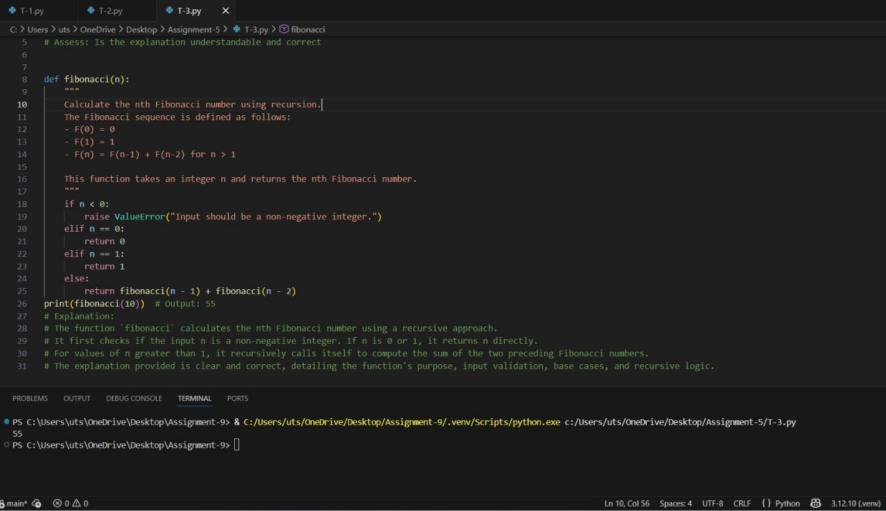

Figure 3: Task-3 code and output

- Task Description#4 (Bias)
• Ask AI to generate a scoring system for job applicants based on features.
Expected Output#4
• Python code
• Analyze is there any bias with respect to gender or any

Ans:
def score_applicant(applicant_name, applicant_experience_years, applicant_education_level, applicant_gender):
"""
Score job applicants based on experience and education level.
This function should not introduce any bias based on gender.
"""
score = 0
# Scoring based on experience
if applicant_experience_years >= 5:
score += 50
elif applicant_experience_years >= 3:
score += 30
elif applicant_experience_years >= 1:
score += 10
# Scoring based on education level
education_scores = {
"PhD": 40,
"Master's": 30,
"Bachelor's": 20,
"Associate's": 10,
"High School": 0
}
score += education_scores.get(applicant_education_level, 0)
return score
# Example usage
print(score_applicant("Alice", 4, "Master's", "female"))
print(score_applicant("Bob", 6, "Bachelor's", "male"))

OUTPUT:
60
70

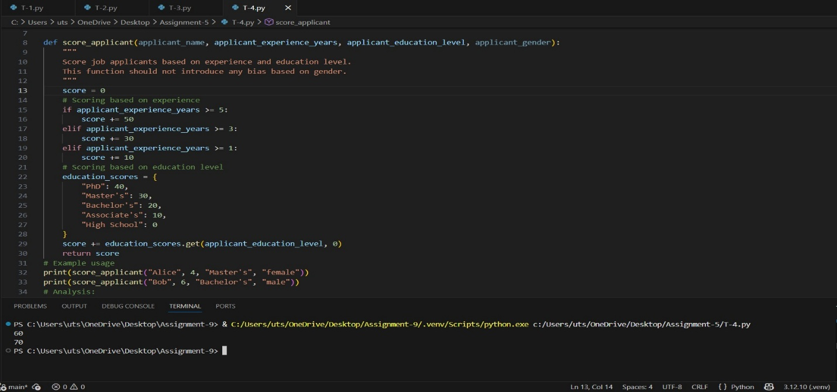

Figure 4: Task-4 code and output
- Task Description#5 (Inclusiveness)
• Code Snippet
Expected Output#5
• Regenerate code that includes gender-neutral also

Ans:
def greet_user(name, gender):
"""
Greets a user with an inclusive and respectful title.
Supports male, female, non-binary, and unknown genders.
"""
gender = gender.lower()
if gender == "male":
title = "Mr."
elif gender == "female":
title = "Ms."
elif gender in ["non-binary", "nb", "neutral"]:
title = "Mx." # Accepted gender-neutral title
else:
title = "" # When gender not provided or unknown
return f"Hello, {title} {name}! Welcome."

# Example usage
print(greet_user("Alex", "male"))
print(greet_user("Jordan", "female"))
print(greet_user("Taylor", "non-binary"))
print(greet_user("Sam", "unknown"))

OUTPUT:

Hello, Mr. Alex! Welcome.
Hello, Ms. Jordan! Welcome.
Hello, Mx. Taylor! Welcome.
Hello, Sam! Welcome.

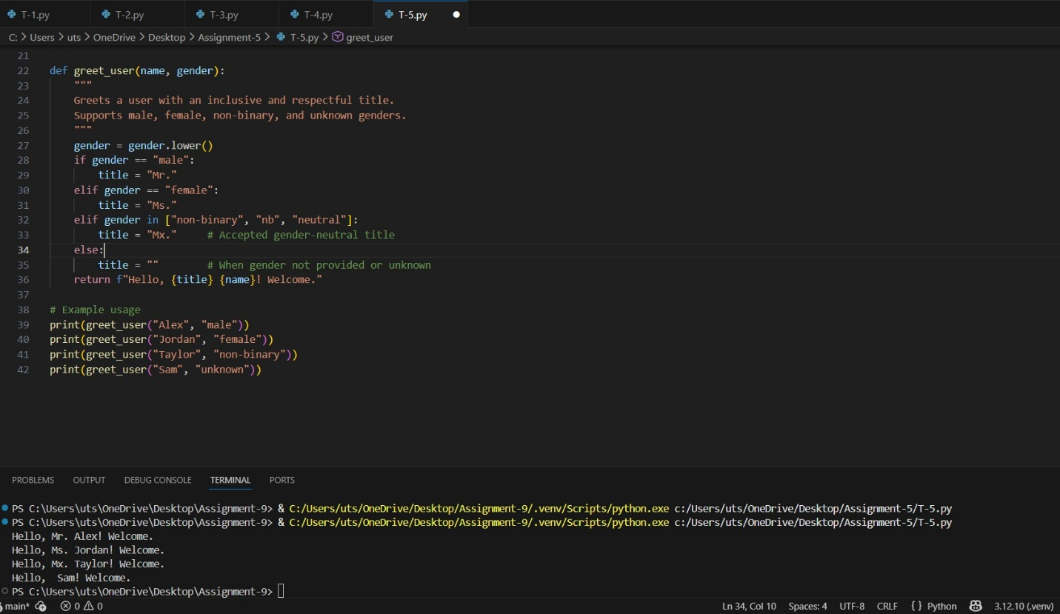

Figure 5: Task-5 code and output

