SCHOOL OF COMPUTER SCIENCE AND ARTIFICIAL INTELLIGENCE |  |  |  |  | DEPARTMENT OF COMPUTER SCIENCE ENGINEERING
ProgramName:B. Tech |  |  |  | Assignment Type: Lab |  |  | AcademicYear:2025-2026
CourseCoordinatorName |  |  |  | Venkataramana Veeramsetty
Instructor(s)Name
  Dr. V. Venkataramana (Co-ordinator)
  Dr. T. Sampath Kumar
  Dr. Pramoda Patro
  Dr. Brij Kishor Tiwari
  Dr.J.Ravichander
  Dr. Mohammand Ali Shaik
  Dr. Anirodh Kumar
  Mr. S.Naresh Kumar
  Dr. RAJESH VELPULA
  Mr. Kundhan Kumar
  Ms. Ch.Rajitha
  Mr. M Prakash
  Mr. B.Raju
  Intern 1 (Dharma teja)
  Intern 2 (Sai Prasad)
  Intern 3 (Sowmya)
  NS_2 ( Mounika)
CourseCode |  |  | 24CS002PC215 | CourseTitle |  | AI Assisted Coding
Year/Sem |  |  | II/I | Regulation |  | R24
Date and Day  of Assignment |  |  | Week3 - Wednesday | Time(s)
Duration |  |  | 2 Hours | Applicableto  Batches
AssignmentNumber:6.3(Present assignment number)/24(Total number of assignments)
 | Q.No. | Question |  |  |  |  |  | ExpectedTime  to complete
 | 1 | Lab 6: AI-Based Code Completion – Classes, Loops, and Conditionals  Lab Objectives:  - To explore AI-powered auto-completion features for core Python constructs.  - To analyze how AI suggests logic for class definitions, loops, and conditionals.  - To evaluate the completeness and correctness of code generated by AI assistants.  Lab Outcomes (LOs):  After completing this lab, students will be able to:  - Use AI tools to generate and complete class definitions and methods.  - Understand and assess AI-suggested loops for iterative tasks.  - Generate conditional statements through prompt-driven suggestions.  - Critically evaluate AI-assisted code for correctness and clarity.  Task Description#1 (Classes)  - Use AI to complete a Student class with attributes and a method.  - Check output  - Analyze the code generated by AI tool  Expected Output#1  - Class with constructor and display_details() method  Task Description#2 (Loops)  - Prompt AI to complete a function that prints the first 10 multiples of a number using a loop.  - Analyze the generated code  - Ask AI to generate code using other controlled looping  Expected Output#2  - Correct loop-based implementation  Task Description#3 (Conditional Statements)  - Ask AI to write nested if-elif-else conditionals to classify age groups.  - Analyze the generated code  - Ask AI to generate code using other conditional statements  Expected Output#3  - Age classification function with appropriate conditions and with explanation  Task Description#4 (For and While loops)  - Generate a sum_to_n() function to calculate sum of first n numbers  - Analyze the generated code  - Get suggestions from AI with other controlled looping  Expected Output#4  - Python code with explanation  Task Description#5 (Class)  - Use AI to build a BankAccount class with deposit, withdraw, and balance methods.  - Analyze the generated code  - Add comments and explain code  Expected Output#5  - Python code with explanation  Note: Report should be submitted a word document for all tasks in a single document with prompts, comments & code explanation, and output and if required, screenshots  Evaluation Criteria: |  |  |  |  |  | Week3 - Wednesday
  Criteria | Max Marks
  Class | 1.0
  Loops | 1.0
  Conditional Statements | 0.5
  Total | 2.5 Marks

- Task Description#1 (Classes)
- Use AI to complete a Student class with attributes and a method.
- Check output
- Analyze the code generated by AI tool
Expected Output#1
- Class with constructor and display_details() method

Ans:
# Class definition for Student
class Student:
def __init__(self, name, roll_number, marks):
self.name = name
self.roll_number = roll_number
self.marks = marks
# Constructor to initialize student attributes
def display_details(self):
print("Name:", self.name)
print("Roll Number:", self.roll_number)
print("Marks:", self.marks)

student1 = Student("Alice", 101, 95)
student1.display_details()

student2 = Student("Bob", 102, 88)
student2.display_details()

#OUTPUT:
Name: Alice
Roll Number: 101
Marks: 95
Name: Bob
Roll Number: 102
Marks: 88

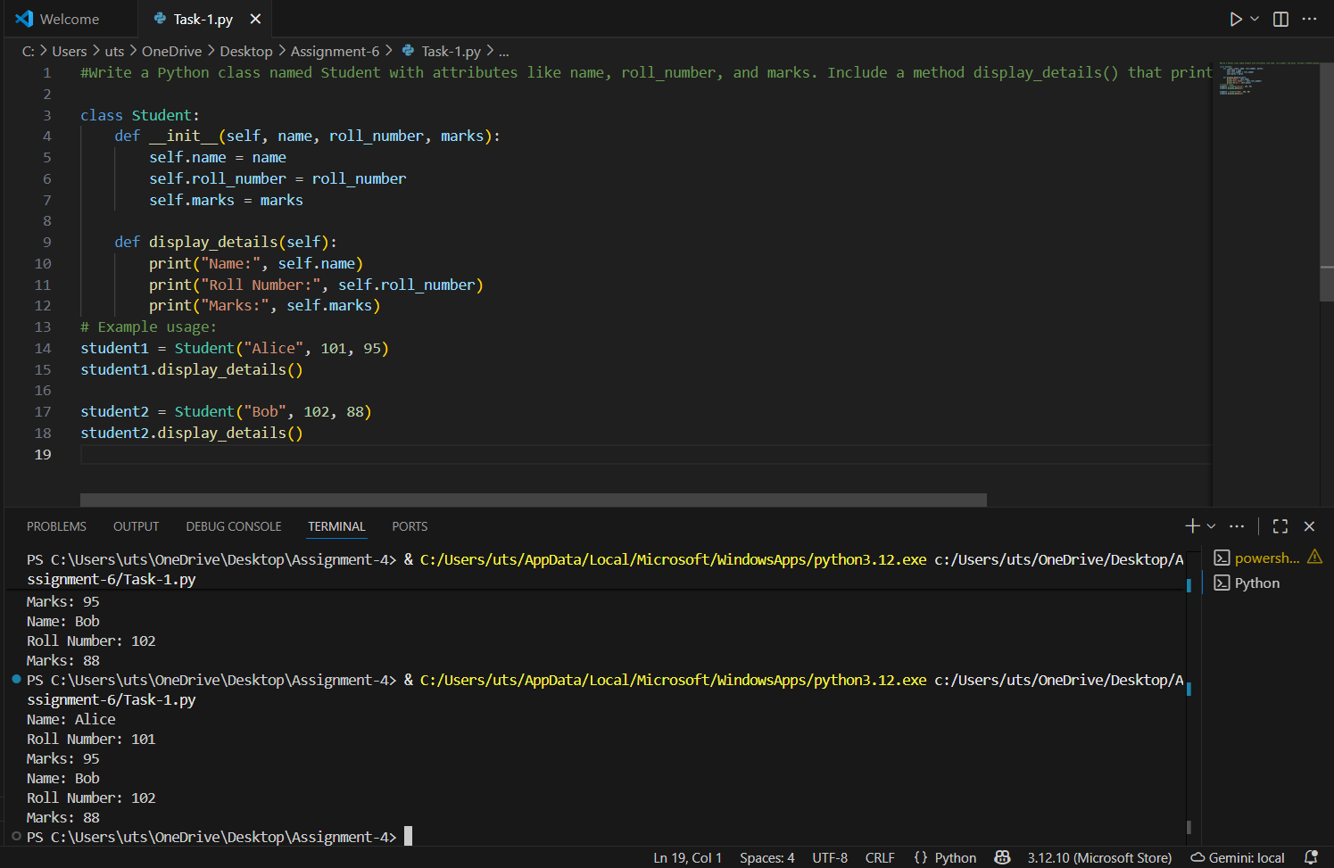

Figure 1: Student attributes code and output

- Task Description#2 (Loops)
• Prompt AI to complete a function that prints the first 10 multiples of a number using a
loop.
• Analyze the generated code
• Ask AI to generate code using other controlled looping
Expected Output#2
• Correct loop-based implementation
Ans:

# Function to print first 10 multiples of a number using for loop
def print_multiples(number):
for i in range(1, 11):
print(f"{number} x {i} = {number * i}") # Loop runs from 1 to 10

print_multiples(5)

OUTPUT:
5 x 1 = 5
5 x 2 = 10
5 x 3 = 15
5 x 4 = 20
5 x 5 = 25
5 x 6 = 30
5 x 7 = 35
5 x 8 = 40
5 x 9 = 45
5 x 10 = 50

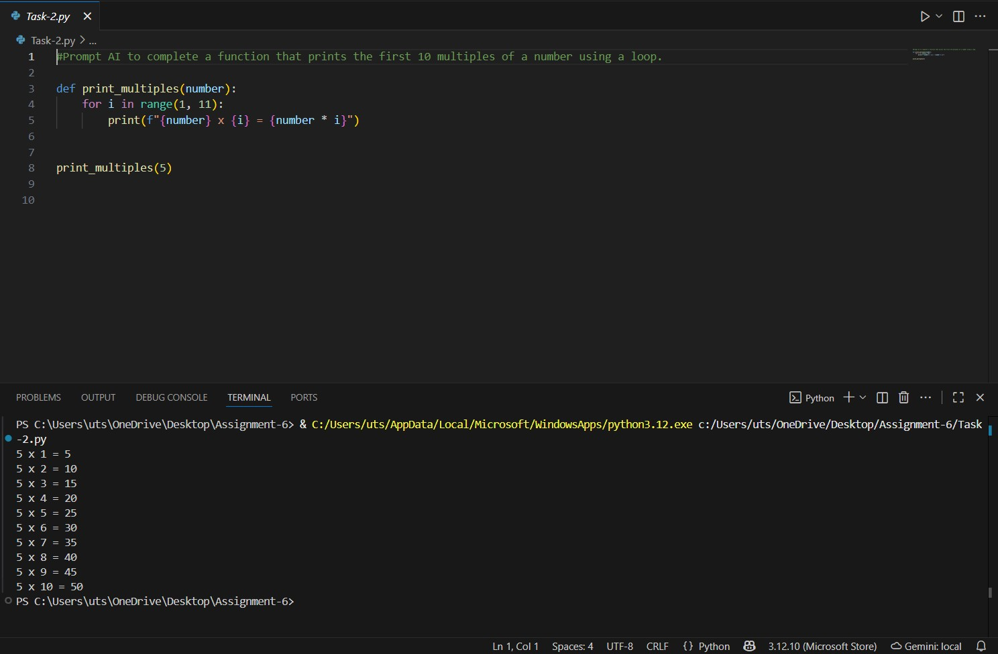

Figure 2: Multiples of a number code and output

- Task Description#3 (Conditional Statements)
• Ask AI to write nested if-elif-else conditionals to classify age groups.
• Analyze the generated code
• Ask AI to generate code using other conditional statements
Expected Output#3
• Age classification function with appropriate conditions and with explanation.
Ans:

age = int(input("Enter your age: "))

#classify age group using nested if-elif-else
if age < 0:
print("Invalid age")
elif age <= 12:
print("Child")
elif age <= 19:
print("Teenager")
elif age <= 64:
print("Adult")
else:
print("Senior")

OUTPUT:

Enter your age: 22
Adult

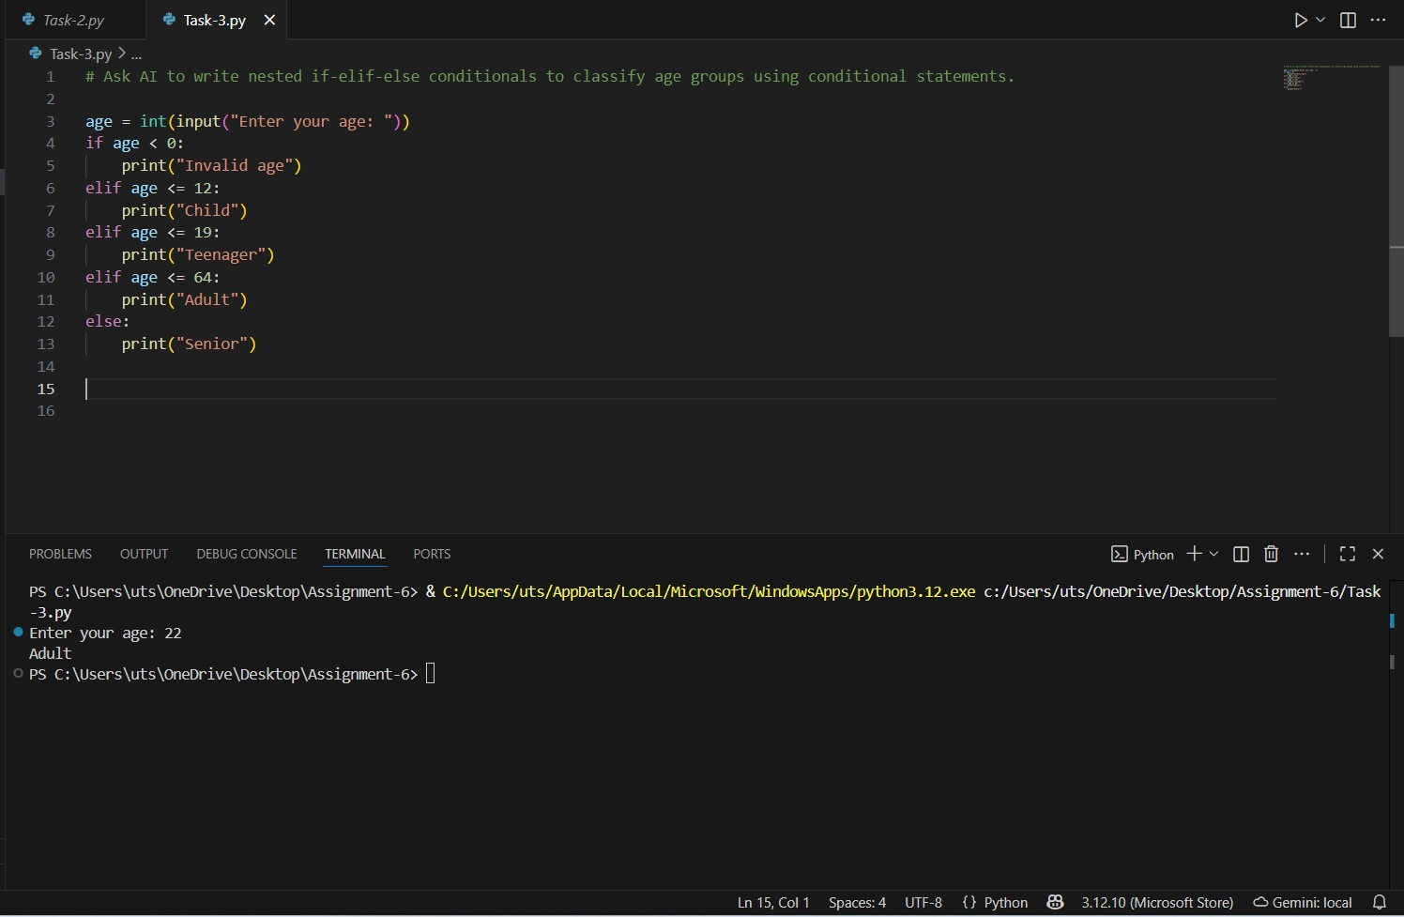

Figure 3: Using Conditional statement age group code and output

- Task Description#4 (For and While loops)
• Generate a sum_to_n() function to calculate sum of first n numbers
• Analyze the generated code
• Get suggestions from AI with other controlled looping
Expected Output#4
• Python code with explanation

Ans:
# Function to calculate the sum of first n numbers using a for loop
def sum_to_n(n):
total = 0
for i in range(1, n + 1):
total += i
return total

print(sum_to_n(10))

OUTPUT:
55

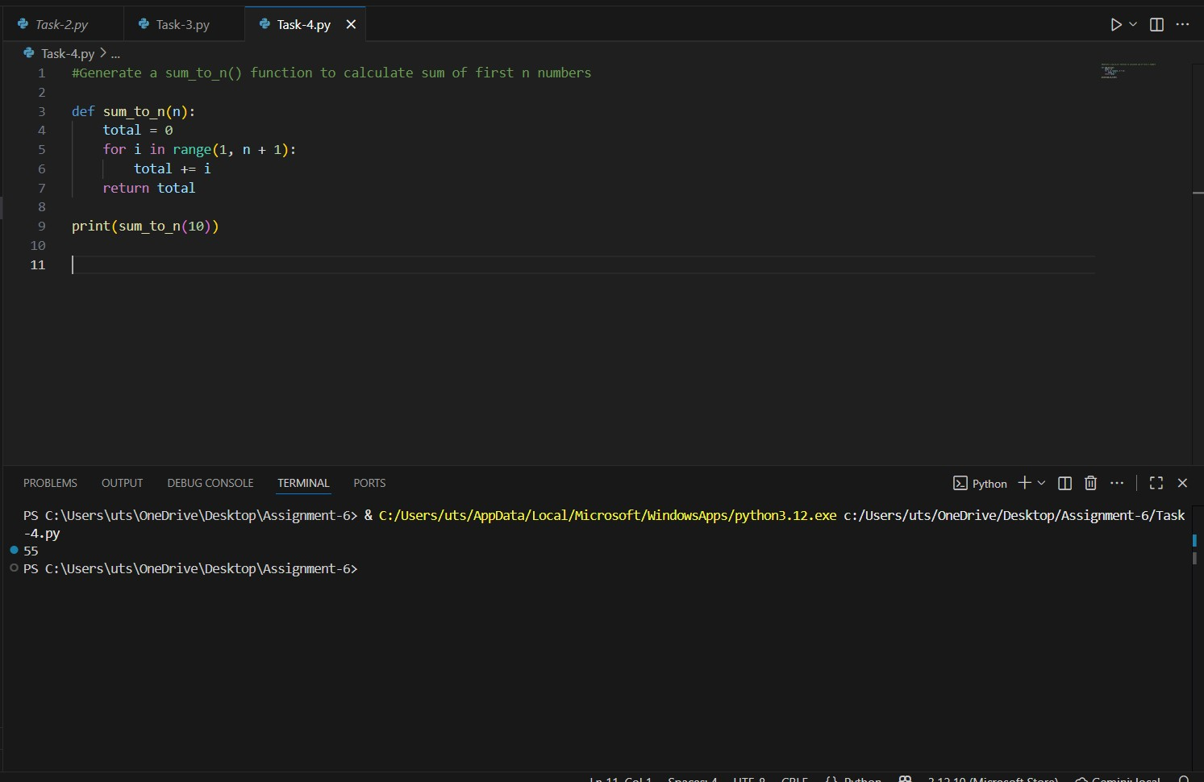

Figure 4: sum of first n numbers code and output using GitHub copilot

- Task Description#5 (Class)
• Use AI to build a BankAccount class with deposit, withdraw, and balance methods.
• Analyze the generated code
• Add comments and explain code
Expected Output#5
• Python code with explanation

Ans:
# Define a class named BankAccount to represent a simple bank account
class BankAccount:
# Initializes the account with a starting balance
def __init__(self):
self.balance = 0.0

# Method to deposit money into the account
def deposit(self, amount):
# Check if the deposit amount is positive
if amount > 0:
self.balance += amount

# Display the deposited amount (formatted to 2 decimal places)
print(f"Deposited: ${amount:.2f}")
else:
print("Deposit amount must be positive.")

# Method to withdraw money from the account
def withdraw(self, amount):
if amount > 0:
# Check if the account has enough balance to cover the withdrawal
if amount <= self.balance:
self.balance -= amount
print(f"Withdrew: ${amount:.2f}")
else:
print("Insufficient funds.")
else:
print("Withdrawal amount must be positive.")

def get_balance(self):
return f"Current balance: ${self.balance:.2f}"

account = BankAccount()
account.deposit(100)
account.withdraw(30)
print(account.get_balance())
account.withdraw(80)
print(account.get_balance())
account.deposit(-20)
print(account.get_balance())

OUTPUT:
Deposited: $100.00
Withdrew: $30.00
Current balance: $70.00
Insufficient funds.
Current balance: $70.00
Deposit amount must be positive.
Current balance: $70.00

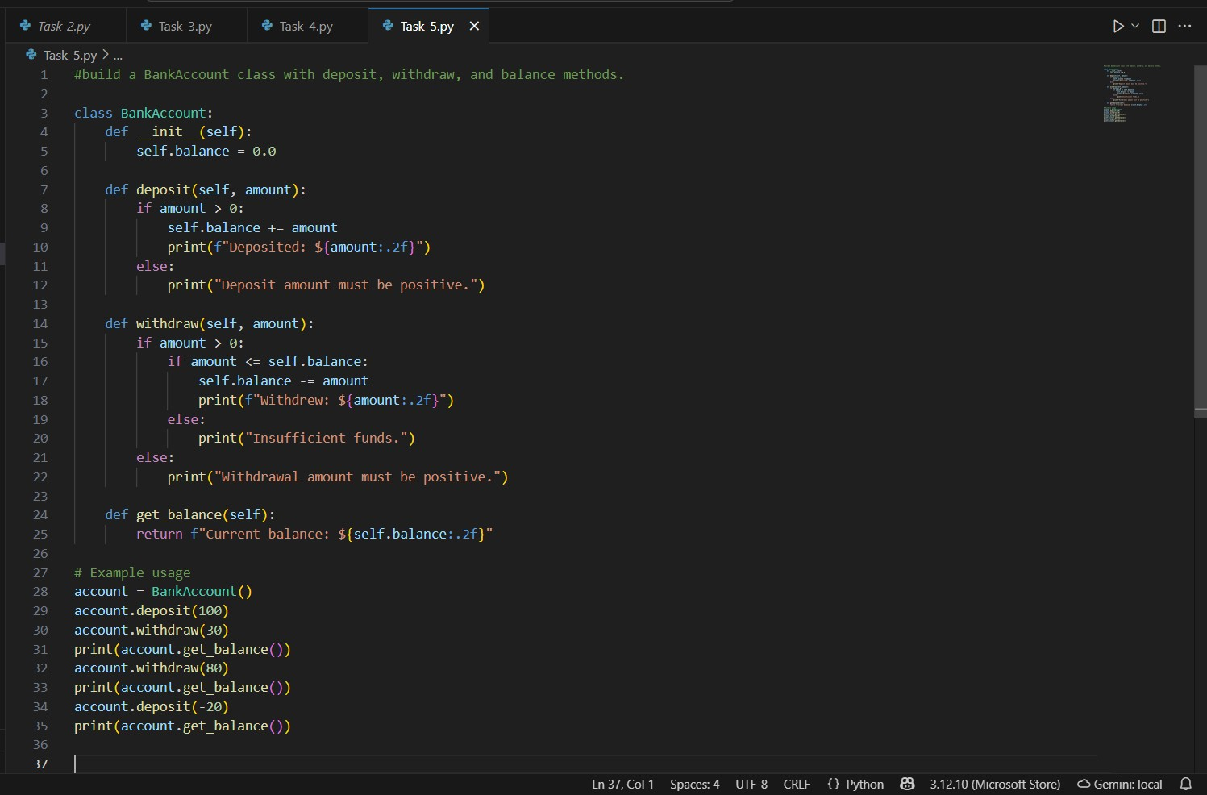

Figure 5: Bank details program code

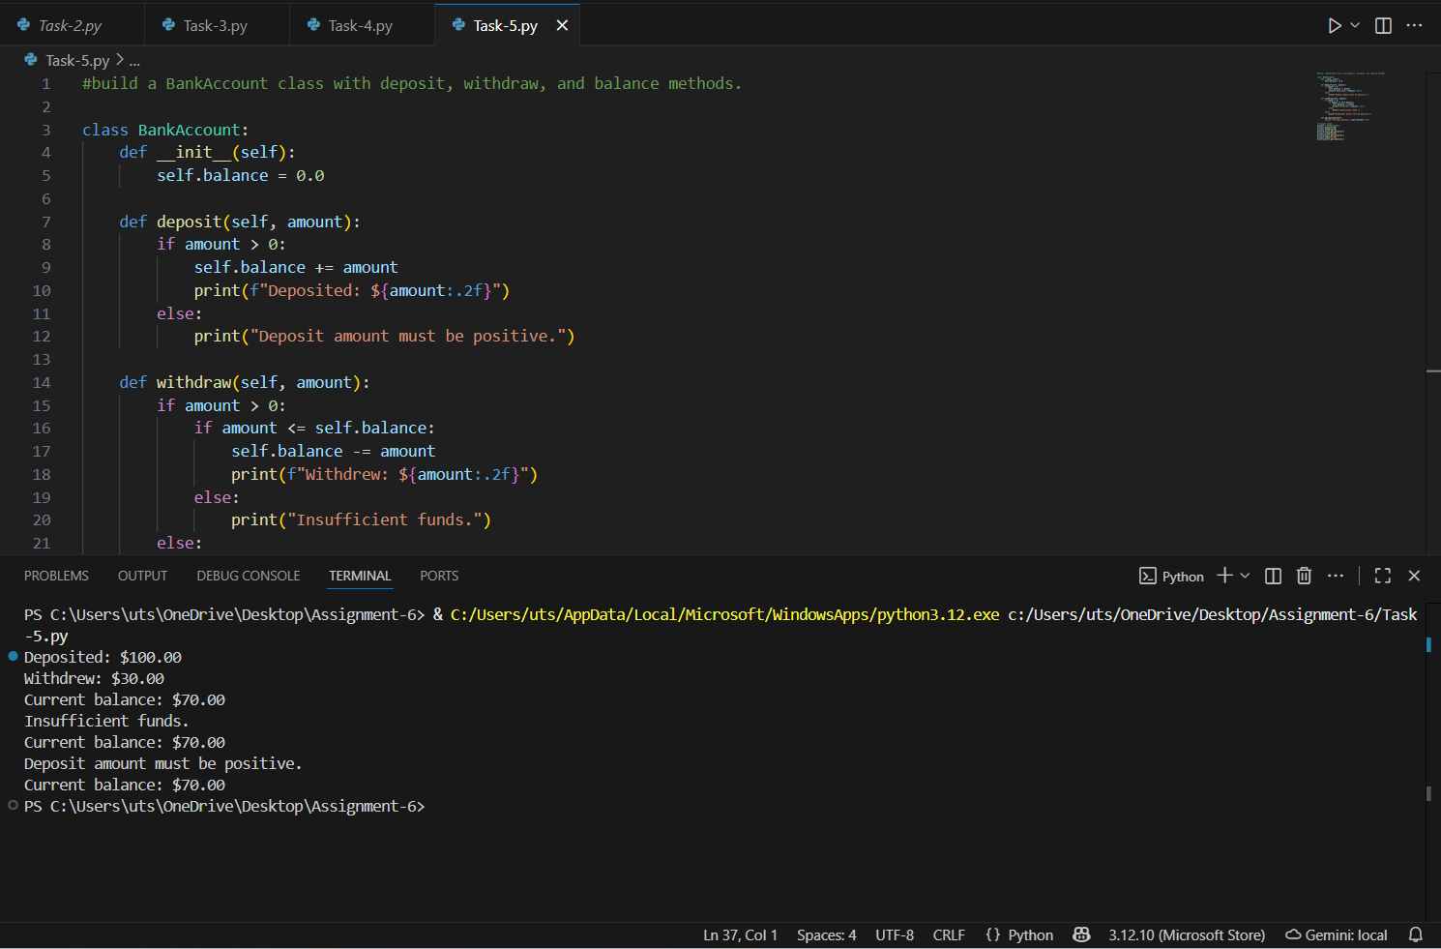

Figure 6: Output of the code

