SCHOOL OF COMPUTER SCIENCE AND ARTIFICIAL INTELLIGENCE |  |  |  |  | DEPARTMENT OF COMPUTER SCIENCE ENGINEERING
ProgramName:M. Tech |  |  |  | Assignment Type: Lab |  |  | AcademicYear:2025-2026
CourseCoordinatorName |  |  |  | Venkataramana Veeramsetty
CourseCode |  |  |  | CourseTitle |  | AI Assisted Problem Solving Using Python
Year/Sem |  |  | II/I | Regulation |  | R24
Date and Day  of Assignment |  |  | 10.11.2025 | Time(s)
Duration |  |  | 2 Hours | Applicableto  Batches
AssignmentNumber:8.3(Present assignment number)/24(Total number of assignments)
 | Q.No. | Question |  |  |  |  |  | ExpectedTime  to complete
 | 1 | Lab 8: Test-Driven Development with AI – Generating and Working with Test Cases  Lab Objectives:  - To introduce students to test-driven development (TDD) using AI code generation tools.  - To enable the generation of test cases before writing code implementations.  - To reinforce the importance of testing, validation, and error handling.  - To encourage writing clean and reliable code based on AI-generated test expectations.  Lab Outcomes (LOs):  After completing this lab, students will be able to:  - Use AI tools to write test cases for Python functions and classes.  - Implement functions based on test cases in a test-first development style.  - Use unittest or pytest to validate code correctness.  - Analyze the completeness and coverage of AI-generated tests.  - Compare AI-generated and manually written test cases for quality and logic  Task Description#1  Use AI to generate test cases for is_valid_email(email) and then implement the validator function.  Requirements:  - Must contain @ and . characters.  - Must not start or end with special characters.  - Should not allow multiple @.  Expected Output#1  - Email validation logic passing all test cases  Task Description#2 (Loops)  - Ask AI to generate test cases for assign_grade(score) function. Handle boundary and invalid inputs.  Requirements  - AI should generate test cases for assign_grade(score) where: 90-100: A, 80-89: B, 70-79: C, 60-69: D, <60: F  - Include boundary values and invalid inputs (e.g., -5, 105, "eighty").  Expected Output#2  Grade assignment function passing test suite  Task Description#3  - Generate test cases using AI for is_sentence_palindrome(sentence). Ignore case, punctuation, and spaces  Requirement  - Ask AI to create test cases for is_sentence_palindrome(sentence)  (ignores case, spaces, and punctuation).  - Example:  "A man a plan a canal Panama" → True  Expected Output#3  - Function returns True/False for cleaned sentences  - Implement the function to pass AI-generated tests.  Task Description#4  - Let AI fix it Prompt AI to generate test cases for a ShoppingCart class (add_item, remove_item, total_cost).  Methods:  Add_item(name,orice)  Remove_item(name)  Total_cost()  Expected Output#4  - Full class with tested functionalities  Task Description#5  - Use AI to write test cases for convert_date_format(date_str) to switch from "YYYY-MM-DD" to "DD-MM-YYYY".  Example: "2023-10-15" → "15-10-2023"  Expected Output#5  - Function converts input format correctly for all test cases  Note: Report should be submitted a word document for all tasks in a single document with prompts, comments & code explanation, and output and if required, screenshots |  |  |  |  |  | Week4 - Wednesday

- Use AI to generate test cases for is_valid_email(email) and then implement the validator function.

Requirements:

- Must contain @ and . characters.
- Must not start or end with special characters.
- Should not allow multiple @.

Expected Output#1
- Email validation logic passing all test cases

Ans:
import re
# Function to validate email addresses
def is_valid_email(email: str) -> bool:
# Regular expression for validating an Email
email_regex = r'^[a-zA-Z0-9]+[a-zA-Z0-9._%+-]*@[a-zA-Z0-9.-]+\.[a-zA-Z]{2,}$'

# Check if email matches the regex
if re.match(email_regex, email):
# Check for multiple @ characters
if email.count('@') == 1:
return True
return False

if __name__ == "__main__":
test_emails = [
"test@example.com",
"invalid-email",
"another.test@domain.co"
]

for email in test_emails:
print(f"Is '{email}' a valid email? {is_valid_email(email)}")

OUTPUT:

Is 'test@example.com' a valid email? True
Is 'invalid-email' a valid email? False
Is 'another.test@domain.co' a valid email? True

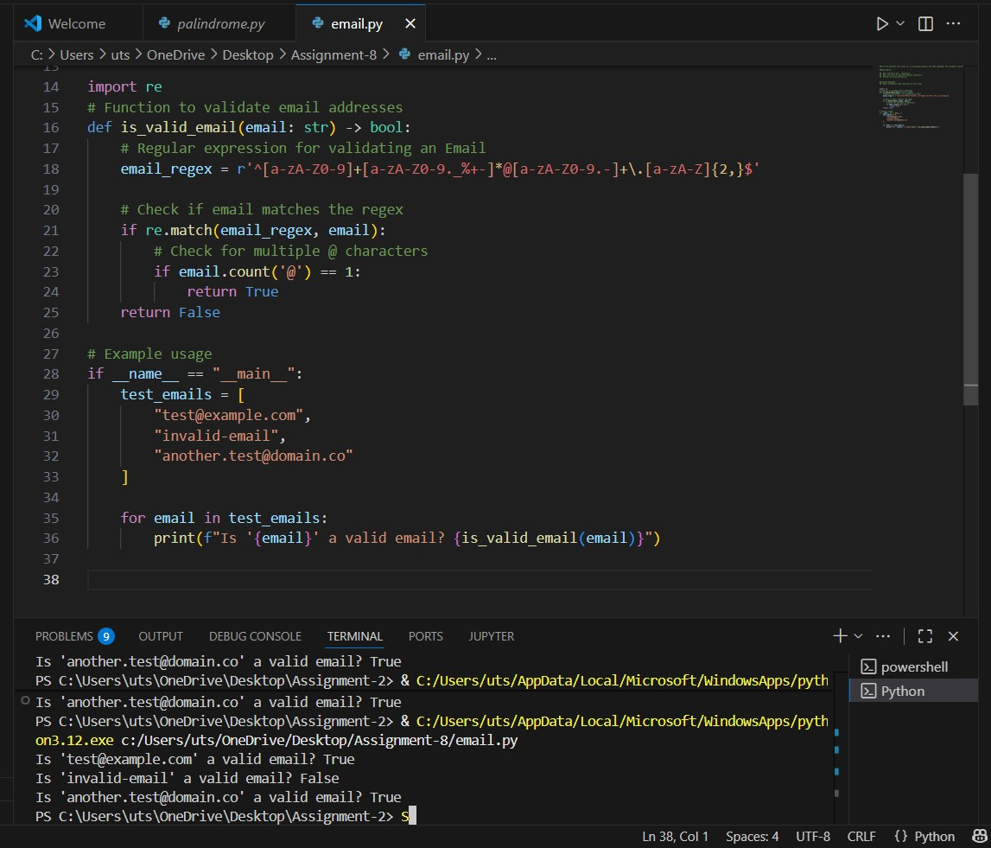

Figure 1: Code and output for Task-1

- Task Description#2 (Loops)
• Ask AI to generate test cases for assign_grade(score) function. Handle boundary and
invalid inputs.
Requirements
• AI should generate test cases for assign_grade(score) where: 90-100: A, 80-89: B, 70-
79: C, 60-69: D, <60: F
• Include boundary values and invalid inputs (e.g., -5, 105, "eighty").
Expected Output#2
Grade assignment function passing test suite

Ans:

def assign_grade(score):
if not isinstance(score, (int, float)):
return "Invalid input"
if score < 0 or score > 100:
return "Invalid input"
if 90 <= score <= 100:
return 'A'
elif 80 <= score < 90:
return 'B'
elif 70 <= score < 80:
return 'C'
elif 60 <= score < 70:
return 'D'
else:
return 'F'
# Test cases for assign_grade function
def test_assign_grade():
test_cases = [
(95, 'A'),
(89, 'B'),
(75, 'C'),
(65, 'D'),
(50, 'F'),
(90, 'A'), # Boundary case
(80, 'B'), # Boundary case
(70, 'C'), # Boundary case
(60, 'D'), # Boundary case
(0, 'F'), # Boundary case
(100, 'A'), # Boundary case
(-5, 'Invalid input'), # Invalid input
(105, 'Invalid input'), # Invalid input
("eighty", 'Invalid input'), # Invalid input
]

for score, expected in test_cases:
result = assign_grade(score)
assert result == expected, f"Test failed for score {score}: expected {expected}, got {result}"

print("All test cases passed!")

if __name__ == "__main__":
test_assign_grade()

OUTPUT:
All test cases passed!

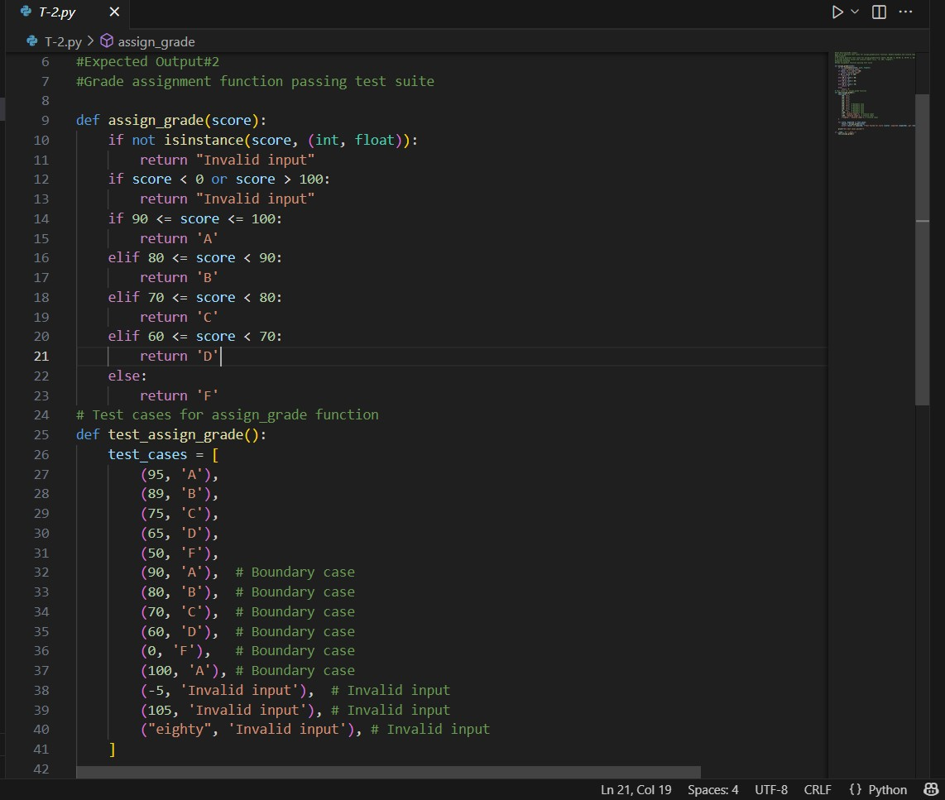

Figure 2: T-2 code

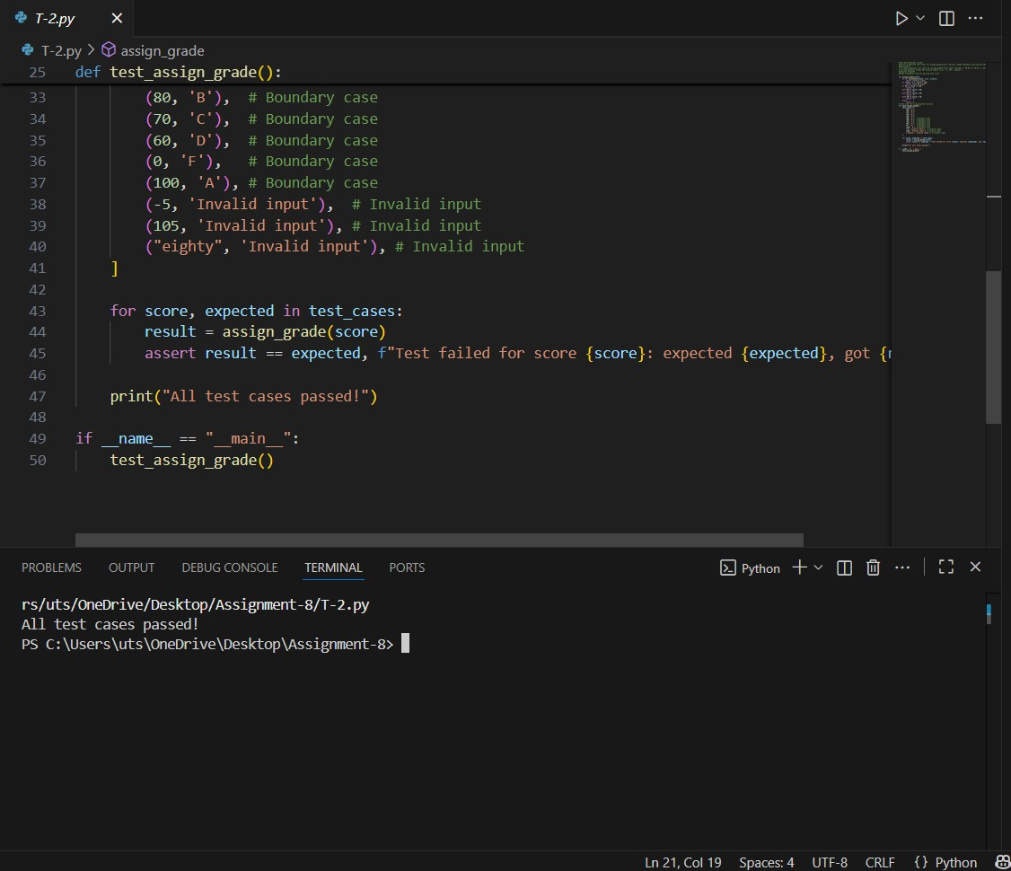

Figure 3: T-2 output

- Task Description#3
• Generate test cases using AI for is_sentence_palindrome(sentence). Ignore case,
punctuation, and spaces
Requirement
• Ask AI to create test cases for is_sentence_palindrome(sentence)
(ignores case, spaces, and punctuation).
• Example:
"A man a plan a canal Panama" → True
Expected Output#3
• Function returns True/False for cleaned sentences
• Implement the function to pass AI-generated tests

Ans:
import string
def is_sentence_palindrome(sentence):
# Clean the sentence: remove punctuation, convert to lowercase, and remove spaces
cleaned = ''.join(char.lower() for char in sentence if char.isalnum())
return cleaned == cleaned[::-1]

# Test cases for is_sentence_palindrome function
def test_is_sentence_palindrome():
test_cases = [
("A man a plan a canal Panama", True),
("No 'x' in Nixon", True),
("Was it a car or a cat I saw?", True),
("Hello World", False),
("", True), # Empty string
(" ", True), # String with only spaces
("Able was I ere I saw Elba", True),
("This is not a palindrome", False),
("12321", True), # Numeric palindrome
("12345", False), # Non-palindrome numeric
]
for sentence, expected in test_cases:
result = is_sentence_palindrome(sentence)
assert result == expected, f"Test failed for sentence '{sentence}': expected {expected}, got {result}"
print("All test cases passed!")
if __name__ == "__main__":
test_is_sentence_palindrome()

OUTPUT:
All test cases passed!

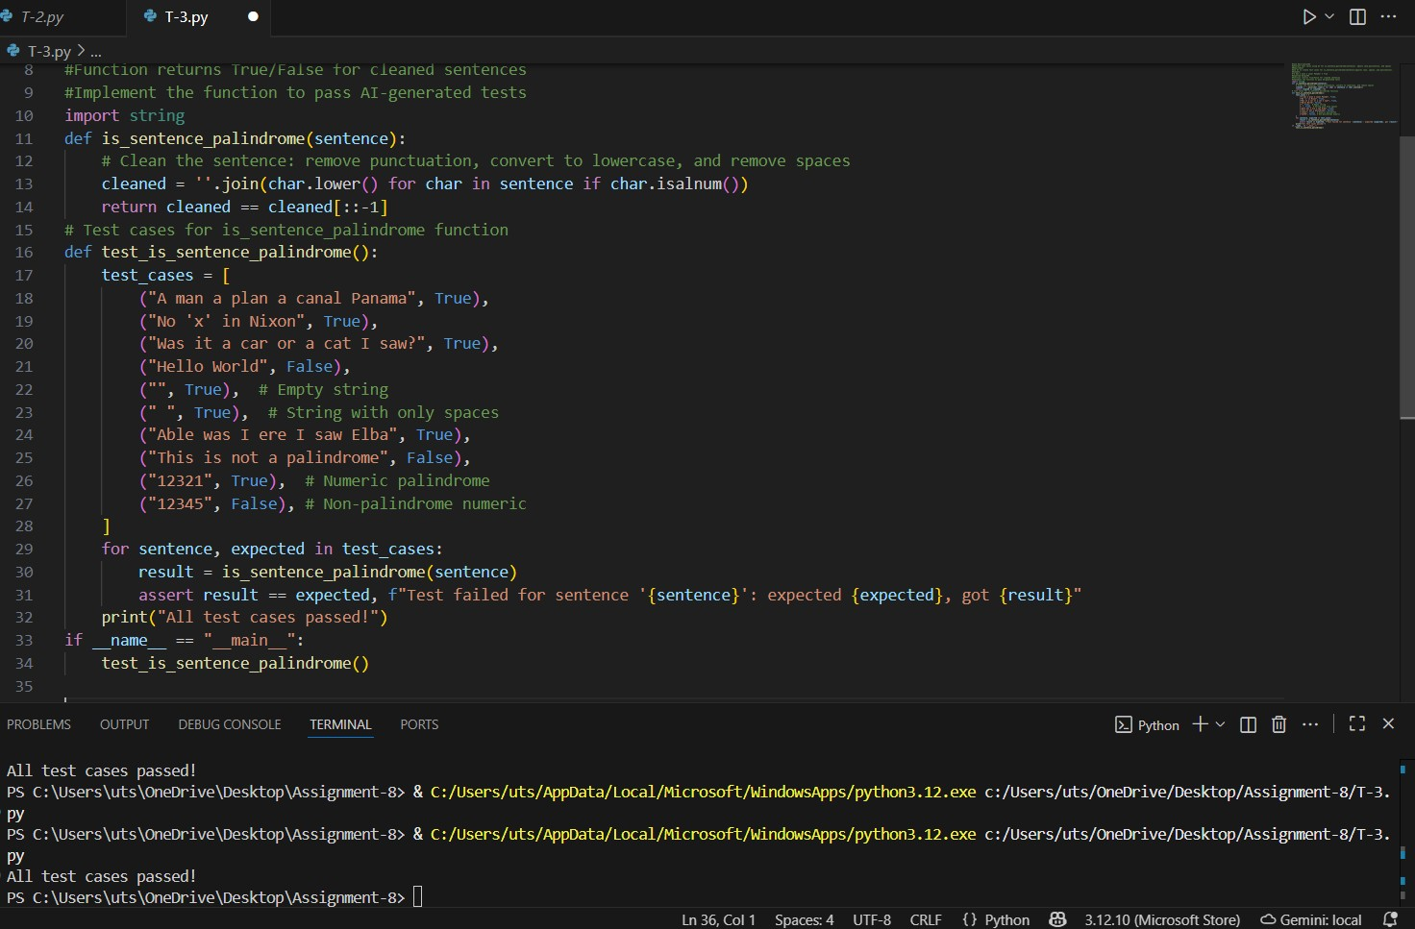

Figure 4: Task-3 code and output

- Task Description#4
• Let AI fix it Prompt AI to generate test cases for a ShoppingCart class (add_item,
remove_item, total_cost).
Methods:
Add_item(name,orice)
Remove_item(name)
Total_cost()
Expected Output#4
• Full class with tested functionalities

Ans:
class ShoppingCart:
def __init__(self):
self.items = {}

def add_item(self, name, price):
if price < 0:
return "Invalid price"
if name in self.items:
self.items[name] += price
else:
self.items[name] = price

def remove_item(self, name):
if name in self.items:
del self.items[name]
else:
return "Item not found"

def total_cost(self):
return sum(self.items.values())

# Test cases for ShoppingCart class
def test_shopping_cart():
cart = ShoppingCart()

# Test adding items
cart.add_item("apple", 1.0)
cart.add_item("banana", 2.0)
assert cart.total_cost() == 3.0, f"Expected total cost 3.0, got {cart.total_cost()}"

# Test adding the same item again
cart.add_item("apple", 1.5)
assert cart.total_cost() == 4.5, f"Expected total cost 4.5, got {cart.total_cost()}"

# Test removing an item
cart.remove_item("banana")
assert cart.total_cost() == 2.5, f"Expected total cost 2.5, got {cart.total_cost()}"

# Test removing an item that doesn't exist
result = cart.remove_item("orange")
assert result == "Item not found", f"Expected 'Item not found', got {result}"

# Test adding an item with invalid price
result = cart.add_item("grape", -1.0)
assert result == "Invalid price", f"Expected 'Invalid price', got {result}"

# Test total cost with no items
cart.remove_item("apple")
assert cart.total_cost() == 0.0, f"Expected total cost 0.0, got {cart.total_cost()}"

print("All test cases passed!")
if __name__ == "__main__":
test_shopping_cart()

OUTPUT:
All test cases passed!

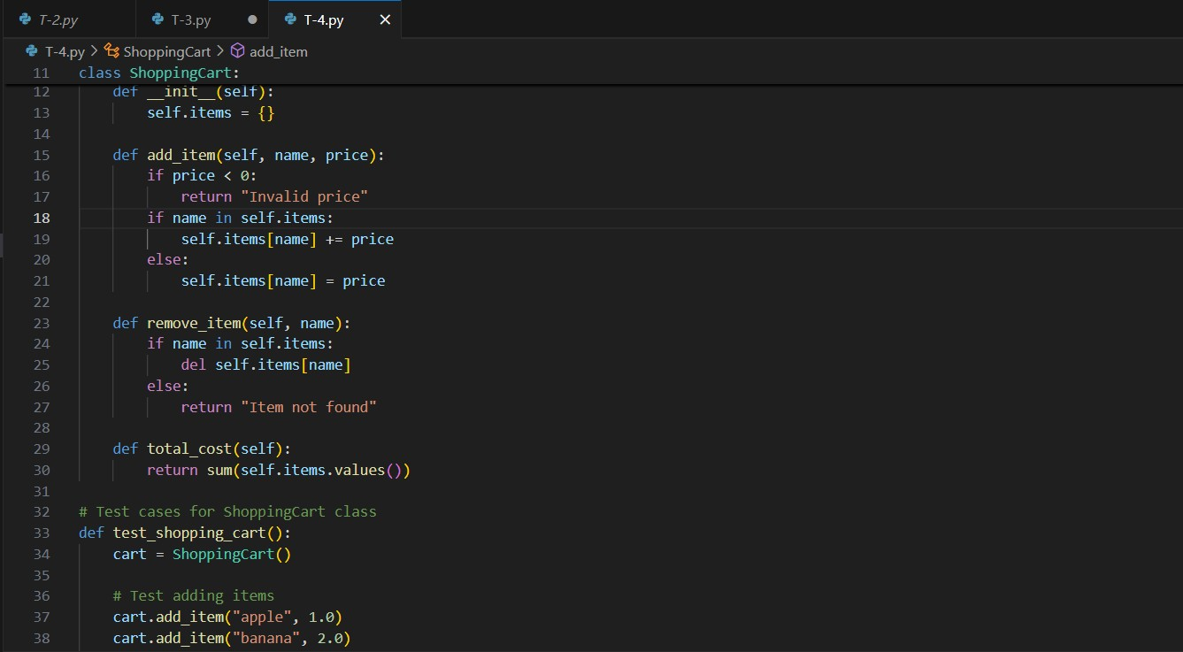

Figure 5: Task-4 code

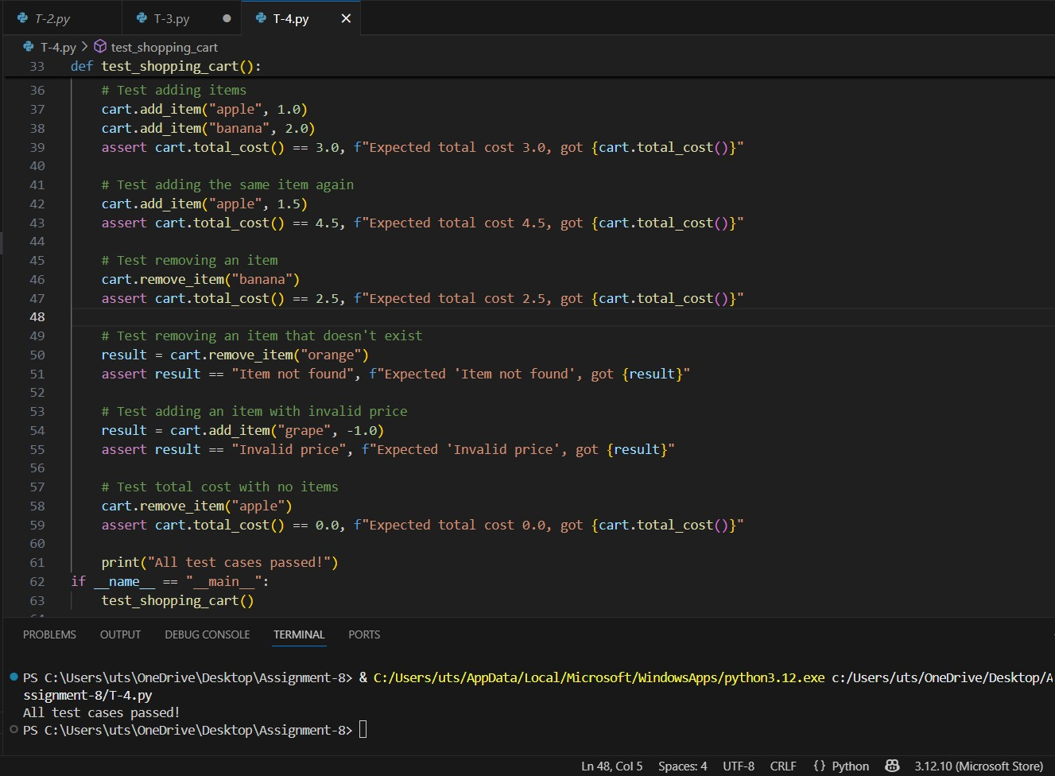

Figure 6: Task-4 output and code

- Task Description#5
• Use AI to write test cases for convert_date_format(date_str) to switch from "YYYY-
MM-DD" to "DD-MM-YYYY".
Example: "2023-10-15" → "15-10-2023"
Expected Output#5
• Function converts input format correctly for all test cases

Ans:
def convert_date_format(date_str):
try:
year, month, day = date_str.split('-')

# Check correct length
if len(year) != 4 or len(month) != 2 or len(day) != 2:
return "Invalid date format"

# Check numeric
if not (year.isdigit() and month.isdigit() and day.isdigit()):
return "Invalid date format"

# Convert to integers
y, m, d = int(year), int(month), int(day)

# Validate ranges
if m < 1 or m > 12:
return "Invalid date format"
if d < 1 or d > 31:
return "Invalid date format"

return f"{day}-{month}-{year}"

except ValueError:
return "Invalid date format"

# Test cases for convert_date_format function
def test_convert_date_format():
test_cases = [
("2023-10-15", "15-10-2023"),
("1999-01-01", "01-01-1999"),
("2000-12-31", "31-12-2000"),
("2024-02-29", "29-02-2024"), # Leap year
("2021-04-30", "30-04-2021"),

("abcd-ef-gh", "Invalid date format"), # Invalid format
("2023/10/15", "Invalid date format"), # Wrong separator
("20231015", "Invalid date format"), # No separators

# These should now return INVALID (as expected)
("2023-13-01", "Invalid date format"),
("2023-00-10", "Invalid date format"),
("2023-10-32", "Invalid date format"),
]

for date_str, expected in test_cases:
result = convert_date_format(date_str)
assert result == expected, f"Test failed for date '{date_str}': expected {expected}, got {result}"

print("All test cases passed!")

if __name__ == "__main__":
test_convert_date_format()

OUTPUT:
All test cases passed!

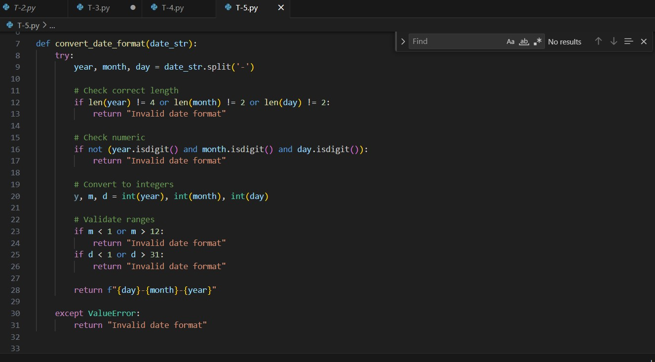

Figure 7: Task-5 code

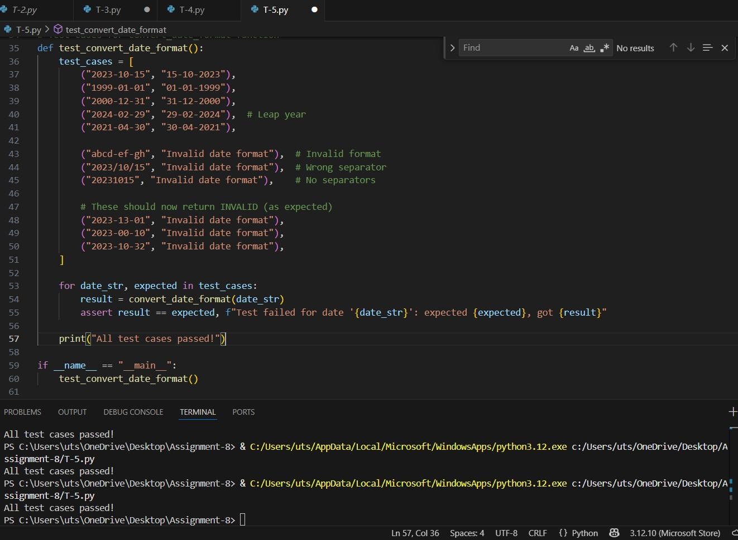

Figure 8: Task-5 output

