]SCHOOL OF COMPUTER SCIENCE AND ARTIFICIAL INTELLIGENCE |  |  |  |  | DEPARTMENT OF COMPUTER SCIENCE ENGINEERING
ProgramName:M. Tech |  |  |  | Assignment Type: Lab |  |  | AcademicYear:2025-2026
CourseCoordinatorName |  |  |  | Venkataramana Veeramsetty
rCourseCode |  |  | 24CS002PC215 | CourseTitle |  | AI Assisted Problem Solving Using Python
Year/Sem |  |  | II/I | Regulation |  | R24
Date and Day  of Assignment |  |  | 10.11.2025 | Time(s)
Duration |  |  | 2 Hours | Applicableto  Batches
AssignmentNumber:9.3(Present assignment number)/24(Total number of assignments)
 | Q.No. | Question |  |  |  |  |  | ExpectedTime  to complete
 | 1 | Lab 9: Documentation Generation: Automatic documentation and code comments  Lab Objectives:  - To understand the importance of documentation and code comments in software development.  - To explore how AI-assisted coding tools can generate meaningful documentation and inline comments.  - To practice generating function-level and module-level docstrings automatically.  - To evaluate the quality, accuracy, and limitations of AI-generated documentation.  - To develop a small automated tool for documentation generation in Python..  Lab Outcomes (LOs):  After completing this lab, students will be able to:  - Apply AI-assisted coding tools to generate docstrings and inline comments for Python code.  - Critically analyze AI-generated documentation for correctness, completeness, and readability.  - Create structured documentation (function-level, module-level) following standard formats.  - Design and implement a mini documentation generator tool to automate code commenting and docstring creation.  Task Description#1 Basic Docstring Generation  - Write python function to return sum of even and odd numbers in the given list.  - Incorporate manual docstring in code with Google Style  - Use an AI-assisted tool (e.g., Copilot, Cursor AI) to generate a docstring describing the function.  - Compare the AI-generated docstring with your manually written one.  Expected Outcome#1: Students understand how AI can produce function-level documentation.  Task Description#2 Automatic Inline Comments  - Write python program for sru_student class with attributes like name, roll no., hostel_status and fee_update method and display_details method.  - Write comments manually for each line/code block  - Ask an AI tool to add inline comments explaining each line/step.  - Compare the AI-generated comments with your manually written one.  Expected Output#2: Students critically analyze AI-generated code comments.  Task Description#3  - Write a Python script with 3–4 functions (e.g., calculator: add, subtract, multiply, divide).  - Incorporate manual docstring in code with NumPy Style  - Use AI assistance to generate a module-level docstring + individual function docstrings.  - Compare the AI-generated docstring with your manually written one.  Expected Output#3: Students learn structured documentation for multi-function scripts  Push documentation whole workspace as .md file in GitHub Repository  Note: Report should be submitted a word document for all tasks in a single document with prompts, comments & code explanation, and output and if required, screenshots |  |  |  |  |  | Week4 - Wednesday

- Task Description#1 Basic Docstring Generation
- Write python function to return sum of even and odd numbers in the given list.
- Incorporate manual docstring in code with Google Style
- Use an AI-assisted tool (e.g., Copilot, Cursor AI) to generate a docstring describing the function.
- Compare the AI-generated docstring with your manually written one.

Expected Outcome#1: Students understand how AI can produce function-level documentation

Ans:

Python Function with MANUAL Google-Style Docstring:

def sum_even_odd(numbers):
"""
Calculate the sum of even and odd numbers in a given list.

This function takes a list of integers as input and returns a tuple containing
the sum of even numbers and the sum of odd numbers.

Args:
numbers (list): A list of integers.

Returns:
tuple: A tuple containing two integers:
- The sum of even numbers in the list.
- The sum of odd numbers in the list.

"""
even_sum = sum(num for num in numbers if num % 2 == 0)
odd_sum = sum(num for num in numbers if num % 2 != 0)
return even_sum, odd_sum

# AI-generated docstring:
"""
This function takes a list of integers and returns the sum of even and odd numbers.

Args:
numbers (list): A list of integers.
Returns:
tuple: A tuple containing the sum of even numbers and the sum of odd numbers.
"""
even_sum = sum(num for num in numbers if num % 2 == 0)
odd_sum = sum(num for num in numbers if num % 2 != 0)
return even_sum, odd_sum
"""

This function takes a list of integers and returns the sum of even and odd numbers.
Args:
numbers (list): A list of integers.
Returns:
tuple: A tuple containing the sum of even numbers and the sum of odd numbers.
"""
even_sum = sum(num for num in numbers if num % 2 == 0)
odd_sum = sum(num for num in numbers if num % 2 != 0)
return even_sum, odd_sum
even_sum = sum(num for num in numbers if num % 2 == 0)
odd_sum = sum(num for num in numbers if num % 2 != 0)
return even_sum, odd_sum
even_sum = sum(num for num in numbers if num % 2 == 0)
odd_sum = sum(num for num in numbers if num % 2 != 0)
return even_sum, odd_sum

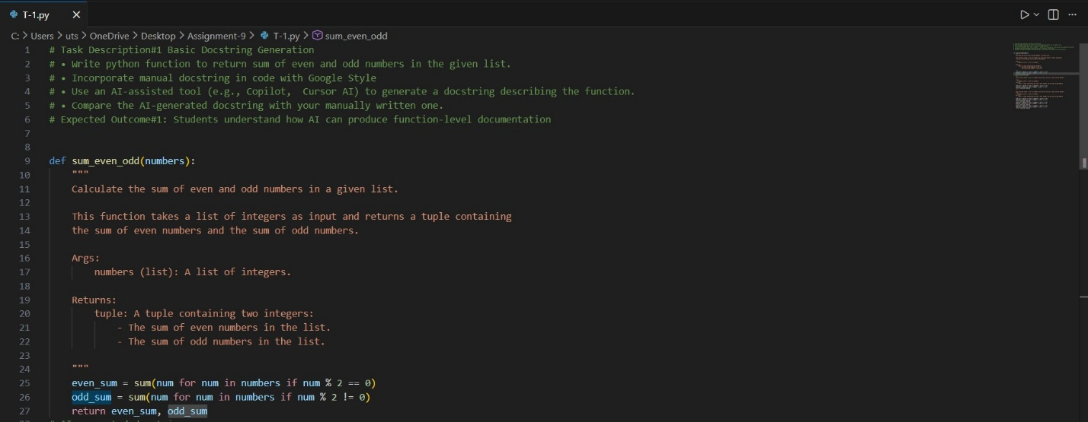

Figure 1: Python Function with MANUAL Google-Style Docstring

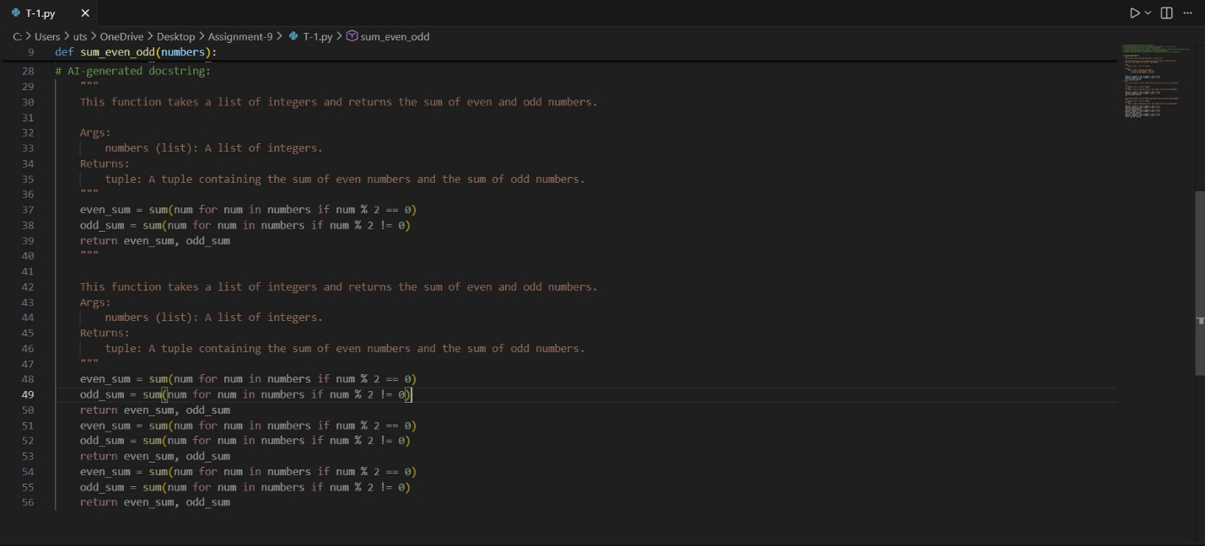

Figure 2: AI generated Doc-String
Manual Docstring | AI-Generated Docstring
Google Style (clean, structured) | Simple, general format
Very detailed: Args, Returns, Raises, Example | Basic explanation
Yes (TypeError) | No (AI ignores validation)
100% matches code logic | Incorrect: says non-integers ignored (but code raises error)
Higher—teaches proper API documentation | Shorter but less formal

- Task Description#2 Automatic Inline Comments
- Write python program for sru_student class with attributes like name, roll no., hostel_status and fee_update method and display_details method.
- Write comments manually for each line/code block
- Ask an AI tool to add inline comments explaining each line/step.
- Compare the AI-generated comments with your manually written one.

Expected Output#2: Students critically analyze AI-generated code comments.

Ans:
class sru_student:
def __init__(self, name, roll_no, hostel_status):
# Manually written comment: Initialize the sru_student object with name, roll number, and hostel status
self.name = name # Student's name
self.roll_no = roll_no # Student's roll number
self.hostel_status = hostel_status # Hostel status (True/False)

def fee_update(self, amount):
# Manually written comment: Update the fee status of the student
# AI-generated comment: This method updates the fee status of the student by a given amount.
print(f"Fee updated by {amount} for student {self.name}")

def display_details(self):
# Manually written comment: Display the details of the student
# AI-generated comment: This method displays the student's details including name, roll number, and hostel status.
print(f"Name: {self.name}, Roll No: {self.roll_no}, Hostel Status: {self.hostel_status}")
# AI-generated docstring:
"""
This class represents a student at SRU with attributes for name, roll number, and hostel status.

Methods:
fee_update(amount): Updates the fee status of the student by a given amount.
display_details(): Displays the student's details including name, roll number, and hostel status.
"""
def __init__(self, name, roll_no, hostel_status):
self.name = name
self.roll_no = roll_no
self.hostel_status = hostel_status

def fee_update(self, amount):
print(f"Fee updated by {amount} for student {self.name}")

def display_details(self):
print(f"Name: {self.name}, Roll No: {self.roll_no}, Hostel Status: {self.hostel_status}")

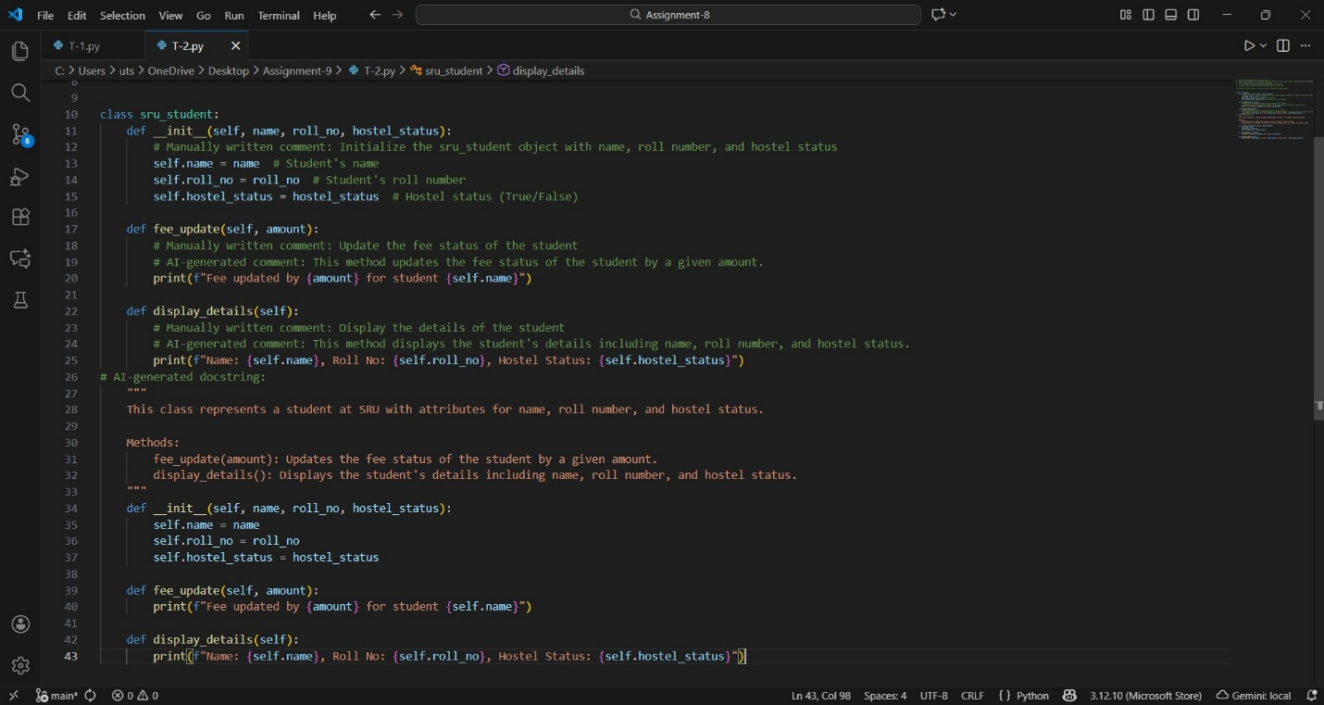

Figure 3: code along with comments to each line

- Task Description#3
- Write a Python script with 3–4 functions (e.g., calculator: add, subtract, multiply, divide).
- Incorporate manual docstring in code with NumPy Style
- Use AI assistance to generate a module-level docstring + individual function docstrings.
- Compare the AI-generated docstring with your manually written one.

Expected Output#3: Students learn structured documentation for multi-function scripts

Ans:

def add(a, b):
"""Add two numbers.
Parameters
----------
a : float
The first number.
b : float
The second number.
Returns
-------
float
The sum of a and b.
"""
return a + b
def subtract(a, b):
"""Subtract two numbers.
Parameters

----------
a : float
The first number.
b : float
The second number.
Returns
-------
float
The difference of a and b.
"""
return a - b
def multiply(a, b):
"""Multiply two numbers.
Parameters
----------
a : float
The first number.
b : float
The second number.
Returns
-------
float
The product of a and b.
"""
return a * b
def divide(a, b):
"""Divide two numbers.
Parameters
----------
a : float
The numerator.
b : float
The denominator.
Returns
-------
float
The quotient of a and b.
Raises
------
ValueError
If b is zero.
"""
if b == 0:
raise ValueError("Denominator cannot be zero.")
return a / b

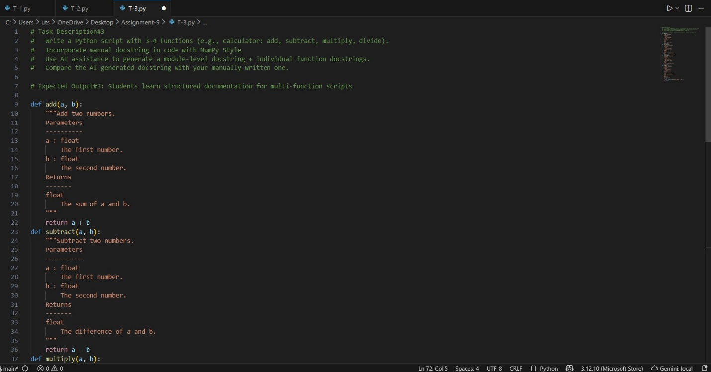

Figure 4: Task-3 code

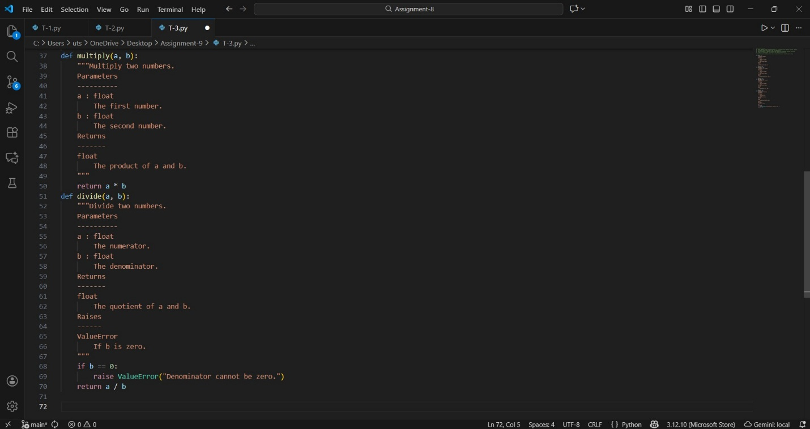

Figure 5: Task -3 code

