SCHOOL OF COMPUTER SCIENCE AND ARTIFICIAL INTELLIGENCE |  |  |  |  | DEPARTMENT OF COMPUTER SCIENCE ENGINEERING
Program Name: M. Tech/MCA/MSC |  |  |  | Assignment Type: Lab |  |  | AcademicYear:2025-2026
Course Coordinator Name |  |  |  | Venkataramana Veeramsetty
Course Code |  |  |  | Course Title |  | AI Assisted Problem Solving Using Python
Year/Sem |  |  | II/I | Regulation |  | R25
Date and Day  of Assignment |  |  | Week5 - Tuesday | Time(s)
Duration |  |  | 2 Hours | Applicable to  Batches |  | M. Tech/MCA/MSC
AssignmentNumber:14.3(Presentassignmentnumber)/24(Totalnumberofassignments)
 | Q.No. | Question |  |  |  |  |  | ExpectedTime  to complete
 | 1 | Lab 14 – Web Frontend Development: AI-assisted HTML/CSS/JS with Python  Lab Objectives  - To understand how AI can generate HTML/CSS/JS templates.  - To practice integrating frontend and backend (Python) for small apps.  - To evaluate AI-generated code for readability, reusability, and responsiveness.  Learning Outcomes  After completing this lab, students will be able to:  - Generate HTML/CSS layouts using AI tools.  - Add JavaScript interactivity with AI suggestions.  - Integrate basic Python (Flask/Streamlit) backend to serve frontend.  - Evaluate AI-generated web code for responsiveness and usability.  - Debug and refine AI-generated frontend code.  Task Description #1 – AI-generated HTML Page  Task: Ask AI to generate a simple HTML homepage for a "Student Info Portal" with a header, navigation menu, and footer.  Expected Output:  - HTML code with <header>, <nav>, <footer>.  - Clean indentation, proper tags, and comments.  Task Description #2 – CSS Styling  Task:  Use AI to add CSS styling to Task #1 homepage for:  - Responsive navigation bar.  - Centered content section.  - Footer with light gray background.  Expected Output:  - HTML + CSS combined.  - AI explains how CSS classes apply.  Expected Output: AI refactors with with open() and try-except:  Task Description #3 – JavaScript Interactivity  Task: Prompt AI to generate a JS script that validates a simple login form (non-empty username/password).  Expected Output:  Working on submit JS validation.  Clear error messages if inputs are empty.  Task Description #4 – Python Backend Integration  Task: Ask AI to generate a Flask app that serves the HTML form (Task #3) and prints the username on successful login. |  |  |  |  |  | Week5 - Tuesday

  - Task Description #1 – AI-generated HTML Page
Task: Ask AI to generate a simple HTML homepage for a "Student Info Portal" with a header, navigation menu, and footer.
Expected Output:
- HTML code with <header>, <nav>, <footer>.
- Clean indentation, proper tags, and comments.
Ans:

CODE:
#Task Description #1 – AI-generated HTML Page
"""Task: Ask AI to generate a simple HTML homepage for a "Student Info Portal" with a header, navigation menu, and footer.
Expected Output:
● HTML code with <header>, <nav>, <footer>.
● Clean indentation, proper tags, and comments."""

# AI-generated HTML code for a "Student Info Portal"
html_code = """
<!DOCTYPE html>
<html lang="en">
<head>
<meta charset="UTF-8">
<meta name="viewport" content="width=device-width, initial-scale=1.0">
<title>Student Info Portal</title>
<style>
body {
font-family: Arial, sans-serif;
margin: 0;
padding: 0;
}
header {
background-color: #4CAF50;
color: white;
padding: 10px 0;
text-align: center;
}
nav {
background-color: #333;
}
nav a {
color: white;
padding: 14px 20px;
text-decoration: none;
display: inline-block;
}
nav a:hover {
background-color: #ddd;
color: black;
}
footer {
background-color: #f1f1f1;
text-align: center;
padding: 10px 0;
position: fixed;
width: 100%;
bottom: 0;
}
</style>
</head>
<body>

<!-- Header Section -->
<header>
<h1>Welcome to the Student Info Portal</h1>
</header>

<!-- Navigation Menu -->
<nav>
<a href="#home">Home</a>
<a href="#about">About</a>
<a href="#courses">Courses</a>
<a href="#contact">Contact</a>
</nav>

<!-- Main Content Area -->
<main>
<h2>Home</h2>
<p>This is the homepage of the Student Info Portal where students can find information about their courses, schedules, and more.</p>
</main>

<!-- Footer Section -->
<footer>
<p>&copy; 2024 Student Info Portal. All rights reserved.</p>
</footer>

</body>
</html>
"""
# Print the generated HTML code
print(html_code)
# Save the HTML code to a file
with open("student_info_portal.html", "w") as file:
file.write(html_code)

OUTPUT:

<p>This is the homepage of the Student Info Portal where students can find information about their courses, schedules, and more.</p>
</main>

<!-- Footer Section -->
<footer>
<p>&copy; 2024 Student Info Portal. All rights reserved.</p>
</footer>

</body>
</html>

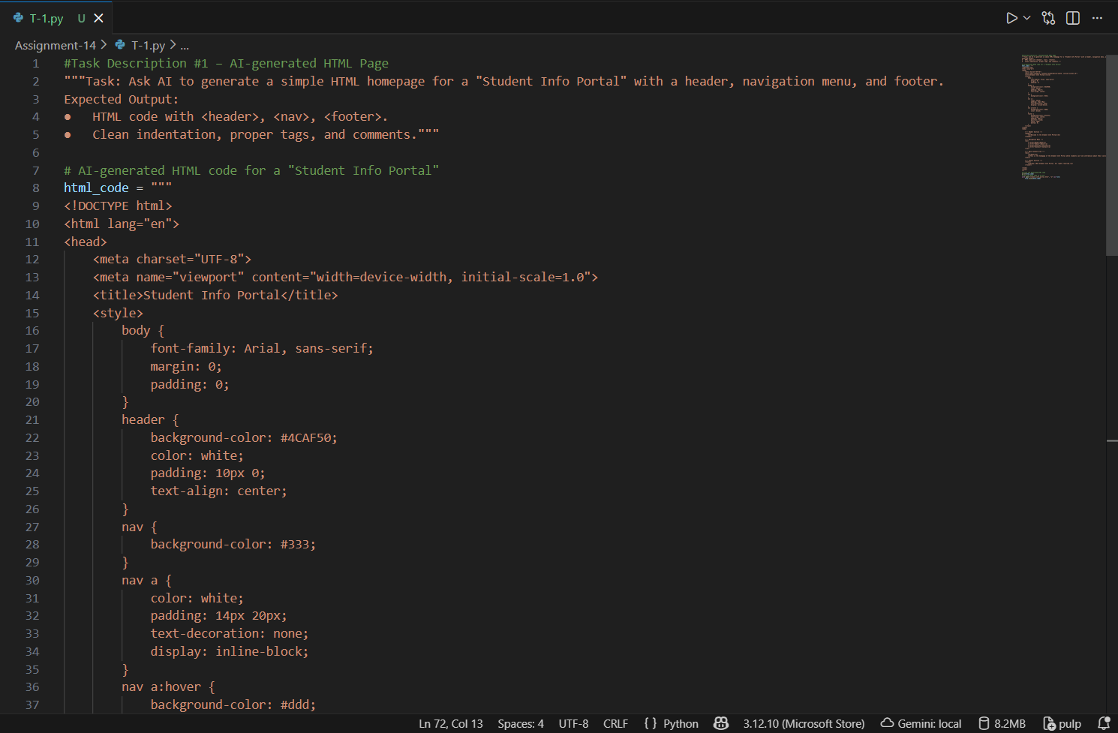

Figure 1: Task-1 code
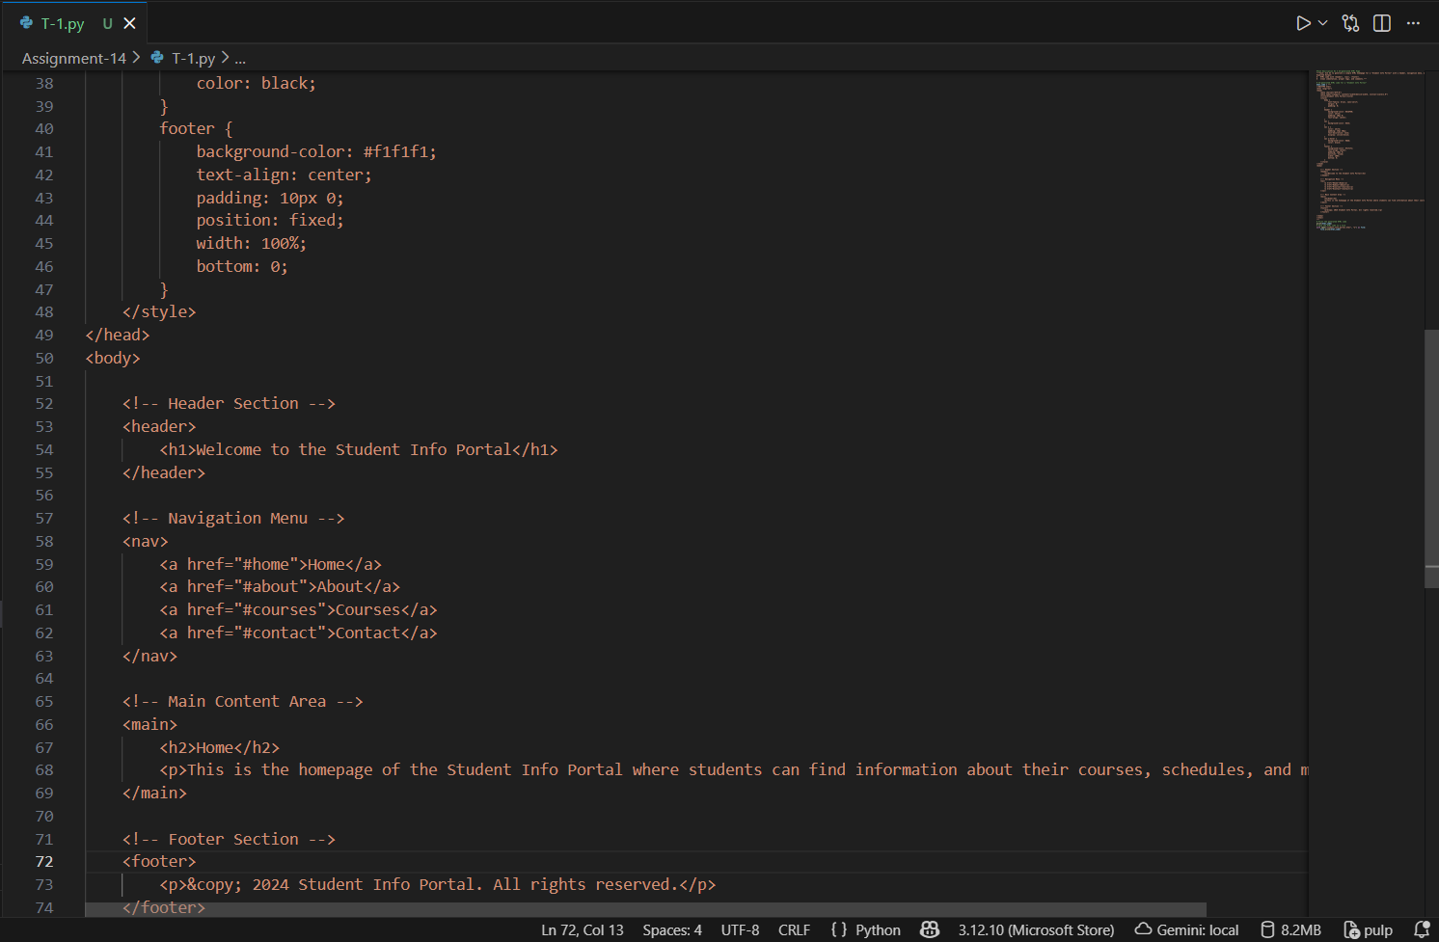
Figure 2: Task-1 code

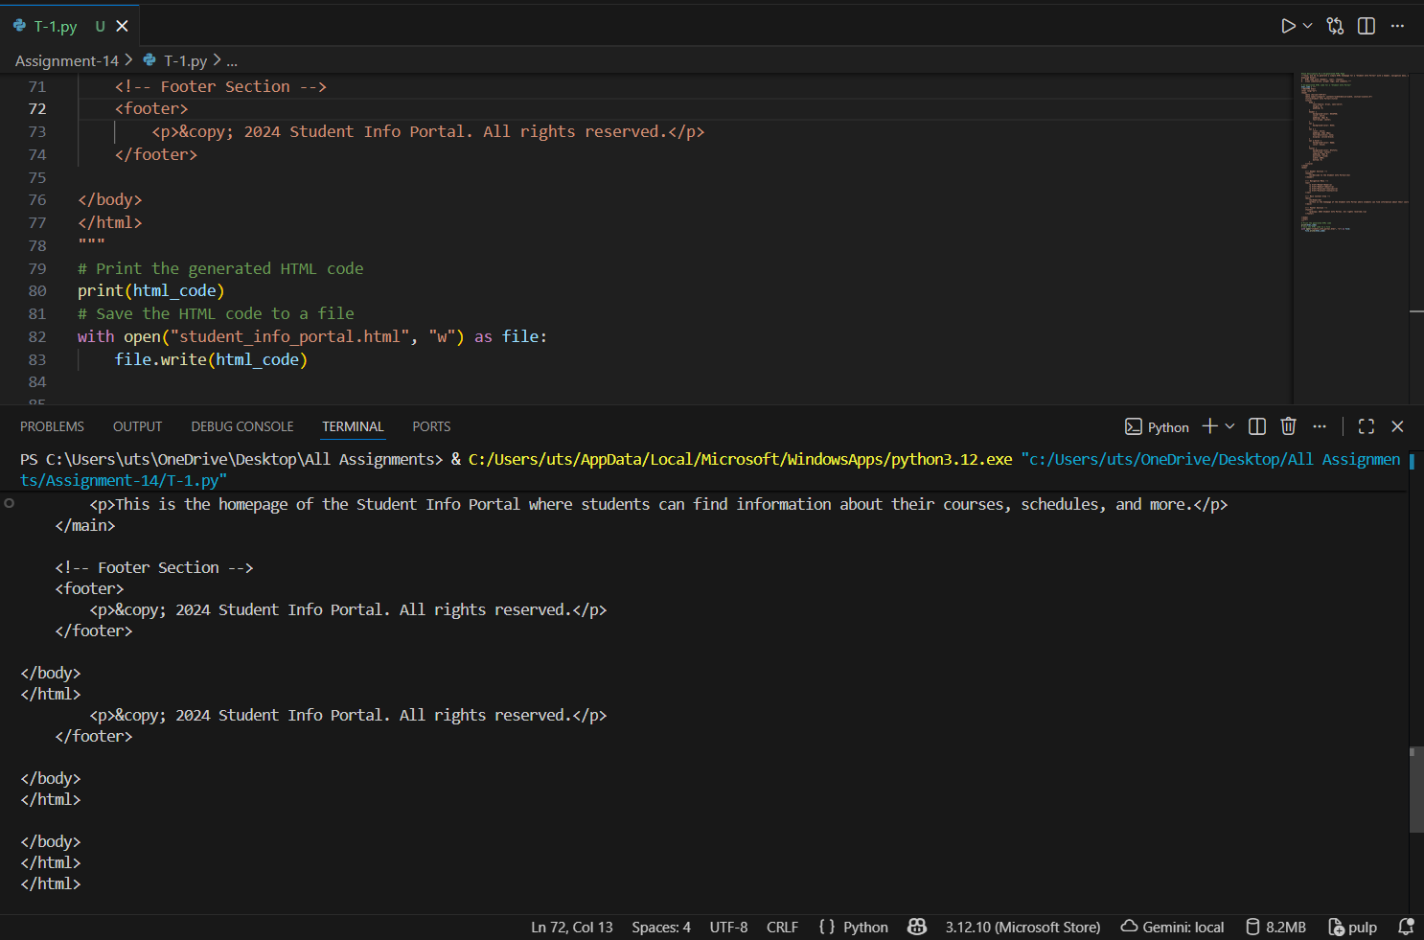
Figure 3:Task-1 output
  - Task Description #2 – CSS Styling
Task:
Use AI to add CSS styling to Task #1 homepage for:
- Responsive navigation bar.
- Centered content section.
- Footer with light gray background.
Expected Output:
- HTML + CSS combined.
- AI explains how CSS classes apply.
Expected Output: AI refactors with with open() and try-except:
Ans:
CODE:
"""Task Description #2 – CSS Styling
Task:
Use AI to add CSS styling to Task #1 homepage for:
● Responsive navigation bar.
● Centered content section.
● Footer with light gray background.
Expected Output:
● HTML + CSS combined.
● AI explains how CSS classes apply.
Expected Output: AI refactors with with open() and try-except:"""

from pydoc import html
# Refactored AI-generated HTML code with CSS styling for "Student Info Portal"

html_code = """
<!DOCTYPE html>
<html lang="en">
<head>
<meta charset="UTF-8">
<meta name="viewport" content="width=device-width, initial-scale=1.0">
<title>Student Info Portal</title>
<style>
body {
font-family: Arial, sans-serif;
margin: 0;
padding: 0;
}
header {
background-color: #4CAF50;
color: white;
padding: 10px 0;
text-align: center;
}
nav {
background-color: #333;
overflow: hidden;
}
nav a {
color: white;
padding: 14px 20px;
text-decoration: none;
display: inline-block;
}
nav a:hover {
background-color: #ddd;
color: black;
}
.content {
text-align: center;
margin: 20px;
}
footer {
background-color: #f1f1f1;
text-align: center;
padding: 10px 0;
position: fixed;
width: 100%;
bottom: 0;
}
@media screen and (max-width: 600px) {
nav a {
float: none;
display: block;
text-align: left;
}
}
</style>

</head>
<body>

<!-- Header Section -->
<header>
<h1>Welcome to the Student Info Portal</h1>
</header>

<!-- Navigation Menu -->
<nav>
<a href="#home">Home</a>
<a href="#about">About</a>
<a href="#courses">Courses</a>
<a href="#contact">Contact</a>
</nav>

<!-- Main Content Area -->
<div class="content">
<h2>Student Information</h2>
<p>This portal provides access to student resources, course information, and contact details.</p>
</div>

<!-- Footer Section -->
<footer>
<p>&copy; 2024 Student Info Portal. All rights reserved.</p>
</footer>

</body>
</html>
"""
try:
with open("Student_Info_Portal.html", "w") as file:
file.write(html_code)
print("HTML file with CSS styling has been created successfully.")
except Exception as e:
print(f"An error occurred while writing the file: {e}")

OUTPUT:

HTML file with CSS styling has been created successfully.

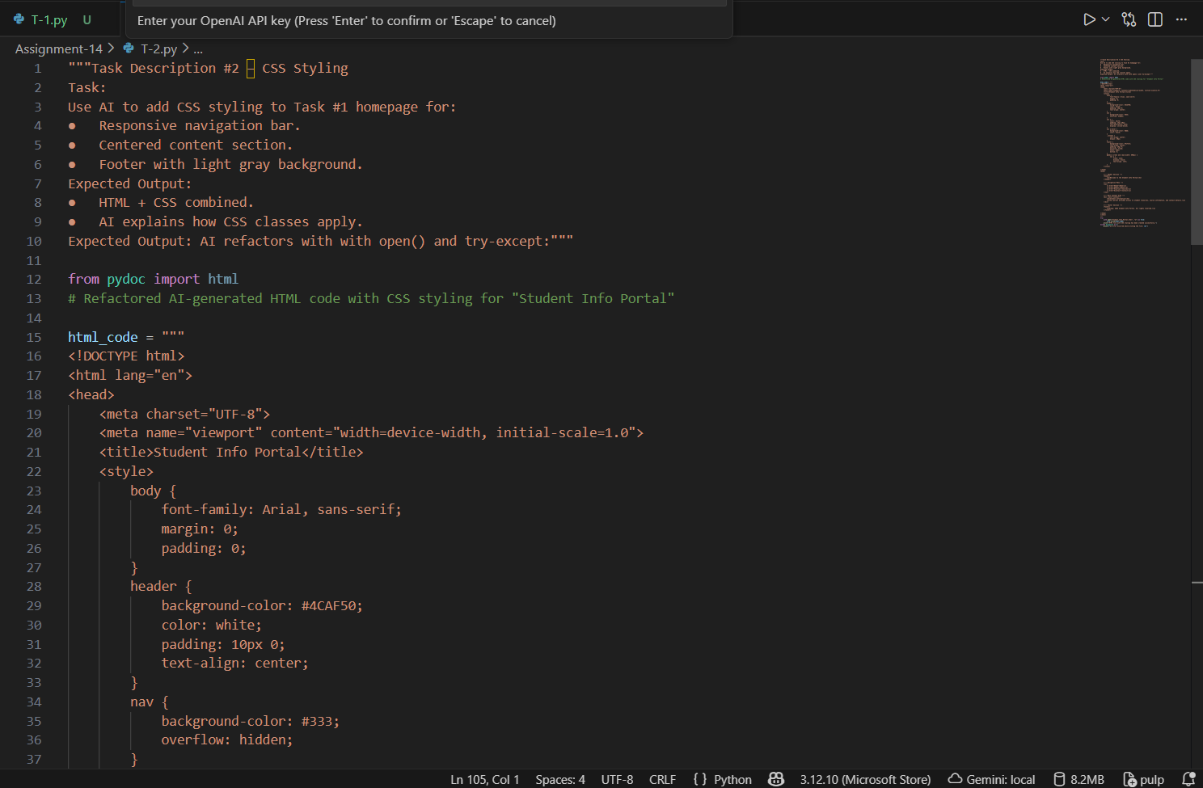

Figure 4: T-2 code

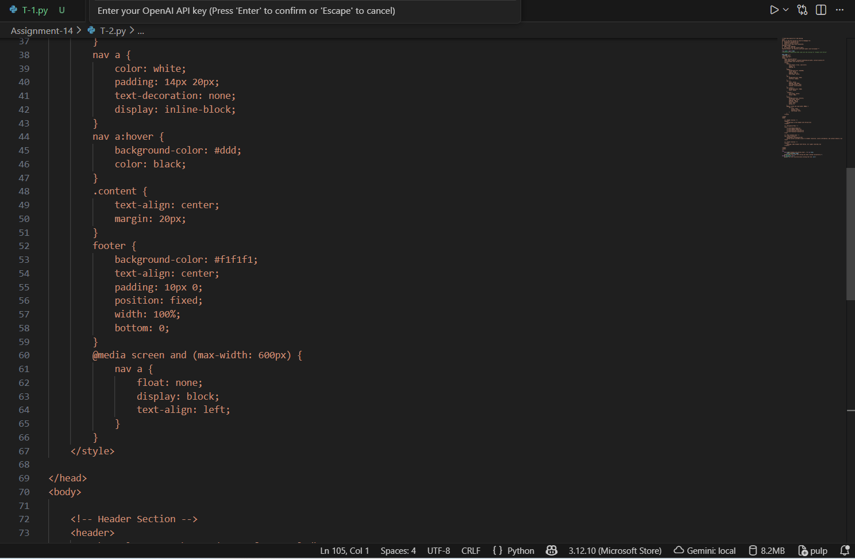
Figure 5: T-2 code

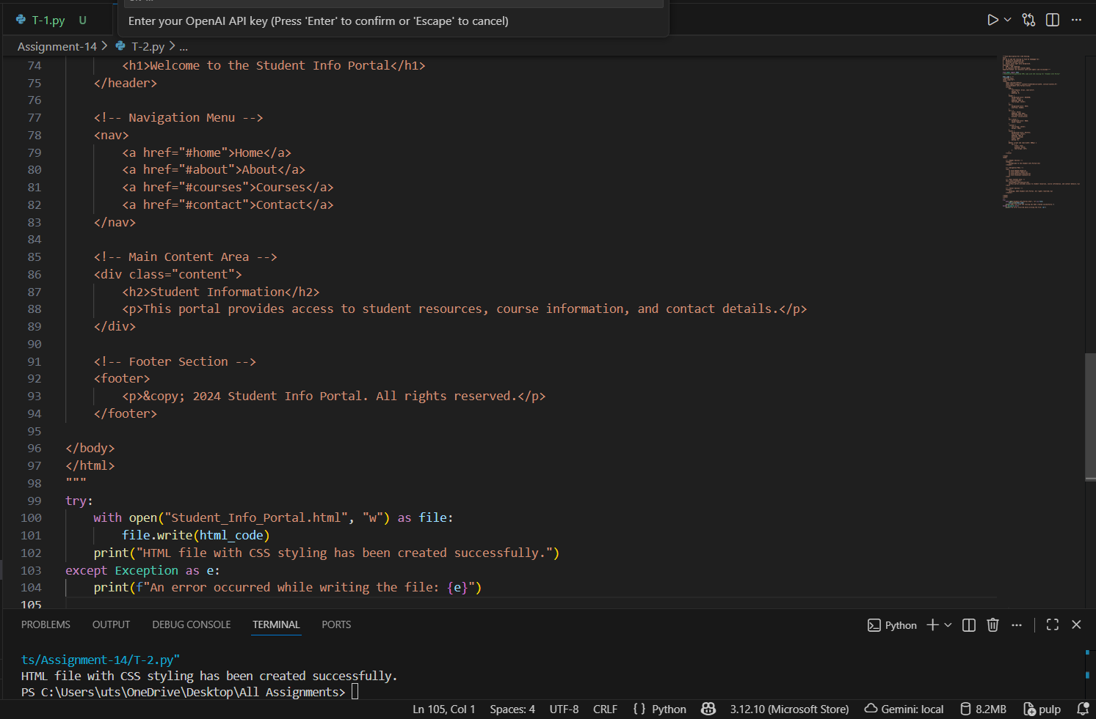

Figure 6: T-2 output
3. Task Description #3 – JavaScript Interactivity
Task: Prompt AI to generate a JS script that validates a simple login form (non-empty username/password).
Expected Output:
Working on submit JS validation.
Clear error messages if inputs are empty.
Ans:
CODE:
<!DOCTYPE html>
<html lang="en">
<head>
<meta charset="UTF-8">
<title>Login Form Validation</title>

<style>
body {
font-family: Arial, sans-serif;
padding: 40px;
background-color: #f4f4f4;
}
.container {
width: 300px;
margin: auto;
padding: 20px;
background: white;
border-radius: 8px;
box-shadow: 0px 0px 8px rgba(0,0,0,0.2);
}
.error {
color: red;
margin-top: 5px;
font-size: 14px;
}
input {
width: 100%;
padding: 8px;
margin-top: 8px;
}
button {
width: 100%;
padding: 10px;
margin-top: 12px;
background-color: #0066ff;
color: white;
border: none;
border-radius: 5px;
font-size: 16px;
}
</style>
</head>

<body>

<div class="container">
<h2>Login Form</h2>

<!-- Login Form -->
<form id="loginForm">
<label>Username:</label><br>
<input type="text" id="username">
<div id="userError" class="error"></div>

<label>Password:</label><br>
<input type="password" id="password">
<div id="passError" class="error"></div>

<button type="submit">Login</button>
</form>
</div>

<script>
// On form submission
document.getElementById("loginForm").addEventListener("submit", function(event) {

// Clear previous messages
document.getElementById("userError").textContent = "";
document.getElementById("passError").textContent = "";

let username = document.getElementById("username").value.trim();
let password = document.getElementById("password").value.trim();

let formIsValid = true;

// Username validation
if (username === "") {
document.getElementById("userError").textContent = "Username cannot be empty.";
formIsValid = false;
}

// Password validation
if (password === "") {
document.getElementById("passError").textContent = "Password cannot be empty.";
formIsValid = false;
}

// Prevent submit if invalid
if (!formIsValid) {
event.preventDefault();
}
});
</script>

</body>
</html>

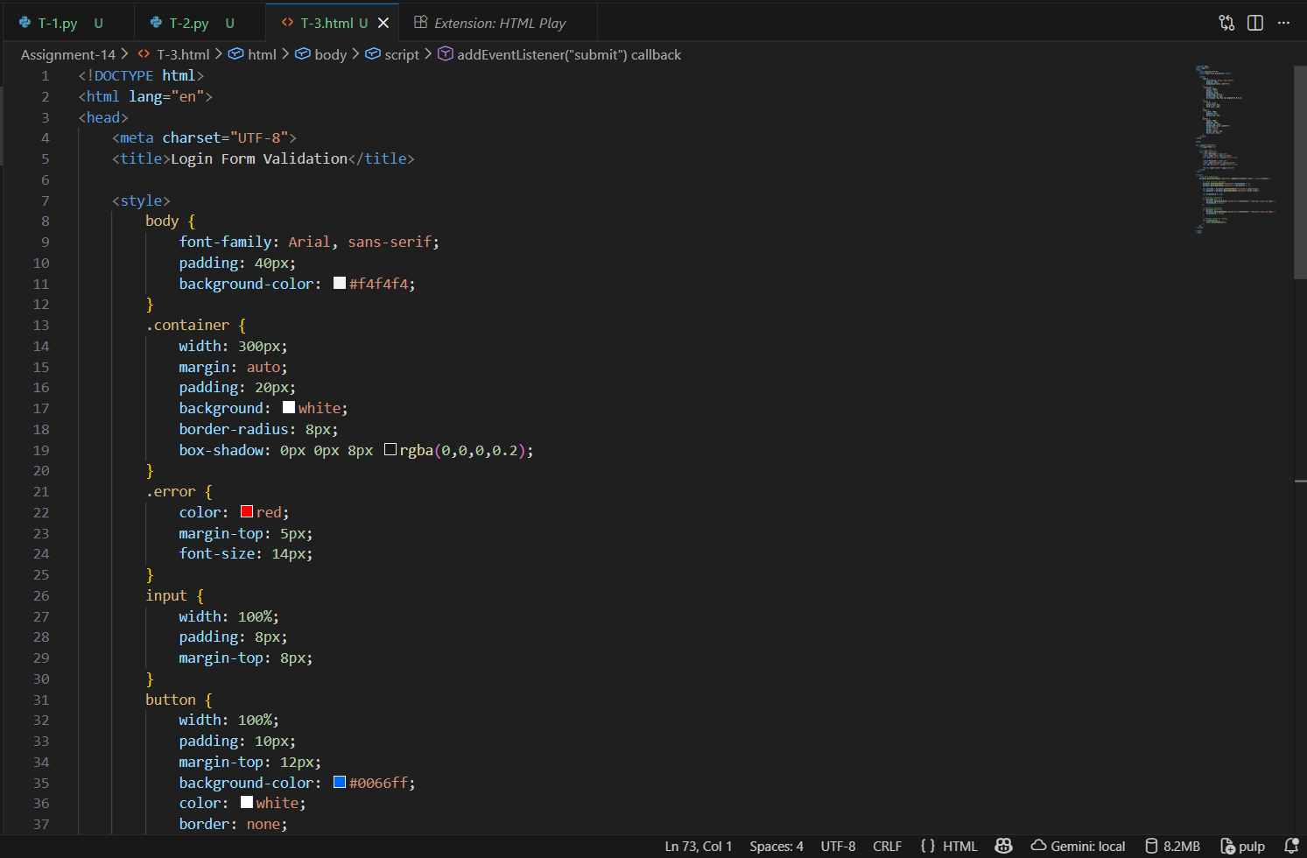

Figure 7: Task-3 code
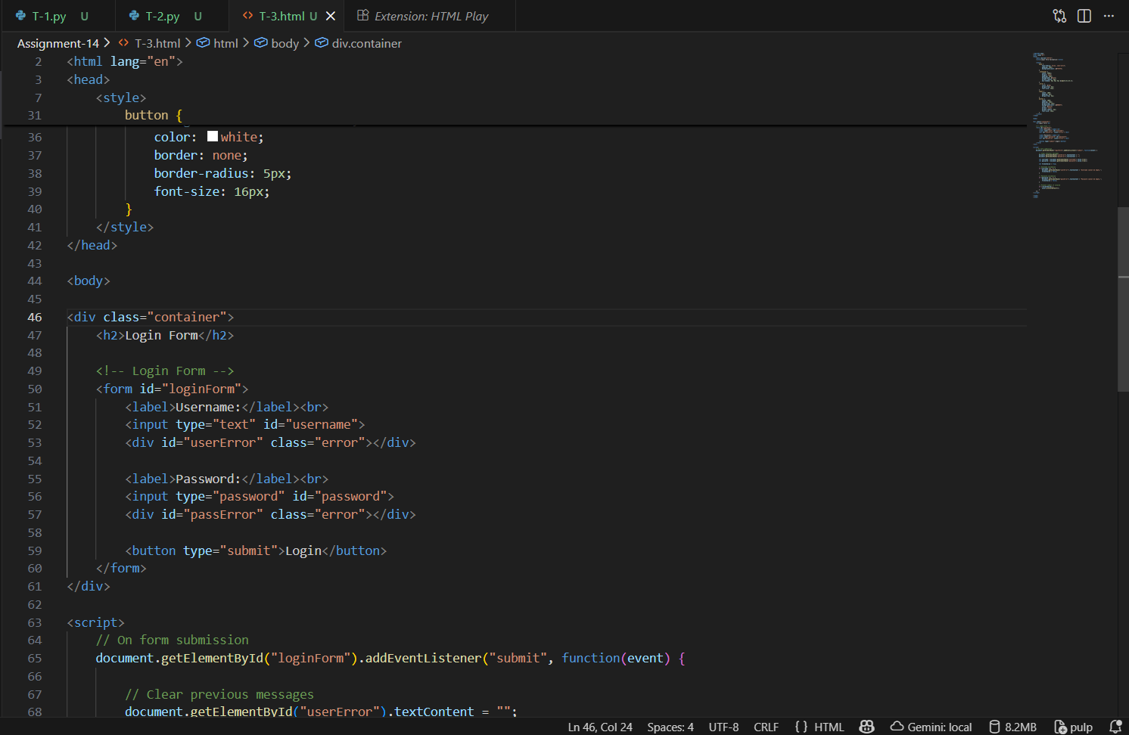

Figure 8: Task-3 code

4.

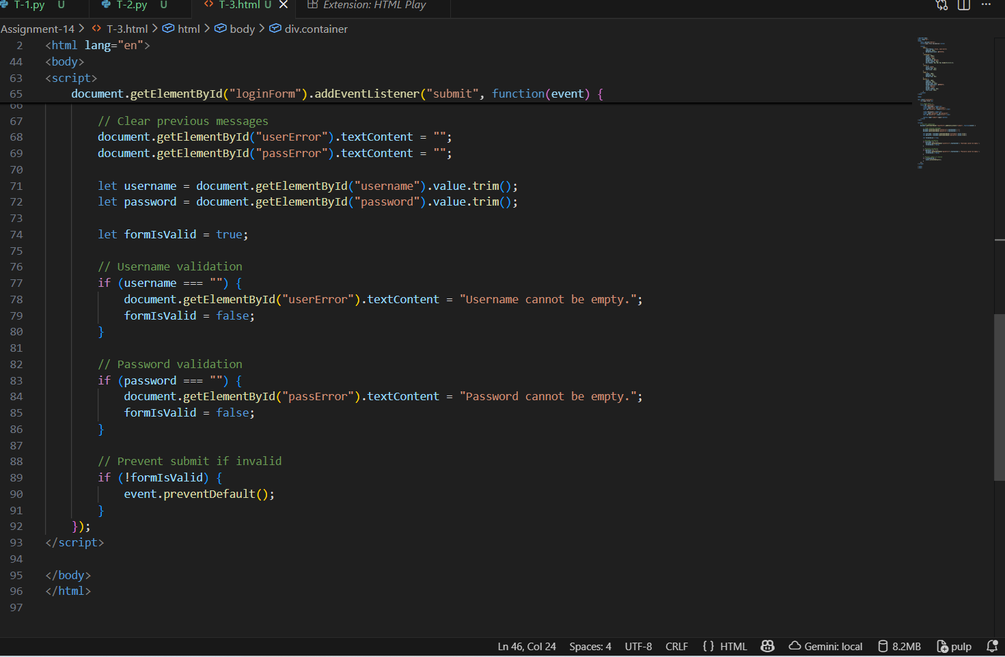

Figure 9: T-3 output code
- Task Description #4 – Python Backend Integration
Task: Ask AI to generate a Flask app that serves the HTML form (Task #3) and prints the username on successful login.

Ans:
CODE:
"""Task Description #4 – Python Backend Integration
Task: Ask AI to generate a Flask app that serves the HTML form (Task #3) and prints the username on successful login."""
<!DOCTYPE html>
<html lang="en">
<head>
<meta charset="UTF-8">
<title>Login Form</title>

<style>
body {
font-family: Arial, sans-serif;
padding: 40px;
background-color: #f4f4f4;
}
.container {
width: 300px;
margin: auto;
padding: 20px;
background: white;
border-radius: 8px;
box-shadow: 0px 0px 8px rgba(0,0,0,0.2);
}
.error {
color: red;
margin-top: 5px;
font-size: 14px;
}
</style>
</head>
<body>

<div class="container">
<h2>Login Form</h2>

<form action="/login" method="POST">
<label>Username:</label>
<input type="text" name="username">

<label>Password:</label>
<input type="password" name="password">

<button type="submit">Login</button>
</form>
</div>

</body>
</html>

