SCHOOLOFCOMPUTER SCIENCE AND ARTIFICIAL INTELLIGENCE |  |  |  |  | DEPARTMENTOFCOMPUTER SCIENCE ENGINEERING
Program Name: M. Tech/MCA/MSC |  |  |  | Assignment Type: Lab |  |  | AcademicYear:2025-2026
Course Coordinator Name |  |  |  | Venkataramana Veeramsetty
Course Code |  |  | 24CS002PC215 | Course Title |  | AI Assisted Problem Solving Using Python
Year/Sem |  |  | II/I | Regulation |  | R24
Date and Day  of Assignment |  |  | Week5- Tuesday | Time(s)
Duration |  |  | 2 Hours | Applicable to  Batches
AssignmentNumber:13.3(Presentassignmentnumber)/24(Totalnumberofassignments)
 | Q.No. | Question |  |  |  |  |  | ExpectedTime  to complete
 | 1 | Lab 13 – Code Refactoring: Improving Legacy Code with AI Suggestions  Lab Objectives  - To introduce the concept of code refactoring and why it matters (readability, maintainability, performance).  - To practice using AI tools for identifying and suggesting improvements in legacy code.  - To evaluate the before vs. after versions for clarity, performance, and correctness.  - To reinforce responsible AI-assisted coding practices (avoiding over-reliance, validating outputs).  Learning Outcomes  After completing this lab, students will be able to:  - Use AI to analyze and refactor poorly written Python code.  - Improve code readability, efficiency, and error handling.  - Document AI-suggested improvements through comments and explanations.  - Apply refactoring strategies without changing functionality.  - Critically reflect on AI’s refactoring suggestions.  Task Description #1 – Remove Repetition  Task: Provide AI with the following redundant code and ask it to refactor  Python Code  def calculate_area(shape, x, y=0):  if shape == "rectangle":  return x * y  elif shape == "square":  return x * x  elif shape == "circle":  return 3.14 * x * x  Expected Output  - Refactored version with dictionary-based dispatch or separate functions.  - Cleaner and modular design.  Task Description #2 – Error Handling in Legacy Code  Task: Legacy function without proper error handling  Python Code  def read_file(filename):  f = open(filename, "r")  data = f.read()  f.close()  return data  Expected Output:  AI refactors with with open() and try-except:  Task Description #3 – Complex Refactoring  Task: Provide this legacy class to AI for readability and modularity improvements:  Python Code  class Student:  def __init__(self, n, a, m1, m2, m3):  self.n = n  self.a = a  self.m1 = m1  self.m2 = m2  self.m3 = m3  def details(self):  print("Name:", self.n, "Age:", self.a)  def total(self):  return self.m1+self.m2+self.m3  Expected Output:  - AI improves naming (name, age, marks).  - Adds docstrings.  - Improves print readability.  - Possibly uses sum(self.marks) if marks stored in a list.  Task Description #4 – Inefficient Loop Refactoring  Task: Refactor this inefficient loop with AI help  Python Code  nums = [1,2,3,4,5,6,7,8,9,10]  squares = []  for i in nums:  squares.append(i * i)  Expected Output: AI suggested a list comprehension |  |  |  |  |  | Week5- Tuesday

1. Task Description #1 – Remove Repetition
Task: Provide AI with the following redundant code and ask it to refactor

Python Code
def calculate_area(shape, x, y=0):
if shape == "rectangle":
return x * y
elif shape == "square":
return x * x
elif shape == "circle":
return 3.14 * x * x

Expected Output
- Refactored version with dictionary-based dispatch or separate functions.
- Cleaner and modular design.

Ans:
PROMPT:
"""Task Description #1 – Remove Repetition
Task: Provide AI with the following redundant code and ask it to refactor

Python Code
def calculate_area(shape, x, y=0):
if shape == "rectangle":
return x * y
elif shape == "square":
return x * x
elif shape == "circle":
return 3.14 * x * x

Expected Output
• Refactored version with dictionary-based dispatch or separate functions.
• Cleaner and modular design."""

CODE and OUTPUT:
def calculate_area(shape, x, y=0):
def area_rectangle(x, y):
return x * y

def area_square(x):
return x * x

def area_circle(x):
return 3.14 * x * x

shape_functions = {
"rectangle": area_rectangle,
"square": area_square,
"circle": area_circle
}

if shape in shape_functions:
if shape == "rectangle":
return shape_functions[shape](x, y)
else:
return shape_functions[shape](x)
else:
raise ValueError("Unknown shape")

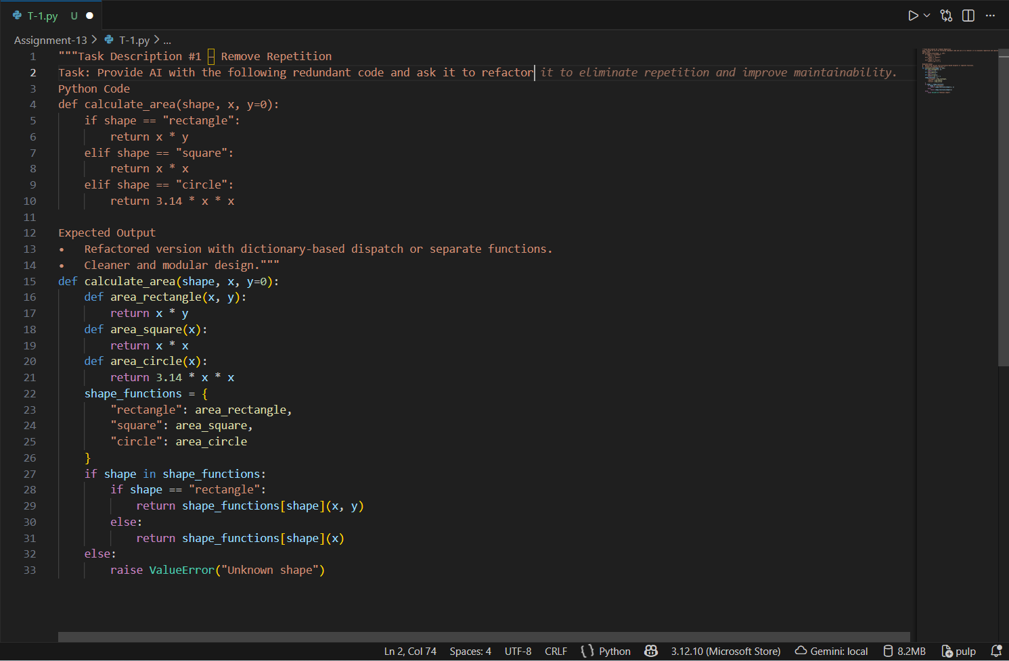
Figure 1: T-1 code

2. Task Description #2 – Error Handling in Legacy Code
Task: Legacy function without proper error handling
Python Code
def read_file(filename):
f = open(filename, "r")
data = f.read()
f.close()
return data
Expected Output:
AI refactors with with open() and try-except

Ans:
PROMPT:
#Task Description #2 – Error Handling in Legacy Code
"""Task: Legacy function without proper error handling
Python Code
def read_file(filename):
f = open(filename, "r")
data = f.read()
f.close()
return data
Expected Output:
AI refactors with with open() and try-except"""

def read_file(example.txt):
try:
with open(example.txt, "r") as f:
data = f.read()
return data
except FileNotFoundError:
return "Error: The file was not found."
#!/usr/bin/env python3
except IOError:
return "Error: An I/O error occurred while reading the file."

# Example usage
if __name__ == "__main__":
filename = "example.txt"
content = read_file(example.txt)
print(content)

OUTPUT:
Hi Hello welcome

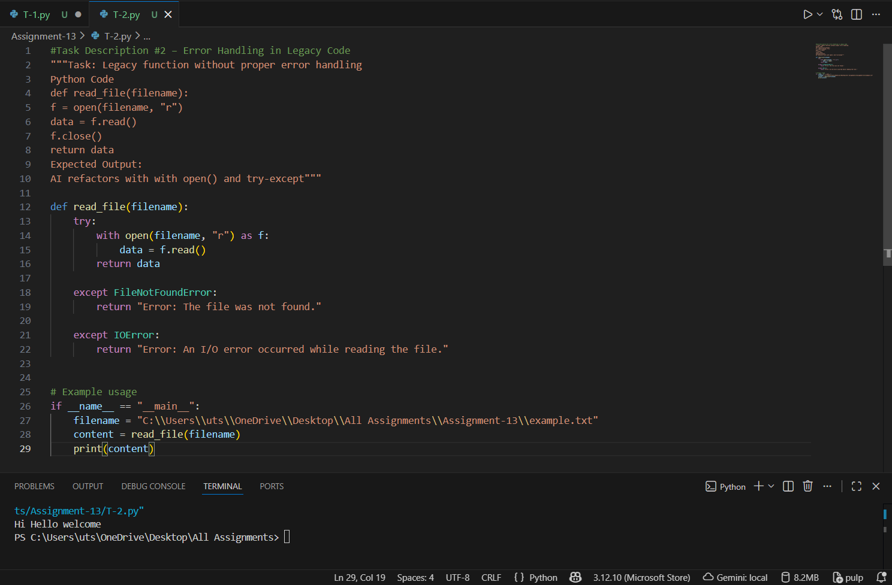

T-2 code and output

3. Task Description #3 – Complex Refactoring
Task: Provide this legacy class to AI for readability and modularity improvements:

Python Code
class Student:
def __init__(self, n, a, m1, m2, m3):
self.n = n
self.a = a
self.m1 = m1
self.m2 = m2
self.m3 = m3
def details(self):
print("Name:", self.n, "Age:", self.a)
def total(self):
return self.m1+self.m2+self.m3
Expected Output:
- AI improves naming (name, age, marks).
- Adds docstrings.
- Improves print readability.
Possibly uses sum(self.marks) if marks stored in a list
Ans:
CODE:
"""Task Description #3 – Complex Refactoring
Task: Provide this legacy class to AI for readability and modularity improvements:

Python Code"""

class Student:
def __init__(self, n, a, m1, m2, m3):
self.n = n
self.a = a
self.m1 = m1
self.m2 = m2
self.m3 = m3
def details(self):
print("Name:", self.n, "Age:", self.a)
def total(self):
return self.m1+self.m2+self.m3
"""Expected Output:
• AI improves naming (name, age, marks).
• Adds docstrings.
• Improves print readability.
• Possibly uses sum(self.marks) if marks stored in a list"""

class Student:
def __init__(self, name, age, marks):
"""
Initialize a Student object with name, age, and marks.

:param name: str - The name of the student.
:param age: int - The age of the student.
:param marks: list - A list of marks obtained by the student.
"""
self.name = name
self.age = age
self.marks = marks

def display_details(self):
"""Print the student's details in a readable format."""
print(f"Student Name: {self.name}, Age: {self.age}")

def calculate_total_marks(self):
"""
Calculate the total marks obtained by the student.

:return: int - The total marks.
"""
return sum(self.marks)

# Example usage
if __name__ == "__main__":
student = Student("Alice", 20, [85, 90, 95])
student.display_details()
total_marks = student.calculate_total_marks()
print(f"Total Marks: {total_marks}")

OUTPUT:
Student Name: Alice, Age: 20
Student Name: Alice, Age: 20
Total Marks: 270
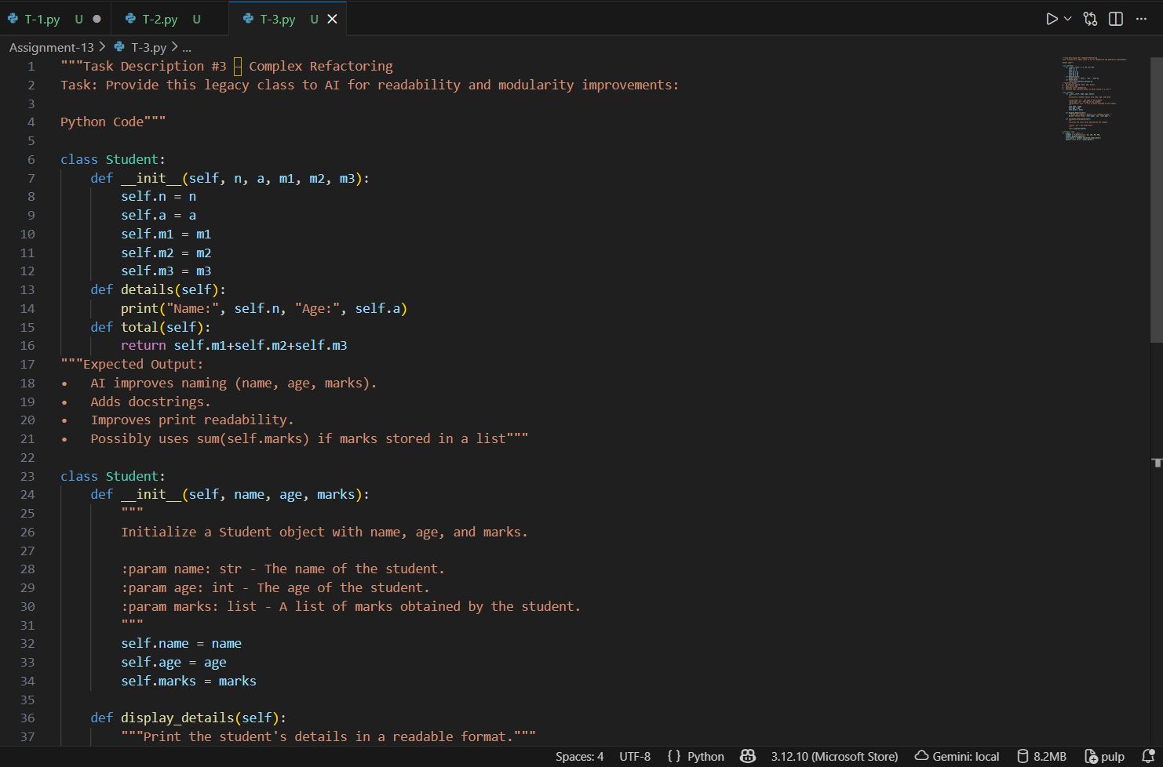
Figure 2: Task-3 code

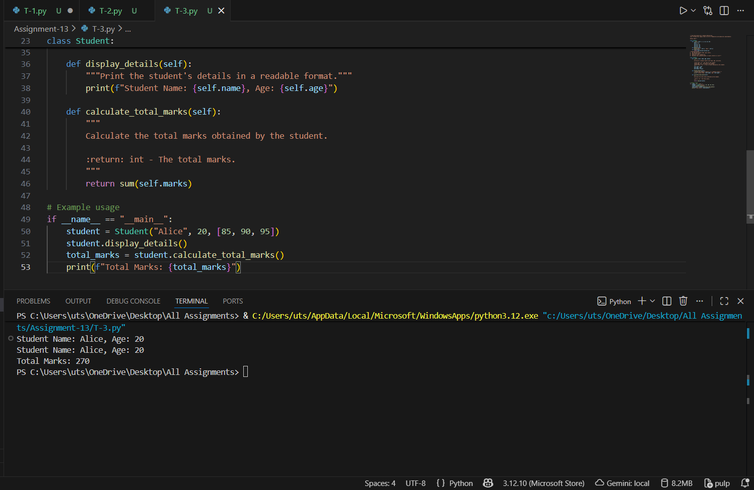
Figure 3: T-3 output

4. Task Description #4 – Inefficient Loop Refactoring
Task: Refactor this inefficient loop with AI help

Python Code
nums = [1,2,3,4,5,6,7,8,9,10]
squares = []
for i in nums:
squares.append(i * i)
Expected Output: AI suggested a list comprehension

Ans:
#Task Description #4 – Inefficient Loop Refactoring
#Task: Refactor this inefficient loop with AI help

#Python Code
nums = [1,2,3,4,5,6,7,8,9,10]
squares = []
for i in nums:
squares.append(i * i)
#Expected Output: AI suggested a list comprehension
squares = [i * i for i in nums]

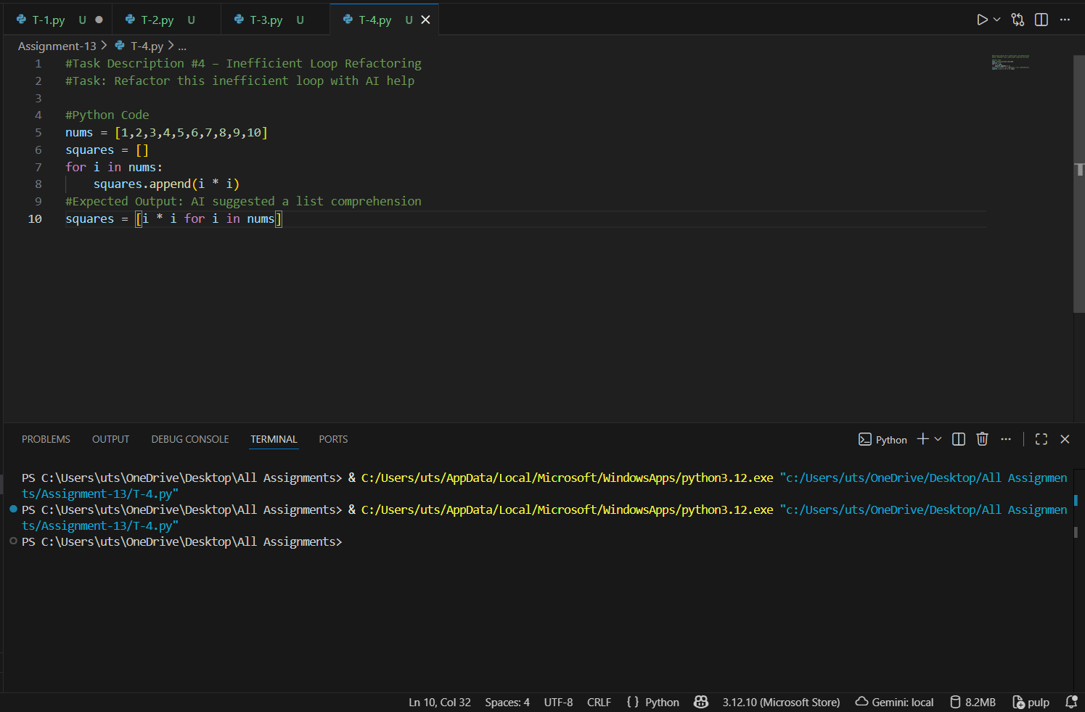
Figure 4: Task -4 code

