SCHOOL OF COMPUTER SCIENCE AND ARTIFICIAL INTELLIGENCE |  |  |  |  | DEPARTMENT OF COMPUTER SCIENCE ENGINEERING
Program Name: M.Tech/MSC/MCA |  |  |  | Assignment Type: Lab |  |  | Academic Year:2025-2026
Course Coordinator Name |  |  |  | Venkataramana Veeramsetty
Course Code |  |  |  | Course Title |  | AI Assisted Problem Solving Using Python
Year/Sem |  |  |  | Regulation |  | R25
Date and Day  of Assignment |  |  | Week5 - Tuesday | Time(s)
Duration |  |  | 2 Hours | Applicable to  Batches
AssignmentNumber:15.4(Present assignment number)/24(Total number of assignments)
 | Q.No. | Question |  |  |  |  |  | Expected Time  to complete
 | 1 | Lab 18 – API Integration: Connecting to External Services with Error Handling  Lab Objectives:  - Learn how to integrate Python programs with external REST APIs.  - Understand API request/response handling using requests or similar libraries.  - Implement proper error handling for failed API calls (timeouts, invalid responses, rate limits).  - Practice extracting and displaying meaningful information from API responses.  Task 1: Connect to a Public API  - Instructions:  - Use Python (or Node.js/JavaScript) to connect to a public API (e.g., OpenWeatherMap or JSONPlaceholder).  - Send a simple GET request to retrieve data.  - Display the response in a readable format (pretty JSON).  - Expected Output:  - Program prints API response (e.g., weather data or posts from JSONPlaceholder).  - Output should be properly formatted JSON (not raw).  Prompt: write a python function that display weather details of a city using weather api without error handling. Display weather details as JSON output  To use this code:  - First, you'll need to sign up for a free API key at Open Weather Map: https://openweathermap.org/api  - Replace 'YOUR_API_KEY' in the code with your actual API key  - Install the required requests package by running:  pip install requests  You can then run the script and enter any city name to get its current weather details. The output will look something like this:  Task 2: Add Error Handling for Invalid API Calls  - Instructions:  - Modify your code from Task 1 to handle errors.  - Include try/except (Python) or try/catch (JavaScript) blocks.  - Handle cases like:  - Invalid URL  - Network timeout  - Wrong API key (if required)  - Print user-friendly error messages.  - Expected Output:  - If the API works, the result is shown as in Task 1.  - If there’s an error, output:  Error: Could not connect to API. Check your API key or network connection.  Prompt: write a python function that display weather details of a city using weather api with error handling. Display weather details as JSON output  To use this code:  - First, you'll need to sign up for a free API key at Open Weather Map: https://openweathermap.org/api  - Replace 'YOUR_API_KEY' in the code with your actual API key  - Install the required requests package by running:  Task 3: Extract and Display Specific Data  - Instructions:  - From the API response (e.g., weather API), extract specific fields (temperature, humidity, description).  - Display them in a user-friendly format (not raw JSON).  - Expected Output:  - City: London  - Temperature: 18°C  - Humidity: 60%  Weather: Clear sky  Task 4: Build a Function with Parameters  - Instructions:  - Write a function that accepts a parameter (e.g., city name for weather API).  - The function should call the API dynamically based on user input.  - Include error handling if the city is invalid.  - Expected Output:  - Input: "New York"  - Output:  - City: New York  - Temperature: 22°C  - Humidity: 55%  - Weather: Few clouds  - Input: "xyz123"  - Output:  Error: City not found. Please enter a valid city.  Prompt: write a python function that display weather details of a city using weather api with error handling. Display weather details in user friendly format  Task 5: Store API Results Locally  - Instructions:  - Extend your function from Task 4.  - Save the extracted API results into a local file (results.json or results.txt).  - Each new request should append results without overwriting old ones.  - Expected Output:  - Console still shows formatted output.  - A local file results.json is created/updated with stored responses like:  - [  - {"city": "London", "temp": 18, "humidity": 60, "weather": "Clear sky"},  - {"city": "New York", "temp": 22, "humidity": 55, "weather": "Few clouds"}  ]  Prompt: write a python function that display weather details of a city using weather api with error handling. Display weather details as JSON output. Store the weather details in current directory as text file, every run output will append  ✅ Deliverables (For All Tasks)  - AI-generated prompts for code and test case generation.  - At least 3 assert test cases for each task.  - AI-generated initial code and execution screenshots.  - Analysis of whether code passes all tests.  - Improved final version with inline comments and explanation.  - Compiled report (Word/PDF) with prompts, test cases, assertions, code, and output. |  |  |  |  |  | Week5 - Tuesday
  - Prompt: write a python function that display weather details of a city using weather api without error handling. Display weather details as JSON output

CODE:
#write a python function that display weather details of a city using weather api without error handling. Display weather details as JSON output

import requests
import json

def get_weather(city):
api_key = "370e6f154e75be9fa82c021e7a54dc71" # Your real API key
url = f"https://api.openweathermap.org/data/2.5/weather?q={city}&appid={api_key}"

response = requests.get(url)
data = response.json()
print(json.dumps(data, indent=4))

city_name = input("Enter a city name: ")
get_weather(city_name)

OUTPUT:
Enter a city name: Hyderabad
{
"coord": {
"lon": 78.4744,
"lat": 17.3753
},
"weather": [
{
"id": 800,
"main": "Clear",
"description": "clear sky",
"icon": "01n"
}
],
"base": "stations",
"main": {
"temp": 294.38,
"feels_like": 293.6,
"temp_min": 294.38,
"temp_max": 294.88,
"pressure": 1016,
"humidity": 40,
"sea_level": 1016,
"grnd_level": 952
},
"visibility": 6000,
"wind": {
"speed": 2.57,
"deg": 70
},
"clouds": {
"all": 9
},
"dt": 1765372219,
"sys": {
"type": 1,
"id": 9214,
"country": "IN",
"sunrise": 1765328733,
"sunset": 1765368743
},
"timezone": 19800,
"id": 9214,
"country": "IN",
"sunrise": 1765328733,
"sunset": 1765368743
},
"timezone": 19800,
"id": 1269843,
"name": "Hyderabad",
"cod": 200
}
PS C:\Users\uts\OneDrive\Desktop\All Assignments>

"id": 9214,
"country": "IN",
"sunrise": 1765328733,
"sunset": 1765368743
},
"timezone": 19800,
"id": 1269843,
"name": "Hyderabad",
"cod": 200
}

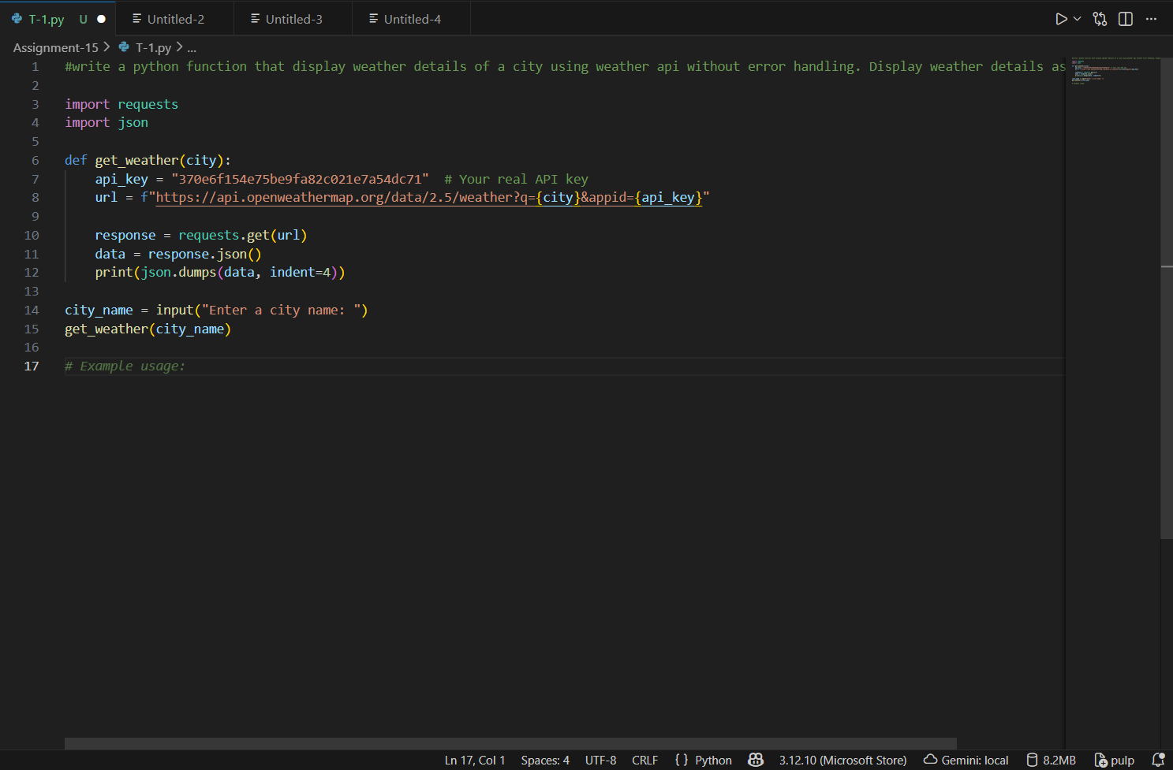
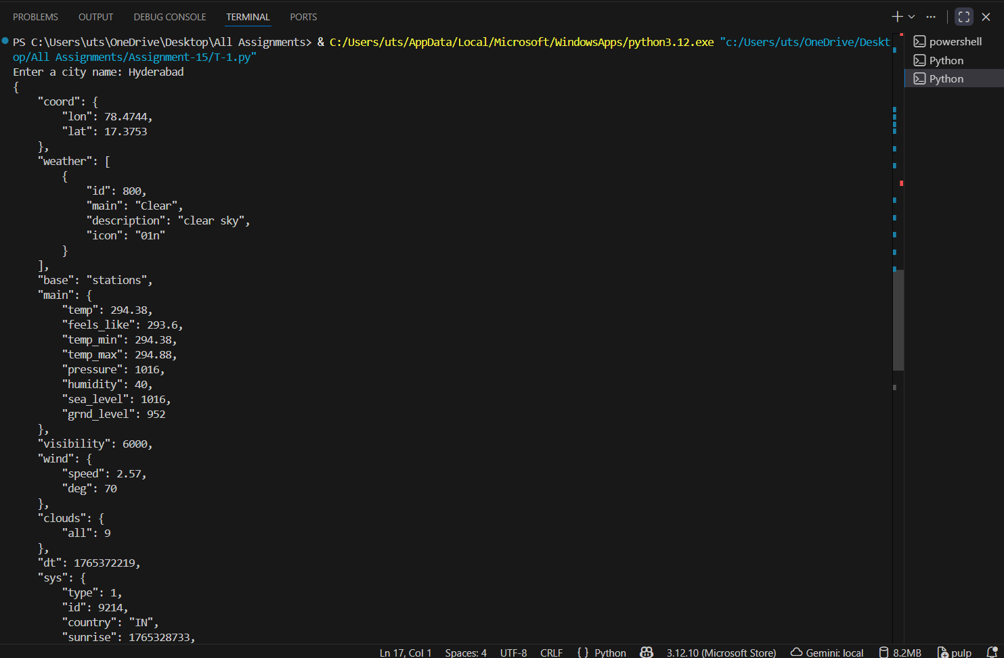

  - Prompt:
#Prompt: write a python function that display weather details of a city using weather api with error handling. Display weather details as JSON output

CODE:

import requests
import json
def get_weather(city):
api_key = "29ddaea09248db24562c72fb891bf625" # Your real API key
url = f"https://api.openweathermap.org/data/2.5/weather?q={city}&appid={api_key}"
try:
response = requests.get(url)
response.raise_for_status() # Raise an error for bad responses (4xx and 5xx)
data = response.json()
print(json.dumps(data, indent=4))
except requests.exceptions.HTTPError as http_err:
print(f"HTTP error occurred: {http_err}") # e.g. 404 Not Found
except requests.exceptions.RequestException as req_err:
print(f"Request error occurred: {req_err}") # e.g. Network problem
except json.JSONDecodeError as json_err:
print(f"JSON decode error occurred: {json_err}") # e.g. Invalid JSON
city_name = input("Enter a city name: ")
get_weather(city_name)

OUTPUT:
Enter a city name: hyderabad
{
"coord": {
"lon": 78.4744,
"lat": 17.3753
},
"weather": [
{
"id": 800,
"main": "Clear",
"description": "clear sky",
"icon": "01n"
}
],
"base": "stations",
"main": {
"temp": 294.38,
"feels_like": 293.6,
"temp_min": 294.38,
"temp_max": 294.88,
"pressure": 1016,
"humidity": 40,
"sea_level": 1016,
"grnd_level": 952
},
"visibility": 6000,
"wind": {
"speed": 2.57,
"deg": 70
},
"clouds": {
"all": 9
},
"dt": 1765372914,
"sys": {
"type": 1,
"id": 9214,
"country": "IN",
"sunrise": 1765328733,
"sunset": 1765368743
},
"timezone": 19800,
"id": 1269843,
"name": "Hyderabad",
"cod": 200
"dt": 1765372914,
"sys": {
"type": 1,
"id": 9214,
"country": "IN",
"sunrise": 1765328733,
"sunset": 1765368743
},
"timezone": 19800,
"id": 1269843,
"name": "Hyderabad",
"cod": 200
"sys": {
"type": 1,
"id": 9214,
"country": "IN",
"sunrise": 1765328733,
"sunset": 1765368743
},
"timezone": 19800,
"id": 1269843,
"name": "Hyderabad",
"cod": 200
"country": "IN",
"sunrise": 1765328733,
"sunset": 1765368743
},
"timezone": 19800,
"id": 1269843,
"name": "Hyderabad",
"cod": 200
},
"timezone": 19800,
"id": 1269843,
"name": "Hyderabad",
"cod": 200
"name": "Hyderabad",
"cod": 200
"cod": 200
}

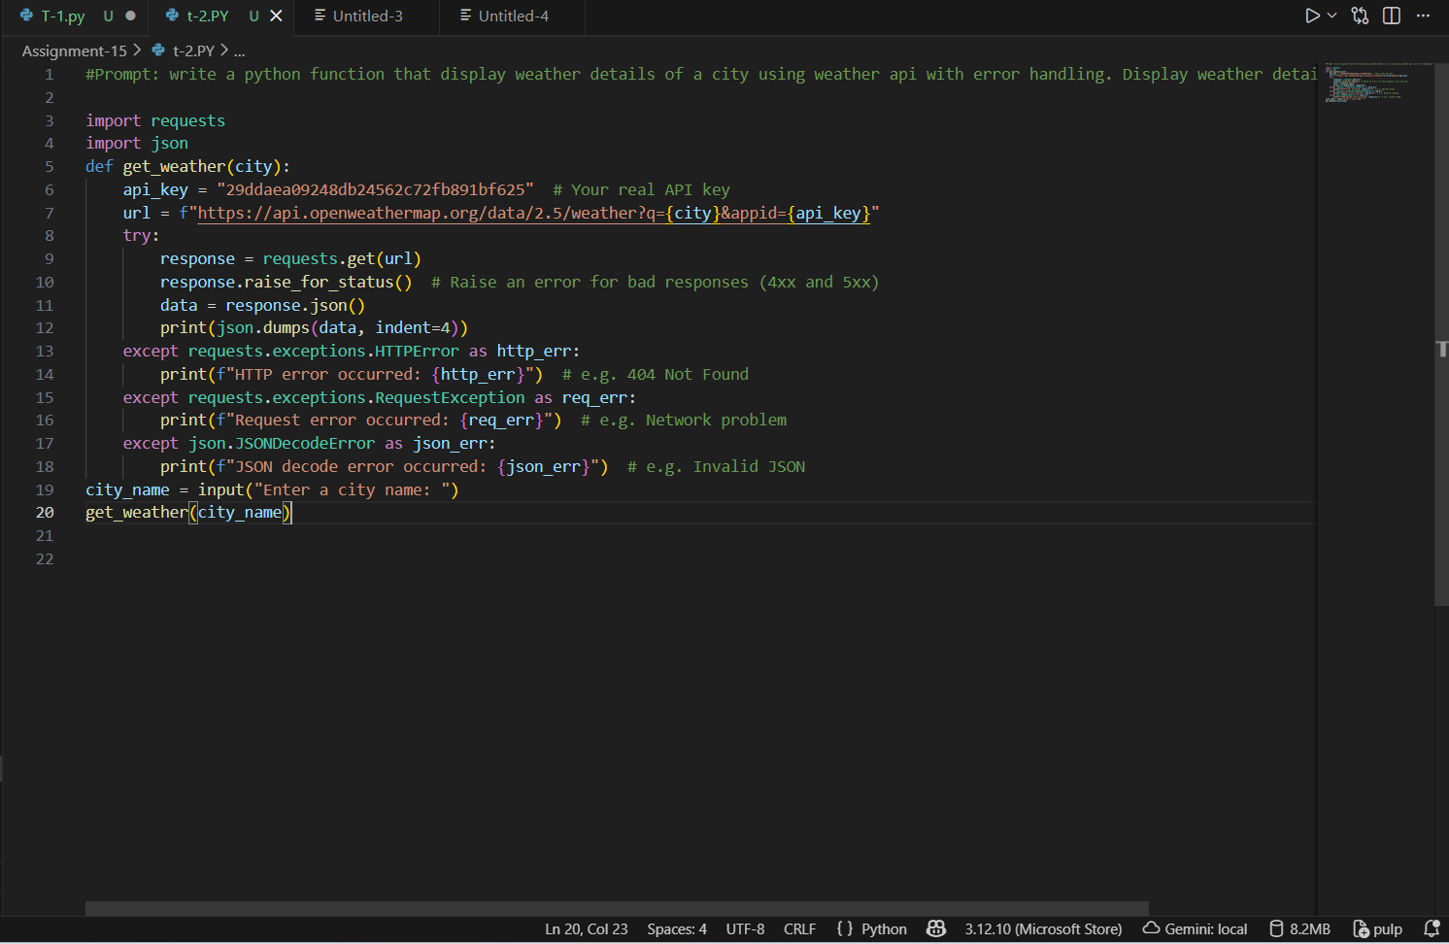

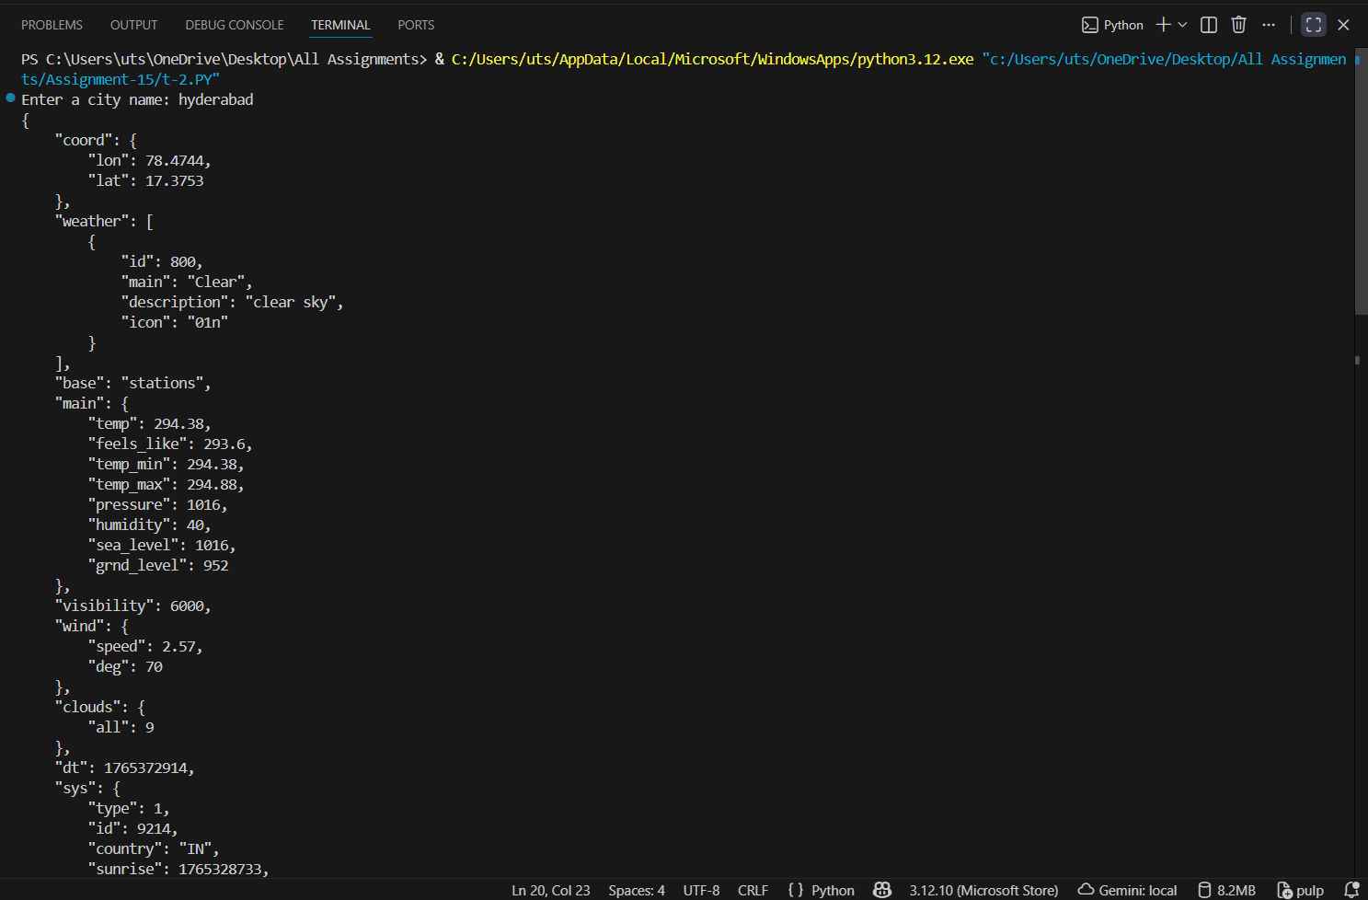

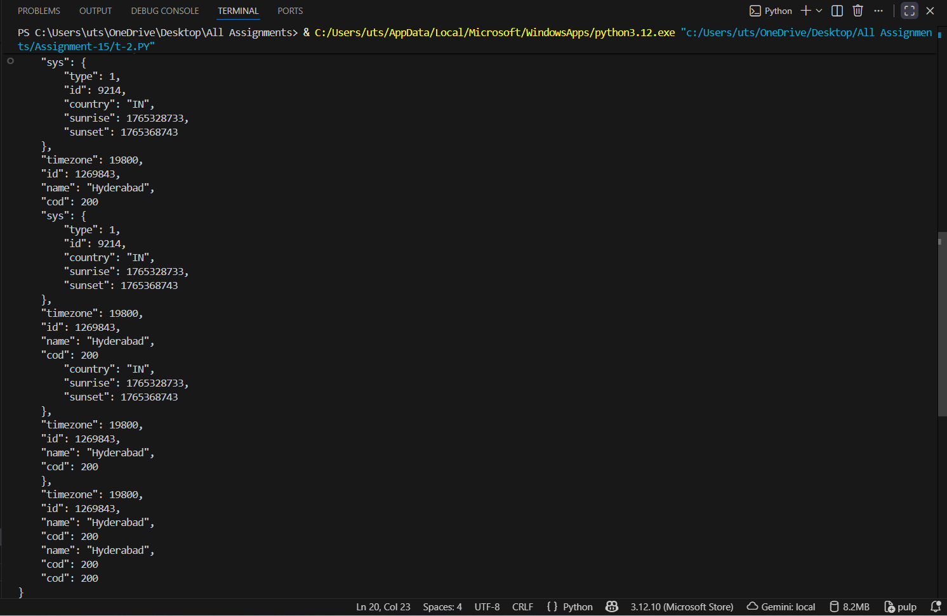

  - CODE AND PROMPT
- """Task 3: Extract and Display Specific Data
- • Instructions:
- 1. From the API response (e.g., weather API), extract specific fields (temperature, humidity, description).
- 2. Display them in a user-friendly format (not raw JSON)."""

- import requests
- def get_weather(city):
- api_key = "29ddaea09248db24562c72fb891bf625" # Your real API key
- url = f"https://api.openweathermap.org/data/2.5/weather?q={city}&appid={api_key}&units=metric"
- try:
- response = requests.get(url)
- response.raise_for_status() # Raise an error for bad responses (4xx and 5xx)
- data = response.json()

- # Extract specific fields
- temperature = data['main']['temp']
- humidity = data['main']['humidity']
- description = data['weather'][0]['description']

- # Display in user-friendly format
- print(f"Weather details for {city}:")
- print(f"Temperature: {temperature}°C")
- print(f"Humidity: {humidity}%")
- print(f"Description: {description.capitalize()}")
- except requests.exceptions.HTTPError as http_err:
- print(f"HTTP error occurred: {http_err}") # e.g. 404 Not Found
- except requests.exceptions.RequestException as req_err:
- print(f"Request error occurred: {req_err}") # e.g. Network problem
- except KeyError as key_err:
- print(f"Key error occurred: {key_err}") # e.g. Missing expected data
- city_name = input("Enter a city name: ")
- get_weather(city_name)

OUTPUT:
Enter a city name: hyderabad
Weather details for hyderabad:
Temperature: 21.23°C
Humidity: 40%
Description: Clear sky

- CODE AND OUTPUT
- """Task 4: Build a Function with Parameters
- • Instructions:
- • Write a function that accepts a parameter (e.g., city name for weather API).
- • The function should call the API dynamically based on user input.
- • Include error handling if the city is invalid."""

- import requests
- def get_weather(city):
- api_key = "29ddaea09248db24562c72fb891bf625" # Your real API key
- url = f"https://api.openweathermap.org/data/2.5/weather?q={city}&appid={api_key}&units=metric"
- try:
- response = requests.get(url)
- response.raise_for_status() # Raise an error for bad responses (4xx and 5xx)
- data = response.json()

- # Extract specific fields
- temperature = data['main']['temp']
- humidity = data['main']['humidity']
- description = data['weather'][0]['description']

- # Display in user-friendly format
- print(f"Weather details for {city}:")
- print(f"Temperature: {temperature}°C")
- print(f"Humidity: {humidity}%")
- print(f"Description: {description.capitalize()}")
- except requests.exceptions.HTTPError as http_err:
- print(f"HTTP error occurred: {http_err}") # e.g. 404 Not Found
- except requests.exceptions.RequestException as req_err:
- print(f"Request error occurred: {req_err}") # e.g. Network problem
- except KeyError as key_err:
- print(f"Key error occurred: {key_err}") # e.g. Missing expected data
- city_name = input("Enter a city name: ")
- get_weather(city_name)

OUTPUT:
Enter a city name: hyderabad
Weather details for hyderabad:
Temperature: 21.23°C
Humidity: 40%
Description: Clear sky

- Code and prompt
- """: Store API Results Locally
- • Instructions:
- • Extend your function from Task 4.
- • Save the extracted API results into a local file (results.json or results.txt).
- • Each new request should append results without overwriting old ones."""

- import requests
- import json
- def get_weather(city):
- api_key = "29ddaea09248db24562c72fb891bf625" # Your real API key
- url = f"https://api.openweathermap.org/data/2.5/weather?q={city}&appid={api_key}&units=metric"
- try:
- response = requests.get(url)
- response.raise_for_status() # Raise an error for bad responses (4xx and 5xx)
- data = response.json()

- # Extract specific fields
- temperature = data['main']['temp']
- humidity = data['main']['humidity']
- description = data['weather'][0]['description']

- # Prepare the result dictionary
- result = {
- "city": city,
- "temperature": temperature,
- "humidity": humidity,
- "description": description.capitalize()
- }

- # Display in user-friendly format
- print(f"Weather details for {city}:")
- print(f"Temperature: {temperature}°C")
- print(f"Humidity: {humidity}%")
- print(f"Description: {description.capitalize()}")

- # Append results to a local file
- with open("results.json", "a") as file:
- file.write(json.dumps(result) + "\n")
- except requests.exceptions.HTTPError as http_err:
- print(f"HTTP error occurred: {http_err}") # e.g. 404 Not Found
- except requests.exceptions.RequestException as req_err:
- print(f"Request error occurred: {req_err}") # e.g. Network problem
- except KeyError as key_err:
- print(f"Key error occurred: {key_err}") # e.g. Missing expected data
- city_name = input("Enter a city name: ")
- get_weather(city_name)

OUTPUT:
Enter a city name: hyderabad
Weather details for hyderabad:
Temperature: 22.23°C
Humidity: 33%
Description: Clear sky

