SCHOOL OF COMPUTER SCIENCE AND ARTIFICIAL INTELLIGENCE |  |  |  |  | DEPARTMENT OF COMPUTER SCIENCE ENGINEERING
Program Name: M. Tech/MCA/MSC |  |  |  | Assignment Type: Lab |  |  | AcademicYear:2025-2026
Course Coordinator Name |  |  |  | Venkataramana Veeramsetty
Course Code |  |  |  | Course Title |  | AI Assisted Problem Solving Using Python
Year/Sem |  |  | II/I | Regulation |  | R24
Date and Day  of Assignment |  |  | Week5- Tuesday | Time(s)
Duration |  |  | 2 Hours | Applicable to  Batches
AssignmentNumber:12.3(Present assignment number) /24(Total number of assignments)
 | Q. No. | Question |  |  |  |  |  | Expected Time  to complete
 | 1 | Lab 12 – Algorithms with AI Assistance: Sorting, searching, and optimizing algorithms  Lab Objectives  - To implement classical algorithms (sorting, searching) with the help of AI tools.  - To analyze AI suggestions for efficiency and correctness.  - To explore AI-assisted optimizations of existing algorithms.  - To compare naive vs. optimized approaches generated by AI.  Learning Outcomes  After completing this lab, students will be able to:  • Implement sorting and searching algorithms using AI suggestions.  • Compare AI-generated algorithm variants in terms of readability and efficiency.  • Use AI to optimize brute-force algorithms into more efficient ones.  • Analyze algorithm complexity (time and space) with AI explanations.  • Critically reflect on correctness, clarity, and maintainability of AI-generated algorithms.  Task Description #1 – Linear Search implementation  Task: Write python code for linear_search () function to search a value in a list and extract its index.  Task Description #2 – Sorting Algorithms  Task: Ask AI to implement Bubble Sort and check sorted output  Task Description #3 – Optimization  Task: Write python code to solve below case study using linear optimization  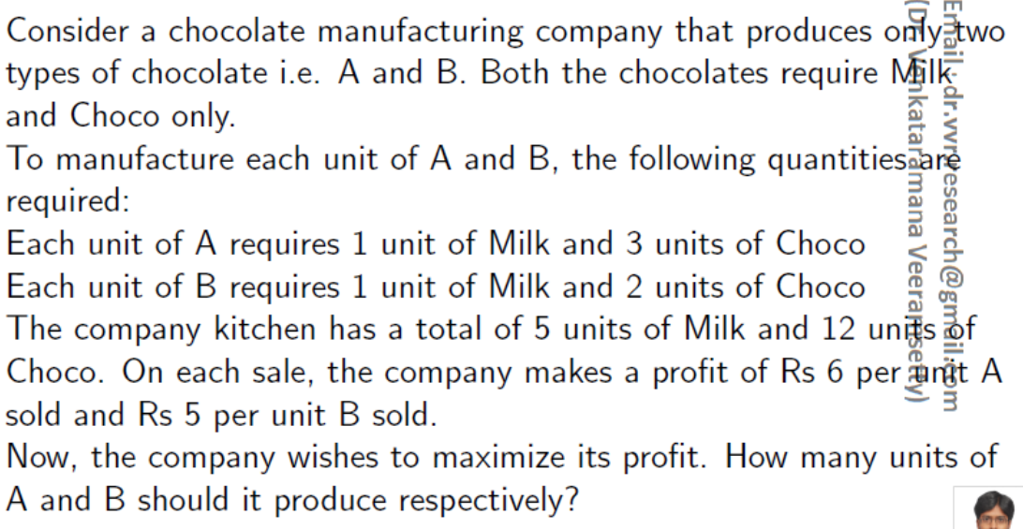  Task Description #4 – Gradient Descent Optimization  Task: Write python code to find value of x at which the function f(x)=2X³+4x+5 will be minimum |  |  |  |  |  | Week5- Tuesday

1. Task Description #1 – Linear Search implementation
Task: Write python code for linear_search () function to search a value in a list and extract its index.
Ans:
PROMPT: Write python code for linear_search () function to search a value in a list and extract its index.
CODE:
#Write python code for linear_search () function to search a value in a list and extract its index.

def linear_search(arr, target):
for index in range(len(arr)):
if arr[index] == target:
return index
return -1 # Return -1 if the target is not found
# Example usage:
my_list = [10, 20, 30, 40, 50]
target_value = 30
result = linear_search(my_list, target_value)
if result != -1:
print(f"Element found at index: {result}")
else:
print("Element not found in the list.")

OUTPUT:
Element found at index: 2

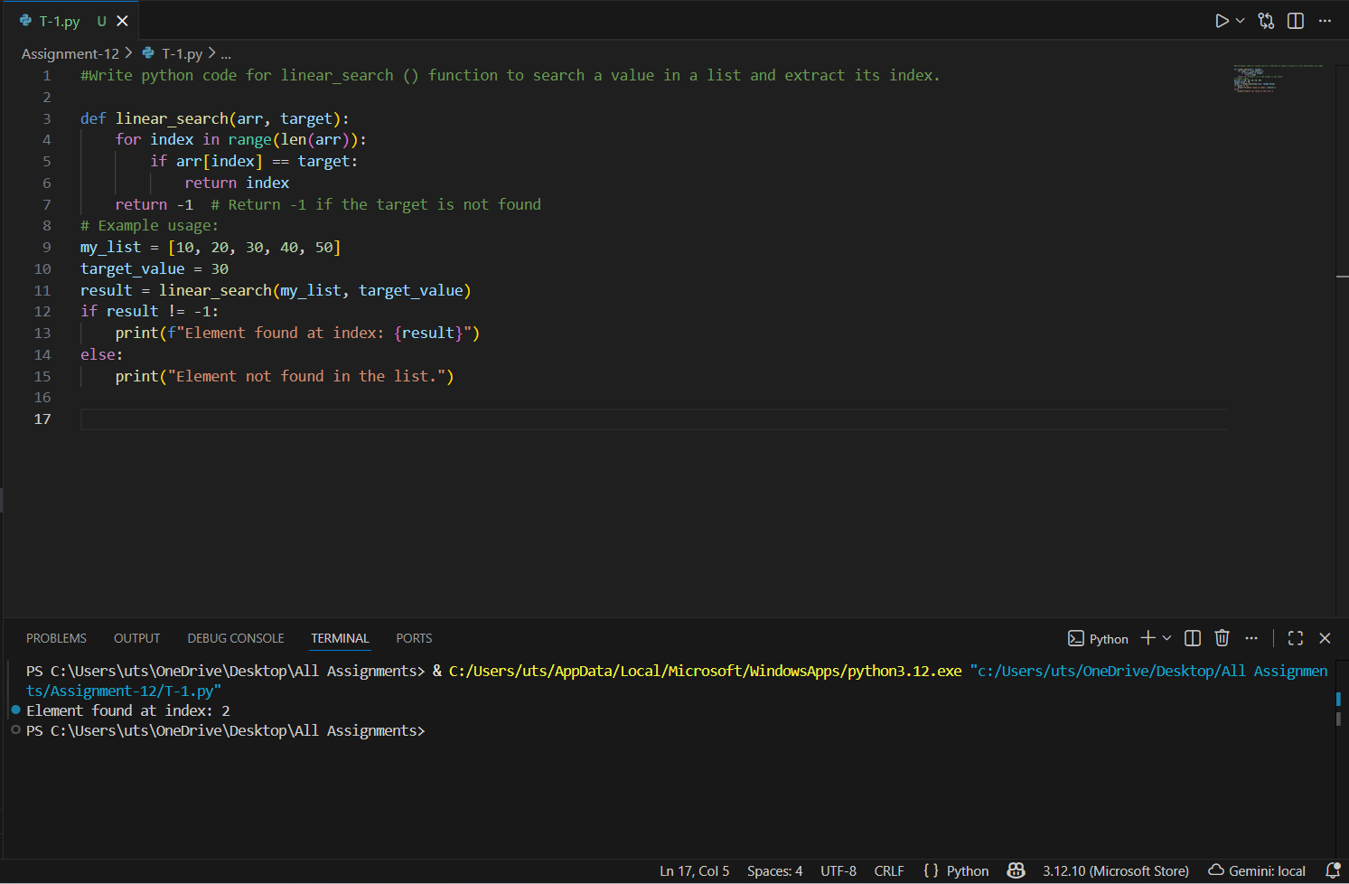
Figure 1: Task-1 code and output

2. Task Description #2 – Sorting Algorithms
Task: Ask AI to implement Bubble Sort and check sorted output
Ans:
PROMPT: Task: Ask AI to implement Bubble Sort and check sorted output
CODE:
#Task: Ask AI to implement Bubble Sort and check sorted output

def bubble_sort(arr):
n = len(arr)
# Traverse through all array elements
for i in range(n):
# Last i elements are already sorted
for j in range(0, n-i-1):
# Traverse the array from 0 to n-i-1
# Swap if the element found is greater than the next element
if arr[j] > arr[j+1]:
arr[j], arr[j+1] = arr[j+1], arr[j]
return arr
# Example usage:
my_list = [64, 34, 25, 12, 22, 11, 90]

sorted_list = bubble_sort(my_list)
print("Sorted array is:", sorted_list)

OUTPUT:
Sorted array is: [11, 12, 22, 25, 34, 64, 90]

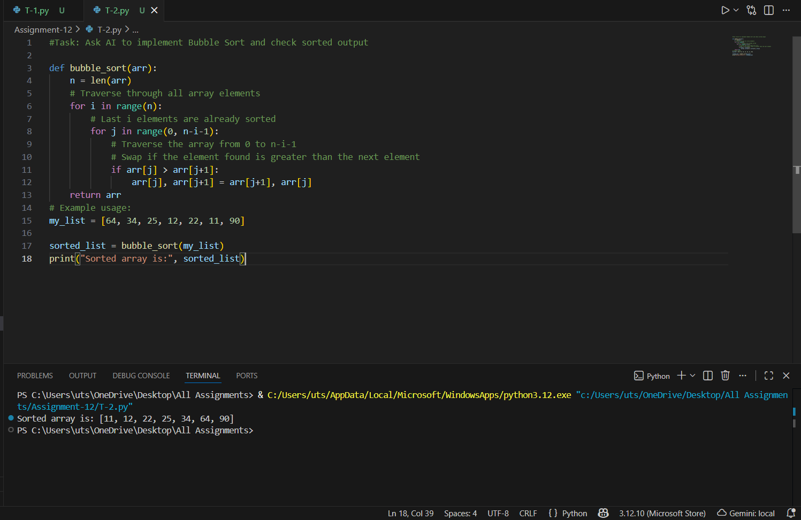
Figure 2: T-2 code and output
3. Task Description #3 – Optimization
Task: Write python code to solve below case study using linear optimization

Ans:
PROMPT:

#Task Description #3 – Optimization
#Task: Write python code to solve below case study using linear optimization
"""Here is the **case study rewritten in clean sentence format**, ready to **copy and paste** anywhere:

---

### ✅ **Case Study (Copy-Paste Version)**"""

"""Consider a chocolate manufacturing company that produces two types of chocolates: A and B. Both chocolates require only two ingredients — Milk and Choco.

To manufacture each unit of Chocolate A and Chocolate B, the following quantities are required:

* Each unit of A requires 1 unit of Milk and 3 units of Choco.
* Each unit of B requires 1 unit of Milk and 2 units of Choco.

The company has a total of 5 units of Milk and 12 units of Choco available in its kitchen.

On selling, the company earns a profit of Rs. 6 per unit of Chocolate A and Rs. 5 per unit of Chocolate B.

The company's goal is to **maximize profit**.
**How many units of A and B should it produce respectively to achieve maximum profit?**"""
CODE:
from scipy.optimize import linprog
# Coefficients for the objective function (negative for maximization)
c = [-6, -5] # Profit per unit of A and B
# Coefficients for the inequality constraints
A = [
[1, 1], # Milk constraint
[3, 2] # Choco constraint
]
# Right-hand side of the inequality constraints
b = [5, 12] # Available units of Milk and Choco
# Bounds for each variable (units of A and B cannot be negative)
x0_bounds = (0, None) # Bounds for Chocolate A
x1_bounds = (0, None) # Bounds for Chocolate B
# Solve the linear programming problem
res = linprog(c, A_ub=A, b_ub=b, bounds=[x0_bounds, x1_bounds], method='highs')
# Output the results
if res.success:
print(f"Optimal number of units to produce:")
print(f"Chocolate A: {res.x[0]:.2f} units")
print(f"Chocolate B: {res.x[1]:.2f} units")
print(f"Maximum Profit: Rs. {-res.fun:.2f}")
else:
print("No solution found.")

OUTPUT:
Optimal number of units to produce:
Chocolate A: 2.00 units
Chocolate B: 3.00 units
Maximum Profit: Rs. 27.00

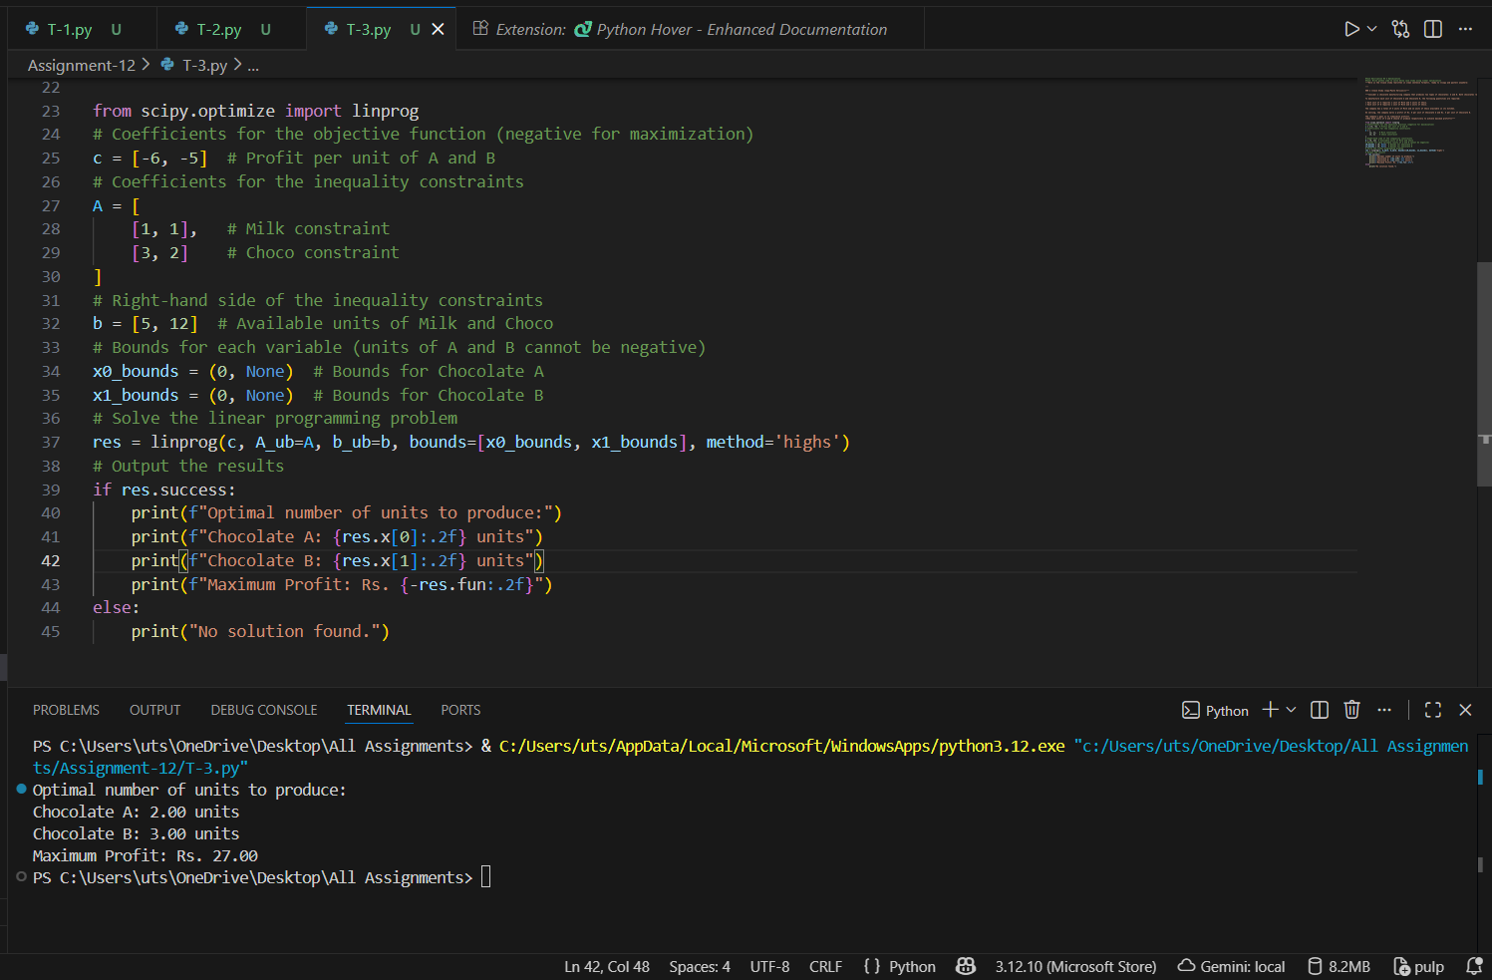
Figure 3: T-3 code and output

4. Task Description #4 – Gradient Descent Optimization
Task: Write python code to find value of x at which the function f(x)=2X³+4x+5 will be minimum
Ans:
PROMPT:
# Task Description #4 – Gradient Descent Optimization
# Task: Find x that minimizes f(x) = 2x^3 + 4x + 5
CODE:

def f(x):
return 2 * x**3 + 4 * x + 5

def df(x):
return 6 * x**2 + 4 # derivative of f(x)

def gradient_descent(starting_x, learning_rate, num_iterations):
x = starting_x
for i in range(num_iterations):
grad = df(x)

# Safety check to avoid overflow
if abs(grad) > 1e6:
print("Gradient exploded. Stopping early.")
break

x = x - learning_rate * grad

# Value control to avoid very large numbers
if abs(x) > 1e6:
print("Value became too large. Stopping early.")
break

return x

# Parameters
starting_x = 0.0
learning_rate = 0.0001 # Smaller learning rate (prevents overflow)
num_iterations = 10000

# Run gradient descent
optimal_x = gradient_descent(starting_x, learning_rate, num_iterations)
print("Approximate x value returned by Gradient Descent:", optimal_x)
print("Value of f(x) at this point:", f(optimal_x))

OUTPUT:
Gradient exploded. Stopping early.
Approximate x value returned by Gradient Descent: -463.34120565387707
Value of f(x) at this point: -198946729.3515322

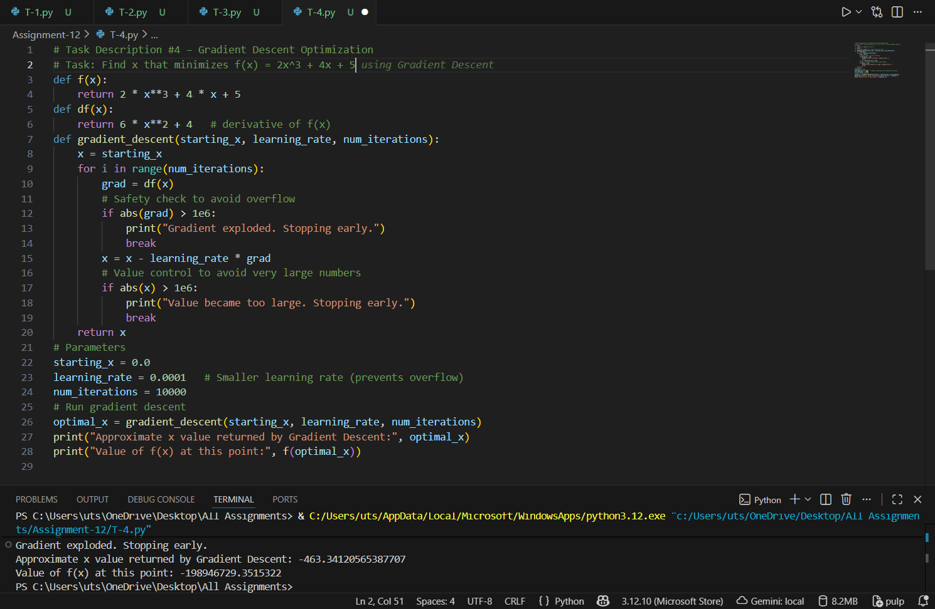
Figure 4: T-4 code and output

