ESTATE INSIGHTS – REAL ESTATE PRICE EXPLORATION TOOL

A Project Report Submitted in the
partial fulfillment of the requirements for the award of the degree of

BACHELOR OF TECHNOLOGY
In

DEPARTMENT OF CSE
By
Yashaswini | :2420030016
Shailaja G | :2420030447
Bhagyalaxmi | :2420030700

Under the Esteemed Guidance of

Dr.N SUNANDA

Associate Professor

Department of CSE

AY-[2026-2027]

Semester:5




K L (Deemed to be) University DEPARTMENT OF CSE

Declaration

We hereby declare that the project report entitled “Estate Insights – Real Estate Price Exploration Tool” is a bonafide record of the work carried out by the undersigned students under the guidance of Dr N. Sunanda, in partial fulfilment of the requirements for the award of the degree of Bachelor of Technology in Computer Science and Engineering at K L (Deemed to be) University.
We further declare that the work presented in this report is based on the implementation available in our project repository and that all external resources used have been acknowledged appropriately.

Yashaswini | :2420030016
Shailaja G | :2420030447
Bhagyalaxmi | :2420030700

`

K L (Deemed to be) University DEPARTMENT OF CSE

CERTIFICATE

This is certify that the mini project based report entitled “Estate Insights – Real Estate Price Exploration Tool” is a bonafide work done and submitted by Yashaswini – 2420030016, Shailaja G – 2420030447, Bhagyalaxmi – 2420030700 in partial fulfillment of the requirements for the award of the degree of BACHELOR OF TECHNOLOGY in Department of CSE K L (Deemed to be University), during the academic year 2026-2027.

Signature of the Guide

Signature of the Course Coordinator Signature of the HOD

ACKNOWLEDGEMENT
The success in this project would not have been possible but for the timely help and guidance rendered by many people. Our wish to express my sincere thanks to all those who has assisted us in one way or the other for the completion of my project.

Our greatest appreciation to my Course Coordinator and my guide Dr.N.Sunanda , Department of CSE which cannot be expressed in words for his/her tremendous support, encouragement and guidance for this project.

We express our gratitude to P. Venkateswara Rao , Head of the Department for CSE for providing us with adequate facilities, ways and means by which we are able to complete this project-based Lab.

We thank all the members of teaching and non-teaching staff members, and also who have assisted me directly or indirectly for successful completion of this project. Finally, I sincerely thank my parents, friends and classmates for their kind help and cooperation during my work.

Yashaswini | :2420030016
Shailaja G | :2420030447
Bhagyalaxmi | :2420030700

Abstract
Estate Insights (Real Estate Price Exploration Tool) is a data science and machine learning based web dashboard developed with Python and Streamlit to explore and understand house prices in Bengaluru. Property datasets contain thousands of records with many locations, sizes and price levels, and reading them manually makes it difficult to compare localities, notice unusual values or understand which factors are associated with a higher selling price.
The system loads a Bengaluru property dataset of 12,717 cleaned records covering 1,304 locations, with attributes such as area type, availability, location, size, society, total area (sq. ft.), bathrooms, balconies and price in lakhs. Python functions clean the area values, extract the number of bedrooms (BHK) from the size field and remove incomplete records. The dashboard then presents summary statistics, missing-value checks, a price distribution, a correlation heatmap, location-wise average prices, a budget filter, a house price estimator and a downloadable dataset. A Linear Regression model based on area and bathroom count is trained inside the application and reports a Mean Absolute Error of 43.86 lakhs and an R² score of 0.42.
The application is protected by a demo login page and uses a navigation sidebar with Home, Data Analysis, Location Analysis, Price Prediction, Machine Learning, Budget Filter, Download Reports and About Project pages. Estate Insights is intended as an academic decision-support and exploration tool; its estimates are statistical approximations and are not an official property valuation.
Keywords: Data Science, Real Estate, House Price Prediction, Exploratory Data Analysis, Linear Regression, Streamlit, Data Visualization.

Index
S. No. | Chapters | Topics | Page.no
 |  | Acknowledgement | 4
 |  | Abstract | 5
1 | Introduction | 1.1 Background of the Project  1.2 Problem Statement  1.3 Scope of the Project  1.4 Objectives  1.5 Importance of the Application  1.6 Target Users / Audience  1.7 Literature Survey  1.8 Proposed System and Methodology | 8-9
2 | System Requirements | 2.1 Hardware Requirements  2.2 Software Requirements  2.3 Development Tools and Frameworks | 10
3 | Technology Stack | 3.1 Front-end  3.2 Back-end  3.3 Data Handling and Machine Learning  3.4 Database  3.5 Version Control  3.6 APIs and External Services | 11
4 | System Architecture | 4.1 High-Level Architecture Diagram  4.2 Description of Each Layer  4.3 Deployment Architecture | 12-13
5 | Design | 5.1 System Workflow  5.2 Data Flow Diagram – Level 0  5.3 Data Flow Diagram – Level 1  5.4 Dataset Description and Data Dictionary  5.5 Dataset Distribution  5.6 Database Schema / Storage Design | 14-16
6 | Implementation | 6.1 Module-wise Implementation  6.2 Front-end Logic and State Management  6.3 Backend Logic  6.4 Machine Learning Methodology  6.5 Database Connectivity  6.6 API Integration and Core Functions  6.7 Authentication and Authorization | 17-19
7 | Features | 7.1 Main Features  7.2 How Each Feature Works  7.3 User Interface Pages | 20
8 | Testing | 8.1 Testing Strategy  8.2 Test Cases and Expected Results  8.3 Tools Used for Testing  8.4 Test Execution and Results | 21-22
9 | Deployment | 9.1 Steps to Deploy Locally  9.2 Environment Configuration  9.3 Hosting of Frontend and Backend | 23
10 | Challenges & Limitations | 10.1 Issues Considered During Development  10.2 Solutions Applied  10.3 Current Limitations | 24
11 | Future Enhancements | 11.1 Planned Features  11.2 Possible Integrations and Optimizations | 25
12 | Conclusion | 12.1 Summary of the Project  12.2 What Was Achieved  12.3 Skills Learned During Development | 26
13 | References | - Books, research papers, documentation sites used | 27
14 | Appendices | 14.1 Screenshots of the Application  14.2 Sample Code Snippets  14.3 Installation and Setup Instructions  14.4 User Manual | 28-34

CHAPTER 1
INTRODUCTION

1.1 Background of the Project
Real estate prices vary widely across cities and localities. The location of a property, its built-up area, the number of rooms and bathrooms, the type of area and the available amenities all influence the selling price. Buyers, sellers, investors and analysts therefore need a clear way to compare properties and to understand why one locality is more expensive than another.
Estate Insights applies data science to a Bengaluru house-price dataset. It converts raw property records into cleaned, structured data and presents them through an interactive dashboard that supports statistical exploration, location-wise comparison, budget-based search and model-based price estimation.

1.2 Problem Statement
Large property datasets are difficult to interpret manually. The records contain inconsistent formats (for example, sizes written as ‘2 BHK’ or ‘4 Bedroom’ and area values that are not always plain numbers), missing values and extreme prices. Users need a simple tool that can clean the data, compare locations, filter properties by budget and show the factors associated with property prices.

1.3 Scope of the Project
- Load and inspect the Bengaluru property dataset in CSV form.
- Examine missing values, summary statistics and column types of the dataset.
- Clean area values, extract the BHK count from the size field and remove incomplete or invalid records.
- Explore price patterns using a price distribution and a correlation heatmap.
- Compare property prices across locations, including the top 10 locations by average price.
- Filter properties by a selected budget range and download the dataset.
- Estimate house prices from user inputs and a Linear Regression model trained on area and bathroom count.
The current project is an analytical prototype built on one historical dataset of Bengaluru. It does not provide live property listings, official valuations, legal or registration information, or guaranteed price predictions.

1.4 Objectives
- Collect and prepare structured property data with relevant features and prices.
- Identify missing values, duplicates, inconsistencies and outliers in the data.
- Analyse price patterns using exploratory data analysis, statistics and visualizations.
- Develop a regression-based price estimation module and evaluate it using MAE and R².
- Provide location-wise price comparison and a budget filter for property search.
- Build an interactive Streamlit dashboard with login, navigation and report download.
- Present the findings in a form that is easy for non-technical users to interpret.

1.5 Importance of the Application
Estate Insights shows how data science can support property-price analysis. Cleaning and exploration reveal patterns and unusual values that would be missed in a raw spreadsheet, location analysis highlights the price differences between localities, and the budget filter and estimator help users shortlist properties. The tool turns raw property records into understandable insights, provided its estimates are treated as guidance and verified before any purchase or investment decision.

1.6 Target Users / Audience
- Home buyers who want to compare localities and find properties within a budget.
- Sellers who want an indicative idea of the price range for a property.
- Investors and real-estate analysts examining price patterns across Bengaluru.
- Students and academic evaluators studying data science and regression models.

1.7 Literature Survey
The following studies on house-price prediction were reviewed to understand existing methods and to identify the gap addressed by this project.
Author(s) & Year | Method / Technique | Key Findings | Limitation / Gap
Zulkifley et al. (2020) | Survey of SVR, ANN and XGBoost for house-price prediction | Machine learning methods can support house-price prediction. | Mainly prediction-focused; limited data-quality processing.
Ja’afar et al. (2021) | Systematic review of machine learning for property valuation | Random Forest and other ML methods show promise. | No complete cleaning, quality-scoring and duplicate-detection pipeline.
Soltani et al. (2022) | Spatial-temporal features combined with ML algorithms | Location and time influence housing prices. | Emphasis on prediction and spatial-temporal analysis.

Research gap: prior work often emphasizes prediction accuracy or spatial analysis. Estate Insights combines data-quality checks, exploratory analysis, locality-wise comparison, a budget filter, predictive estimation and an interactive dashboard in one workflow, so that users can explore why prices vary and not only obtain a predicted price.

1.8 Proposed System and Methodology
The project follows a five-step methodology from problem definition to testing:
- Step 1 – Define the problem: set the price-analysis goals and decide which features to explore.
- Step 2 – Collect data: select a public Bengaluru real-estate dataset and confirm its rows and columns.
- Step 3 – Design: plan a Python analytics pipeline, a regression model and a Streamlit dashboard.
- Step 4 – Implement: develop the preprocessing, exploratory analysis, location analysis, model and dashboard modules.
- Step 5 – Test and evaluate: evaluate the model using MAE and R² and test the filters, pages and outputs.
Key contribution: the project emphasizes understanding the factors behind prices, not only producing a predicted price. It brings data cleaning, location-wise exploration, model-based estimation and interactive visualization together in a single tool.

CHAPTER 2
SYSTEM REQUIREMENTS

2.1 Hardware Requirements
The repository does not specify a mandatory hardware configuration. The following is a practical setup for running the dashboard; actual requirements depend on the dataset size and the machine used.
Component | Recommended development configuration
Processor | Standard laptop / PC with a modern dual-core or better processor
RAM | Sufficient memory for dataset processing; 8 GB or more recommended
Storage | Local storage for the CSV dataset, source code and Python libraries
Display | 1366 × 768 or higher
Network | Internet connection for installing libraries and reading documentation; the dashboard runs locally after setup

2.2 Software Requirements
Software | Purpose
Windows / Linux | Operating system for development and execution (Windows was used for testing)
Python | Data processing, analysis and machine-learning implementation
Streamlit | Building and running the interactive web dashboard
Visual Studio Code or Google Colab | Source-code editing and experimentation
Modern web browser | Accessing the dashboard at localhost:8501 (tested in Microsoft Edge)
Git / GitHub | Source-code version control, if used by the team

2.3 Development Tools and Frameworks
The project is developed in Python. Pandas and NumPy are used for data handling, Scikit-learn for the Linear Regression model and its evaluation, Matplotlib and Plotly for visualization, and Streamlit for the web dashboard. The dashboard uses custom styling to give a dark blue interface with metric cards, a sidebar menu and data tables.
Exact installed versions should be recorded from the team’s development environment (for example, using pip freeze) before final submission.

CHAPTER 3
TECHNOLOGY STACK

3.1 Front-end
The user interface is built entirely with Streamlit. A sidebar titled ‘ESTATE INSIGHTS – Real Estate Intelligence’ provides radio-button navigation to eight pages. Streamlit widgets such as number inputs, a searchable select box, a budget slider, buttons, metric cards, interactive data tables and a download button provide the interaction, and custom CSS gives the application its dark blue theme.

3.2 Back-end
Python contains the data-processing and machine-learning logic. Functions such as clean_area, extract_bhk, clean_data and average_price_by_location prepare and summarize the data, and Scikit-learn trains and evaluates the Linear Regression model. Streamlit runs these functions on the server side every time the user interacts with a page.

3.3 Data Handling and Machine Learning
Technology | Role in Estate Insights
Pandas | Reading the CSV file, cleaning, filtering, grouping and summary statistics
NumPy | Numerical operations and handling of missing (NaN) values
Scikit-learn | train_test_split, Linear Regression and evaluation metrics (MAE, R²)
Linear Regression | Regression algorithm used to estimate price from area and bathroom count
Matplotlib / Plotly | Price distribution, correlation heatmap and location charts
Streamlit | Web dashboard, widgets, tables and report download
Regular expressions (re) | Extracting the number of bedrooms (BHK) from the size field

3.4 Database
The project uses a CSV file as its data source, and records are held in memory (as Pandas DataFrames) while the application is running. No relational or NoSQL database is used, so the report does not describe MySQL, MongoDB or another database as an implemented component.

3.5 Version Control
Git and GitHub are suitable for tracking source-code changes, maintaining project history and collaborating as a team. A repository link was not provided for this project; add the actual URL here if required by the faculty.

3.6 APIs and External Services
The dashboard does not call any external API. All computation is performed locally in Python, and the dataset is read from a local CSV file. Streamlit’s built-in download button is used to export the dataset from the Download Reports page.

CHAPTER 4
SYSTEM ARCHITECTURE

4.1 High-Level Architecture Diagram
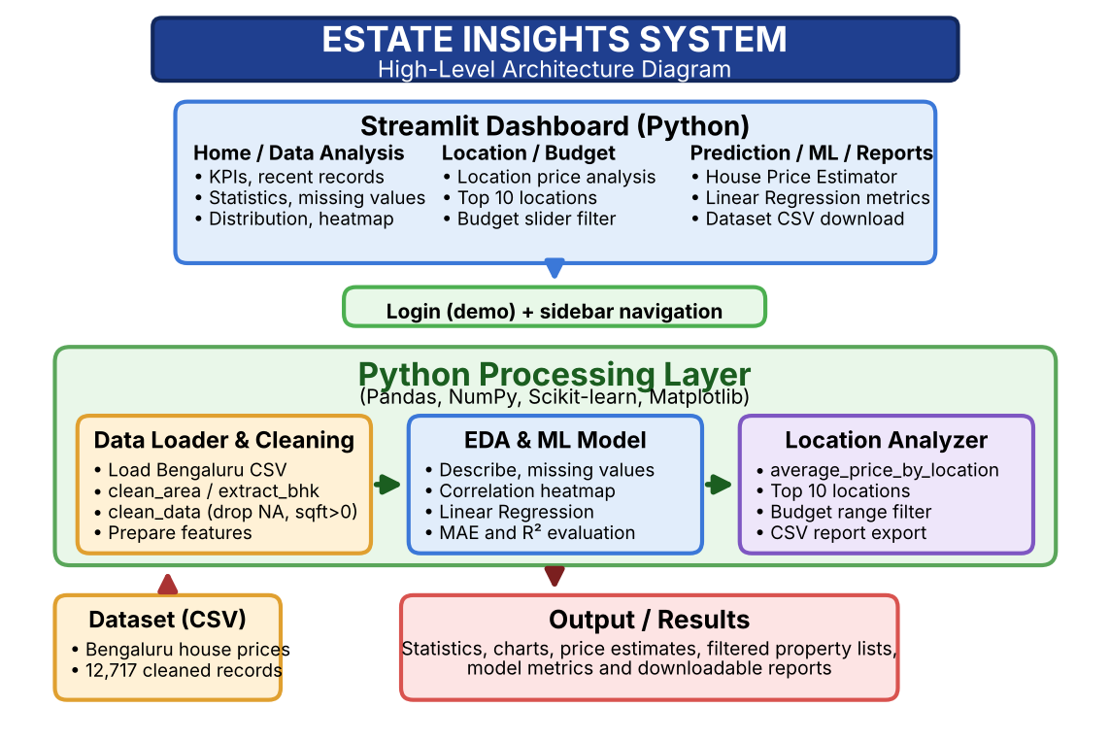Figure 4.1: Logical high-level architecture of Estate Insights. The Streamlit dashboard sends user actions to the Python processing layer, which reads the Bengaluru CSV dataset, cleans it, performs analysis and model training, and returns charts, tables, estimates and reports.

4.2 Description of Each Layer

Presentation Layer
The presentation layer is the Streamlit dashboard. It contains the login page, the sidebar menu and the eight pages (Home, Data Analysis, Location Analysis, Price Prediction, Machine Learning, Budget Filter, Download Reports and About Project). It displays metric cards, tables, charts, input forms, the model metrics and the estimated prices.

Application / Processing Layer
Python functions receive the user’s inputs from the dashboard and perform the required work: cleaning the data, computing statistics and correlations, grouping prices by location, filtering by budget, and training and applying the Linear Regression model with Scikit-learn. The results are returned to the presentation layer for display.

Data Layer
The data layer is the Bengaluru property dataset stored as a CSV file and loaded into a Pandas DataFrame. After cleaning, it contains 12,717 property records with attributes such as area type, availability, location, size, society, total area, bathrooms, balconies and price in lakhs.

4.3 Deployment Architecture
The project is deployed locally. The Streamlit application runs on the user’s machine and is opened in a web browser at localhost:8501. Cloud hosting or a production deployment is not demonstrated by the project files. The commands used to start the dashboard are:
pip install streamlit pandas numpy scikit-learn matplotlib plotly
streamlit run app.py
http://localhost:8501

CHAPTER 5
DESIGN

5.1 System Workflow
Start
|
Login page (demo credentials)
|
Load Bengaluru property CSV
|
Clean area, extract BHK, drop incomplete records
|
Exploratory analysis (statistics, missing values,
distribution, correlation)
|
Train Linear Regression model (80:20 split)
|
User selects a page from the sidebar menu
|
Display analysis, location prices, budget results,
price estimates or dataset download
|
End

5.2 Data Flow Diagram – Level 0
[Buyer / Seller / Analyst]
|
| Login, location, budget, area, bathrooms
v
+--------------------------------------+
| ESTATE INSIGHTS |
| Data cleaning, EDA, ML and reporting |
+--------------------------------------+
|
| Statistics, charts, filtered properties,
| price estimates and dataset download
v
[Buyer / Seller / Analyst]

5.3 Data Flow Diagram – Level 1
[Property CSV]
|
v
(1) Data Loader ------> (2) Missing-value / Quality Check
|
v
(3) Data Cleaning (clean_area, extract_bhk, clean_data)
|
+------------------+------------------+
| | |
v v v
(4) EDA and (5) Location (6) Budget Filter
Statistics Analysis
| | |
+------------------+------------------+
|
v
(7) Linear Regression Model (train / predict)
|
v
[Dashboard output / CSV download]

5.4 Dataset Description and Data Dictionary
The dataset used is a public Bengaluru house-price dataset. After cleaning, the application reports 12,717 property records from 1,304 locations. Each record has nine original attributes, and an additional BHK value is derived from the size field. The target variable is the selling price, expressed in lakhs of rupees.
Field | Description | Example / type
area_type | Type of area measurement or plot | Super built-up Area
availability | Possession status or availability date | Ready To Move
location | Locality of the property in Bengaluru | Electronic City Phase II
size | Number of bedrooms as text | 2 BHK / 4 Bedroom
society | Name of the housing society (may be empty) | Coomee
total_sqft | Total area in square feet | 1056
bath | Number of bathrooms | 2
balcony | Number of balconies (some values missing) | 1
price | Selling price in lakhs (target variable) | 39.07

5.5 Dataset Distribution
The tables below summarize the dataset as reported by the Data Analysis and Home pages of the application. The distribution of prices and the correlation heatmap are shown in Figures A.5 and A.6 of the Appendix.
Dataset property | Observed value
Number of property records | 12,717
Number of unique locations | 1,304
Original columns | 9
Records with a balcony value | 12,185 (532 blank)
Mean house price | ₹ 114.14 lakhs
Target variable | price (in lakhs)

Price statistic (lakhs) | Value
Count | 12,717
Mean | 114.1443
Standard deviation | 151.6043
Minimum | 8
25th percentile | 50
Median (50%) | 73
75th percentile | 120
Maximum | 3600

Feature / relationship | Summary
Bathrooms (bath) | count 12,717; mean 2.7086; std 1.3578; min 1; median 2; max 40
Balcony | count 12,185; mean 1.5823; std 0.8226; min 0; median 2; max 3
Correlation: total_sqft and price | 0.57
Correlation: bath and price | 0.45
Correlation: total_sqft and bath | 0.39

Observations: the median price (73 lakhs) is much lower than the mean (114.14 lakhs) and the maximum is 3600 lakhs, so the price distribution is strongly right-skewed with a small number of very expensive properties. Area has the strongest relationship with price (0.57), followed by the number of bathrooms (0.45).

5.6 Database Schema / Storage Design
The present implementation uses a CSV dataset as its data source and keeps working records in application memory. The following logical record structure describes the CSV fields; it is not a claim that a database table has been created.
PropertyRecord
--------------
area_type : string
availability : string
location : string
size : string (e.g. 2 BHK, 4 Bedroom)
society : string (optional)
total_sqft : float (after cleaning)
bath : integer
balcony : integer (optional)
price : float (lakhs)
bhk : integer (derived from size)

CHAPTER 6
IMPLEMENTATION

6.1 Module-wise Implementation
Module | Implementation description
Data Loading and Cleaning | Reads the Bengaluru CSV file into a Pandas DataFrame. clean_area converts area values to numbers, extract_bhk reads the BHK count from the size text and clean_data removes incomplete or invalid records.
Home Dashboard | Shows total properties (12,717), total locations (1,304), average house price (₹ 114.14 lakhs), a project overview and a table of recent property records.
Data Analysis | Displays the dataset overview (summary statistics), missing values by column, the house price distribution and the correlation heatmap.
Location Analysis | Lets the user choose a location from a searchable list and shows the Top 10 locations by average price using average_price_by_location.
Price Prediction | House Price Estimator: takes area (sq. ft.), number of bedrooms and number of bathrooms and returns an estimated price when ‘Estimate House Price’ is pressed.
Machine Learning | Trains a Linear Regression model on area and bathroom count, reports MAE (43.86 lakhs) and R² (0.42) and predicts the price for a given area and number of bathrooms.
Budget Filter | A range slider selects the budget in lakhs (8.00 to 2223.11 in the screenshot); the page shows the number of available properties and a table of the matching records.
Download Reports | Provides a ‘Download Complete Dataset’ button to export the Bengaluru property dataset.
Login and Logout | A demo login page protects the application; after login the sidebar shows ‘Logged in as Admin’ and a Logout button.

6.2 Front-end Logic and State Management
The dashboard is a single Streamlit application organized into pages. A sidebar radio menu (Home, Data Analysis, Location Analysis, Price Prediction, Machine Learning, Budget Filter, Download Reports and About Project) selects which page is rendered. The login state is kept for the session, so the menu and the ‘Logged in as Admin’ panel are shown only after a successful login. Streamlit re-runs the script on every interaction, which updates the tables, charts and metrics according to the selected inputs.

6.3 Backend Logic
The processing logic is written as Python functions. clean_area removes commas and converts an area value to a float, returning NaN for values that cannot be converted. extract_bhk uses a regular expression to read the first number in the size field (for example, 2 from ‘2 BHK’ or 4 from ‘4 Bedroom’). clean_data drops incomplete rows, standardizes the location text, converts total_sqft to numeric values and keeps only records with a positive area and a valid price. average_price_by_location groups the data by location and returns the mean price in descending order.

6.4 Machine Learning Methodology

6.4.1 Data Preprocessing
- Remove records with missing values using dropna().
- Convert location names to lowercase and remove extra spaces.
- Clean total_sqft by removing commas and converting it to a number; non-numeric values become NaN.
- Extract the number of bedrooms (bhk) from the size field using a regular expression.
- Drop rows where total_sqft or price is missing.
- Keep only records whose total_sqft is greater than zero.

6.4.2 Feature Selection
The model uses numerical attributes that are directly related to price. The correlation analysis shows that total area has a correlation of 0.57 with price and the number of bathrooms has a correlation of 0.45, so both are useful predictors. The number of bedrooms (bhk) is derived from the size field and is included in the training workflow. Categorical attributes such as location are used for analysis and filtering and can be encoded in future versions.
The Linear Regression relationship is expressed as:
price = b0 + b1 × total_sqft + b2 × bath + b3 × bhk
The data is split into a training set (80%) and a test set (20%) using train_test_split with random_state = 42, so that the model is evaluated on records it has not seen during training.

6.4.3 Linear Regression
Linear Regression is a supervised learning algorithm that models a continuous target as a weighted sum of the input features. It is simple, fast and easy to interpret, which makes it a suitable baseline for house-price estimation. The model finds the coefficients that minimize the squared difference between the actual and predicted prices on the training data.
In the Machine Learning page of the dashboard, the model is trained when the page is opened and the message ‘Linear Regression model trained successfully!’ is shown. The user then enters the area in square feet (default 1200) and the number of bathrooms (default 2) and presses ‘Predict Using ML Model’ to obtain an estimated price. Random Forest and XGBoost regression were identified in the project plan as candidates for comparison and are listed under future enhancements.

6.4.4 Model Evaluation
The model is evaluated on the held-out test set. The dashboard reports a Mean Absolute Error (MAE) of 43.86 lakhs and an R² score of 0.42. The MAE means that, on average, the predicted price differs from the actual price by about 43.86 lakhs. An R² of 0.42 means that the model explains about 42% of the variation in price, which is reasonable for a simple model using only area and bathroom count but shows that other factors such as location have a large influence. These values are reported for the model as configured in the dashboard (area and bathroom count as inputs).

6.5 Database Connectivity
No external database connection is present in the project. The CSV file is loaded using Pandas and the records are maintained in memory during execution. A database-backed storage layer can be considered as a future enhancement.

6.6 API Integration and Core Functions
The application does not expose or consume a REST API; Streamlit handles the interaction between the interface and the Python code. The core functions that perform the work are listed below.
Function / call | Input | Purpose
clean_area(value) | Area value (text) | Removes commas and converts the area to a float; returns NaN if conversion fails
extract_bhk(value) | Size text | Extracts the first number (BHK / bedrooms) from the size field
clean_data(df) | DataFrame | Drops missing values, standardizes location text, converts total_sqft and removes invalid rows
average_price_by_location(df) | DataFrame | Returns mean price per location sorted in descending order
train_test_split(X, y) | Features and price | Splits data 80:20 with random_state = 42
LinearRegression().fit() | Training data | Trains the price regression model
model.predict() | Area, bathrooms (and BHK) | Returns the estimated price in lakhs

6.7 Authentication and Authorization
The application has a simple demo login page. The login screen asks for a username and a password and displays the demo credentials for evaluation. After a successful login the sidebar shows ‘Logged in as Admin’ and provides a Logout button that returns the user to the login page. This is intended only to demonstrate access control in a local academic project; the credentials are fixed, there are no user roles and the passwords are not stored securely. Proper authentication, authorization and secure user management should be added before any public deployment.

CHAPTER 7
FEATURES

7.1 Main Features
- Demo login and logout to access the dashboard.
- Home dashboard with total properties, total locations and average house price.
- Dataset overview with summary statistics and missing-value report.
- House price distribution chart and correlation heatmap.
- Location analysis with a searchable location list and the top 10 locations by average price.
- House Price Estimator based on area, bedrooms and bathrooms.
- Machine Learning page using Linear Regression with MAE and R² metrics.
- Budget Filter with a range slider, property count and result table.
- Download of the complete Bengaluru property dataset.
- Dark-themed responsive interface with sidebar navigation.

7.2 How Each Feature Works
After logging in, the user lands on the Home page, which shows the key indicators (12,717 properties, 1,304 locations and an average price of ₹ 114.14 lakhs) and a table of recent property records. The Data Analysis page shows the dataset overview, missing values, the distribution of house prices and the correlation heatmap between total_sqft, bath and price.
On the Location Analysis page the user selects a location from a searchable drop-down list to explore its prices and sees a chart of the top 10 locations by average price. On the Budget Filter page the user moves the budget slider, and the application immediately shows the number of available properties and the matching records. The Download Reports page exports the dataset.
For price estimation, the user enters the area, number of bedrooms and number of bathrooms on the Price Prediction page, or the area and number of bathrooms on the Machine Learning page, and presses the estimate button. The inputs are passed to the trained model, and the estimated price is displayed. Screenshots of every page are given in the Appendix (Figures A.1 to A.11).

7.3 User Interface Pages
Page / module | Purpose
Login | Protects the dashboard with a demo username and password (Figure A.1).
Home | Real Estate Dashboard with KPIs, project overview and recent property records (Figures A.2 and A.3).
Data Analysis | Dataset overview, missing values, price distribution and correlation heatmap (Figures A.4 to A.6).
Location Analysis | Choose a location and view the top 10 locations by average price (Figure A.7).
Price Prediction | House Price Estimator using area, bedrooms and bathrooms (Figure A.8).
Machine Learning | Linear Regression metrics and price prediction (Figure A.9).
Budget Filter | Find houses within a selected budget (Figure A.10).
Download Reports | Download the complete property dataset (Figure A.11).
About Project | Provides information about the project.

CHAPTER 8
TESTING

8.1 Testing Strategy
Testing verifies that the data is loaded and cleaned correctly, that each page of the dashboard displays the expected output, that the filters respond to the selected inputs, and that the machine-learning page trains the model and reports its metrics. As Estate Insights is an interactive Streamlit application, the testing is mainly manual functional testing performed by running the dashboard locally in a web browser and observing the outputs.

8.2 Test Cases and Expected Results
Test ID | Test objective | Test input / action | Expected result
TC-01 | Login | Open the application and log in with the demo credentials | Dashboard opens and the sidebar shows ‘Logged in as Admin’
TC-02 | Load dataset | Open the Home page | Total properties (12,717), total locations (1,304) and average price are displayed
TC-03 | Dataset overview | Open Data Analysis | Summary statistics and missing values are displayed
TC-04 | Price distribution | Scroll to House Price Distribution | Histogram with density curve of house prices is displayed
TC-05 | Correlation | Scroll to Correlation Heatmap | Heatmap of total_sqft, bath and price is displayed
TC-06 | Location selection | Open Location Analysis and type a location | Matching locations are listed and can be selected
TC-07 | Top locations chart | Scroll to Top 10 Locations by Average Price | Bar chart of the top 10 locations is displayed
TC-08 | Price estimation form | Enter area, bedrooms, bathrooms and press Estimate House Price | An estimated price is returned
TC-09 | Model training and metrics | Open Machine Learning | Model is trained and MAE and R² are displayed
TC-10 | ML prediction | Enter area and bathrooms and press Predict Using ML Model | A predicted price is displayed
TC-11 | Budget filter | Move the budget slider | Property count and table update for the selected range
TC-12 | Download dataset | Press Download Complete Dataset | The dataset file is downloaded

8.3 Tools Used for Testing
- Web browser (Microsoft Edge) – manual interaction with the running dashboard and verification of displayed results.
- Streamlit development server – running the application locally at localhost:8501.
- Manual dataset inspection – checking record counts, columns and sample rows against the Home and Data Analysis pages.
- Scikit-learn metrics – MAE and R² used to evaluate the regression model.

8.4 Test Execution and Results
The test cases were exercised by running the dashboard locally. The screenshots in the Appendix (Figures A.1 to A.11) capture the observed outputs of the login, home, data analysis, location analysis, price estimation, machine learning, budget filter and download pages. The values observed in the running application are summarized below.
streamlit run app.py
# open http://localhost:8501 in the browser
Metric | Observed value
Testing method | Manual functional testing in the browser
Records loaded (Home page) | 12,717
Locations (Home page) | 1,304
Average house price | ₹ 114.14 lakhs
Budget filter (8.00 to 2223.11 lakhs) | 12,708 properties available
Linear Regression – Mean Absolute Error | 43.86 lakhs
Linear Regression – R² score | 0.42

CHAPTER 9
DEPLOYMENT

9.1 Steps to Deploy Locally

9.1.1 Create the Environment and Install Libraries
python -m venv venv
.\venv\Scripts\Activate.ps1
pip install streamlit pandas numpy scikit-learn matplotlib plotly
Install Python 3.10 or later, create a virtual environment and install the required libraries inside it. This keeps the project dependencies separate from other Python projects on the machine.

9.1.2 Prepare the Project Folder
cd estate-insights
dir
The project folder must contain the Streamlit application file and the Bengaluru property CSV dataset. Both files should be in the folder from which the application is started so that the dataset can be loaded.

9.1.3 Run the Streamlit Dashboard
streamlit run app.py
Open the local URL printed by Streamlit, normally http://localhost:8501. The login page appears first; after logging in, the Estate Insights dashboard is available.

9.2 Environment Configuration
Use a Python virtual environment to isolate the project dependencies. Make sure that the dataset file name and path used in the code match the file placed in the project folder. Record the versions of Python and of the installed libraries (pip freeze) so that the environment can be reproduced.

9.3 Hosting of Frontend and Backend
The project documents local execution only. A public deployment (for example on Streamlit Community Cloud) would require uploading the code and dataset to a repository, listing the dependencies in a requirements file, replacing the fixed demo credentials with secure authentication and monitoring the service. These steps are recommendations and have not been claimed as completed.

CHAPTER 10
CHALLENGES AND LIMITATIONS

10.1 Issues Considered During Development
- Missing and incomplete values: 532 records have no balcony value and some records have empty society names.
- Inconsistent formats: the size field mixes values such as ‘2 BHK’ and ‘4 Bedroom’, and total_sqft is not always a plain number.
- Extreme prices: prices range from 8 to 3600 lakhs while the median is 73 lakhs, producing a strongly skewed distribution.
- A very large number of locations (1,304) makes selection and comparison difficult.
- Choosing features and a model that gives useful estimates with limited numerical attributes.

10.2 Solutions Applied
- clean_area and clean_data convert area values to numbers and remove records that cannot be used.
- extract_bhk uses a regular expression to turn different size formats into a single numeric BHK value.
- Outliers were examined using the distribution plot and summary statistics before deciding how to treat them; valid high-value properties are retained.
- A searchable location selector and a top 10 chart make it easier to explore locations.
- Linear Regression was used as an interpretable baseline and evaluated with MAE and R² on a held-out test set.

10.3 Current Limitations
- The analysis depends on the completeness and reliability of one Bengaluru dataset; market conditions change over time and by location.
- The Linear Regression model has an R² of 0.42 and an MAE of 43.86 lakhs, so its estimates are approximate.
- The dashboard model uses only area and bathroom count; location and other attributes are not yet part of the model.
- A model trained on one city and period may not generalize to other regions or later years.
- Login uses fixed demo credentials with no user roles or secure password storage.
- No persistent database is used and the dataset is not updated automatically.
- The application has been run locally only; cloud deployment has not been demonstrated.

CHAPTER 11
FUTURE ENHANCEMENTS

11.1 Planned Features
- Compare Linear Regression with Random Forest and XGBoost regression using MAE, MSE, RMSE, R² and MAPE, and report the best measured model.
- Include location and BHK (encoded) as model features to improve accuracy.
- Apply outlier treatment and a log transformation of price to reduce the effect of extreme values.
- Use larger, more recent datasets and additional economic and location indicators.
- Add map-based exploration of localities.
- Replace the demo login with secure authentication and user roles.
- Store data in a database and automate dataset updates.
- Deploy the Streamlit dashboard online and add model monitoring.

11.2 Possible Integrations and Optimizations
The system can be extended with feature-importance and explainability views that show which attributes influence a price estimate. Cross-validation and hyper-parameter tuning can be used to compare models fairly. A production deployment should include encryption, privacy controls, secure authentication, monitoring and backup policies. Potential applications include property comparison across localities, buyer and seller price exploration, and investment and market analysis for buyers, sellers, investors and real-estate analysts.

CHAPTER 12
CONCLUSION

12.1 Summary of the Project
Estate Insights demonstrates a data science workflow for real-estate price analysis. It combines data cleaning, exploratory analysis, location-wise comparison, a budget filter, a Linear Regression price model and an interactive Streamlit dashboard in one tool. The dashboard processes 12,717 Bengaluru property records across 1,304 locations and reports a Mean Absolute Error of 43.86 lakhs and an R² score of 0.42 for the regression model.

12.2 What Was Achieved
- A cleaned Bengaluru property dataset was prepared using clean_area, extract_bhk and clean_data.
- Exploratory analysis was implemented with summary statistics, missing-value checks, a price distribution and a correlation heatmap.
- Location-wise price analysis and a top 10 locations chart were developed.
- A budget filter and a downloadable dataset report were provided.
- A Linear Regression model was trained and evaluated using MAE and R².
- A House Price Estimator and a Machine Learning prediction page were created.
- A dark-themed Streamlit dashboard with login, sidebar navigation and eight pages was built.

12.3 Skills Learned During Development
- Understanding the data science lifecycle from data loading to interpretation.
- Cleaning and preparing real-world data using Pandas, NumPy and regular expressions.
- Performing exploratory data analysis and interpreting distributions and correlations.
- Training and evaluating a regression model using Scikit-learn.
- Building an interactive web dashboard using Streamlit.
- Visualizing data with Matplotlib and presenting results clearly.
- Testing an application, documenting a software project and working as a team.

CHAPTER 13
REFERENCES
- Zulkifley et al. (2020). House Price Prediction using a Machine Learning Model: A Survey of Literature.
- Ja’afar et al. (2021). Machine Learning for Property Price Prediction and Price Valuation: A Systematic Literature Review.
- Soltani et al. (2022). Housing Price Prediction Incorporating Spatio-Temporal Dependency into Machine Learning Algorithms.
- Breiman, L. (2001). Random Forests. Machine Learning, 45(1), 5–32.
- Pedregosa, F. et al. (2011). Scikit-learn: Machine Learning in Python. Journal of Machine Learning Research, 12, 2825–2830.
- McKinney, W. (2022). Python for Data Analysis, 3rd ed., O’Reilly.
- Scikit-learn documentation: https://scikit-learn.org/stable/
- Python documentation: https://docs.python.org/3/
- Pandas documentation: https://pandas.pydata.org/docs/
- NumPy documentation: https://numpy.org/doc/
- Streamlit documentation: https://docs.streamlit.io/
- Plotly Python documentation: https://plotly.com/python/
- Matplotlib documentation: https://matplotlib.org/stable/
Also refer to the Estate Insights source code and the Bengaluru house-price dataset used in the project.

CHAPTER 14
APPENDICES

14.1 Screenshots of the Application
The following screenshots were captured from the running Estate Insights application (Streamlit, localhost:8501). Each figure shows the page named in its caption.
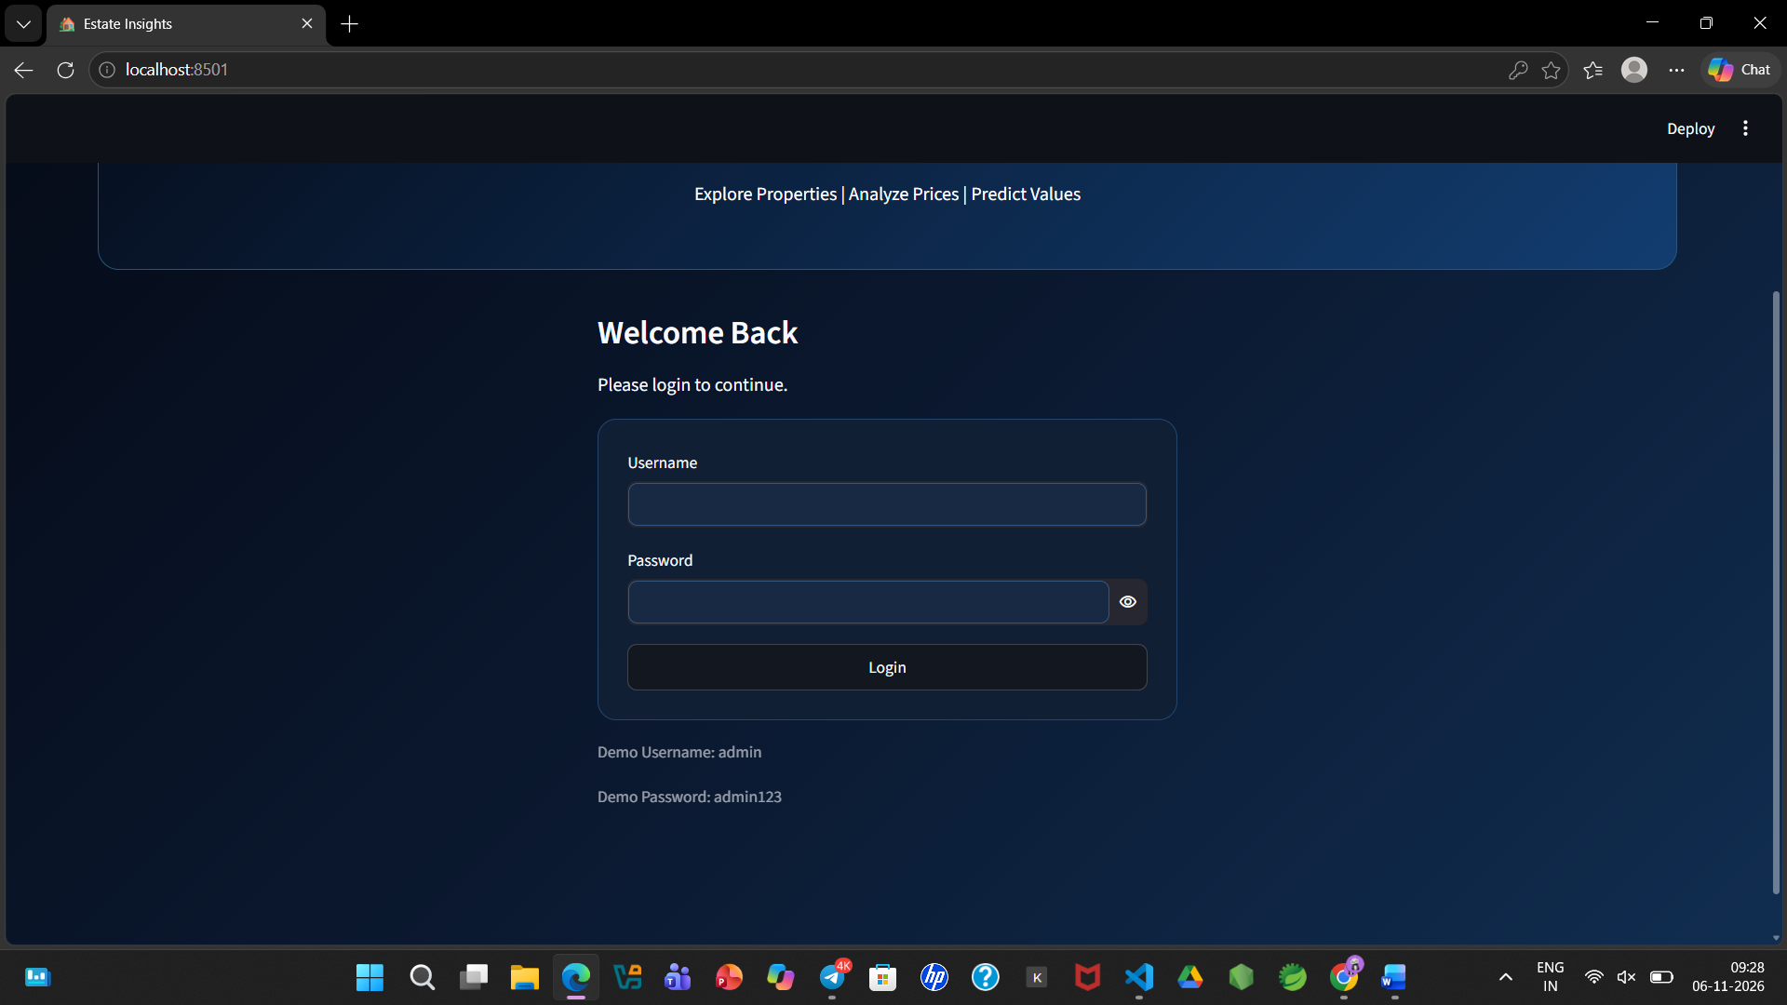
Figure A.1 – Login page
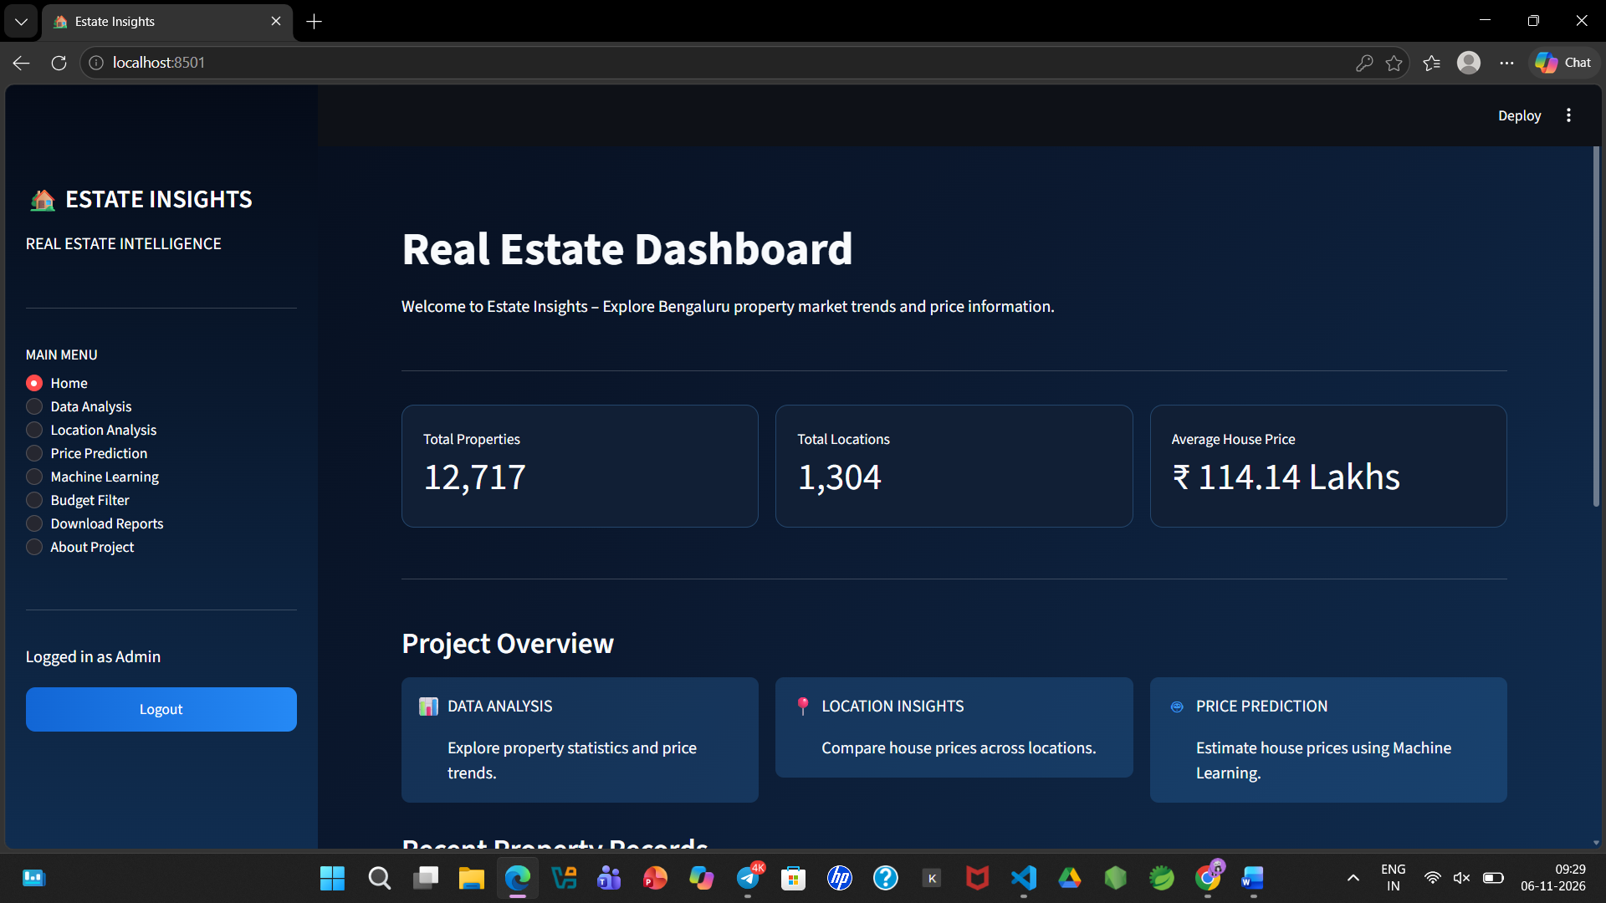
Figure A.2 – Real Estate Dashboard (Home page with KPIs and project overview)
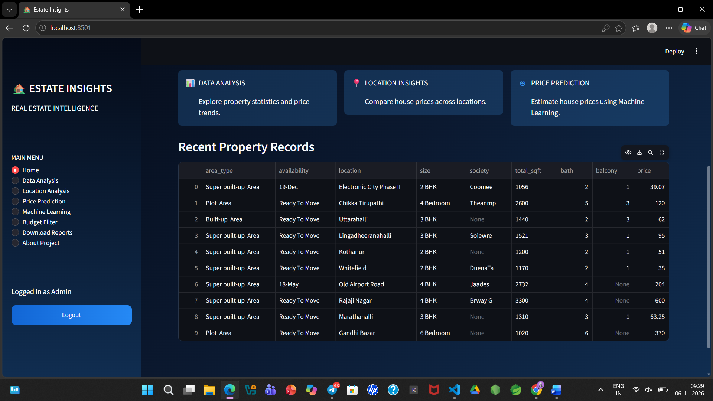
Figure A.3 – Recent property records
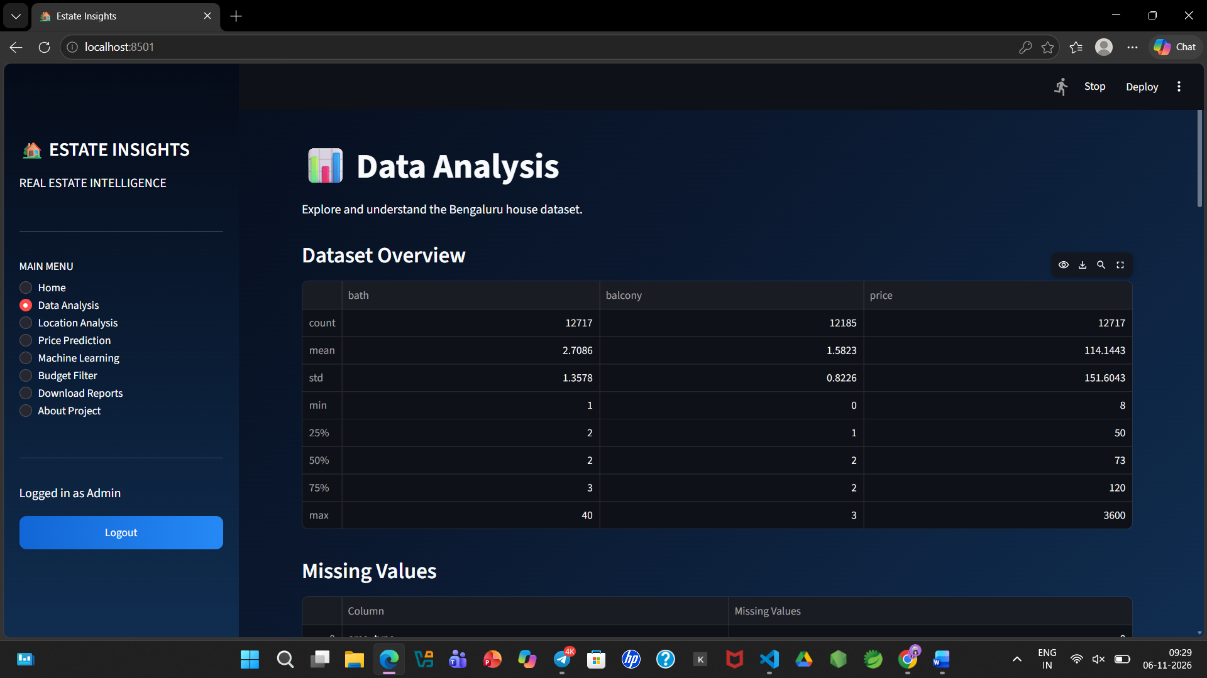
Figure A.4 – Data Analysis: dataset overview and missing values
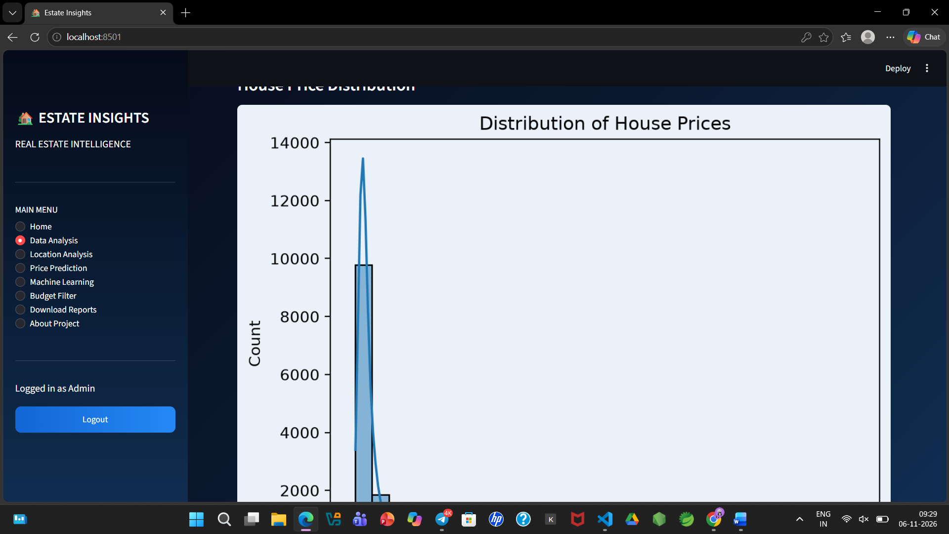
Figure A.5 – House price distribution
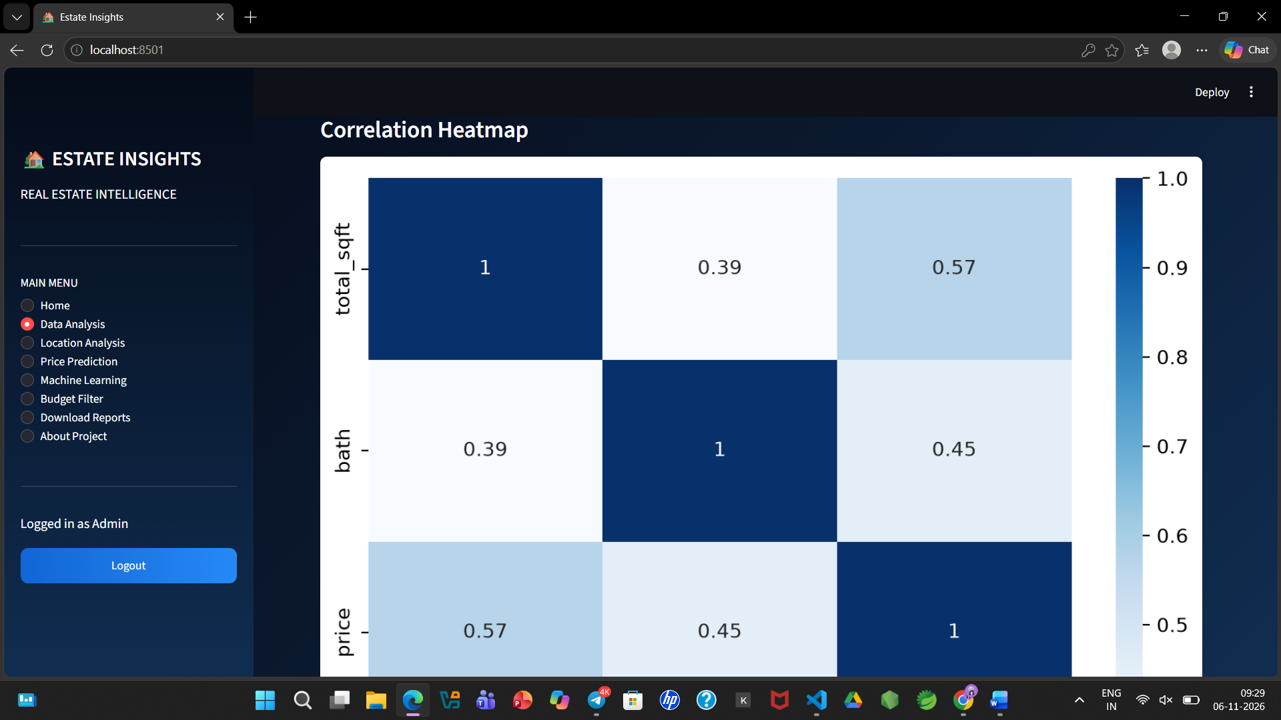
Figure A.6 – Correlation heatmap of total_sqft, bath and price
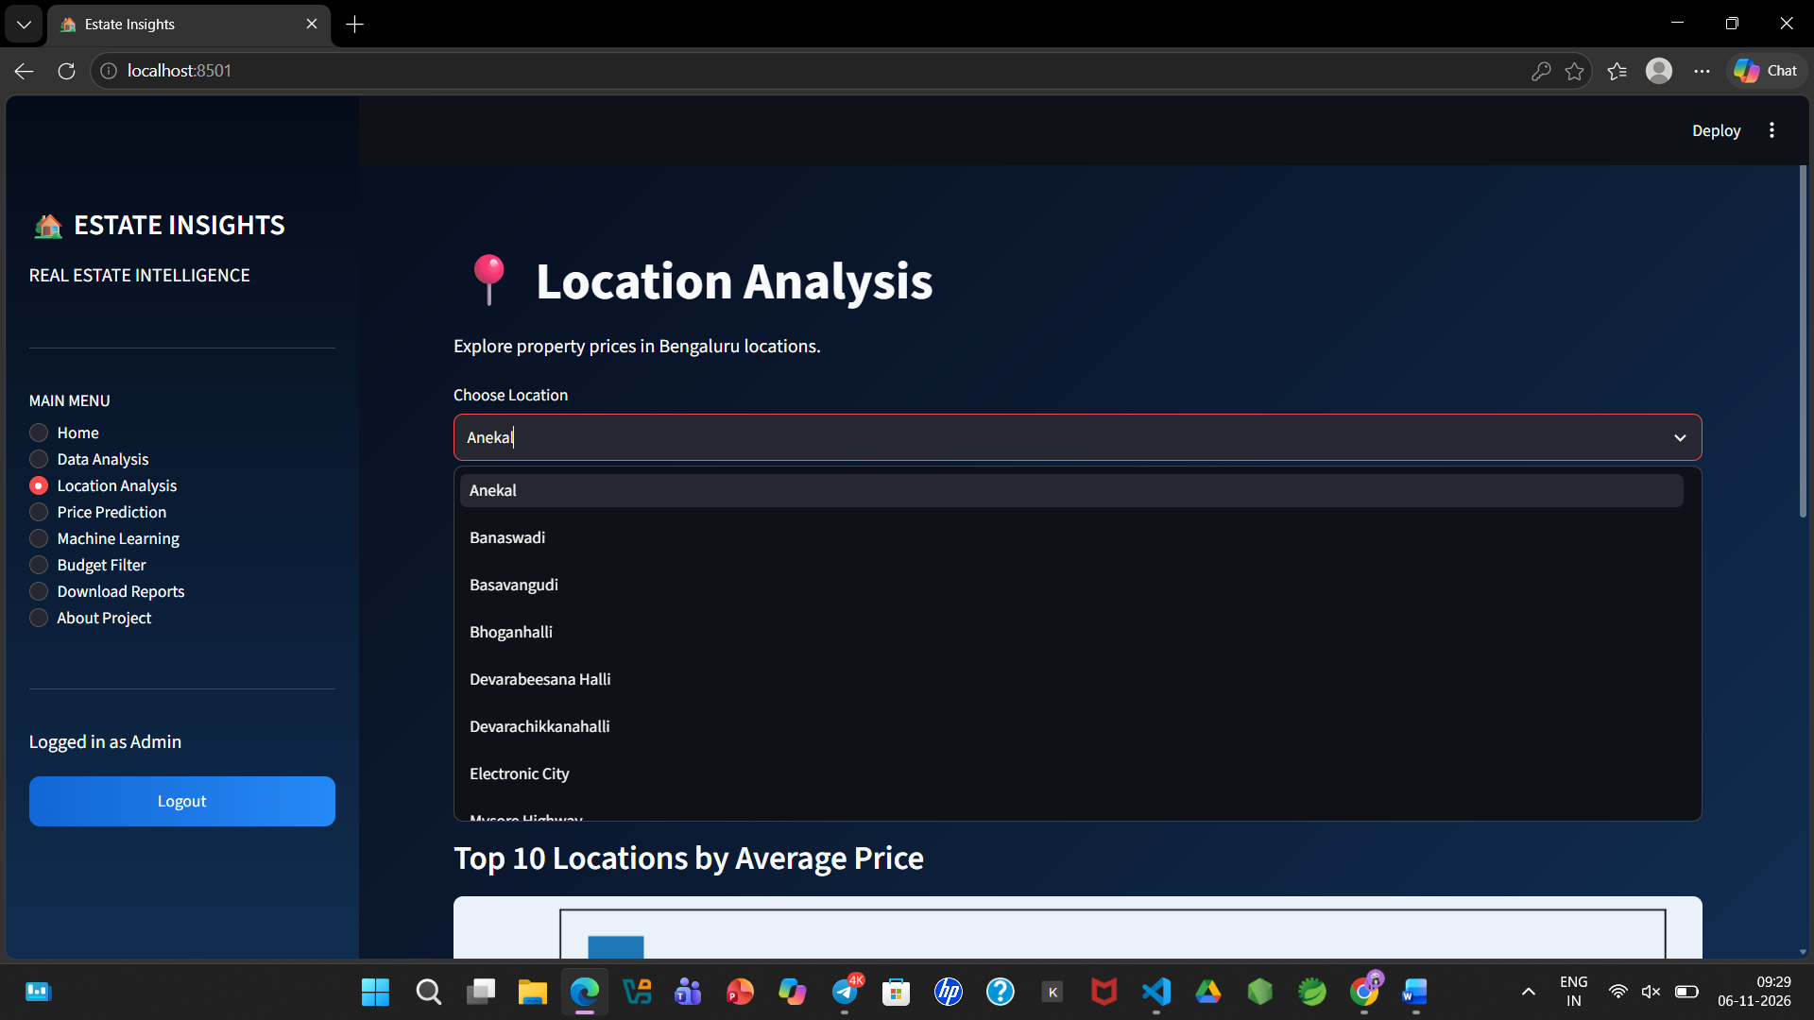
Figure A.7 – Location Analysis: choose location and top 10 locations
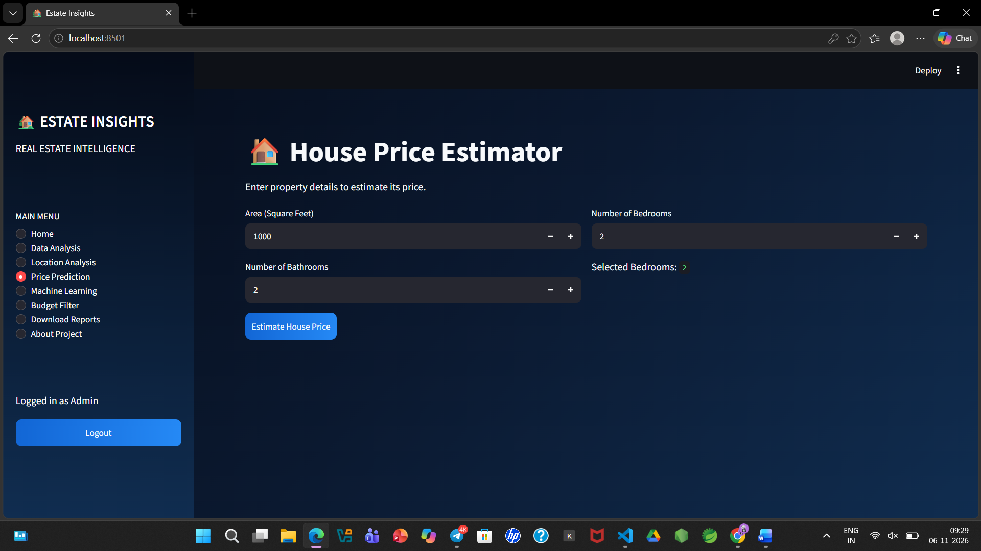
Figure A.8 – House Price Estimator (Price Prediction page)
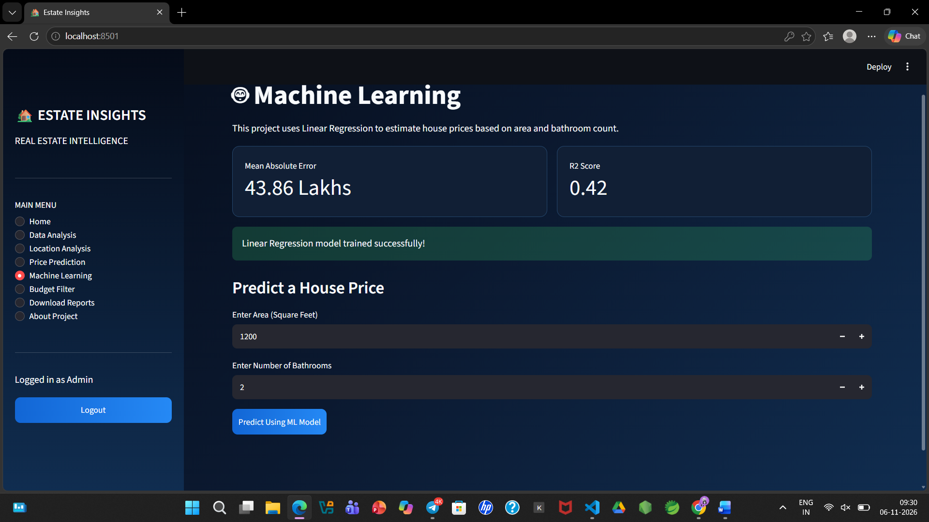
Figure A.9 – Machine Learning page: Linear Regression metrics and prediction form
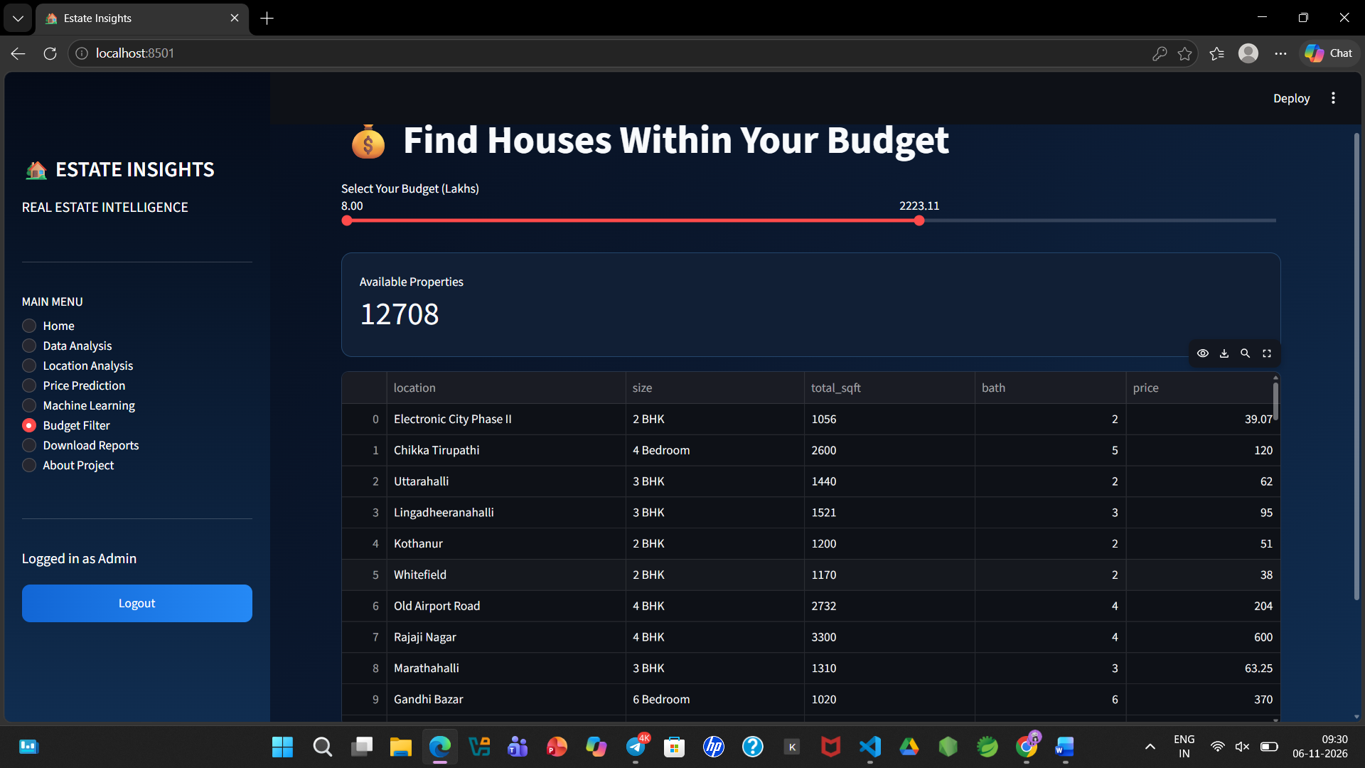
Figure A.10 – Budget Filter: find houses within your budget
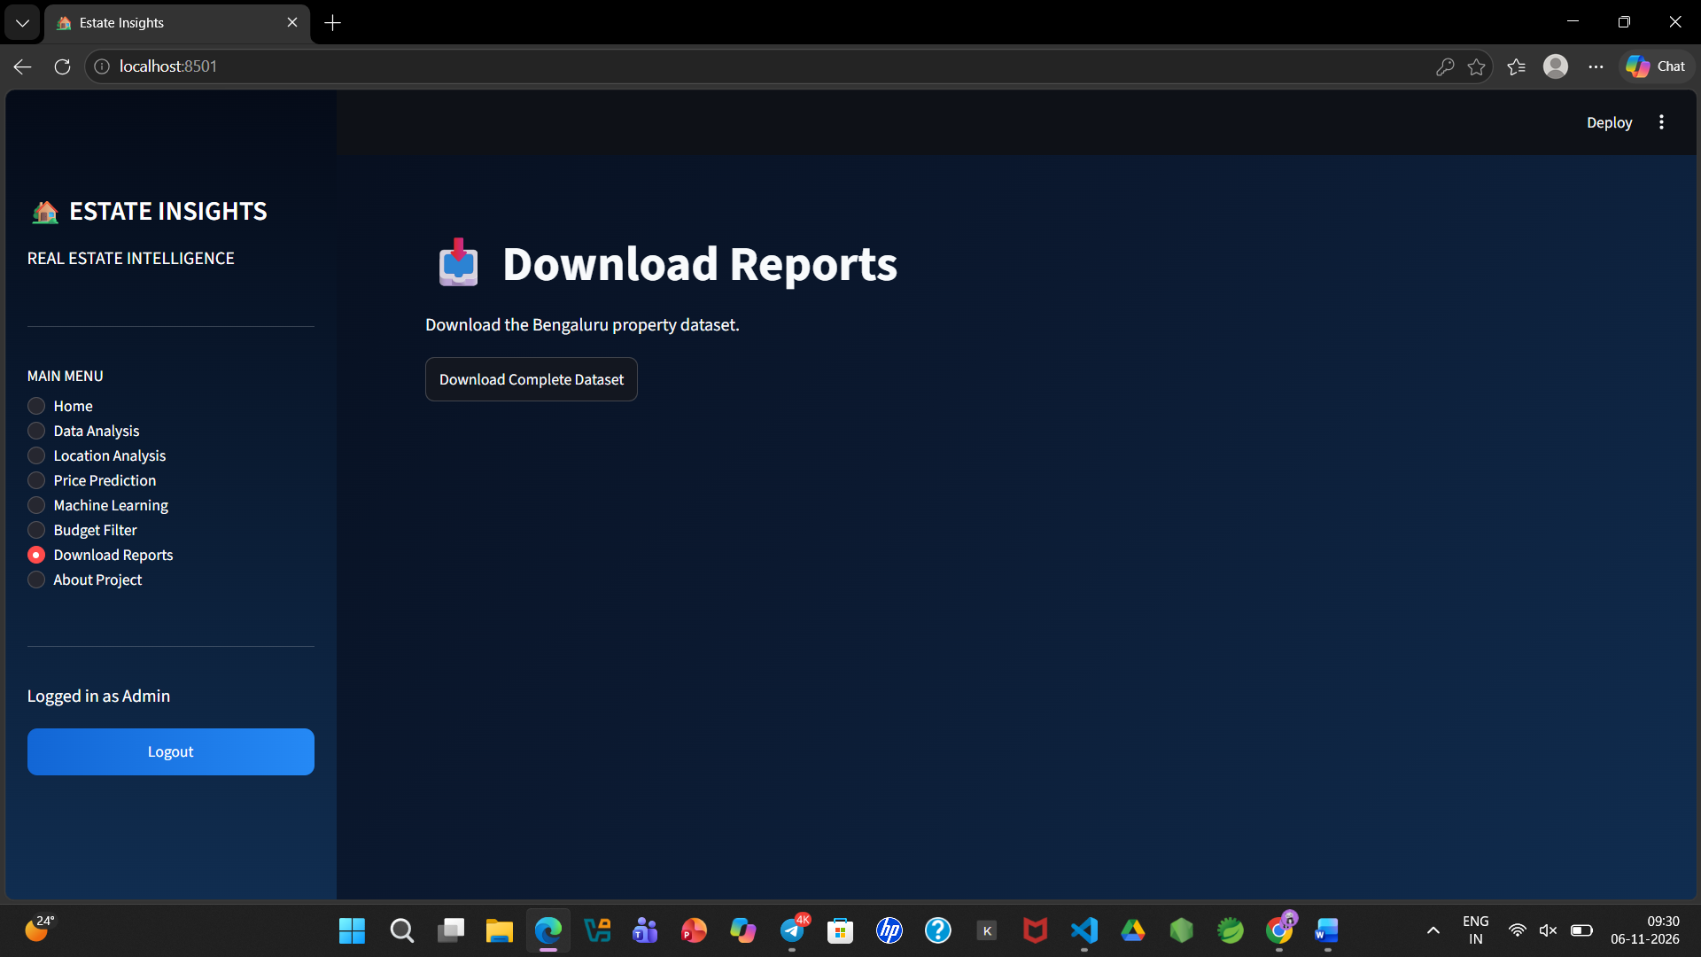
Figure A.11 – Download Reports page

14.2 Sample Code Snippets
Area cleaning and BHK extraction functions:
def clean_area(value):
if not isinstance(value, str):
return np.nan
value = value.lower().strip()
value = value.replace(",", "")
try:
return float(value)
except ValueError:
return np.nan
def extract_bhk(value):
if pd.isna(value):
return np.nan
match = re.search(r"\d+", str(value))
if match:
return int(match.group())
return np.nan
Average price by location (used for the Top 10 locations chart):
def average_price_by_location(df):
location_prices = df.groupby('location')['price'].mean()
return location_prices.sort_values(ascending=False)
Data cleaning logic (simplified representation from the backend preprocessing module):
def clean_data(df):
df = df.dropna()
df['location'] = df['location'].str.lower().str.strip()
df['total_sqft'] = pd.to_numeric(
df['total_sqft'], errors='coerce'
)
df = df.dropna(subset=['total_sqft', 'price'])
df = df[df['total_sqft'] > 0]
return df
Model training workflow (conceptual):
X = df[['total_sqft', 'bath', 'bhk']]
y = df['price']
X_train, X_test, y_train, y_test = train_test_split(
X, y, test_size=0.2, random_state=42
)
model = LinearRegression()
model.fit(X_train, y_train)
predictions = model.predict(X_test)

14.3 Installation and Setup Instructions
Install Python 3.10 or later and create a virtual environment. Install the required libraries using pip install streamlit pandas numpy scikit-learn matplotlib plotly. Place the Streamlit application file and the Bengaluru property CSV dataset in the same project folder and start the dashboard with streamlit run app.py. The dashboard opens in the browser at http://localhost:8501.

14.4 User Manual
- Start the dashboard with streamlit run app.py and open http://localhost:8501 in the browser.
- Log in using the demo username and password shown on the login page.
- Use the Home page to view total properties, total locations, average price and recent property records.
- Open Data Analysis to review the dataset overview, missing values, price distribution and correlation heatmap.
- Open Location Analysis, choose a location and review the top 10 locations by average price.
- Open Price Prediction, enter the area, bedrooms and bathrooms and press Estimate House Price.
- Open Machine Learning to view MAE and R², then enter the area and bathrooms and press Predict Using ML Model.
- Open Budget Filter and move the slider to list properties within the selected budget.
- Open Download Reports and press Download Complete Dataset to save the data.
- Press Logout in the sidebar when finished.

