Customer Order Analysis Report
Objective
The notebook analyzes customer purchasing behavior from order records structured as: (customer_name, product, price, category). The dataset contains six customers: Andy, Bob, Charles, David, Joe, and Jessy. The analysis groups their purchases, categorizes products, calculates spending and category revenue, identifies high-spending customers, and uses set operations to examine purchasing patterns.
1. Store customer orders
• Create a list of customer names
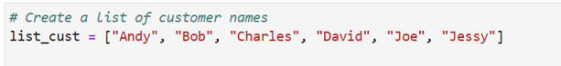
• Store each customer's order details (customer name, product, price, category) as tuples inside a list
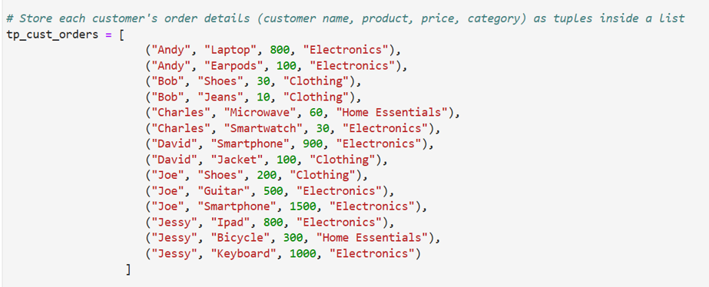
• Use a dictionary where keys are customer names and values are lists of ordered products
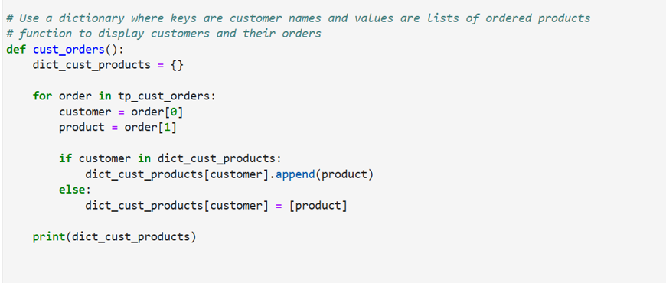
Output:
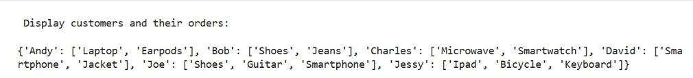
2. Classify products by category
• Use a dictionary to map each product to its respective category
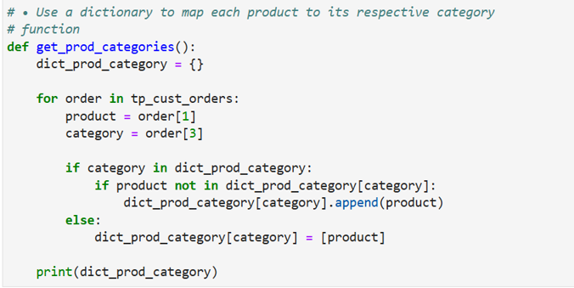
Output:
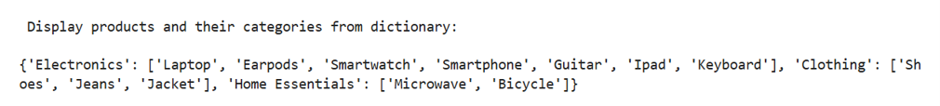
• Create a set of unique product categories
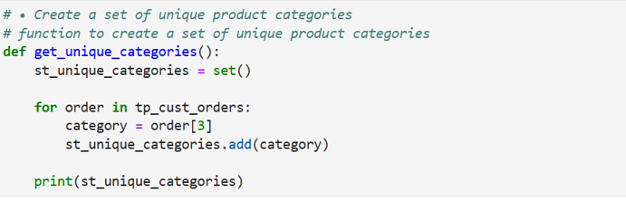
• Display all available product categories
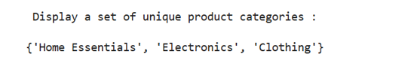
3. Analyze customer orders
• Use a loop to calculate the total amount each customer spends
• If the total purchase value is above $100, classify the customer as a high-value buyer
• If it is between $50 and $100, classify the customer as a moderate buyer
• If it is below $50, classify them as a low-value buyer
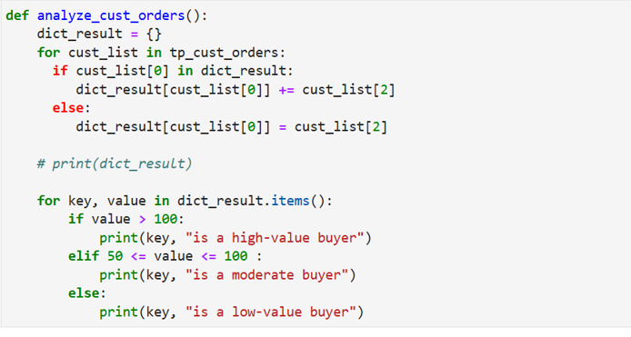
Output:
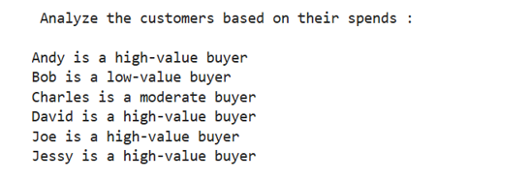
4. Generate business insights
• Calculate the total revenue per product category and store it in a dictionary
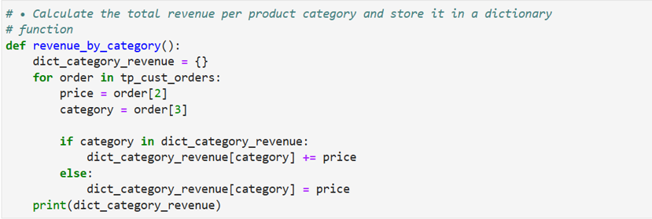
Output:
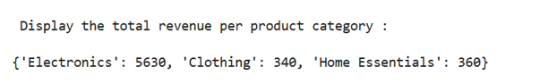
• Extract unique products from all orders using a set
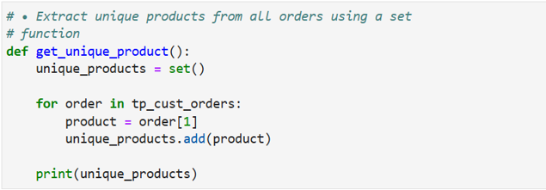
Output:
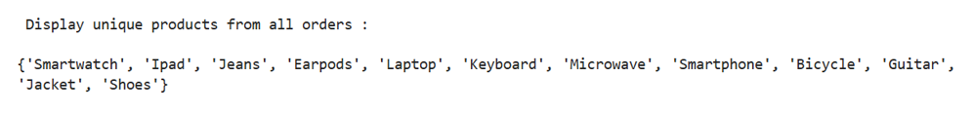
• Use a list comprehension to find all customers who purchased electronics
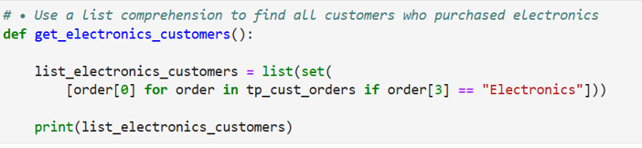
Output:
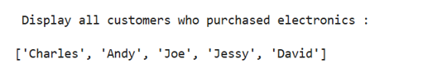
• Identify the top three highest-spending customers using sorting
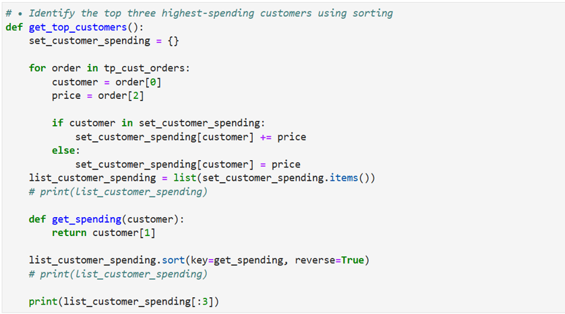
Output:
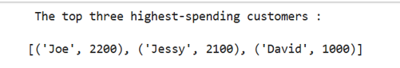

5. Organize and display data
• Print a summary of each customer’s total spending and their classification
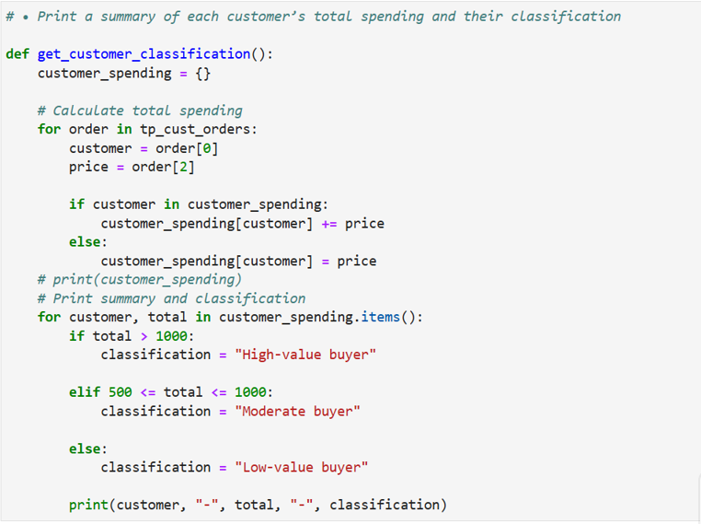
Output:
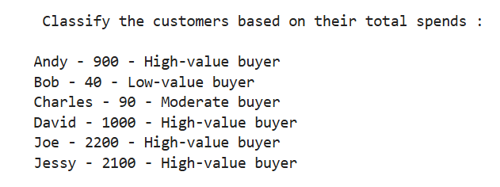
• Use set operations to find customers who purchased from multiple categories
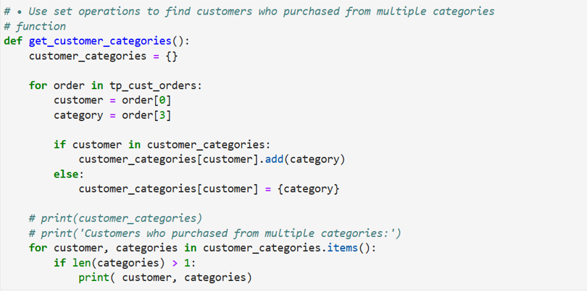
Output:
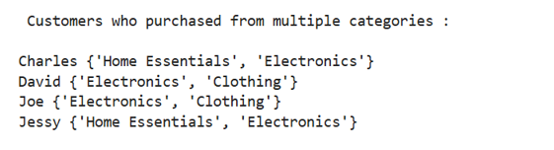
• Identify common customers who bought both electronics and clothing
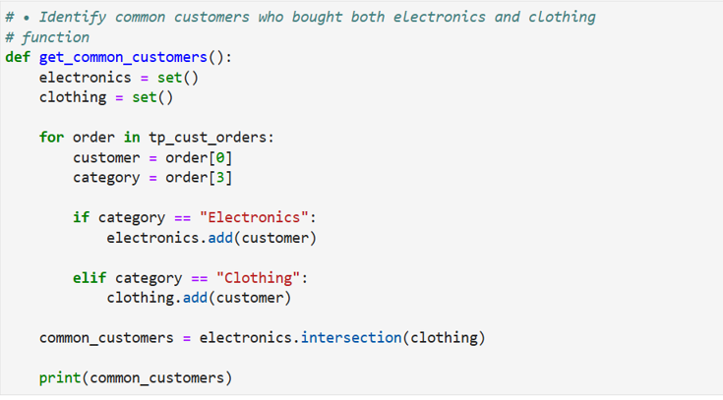
Output:
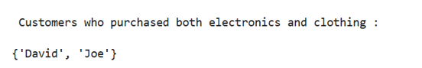
Overall assessment
The notebook demonstrates the Python concepts, dictionaries, sets, loops, tuples, lists and list comprehension for filtering Electronics customers, functions for organizing the program, and. sort() with a custom key function for identifying the highest-spending customers.
From a business perspective, the analysis shows that Joe is the highest-spending customer at $2,200, followed by Jessy at $2,100; Electronics is the dominant category with $5,630 in revenue; five of the six customers purchased Electronics; and David and Joe purchased from both Electronics and Clothing.

