< Project Name >

**Business Requirements Document**

**Prepared for**



<https://hersecondinnings.com/>

**Prepared by**

*HSI BATCH 5 Returnship Team*

For internal use only

Document Control

Change Record

| Date | Author | Version | Change Reference |
| --- | --- | --- | --- |
|  |  |  |  |
| 01/06/2021 | Amitha  Julie  Shalaja | 1.0 | Initial version |
|  |  |  |  |
|  |  |  |  |
|  |  |  |  |
|  |  |  |  |

Participants

Contributors

| Name | Representing | Role |
| --- | --- | --- |
| Vrinda | HSI | Business PM |
| Nisha | HSI | Business Analyst |
| Shailaja | HSI | IT Analyst + Developer |
| Julie | HSI | IT Analyst + Developer |
| Amitha | HSI | IT Analyst + Developer |

Reviewers/Approvers

| Name | Representing | Role | Approval Date |
| --- | --- | --- | --- |
|  |  |  |  |
| Vrinda |  | Business PM |  |
| Nisha |  | Business Analyst |  |

**Contents**

1. Executive Summary 4

2. Business objective 4

2.1 Background 4

2.2 In-Scope 4

2.2 Out-of-Scope 4

2.4 Assumptions 5

3. Functional Requirements 5

FR-001: Bot Login 5

FR-002: Bot Scheduling 6

4. Non-Functional Requirements 11

5. Glossary 12

6. References 13

7. Appendix 14

# **Executive Summary**

One of the services provided by HSI is Her Second Innings has been created as a platform to make women financially independent, emotionally strong and socially empowered. HSI group enables us to succeed professionally

# **Business objective**

## **Background**

Present Business Process in brief

* 1. As _ IS process Diagram

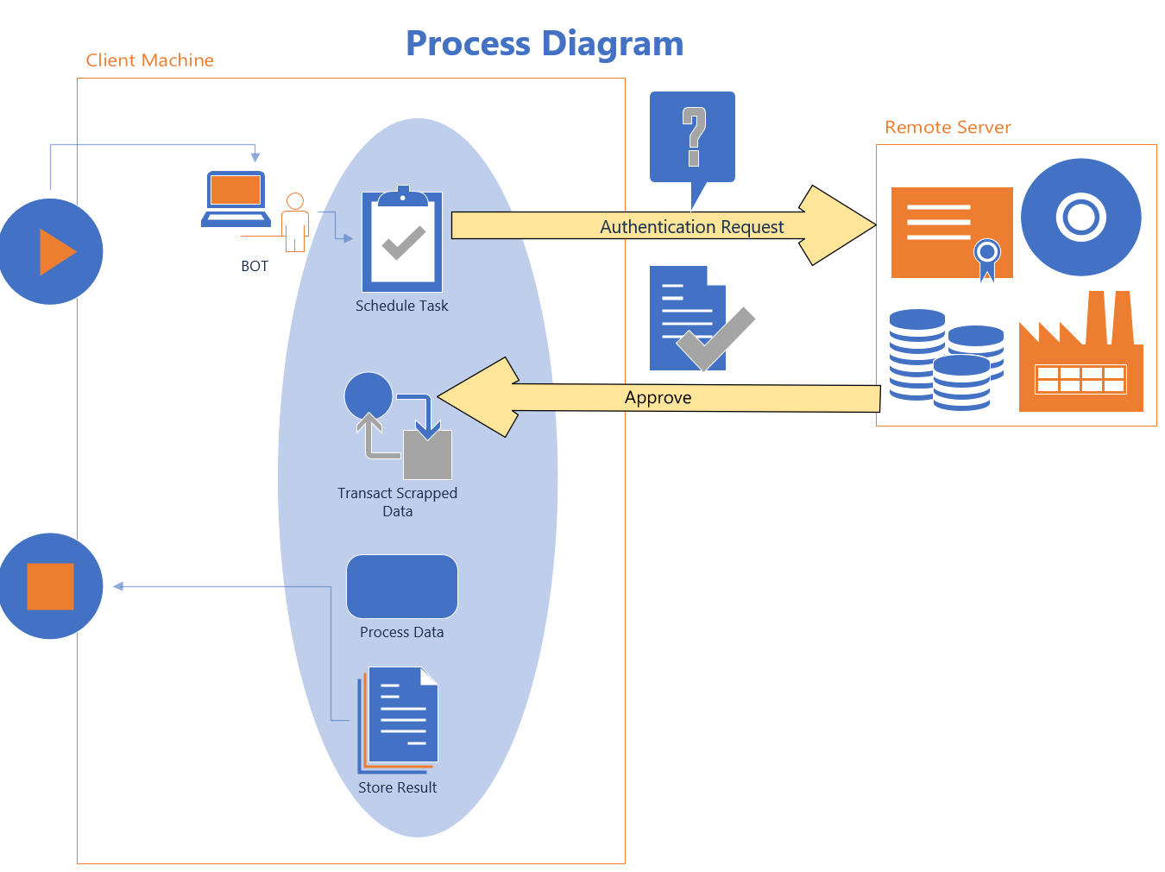

* 1. As -IS Process Description Step by Step in detail

1. Sending Authentication Request to the Remote Machine for Server Connectivity.
2. Authentication Request Approved.
3. Starts Scraping Desktop\Web application based on the requirement.
4. Scrapped data processes.
5. Processed data stored into the local machine.

## **2.4 In-Scope**

To enable execution of job on the remote server using the uipath bot.

## **2.5 Out-of-Scope**

Data Encryption and decryption during data processing.

# **Functional Requirements( Example headings-Change Appropriately) Accompanying snapshots can be included for clarity**

|  |  |
| --- | --- |
| **ID** | **Requirement Description** |
| **Establishing Connection between Client and Server** | | Establishing Connection between Client and Server |
| FR-001 |  |
| **Scrap Data** | |
| FR-002 |  |
| FR-003 |  |
| FR-004 |  |
| **Notification** | |
| FR-005 | Notifies intended team after every run |

## **FR-001: Bot Login**

|  |  |
| --- | --- |
| **Goal** | Establishing Connection between Client and Server |
| **Pre-Condition** | 1. VNC Client in Local Machine 2. VNC Server in Remote Machine |
| **Flow** | 1. Sending Authentication Request to the Remote Machine for Server Connectivity. 2. Authentication Request Approved and connection established. |
| **Post-Condition** | Connection between Client and Server Established successfully. |

## 

## **FR-002: Scrap and store the data into Notepad**

|  |  |
| --- | --- |
| **Goal** | The bot is able to   * Identify * Extracts data * Store the data into the notepad |
| **Flow** | 1. Identify   ***b.1 Sample Format of what the BOT sees on login or whatever etc***  Image of the scrap or what its about to scrap etc.  ***b.2 Sample 2***  a)   1. The relevant information needs to be transported to excel   **Eg Email to Excel Column Mapping**   |  |  | | --- | --- | | **Email Column** | **Excel Column** | | Name: | Name | | Date & Time: | DateTime of Enquiry /Search | | Phone: | Phone | | Requirement: | Comments* | | Email: | Email | | Email Body |  | | Subject |  | |  |  | |  |  | |  |  | |  |  | |  |  | |  |  | |

## **FR-004:**

## **FR-005:**

# Non-Functional Requirements

|  |  |
| --- | --- |
| **ID** | **Requirement** |
| NFR 1 | Need to add PDF and Email Automation in our BOT. |

# Glossary

This section explains all of the terms and abbreviations that were used in this document, for those who are unfamiliar with them. Not everybody who reads this document will understand all of the terms, so this section is helpful.

|  |  |
| --- | --- |
| **Term** | **Explanation** |
|  |  |
| VNC | VNC Viewer |
| API | Application Programming interface |
| CV | Computer Vision Package |
|  |  |
|  |  |
|  |  |
|  |  |
|  |  |

# References

This section contains links to all other places that were referred to in this document. These may include to automate the process:

* Documents on shared document control systems (such as SharePoint)
* Web sites
* URLs or network locations

|  |  |
| --- | --- |
| **Name** | **Link** |
|  |  |
|  |  |
|  |  |
|  |  |
|  |  |

# Appendix

This section may include any other information that does not fit in the document above. This may include:

* Any other Details of the processes
* Analysis of existing process and benefits for the Business Objectives section.
* Any other information you might need

Beware of overloading this document with information. Preferably, any extra documents should be created separately and linked to, rather than embedding, as it is better for file sizes and version control.