­­­­­

|  |  |
| --- | --- |
|  |  |



Development

Specification

Document

Table of Contents

I. Purpose 3

II. Automated process details 4

4 Runtime guide 5

4.1 Architectural structure of the Master Project 5

4.2 Master Project Runtime Details 5

4.3 Project details 6

4.4 Project(s) workflows 7

5 Other Details 8

6 Glossary 9

# Purpose



The purpose of the document is to record the outcome specific to the automated master project and its sub components: projects, workflows, sequences etc.

Some of the content will be taken from the Solution Design Document, whereas the content specific to this will be more detailed and is designed to enable troubleshooting of the automated solution in UAT as well as post release into production. Objectives

# Automated process details



|  |  |
| --- | --- |
| Item | Description |
| Master Project Name | Computer Vision for Remote Connection |
| Robot Type | Bot |
| Orchestrator used? | Yes |
| Scalable | Yes. You can add Web Scraping ‘n’ number of times. |
| UiPath version used | 2020.10.2 |

# Runtime guide

## Architectural structure of the Master Project

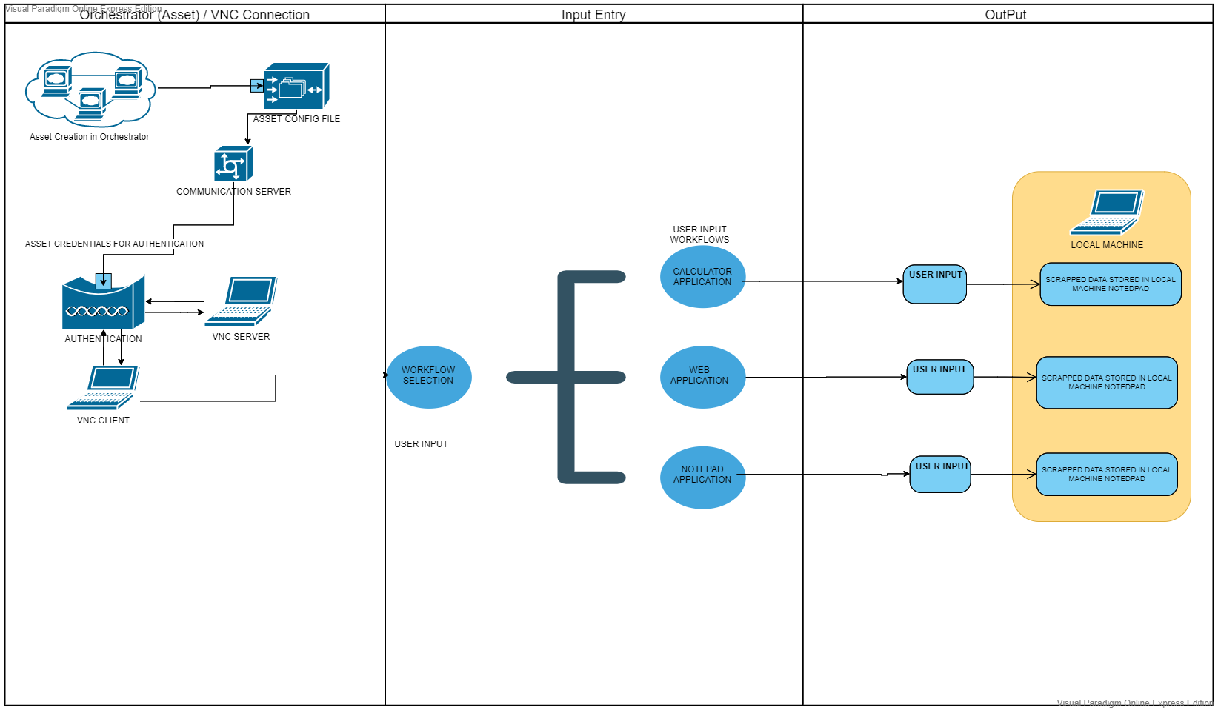

## Master Project Runtime Details

|  |  |
| --- | --- |
| ITEM NAME | DESCRIPTION  Fill in each bolded section - empty fields are not allowed. If the section does not apply to your automation then mark as n/a. |
| Production environment details | *Running Virtual Remote Machine using VNC Client and VNC Server, Scrapping the Application running on the Remote Machine selected by the end user (WEB\Desktop app\Notepad).*  *UiPath Studio: Reframe work* |
| Prerequisites to run | ***Connections:***  ***1.Login in to VNC Client.***  ***2. VNC Client to VNC Server.***  ***3.Orchestrator Connection for Assets.*** |
| Input Data | ***Selection given for user (WEB\Calculator\Notepad) for scrapping in config file.*** |
| Expected output | ***Scrapped Data storing into Local Machine’s Notepad.*** |
| How to start the automated process | ***Start the job.*** |
| How to restart the process from a certain step? | ***Not possible. The process can be restarted from the Init state.*** |
| Reporting  (queues reporting, Kibana or another platform) | *n/a.* |
| Manual error handling?  (roll back or manually complete failed transactions). Procedures to reset the item. E.g. “set status as investigating” | ***In case of error, the process can be restarted or stopped. By Clicking Ok/Cancel. Yes manual error handling required.*** |
| How to resume the process in case of error? | ***Process Starts/Stops.*** *By Clicking Ok/Cancel.* |
| How to manually fix transactions with error? | *Debug and fix the errors or change the config values.* |
| How is Orchestrator used? | ***Assets Credentials are stored in the Orchestrator.*** |
| Password policies  (mention any specific compliance requests) | API Key and Asset Credentials needs to maintain in the whole projects. Credentials are stored in Config file. |
| Stored credentials  (Never use hardcore credentials in the workflow!) | *Orchestrator used for asset passwords.* |
| List of Asset Names  (Naming convention: ProcessName_AssetName) | ***VNC_Client***  ***VNC_Server*** |
| List of queues names  (Naming convention: ProcessName_QueueName) | n/a. |
| Schedule Details | n/a |
| Multiple Resolutions Supported?  (in case of image automation / Citrix and VDI) | Yes. |
| Recommended Resolution | *Google Cloud Vision OCR /Citrix (License Needed).* |

## Project details

|  |  |
| --- | --- |
| ITEM NAME | DESCRIPTION  Fill in each section - empty fields are not allowed. If the section does not apply to your automation then mark as n/a. |
| Environment used for development  (name, location, configuration details etc) | *VNC Viewer (VNC_Client and VNC Server)*  *Computer Vision Package*  *Orchestrator (Asset)*  *API Key*  *UIPATH 2020.10.2* |
| Environment prerequisites  (OS details, libraries, required apps) | *Windows 10, VNC Viewer (VNC_Client and VNC Server), WEB\Desktop Applications and Notepad.* |
| Repository for project  (where is the developed project stored) | ***Google Drive:*** https://drive.google.com/drive/folders  /1Yyg6UFKl3rdWJQAjOBG5nChmTRmeetUW?usp=sharing.  ***GitHub:*** <https://github.com/shailajasunil>  /ComputerVisionUsingUIPath.git |
| Configuration method  (assets, excel file, Json file) | *Getting Asset Credentials from orchestrator into Config file.* |
| Configuration details  (path for input files, configuration Orchestrator assets used) | ***Computer Vision Package/ VNC Authentication workflow.***  **Web Application Workflow for Web Scrapping.**  **Desktop Application Workflow for calculator Application Scrapping.**  **Notepad Scrapping Workflow.**  **All the above workflows integrated with main workflow.** |
| List of reused components |  |
| *VNC Viewer (VNC_Client and VNC Server)*  *Computer Vision Package*  *Orchestrator (Asset)*  *API Key* |
| Login Level | Sending Authentication Request from the Local Machine to the Remote Machine for Server Connectivity. |
| Details about automation (if the apps were automated using UI Automation, Image & Text) | ***To*** enable execution of job on the remote server using the UiPath Bot.  The **objective** of this project is to **automate**   * Sending Authentication Request from the Local Machine to the Remote Machine for Server Connectivity. * Authentication Request Approved. * Opening an application in remote system and get data from website * Calculator – calculate and show result in the Local system * Notepad - read text and display on local system * Close the connection with the Remote Machine   *Sends the file over email to a recipient list.* |
| In case of FOR, can the user operate the computer while the robot is running? | No, user can operate only when errors occurs. |
| Custom error logs defined in the workflows  (where Throw Activity was used, or custom log message was defined) | 1. *EmailNotAvailable Has no account in the VNC Viewer* 2. *Authentication Error – Client Machine and Remote Machine* 3. *Source Missing – the source files are not present (Integration issue)* 4. *Connection Failed-Due to Power\WIFI connection.* 5. *Remote Machine Screen Locked* 6. *Valid API key Not entered* 7. *Input data not scrapping properly or not found.* |
| Frequent errors found in the development phase | *1. Errors with selectors.*  *2. Expiring license for Excel account (can also happen in prod).*  *3.System.Exception*  *4.* when I tried to invoke the [activities](https://docs.uipath.com/activities/docs/introduction) I got below error.  System.Reflection. TargetInvocationException  5. System.MissingMethodException: Method not found.  6. Element not found exception  7. In certain situations, anchors and targets could not be clicked.  8. OCR engine used with the Computer Vision activities returned no results after screen scraping.  . |
| Workarounds used in the automation phase | ***Tried Removing the Login details and kept Desktop Open.***  ***Used Speech Package.*** |

## Project(s) workflows

|  |  |  |  |
| --- | --- | --- | --- |
| Workflow Name | Description | Input Argument | Output Argument |
| Take from Solution Design Document | Take from Solution Design Document and edit if need be |  |  |

# Other Details

### Debugging Tips

UiPath has a real-time engine that checks for errors while working with your workflow. Whenever an activity has errors, UiPath Workflow Designer notifies and gives you details about the issue encountered.

The activity that is currently being executed is highlighted during the debugging process, and for workflows that employ UI automation, you can also highlight the element used by an activity.

The **Properties Inspector** panel, that is displayed only in debugging, shows relevant properties for the active action, and the current value of all variables declared in the given scope.

Additionally, a detailed log is displayed in the **Output** panel, so that you can check the stages of your workflow.

You can slow down the debugging process with the **Slow Step** option, take a step by step approach or create pauses on certain activities by adding breakpoints.

Using Watch Window in the debugger you can see the value of the variables during run time and modify them as well.

### Post UAT Specifications

|  |  |
| --- | --- |
| ITEM NAME | DESCRIPTION  Fill in each bolded section - empty fields are not allowed. If the section does not apply to your automation then mark as n/a. |
| Average Handling Time per Transaction | 1.5mins |
| Recommended Number of Robots for the specified volumes - insert volume per frequency from PDD, Process Overview, Values for Number of times the process is ran per selected frequency and Process Frequency and | One |
| Specified Schedule | ***To*** enable execution of job on the remote server using the UiPath Bot.  The **objective** of this project is to **automate**   * Sending Authentication Request from the Local Machine to the Remote Machine for Server Connectivity. * Authentication Request Approved. * Opening an application in remote system and get data from website or some a * Calculator – calculate and show result in the Local system * Notepad - read text and display on local system * Close the connection with the Remote Machine * *Sends the file over email to a recipient list* |

## 

# 

# Glossary

**Master project** – CV_MutiActivity.xaml. The activities and exceptions in this process that are in the scope for RPA, are listed below.

Full Scope for RPA- the process is to be 100%automated. Connecting to remote machine. Opening an application or website and perform actions and then getting the data to local machine.

Invoking 3 Workflows.

1.CV_calculator.xaml

2. CV_WebScraping.xaml

3.CV_NotePad.xaml

Global Variables:

Table 2 - Global variables table

Name Data type Is written in workflows Is read in workflows

