­­­­­

|  |  |
| --- | --- |
|  |  |

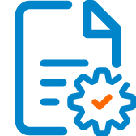

Solution Design

Document

Table of Contents

I. Purpose 3

II. Automated process details 4

3 Runtime guide 5

3.1 Architectural structure of the Master Project 5

3.2 Master Project Runtime Details 5

3.3 Project name 1 6

3.4 Project(s) workflows 6

3.5 Packages 7

3.6 Architectural structure of the Master Project 7

4 Other Details 8

Future Improvements 8

Other Remarks 8

5 Glossary 9

# Purpose



Outlines the major components of the Master Project (the overall output of the development, containing one or multiple projects that together cover the scope of the robotic process automation) taking into account all the business restrictions (scheduling, peaks, future increases in volume etc.). The focus of the Solution Architect will be on:

* Robustness;
* Scalability;
* Efficiency;
* Replicability;
* Reusability of component

The information herein is targeted primarily at the developers that will initially implement the solution and subsequently at the support developers in case of change requests.

# Automated process details

|  |  |
| --- | --- |
| Item | Description |
| Master Project Name | Computer Vision for Remote Connection |
| Robot Type | Unattended |
| Orchestrator used? | Yes |
| Scalable | No |
| UiPath version used | 2020.10.2 |

# Runtime guide

## Architectural structure of the Master Project

.2

## Master Project Runtime Details

|  |  |
| --- | --- |
| ITEM NAME | DESCRIPTION  *Fill in each bolded section - empty fields are not allowed. If the section does not apply to your automation then mark as n/a.* |
| Production environment details | *Running Virtual Remote Machine using VNC Client and VNC Server , Scrapping the Application running on the Remote Machine selected by the end user(WEB\Desktop app\Notepad).* |
| Prerequisites to run | ***Connections:***  ***1.Login in to VNC Client.***  ***2. VNC Client To VNC Server.***  ***3.Orchestrator Connection for Assets.*** |
| Input Data | ***Selection given for user (WEB\Calculator\Notepad) for scrapping in config file.*** |
| Expected output | ***Scrapped Data storing into Local Machine’s Notepad.*** |
| How to start the automated process | ***By Running the process*** |
| Reporting | *Notepad containing the scrapped data in it.* |
| (queues reporting, Kibana or another platform) | ***n/a.*** |
| How is Orchestrator used? | ***Assets Credentials are stored in the Orchestrator.*** |
| Password policies |  |
| (mention any specific compliance requests) | ***API Key from the Orchestrator. And all Assets credentials handled in the orchestrator. Using the Credentials from the config file.*** |
| Stored credentials | *Orchestrator used for asset passwords.* |
| (Never use hardcore credentials in the workflow!) | ***No.*** |
| List of queues names | ***n/a.*** |
| (Naming convention: ProcessName_QueueName) | *n/a.* |
| Schedule Details | ***n/a.*** |
| Multiple Resolutions Supported?  (in case of image automation / Citrix and VDI) | *Yes,. If change the pixels or resolution in remote machine, Computer Vision still supports.* |
| Recommended Resolution | *Google Cloud Vision OCR /Citrix(License Needed).* |

## Project name 1

|  |  |
| --- | --- |
| ITEM NAME | DESCRIPTION  *Fill in each section - empty fields are not allowed. If the section does not apply to your automation then mark as n/a.* |
| Environment used for development  (name, location, configuration details etc) | *VNC Viewer (VNC_Client and VNC Server)*  *Computer Vision Package*  *Orchestrator (Asset)*  *API Key*  *UIPATH 2020.10.2 Reframe work.* |
| Environment prerequisites  (OS details, libraries, required apps) | *Windows 10, VNC Viewer (VNC_Client and VNC Server), WEB\Desktop Applications and Notepad Reframe work..* |
| Repository for project  (where is the developed project stored) | ***GoogleDrive:***https://drive.google.com/drive/folders  /1Yyg6UFKl3rdWJQAjOBG5nChmTRmeetUW?usp=sharing.  ***GitHub:*** <https://github.com/shailajasunil>  /ComputerVisionUsingUIPath.git |
| Configuration method  (assets, excel file, Json file) | *Getting Asset Credentials from orchestrator into Config file.* |
| List of reused components | ***Computer Vision Package/ VNC Authentication workflow.***  **1.Web Application Workflow for Web Scrapping.**  **2.DeskTop Application Workflow for calculator Application Scrapping.**  **3.NotePad Scrapping Workflow.**  **All the above workflows integrated with main workflow.** |
|
| List of new reusable components | *VNC Viewer (VNC_Client and VNC Server)*  *Computer Vision Package*  *Config File*  *Orchestrator (Asset)*  *Reframe work.*  *API Key* |

## Project(s) workflows

|  |  |
| --- | --- |
| Workflow Name | Description |
| Main | *invokes all the other workflows.*  1.Web Application Workflow for Web Scrapping.  2.DeskTop Application Workflow for calculator Application Scrapping.  3.NotePad Scrapping Workflow.  All the above workflows integrated with main workflow.  Main: CV_MultiActivity.xaml  Sub_Workflow1: CV_NotePad.xaml  Sub_Workflow1: CV_Calculator.xaml  Sub_Workflow1: CV_WebScraping.xaml |

## Packages

|  |  |
| --- | --- |
| Package Name | Description |
| UiPath.ComputerVision.LocalServer | All of the activities in this pack only function when inside a **CV Screen Scope** activity, which establishes the actual connection to the neural network server, thus enabling you to analyze the UI of the apps you want to automate. Any workflow using the Computer Vision activities must begin with dragging a **CV Screen Scope** activity to the **Designer** panel. Once this is done, the **Indicate on screen** button in the body of the scope activity can be used to select the area of the screen that you want to work in. |
| Speech Package | ***Adding audio for process flow.*** |

## Architectural structure of the Master Project

## 

# Other Details

### Future Improvements

### *Example:*

*• Optimize the processing algorithm by adding PDF Automation*

*• Implement process error recovery (retry)*

*• Enable support for multiple Application Automation.*

### Other Remarks

The Cloud account is a [community](https://communityevents.uipath.com/) account and seems to have a limit to 240 Megapixels/Min. For a company with a lot of [robot](https://docs.uipath.com/robot/docs/introduction), if the same developer are developing all the bot it means same key will be used on all [robot](https://docs.uipath.com/robot/docs/introduction) and soon enough the threshold will be reached.

# Glossary

**Master project** - **Master project** – Containing:

Authentication workflow and 3 other work flows. This Project is connecting all the work flows based on the user selection..

***To*** enable execution of job on the remote server using the UiPath Bot.

The **objective** of this project is to **automate**

Sending Authentication Request from the Local Machine to the Remote Machine for Server Connectivity.

Authentication Request Approved.

Opening an application in remote system and get data from website or some a

Calculator – calculate and show result in the Local system

Notepad - read text and display on local system

Close the connection with the Remote Machine

**Project** - an UiPath Studio project containing one or multiple workflow files. A project can be converted to a package and run independently, covering a particular scope within the master project. Or multiple projects can be converted into one package depending on the aims and restrictions of the automation. The project is used when defining the development and support phase of the automation.

**Package** - the output of compiling one or multiple projects. A package can be deployed on the robot machine and be executed by the robot service. Only one package can be executed at a given time by a robot. The package is used when defining the running phase of the automation.

Workflow - a component of the package, the workflow encapsulates a part of the project logic. The workflow can be of type: sequence, flowchart or state machine. A workflow is saved as an .xaml file inside the project folder. A workflow file can be invoked from another workflow and by default there is an initial workflow file that will run when executing the package.

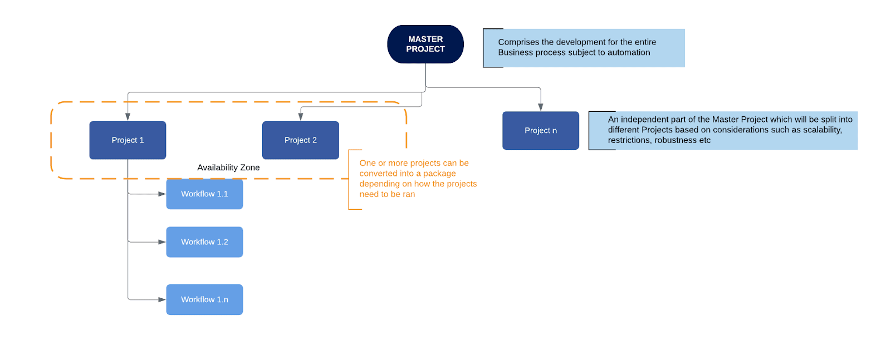

**Activity** - an action that the robot executes.

**Sequence** - a workflow where activities are executed one after another, in a sequential order

**Flowchart** - a workflow where activities are connected by arrows and the logic of the workflow can be easily followed in a visual manner. The flowchart can also be exported as an image from UiPath studio.

**State machine** - a more advanced way of organizing a workflow, similar to a flowchart.

**BOR** - Back office robot

**FOR** – Front office robot

**Orchestrator** – Enterprise architecture server platform supporting: release management, centralized logging, reporting, auditing and monitoring tools, remote control, centralized scheduling, queue/robot workload management, assets management.



.